1. Java Basics: Variables, Data Types, Operators, Control Structures, Loops, Methods, Arrays, and Strings.

**Variables:**

Variables is a container which can hold data, to represent data we need variables

Without having data type we cannot store variable data. Based on the data we have we can use assign data type.

|  |
| --- |
| package Basics;  public class VariablesAndDataTypes {  public static void main(String[] args){  //int a; >> declaration  //a = 100; >> assignment   int a = 100;  System.*out*.println(a);  a = 200; //changing a value to 200  System.*out*.println(a);   //Approach1 : individual assignment - if all the variables belong to diff data type  int k = 100;  int b = 200;  int c = 300; //Approach2: create variables and then assign data - if all the variables belong to same data type  int d,e,f;  d = 400;  e = 500;  f = 600;  //Approach3: we declare data type once and assign variables - if all the variables belong to same data type  int g = 200, h = 300,i = 400;  System.*out*.println("The value of g is " +g);  System.*out*.println("The value of h is " +h);  System.*out*.println("The value of g is " +i);  //To print all the values in single statement  System.*out*.println(g+" "+h+" "+i);  } } |

**Data types**

It represents type of data

There are two types of data types

1. Primitive
2. Non primitive/derived/collections

**Primitive data types**: Java has eight primitive data types, which are predefined by the programming language and used to store simple values:

* byte, short, int, long 🡪 number without decimal
* float, double is for representing decimal numbers
* char is to represent a single character(using single quote : char c = ‘A’; )
* Boolean is to represent true or false

**Non Primitive data types**:

* String, Arraylist, HashMap, HashSet etc.

Difference b.w:

|  |  |
| --- | --- |
| primitive | Non primitive |
| It starts with small letter | It starts with capital letter |
| We can store one value at a time in a variable | We can store multiple values in a variable |

* From the below table, if we assign long for int range value: the memory allocated will be higher than expected and will be wasted, thatswhy we need to choose the data type based on the value
* Most of the times we use int.

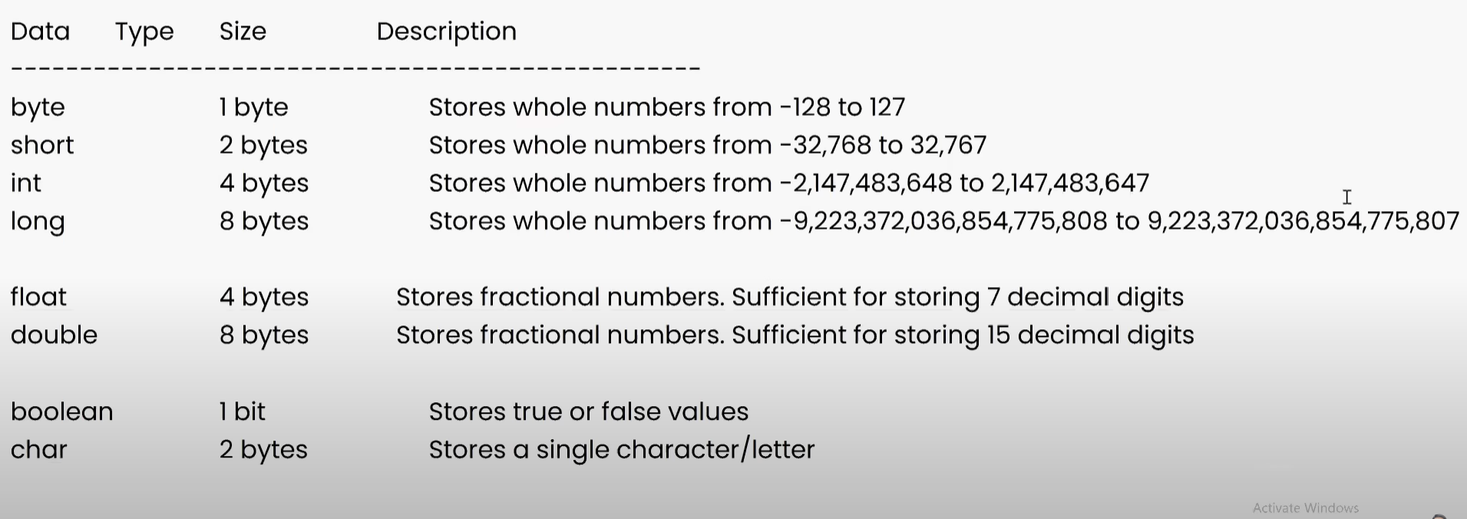

Some important usage of Boolean variable

* Suppose if we have some flag value that will set to false
* Checking whether given value is present in the set of values or not. Based on that condition the flag value will be true.

Some miscellaneous discussion about data types:

* Java is statically typed programming language . We cannot change it to diff data type

int x = 100;

x = “welcome”; //invalid

* Python is dynamically typed programming language, we don’t need to declare data type and it changes dynamically when we assign another value.

x = 100;

x = “welcome”

2. Object-Oriented Programming (OOP): Classes, Objects, Inheritance, Polymorphism, Encapsulation, and Abstraction.

3. Exception Handling: Try-Catch Blocks, Exception Types, and Custom Exceptions.

4. Collections Framework: Lists, Sets, Maps, and Iterators.

5. File Input/Output (I/O): Reading and Writing Files, Streams, and Buffered Readers/Writers.

6. Multithreading: Creating and Managing Threads, Synchronization, and Deadlocks.

7. Java Libraries and Frameworks: Familiarity with libraries like Apache Commons, and frameworks like TestNG or JUnit.

8. Selenium WebDriver: Java bindings for Selenium, WebDriver architecture, and browser automation.

9. Test Automation Frameworks: Page Object Model, Data-Driven Testing, and Behavior-Driven Development (BDD).

10. Java 8 Features: Lambda Expressions, Functional Programming, and Stream API (if applicable).

Mastering these topics will provide a solid foundation for a career in Automation QA using Java. Good luck!