|  |  |
| --- | --- |
| logo  **STUDENT PERFORMANCE EXPERT SYSTEM** | Presented by  Manikantha S Chavali  Manikanth Reddy Lekkala  Group 5    12/05/2017 |

Table of Contents

Contents

Organizational Context 3

Problems solved by application 3

Nature of support 3

Decision Maker & Decision Making 3

Users of the Decision Support 3

Category of Decision 3

Benefits of Decision Support 4

Factors Impacting Decision 4

Decision Support Requirements 5

Data Source for Decision Support 5

Analytics Involved 5

Specific Outcomes of the Decision 5

Architecture and DSS Type 6

Architecture 6

DSS Type 6

List of Technologies used 6

Data Components 7

Model Components 8

Model Example 9

User Interface 10

User Manual 11

Professor 11

Student 11

Administrator 12

# Organizational Context

The student performance expert decision support system, will support the CIS department faculty and students of the Murray State University

## Problems solved by application

The students while in half way through the semester or as the semester progresses, were not be able to know how better they should perform to secure a better grade. The future score analysis of the student performance can’t be known based on the current system as the weightage for each of the tasks (includes assignments, quizzes, homework’s, etc.) have been the same. Our system would provide the weightage based scores and analysis for each task. Once the score based on its weightage is calculated, the performance analysis for each student can be identified. Also, his future scores needed (across each task) to secure a better grade can be identified.

## Nature of support

* A user interface for the faculty to analyze the student performance both at individual and class levels.
* A user interface for students to view to current performance and as well as their future score prediction in correspondence to their desired grade.

# Decision Maker & Decision Making

## Users of the Decision Support

The following are the intended users for the application:

* Murray State University staff
* Murray State University CIS department faculty
* Murray State University CIS department students

## Category of Decision

The decisions involved in the system are mostly structured. The students’ performance is based on the weighted scores recorded in the database. The future score prediction also involves the current performance matched with the desired grade the student aims. The tasks weightage and the students raw scores are combined to provide the current as well as future performance that must be aimed.

## Benefits of Decision Support

The following are the benefits to the organization and its environment:

* The expert system would help the student know his weighted scores and ‘what if’ analysis, as the semester progresses. The student need not wait till the semester end to know their overall performance. They would be able to know what future scores they would require across each of the tasks to achieve their desired grades.
* The faculty would be able to know the performance of the students both at individual level and as well at the class level. Since the scores of each student are calculated as a weighted score, the exact performance of the student can be known in more detailed fashion. Also, the overall performance of the class would be more realistic. This would help the faculty to plan better for their course and can also boost the student to increase the performance.

## Factors Impacting Decision

The following are the factors that impact the decision making:

* The primary factor that impact the decision making in this system would be weightage of the tasks like the assignments, quizzes, homework’s, etc. The weightage could be changed as per the faculty requirement for each of the task.
* Also, the desired grade the student would like to target impact the decision making. The individual performance and decisions would change as the target (here the desired grade) for the individuals keeps changing.

# Decision Support Requirements

## Data Source for Decision Support

The data inputs for the decision support are:

* The individual score weightage. These details would be provided by the faculty of the specific course.
* The number of tasks. These details would also be decided by the faculty. They can add or delete the number of tasks and each of the sub -tasks (like quiz1, quiz 2 under task quiz).
* The students registered. The number of students registered for the course would let the overall class as well as their individual performance be decided.
* A separate database for this system would be designed with all the significant tables. A separate table for the Students, Courses, Weightages, Faculty, Tasks and Sub-tasks would be part of the design.

## Analytics Involved

Our expert system is a model based system. This helps us in decision making, perform a ‘what if’ analysis and as well as predict the future required performance at the individual student level.

## Specific Outcomes of the Decision

The students of the CIS department of Murray State University would be able to know their current performance as well as their required performance in each of the tasks, to achieve the desired grade.

# Architecture and DSS Type

## Architecture

A screenshot of text

Description generated with very high confidence

## DSS Type

This is model-based expert system that help users analyze and predict performance of student of Murray State university.

## List of Technologies used

The list of technologies used for the application development are:

* PHP for administrator access
* MySQL DB to create database
* Excel VBA for user interaction

# Data Components

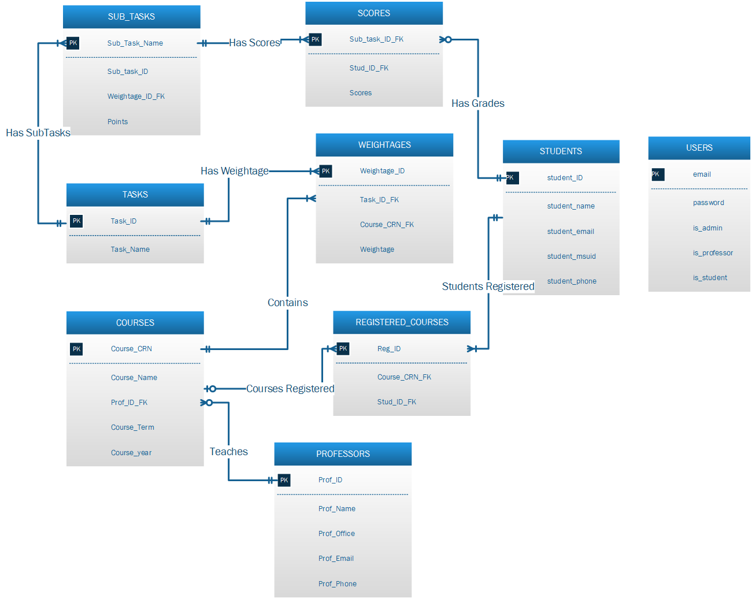

The relationships that exist in the “Student Performance Expert System” are as follows-

* The users table would be a single standalone table that has the list of the users mail-ids to authenticate the users while they login. The privileges for the user are set based on the mail-id and identifies them as student, faculty and administrator.
* Each student has one or more number of registered courses, 1:M, linked to his/ her profile.
* Each student can have zero or more number of sub-tasks attached to their course.
* Each professor can teach one or more courses.
* The courses table can have zero or more number of courses and each course has one or more, 1:M, weightages.
* Each task has one or more sub-tasks and each task has one or more, 1:M, weightages.
* Each of the sub-tasks has scores and the scores table has grades against each of the student in the course.

## Model Components

Category: Heuristics

Objective: To provide a user interface for faculty as well as students to analyze their performance both at individual and class levels. To help students know their current as well as future score prediction in correspondence to their desired grade.

Technique: The user would be able to use the weighted scores recorded in the database and perform a what if analysis to predict the future performances and grades. The tasks weightage and the students raw scores are combined to provide the current as well as future performance that must be aimed.

Algorithm followed for the system analysis: The front end login screen would provide a user interface and based on the mail-id, the user would be categorized as admin, student and faculty. If the mail-id belongs to both student and faculty database, a pop-up screen would appear asking the user to choose the role they would like to login. Once the login is successful the user can navigate to the list of courses they are enrolled (students) or the list of courses they (faculty) teach. The admin would have the privilege to add the students to courses as well as create or remove users from the system. The students or faculty can see the scores and can perform a what if analysis on the future scores for each of the sub tasks. These results would help them analyze their performance both at individual and class level. It also predicts the required scores to achieve the desired grade.

## Model Example

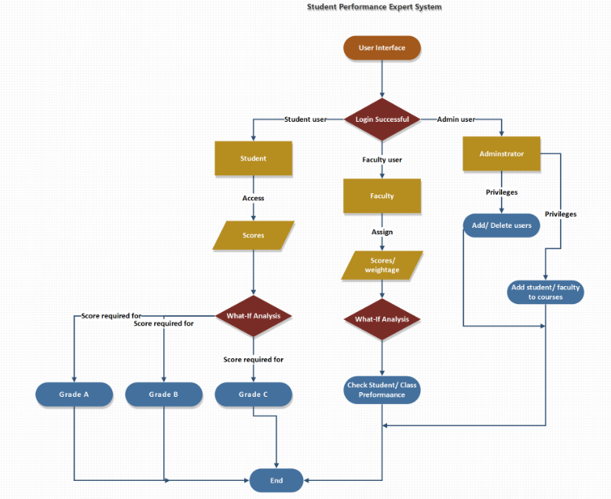

# User Interface

Figure 1. Login Screen

A screenshot of a cell phone

Description generated with high confidence

Figure 2. Student Dashboard Screen

A screenshot of a social media post

Description generated with very high confidence

Figure 3. Professor Dashboard Screen

A screenshot of a social media post

Description generated with very high confidence

# User Manual

The application user guidelines are as follows:

* The excel application has a login screen which requires a login username and a password. The username is the Murray State University ‘Canvas’ username and the default password are the professor or student M#ID excluding the ‘M00’ characters.
* Based on the user login id (professor or student), the dashboard screen displays accordingly.

## Professor

* The professor has the access to the list of courses he/ she teaches, and the students enrolled in the course.
* The professor once selects the course, the tasks associated with it would be displayed, along with sub-tasks and the scores.
* The tasks display the list of tasks and the weightages corresponding to the course.
* The sub-task allows the user to add, update delete the sub-tasks.
* The scores allow the users to update and delete the scores.

## Student

* The student when logged into the system will be able to see the courses he/ she has enrolled.
* The scores when selected allow the user to view a weighted percentage achieved so far.

## Administrator

Figure 4. phpMyAdmin login screen

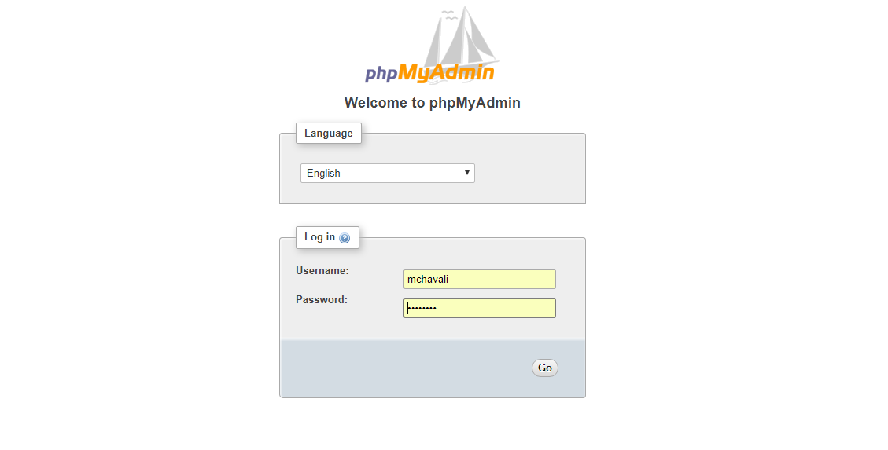

* The url to access the database is <http://csclab.murraystate.edu/phpmyadmin/>
* The database used for the application is ‘**lms_mchavali’**
* The username and password for the system are: ‘mchavali’ and ‘mchavali’.
* The admin has the right to access the database tables. He/ she can add, update and delete the fields and triggers for the tables.