Primitive data types:

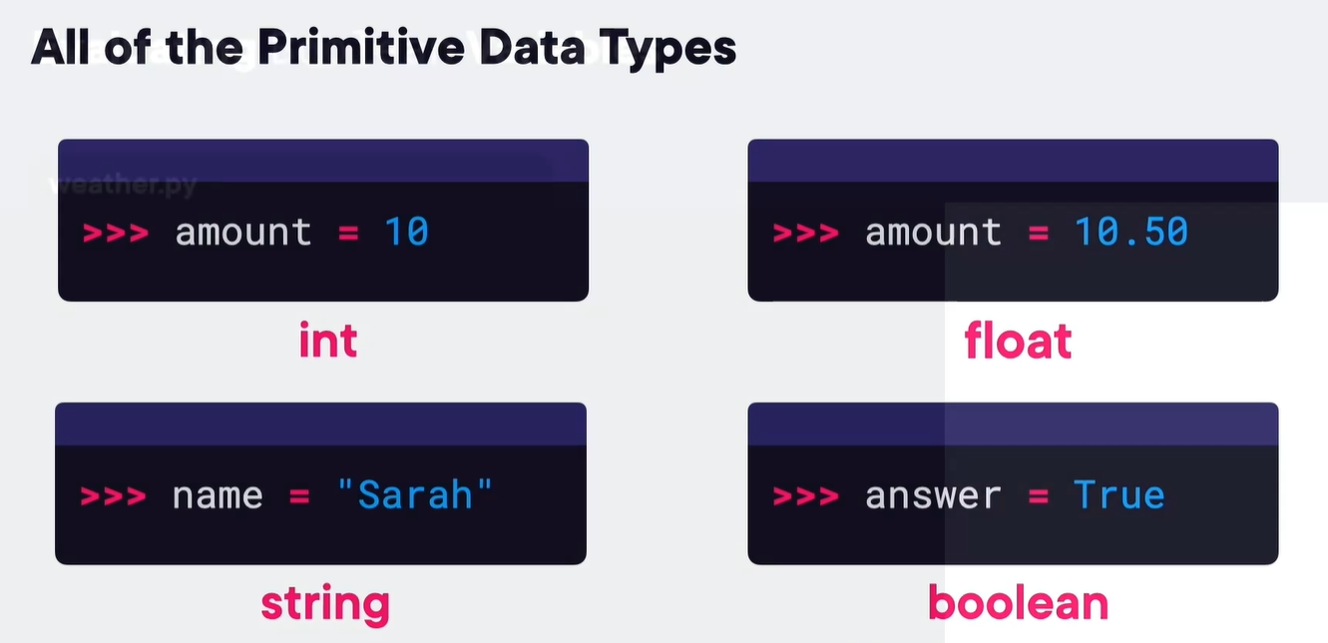

Input function

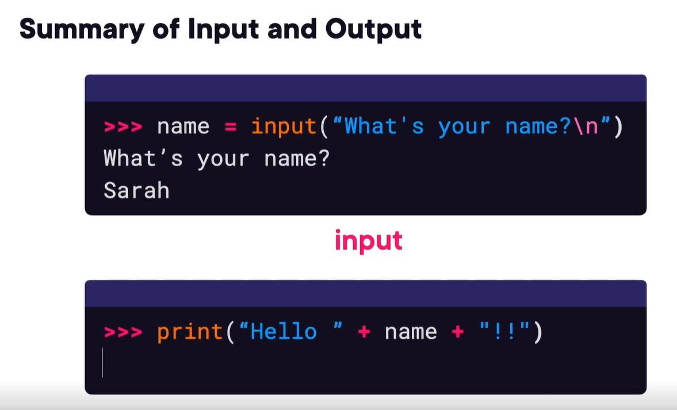

* Int(100.110) – to convert float to int
* Float(100) – to convert int to floats
* Str(100) – to convert object to string
* String = ‘name’ or String =”name” both can be used for strings
* 
 