CSA1509-Cloud computing and Big Data Analytics
Name : Reddem Yashaswini
Reg.no: 192525438
EXPERIMENT 22 :
To write a procedure to run the virtual machine of different configuration and to check how many virtual machines can be utilized at a particular time.
Aim :
To run virtual machines with different configurations and determine the maximum number of virtual machines that can be utilized simultaneously on a host system.
Short Procedure :
- Open the virtualization software such as VirtualBox.
- Create a virtual machine with a selected configuration (CPU, RAM, and storage).
- Install the required operating system in the virtual machine.
- Start the virtual machine and verify that it is running properly.
- Create additional virtual machines with different configurations.
- Start multiple VMs simultaneously and monitor CPU, RAM, and storage utilization.
- Gradually increase the number of running VMs until the host system reaches its resource limit.
- Record the maximum number of VMs that can run simultaneously without significant performance degradation.
- Compare the results for different VM configurations and note the resource utilization.
Result:
- The number of virtual machines that can run simultaneously depends on the host system's available RAM, CPU, and storage resources

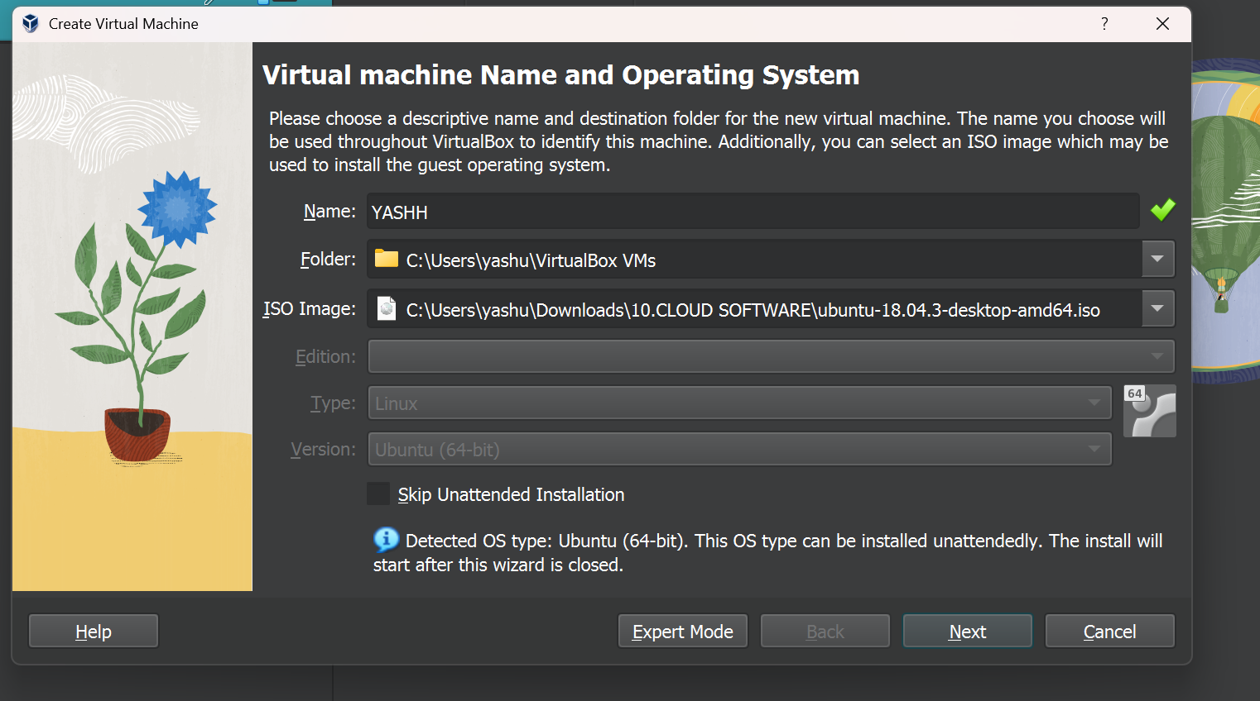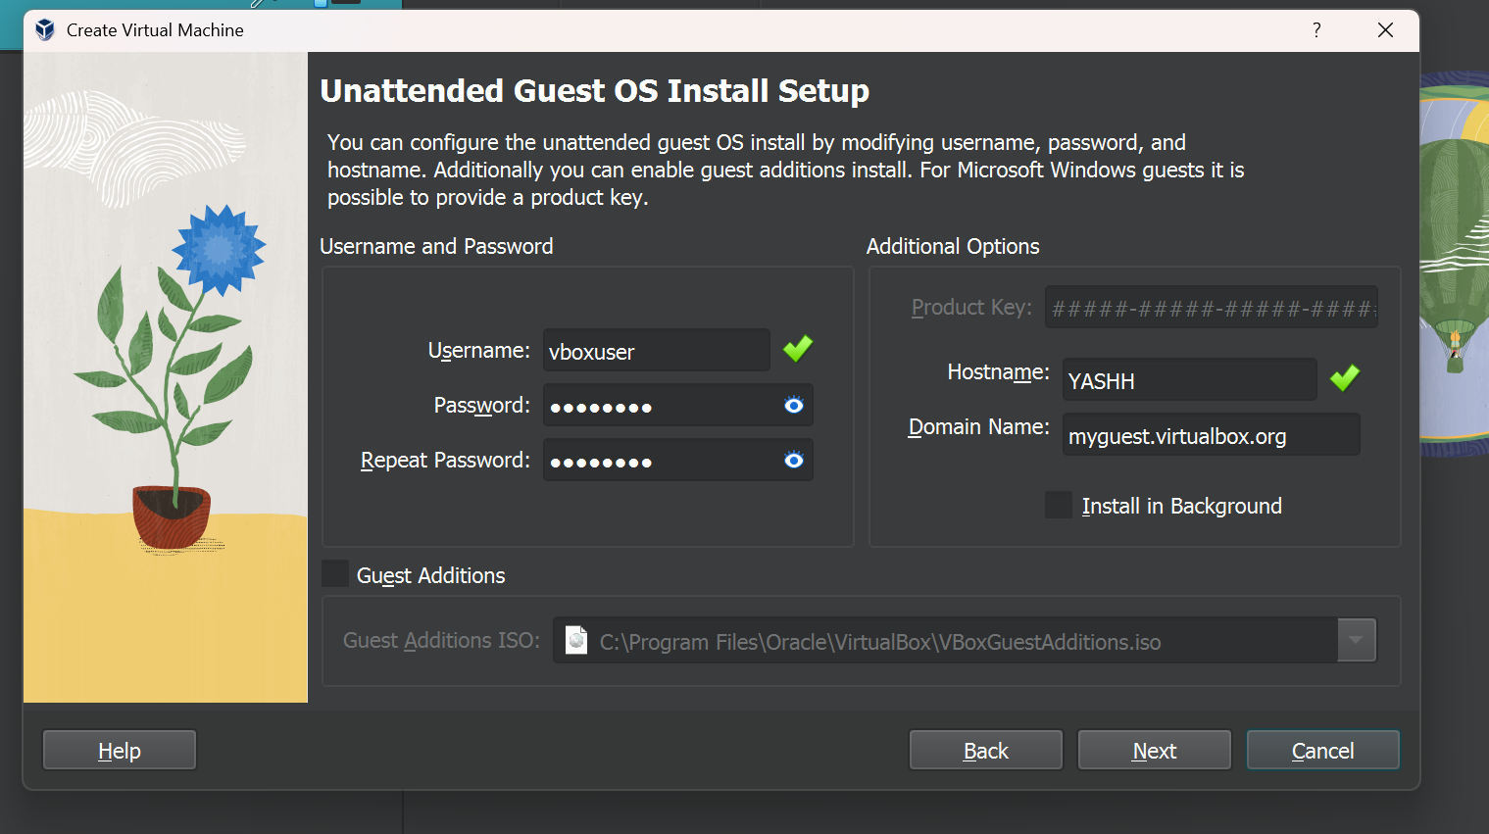
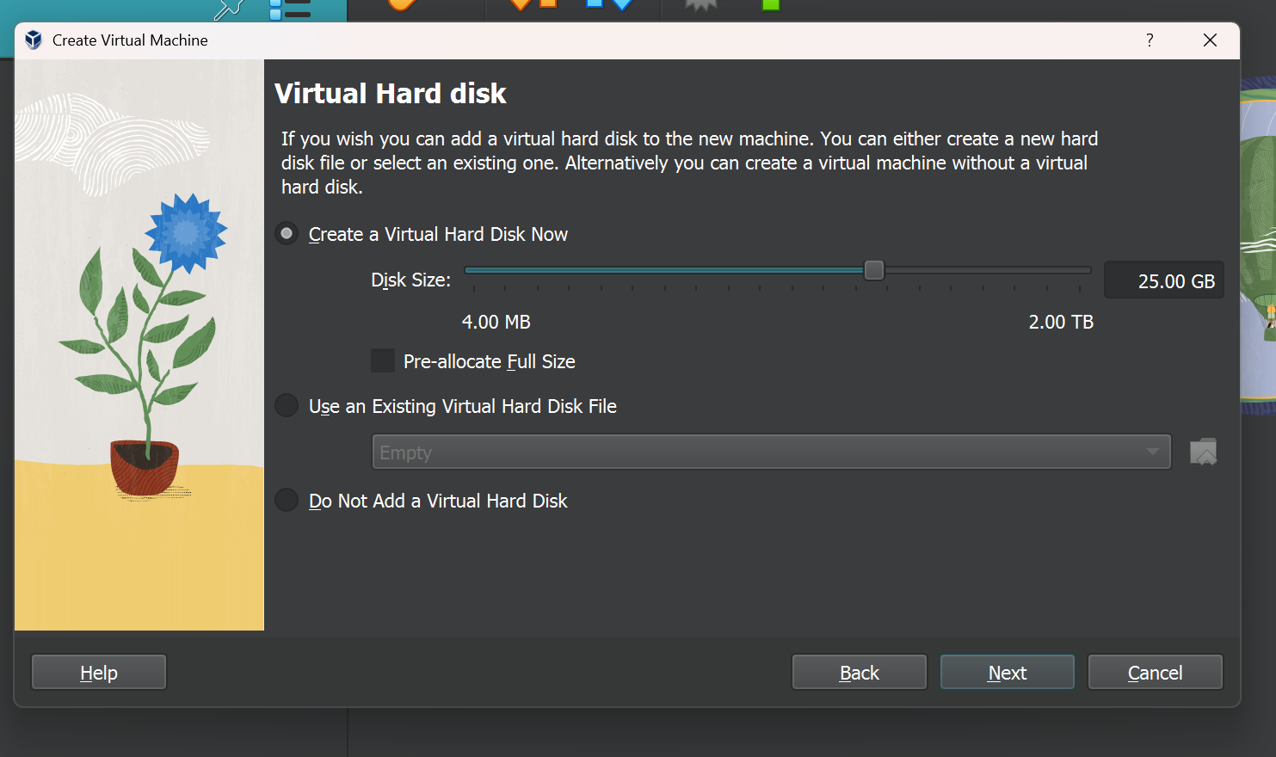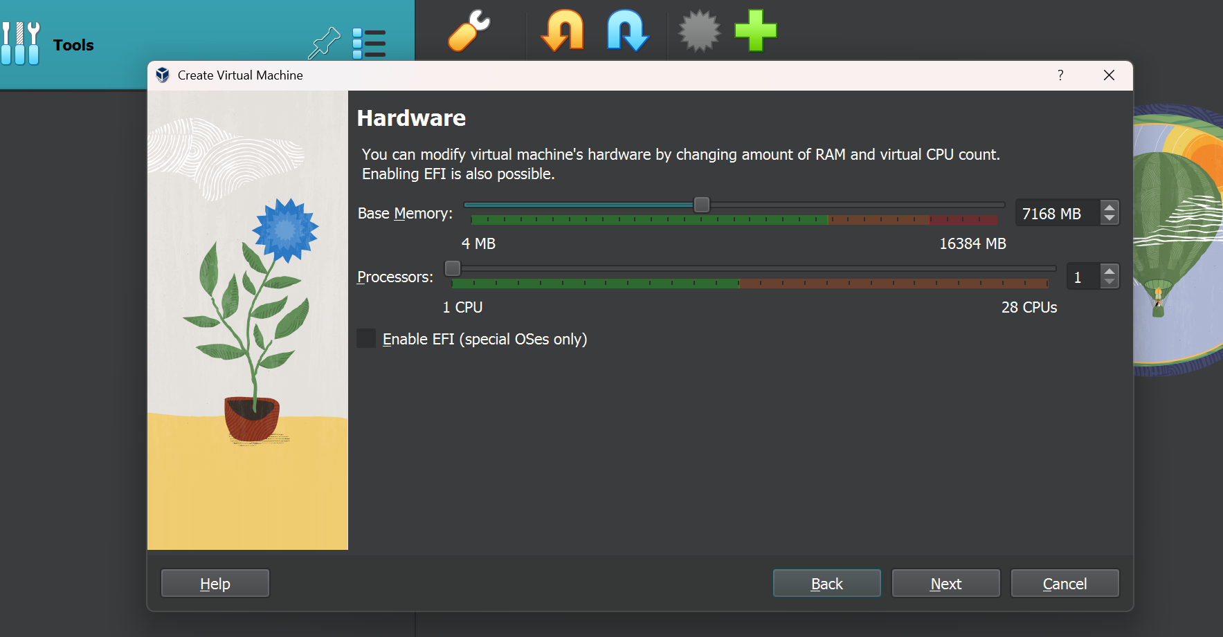

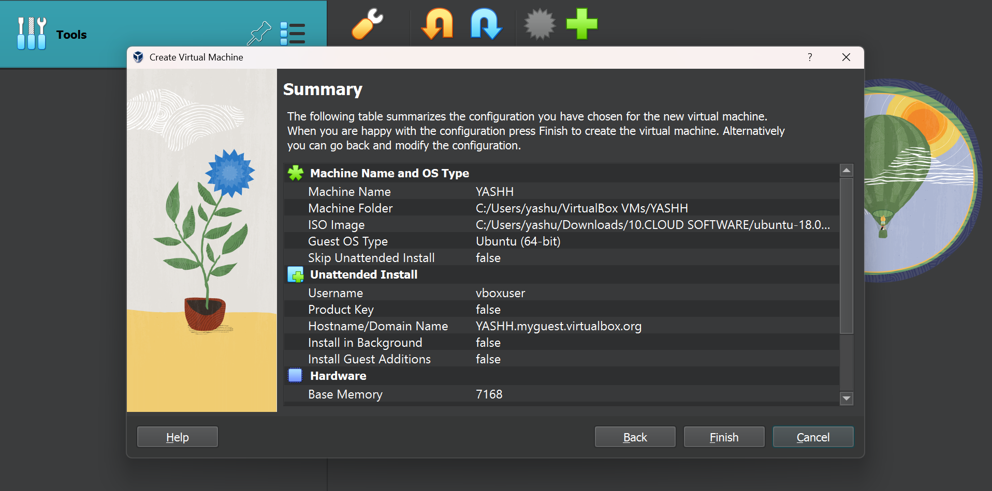
FIG : PROCESS OF CREATING A VM
Like above two more VMs are installed

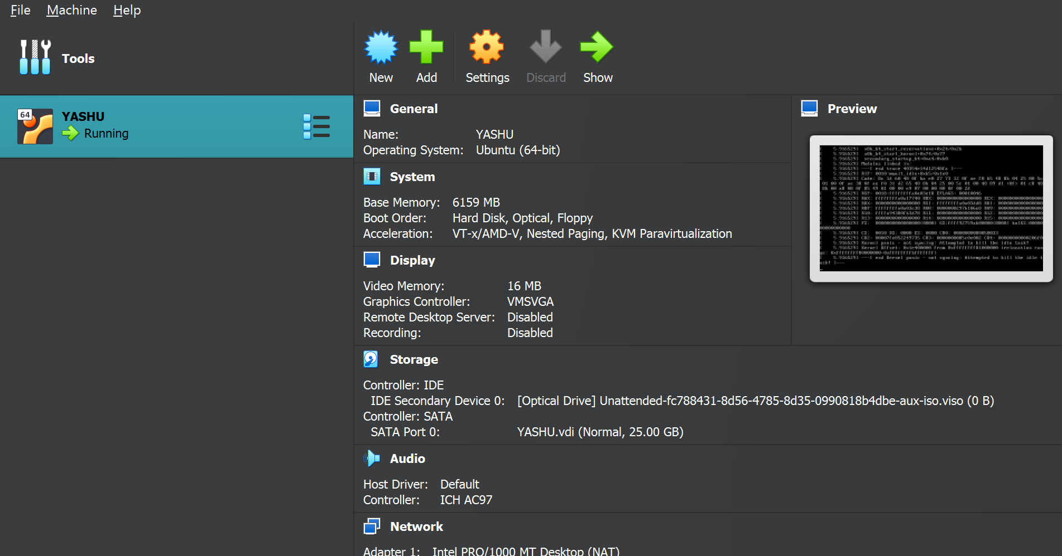
FIG : INSTALLATION OF VM YASHU

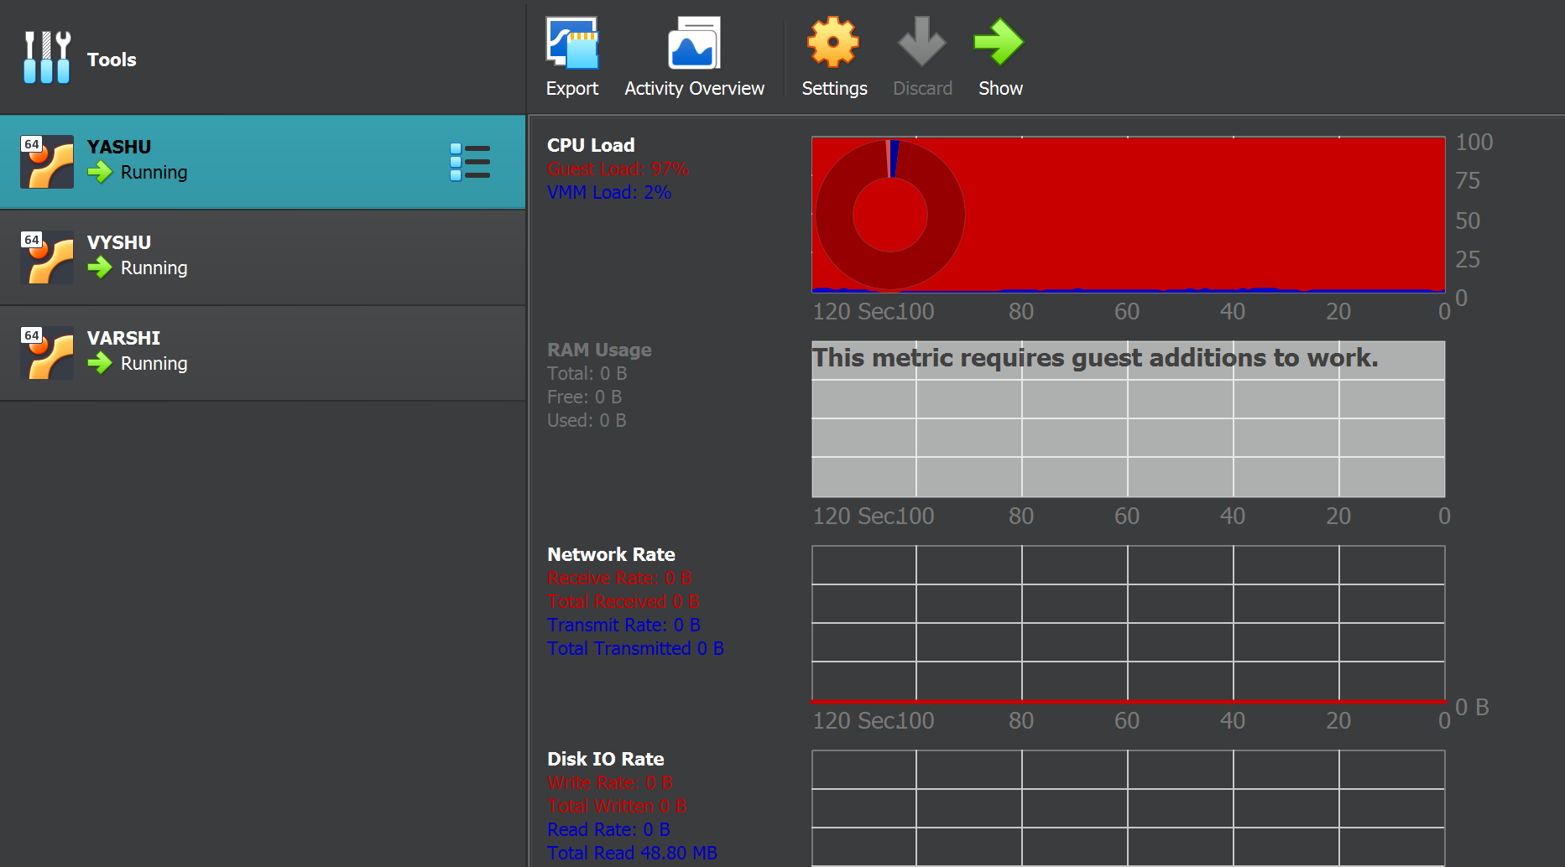
FIG : ACTIVITY STATUS OF VM YASHU

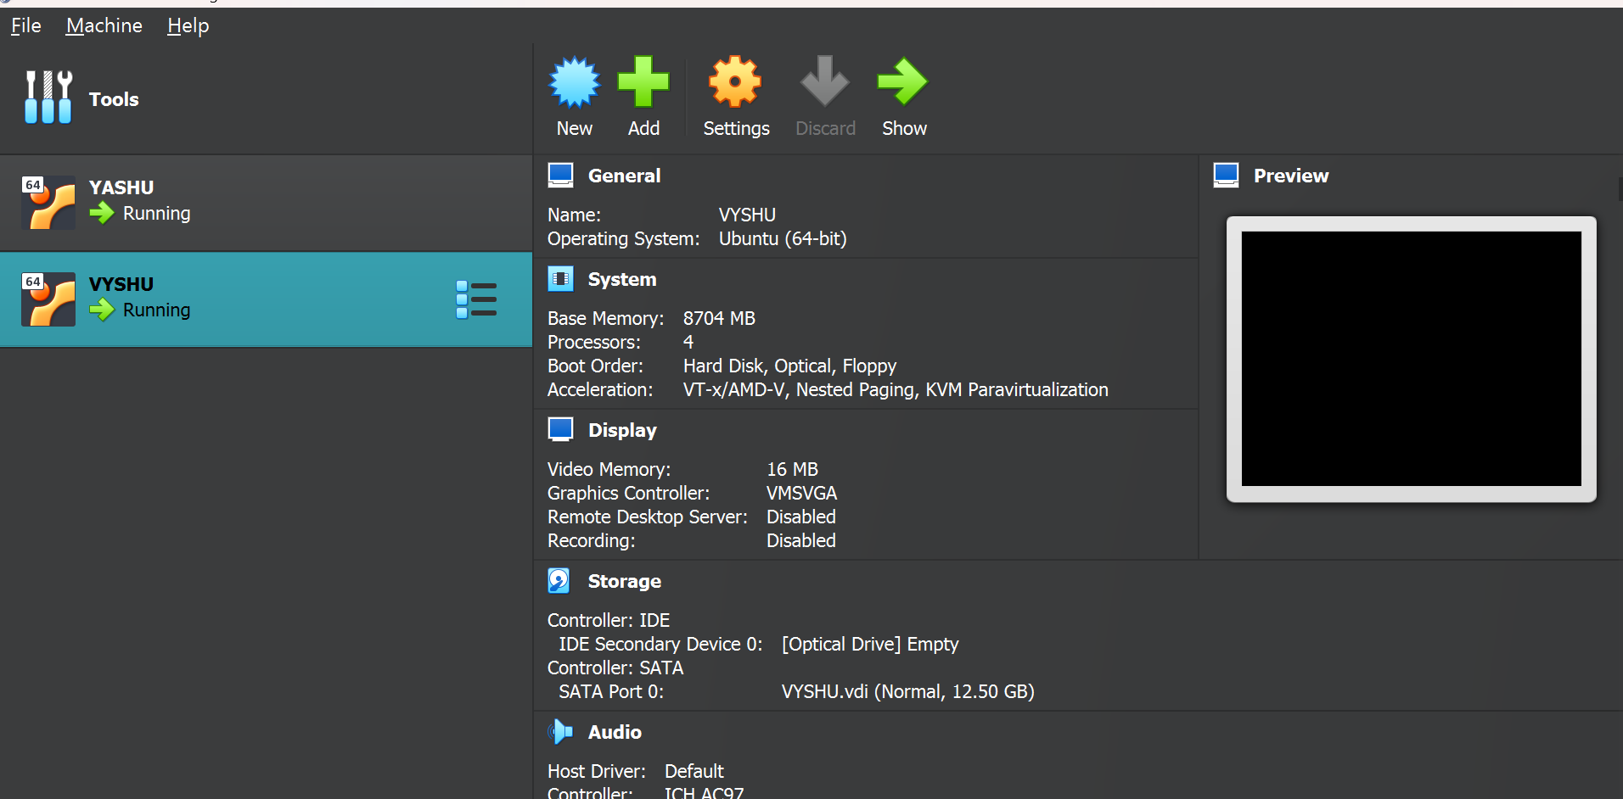
FIG : INSTALLATION OF VM VYSHU

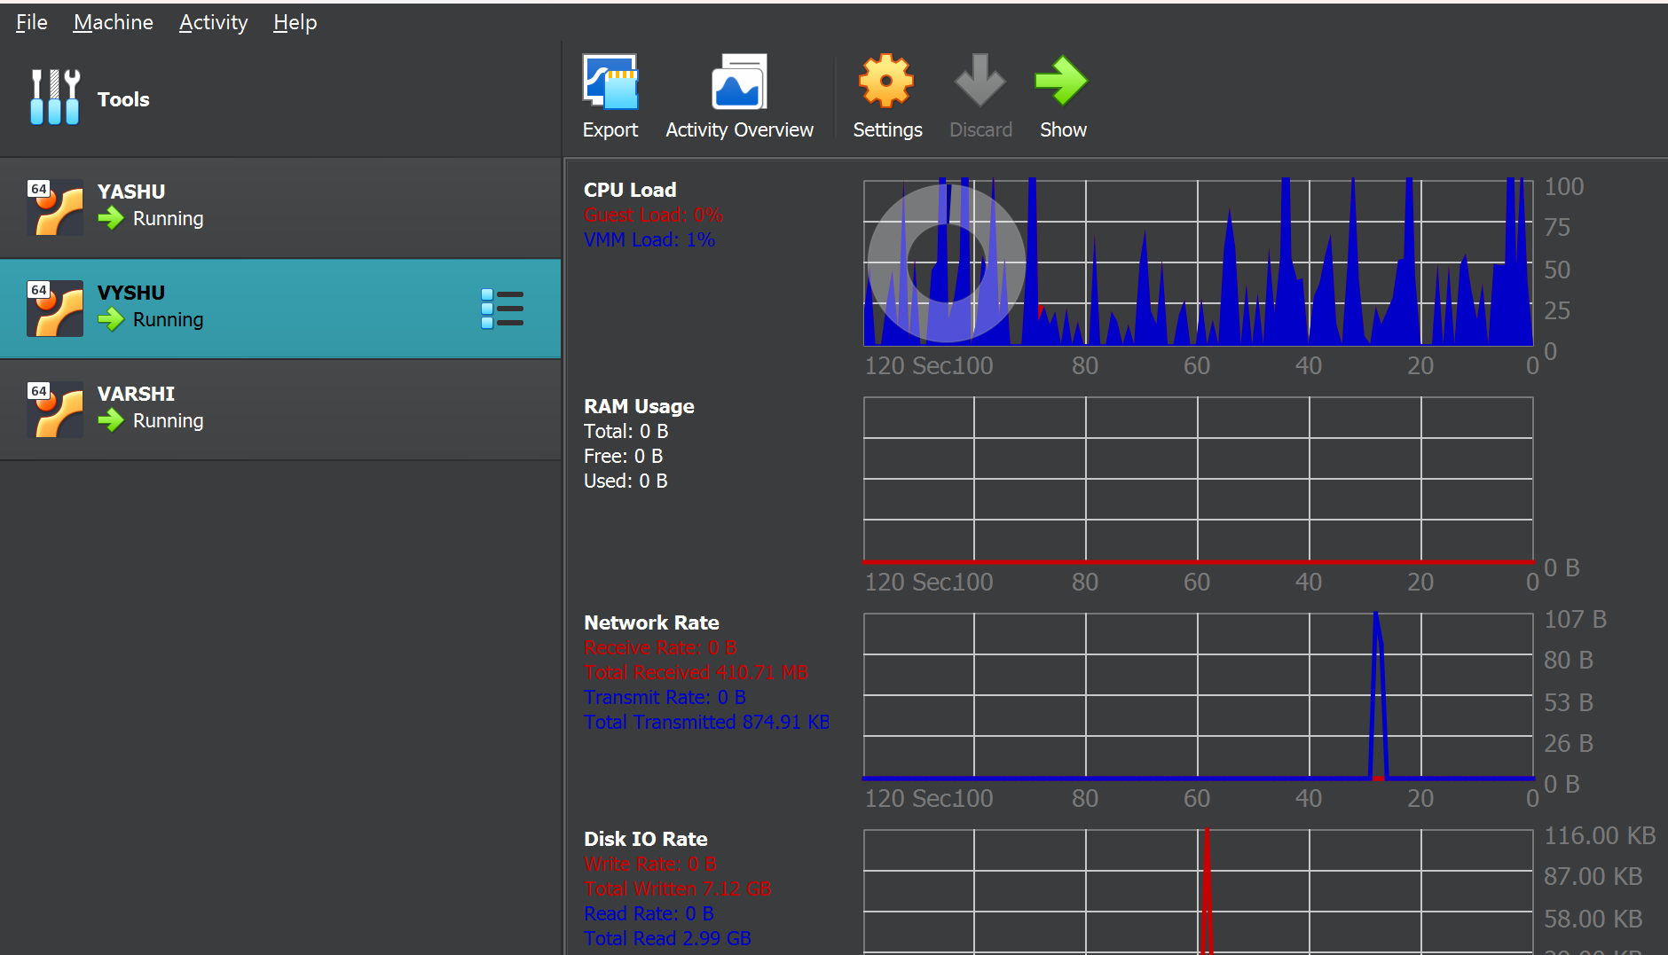
FIG : ACTIVITY STATUS OF VM VYSHU

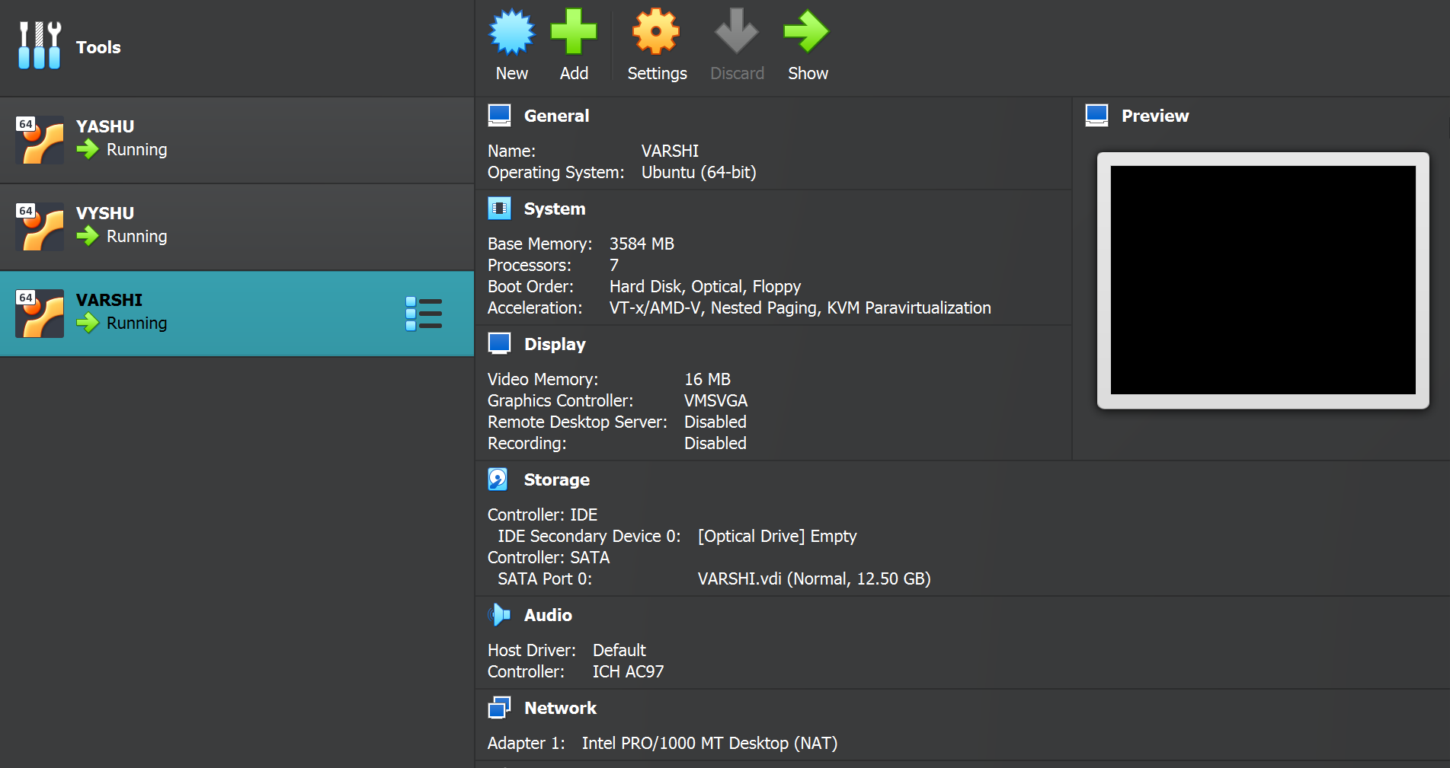
FIG : INSTALLATION OF VM VARSHI

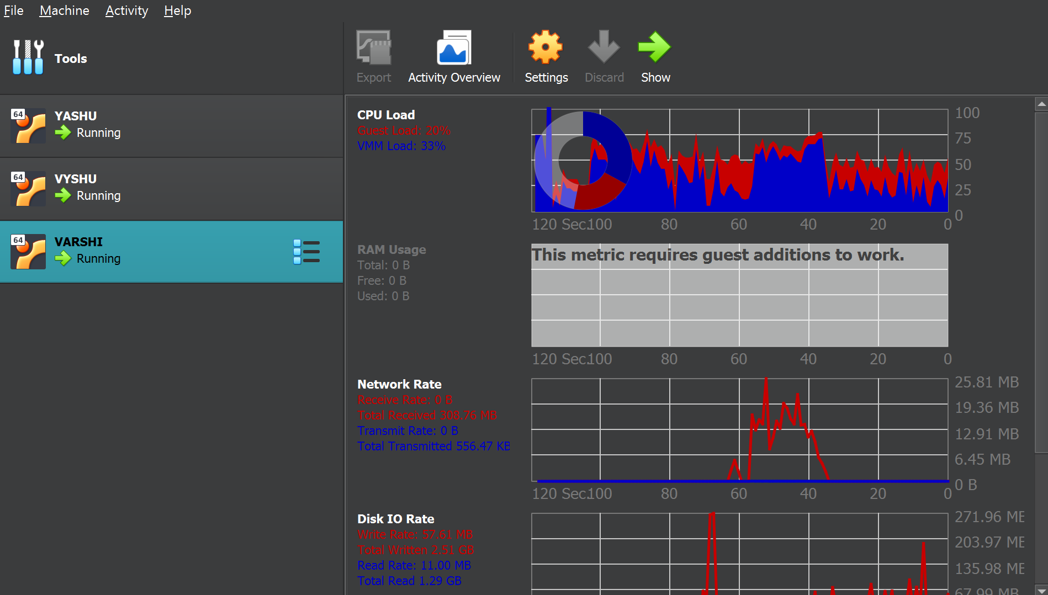
FIG : ACTIVITY STATUS OF VM VARSHI

