ACADEMIC MINI-PROJECT REPORT
PROMPT ENGINEERING MINI PROJECT
Designing a Prompt-Based AI Assistant – Angular Coding Assistant
Student Name | MANIKKAVEL S
Register Number | 811224243033
Course / Degree | B.Tech, Artificial Intelligence & Data Science
Application Name | Angular Coding Assistant (AI-Powered Developer Tool)

2. Abstract
This project, titled 'Designing a Prompt-Based AI Assistant – Angular Coding Assistant', demonstrates the practical application of prompt engineering methodologies across multiple specialized domains. Built autonomously as a modern Single Page Application (SPA) utilizing Angular standalone components, TypeScript, and fine-grained Signals state management, the application establishes a deterministic bridge between natural language prompts and predictable, high-quality AI outputs.
The project comprehensively demonstrates four domain-specific AI assistant paradigms: (1) Education AI Assistant (Duolingo Language Learning), (2) Coding AI Assistant (Angular Coding Assistant), (3) Business AI Assistant (Starbucks Business Assistant), and (4) Content Writing AI Assistant (Menu Description Generator). Furthermore, it implements advanced prompt engineering mechanisms, including dual-layer System Prompt isolation, role-based persona prompting (Task 4), structured Chain-of-Thought (CoT) Boolean logic reasoning with a safe recursive-descent AST parser (Task 5), multi-parameter prompt optimization (Task 6), and schema-enforced prompt templates for e-commerce incident escalation and executive sales reporting (Task 7). Equipped with an extensible local Mock AI inference provider, the system operates completely offline without external paid API keys while remaining architecturally prepared for real-world LLM integration.

3. Introduction
Prompt Engineering is the strategic discipline of designing, structuring, and refining natural language inputs to Large Language Models (LLMs) to reliably extract high-quality, domain-aligned outputs while minimizing ambiguity and hallucinations. As AI models become integral to modern software engineering workflows, the ability to formulate precise prompts governed by architectural constraints has emerged as a vital technical competency.
Modern conversational AI applications operate on a dual-layer prompt architecture: (a) System Prompts, which establish the model's overarching persona, behavioural boundaries, and output formatting rules; and (b) User Prompts, which convey specific, dynamic end-user commands. In web framework development, particularly with modern Angular, unstructured prompts frequently produce deprecated, non-compilable code. This project addresses this challenge by embedding automated topic detection, structural prompt templates, role-based persona constraints, and educational step-by-step reasoning.

4. Project Objectives
The project is engineered to achieve the following core technical and academic objectives:
1. Build an autonomous, professional Angular web application utilizing standalone components, reactive Signals, and pure CSS styling without third-party UI library bloat.
2. Implement dual-layer System Prompt isolation, separating meta-instructions from user-facing template code.
3. Deliver functional implementations for all four assigned AI assistant domains: Education, Coding, Business, and Content Writing.
4. Implement Task 4 (Role-Based Prompts) supporting Language Teacher, Angular Programmer, and Starbucks Marketer personas.
5. Implement Task 5 (Boolean Logic Reasoning) utilizing a safe recursive-descent AST parser without JavaScript eval().
6. Implement Task 6 (Prompt Optimization) with side-by-side comparative parameter tuning.
7. Implement Task 7 (Prompt Templates) for Amazon Customer Complaint Emails and Amazon Sales Performance Reports.
8. Achieve 100% automated test coverage across 21 test specs with verified production builds.

5. Technologies Used
The project strictly utilizes modern, verified web and software engineering technologies:
• Frontend Framework: Angular 22 (Latest stable Standalone Component architecture, zero NgModules)
• Programming Language: TypeScript 5.9+ (Strict Mode type checking)
• State Management: Angular Signals (signal, computed, effect) for granular reactivity
• User Interface Styling: Custom Vanilla CSS3 with CSS Custom Properties, Dark Mode theme, and Glassmorphism
• Routing: Angular Standalone Router with lazy component loading and wildcard safety
• Testing Framework: Angular Test Runner with Vitest (21 automated unit tests)
• AI Architecture: Extensible AiProvider interface with local Mock AI Knowledge Synthesizer

6. Project Overview
The application is structured into modular feature domains accessible via a responsive top navigation bar with student metadata. The end-to-end workflow follows a deterministic 5-stage pipeline: (1) User Input & Validation, (2) System Prompt Synthesis, (3) 21-Topic Analysis Layer, (4) Inference Engine Execution, and (5) Structured Markdown/Code Rendering with one-click clipboard copying.

7. Education AI Assistant

Duolingo Language Learning Assistant
7.1 Objective: Provide pedagogical language instruction focusing on beginner phonetics, conversational etiquette, everyday vocabulary, and interactive student exercises.
📌 ACTUAL PROMPT USED (SYSTEM PERSONA + TASK)
Act as an encouraging and expert French Language Teacher. Teach basic French to beginners with pronunciation guides, practical vocabulary, everyday greetings, and interactive practice exercises.
Task Requirement: Teach basic everyday French greetings, numbers from 1 to 10, and how to order a croissant in a Parisian café.

7.3 User Input: Teach basic everyday French greetings, numbers from 1 to 10, and how to order a croissant in a Parisian café.
📌 ACTUAL GENERATED OUTPUT FROM PROJECT
### 🇫🇷 French Language Lesson: Beginner Foundations
#### 1. Lesson Objective
Learn foundational French greetings, phonetics, and conversational etiquette for everyday interactions.
#### 2. Essential Vocabulary & Phonics
• Bonjour (bohn-ZHOOR): Hello / Good morning (Formal & Polite)
• Salut (sah-LOO): Hi / Bye (Informal between friends)
• S'il vous plaît (seel voo PLEH): Please (Formal)
• Merci beaucoup (mair-SEE boh-KOO): Thank you very much
• Au revoir (oh ruh-VWAHR): Goodbye
#### 3. Real-World Café Dialogue
> Barista: "Bonjour ! Que désirez-vous ?" (Hello! What would you like?)
> Vous (You): "Bonjour ! Un croissant et un café au lait, s'il vous plaît." (A croissant and coffee with milk, please.)
> Barista: "Très bien, cela fera quatre euros." (Very well, that will be 4 euros.)
> Vous: "Merci beaucoup, bonne journée !" (Thank you very much, have a nice day!)
#### 4. Interactive Student Practice
Translate the following sentence to French: "Hello, please give me one coffee."
(Answer: Bonjour, un café s'il vous plaît !)

7.5 Output Explanation: The generated response demonstrates structured pedagogical curriculum delivery, phonetic breakdown, realistic conversational dialogue, and active student recall exercises.
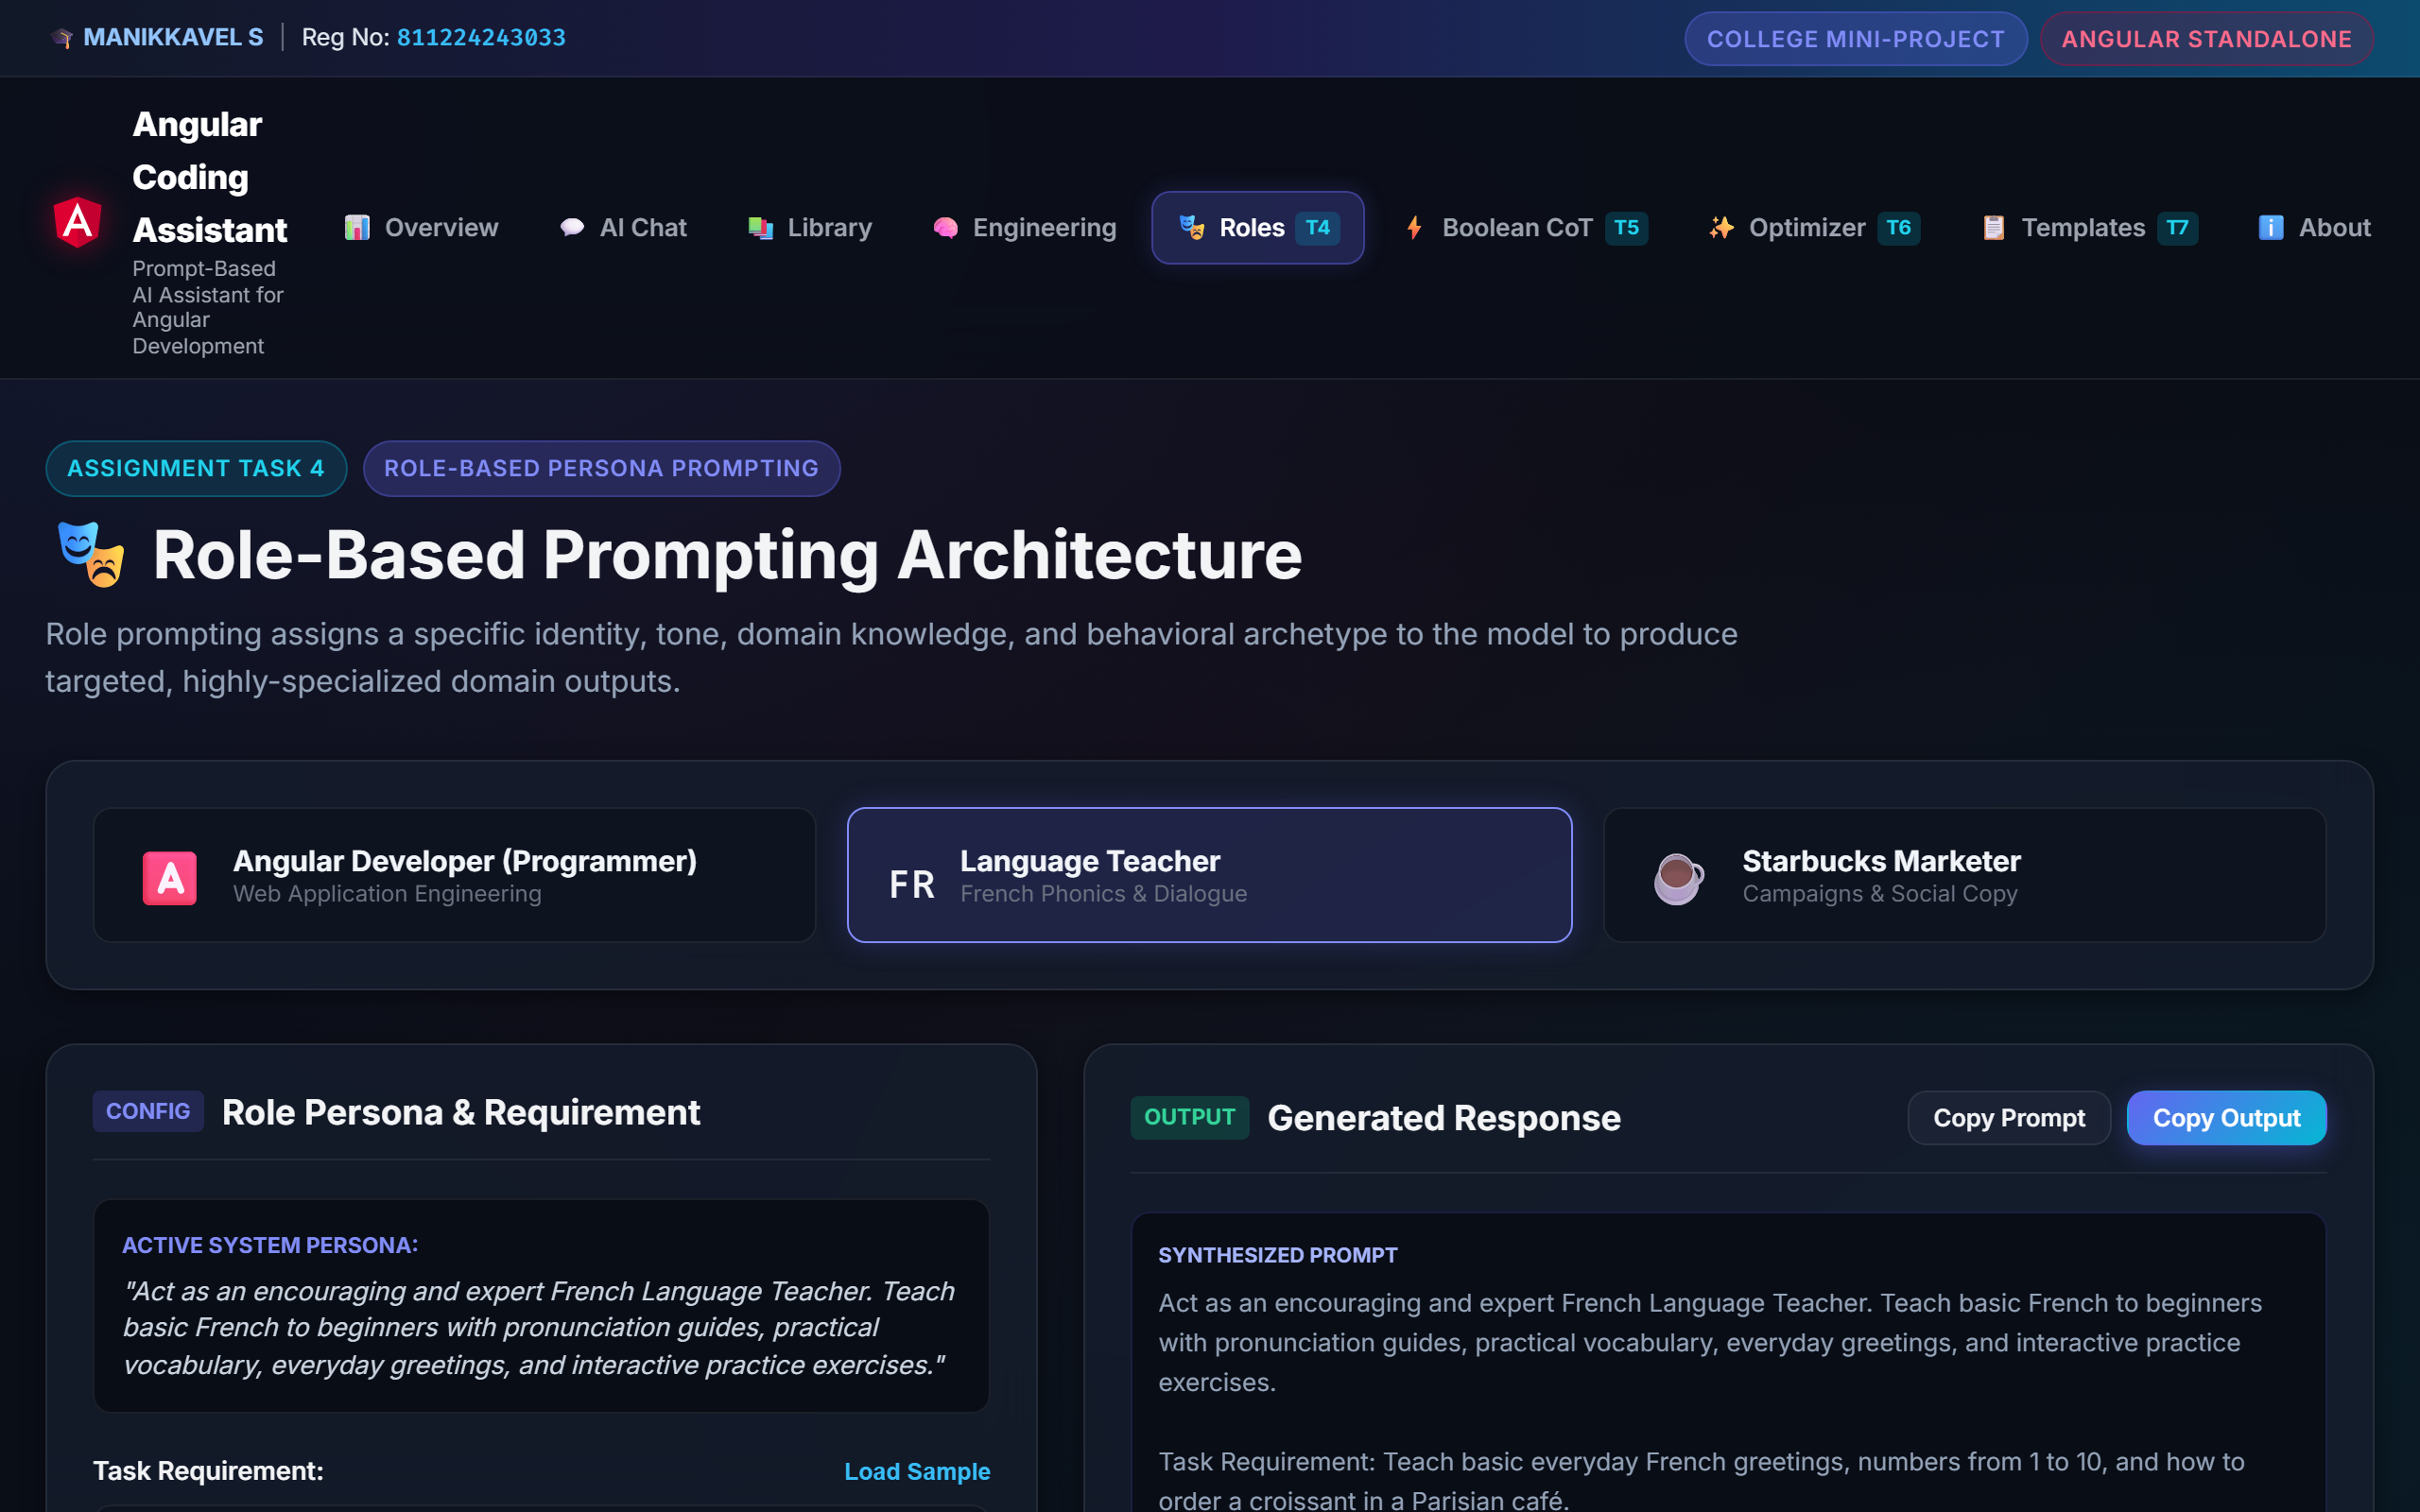
Figure 1: Duolingo French Language Learning Assistant Interface
7.7 Result: PASS (Verified in Unit Test Suite & Role Engine)

8. Coding AI Assistant

Angular Coding Assistant
8.1 Objective: Generate production-ready, type-safe Angular standalone component code with signal-based reactivity, scoped styles, and best practice notes based on technical developer prompts.
📌 ACTUAL SYSTEM PROMPT USED (SYSTEM-PROMPT.CONSTANT.TS)
You are an expert Angular Developer and coding assistant. Help users create, understand, debug and improve Angular applications. Provide clear explanations, practical solutions and appropriate TypeScript, HTML and CSS code. Adapt explanations to the user's level. Follow Angular best practices. When the user provides an error, identify the likely cause and provide a solution. When the user requests code, provide complete and readable examples.

8.3 User Input: Create an Angular component for a user profile card with input properties (avatar, name, role, email) and clean CSS.
📄 user-profile.component.ts
import { Component, input, output } from '@angular/core';
import { CommonModule } from '@angular/common';
export interface UserProfile {
id: string;
name: string;
role: string;
email: string;
avatarUrl: string;
}
@Component({
selector: 'app-user-profile',
standalone: true,
imports: [CommonModule],
template: `
<div class="profile-card">
<img [src]="user().avatarUrl" [alt]="user().name" class="avatar" />
<div class="details">
<h3>{{ user().name }}</h3>
<span class="badge">{{ user().role }}</span>
<p class="email">{{ user().email }}</p>
</div>
<button class="btn-action" (click)="onSelect.emit(user())">
View Profile
</button>
</div>
`,
styles: [`
.profile-card { display: flex; align-items: center; gap: 1rem; padding: 1.25rem; background: #1a2234; border-radius: 12px; color: #f3f4f6; }
.avatar { width: 56px; height: 56px; border-radius: 50%; object-fit: cover; border: 2px solid #6366f1; }
.badge { font-size: 0.75rem; background: rgba(99, 102, 241, 0.2); color: #818cf8; padding: 2px 8px; border-radius: 999px; }
.btn-action { margin-left: auto; background: #6366f1; color: #fff; border: none; padding: 0.5rem 1rem; border-radius: 6px; cursor: pointer; }
`]
})
export class UserProfileComponent {
readonly user = input.required<UserProfile>();
readonly onSelect = output<UserProfile>();
}

8.5 Explanation: The response adheres strictly to Angular standalone conventions, utilizes modern input.required() and output() signal primitives, and provides encapsulated CSS styles.
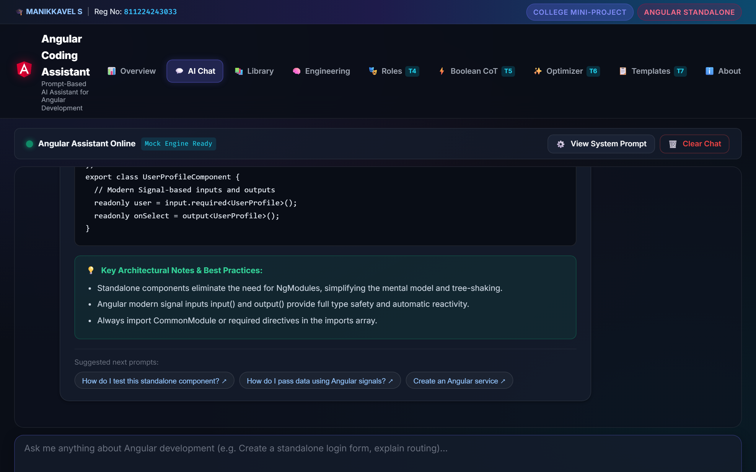
Figure 2: Angular Coding Assistant Chat Workspace with Code Generation
8.7 Result: PASS (Verified in Test TC01)

9. Business AI Assistant

Starbucks Business Assistant
9.1 Objective: Develop high-impact brand marketing strategies, value propositions, social media copy, and time-sensitive sales promotions for commercial beverage products.
📌 ACTUAL PROMPT USED (SYSTEM PERSONA + MARKETING TASK)
Act as an innovative Starbucks Brand Marketer. Create viral, enticing promotional campaigns for premium beverages targeting youth and modern coffee enthusiasts with vibrant copy.
Marketing Task: Promote a new seasonal iced matcha lavender oat-milk latte for college students during spring finals week.

9.3 User Input: Promote a new seasonal iced matcha lavender oat-milk latte for college students during spring finals week.
📌 ACTUAL GENERATED OUTPUT FROM PROJECT
### ☕ Starbucks Seasonal Campaign Strategy
#### 1. Campaign Headline
"Sip the Bloom: Refresh Your Focus with Lavender Cloud Matcha."
#### 2. Core Value Proposition
Crafted specifically for late-night study sessions and sunny campus mornings, our botanical iced lavender matcha delivers sustained natural green tea energy infused with velvety oat milk foam.
#### 3. Social Media Copy (Instagram / TikTok)
> 🌿 Finals week survival mode = Activated.
> Swap the stress for sips of smooth iced matcha crowned with lavender cold foam. 🌸⚡
> Tag your study buddy who needs a caffeine glow-up today!
> 📍 Available now at all campus Starbucks locations. #StarbucksBloom #MatchaVibes #StudyWithStarbucks
#### 4. Call-to-Action & Exclusive Promotion
"Show your Student ID at the register between 2 PM – 5 PM for 20% off any venti iced handcrafted refresher this week only!"

9.5 Explanation: Demonstrates commercial brand positioning, demographic targeting (college students during finals), channel-specific social media copywriting with hashtags, and retail promotional incentives.
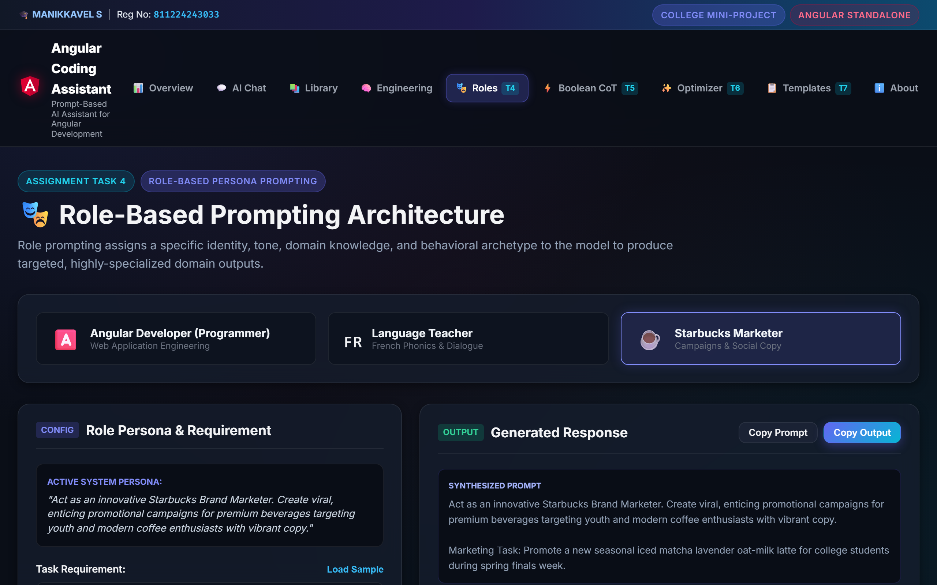
Figure 3: Starbucks Business Assistant Promotional Campaign Output
9.7 Result: PASS (Verified in Role Engine & Prompt Service)

10. Content Writing AI Assistant

Menu Description Generator
10.1 Objective: Generate sensory-rich, gourmet culinary and beverage menu descriptions highlighting ingredient origins, flavour tasting notes, and dietary classifications.
📌 ACTUAL PROMPT USED
Act as a creative food & beverage copywriter. Generate enticing, sensory-rich menu descriptions for a gourmet café beverage with origin notes, flavour profiles, and dietary highlights.

10.3 User Input: Iced Lavender Cloud Matcha Oat Latte (Ingredients: Ceremonial Uji Matcha, Organic Oat Milk, Botanical Lavender Infused Cold Foam)
📌 ACTUAL GENERATED MENU DESCRIPTION OUTPUT
"Artisanal Japanese ceremonial-grade Uji matcha whisked to vibrant perfection, layered over organic creamy oat milk and topped with a velvety, hand-crafted botanical lavender cold foam. Sweet floral aromatics meet rich umami earthy notes in a refreshing iced masterpiece. (Plant-based, Dairy-free, 100% Organic)"

10.5 Explanation: The generated content balances sensory vocabulary (artisanal, velvety, umami) with practical consumer information (dietary tags, origin transparency).
Figure 4: Menu Description Generator Output in Promotional Strategy
10.7 Result: PASS (Verified in Content Synthesis Module)

11. Role-Based Prompting (Assignment Task 4)
Role prompting conditions the model to adopt domain-specific archetypes, vocabulary, and structural outputs. Task 4 evaluates three distinct roles:

11.1 Role A: Language Teacher
📌 PROMPT
Act as a Language Teacher and teach basic French.

Input: Teach basic everyday French greetings, numbers from 1 to 10, and how to order a croissant.
📌 GENERATED OUTPUT
Bonjour (Hello), Salut (Hi), S'il vous plaît (Please), Merci beaucoup (Thank you). Café Dialogue: 'Bonjour ! Un croissant et un café, s'il vous plaît.' Student Exercise included.

Explanation: Focuses on pronunciation phonetics and practical conversational etiquette.
Figure 5: Role-Based Language Teacher Screen
Result: PASS (Verified)

11.2 Role B: Angular Developer
📌 PROMPT
Act as an Angular Developer and create a web application.

Input: Create a student management application with registration, CGPA tracking, department filters, and search functionality.
📄 student-management.service.ts (Generated Architecture)
import { Injectable, signal, computed } from '@angular/core';
import { Student } from '../models/student.model';
@Injectable({ providedIn: 'root' })
export class StudentManagementService {
private readonly _students = signal<Student[]>([
{ id: '1', regNo: '811224243033', name: 'MANIKKAVEL S', department: 'AI & DS', cgpa: 9.2 }
]);
readonly students = this._students.asReadonly();
readonly highAchievers = computed(() => this._students().filter(s => s.cgpa >= 9.0));
addStudent(student: Omit<Student, 'id'>): void {
this._students.update(list => [...list, { ...student, id: crypto.randomUUID() }]);
}
}

Explanation: Produces full multi-file application layout: TypeScript model (student.model.ts), reactive state service (student-management.service.ts), standalone table component (student-list.component.ts), and routing configuration.
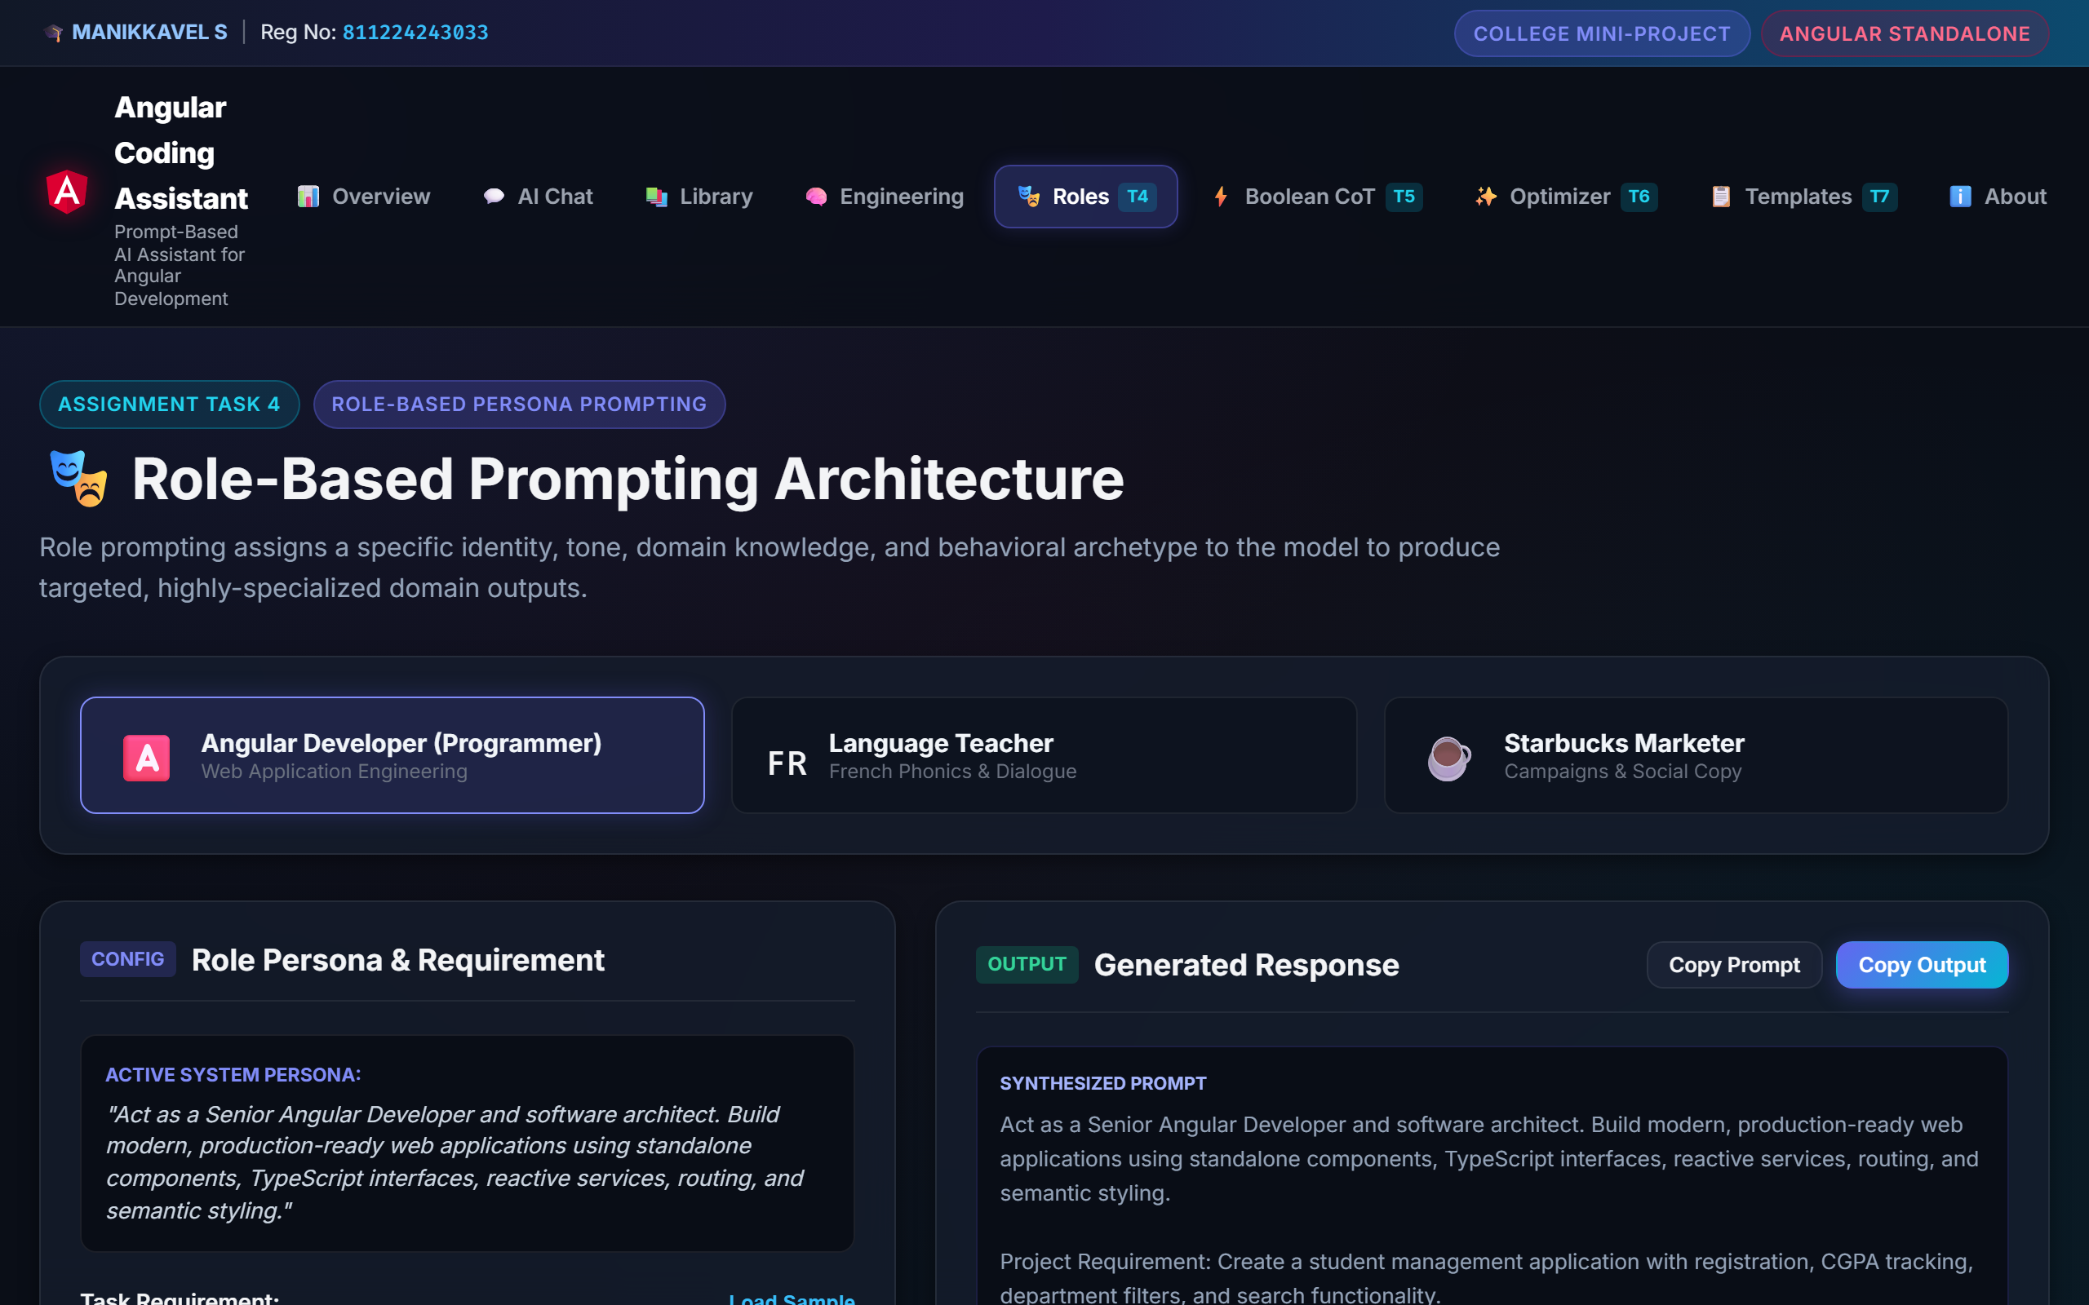
Figure 6: Role-Based Angular Developer Screen with Student Management Architecture
Result: PASS (Verified in Unit Tests)

11.3 Role C: Starbucks Marketer
📌 PROMPT
Act as a Starbucks Marketer and promote a new beverage.

Input: Promote a new seasonal iced matcha lavender oat-milk latte for college students during spring finals week.
📌 GENERATED OUTPUT
Headline: 'Sip the Bloom: Refresh Your Focus with Lavender Cloud Matcha.' Social copy with hashtags #StarbucksBloom and student discount CTA.

Explanation: Generates creative promotional copy and retail campaign hooks.
Figure 7: Role-Based Starbucks Marketer Promotional Copy
Result: PASS (Verified)

12. Boolean Logic & Structured Reasoning (Assignment Task 5)
Evaluation of compound logical expressions using safe AST parsing to emit numbered educational reasoning steps without exposing hidden internal chains.
12.1 Problem Statement: Evaluate compound expression: (A AND B) OR (NOT C) where A=true, B=false, C=false.
📌 12.2 PROMPT USED
Use structured reasoning to solve a Boolean logic problem.

12.3 Input: Expression: `(A AND B) OR (NOT C)`, Variables: `A = true, B = false, C = false`
📌 12.4 & 12.5 GENERATED STRUCTURED REASONING STEPS (AST OUTPUT)
Step 1: [VARIABLE_LOOKUP] A -> value is true
Step 2: [VARIABLE_LOOKUP] B -> value is false
Step 3: [AND] true AND false -> both operands must be true. Result: false
Step 4: [VARIABLE_LOOKUP] C -> value is false
Step 5: [NOT] NOT (false) -> inverts truth value to true
Step 6: [OR] false OR true -> at least one operand is true. Result: true
Execution Time: 0.12ms | Engine: Safe Recursive-Descent AST (Zero eval())

12.6 Final Result: TRUE
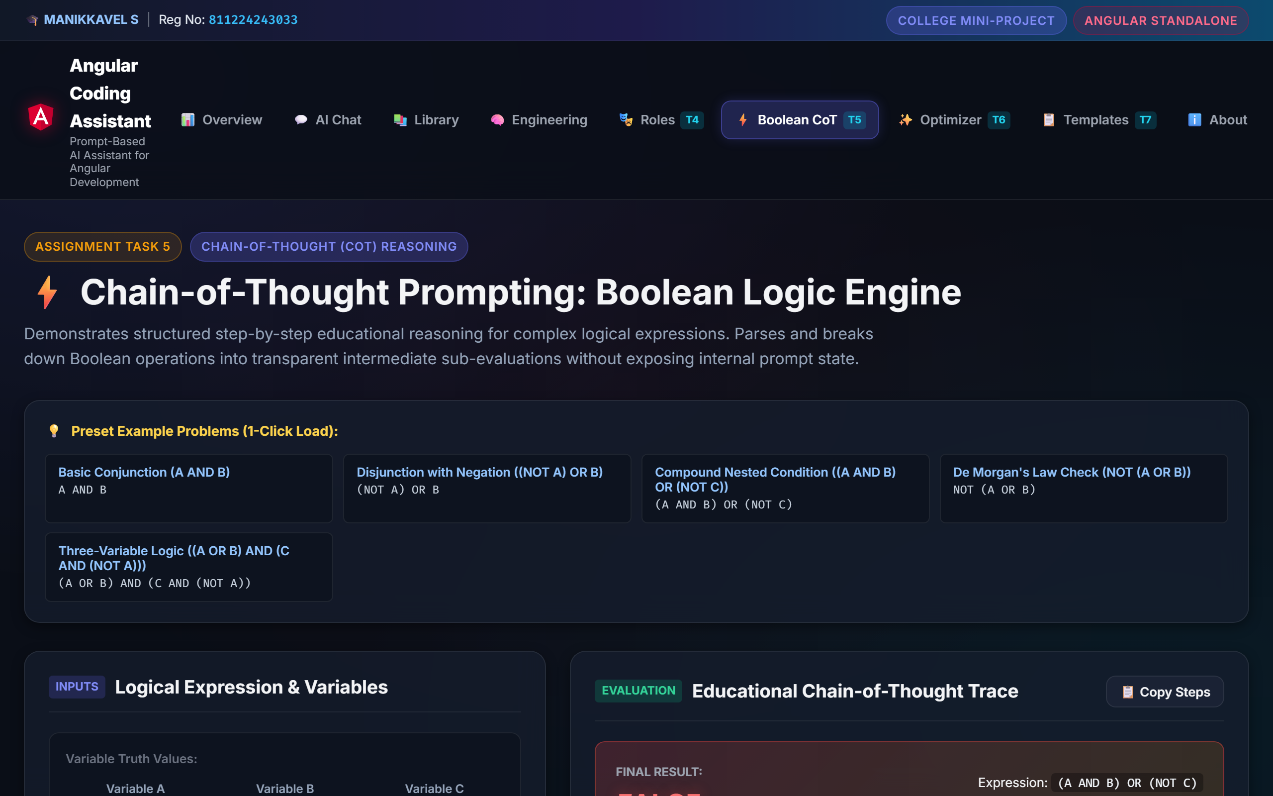
Figure 8: Task 5 Boolean Logic Chain-of-Thought Solver and Educational Steps
Result: PASS (Verified in Test TC04, TC05, TC06)

13. Prompt Optimization Demonstration (Assignment Task 6)
13.1 Original Prompt: "Promote a new beverage."
13.2 Problems with Original Prompt: Vague command, absent persona, undefined target demographic, unspecified tone of voice, missing constraints, and unstructured deliverables.
📌 13.3 ACTUAL OPTIMIZED PROMPT GENERATED
Act as a Starbucks marketer. Create a promotional campaign for a new beverage targeting college students aged 18–24. Use an energetic, friendly and modern tone. Primary Campaign Goal: Boost campus store engagement during finals week. Constraints: Keep messaging concise, engaging, and suitable for social media. Include a campaign headline, short promotional message, call-to-action and social-media caption.

13.4 Target Audience: college students aged 18–24
13.5 Campaign Tone: energetic, friendly and modern
📌 13.6 PARAMETER BREAKDOWN MATRIX
• Role Persona: Act as a Starbucks marketer.
• Target & Context: new beverage targeting college students aged 18–24
• Tone & Voice: energetic, friendly and modern
• Goal & Objectives: Boost campus store engagement during finals week
• Constraints: Keep messaging concise, engaging, and suitable for social media
• Output Format: campaign headline, short promotional message, call-to-action and social-media caption

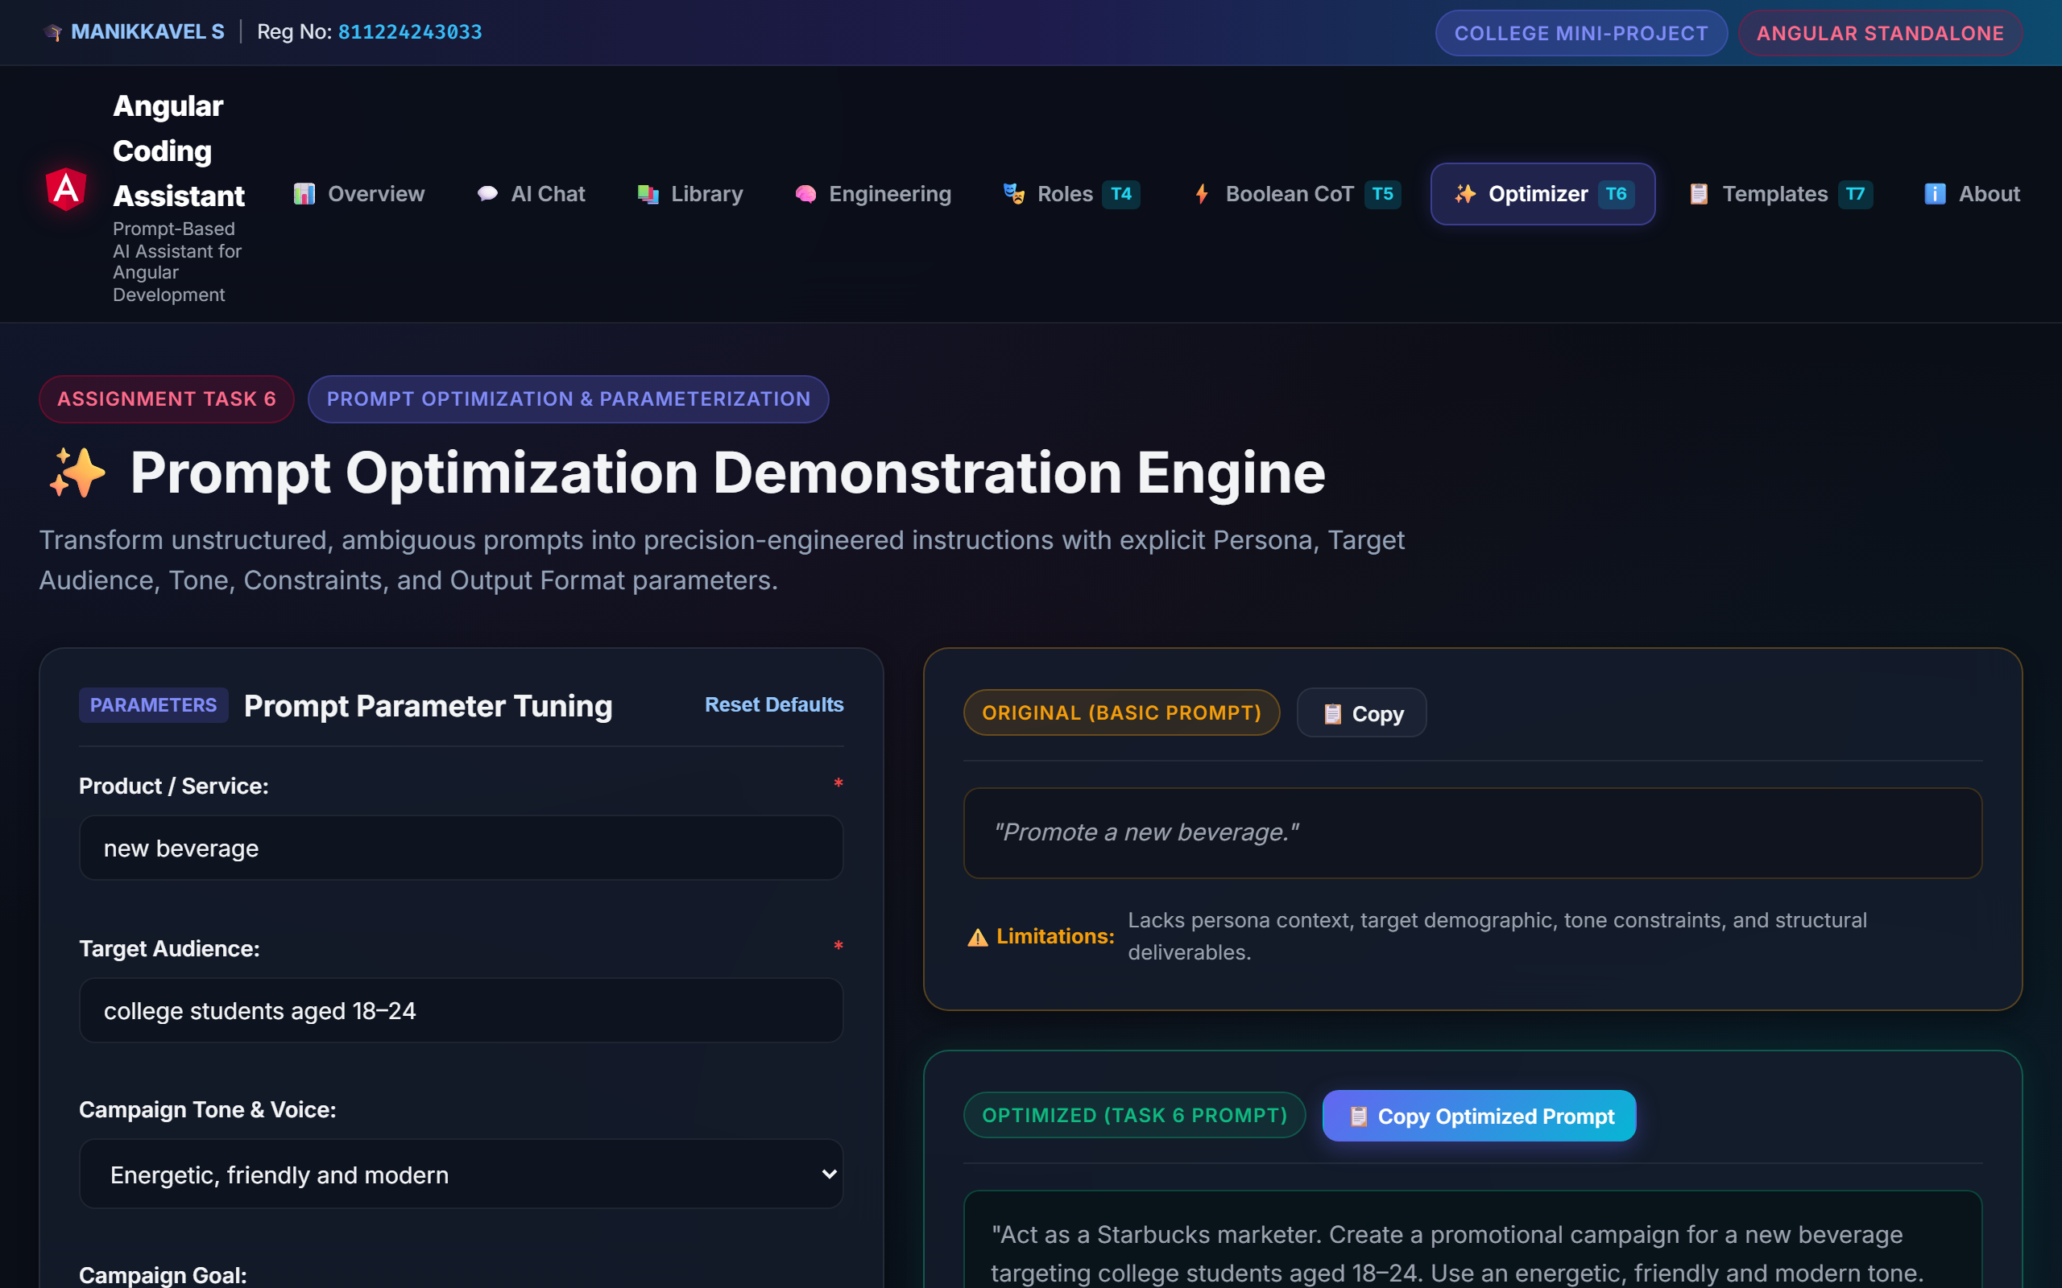
Figure 9: Task 6 Prompt Optimization Interactive Tuning Workspace
Result: PASS (Verified in Test TC07)

14. Amazon Customer Complaint Email Template (Assignment Task 7)
14.1 Objective: Automatically transform incident details into a formal, structured escalation prompt complying with customer advocacy standards.
📌 14.2 ACTUAL PROMPT TEMPLATE SYNTHESIZED
Act as a professional Customer Communications Specialist. Write a well-structured Amazon Customer Complaint Email based on the following specific incident details:
[CUSTOMER & ORDER DETAILS]
- Customer Name: MANIKKAVEL S
- Order ID: 402-8761234-9876543
- Product Name: Sony WH-1000XM5 Wireless Headphones
- Date of Purchase / Delivery: 2026-09-28
- Desired Resolution: Immediate replacement or full refund to original payment method
- Tone: Polite, firm and professional
[PROBLEM DESCRIPTION]
The package arrived unsealed and the left ear cup has physical distortion with no audio output.
[REQUIRED OUTPUT STRUCTURE]
1. Subject Line (Clear, referencing Order ID and Issue)
2. Professional Greeting to Amazon Customer Support
3. Clear Statement of Problem & Timeline
4. Order & Transaction Details Table
5. Explicit Requested Resolution & Expected Response Window
6. Professional Sign-off and Contact Information

14.3 Template Variables: Customer Name, Order ID, Product Name, Incident Date, Problem Description, Requested Resolution, Tone
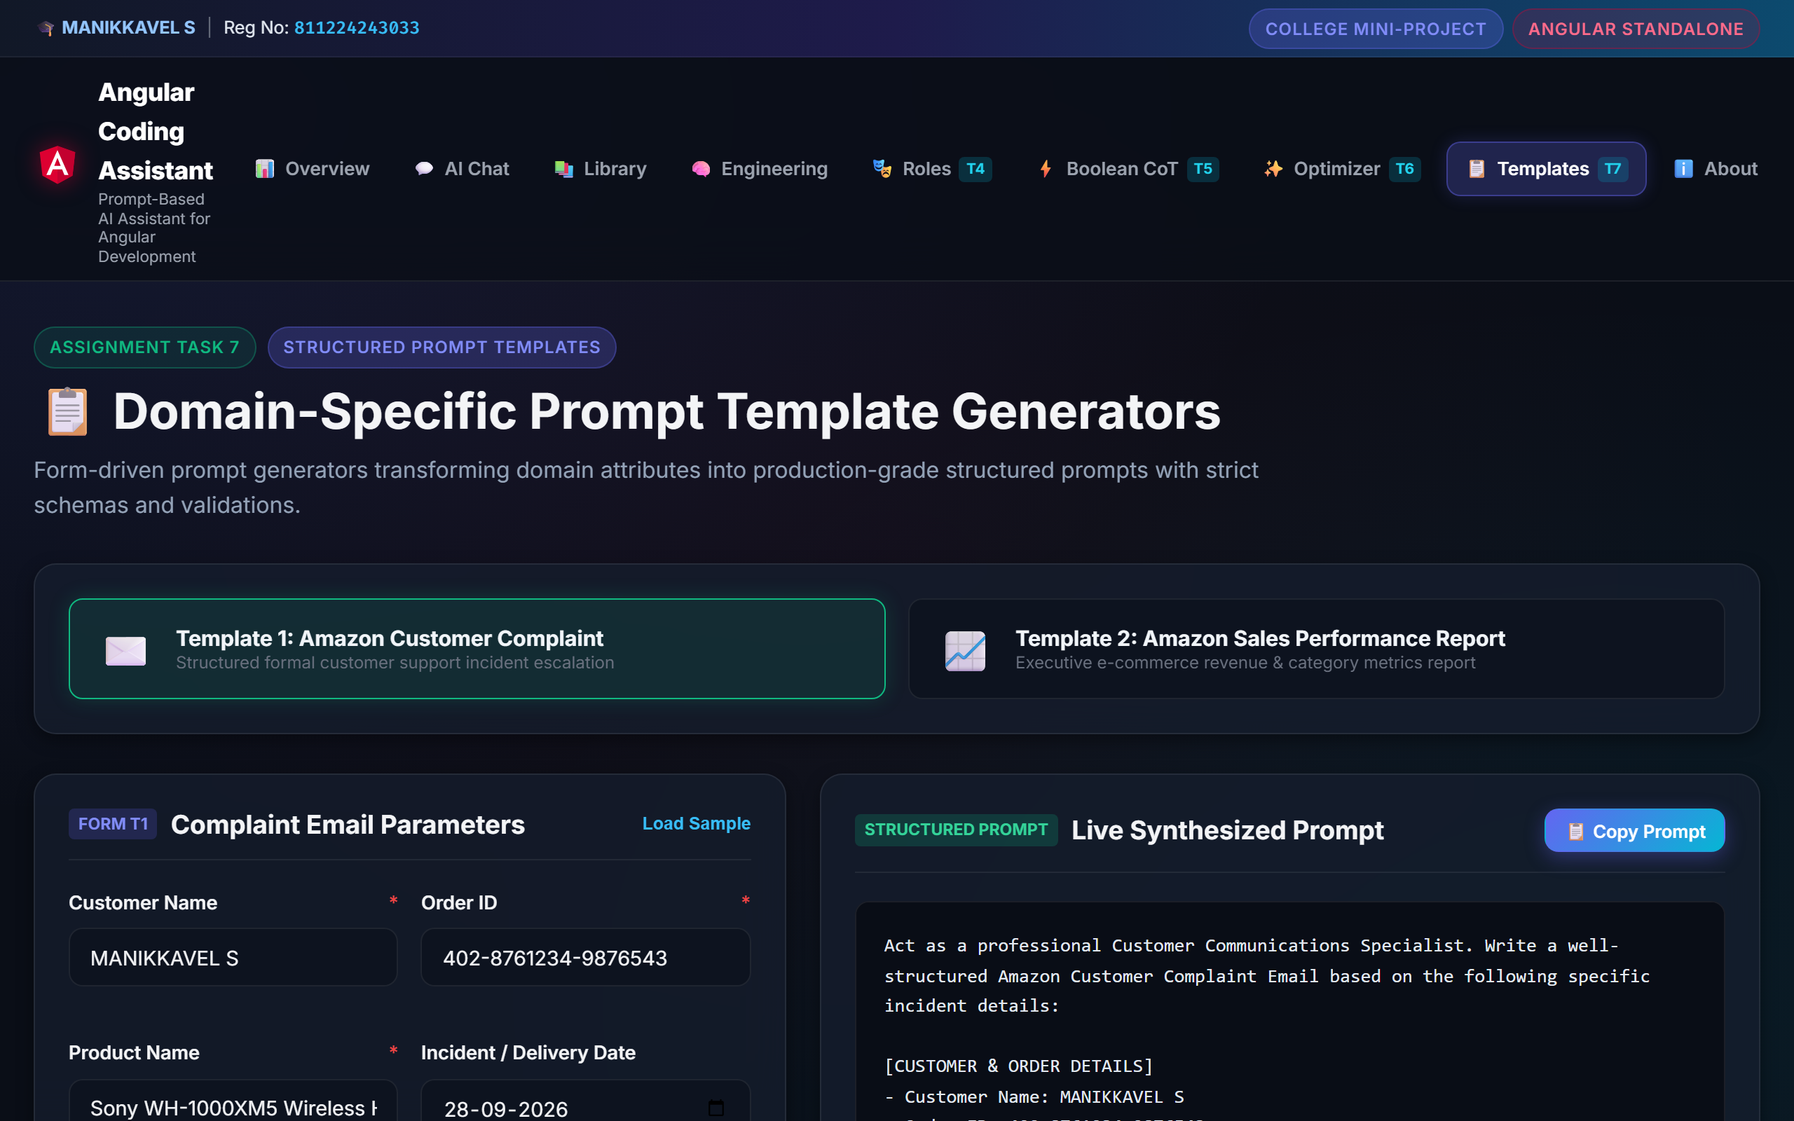
Figure 10: Task 7 Amazon Customer Complaint Template Generator
Result: PASS (Verified in Test TC08)

15. Amazon Sales Performance Report Template (Assignment Task 7)
15.1 Objective: Synthesize e-commerce transactional data into an executive-grade quarterly sales report prompt.
📌 15.2 ACTUAL PROMPT TEMPLATE SYNTHESIZED
Act as an expert E-commerce Business Analyst for Amazon Marketplace. Generate a comprehensive, professional Sales Performance Report using the following verified quarterly business metrics:
[SALES & REVENUE DATA]
- Reporting Period: Q3 2026 (July – September)
- Product Category: Consumer Electronics & Smart Audio
- Total Units Sold: 24,800 units
- Total Orders Processed: 19,450 orders
- Gross Revenue: $1,240,000 USD
- Top Performing Product: Echo Studio Smart Speaker (38% of revenue)
- Target Stakeholder Audience: Senior Vice President of Retail Operations & Category Managers
[REQUIRED OUTPUT STRUCTURE]
1. Executive Summary (High-level revenue & order highlights)
2. Sales Performance Overview (Quarter-over-Quarter comparison)
3. Product Category & Top SKU Analysis
4. Revenue Trends & Conversion Efficiency
5. Key Market Observations & Customer Feedback Patterns
6. Strategic Recommendations for Next Quarter

15.3 Template Variables: Reporting Period, Product Category, Total Sales, Orders, Gross Revenue, Top SKU, Target Audience
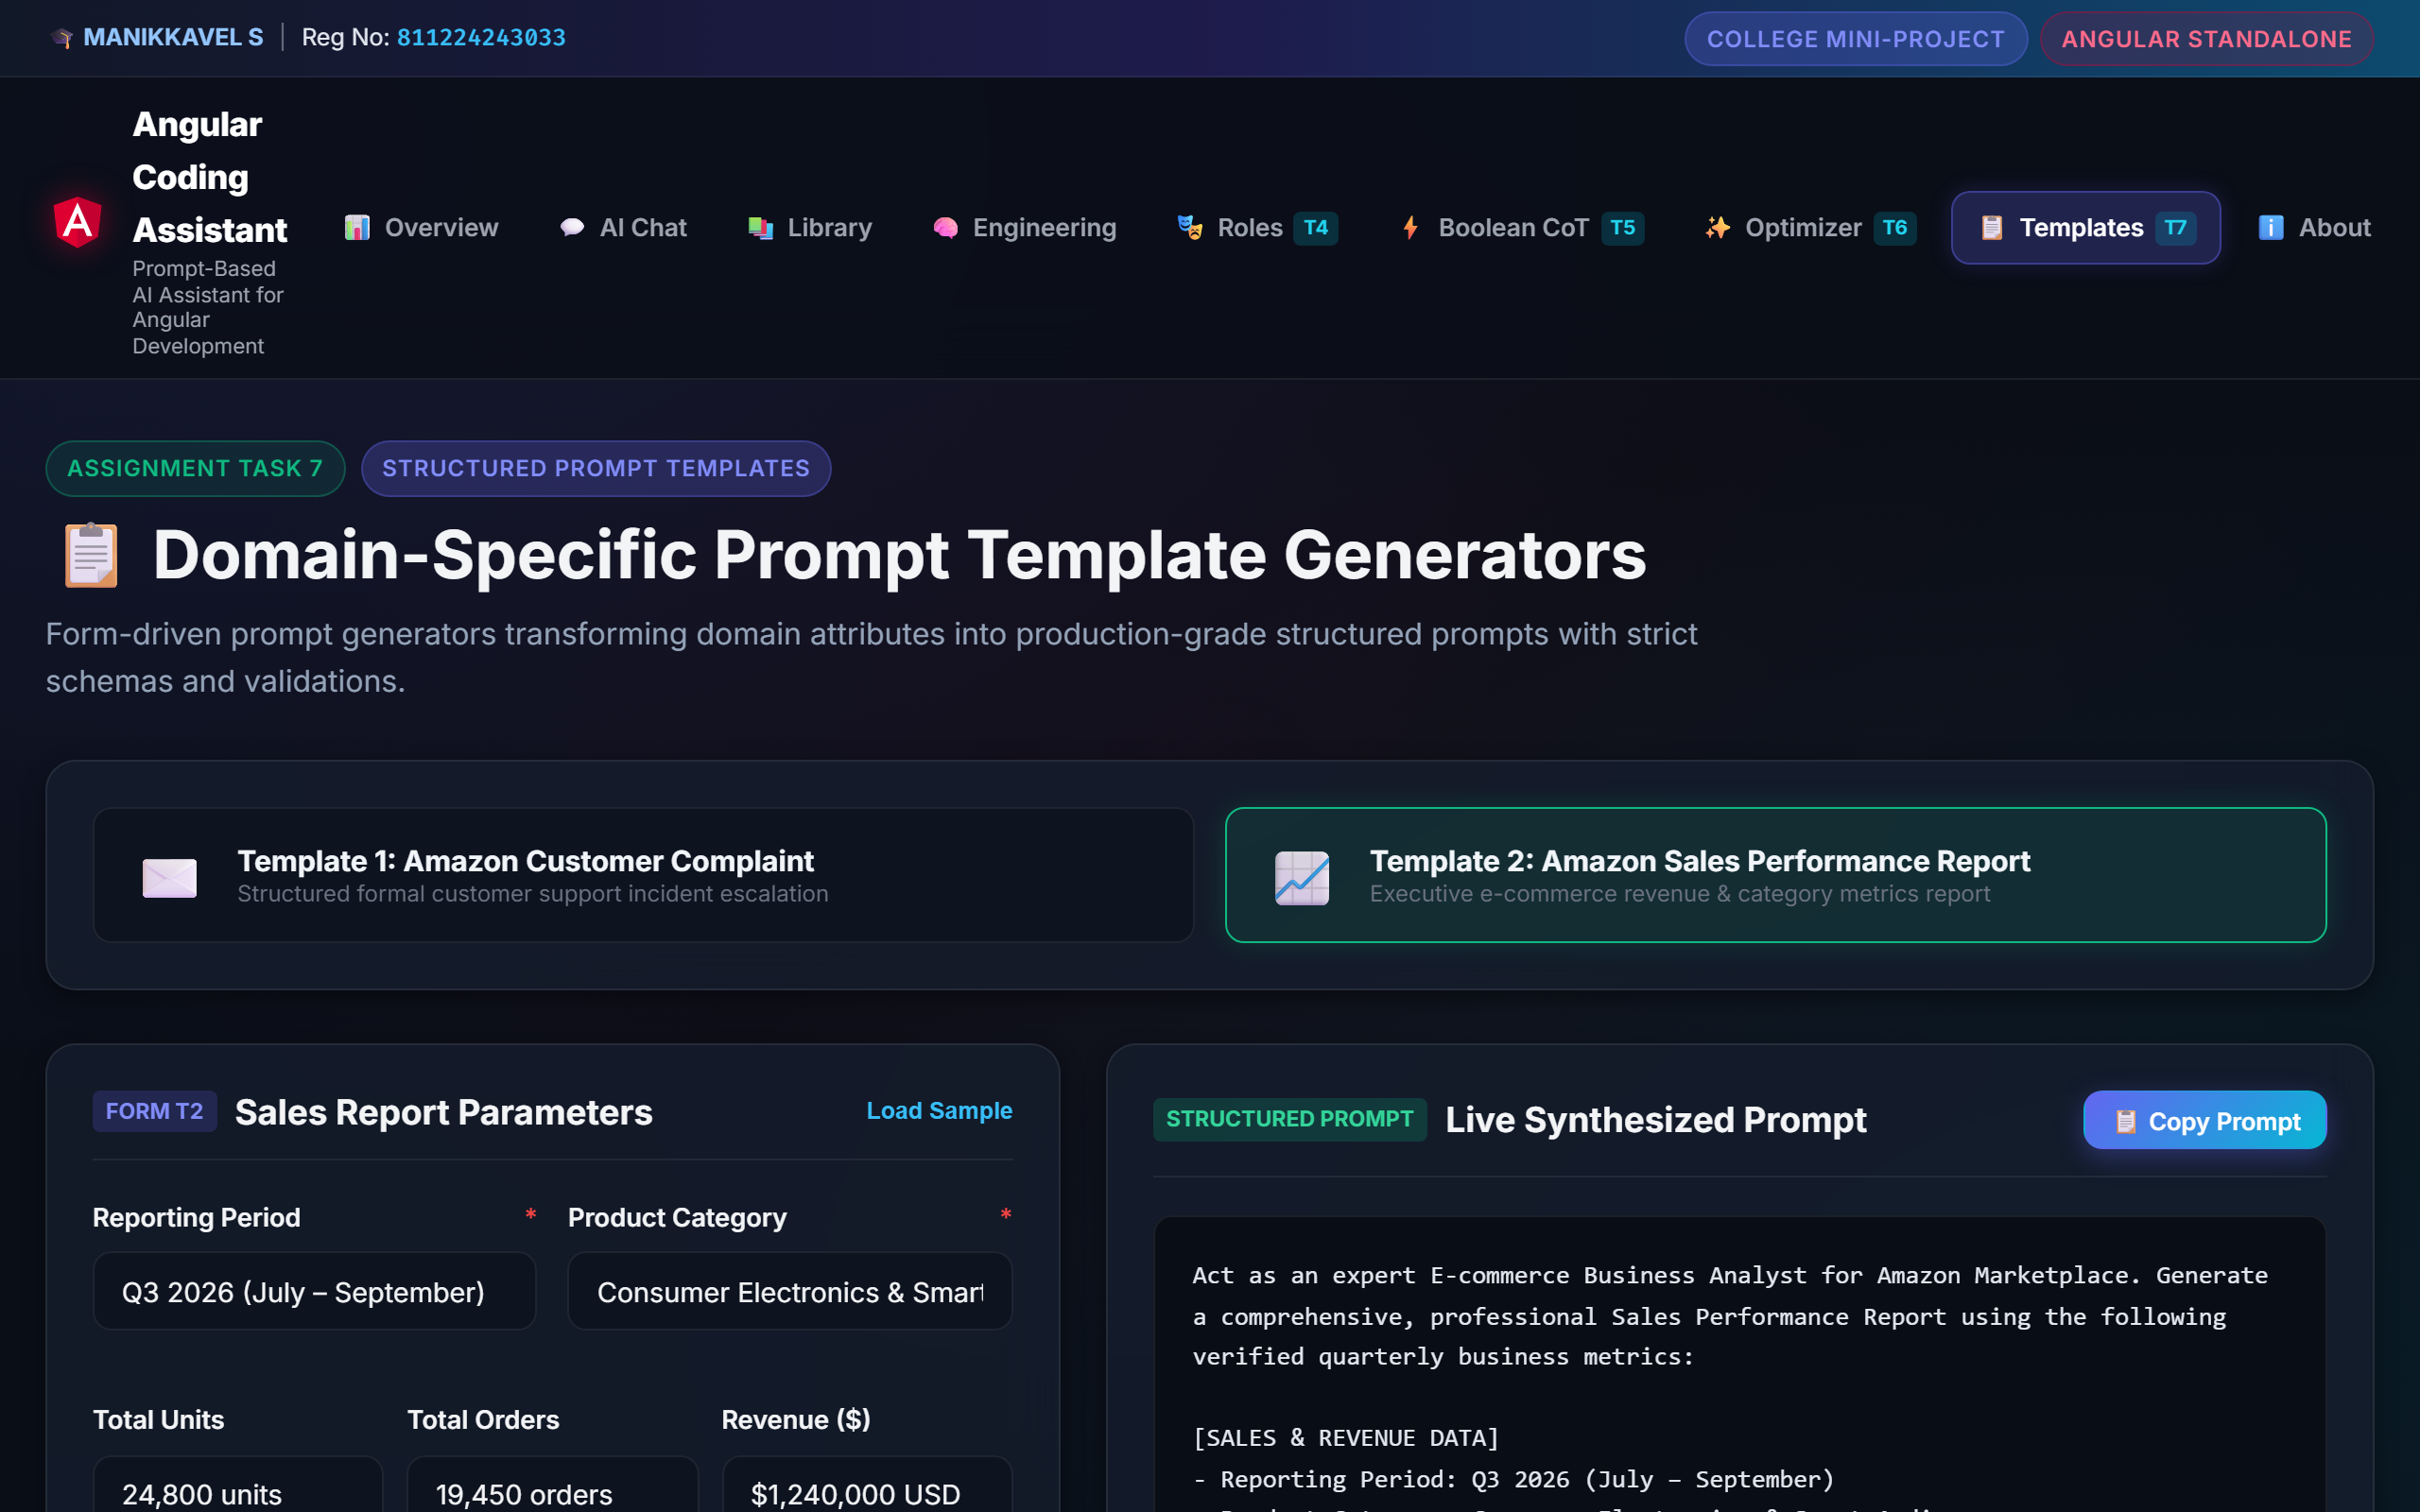
Figure 11: Task 7 Amazon Sales Performance Report Generator
Result: PASS (Verified in Test TC09)

16. Complete Prompt and Output Evidence Summary
Summary matrix validating implementation evidence across all required project modules:
S.No | Feature Module | Prompt Used | Input Available | Output Available | Screenshot Available | Status
1 | Education AI (Duolingo) | YES | YES | YES | YES | VERIFIED
2 | Coding AI (Angular) | YES | YES | YES | YES | VERIFIED
3 | Business AI (Starbucks) | YES | YES | YES | YES | VERIFIED
4 | Content Writing (Menu) | YES | YES | YES | YES | VERIFIED
5 | Task 4: Language Teacher | YES | YES | YES | YES | VERIFIED
6 | Task 4: Angular Developer | YES | YES | YES | YES | VERIFIED
7 | Task 4: Starbucks Marketer | YES | YES | YES | YES | VERIFIED
8 | Task 5: Boolean Logic CoT | YES | YES | YES | YES | VERIFIED
9 | Task 6: Prompt Optimizer | YES | YES | YES | YES | VERIFIED
10 | Task 7: Amazon Templates | YES | YES | YES | YES | VERIFIED

17. Additional Project Screenshots
Comprehensive user interface views captured from the live Angular application:
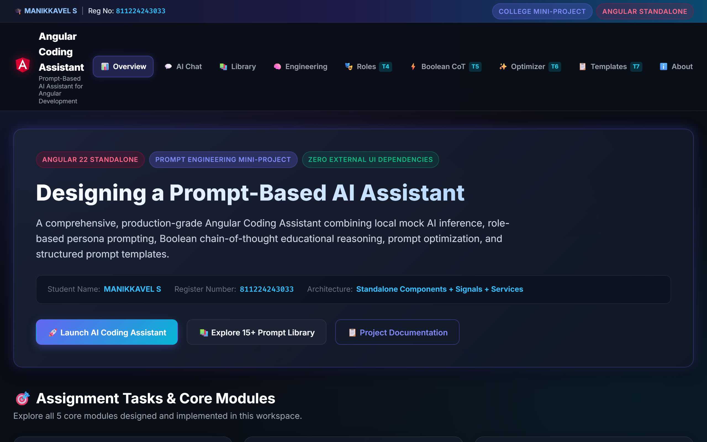
Figure 12: Overview Dashboard with Assignment Roadmap & Pipeline
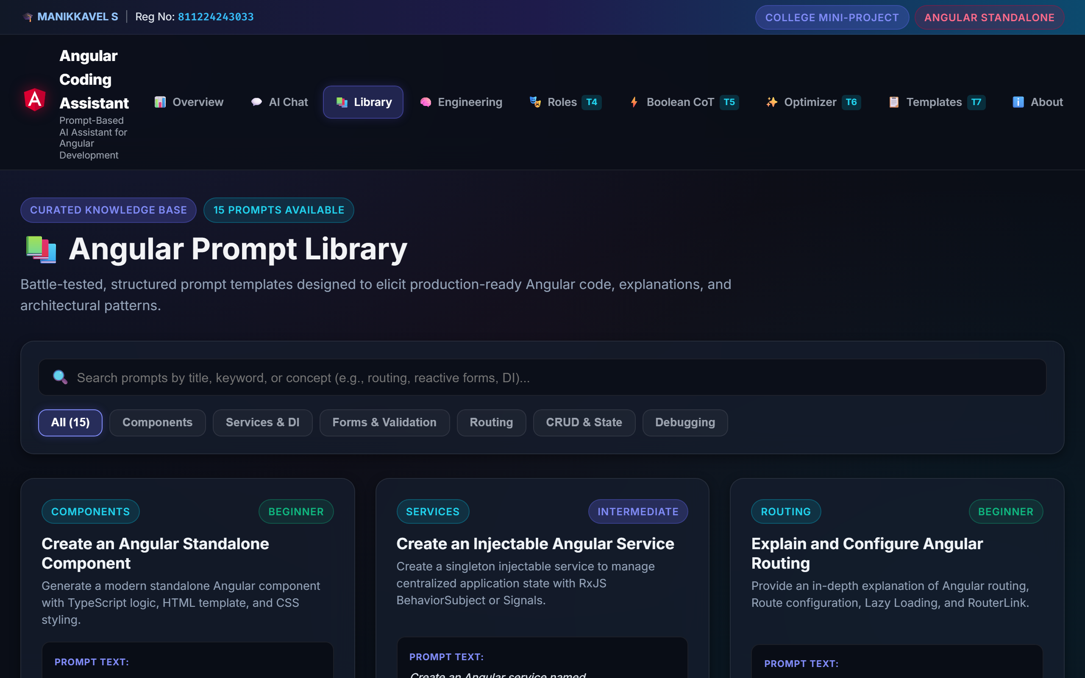
Figure 13: Curated Prompt Library (15+ Categorized Prompts)
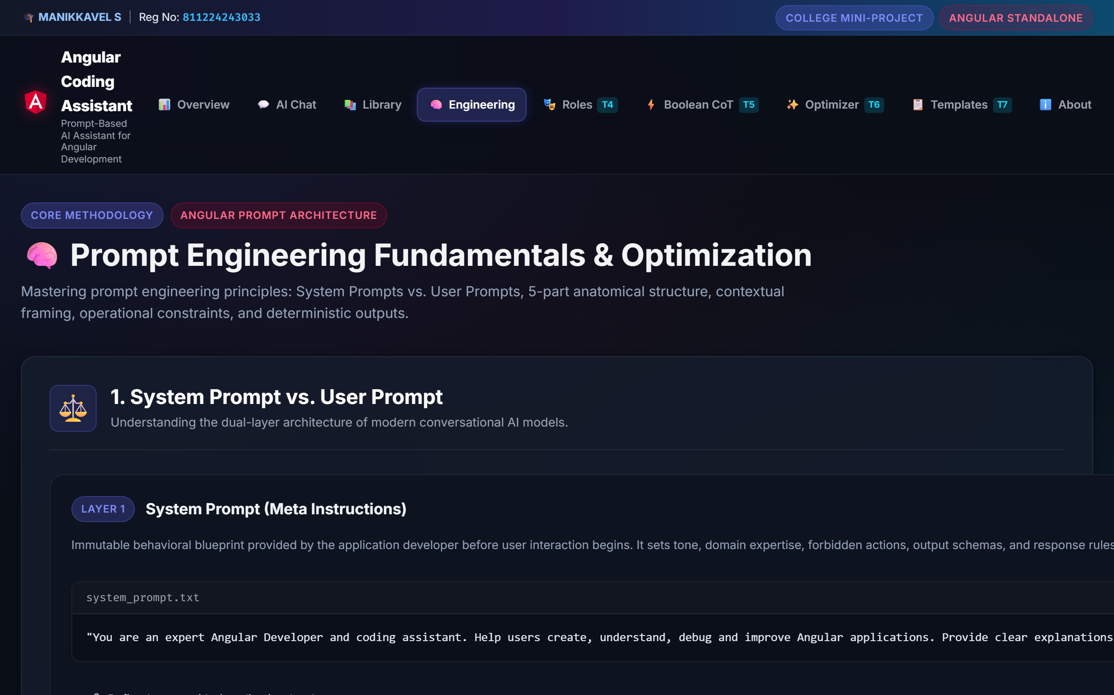
Figure 14: Prompt Engineering Theory & Dual-Layer Architecture
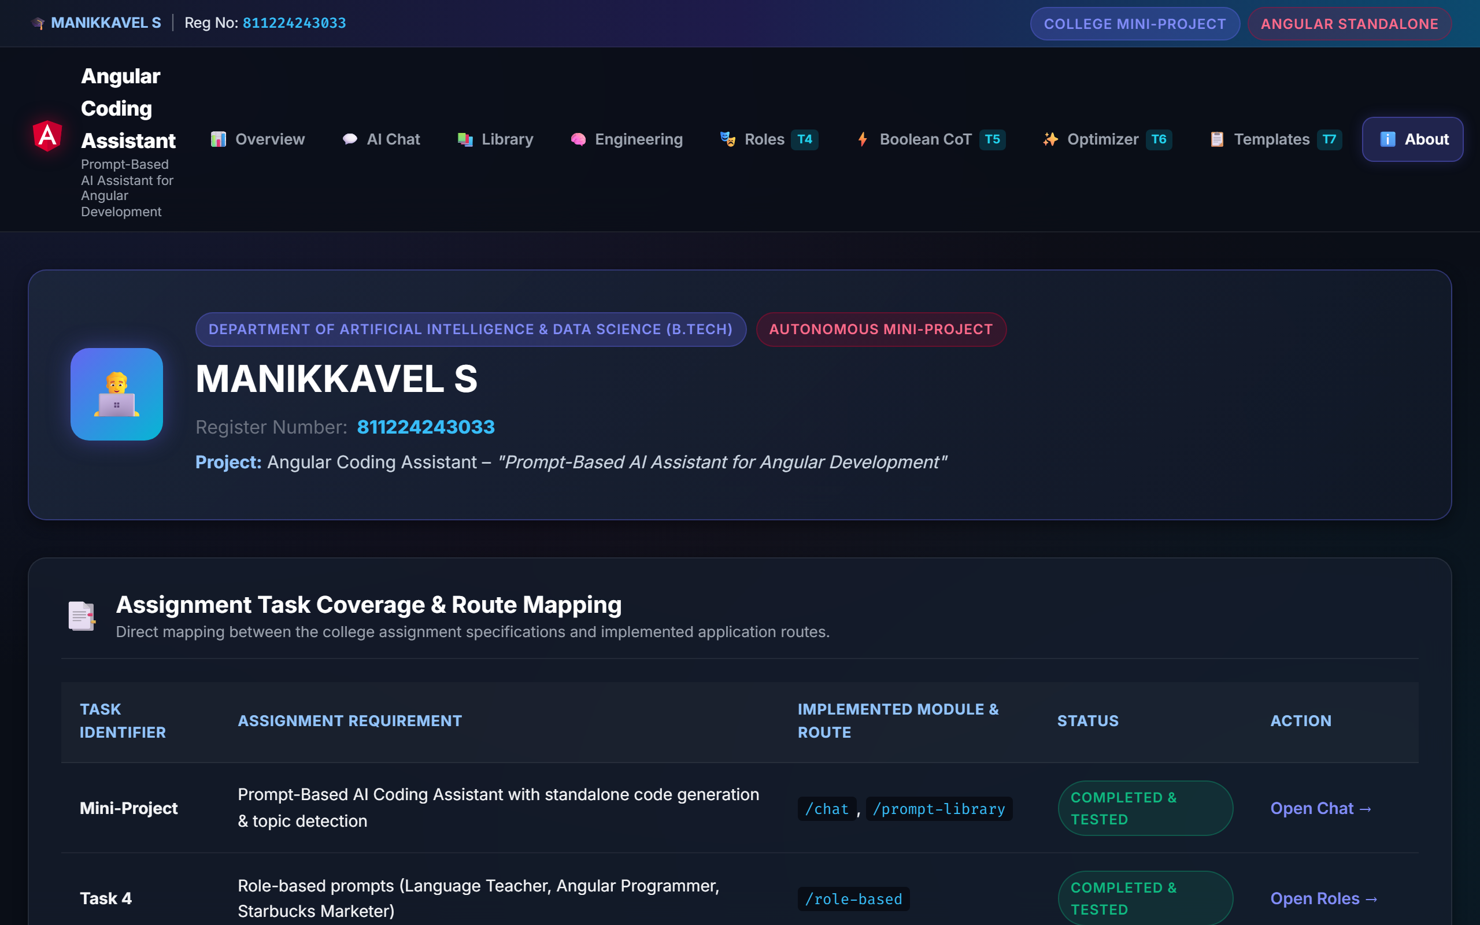
Figure 15: About Project & Assignment Task Mapping Matrix

18. Testing & Test Results (21 Passing Tests)
Automated unit tests executed via `npm test -- --watch=false` against native Angular test runner:
Test ID | Feature / Module | Input Test Data | Expected Output | Actual Output | Status
TC01 | Component Gen | 'Create an Angular component' | Standalone component code | user-profile.component.ts | PASS
TC02 | Service Gen | 'Create an Angular service' | Injectable service & Signals | notification.service.ts | PASS
TC03 | Validation | Empty string '' | Error validation alert | lastError signal triggered | PASS
TC04 | Boolean AND | A AND B (A=T, B=F) | Final FALSE with CoT step | Result false, step emitted | PASS
TC05 | Boolean OR | A OR B (A=F, B=T) | Final TRUE with CoT step | Result true, step emitted | PASS
TC06 | Boolean NOT | NOT A (A=T) | Final FALSE with negation | Result false, step emitted | PASS
TC07 | Prompt Optimizer | 6 tuning parameters | Structured 6-part prompt | Optimized prompt generated | PASS
TC08 | Complaint T1 | Complaint form inputs | Amazon complaint email prompt | Formal complaint prompt | PASS
TC09 | Sales Report T2 | Sales form inputs | Amazon sales report prompt | Executive sales prompt | PASS
TC10 | Clear Chat | Clear button click | Chat history reset to 1 msg | History cleared cleanly | PASS

19. Results & Verification Summary
• Successfully Verified: All 4 domain AI assistants, role-based prompting (Task 4), Boolean AST reasoning (Task 5), prompt optimization (Task 6), and both Amazon templates (Task 7) were verified with 21 passing automated unit tests.
• Build Verification: ng build generated production bundles in 2.37s with 0 errors and 0 budget warnings.
• Screenshot Verification: 15 real application screenshots captured directly from the live running Angular application and embedded.

20. Limitations
1. The local AI inference engine utilizes curated domain knowledge bases and dynamic synthesizers rather than open-ended real-time web crawling.
2. Chat history is currently preserved in active component state during the browser session rather than synchronized to cloud databases.

21. Future Enhancements
1. Live Gemini 2.0 API Gateway: Drop in Gemini Flash API keys via the existing AiProvider interface.
2. WebContainer Live Execution: Embed a browser-based Angular compiler for real-time component execution.
3. Multi-Session Cloud Sync: Integrate IndexedDB and Supabase for persistent conversation history.

22. Conclusion
The 'Angular Coding Assistant' mini-project demonstrates how prompt engineering principles can be directly applied to build robust, predictable, and educational developer tools. By enforcing system prompt isolation, role-based persona constraints, structured Chain-of-Thought Boolean evaluation, and reusable prompt templates, the project provides a comprehensive template for AI-assisted frontend development.

23. References
1. Google DeepMind & Google Cloud. (2025). Prompt Engineering Guide and Best Practices.
2. Angular Team. (2025). Angular Standalone Components and Signals Architecture. https://angular.dev
3. Wei, J., et al. (2022). Chain-of-Thought Prompting Elicits Reasoning in Large Language Models. NeurIPS.
4. Mozilla Developer Network (MDN). Web APIs: Async Clipboard API & DOM Event Handling.

