Game Design Document

Fill up the following document

1. Write the title of your project.

Space quest

1. What is the goal of the game?

The goal of my game is that you have to dodge what the NPC’s shoot at you. And survive throughout the wave.

1. Write a brief story of your game.

The Zegnos are the most dominant beings on the whole universe. They want to rule the whole universe, they have high-tech weapons and artillery. They are trying to wipe out humans. Will they humans survive?....

1. Which are the playing characters of this game?

* Playing characters are the ones who respond to the user based on the input from the user.
* Cars, monkeys, dinos, wizards, etc., are the playing characters in the game.

|  |  |  |
| --- | --- | --- |
| Number | Character Name | What can this character do? |
| 1 | Fighterjets | Shoot bullets at the aliens, and dodge at high speeds |
| 2 |  |  |
| 3 |  |  |
| 4 |  |  |
| 5 |  |  |
| 6 |  |  |
| 7 |  |  |
| 8 |  |  |

1. Which are the Non-Playing Characters of this game?

* Non-Playing characters are the ones that don't have an action or behavior when the user interacts with the game.
* Hurdles, stones, bananas, coins, etc., are non-playing characters in the game.

|  |  |  |
| --- | --- | --- |
| Number | Character Name | What can this character do? |
| 1 | The Zegnos | They can shoot weapons, and travel at the speed of light. |
| 2 | Fuel | Regenerate the fighterjets |
| 3 | Planets | They are in the distant, thus they are idle |
| 4 |  |  |
| 5 |  |  |
| 6 |  |  |
| 7 |  |  |
| 8 |  |  |

Draw your imagination of this game. What does this game look like?

* Draw the game either on your computer or on paper.
* Add images of the game scenes to show each of the playing and non-playing characters at least once.

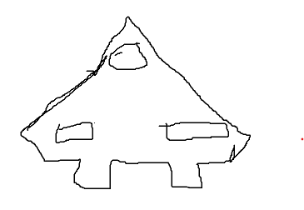

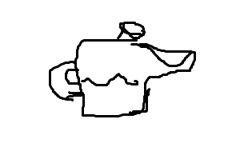

How do you plan to make your game engaging?

By adding diffuculties, and adding great images and great coding.