**Assignment #4**

**Manik Virdi**

**(8669256)**

**24th July 2019**

**SENG8040**

**Testing Methodologies**

**Assignment #4: Rubric**

|  |  |  |  |
| --- | --- | --- | --- |
| **#** | **Mark** | **Weight** | **Criteria** |
|  |  |  | **Part 1: Decision Table** |
| **1.** |  | 6 | All conditions and actions identified in the full decision table |
| **2.** |  | 3 | Correct "don't cares" identified in second decision table |
| **3.** |  | 3 | All redundancies removed in final decision table |
| **4.** |  | 8 | Correct test cases derived from final decision table |
|  |  |  | **Part 2, Task 1: Web Application** |
| **5.** |  | 3 | Form input fields are validated properly |
| **6.** |  | 3 | Data input is saved |
| **7.** |  | 3 | After saving, information entered is displayed, including link to the correct JD Power and Associates page |
| **8.** |  | 3 | Page created to display a list of previously saved data |
|  |  |  | **Part 2, Task 2: System Tests** |
| **9.** |  | 8 | System test 1 works and is unique compared to the other system tests |
| **10.** |  | 8 | System test 2 works and is unique compared to the other system tests |
| **11.** |  | 8 | System test 3 works and is unique compared to the other system tests |
| **12.** |  | 8 | System test 4 works and is unique compared to the other system tests |
| **13.** |  | 8 | System test 5 works and is unique compared to the other system tests |
|  |  |  | **Version Control** |
| **14.** |  | 3 | Screenshot showing repository with a commit history. |
|  |  | -0.5 per | **Programming standards deductions (i.e. spelling mistakes, naming, etc.).** |
|  |  | -15 | **Failure to present or not ready when asked deduction.** |
|  |  | -15 | **Late submission (per day)** |
|  |  | -7.5 | **Hard copy not handed in or not all documents listed handed in (order).** |
|  |  | **75** | **Total Marks** |

**# Part 1 (Decision Table)**

**#Decision Table:**

|  |  |  |  |  |  |  |  |  |  |  |  |  |  |  |  |  |  |
| --- | --- | --- | --- | --- | --- | --- | --- | --- | --- | --- | --- | --- | --- | --- | --- | --- | --- |
| **Conditions** | | | | | | | | | | | | | | | | | |
| **C1** | **Ac.** | **<3** | | | | | | | | **3** | | | | | | | |
| **C2** | **Ex.** | **0<1** | | **1 to <2** | | **2 to 9** | | **>9** | | **0** | | **1 to <2** | | **2 to 9** | | **>9** | |
| **C3** | **Ag.** | **<30** | **30** | **<30** | **30** | **<30** | **30** | **<30** | **30** | **<30** | **30** | **<30** | **30** | **<30** | **30** | **<30** | **30** |
| **Actions** | | | | | | | | | | | | | | | | | |
| **A1** | **No Ins.** |  |  |  |  |  |  |  |  | **X** | **X** | **X** | **X** | **X** | **X** | **X** | **X** |
| **A2** | **Ins. B.R.**  **$3000** | **X** | **X** |  |  |  |  |  |  |  |  |  |  |  |  |  |  |
| **A3** | **Ins. B.R. $2000** |  |  | **X** | **X** | **X** | **X** |  |  |  |  |  |  |  |  |  |  |
| **A4** | **Ins. B.R. $1000** |  |  |  |  |  |  | **X** | **X** |  |  |  |  |  |  |  |  |
| **A5** | **R.R. -20%** |  |  |  |  |  | **X** |  | **X** |  |  |  |  |  |  |  |  |

**Where:**

**Ac. – Accidents. Ins.- Insurance**

**Ex. – Experience B.R.- Base Rate**

**Ag. – Age R.R.- Rate Reduction**

**# Don’t Care Table:**

|  |  |  |  |  |  |  |  |  |  |  |  |  |  |  |  |  |  |
| --- | --- | --- | --- | --- | --- | --- | --- | --- | --- | --- | --- | --- | --- | --- | --- | --- | --- |
| **Conditions** | | | | | | | | | | | | | | | | | |
| **C1** | **Ac.** | **<3** | | | | | | | | **3** | | | | | | | |
| **C2** | **Ex.** | **0<1** | | **1 to <2** | | **2 to 9** | | **>9** | | **-** | | **-** | | **-** | | **-** | |
| **C3** | **Ag.** | **-** |  | **-** |  | **<30** | **30** | **<30** | **30** | **-** | **-** | **-** |  | **-** |  | **-** |  |
| **Actions** | | | | | | | | | | | | | | | | | |
| **A1** | **No Ins.** |  |  |  |  |  |  |  |  | **X** | **X** | **X** | **X** | **X** | **X** | **X** | **X** |
| **A2** | **Ins. B.R.**  **$3000** | **X** | **X** |  |  |  |  |  |  |  |  |  |  |  |  |  |  |
| **A3** | **Ins. B.R. $2000** |  |  | **X** | **X** | **X** | **X** |  |  |  |  |  |  |  |  |  |  |
| **A4** | **Ins. B.R. $1000** |  |  |  |  |  |  | **X** | **X** |  |  |  |  |  |  |  |  |
| **A5** | **R.R. -20%** |  |  |  |  |  | **X** |  | **X** |  |  |  |  |  |  |  |  |

**Where:**

**Ac. – Accidents. Ins.- Insurance**

**Ex. – Experience B.R.- Base Rate**

**Ag. – Age R.R.- Rate Reduction**

**#Redundancy Table:**

|  |  |  |  |  |  |  |  |  |
| --- | --- | --- | --- | --- | --- | --- | --- | --- |
| **Conditions** | | | | | | | | |
| **C1** | **Ac.** | **<3** | | | | | | **3** |
| **C2** | **Ex.** | **0<1** | **1 to <2** | **2 to 9** | | **>9** | | **N.A.** |
| **C3** | **Ag.** | **N.A.** | **N.A.** | **<30** | **30** | **<30** | **30** | **N.A.** |
| **Actions** | | | | | | | | |
| **A1** | **No Ins.** |  |  |  |  |  |  | X |
| **A2** | **Ins. B.R. $3000** | X |  |  |  |  |  |  |
| **A3** | **Ins. B.R. $2000** |  | X | X | X |  |  |  |
| **A4** | **Ins. B.R. $1000** |  |  |  |  | X | X |  |
| **A5** | **R.R. -20%** |  |  |  | X |  | X |  |

**Where:**

**Ac. – Accidents. Ins.- Insurance**

**Ex. – Experience B.R.- Base Rate**

**Ag. – Age R.R.- Rate Reduction**

**#Test cases:**

|  |  |  |
| --- | --- | --- |
| **Test Id:** | **Test Step(s)** | **Test Outcome(s)** |
| 1. | Accidents greater than or equal to 3 | No Insurance regardless of experience and age. |
| 2. | Accidents less than 3 (No experience) | Insurance with Base Rate of $3000 (regardless of age) |
| 3. | Accidents less than 3 (experience 1 to <2 years) | Insurance with Base Rate of $2000 (regardless of age) |
| 4. | Accidents less than 3 (experience 2 to 9) | Insurance with Base Rate of $2000 (if age is less than 30) |
| 5. | Accidents less than 3 (experience 2 to 9) | Insurance with Base Rate of $2000 and Rate Reduction of 20%. **[1-20/100=0.8. Therefore, 0.8*2000=$1600]**  **(**if age is equal to or greater than 30) |
| **6.** | Accidents less than 3 (experience >9) | Insurance with Base Rate of $1000 (if age is less than 30) |
| 7. | Accidents less than 3 (experience >9) | Insurance with Base Rate of $1000 and Rate Reduction of 20%. **[1-20/100=0.8. Therefore,0.8*1000=$800]**  (if age is equal to or greater than 30) |

**#Part 2**

**#1 Screenshot of index page opened in Firefox**

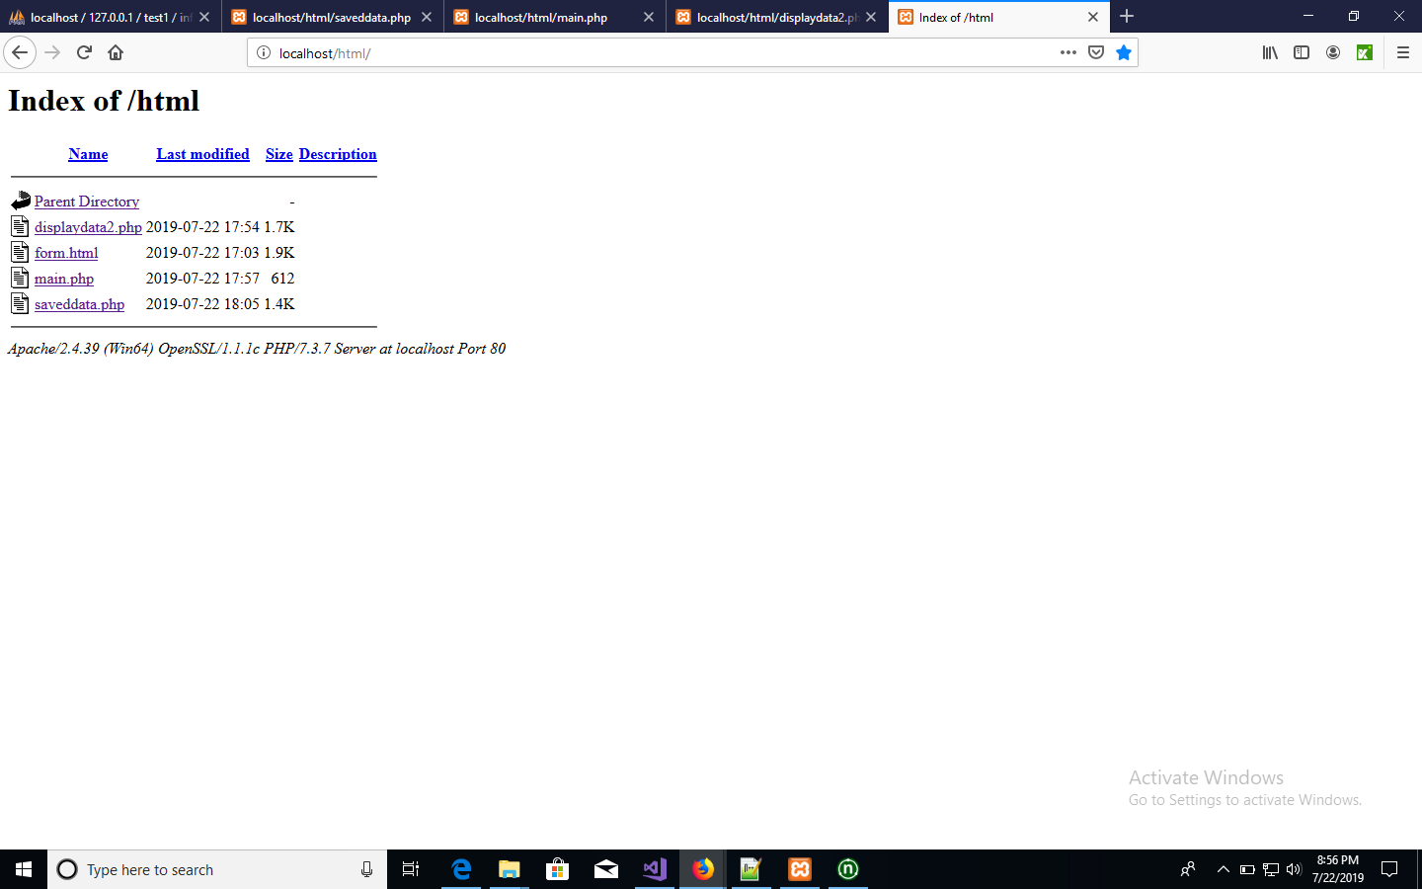

**#2 Screenshot of main page showing two options ‘New’ and ‘Search’**

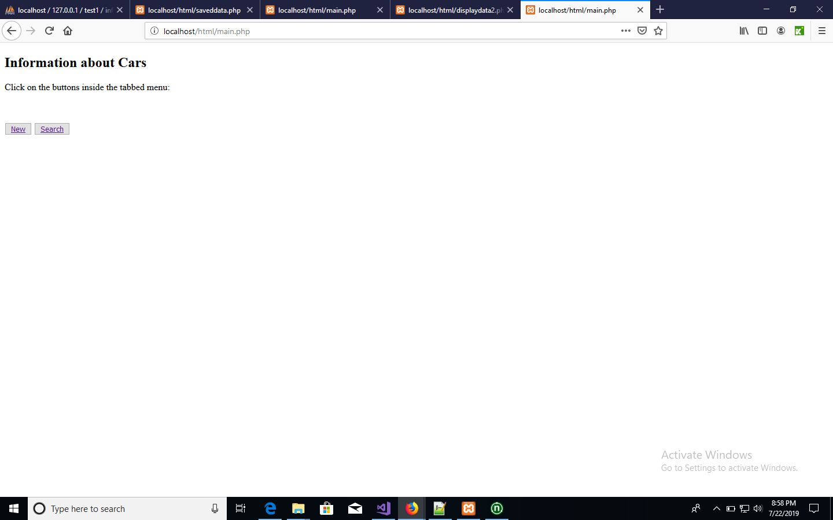

**#3 Customer Information filled in the form**

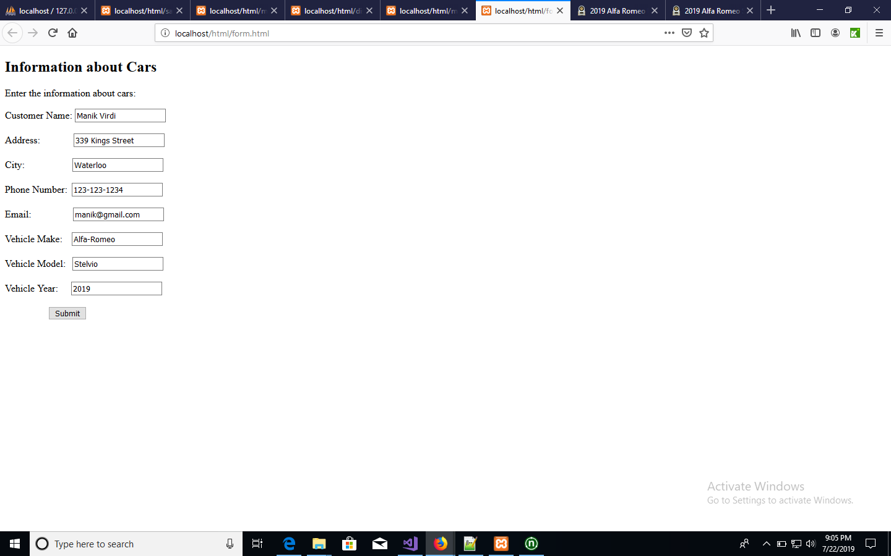

**#4 Customer Information successfully displayed on separate page along with the link to *jdpower* website**

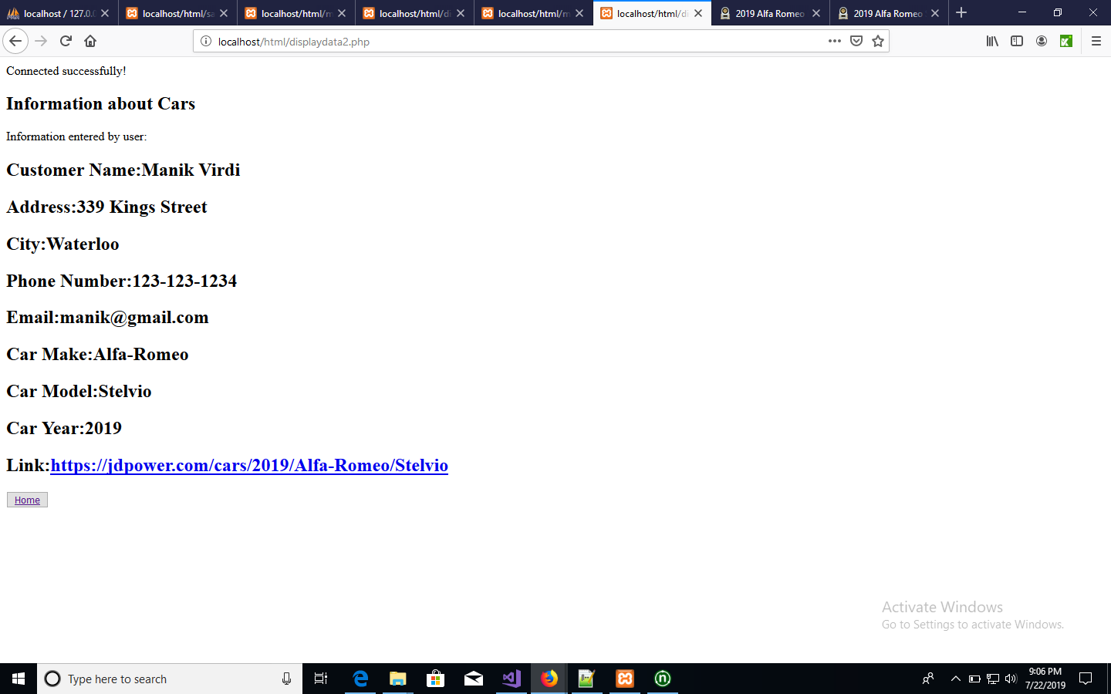

**#5 List of all customers displayed on single page**

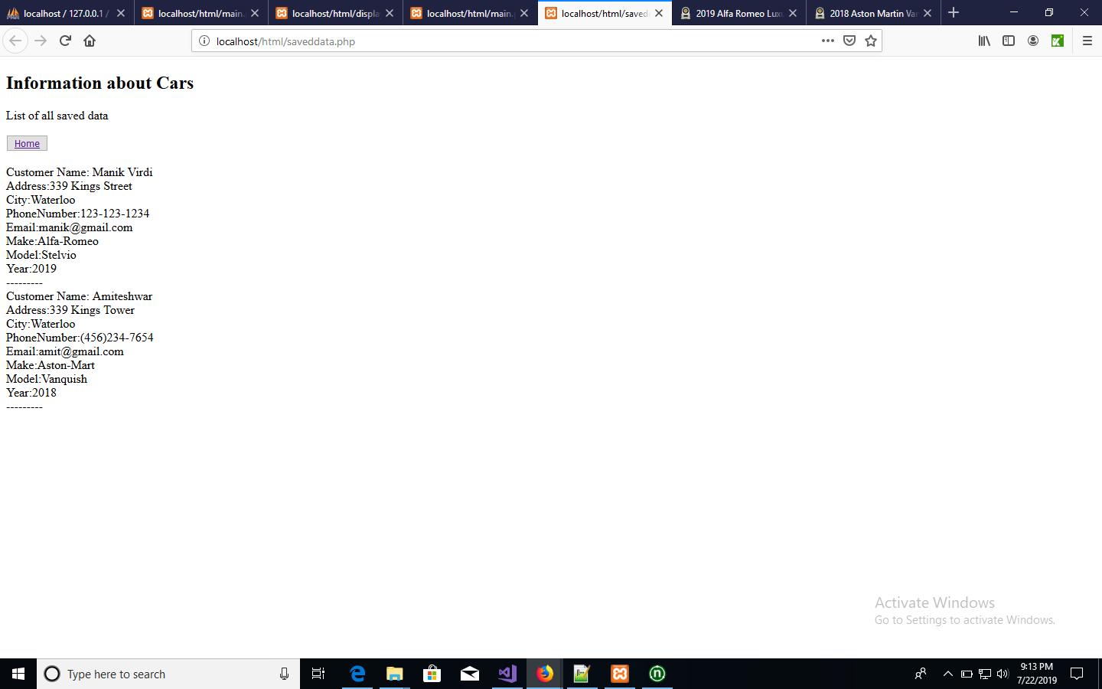

**#Test Case Screenshot Katalon**

**#1 Website_EnterValues_ResultDataDisplayed**

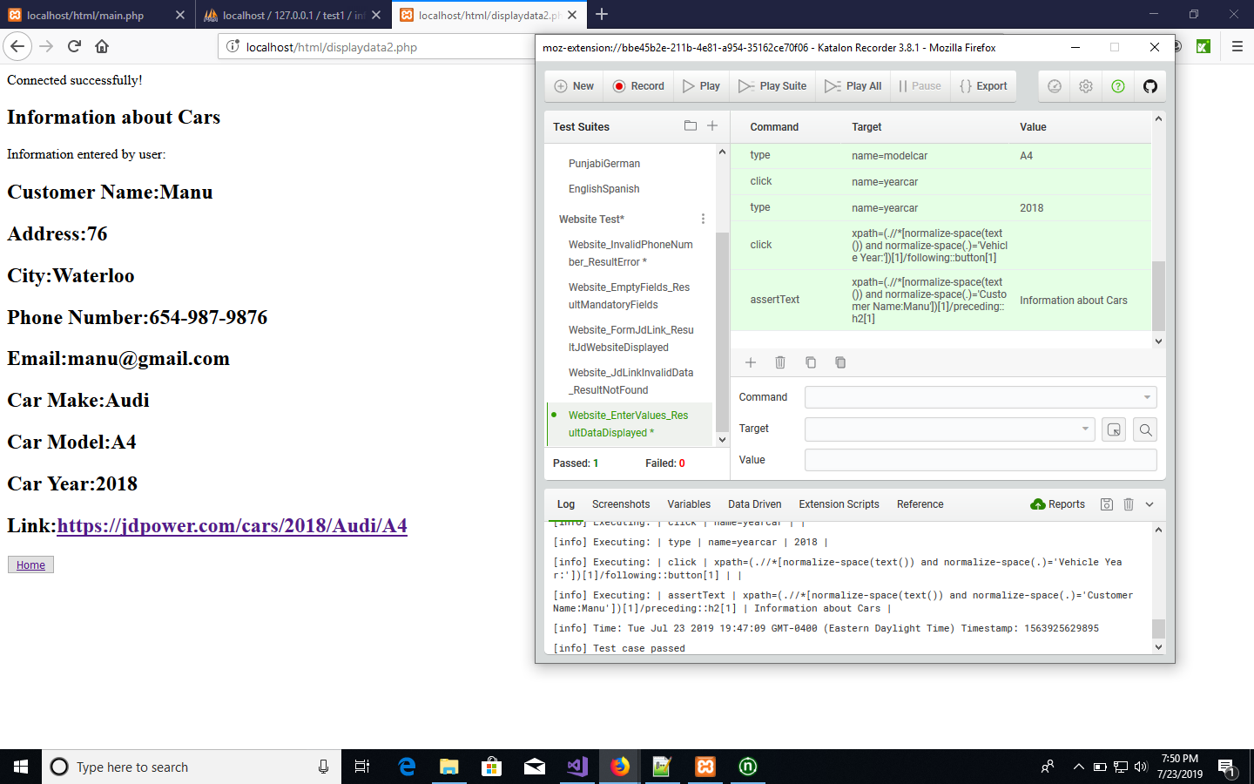

**#2 Website_InvalidPhoneNumber_ResultError()**

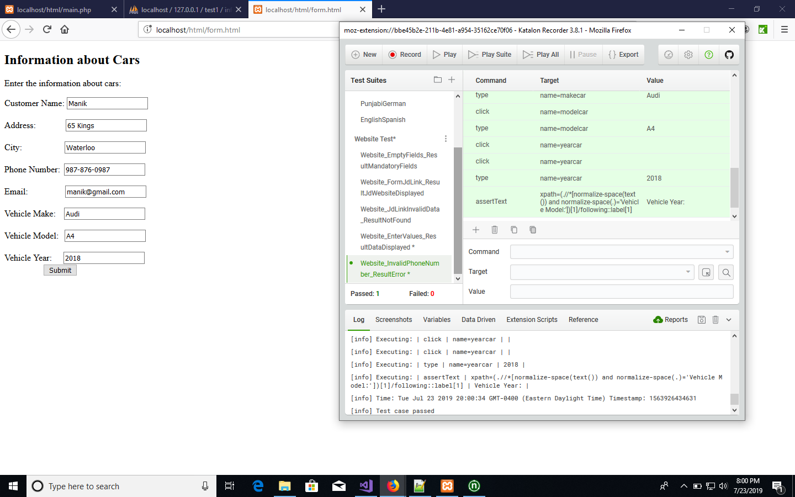

**#3 Website_EmptyFields_ResultMandatoryFields()**

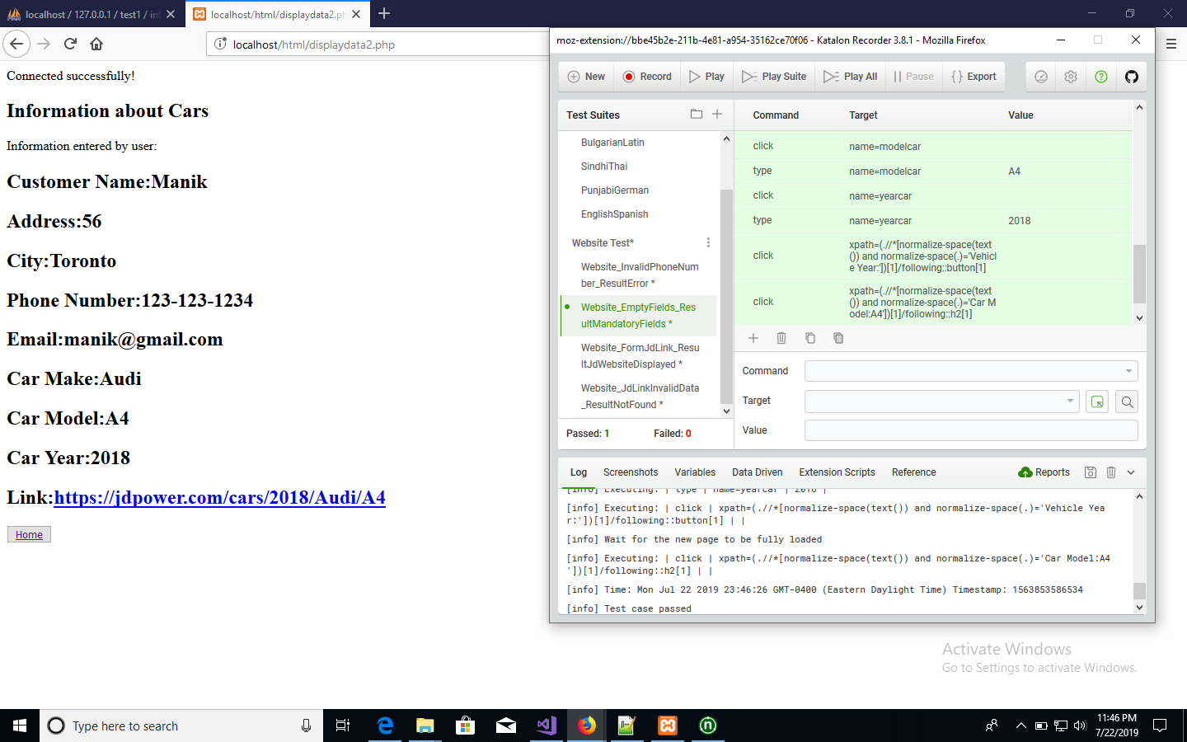

**#4 Website_FormJdLink_ResultJdWebsiteDisplayed()**

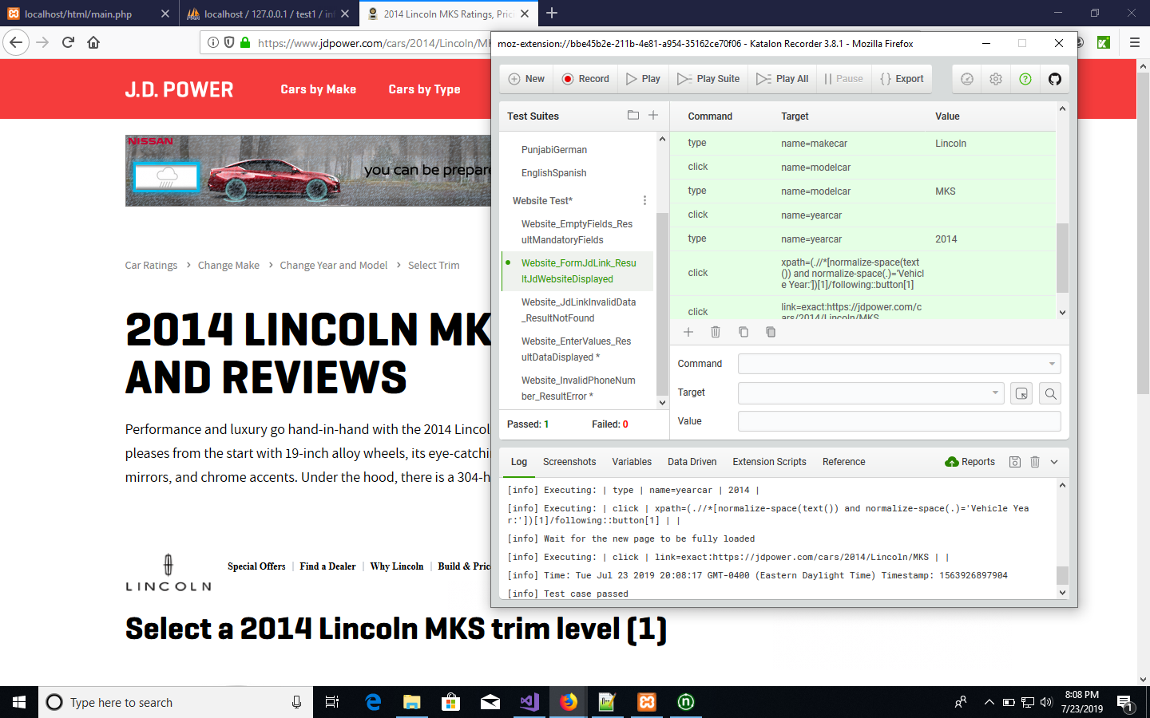

**#5 Website_JdLinkInvalidData_ResultNotFound()**

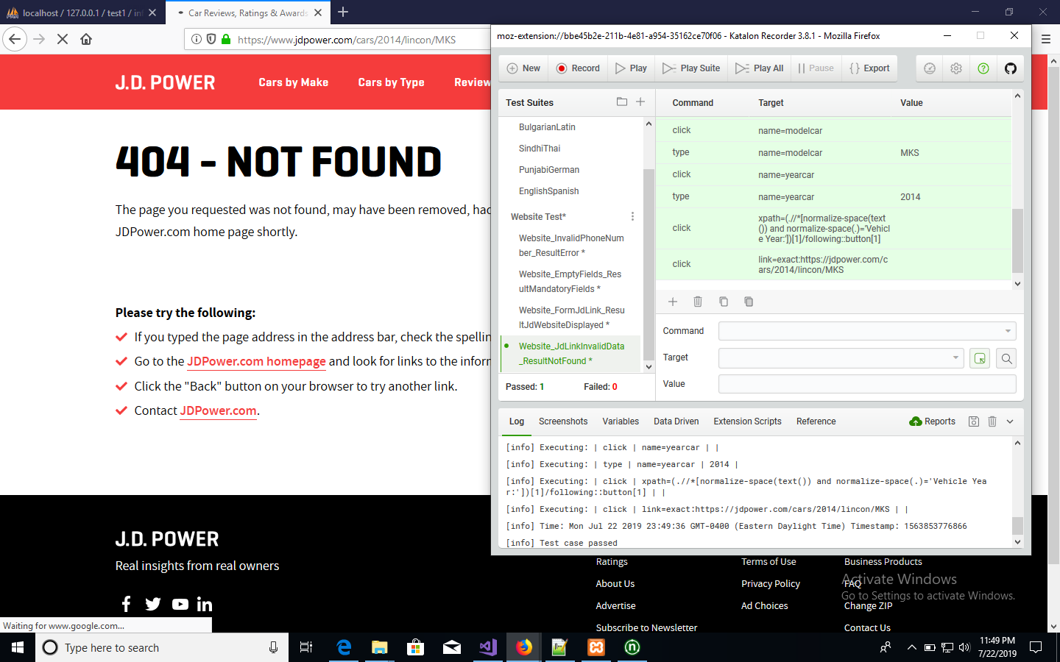

**# Katalon Screenshot for All Test Cases Running**

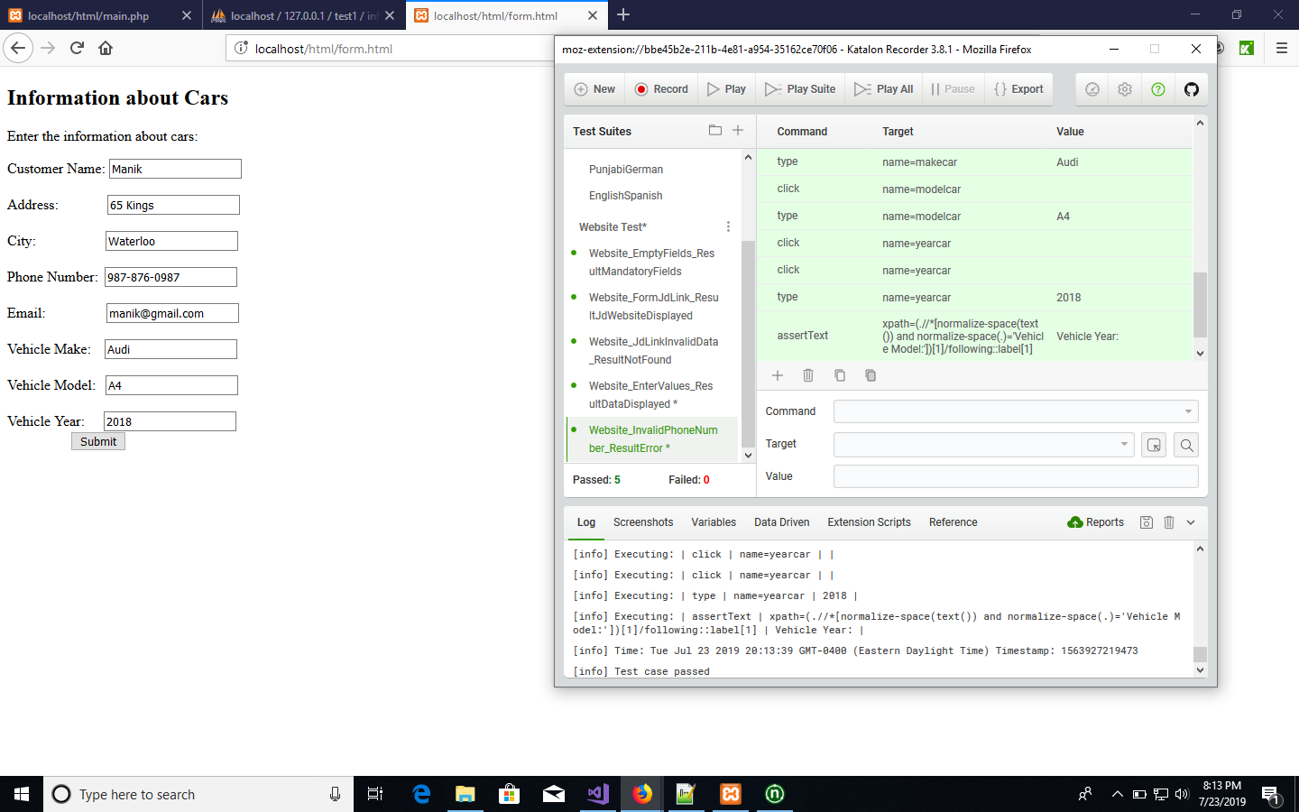

**# For all System Test C# Source Code**

using System;

using System.Text;

using System.Text.RegularExpressions;

using System.Threading;

using NUnit.Framework;

using OpenQA.Selenium;

using OpenQA.Selenium.Firefox;

using OpenQA.Selenium.Support.UI;

namespace ClassLibrary6

{

[TestFixture]

public class Class1

{

private IWebDriver driver;

private StringBuilder verificationErrors;

private string baseURL;

private bool acceptNextAlert = true;

[SetUp]

public void SetupTest()

{

driver = new FirefoxDriver();

baseURL = "https://www.katalon.com/";

verificationErrors = new StringBuilder();

}

[TearDown]

public void TeardownTest()

{

try

{

driver.Quit();

}

catch (Exception)

{

// Ignore errors if unable to close the browser

}

Assert.AreEqual("", verificationErrors.ToString());

}

[Test]

public void Website_EmptyFields_ResultMandatoryFields()

{

driver.Navigate().GoToUrl("http://localhost/html/form.html");

driver.FindElement(By.XPath("//body")).Click();

driver.FindElement(By.XPath("(.//*[normalize-space(text()) and normalize-space(.)='Vehicle Year:'])[1]/following::button[1]")).Click();

driver.FindElement(By.Id("firstname")).Clear();

driver.FindElement(By.Id("firstname")).SendKeys("Manik");

driver.FindElement(By.Name("address1")).Click();

driver.FindElement(By.Name("address1")).Clear();

driver.FindElement(By.Name("address1")).SendKeys("56");

driver.FindElement(By.XPath("(.//*[normalize-space(text()) and normalize-space(.)='Information about Cars'])[1]/following::form[1]")).Click();

driver.FindElement(By.Name("city1")).Click();

driver.FindElement(By.Name("city1")).Clear();

driver.FindElement(By.Name("city1")).SendKeys("Toronto");

driver.FindElement(By.Name("PhoneNumber1")).Click();

driver.FindElement(By.Name("PhoneNumber1")).Clear();

driver.FindElement(By.Name("PhoneNumber1")).SendKeys("123-123-1234");

driver.FindElement(By.Name("email")).Click();

driver.FindElement(By.Name("email")).Clear();

driver.FindElement(By.Name("email")).SendKeys("manik@gmail.com");

driver.FindElement(By.Name("makecar")).Click();

driver.FindElement(By.Name("makecar")).Clear();

driver.FindElement(By.Name("makecar")).SendKeys("Audi");

driver.FindElement(By.Name("modelcar")).Click();

driver.FindElement(By.Name("modelcar")).Clear();

driver.FindElement(By.Name("modelcar")).SendKeys("A4");

driver.FindElement(By.Name("yearcar")).Click();

driver.FindElement(By.Name("yearcar")).Clear();

driver.FindElement(By.Name("yearcar")).SendKeys("2018");

driver.FindElement(By.XPath("(.//*[normalize-space(text()) and normalize-space(.)='Vehicle Year:'])[1]/following::button[1]")).Click();

driver.FindElement(By.XPath("(.//*[normalize-space(text()) and normalize-space(.)='Car Model:A4'])[1]/following::h2[1]")).Click();

}

[Test]

public void Website_FormJdLink_ResultJdWebsiteDisplayed()

{

driver.Navigate().GoToUrl("http://localhost/html/form.html");

driver.FindElement(By.Id("firstname")).Click();

driver.FindElement(By.Id("firstname")).Clear();

driver.FindElement(By.Id("firstname")).SendKeys("Manu");

driver.FindElement(By.Name("address1")).Click();

driver.FindElement(By.Name("address1")).Clear();

driver.FindElement(By.Name("address1")).SendKeys("87 Columbia Street");

driver.FindElement(By.Name("city1")).Click();

driver.FindElement(By.Name("city1")).Clear();

driver.FindElement(By.Name("city1")).SendKeys("Waterloo");

driver.FindElement(By.Name("PhoneNumber1")).Click();

driver.FindElement(By.Name("PhoneNumber1")).Clear();

driver.FindElement(By.Name("PhoneNumber1")).SendKeys("123-456-9876");

driver.FindElement(By.Name("email")).Click();

driver.FindElement(By.Name("email")).Clear();

driver.FindElement(By.Name("email")).SendKeys("manu@gmail.com");

driver.FindElement(By.Name("makecar")).Click();

driver.FindElement(By.Name("makecar")).Clear();

driver.FindElement(By.Name("makecar")).SendKeys("Lincoln");

driver.FindElement(By.Name("modelcar")).Click();

driver.FindElement(By.Name("modelcar")).Clear();

driver.FindElement(By.Name("modelcar")).SendKeys("MKS");

driver.FindElement(By.Name("yearcar")).Click();

driver.FindElement(By.Name("yearcar")).Clear();

driver.FindElement(By.Name("yearcar")).SendKeys("2014");

driver.FindElement(By.XPath("(.//*[normalize-space(text()) and normalize-space(.)='Vehicle Year:'])[1]/following::button[1]")).Click();

driver.FindElement(By.LinkText("https://jdpower.com/cars/2014/Lincoln/MKS")).Click();

}

[Test]

public void Website_JdLinkInvalidData_ResultNotFound()

{

driver.Navigate().GoToUrl("http://localhost/html/form.html");

driver.FindElement(By.Id("firstname")).Click();

driver.FindElement(By.Id("firstname")).Clear();

driver.FindElement(By.Id("firstname")).SendKeys("pammi");

driver.FindElement(By.Name("address1")).Click();

driver.FindElement(By.Name("address1")).Clear();

driver.FindElement(By.Name("address1")).SendKeys("56 kings");

driver.FindElement(By.Name("city1")).Click();

driver.FindElement(By.Name("city1")).Clear();

driver.FindElement(By.Name("city1")).SendKeys("Brampton");

driver.FindElement(By.Name("PhoneNumber1")).Click();

driver.FindElement(By.Name("PhoneNumber1")).Clear();

driver.FindElement(By.Name("PhoneNumber1")).SendKeys("123-123-1234");

driver.FindElement(By.Name("email")).Click();

driver.FindElement(By.Name("email")).Clear();

driver.FindElement(By.Name("email")).SendKeys("pammi@gmail.com");

driver.FindElement(By.Name("makecar")).Click();

driver.FindElement(By.Name("makecar")).Clear();

driver.FindElement(By.Name("makecar")).SendKeys("lincon");

driver.FindElement(By.Name("modelcar")).Click();

driver.FindElement(By.Name("modelcar")).Clear();

driver.FindElement(By.Name("modelcar")).SendKeys("MKS");

driver.FindElement(By.Name("yearcar")).Click();

driver.FindElement(By.Name("yearcar")).Clear();

driver.FindElement(By.Name("yearcar")).SendKeys("2014");

driver.FindElement(By.XPath("(.//*[normalize-space(text()) and normalize-space(.)='Vehicle Year:'])[1]/following::button[1]")).Click();

driver.FindElement(By.LinkText("https://jdpower.com/cars/2014/lincon/MKS")).Click();

}

[Test]

public void Website_EnterValues_ResultDataDisplayed()

{

driver.Navigate().GoToUrl("http://localhost/html/form.html");

driver.FindElement(By.XPath("(.//*[normalize-space(text()) and normalize-space(.)='Vehicle Year:'])[1]/following::button[1]")).Click();

driver.FindElement(By.Id("firstname")).Clear();

driver.FindElement(By.Id("firstname")).SendKeys("Manu");

driver.FindElement(By.Name("address1")).Click();

driver.FindElement(By.Name("address1")).Clear();

driver.FindElement(By.Name("address1")).SendKeys("76");

driver.FindElement(By.Name("city1")).Click();

driver.FindElement(By.Name("city1")).Clear();

driver.FindElement(By.Name("city1")).SendKeys("Waterloo");

driver.FindElement(By.Name("PhoneNumber1")).Click();

driver.FindElement(By.Name("PhoneNumber1")).Clear();

driver.FindElement(By.Name("PhoneNumber1")).SendKeys("654-987-9876");

driver.FindElement(By.Name("email")).Click();

driver.FindElement(By.Name("email")).Clear();

driver.FindElement(By.Name("email")).SendKeys("manu@gmail.com");

driver.FindElement(By.Name("makecar")).Click();

driver.FindElement(By.Name("makecar")).Clear();

driver.FindElement(By.Name("makecar")).SendKeys("Audi");

driver.FindElement(By.Name("modelcar")).Click();

driver.FindElement(By.Name("modelcar")).Clear();

driver.FindElement(By.Name("modelcar")).SendKeys("A4");

driver.FindElement(By.Name("yearcar")).Click();

driver.FindElement(By.Name("yearcar")).Clear();

driver.FindElement(By.Name("yearcar")).SendKeys("2018");

driver.FindElement(By.XPath("(.//*[normalize-space(text()) and normalize-space(.)='Vehicle Year:'])[1]/following::button[1]")).Click();

Assert.AreEqual("Information about Cars", driver.FindElement(By.XPath("(.//*[normalize-space(text()) and normalize-space(.)='Customer Name:Manu'])[1]/preceding::h2[1]")).Text);

}

[Test]

public void Website_InvalidPhoneNumber_ResultError()

{

driver.Navigate().GoToUrl("http://localhost/html/form.html");

driver.FindElement(By.Id("firstname")).Clear();

driver.FindElement(By.Id("firstname")).SendKeys("Manik");

driver.FindElement(By.Name("address1")).Click();

driver.FindElement(By.Name("address1")).Clear();

driver.FindElement(By.Name("address1")).SendKeys("65");

driver.FindElement(By.Name("city1")).Click();

driver.FindElement(By.Name("address1")).Click();

driver.FindElement(By.Name("address1")).Clear();

driver.FindElement(By.Name("address1")).SendKeys("65 Kings");

driver.FindElement(By.Name("city1")).Click();

driver.FindElement(By.Name("city1")).Clear();

driver.FindElement(By.Name("city1")).SendKeys("Waterloo");

driver.FindElement(By.Name("PhoneNumber1")).Click();

driver.FindElement(By.Name("PhoneNumber1")).Clear();

driver.FindElement(By.Name("PhoneNumber1")).SendKeys("1234567890");

driver.FindElement(By.Name("email")).Click();

driver.FindElement(By.Name("PhoneNumber1")).Click();

driver.FindElement(By.Name("PhoneNumber1")).Clear();

driver.FindElement(By.Name("PhoneNumber1")).SendKeys("987-876-0987");

driver.FindElement(By.Name("email")).Click();

driver.FindElement(By.Name("email")).Clear();

driver.FindElement(By.Name("email")).SendKeys("manik@gmail.com");

driver.FindElement(By.Name("makecar")).Click();

driver.FindElement(By.Name("makecar")).Clear();

driver.FindElement(By.Name("makecar")).SendKeys("Audi");

driver.FindElement(By.Name("modelcar")).Click();

driver.FindElement(By.Name("modelcar")).Clear();

driver.FindElement(By.Name("modelcar")).SendKeys("A4");

driver.FindElement(By.Name("yearcar")).Click();

driver.FindElement(By.Name("yearcar")).Click();

driver.FindElement(By.Name("yearcar")).Clear();

driver.FindElement(By.Name("yearcar")).SendKeys("2018");

Assert.AreEqual("Vehicle Year:", driver.FindElement(By.XPath("(.//*[normalize-space(text()) and normalize-space(.)='Vehicle Model:'])[1]/following::label[1]")).Text);

}

private bool IsElementPresent(By by)

{

try

{

driver.FindElement(by);

return true;

}

catch (NoSuchElementException)

{

return false;

}

}

private bool IsAlertPresent()

{

try

{

driver.SwitchTo().Alert();

return true;

}

catch (NoAlertPresentException)

{

return false;

}

}

private string CloseAlertAndGetItsText()

{

try

{

IAlert alert = driver.SwitchTo().Alert();

string alertText = alert.Text;

if (acceptNextAlert)

{

alert.Accept();

}

else

{

alert.Dismiss();

}

return alertText;

}

finally

{

acceptNextAlert = true;

}

}

}

}

**# HTML Code**

**Page1: Form.html**

<!DOCTYPE html>

<html>

<head>

<script src="validationcode.js">

</script>

<title></title>

<style>

.firstname

{

margin-left:0px;

}

.address1

{

margin-left:50px;

}

.City

{

margin-left:73px;

}

.number

{

margin-left:3px;

}

.mail

{

margin-left:63px;

}

.make

{

margin-left:11px;

}

.model

{

margin-left:7px;

}

.year

{

margin-left:17px;

}

.submit1

{

margin-left:70px;

}

</style>

</head>

<body>

<h2>Information about Cars</h2>

<p>Enter the information about cars:</p>

<div>

<form action="displaydata2.php" method="post" onsubmit = "true">

<label for="Customername">Customer Name:</label>

<input type="text" class="firstname" id="firstname" name="firstname" placeholder="enter first name" required><br><br>

<label for="address">Address:</label>

<input type="text" class="address1" name="address1" placeholder="enter address" required><br><br>

<label for="city">City:</label>

<input type="text" class="City" name="city1" placeholder="enter city" required><br><br>

<label for="phonenumber">Phone Number:</label>

<input type="text" class="number" name="PhoneNumber1"" pattern="^\d{3}-\d{3}-\d{4}$"

placeholder="eg. 123-123-1234" required><br><br>

<label for="email">Email:</label>

<input type="text" class="mail" placeholder="eg. abc@xyz.com" name="email" pattern="[a-z0-9._%+-]+@[a-z0-9.-]+\.[a-z]{2,}$" required><br><br>

<label for="make">Vehicle Make:</label>

<input type="text" class="make" name="makecar" placeholder="enter vehicle make" required><br><br>

<label for="model">Vehicle Model:</label>

<input type="text" class="model" name="modelcar" placeholder="enter vehicle model" required><br><br>

<label for="year">Vehicle Year:</label>

<input type="text" class="year" name="yearcar" placeholder="enter vehicle year" required><br>

<button type="submit" class="submit1" value="Submit" onclick="ValidateEmail(html.form.email)">Submit</button><br><br>

</form>

</div>

</body>

</html>

**Page 2: main.php**

<!DOCTYPE html>

<html>

<head>

<meta name="viewport" content="width=device-width, initial-scale=1">

<style>

.tab1

{

margin-left:0px;

}

.tab1

{

margin-left:25px;

}

</style>

</head>

<body>

<h2>Information about Cars</h2>

<p>Click on the buttons inside the tabbed menu:</p><br><br>

<div>

<button class="tablinks" class="tab1" onclick="opennew(event, 'new')"><a href="./form.html" target="_blank">New</a></button>

<button class="tablinks" class="tab2" onclick="opensearch(event, 'search')"><a href="./saveddata.php" target="_blank">Search</a></button>

</div>

</body>

</html>

**Page 3: displaydata2.php**

<?php

$firstname = $_REQUEST['firstname'];

$address = $_REQUEST['address1'];

$city = $_REQUEST['city1'];

$phonenumber = $_REQUEST['PhoneNumber1'];

$email = $_REQUEST['email'];

$makecar = $_REQUEST['makecar'];

$modelcar = $_REQUEST['modelcar'];

$yearcar = $_REQUEST['yearcar'];

$link = "https://jdpower.com/cars/$yearcar/$makecar/$modelcar";

$servername = "localhost";

$username = "root";

$password = "";

$database = "test1";

// Create a connection

$conn = new mysqli($servername, $username, $password, $database);

// Check the connection

if (!$conn) {

die("The Connection failed: " . mysqli_connect_error());

}

else

{

echo "Connected successfully!";

}

$sql = "INSERT INTO `information` (`Customer_Name`, `Address`, `City`, `Phone_Number`, `Email`, `Vehicle_Make`, `Vehicle_Model`, `Vehicle_Year`)

VALUES ('$firstname', '$address', '$city', '$phonenumber', '$email', '$makecar', '$modelcar', '$yearcar')";

$conn->query($sql);

?>

<!DOCTYPE html

<html>

<head>

<meta name="viewport" content="width=device-width, initial-scale=1">

<style>

</style>

</head>

<body>

<h2>Information about Cars</h2>

<p>Information entered by user:</p>

<h2>Customer Name:<?php echo $firstname; ?></h2>

<h2>Address:<?php echo $address; ?></h2>

<h2>City:<?php echo $city; ?></h2>

<h2>Phone Number:<?php echo $phonenumber; ?></h2>

<h2>Email:<?php echo $email; ?></h2>

<h2>Car Make:<?php echo $makecar; ?></h2>

<h2>Car Model:<?php echo $modelcar; ?></h2>

<h2>Car Year:<?php echo $yearcar; ?></h2>

<h2>Link:<a href ="<?php echo $link ?>"><?php echo $link ?></a></h2>

<div class="tab">

<button class="tablinks" onclick="openhome(event, 'home')"><a href="./main.php" target="_blank">Home</a></button>

</div>

</body>

</html>

**Page 4: saveddata.php**

<!DOCTYPE html>

<html>

<head>

<meta name="viewport" content="width=device-width, initial-scale=1">

<style>

</style>

</head>

<body>

<h2>Information about Cars</h2>

<p>List of all saved data</p>

<div class="tab">

<button class="tablinks" onclick="openhome(event, 'home')"><a href="./main.php" target="_blank">Home</a></button>

</div>

</body>

</html>

<?php

$servername = "localhost";

$username = "root";

$password = "";

$database = "test1";

// Create a connection

$conn = new mysqli($servername, $username, $password, $database);

// Check the connection

if (!$conn) {

die("The Connection failed: " . mysqli_connect_error());

}

else

{

//echo "Connected successfully!";

}

$sql = "SELECT Customer_Name, Address, City, Phone_Number, Email, Vehicle_Make, Vehicle_Model, Vehicle_Year FROM information ORDER BY Customer_Id DESC";

$result = $conn->query($sql);

while($row = $result->fetch_assoc())

{

echo "<br>"."Customer Name: " . $row["Customer_Name"] ."<br>". " Address:" . $row["Address"]."<br>". "City:" . $row["City"]. "<br>"."PhoneNumber:" .

$row["Phone_Number"]."<br>".

"Email:" . $row["Email"]."<br>". "Make:" . $row["Vehicle_Make"]."<br>". "Model:" . $row["Vehicle_Model"]."<br>". "Year:" . $row["Vehicle_Year"]."<br>"."---------";

}

$conn->query($sql);

?>

**#Screenshot of NUnit Test Case**

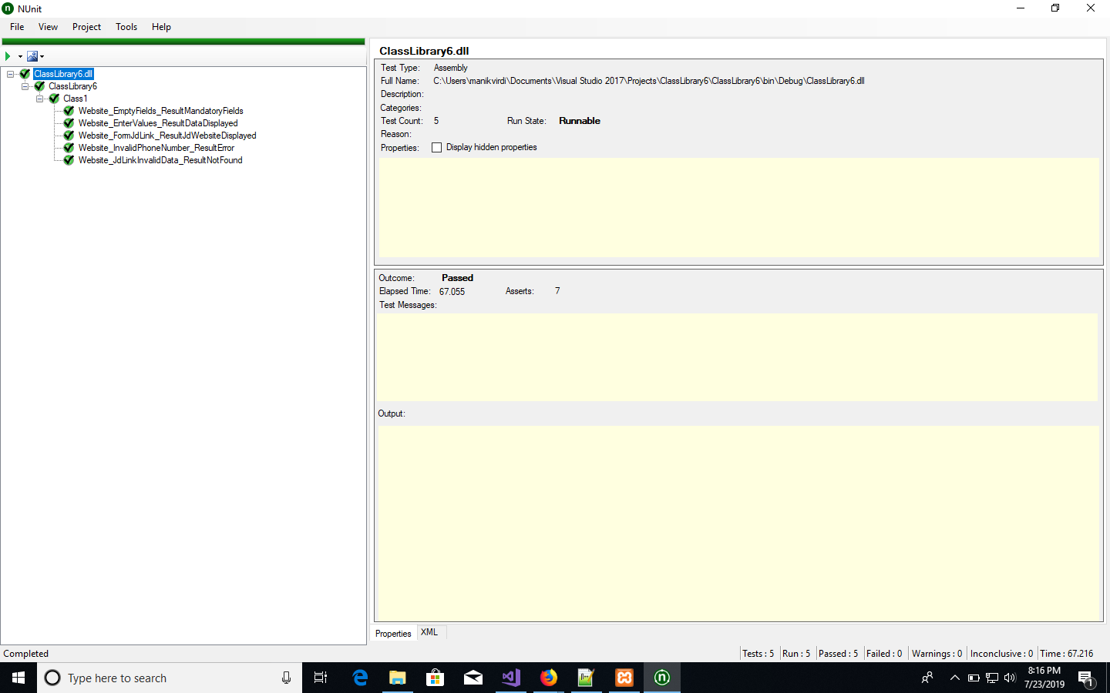

**# GitHub Commits**

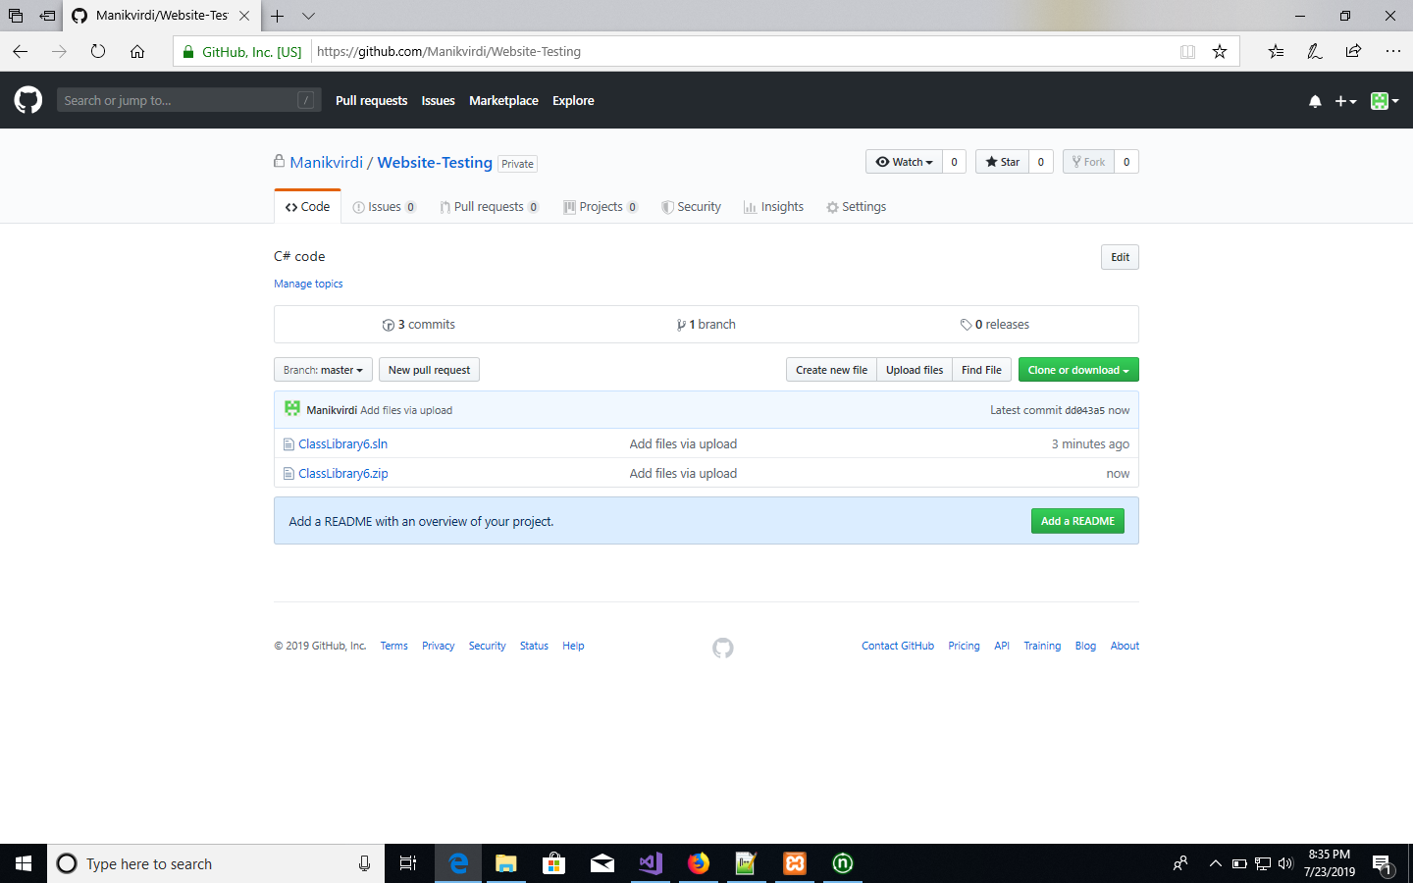

**#References**

1. <https://www.w3schools.com/howto/howto_css_contact_form.asp>
2. <https://www.w3schools.com/howto/tryit.asp?filename=tryhow_js_tabs>
3. <https://www.geeksforgeeks.org/form-validation-using-html-javascript/>
4. <https://www.w3schools.com/php/php_mysql_connect.asp>
5. <https://www.w3resource.com/javascript/form/email-validation.php>
6. <https://www.w3resource.com/javascript/form/phone-no-validation.php>
7. <https://www.w3schools.com/js/js_validation.asp>
8. <https://www.w3schools.com/tags/att_input_pattern.asp> (for Email)
9. <https://www.w3schools.com/php/php_mysql_select.asp>
10. <https://www.siteground.com/tutorials/php-mysql/display-table-data/>
11. <https://www.w3schools.com/sql/sql_orderby.asp>