**Instructions on working of the project**

**“Hair Salon”**

**Submitted To: Igor Pustylnick**

**Submitted By: Manik Virdi (8669256)**

**Jasleen Kaur (8664181)**

**Neema Joseph (8658021)**

**Sidharth Bhardwaj (8663146)**

**Instructions on how to use “Hair Salon” system?**

This document will describe the detailed explanation of the “Hair Salon” system: How the system will work, what are the functionalities and their validations, How the user will interact with the system and save the data of customers according to their different service requirements. Later on, Salon System can retrieve the saved data and search the customer’s data with “Age”.

**Working of the Project:**

1. The user will interact with the system by entering details. Watermarks are mentioned in the text boxes so that user can take hint on what to mention in the text field.
2. Firstly, the user will enter the name in the text box.
3. User will choose from the drop box, the type of the customer that is Woman, Man or Kids.
4. After selecting the required type of customer, new text box is shown in the main window which gives the following services as options: Man (Need Style beard?), Woman (Need Make-Up?) or Kids (Need Sensitive Trimming?).
5. User will enter the age.
6. Now, the user will choose what type of above-mentioned service is needed.
7. Amount will be entered according to the type of the service required.
8. User will enter the Phone Number in the specific Format. (e.g.234-234-2345) Phone Number cannot start from 1 or 0.
9. Next, the credit card details are entered.
10. After filling all the details, data can be saved by clicking on the “Save” button.
11. If there is any error, then it will show a pop-up window
12. When the user clicks on “Show” button, all the previous data is shown in the grid at the bottom of the window.
13. “Reset” button clears all the fields.
14. User can search the data by specifying the age and it will be displayed in sorted order.
15. All the data will be displayed in the data grid.
16. In the Grid, there is a column titled “Task” which shows what service has been provided. (e.g. Make Up Done)

**Clients:**

There are 3 types of clients with special services:

* Man (Need Style beard?)
* Woman (Need Make-Up?)
* Kids (Need Sensitive Trimming?)

**Validations:**

1. All the input fields are mandatory and cannot be null.
2. Age cannot be zero and above 90. If the age of the customer is between 50 and 90, then the text will turn in red color.
3. Credit Card value cannot be:

* Null.
* More than 16 digits.
* Cannot use special characters or alphabets (text will turn in red color).

1. Incorrect data will be in red color and it will not be saved.
2. Amount should be in the range of 0-10000
3. Phone Number should be in specific format (ANN-NNN-NNNN), the first digit cannot be 0 or 1 and other digits can be from 0-9, otherwise text will be in red color.
4. If the age is above 50, it is highlighted in red color in the grid.

**Events:**

1. Save: This event will save the data in XML file.
2. Show: This event will show the details of all the customers
3. Search by age: This event will search the customer by entering the specific age.
4. Reset: This event will reset all the text fields.

**Screenshot of Running Project:**

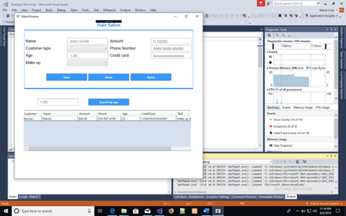

**Figure1: Data Entered with valid values**

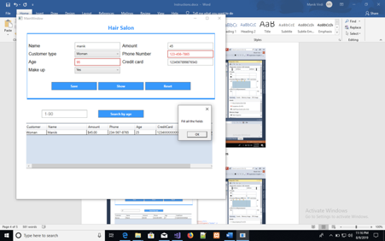

**Figure2: Data Entered with invalid values**

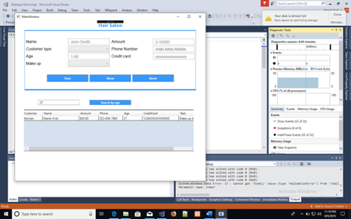

**Figure3: Data searched with “Age”**

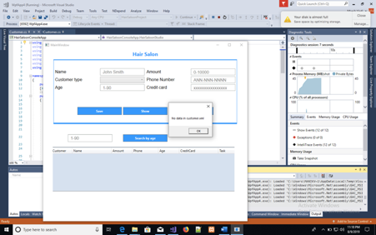

**Figure4: Showing text box with null value.**