Group Level Analyses

Manikya Alister

load(here("data/derived/model_comparison.Rdata"))  
load(here("data/clean/all_data_clean.Rdata"))  
data <- all_data[[1]] %>%  
 mutate(update = post_adjusted - pre_adjusted)   
  
d_independence <- data %>%   
 filter(consensus != "contested")  
  
d_consensus_only <- data %>%   
 filter(consensus != "dependent")

# Priors

# load claim info  
claim_info <- read.csv(here("data/derived/source_data.csv"))  
full_claims <- claim_info %>%  
 select(claimId, claim)  
  
# make darta set that include the full claim  
data$full_claim <- claim_info$claim[match(data$claim, claim_info$claimId)]  
  
# Make pretty -- make it so that each plot fill is part of a gradient  
colour_gradient = scales::seq_gradient_pal("blue", "seagreen" , "Lab") (seq(0,1,length.out=15))  
  
# Make figure (I know you might want to just use the code for the plot in the last paper but   
claim_types <- unique(data$claim_type)  
  
plot_list = NULL  
# here's my attempt at reproducing it! Still needs a few tweaks)  
for (i in 1:length(claim_types)){  
 ct <- claim_types[i]  
   
 plot_data <- data %>%  
 filter(claim_type == ct)   
   
 medians <- plot_data %>%  
 group_by(full_claim) %>%  
 summarise(median_prior = median(pre)) %>%  
 arrange(median_prior)  
   
 plot_data$full_claim <- factor(plot_data$full_claim, levels = medians$full_claim)  
   
 plot <- plot_data %>%  
 ggplot(aes(x = pre, y = full_claim))+  
 geom_density_ridges(aes(fill = full_claim), alpha = .3, scale = 1.5)+  
 scale_fill_manual(values = colour_gradient)+  
 scale_y_discrete(labels = label_wrap(70), position = "right")+  
 labs(title = ct, x = "Prior", y = "")+  
 xlim(0,100)+  
 theme_classic()+  
 theme(  
 plot.margin = unit(c(1.5, 0.5, 0.5, 0.5), "cm"),  
 legend.position = "none",  
 axis.text.y = element_text(size = 12, lineheight = 1.2) # Adjust the size as needed  
  
 )  
 plot_list[[i]] <- plot  
}  
  
# re order so that similar claim types are together  
plot_list <- plot_list[c(1,4,2,3)]  
  
ggarrange(plotlist = plot_list, nrow = 2, ncol = 2)

Picking joint bandwidth of 10

Picking joint bandwidth of 8.64

Picking joint bandwidth of 7.22

Picking joint bandwidth of 6.52

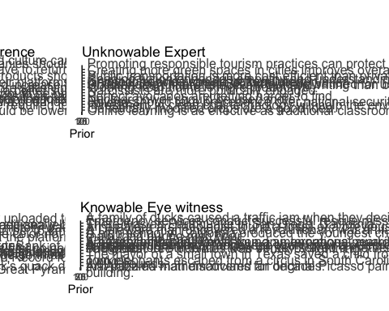

ggsave("07_Plots/priors.png", width = 20, height = 20)

# What are the average belief updates for each claim type?

### Independent v Dependent consensus

mean_updates <- data %>%  
 group_by(claim_type, consensus) %>%  
 summarise(mean_update = mean(update),  
 se_update = sd(update) / sqrt(n())  
)

`summarise()` has grouped output by 'claim_type'. You can override using the  
`.groups` argument.

colour_scale <- c("purple", "darkblue", "red")  
  
mean_updates %>%   
 ggplot(aes(x = claim_type, y = mean_update, fill = consensus)) +   
 geom_col(position = "dodge", colour = "black", size = 0.2, alpha = .6) +  
 geom_errorbar(aes(ymin = mean_update - se_update, ymax = mean_update + se_update),   
 position = position_dodge(.9), width = 0.2) +  
 geom_jitter(data = data, aes(x = claim_type, y = update, colour = consensus, group = consensus),   
 position = position_jitterdodge(dodge.width = .9, jitter.width = .2), alpha = 0.1) +  
 ylim(-30, 69) +  
 labs(title = "",  
 x = "Claim Type",  
 y = "Mean Update (Post - Prior)") +  
 theme_bw()+  
 theme(legend.position = "top") +  
 labs(colour = "Trial Type", fill = "Trial Type")+  
 scale_color_manual(values = colour_scale) + # Replace with your desired colors  
 scale_fill_manual(values = colour_scale) # Replace with your desired colors

Warning: Using `size` aesthetic for lines was deprecated in ggplot2 3.4.0.  
ℹ Please use `linewidth` instead.

Warning: Removed 186 rows containing missing values (`geom_point()`).

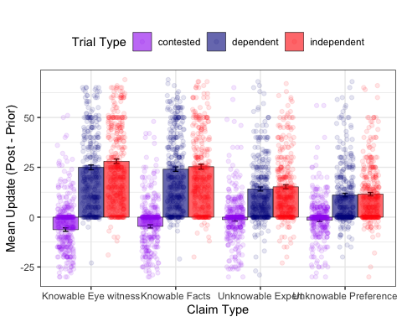

ggsave(filename = here("analyses/07_Plots/update-by-topic.png"), width = 6, height = 4)

Warning: Removed 186 rows containing missing values (`geom_point()`).

### Contested v Independent Consensus

mean_updates_co <- d_consensus_only %>%  
 group_by(claim_type, consensus) %>%  
 summarise(mean_update = mean(update),  
 se_update = sd(update) / sqrt(n()),  
 post = mean(post)  
)

`summarise()` has grouped output by 'claim_type'. You can override using the  
`.groups` argument.

mean_updates_co %>%   
 ggplot(aes(x = claim_type, y = mean_update, fill = consensus)) +   
 geom_col(position = "dodge", colour = "black", size = 0.2, alpha = .6) +  
 geom_errorbar(aes(ymin = mean_update - se_update, ymax = mean_update + se_update),   
 position = position_dodge(0.9), width = 0.2) +  
 geom_jitter(data = d_consensus_only, aes(x = claim_type, y = update, colour = consensus),   
 position = position_jitterdodge(), alpha = 0.2) +  
 ylim(-50, 100) +  
 labs(title = "",  
 x = "Claim Type",  
 y = "Mean Update (Post - Prior)") +  
 theme_classic()

Warning: Removed 18 rows containing missing values (`geom_point()`).

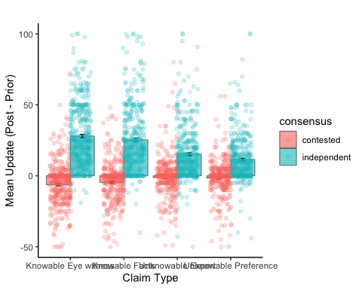

# What are the average deltas (independent - dependent) for each claim type?

deltas_claim_type <- d_independence %>%   
 filter(consensus != "contested") %>%  
 pivot_wider(names_from = consensus, values_from = update) %>%  
 group_by(claim_type) %>%  
 summarise(delta = mean(independent, na.rm = TRUE)-mean(dependent, na.rm = TRUE), post = mean(post))  
  
deltas_claim_type %>%   
 ggplot(aes(x = claim_type, y = delta))+  
 geom_col(fill = "seagreen")+  
 theme_classic()+  
 labs(x = "Claim Type", y = "Delta (Independent - Dependent)")

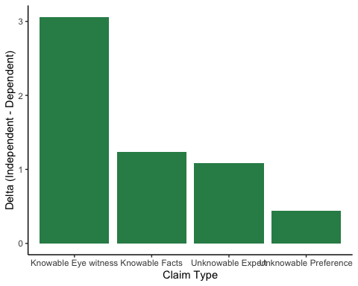

# Modelling

# load output   
load(here("data/derived/group_output_combined.Rdata"))

## Model Comparison

### Excluding contested condition (independent v dependent)

model_LOOICs %>%  
 filter(excluded_condition == "contested") %>%  
 mutate(model_rank = rank(all_looic),  
 all_looic = round(all_looic),  
 all_se = round(all_se))

model excluded_condition all_looic all_se model_rank  
1 group-prior contested 26952 103 4  
2 group-prior-consensus contested 26946 103 3  
3 group-prior-consensus-claim contested 26493 111 1  
4 group-prior-consensusXclaim contested 26496 111 2

### Excluding dependent condition (independent v contested)

model_LOOICs %>%  
 filter(excluded_condition == "dependent") %>%  
 mutate(model_rank = rank(all_looic),  
 all_looic = round(all_looic),  
 all_se = round(all_se))

model excluded_condition all_looic all_se model_rank  
1 group-prior dependent 27693 100 4  
2 group-prior-consensus dependent 26633 116 3  
3 group-prior-consensus-claim dependent 26565 117 2  
4 group-prior-consensusXclaim dependent 26335 121 1

## Estimates

### Excluding contested condition (independent v dependent)

load(here("analyses/02_output/group-prior-consensus-claim-rm-contested.Rdata"))  
  
getCredibleInt <- function(output, probs = c(0.055, 0.945), decimals = 3){ # default is 89% credible interval   
 posterior_sample <- as_draws_df(output)  
 # only include fixed effects  
 posterior_sample <- posterior_sample %>%  
 select(starts_with("b_"))  
 interval <- t(round(apply(posterior_sample, 2, function(x) quantile(x, probs = probs)),3))  
 colnames(interval) = c("Lower-CI", "Upper-CI")  
 interval  
}  
  
  
getParamDetails <- function(output){  
 intervals_89 <- getCredibleInt(output)  
 sum_output <- summary(output)  
 details <- cbind(round(sum_output$fixed[,"Estimate"],3), intervals_89)  
 colnames(details) <- c("Estimate", "Lower", "Upper")  
 details  
}  
  
getParamDetails(output)

Warning: Dropping 'draws_df' class as required metadata was removed.

Estimate Lower Upper  
b_Intercept 42.896 40.789 44.977  
b_pre_adjusted 0.666 0.648 0.684  
b_consensusindependent 1.678 0.725 2.620  
b_claim_typeKnowableFacts -2.706 -4.055 -1.329  
b_claim_typeUnknowableExpert -12.420 -13.816 -11.054  
b_claim_typeUnknowablePreference -15.898 -17.271 -14.512

# post hoc comparisons   
em <- emmeans(output, ~claim_type)  
summary(pairs(em), point.est = mean, level = .89)

contrast estimate lower.HPD upper.HPD  
 Knowable Eye witness - Knowable Facts 2.71 1.33 4.03  
 Knowable Eye witness - Unknowable Expert 12.42 11.02 13.77  
 Knowable Eye witness - Unknowable Preference 15.90 14.47 17.21  
 Knowable Facts - Unknowable Expert 9.71 8.29 11.06  
 Knowable Facts - Unknowable Preference 13.19 11.80 14.48  
 Unknowable Expert - Unknowable Preference 3.48 2.12 4.85  
  
Results are averaged over the levels of: consensus   
Point estimate displayed: mean   
HPD interval probability: 0.89

### Excluding dependent condition (independent v contested)

load(here("analyses/02_output/group-prior-consensusXclaim-rm-dependent.Rdata"))  
getParamDetails(output)

Warning: Dropping 'draws_df' class as required metadata was removed.

Estimate Lower Upper  
b_Intercept 9.541 7.817 11.263  
b_pre_adjusted 0.716 0.698 0.733  
b_consensusindependent 32.895 31.117 34.678  
b_claim_typeKnowableFacts 1.904 0.034 3.759  
b_claim_typeUnknowableExpert 6.404 4.585 8.206  
b_claim_typeUnknowablePreference 4.206 2.330 6.020  
b_consensusindependent:claim_typeKnowableFacts -4.648 -7.203 -2.058  
b_consensusindependent:claim_typeUnknowableExpert -18.784 -21.359 -16.173  
b_consensusindependent:claim_typeUnknowablePreference -21.488 -24.128 -18.802

# post hoc comparisons   
em <- emmeans(output, ~claim_type:consensus)  
summary(pairs(em), point.est = mean, level = .89)

contrast estimate  
 Knowable Eye witness contested - Knowable Facts contested -1.90  
 Knowable Eye witness contested - Unknowable Expert contested -6.40  
 Knowable Eye witness contested - Unknowable Preference contested -4.21  
 Knowable Eye witness contested - Knowable Eye witness independent -32.90  
 Knowable Eye witness contested - Knowable Facts independent -30.15  
 Knowable Eye witness contested - Unknowable Expert independent -20.51  
 Knowable Eye witness contested - Unknowable Preference independent -15.61  
 Knowable Facts contested - Unknowable Expert contested -4.50  
 Knowable Facts contested - Unknowable Preference contested -2.30  
 Knowable Facts contested - Knowable Eye witness independent -30.99  
 Knowable Facts contested - Knowable Facts independent -28.25  
 Knowable Facts contested - Unknowable Expert independent -18.61  
 Knowable Facts contested - Unknowable Preference independent -13.71  
 Unknowable Expert contested - Unknowable Preference contested 2.20  
 Unknowable Expert contested - Knowable Eye witness independent -26.49  
 Unknowable Expert contested - Knowable Facts independent -23.75  
 Unknowable Expert contested - Unknowable Expert independent -14.11  
 Unknowable Expert contested - Unknowable Preference independent -9.21  
 Unknowable Preference contested - Knowable Eye witness independent -28.69  
 Unknowable Preference contested - Knowable Facts independent -25.95  
 Unknowable Preference contested - Unknowable Expert independent -16.31  
 Unknowable Preference contested - Unknowable Preference independent -11.41  
 Knowable Eye witness independent - Knowable Facts independent 2.74  
 Knowable Eye witness independent - Unknowable Expert independent 12.38  
 Knowable Eye witness independent - Unknowable Preference independent 17.28  
 Knowable Facts independent - Unknowable Expert independent 9.64  
 Knowable Facts independent - Unknowable Preference independent 14.54  
 Unknowable Expert independent - Unknowable Preference independent 4.90  
 lower.HPD upper.HPD  
 -3.71 -0.0143  
 -8.10 -4.5202  
 -6.03 -2.3498  
 -34.63 -31.0764  
 -31.93 -28.2900  
 -22.40 -18.6755  
 -17.38 -13.7160  
 -6.41 -2.7632  
 -4.10 -0.3702  
 -32.82 -29.1070  
 -30.08 -26.3915  
 -20.46 -16.6782  
 -15.68 -11.9267  
 0.33 4.0595  
 -28.42 -24.7904  
 -25.65 -21.8483  
 -16.04 -12.2953  
 -11.09 -7.4396  
 -30.48 -26.9966  
 -27.79 -24.0970  
 -18.07 -14.2726  
 -13.32 -9.5231  
 0.93 4.5304  
 10.52 14.1399  
 15.46 19.1727  
 7.91 11.6290  
 12.73 16.4984  
 3.01 6.8053  
  
Point estimate displayed: mean   
HPD interval probability: 0.89

Initial thoughts. No group level effects of independence when looking at the estimate, but according to model comparison it’s still better than the null. No independence X claim type interaction despite hinting showing possible signs in the figures.

Looks like there’s an interaction between claim type X consensus, such that people are more convinced by a consensus generally under certain kinds of claims.