Exploratory Analyses

Ee Von Soh & Manikya Alister

2024-01-16

## What are the average belief updates for each source type

### Consensus as a function of source type

## Warning: Using `size` aesthetic for lines was deprecated in ggplot2 3.4.0.  
## ℹ Please use `linewidth` instead.  
## This warning is displayed once every 8 hours.  
## Call `lifecycle::last_lifecycle_warnings()` to see where this warning was  
## generated.

## Warning: Removed 186 rows containing missing values (`geom_point()`).

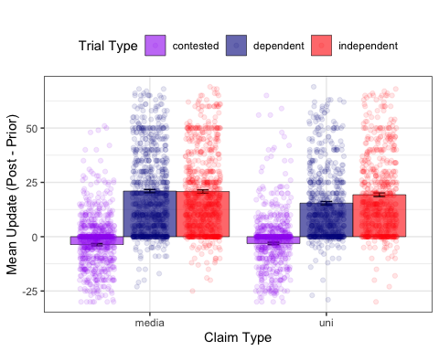

It looks like the effect of independence only appeared when the primary source was a university. When it was a news outlet, there did not appear to be any difference between independent and dependent sources at the group level. The standard consensus effect (contested v independent) did not appear to be influenced by source type.

### Consensus as a function of source type *and* claimi type

## Warning: Removed 186 rows containing missing values (`geom_point()`).

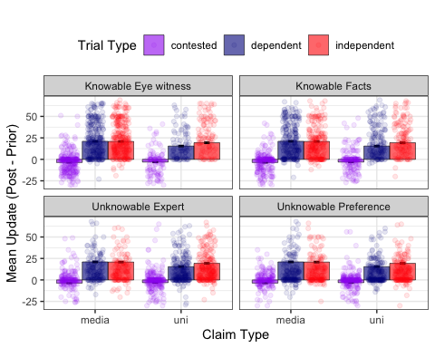 Across all claim types, it seems that the effect of source independence only occurred when the source was a university.

### Contested V Dependent Consensus

## Exploratory Data Analysis for Demographics

### Age

#### Statistics

#### Histogram - visualise age distribution

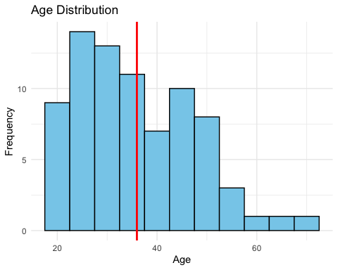

#### Probability Density Function

Skewed Distribution. Probably because the max age is 72.

### Gender

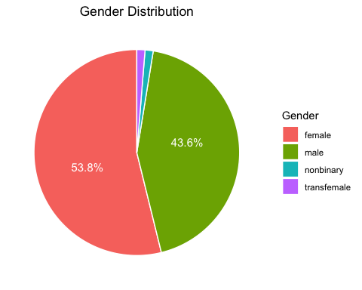

### Education

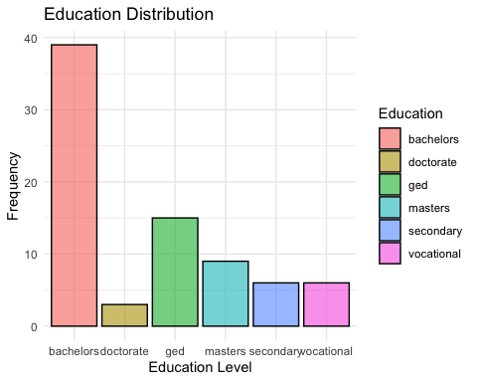

### Social Media Usage

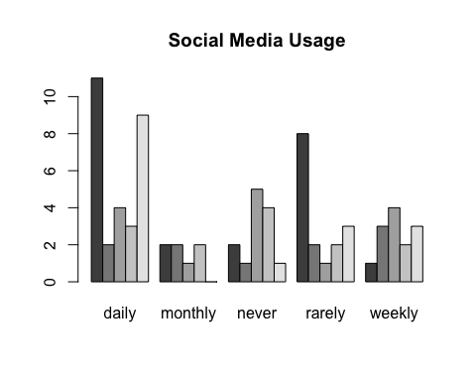

## Merge Data with Demographics Information

## # A tibble: 18 × 3  
## # Groups: consensus [3]  
## consensus demographics_education mean_update  
## <chr> <chr> <dbl>  
## 1 contested bachelors -3.13  
## 2 contested doctorate -5.08  
## 3 contested ged -4.37  
## 4 contested masters -2.42  
## 5 contested secondary -2.81  
## 6 contested vocational -4.31  
## 7 dependent bachelors 17.0   
## 8 dependent doctorate 15.7   
## 9 dependent ged 21.2   
## 10 dependent masters 22.8   
## 11 dependent secondary 14.7   
## 12 dependent vocational 20.5   
## 13 independent bachelors 19.4   
## 14 independent doctorate 13.6   
## 15 independent ged 23.4   
## 16 independent masters 22.5   
## 17 independent secondary 17.3   
## 18 independent vocational 19.3

### Functions for Plotting

### Education

## # A tibble: 18 × 4  
## # Groups: consensus [3]  
## consensus demographics_education mean_update n_obs  
## <chr> <chr> <dbl> <dbl>  
## 1 contested bachelors -3.13 13  
## 2 contested doctorate -5.08 1  
## 3 contested ged -4.37 5  
## 4 contested masters -2.42 3  
## 5 contested secondary -2.81 2  
## 6 contested vocational -4.31 2  
## 7 dependent bachelors 17.0 13  
## 8 dependent doctorate 15.7 1  
## 9 dependent ged 21.2 5  
## 10 dependent masters 22.8 3  
## 11 dependent secondary 14.7 2  
## 12 dependent vocational 20.5 2  
## 13 independent bachelors 19.4 13  
## 14 independent doctorate 13.6 1  
## 15 independent ged 23.4 5  
## 16 independent masters 22.5 3  
## 17 independent secondary 17.3 2  
## 18 independent vocational 19.3 2

#### Grouped Bar Plot with Jitters

#### With Label

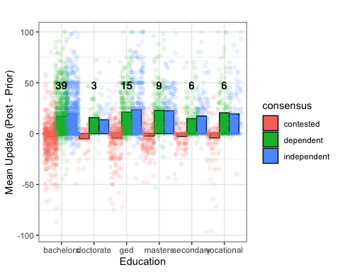

### Social Media Usage

#### Facebook

##### Basic Grouped Bar Plot

##### With Labels for total observations

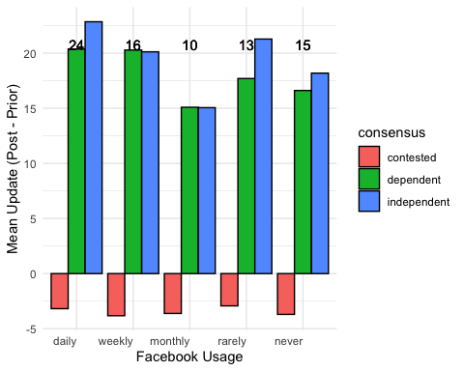

##### With Jittered Points

#### Twitter

##### Basic Grouped Bar Plot

##### With Labels

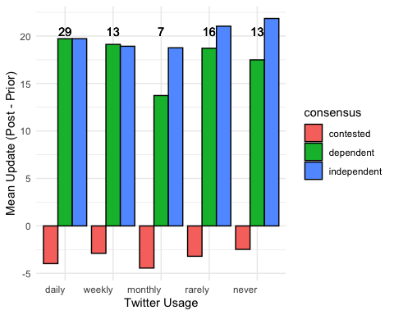

### Politics

#### Basic Grouped Bar Plot

#### With Labels

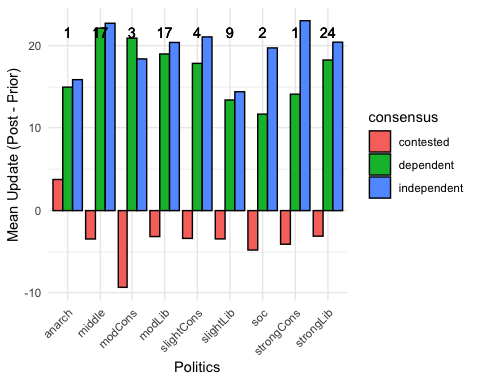

### What are the Average Deltas (independent - dependent) for each claim type

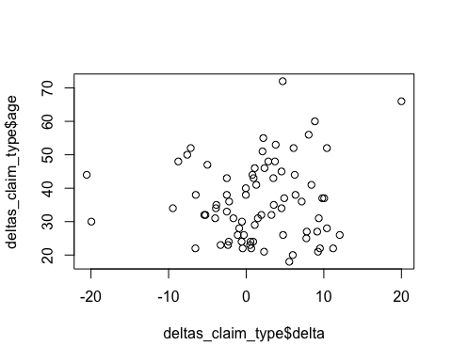

## [1] 0.08049964