Exploratory Analyses
Ee Von Soh & Manikya Alister
2024-01-16

What are the average belief updates for each source type

Consensus as a function of source type
## Warning: Using `size` aesthetic for lines was deprecated in ggplot2 3.4.0.
## ℹ Please use `linewidth` instead.
## This warning is displayed once every 8 hours.
## Call `lifecycle::last_lifecycle_warnings()` to see where this warning was
## generated.
## Warning: Removed 186 rows containing missing values (`geom_point()`).
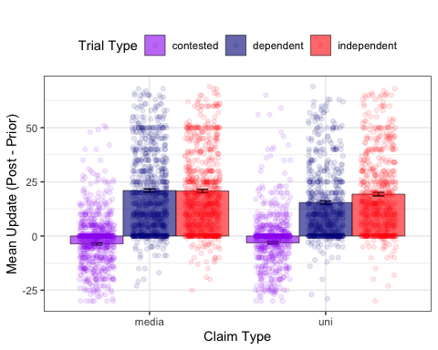
It looks like the effect of independence only appeared when the primary source was a university. When it was a news outlet, there did not appear to be any difference between independent and dependent sources at the group level. The standard consensus effect (contested v independent) did not appear to be influenced by source type.

Consensus as a function of source type and claimi type
## Warning: Removed 186 rows containing missing values (`geom_point()`).
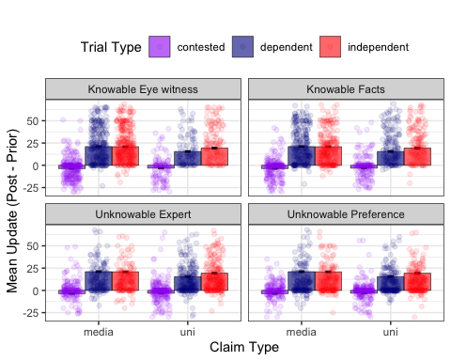 Across all claim types, it seems that the effect of source independence only occurred when the source was a university.

Contested V Dependent Consensus

Exploratory Data Analysis for Demographics

Age

Statistics

Histogram - visualise age distribution
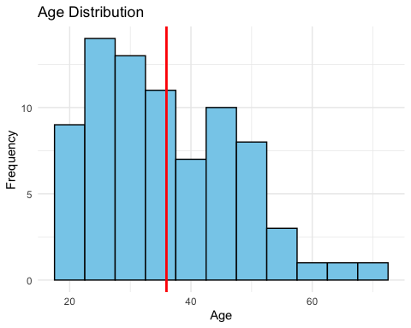

Probability Density Function
Skewed Distribution. Probably because the max age is 72.

Gender
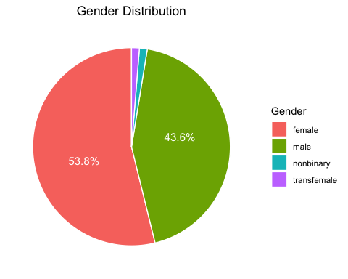

Education
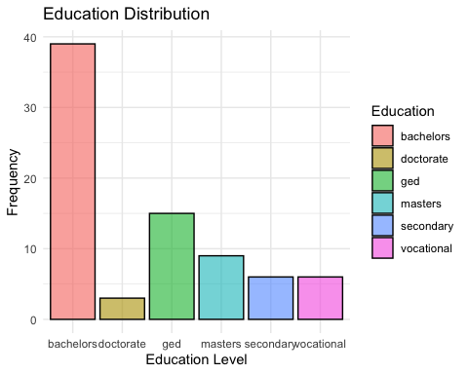

Social Media Usage
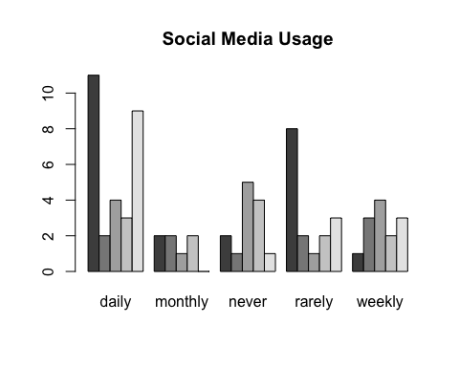

Merge Data with Demographics Information
## # A tibble: 18 × 3
## # Groups: consensus [3]
## consensus demographics_education mean_update
## <chr> <chr> <dbl>
## 1 contested bachelors -3.13
## 2 contested doctorate -5.08
## 3 contested ged -4.37
## 4 contested masters -2.42
## 5 contested secondary -2.81
## 6 contested vocational -4.31
## 7 dependent bachelors 17.0
## 8 dependent doctorate 15.7
## 9 dependent ged 21.2
## 10 dependent masters 22.8
## 11 dependent secondary 14.7
## 12 dependent vocational 20.5
## 13 independent bachelors 19.4
## 14 independent doctorate 13.6
## 15 independent ged 23.4
## 16 independent masters 22.5
## 17 independent secondary 17.3
## 18 independent vocational 19.3

Functions for Plotting

Education
## # A tibble: 18 × 4
## # Groups: consensus [3]
## consensus demographics_education mean_update n_obs
## <chr> <chr> <dbl> <dbl>
## 1 contested bachelors -3.13 13
## 2 contested doctorate -5.08 1
## 3 contested ged -4.37 5
## 4 contested masters -2.42 3
## 5 contested secondary -2.81 2
## 6 contested vocational -4.31 2
## 7 dependent bachelors 17.0 13
## 8 dependent doctorate 15.7 1
## 9 dependent ged 21.2 5
## 10 dependent masters 22.8 3
## 11 dependent secondary 14.7 2
## 12 dependent vocational 20.5 2
## 13 independent bachelors 19.4 13
## 14 independent doctorate 13.6 1
## 15 independent ged 23.4 5
## 16 independent masters 22.5 3
## 17 independent secondary 17.3 2
## 18 independent vocational 19.3 2

Grouped Bar Plot with Jitters

With Label
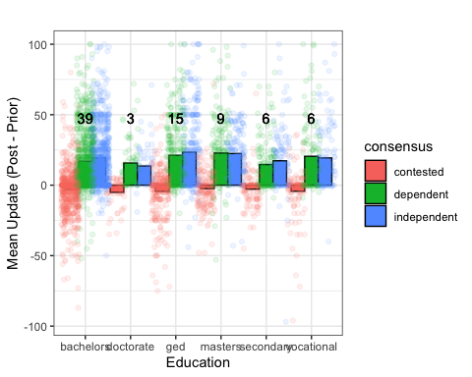

Social Media Usage

Facebook

Basic Grouped Bar Plot

With Labels for total observations
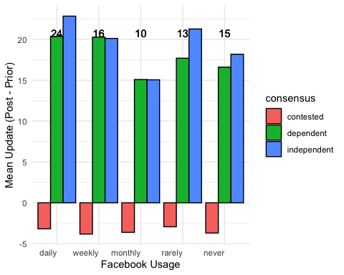

With Jittered Points

Twitter

Basic Grouped Bar Plot

With Labels
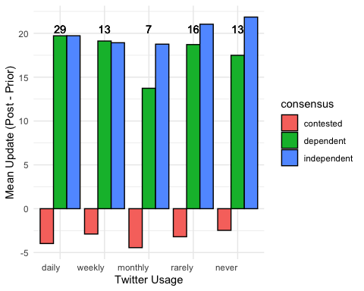

Politics

Basic Grouped Bar Plot

With Labels
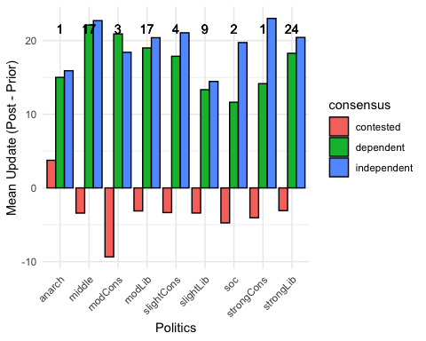

What are the Average Deltas (independent - dependent) for each claim type
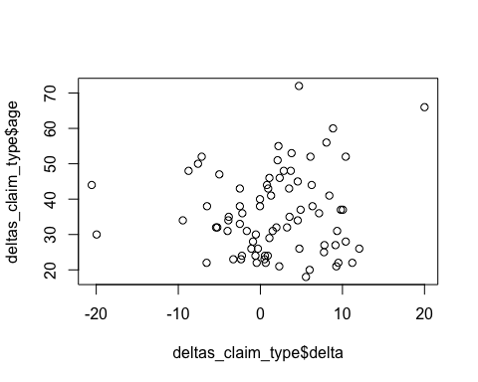
## [1] 0.08049964

