Group Level Analyses
Manikya Alister
load(here("data/derived/model_comparison.Rdata"))
load(here("data/clean/all_data_clean.Rdata"))
data <- all_data[[1]] %>%
mutate(update = post_adjusted - pre_adjusted)
d_independence <- data %>%
filter(consensus != "contested")
d_consensus_only <- data %>%
filter(consensus != "dependent")

Priors
# load claim info
claim_info <- read.csv(here("data/derived/source_data.csv"))
full_claims <- claim_info %>%
select(claimId, claim)
# make darta set that include the full claim
data$full_claim <- claim_info$claim[match(data$claim, claim_info$claimId)]
# Make pretty -- make it so that each plot fill is part of a gradient
colour_gradient = scales::seq_gradient_pal("blue", "seagreen" , "Lab") (seq(0,1,length.out=15))
# Make figure (I know you might want to just use the code for the plot in the last paper but
claim_types <- unique(data$claim_type)
plot_list = NULL
# here's my attempt at reproducing it! Still needs a few tweaks)
for (i in 1:length(claim_types)){
ct <- claim_types[i]
plot_data <- data %>%
filter(claim_type == ct)
medians <- plot_data %>%
group_by(full_claim) %>%
summarise(median_prior = median(pre)) %>%
arrange(median_prior)
plot_data$full_claim <- factor(plot_data$full_claim, levels = medians$full_claim)
plot <- plot_data %>%
ggplot(aes(x = pre, y = full_claim))+
geom_density_ridges(aes(fill = full_claim), alpha = .3, scale = 1.5)+
scale_fill_manual(values = colour_gradient)+
scale_y_discrete(labels = label_wrap(70), position = "right")+
labs(title = ct, x = "Prior", y = "")+
xlim(0,100)+
theme_classic()+
theme(
plot.margin = unit(c(1.5, 0.5, 0.5, 0.5), "cm"),
legend.position = "none",
axis.text.y = element_text(size = 12, lineheight = 1.2) # Adjust the size as needed
)
plot_list[[i]] <- plot
}
# re order so that similar claim types are together
plot_list <- plot_list[c(1,4,2,3)]
ggarrange(plotlist = plot_list, nrow = 2, ncol = 2)
Picking joint bandwidth of 10
Picking joint bandwidth of 8.64
Picking joint bandwidth of 7.22
Picking joint bandwidth of 6.52
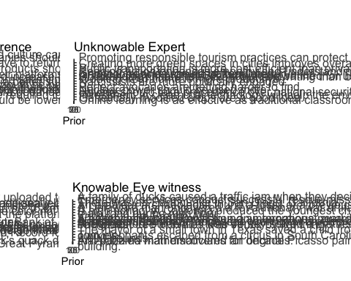
ggsave("07_Plots/priors.png", width = 20, height = 20)

What are the average belief updates for each claim type?

Independent v Dependent consensus
mean_updates <- d_independence %>%
group_by(claim_type, consensus) %>%
summarise(mean_update = mean(update),
se_update = sd(update) / sqrt(n())
)
`summarise()` has grouped output by 'claim_type'. You can override using the
`.groups` argument.
colour_scale <- c("purple", "darkblue", "red")
mean_updates %>%
ggplot(aes(x = claim_type, y = mean_update, fill = consensus)) +
geom_col(position = "dodge", colour = "black", size = 0.2, alpha = .6) +
geom_errorbar(aes(ymin = mean_update - se_update, ymax = mean_update + se_update),
position = position_dodge(.9), width = 0.2) +
geom_jitter(data = data, aes(x = claim_type, y = update, colour = consensus, group = consensus),
position = position_jitterdodge(dodge.width = .9, jitter.width = .2), alpha = 0.1) +
ylim(-30, 69) +
labs(title = "",
x = "Claim Type",
y = "Mean Update (Post - Prior)") +
theme_bw()+
theme(legend.position = "top") +
labs(colour = "Trial Type", fill = "Trial Type")+
scale_color_manual(values = colour_scale) + # Replace with your desired colors
scale_fill_manual(values = colour_scale) # Replace with your desired colors
Warning: Using `size` aesthetic for lines was deprecated in ggplot2 3.4.0.
ℹ Please use `linewidth` instead.
Warning: Removed 186 rows containing missing values (`geom_point()`).
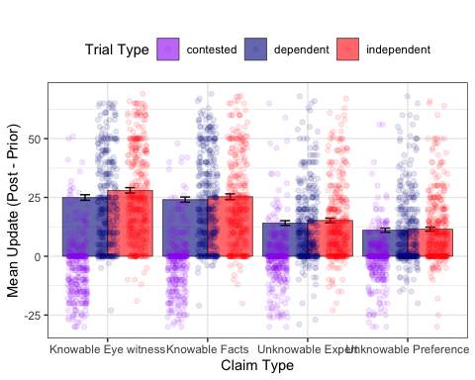
ggsave(filename = here("analyses/07_Plots/update-by-topic.png"), width = 6, height = 4)
Warning: Removed 186 rows containing missing values (`geom_point()`).

What are the average deltas (independent - dependent) for each claim type?
deltas_claim_type <- d_independence %>%
filter(consensus != "contested") %>%
pivot_wider(names_from = consensus, values_from = update) %>%
group_by(claim_type) %>%
summarise(delta = mean(independent, na.rm = TRUE)-mean(dependent, na.rm = TRUE), post = mean(post))
deltas_claim_type %>%
ggplot(aes(x = claim_type, y = delta))+
geom_col(fill = "seagreen")+
theme_classic()+
labs(x = "Claim Type", y = "Delta (Independent - Dependent)")
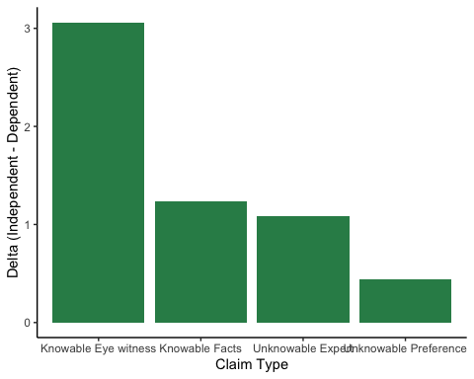

Modelling
# load output
load(here("data/derived/group_output_combined.Rdata"))

Model Comparison

Excluding contested condition (independent v dependent)
model_LOOICs %>%
filter(excluded_condition == "contested") %>%
mutate(model_rank = rank(all_looic),
all_looic = round(all_looic),
all_se = round(all_se))
model excluded_condition all_looic all_se model_rank
1 group-prior contested 26952 103 4
2 group-prior-consensus contested 26946 103 3
3 group-prior-consensus-claim contested 26493 111 1
4 group-prior-consensusXclaim contested 26496 111 2

Excluding dependent condition (independent v contested)
model_LOOICs %>%
filter(excluded_condition == "dependent") %>%
mutate(model_rank = rank(all_looic),
all_looic = round(all_looic),
all_se = round(all_se))
model excluded_condition all_looic all_se model_rank
1 group-prior dependent 27693 100 4
2 group-prior-consensus dependent 26633 116 3
3 group-prior-consensus-claim dependent 26565 117 2
4 group-prior-consensusXclaim dependent 26335 121 1

Estimates

Excluding contested condition (independent v dependent)
load(here("analyses/02_output/group-prior-consensus-claim-rm-contested.Rdata"))
getCredibleInt <- function(output, probs = c(0.055, 0.945), decimals = 3){ # default is 89% credible interval
posterior_sample <- as_draws_df(output)
# only include fixed effects
posterior_sample <- posterior_sample %>%
select(starts_with("b_"))
interval <- t(round(apply(posterior_sample, 2, function(x) quantile(x, probs = probs)),3))
colnames(interval) = c("Lower-CI", "Upper-CI")
interval
}
getParamDetails <- function(output){
intervals_89 <- getCredibleInt(output)
sum_output <- summary(output)
details <- cbind(round(sum_output$fixed[,"Estimate"],3), intervals_89)
colnames(details) <- c("Estimate", "Lower", "Upper")
details
}
getParamDetails(output)
Warning: Dropping 'draws_df' class as required metadata was removed.
Estimate Lower Upper
b_Intercept 42.896 40.789 44.977
b_pre_adjusted 0.666 0.648 0.684
b_consensusindependent 1.678 0.725 2.620
b_claim_typeKnowableFacts -2.706 -4.055 -1.329
b_claim_typeUnknowableExpert -12.420 -13.816 -11.054
b_claim_typeUnknowablePreference -15.898 -17.271 -14.512
# post hoc comparisons
em <- emmeans(output, ~claim_type)
summary(pairs(em), point.est = mean, level = .89)
contrast estimate lower.HPD upper.HPD
Knowable Eye witness - Knowable Facts 2.71 1.33 4.03
Knowable Eye witness - Unknowable Expert 12.42 11.02 13.77
Knowable Eye witness - Unknowable Preference 15.90 14.47 17.21
Knowable Facts - Unknowable Expert 9.71 8.29 11.06
Knowable Facts - Unknowable Preference 13.19 11.80 14.48
Unknowable Expert - Unknowable Preference 3.48 2.12 4.85
Results are averaged over the levels of: consensus
Point estimate displayed: mean
HPD interval probability: 0.89

Excluding dependent condition (independent v contested)
load(here("analyses/02_output/group-prior-consensusXclaim-rm-dependent.Rdata"))
summary(output)
Family: gaussian
Links: mu = identity; sigma = identity
Formula: post_adjusted ~ (1 | participant) + pre_adjusted + consensus * claim_type
Data: filtered_data (Number of observations: 3120)
Draws: 4 chains, each with iter = 2000; warmup = 1000; thin = 1;
total post-warmup draws = 4000
Group-Level Effects:
~participant (Number of levels: 78)
Estimate Est.Error l-95% CI u-95% CI Rhat Bulk_ESS Tail_ESS
sd(Intercept) 3.64 0.45 2.82 4.57 1.00 1830 2296
Population-Level Effects:
Estimate Est.Error l-95% CI
Intercept 9.54 1.09 7.45
pre_adjusted 0.72 0.01 0.69
consensusindependent 32.90 1.13 30.72
claim_typeKnowableFacts 1.90 1.16 -0.39
claim_typeUnknowableExpert 6.40 1.14 4.16
claim_typeUnknowablePreference 4.21 1.17 1.89
consensusindependent:claim_typeKnowableFacts -4.65 1.61 -7.78
consensusindependent:claim_typeUnknowableExpert -18.78 1.61 -21.85
consensusindependent:claim_typeUnknowablePreference -21.49 1.67 -24.70
u-95% CI Rhat Bulk_ESS
Intercept 11.66 1.00 3244
pre_adjusted 0.74 1.00 9252
consensusindependent 35.08 1.00 2728
claim_typeKnowableFacts 4.13 1.00 3725
claim_typeUnknowableExpert 8.60 1.00 3434
claim_typeUnknowablePreference 6.46 1.00 3643
consensusindependent:claim_typeKnowableFacts -1.46 1.00 3347
consensusindependent:claim_typeUnknowableExpert -15.60 1.00 3196
consensusindependent:claim_typeUnknowablePreference -18.21 1.00 3571
Tail_ESS
Intercept 3269
pre_adjusted 3020
consensusindependent 2952
claim_typeKnowableFacts 3012
claim_typeUnknowableExpert 2842
claim_typeUnknowablePreference 3533
consensusindependent:claim_typeKnowableFacts 3286
consensusindependent:claim_typeUnknowableExpert 3189
consensusindependent:claim_typeUnknowablePreference 3635
Family Specific Parameters:
Estimate Est.Error l-95% CI u-95% CI Rhat Bulk_ESS Tail_ESS
sigma 16.31 0.21 15.91 16.71 1.00 9689 2750
Draws were sampled using sampling(NUTS). For each parameter, Bulk_ESS
and Tail_ESS are effective sample size measures, and Rhat is the potential
scale reduction factor on split chains (at convergence, Rhat = 1).
getParamDetails(output)
Warning: Dropping 'draws_df' class as required metadata was removed.
Estimate Lower Upper
b_Intercept 9.541 7.817 11.263
b_pre_adjusted 0.716 0.698 0.733
b_consensusindependent 32.895 31.117 34.678
b_claim_typeKnowableFacts 1.904 0.034 3.759
b_claim_typeUnknowableExpert 6.404 4.585 8.206
b_claim_typeUnknowablePreference 4.206 2.330 6.020
b_consensusindependent:claim_typeKnowableFacts -4.648 -7.203 -2.058
b_consensusindependent:claim_typeUnknowableExpert -18.784 -21.359 -16.173
b_consensusindependent:claim_typeUnknowablePreference -21.488 -24.128 -18.802
# post hoc comparisons
em <- emmeans(output, ~claim_type:consensus)
summary(pairs(em), point.est = mean, level = .89)
contrast estimate
Knowable Eye witness contested - Knowable Facts contested -1.90
Knowable Eye witness contested - Unknowable Expert contested -6.40
Knowable Eye witness contested - Unknowable Preference contested -4.21
Knowable Eye witness contested - Knowable Eye witness independent -32.90
Knowable Eye witness contested - Knowable Facts independent -30.15
Knowable Eye witness contested - Unknowable Expert independent -20.51
Knowable Eye witness contested - Unknowable Preference independent -15.61
Knowable Facts contested - Unknowable Expert contested -4.50
Knowable Facts contested - Unknowable Preference contested -2.30
Knowable Facts contested - Knowable Eye witness independent -30.99
Knowable Facts contested - Knowable Facts independent -28.25
Knowable Facts contested - Unknowable Expert independent -18.61
Knowable Facts contested - Unknowable Preference independent -13.71
Unknowable Expert contested - Unknowable Preference contested 2.20
Unknowable Expert contested - Knowable Eye witness independent -26.49
Unknowable Expert contested - Knowable Facts independent -23.75
Unknowable Expert contested - Unknowable Expert independent -14.11
Unknowable Expert contested - Unknowable Preference independent -9.21
Unknowable Preference contested - Knowable Eye witness independent -28.69
Unknowable Preference contested - Knowable Facts independent -25.95
Unknowable Preference contested - Unknowable Expert independent -16.31
Unknowable Preference contested - Unknowable Preference independent -11.41
Knowable Eye witness independent - Knowable Facts independent 2.74
Knowable Eye witness independent - Unknowable Expert independent 12.38
Knowable Eye witness independent - Unknowable Preference independent 17.28
Knowable Facts independent - Unknowable Expert independent 9.64
Knowable Facts independent - Unknowable Preference independent 14.54
Unknowable Expert independent - Unknowable Preference independent 4.90
lower.HPD upper.HPD
-3.71 -0.0143
-8.10 -4.5202
-6.03 -2.3498
-34.63 -31.0764
-31.93 -28.2900
-22.40 -18.6755
-17.38 -13.7160
-6.41 -2.7632
-4.10 -0.3702
-32.82 -29.1070
-30.08 -26.3915
-20.46 -16.6782
-15.68 -11.9267
0.33 4.0595
-28.42 -24.7904
-25.65 -21.8483
-16.04 -12.2953
-11.09 -7.4396
-30.48 -26.9966
-27.79 -24.0970
-18.07 -14.2726
-13.32 -9.5231
0.93 4.5304
10.52 14.1399
15.46 19.1727
7.91 11.6290
12.73 16.4984
3.01 6.8053
Point estimate displayed: mean
HPD interval probability: 0.89
Initial thoughts. No group level effects of independence when looking at the estimate, but according to model comparison it’s still better than the null. No independence X claim type interaction despite hinting showing possible signs in the figures.
Looks like there’s an interaction between claim type X consensus, such that people are more convinced by a consensus generally under certain kinds of claims.

