Modelling the impact of increasing sources using Bayesian, non-linear (power function) regressions
Manikya Alister
Table of contents

In this document we rerun the same analyses in evaluate-brms-modelling.qmd but without excluding any participants. Look at the original document for more details about the analyses.

Experiment 1

Results

Non-linear Bayesian Modelling

Model Fit
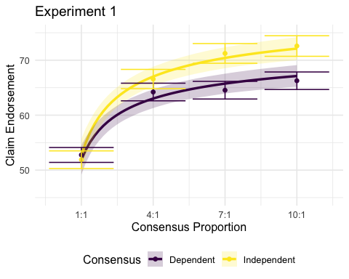
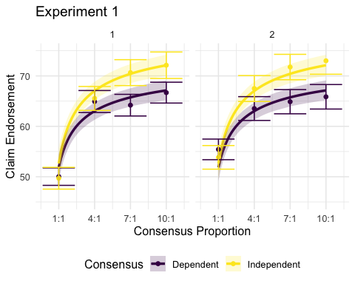

Model Comparison
Table 1: Model comparison statistics for Experiment 1. Models are ranked by Leave-One-Out Information Criterion (LOOIC), with lower values indicating better predictive performance. SE = standard error of LOOIC. ΔELPD = difference in expected log pointwise predictive density from the best-fitting model, with values closer to zero indicating similar performance. SE(ΔELPD) = standard error of the difference in ELPD. Weight = relative probability of each model relative to the other models, caluclated using pseudo Bayesian model avereging. Models varying only the rate and increase parameters by consensus showed the best predictive performance.
Model | Rank | LOOIC | SE | ΔELPD | SE(ΔELPD) | Weight
Rate + Increase | 1 | 9800.55 | 56.14 | 0.00 | 0.00 | 0.30
Increase | 2 | 9800.6 | 56.09 | -0.02 | 0.12 | 0.29
Full Model | 3 | 9802.52 | 56.20 | -0.98 | 0.59 | 0.11
Start + Increase | 4 | 9802.54 | 56.20 | -0.99 | 0.62 | 0.11
Start + Rate | 5 | 9804.53 | 55.89 | -1.99 | 1.36 | 0.05
Rate | 6 | 9805.14 | 55.21 | -2.29 | 1.76 | 0.07
Start | 7 | 9805.27 | 55.84 | -2.36 | 1.71 | 0.05
Null | 8 | 9814.26 | 54.04 | -6.86 | 3.57 | 0.02
Table 2: Parameter estimates of the best performing model in Experument 1: the Increase model, in which the Increase parameter is the only parameter that can vary across consensus independence conditions. This change across conditions is operationalised by estimating Increase for the baseline condition (the Dependent condition), then estimating the change in that paremter in the independent condition.
Parameters | Estimate | l-95% CI | u-95% CI
Start | 52.64 | 50.41 | 54.81
Increase_{Dependent} | 22.12 | 17.38 | 28.17
Increase_{Independent} | 28.87 | 22.69 | 36.77
Rate_{Dependent} | 0.49 | 0.37 | 0.66
Rate_{Independent} | 0.53 | 0.39 | 0.71

Experiment 2

Results

Non-linear Bayesian Modelling

Model Fit
As per Figure X, the model provides a good fit for all three consensus independence conditions.
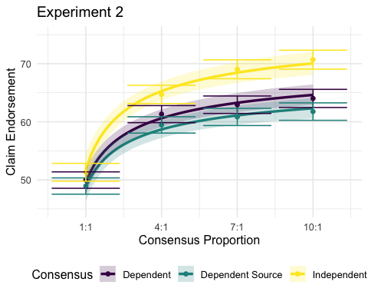
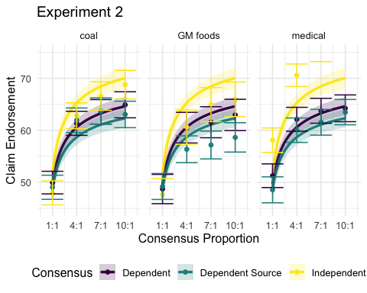

Model Comparison
Table 3: Model comparison using LOOIC (lower LOOIC = better performance).
Model | Rank | LOOIC | SE | ΔELPD | SE(ΔELPD) | Weight
Start + Increase | 1 | 21530.3 | 78.06 | 0.00 | 0.00 | 0.17
Full Model | 2 | 21530.46 | 78.07 | -0.08 | 0.10 | 0.16
Increase | 3 | 21530.74 | 78.02 | -0.22 | 2.25 | 0.21
Rate + Increase | 4 | 21530.85 | 77.96 | -0.28 | 2.22 | 0.19
Start + Rate | 5 | 21532.08 | 77.94 | -0.89 | 1.10 | 0.12
Start | 6 | 21533.45 | 77.85 | -1.58 | 1.71 | 0.11
Rate | 7 | 21536.97 | 77.60 | -3.34 | 3.19 | 0.03
Null | 8 | 21578.96 | 76.18 | -24.33 | 7.47 | 0.00
Parameters | Estimate | l-95% CI | u-95% CI
Start | 50.26 | 48.64 | 51.96
Increase_{Dependent} | 22.35 | 17.97 | 27.95
Increase_{Dependent Source} | 17.24 | 13.87 | 21.57
Increase_{Independent} | 31.21 | 25.10 | 39.04
Rate | 0.50 | 0.37 | 0.65
Table 4: Experiment 2 Model comparison using LOOIC (lower LOOIC = better performance), comparing Independent vs. Dependent (excluding Dependent Source)
Model | Rank | LOOIC | SE | ΔELPD | SE(ΔELPD) | Weight
Increase | 1 | 17013.47 | 66.28 | 0.00 | 0.00 | 0.27
Rate + Increase | 2 | 17013.95 | 66.34 | -0.24 | 0.13 | 0.21
Full Model | 3 | 17014.85 | 66.44 | -0.69 | 1.13 | 0.13
Start + Increase | 4 | 17015.01 | 66.40 | -0.77 | 1.11 | 0.12
Start + Rate | 5 | 17016.01 | 66.31 | -1.27 | 1.74 | 0.10
Start | 6 | 17016.6 | 66.31 | -1.57 | 2.00 | 0.09
Rate | 7 | 17018.64 | 66.05 | -2.59 | 1.74 | 0.06
Null | 8 | 17030.73 | 65.45 | -8.63 | 3.80 | 0.01
Table 5: Parameter estimates of the best performing model in Experument 2 comparing Independent vs. Dependent Consensys: the Increase model, in which the Increase parameter is the only parameter that can vary across consensus independence conditions.
Parameters | Estimate | l-95% CI | u-95% CI
Start | 50.38 | 48.43 | 52.36
Increase_{Dependent} | 21.45 | 17.14 | 26.65
Increase_{Independent} | 29.19 | 23.32 | 36.27
Rate | 0.49 | 0.38 | 0.65
Table 6: Experiment 2 Model comparison using LOOIC (lower LOOIC = better performance), comparing Dependent vs. Dependent Source (excluding Independent)
Model | Rank | LOOIC | SE | ΔELPD | SE(ΔELPD) | Weight
Increase | 1 | 17487.67 | 67.39 | 0.00 | 0.00 | 0.16
Rate + Increase | 2 | 17487.94 | 67.49 | -0.13 | 0.08 | 0.14
Start | 3 | 17488.04 | 67.43 | -0.18 | 0.85 | 0.14
Rate | 4 | 17488.14 | 67.45 | -0.24 | 0.70 | 0.13
Start + Rate | 5 | 17488.53 | 67.44 | -0.43 | 0.79 | 0.11
Full Model | 6 | 17488.81 | 67.44 | -0.57 | 0.59 | 0.09
Start + Increase | 7 | 17488.89 | 67.43 | -0.61 | 0.60 | 0.09
Null | 8 | 17489.13 | 67.38 | -0.73 | 1.49 | 0.13
Table 7: Parameter estimates of the best performing model in Experiment 2 comparing Dependent vs. Dependent Source: the Start model, in which the Start parameter is the only parameter that can vary across consensus conditions.
Parameters | Estimate | l-95% CI | u-95% CI
Start_{Dependent} | 50.37 | 48.30 | 52.58
Start_{Dependent Source} | 48.58 | 46.59 | 50.71
Increase | 20.39 | 16.27 | 25.59
Rate | 0.49 | 0.37 | 0.66

