**Assignment 1: Storage Account**

## ****Question 1:****

# Create a ADLS storage account with the name: yourname+yourdob+adls

# 2. While making ensure it is in the resource group name: - Azurelib-Academy and the region is US-east.

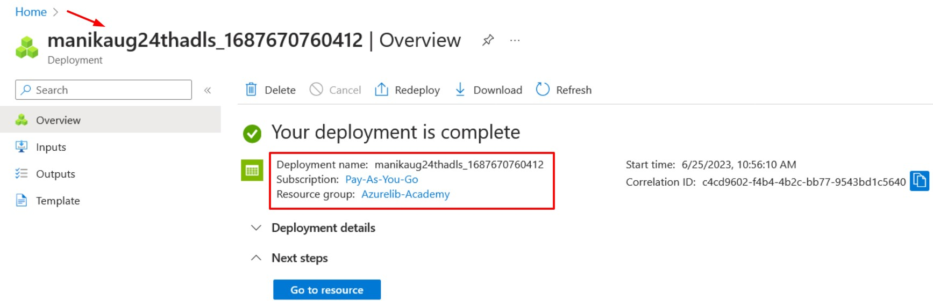

# 3. Try to change the soft delete time for 7 days to 10 days.

# 4. Create a container name ****landing**** (publicly accessible)

# 5. Create another container name ****raw**** private (publicly not accessible)

# 6. Create a directory Practice-1 in both container

# 7. Upload any text file in both container inside the Practice-1.

# 8. Delete the file just uploaded

# 9. Try to restore the deleted file.

## ****Question 2:****

# Create a Blob storage account with the name: yourname+yourdob+stg

# While making ensure it is in the resource group name: - Azurelib-Academy and the region is US-east

# Try to enable versioning.

# Create a container name ****landing**** (publicly accessible)

# Upload any text file in container created recently.

# Upload one more text file with giving folder path in azure blob storage account.

# Try to delete the folder and check if you are allowed to delete.

Directory cannot be allowed to delete.

# 8. Now try to delete the file directly without deleting the folder and check if folder also get deleted.

If we delete the blob file, which is inside the folder/ directory then directory will get deleted automatically.

