TECHNICAL REPORT - AI-BASED TRAFFIC SIGNAL CONTROLLER USING VLSI
Author: MANIKYAM MEDIDA | Domain: VLSI | Program: Elevance Skills internship
Figures are referenced from the repository folders docs/diagrams/ and sim/Screenshots/.

1. Project Overview
The project extends the Elevance Skills training traffic controller (single road, one timer, three fixed density levels) into a two-junction system: two reusable 4-way junction controllers, a shared fair pedestrian arbiter, one emergency input, a green-wave link between the junctions and adaptive green timing. Goals: genuine parameterization, safety (non-zero All-Red, bounded emergency response), fairness (no pedestrian starvation) and self-checking verification. Scope is RTL design and simulation in ModelSim.

2. Architecture
Modules: amtgc_top (integration), junction_controller x2 (each owns a generic_timer), ped_arbiter, one extra generic_timer for the green-wave offset.
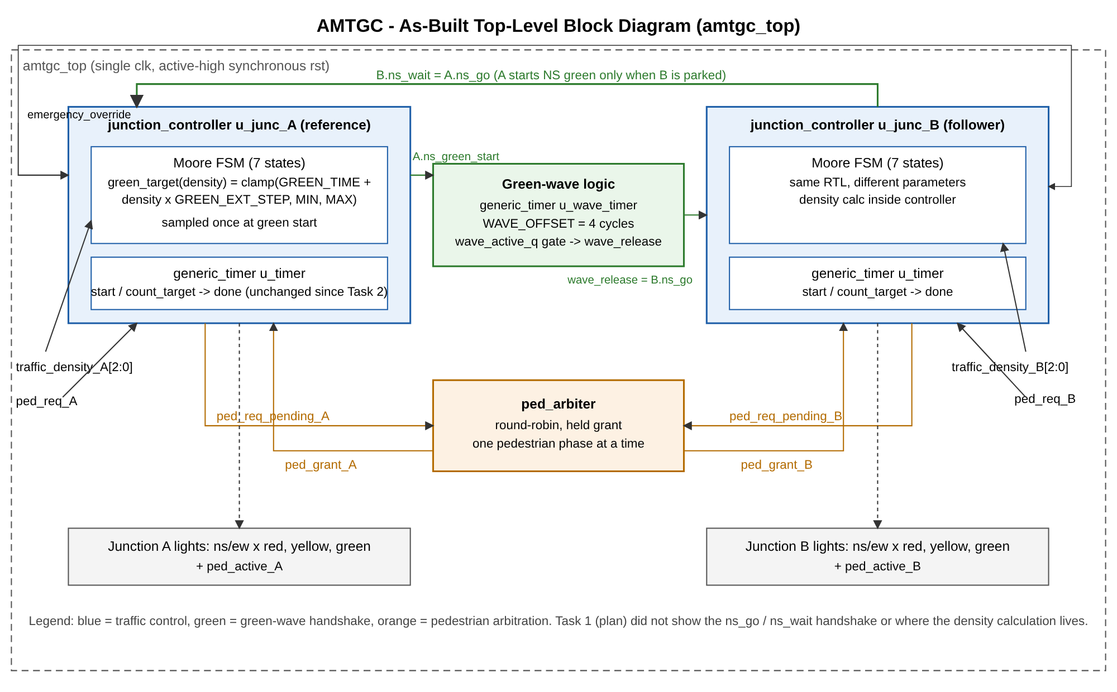Figure 1: as-built block diagram
Why separate modules: the timer is traffic-agnostic and reused four times (two junctions, wave offset, tests); the controller is reused for both junctions with different parameters; the arbiter is the only place that knows about both junctions' pedestrian requests.
Why one shared arbiter: a single point of decision gives a defined fairness policy and avoids duplicate logic; it only sees request/grant, so it depends on no junction internals.
Clock/reset: single clock domain, active-high synchronous reset. Rationale: one clock already required, deterministic behaviour in simulation, and emergency (a synchronous input) never conflicts with reset because it is not implemented through reset.
Design changes since the Task 1 plan (honest list): green wave implemented as a handshake (ns_go/ns_wait, NS_WAIT state) instead of passive logic, because independent junctions with different cycle lengths cannot hold a constant offset; phase-length compensation for timer latency; hidden request during the pedestrian phase.

3. RTL Design
- generic_timer: start loads the target and clears the counter; done is a one-cycle pulse (target+1) cycles after the start request; count_target = 0 completes on the next cycle; reset clears all state. Not modified after Task 2.
- junction_controller: parameters GREEN_TIME, GREEN_EXT_STEP, MIN_GREEN_TIME, MAX_GREEN_TIME, YELLOW_TIME, RED_TIME, PED_TIME, COUNTER_WIDTH, DENSITY_WIDTH. Timer is restarted on every state change; target = TIME - TIMER_LATENCY so each phase lasts exactly TIME cycles.
- Adaptive green: computed in the controller (function green_target) from density sampled in the cycle the green is requested; the timer latches the target at start, so later density changes cannot affect the running phase. Computation sits in the controller because it is traffic policy; the timer must stay generic.
- Pedestrian: rising-edge request, latched, serviced only at an All-Red boundary with the arbiter's grant; the request is hidden from the arbiter during the pedestrian phase.
- ped_arbiter: held grant; contested decisions alternate (pointer moves only on contested decisions).
- Coding rules satisfied: named ports, defaults in all cases, defined reset values, non-blocking sequential assignments, no magic numbers in FSM logic, parameter sanity checks.

4. FSM Design
States: NS_GREEN, NS_YELLOW, ALL_RED, EW_GREEN, EW_YELLOW, PED_PHASE, NS_WAIT.
Moore outputs - Normal order: NS_GREEN -> NS_YELLOW -> ALL_RED -> EW_GREEN -> EW_YELLOW -> ALL_RED -> (NS_WAIT) -> NS_GREEN.
Emergency forces ALL_RED from any state; recovery completes a full RED_TIME interval then restarts through NS_GREEN (gated by the wave logic). 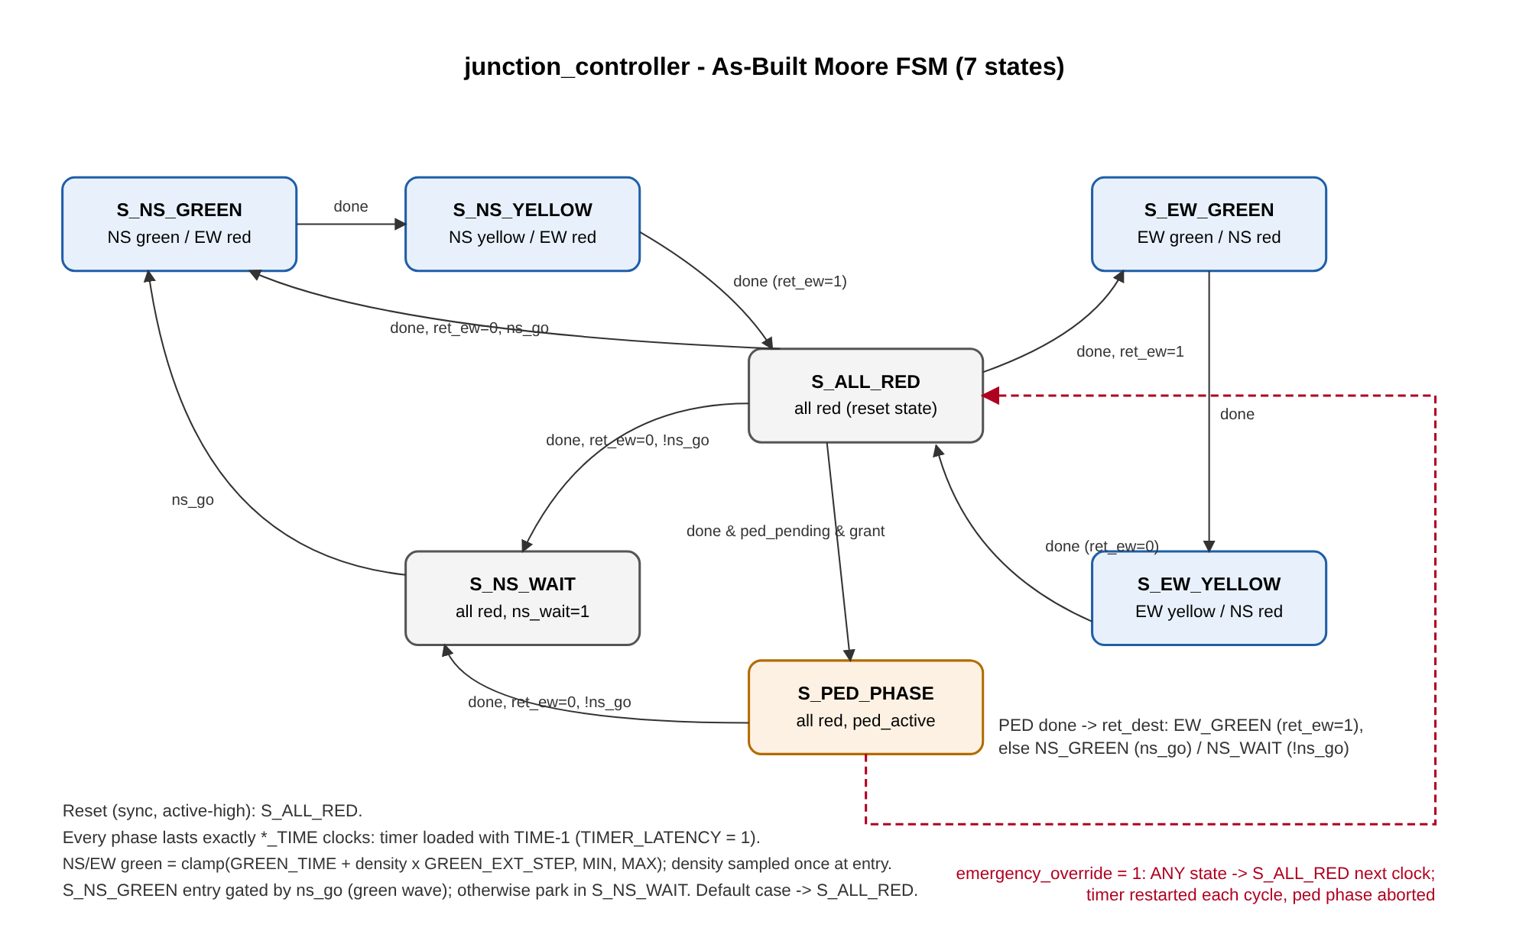 Figure 2: junction_controller state diagram.

5. Verification Methodology
Layers: standalone timer bench (3 widths, zero target, reset while counting); standalone controller bench (two instances with different parameters, floor/cap, pedestrian retention, emergency sweep, reset); system bench; unified Task 5 bench. Self-checking via junction_monitor (exact phase lengths, one-hot lights, no conflicting greens, phase order, All-Red one clock after emergency/reset, safe restart through NS), green-wave scoreboard (measured on every B start), arbiter checks (alternation, mutual exclusion), pedestrian starvation watchdog and emergency-phase coverage bins.
Random run: 20000 cycles (density every cycle, pedestrian ~1/20, emergency ~1/150, reset ~1/3000); justification in the testbench header. Mutation tests demonstrate the checks can fail.
Evidence:
- sim/logs/task5_full_verification.log,
- sim/logs/task5_mutation_tests.log,
- docs/Task5_Coverage_Statement.md,
- docs/RTL_CHECKSUMS.txt.

6. Simulation Results
- Timer: 12/12 checks pass in the Task 5 run (3 widths x 4 tests) (Figure 3).
- Unified bench: 20/20 plan scenarios and 9 extras covered (29/29); 835 green-wave measurements all exactly 4 cycles; 120 simultaneous requests alternate 30/30; A served 684 and B 657 pedestrian phases overall; run length 242175 ns.
- Density sweep (system bench), green cycles per density 0..7: junction A (base 4, step 2, min 3, max 12): 4, 6, 8, 10, 12, 12, 12, 12; junction B (base 2, step 1, min 3, max 8): 3, 3, 4, 5, 6, 7, 8, 8. Green rises with density, B is raised to its floor at density 0..1, both saturate at the cap (Figure 7).
- Green-wave offset: cursors at 75000 ps and 115000 ps give 40000 ps = 4 cycles (Figure 4b).
- Mutations (each applied, run, restored; restored RTL passes):
# | Mutation | Failure message | Time
1 | All-Red skipped | [A] SAFETY: conflicting green without All-Red gap | 145 ns
2 | Emergency disabled | [A] EMERGENCY/RESET: not All-Red one clock after assertion | 17365 ns
3 | Fixed-priority arbiter | ARBITER FAIRNESS FAIL: same junction won contested rounds 0 and 1 | 1515 ns
4 | Min-green clamp removed | [B] NS_GREEN duration FAIL: expected 3 cycles, observed 2 | 145 ns
Figures
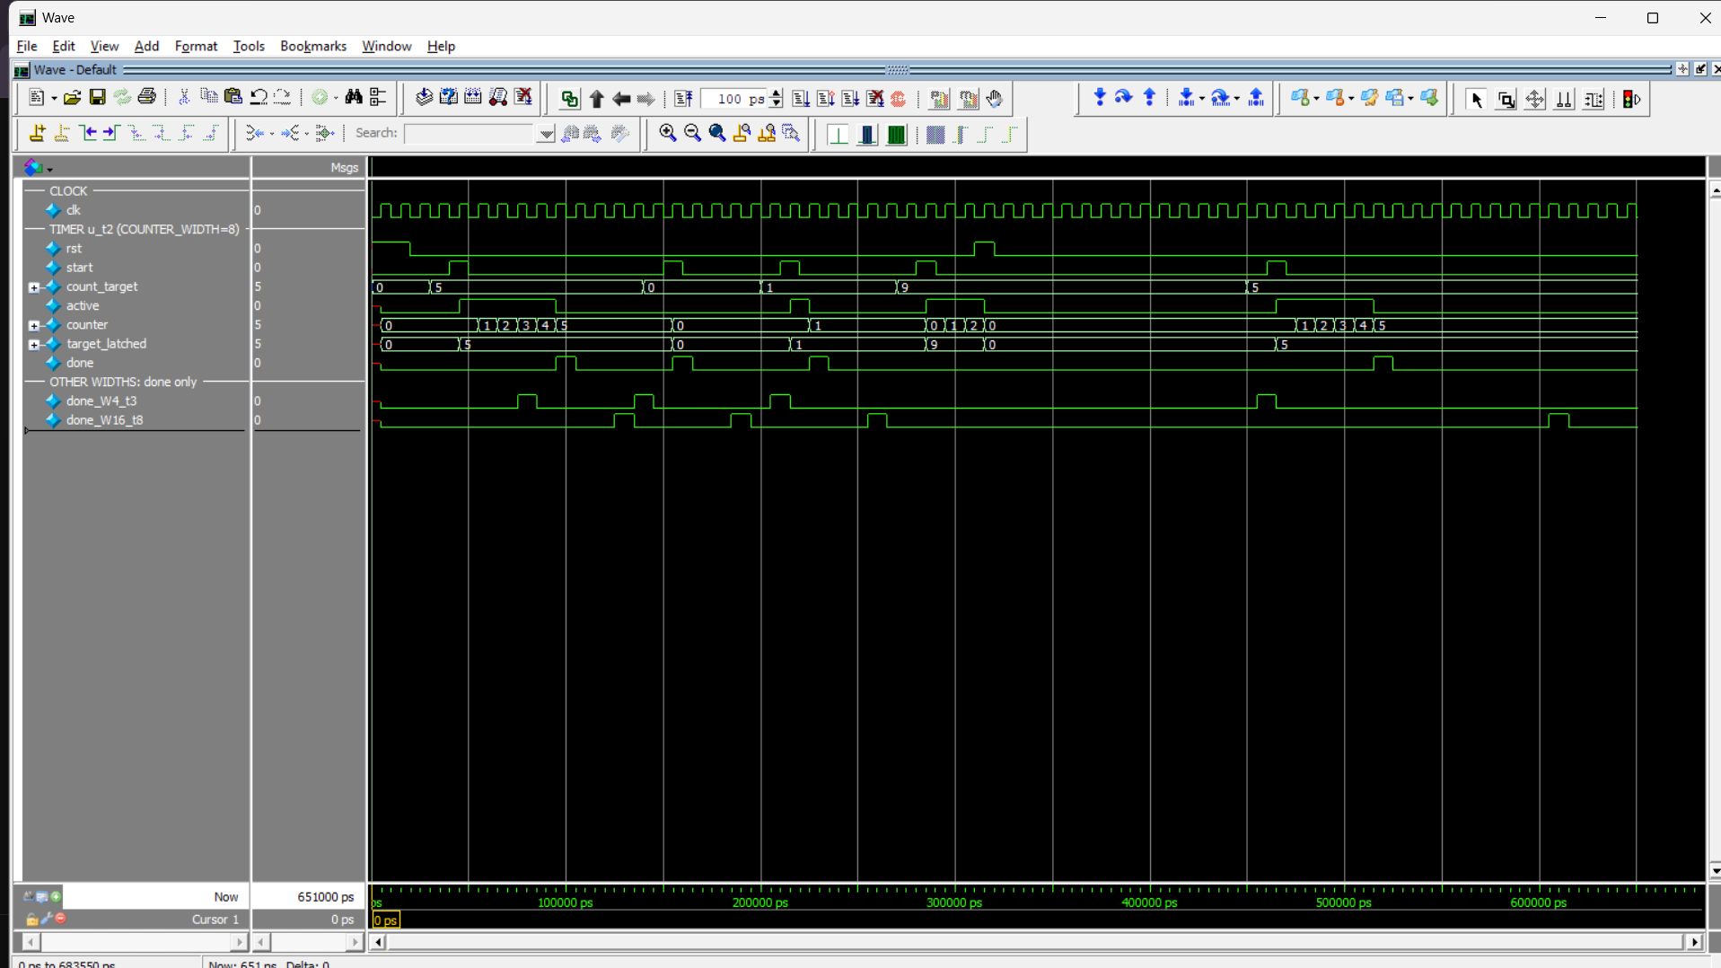Figure 3: generic_timer waveform (Task 2).
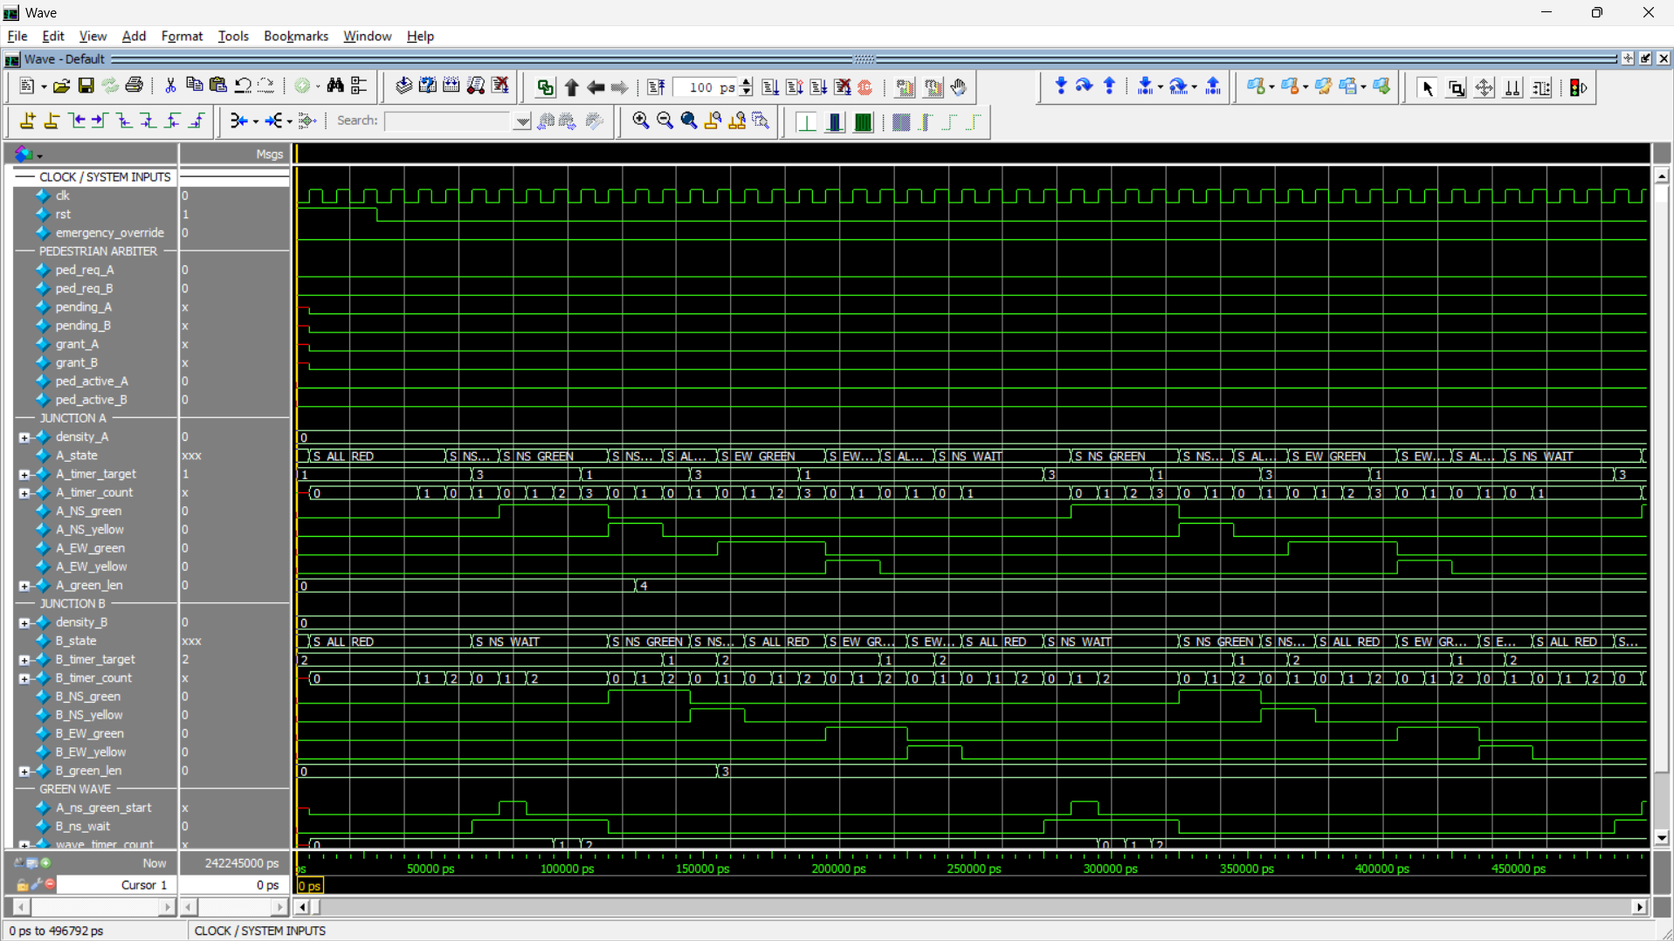Figure 4: normal two-junction operation (Task 5).
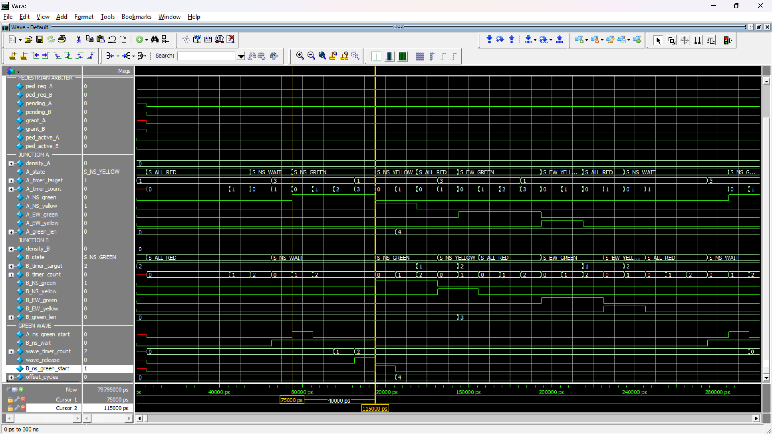Figure 4b: green-wave offset, 40000 ps = 4 cycles (Task 3).
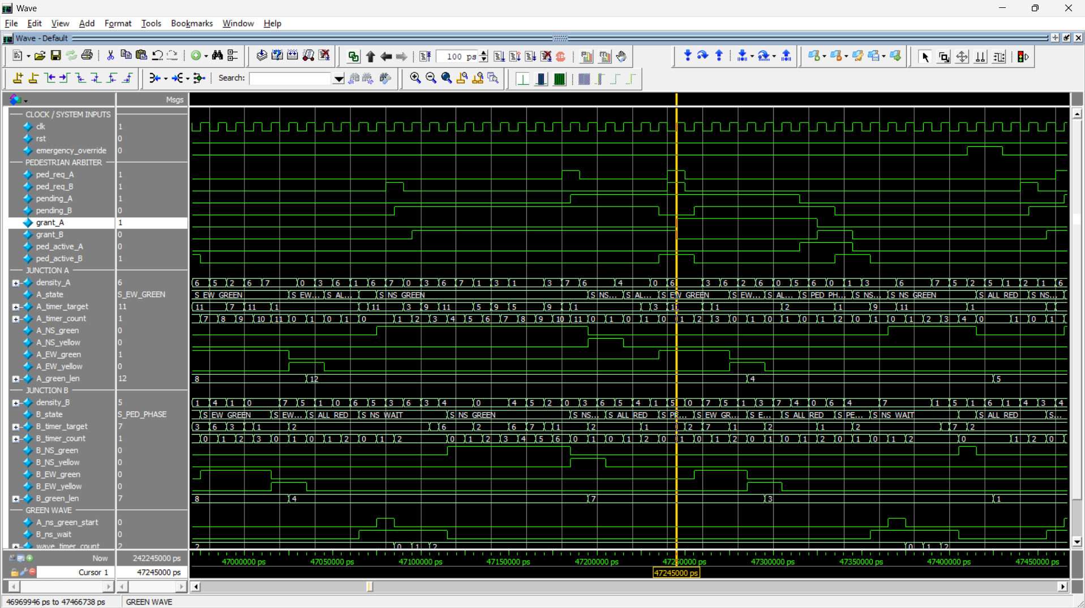Figure 5: pedestrian arbitration alternating between A and B.
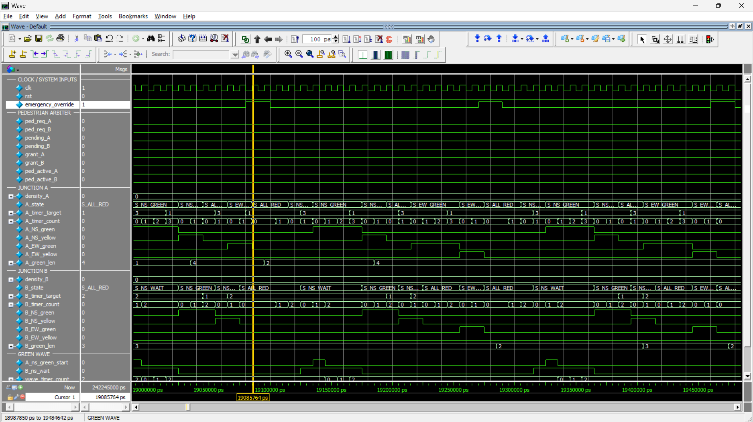Figure 6: emergency override forces All-Red.
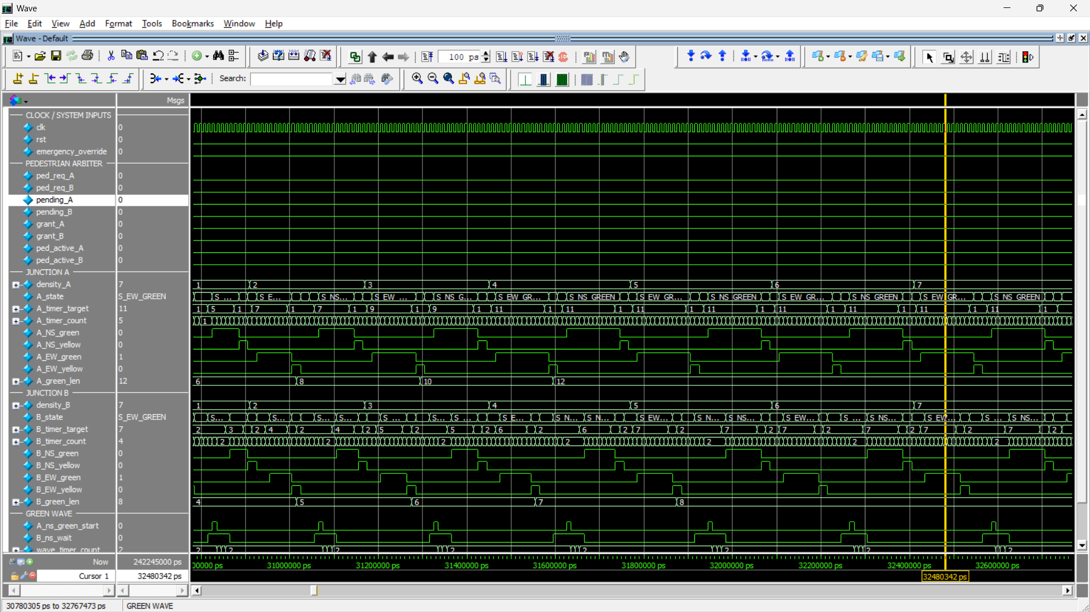Figure 7: adaptive green at maximum density (A 12, B 8 cycles).

7. Challenges Faced (BUG_LOG.md)
- Green wave cannot be passive: found while reviewing the controller; fixed with a handshake.
- Timer latency made every phase one cycle too long: found by hand-tracing before simulation; compensated and checked by exact-length monitors.
- Stale timer pulse at emergency release: fixed by restarting the timer every override cycle.
- Arbiter pointer moved on uncontested grants, breaking alternation; request hiding prevents grant hold-up.
- A surviving mutant (minimum-green clamp, BUG-07) exposed a bench weakness: junction B's base green equalled its floor, so removing the clamp changed nothing. Setting B's base below the floor fixed it, and the mutant is now caught.
- Tooling: missing/old testbench files, Tcl path backslashes, wave screenshots too zoomed out. Honest note: the six RTL/architecture issues were found by review before first simulation; the first simulation of each final module passed. The mutation test was the one case where simulation exposed a weakness (in the testbench).

8. Trade-offs and Future Improvements
Trade-offs: A waits for B (couples the junctions, keeps the offset exact); emergency aborts a pedestrian phase without re-queuing; sampled-at-start density is stable but reacts to traffic one phase late.
Improvements: multiple random seeds and tool-based coverage; SVA properties; a configurable emergency-recovery policy; per-direction density inputs; synthesis and timing checks; more than two junctions.

9. Conclusions
The system meets the functional, safety and fairness requirements in simulation, with a self-checking environment, documented bugs and limitations, and a frozen, checksummed RTL. The main lessons: make the verification able to fail (mutation testing), hand-check timing conventions early, and keep interfaces (timer, arbiter) small enough to reuse.

Appendix A - Evidence index
Task | Documentation | Logs | Screenshots
1 Planning | Task1-4_AsBuilt_Documentation.md, diagrams/ | - | -
2 RTL (timer, FSM) | Task1-4_AsBuilt_Documentation.md | task2_timer_and_junction_console.log | Task2_01..03
3 Integration | same | task3_integration.log | Task3_01..03
4 Adaptive timing | same | task4_density.log | Task4_01..04
5 Verification | Task5_Coverage_Statement.md, BUG_LOG.md | task5_full_verification.log, task5_mutation_tests.log | Task5_01..04
6 Delivery | README.md, ASSUMPTIONS.md, Self_Attestation_Checklist.md, Demo_Video_Script.md | - | -

Appendix B - Frozen RTL
SHA-256 hashes in docs/RTL_CHECKSUMS.txt (generic_timer, junction_controller, ped_arbiter, amtgc_top). The RTL in the repository must hash to these values.

