Diabetes Hospital Readmission
  - Data Analysis and Visualization: Certification Project Report

Name: Manil Bista
Date: 2083/06/26
Repository: https://github.com/ManilBista/healthcare-readmission-analysis

Dataset: UCI Diabetes 130-US Hospitals for Years 1999-2008

Objective
This project analyses the UCI Diabetes 130-US Hospitals dataset (1999-2008). Each row of the raw file is one hospital encounter of a patient with diabetes. The question is: which patients are readmitted within 30 days of discharge? The report follows the steps of the certification task and shows the notebook code and its saved output for each step.
How to read the figures. "Figure N" shows the code of a notebook cell with line numbers. "Figure N-out" shows the output saved in the notebook for that cell, and "Figure N-chart" shows a saved chart. Nothing was rerun. Cell numbers count from 0 in the notebook file. Outputs longer than 20 lines show the first 12 lines, "..." and the last 3 lines.

1. Data Collection and Exploration
Notebook Setup and Part 1. Part 1 only looks at the raw data (df_raw). Nothing is changed here.

1.1 Dataset loading
What was done. The Setup cell reads diabetic_data.csv into the pandas DataFrame df_raw with pd.read_csv. IDS_mapping.csv holds three lookup tables stacked in one file, so it is read once as a whole (mapping) and once per table with nrows and skiprows. Why: every later part reuses these tables, so they are loaded once. Result: this cell has no saved output. The shape is shown in Figure 4-out.
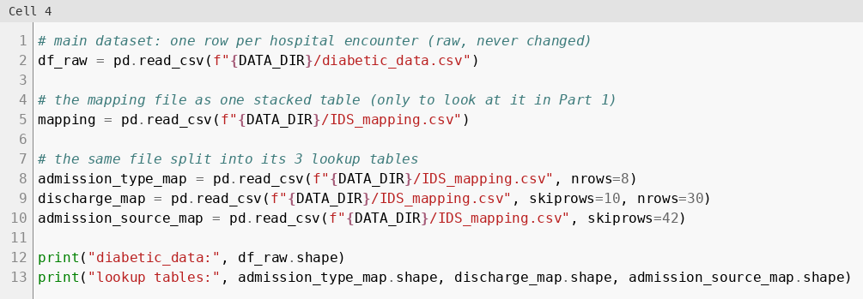
Figure 1: Load diabetic_data.csv and the three IDS_mapping.csv lookup tables with pandas
The first five rows show the raw values. The weight column already shows the "?" placeholder.
Figure 2: First look at the raw data with df_raw.head()
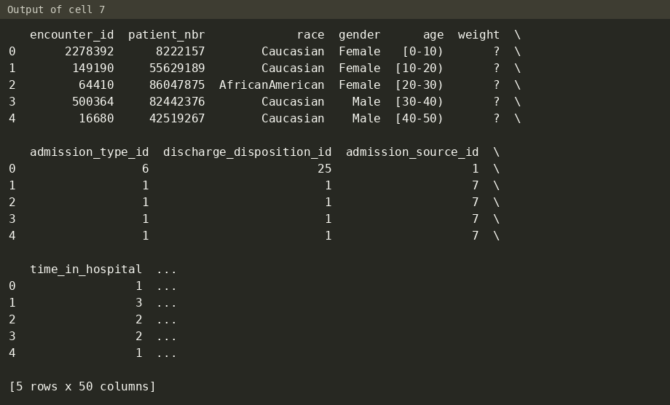
Figure 2-out: output (cell 7)
The mapping file has 67 rows and 2 columns. The three tables sit on top of each other: row 9 is the header of the discharge table.
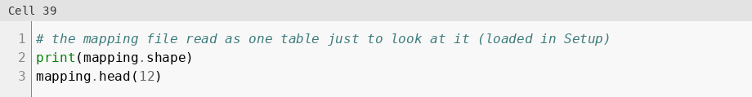
Figure 3: Look at the stacked ID mapping file
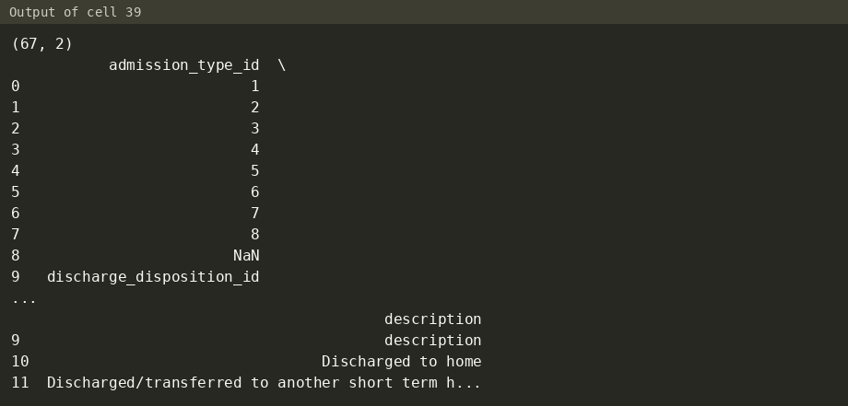
Figure 3-out: output (cell 39)

1.2 Structure: rows, columns and data types
The raw data has 101,766 rows and 50 columns. 13 columns are numbers (int64) and 37 are text (object). Some numbers are really codes: admission_type_id, discharge_disposition_id and admission_source_id only make sense with the mapping file.
Figure 4: Number of rows and columns
Figure 4-out: output (cell 9)
Figure 5: Data type and non-null count of every column
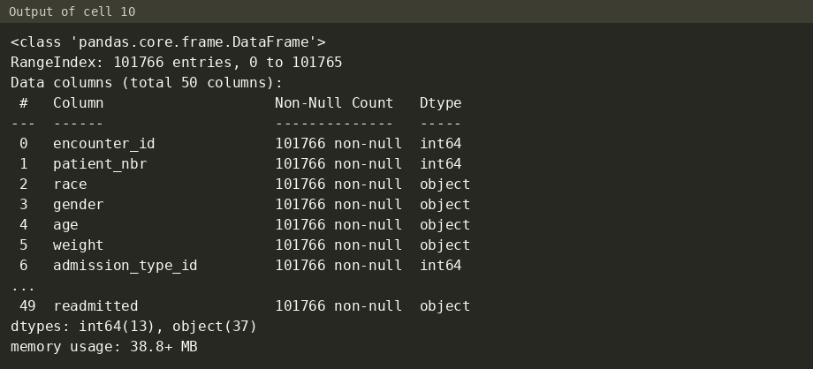
Figure 5-out: output (cell 10)
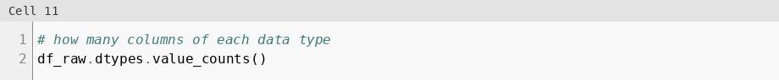
Figure 6: Count of columns per data type
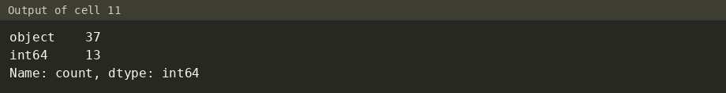
Figure 6-out: output (cell 11)

1.3 Summary statistics
What was done: describe() gives count, mean, std, min, quartiles and max of the numeric columns. describe(include="object") gives count, number of unique values, most common value and its frequency for the text columns. What it shows:
- encounter_id and patient_nbr are IDs, so their mean and std mean nothing.
- number_emergency has a 75% value of 0 and a max of 76. number_inpatient has a 75% value of 1 and a max of 21. A few extreme values exist.
- citoglipton has only 1 unique value (examide too, in the hidden part of the output).
- diag_1, diag_2 and diag_3 have 717, 749 and 790 different codes.
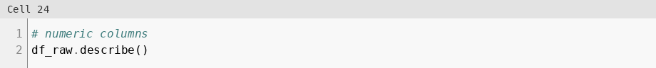
Figure 7: Summary statistics of the numeric columns
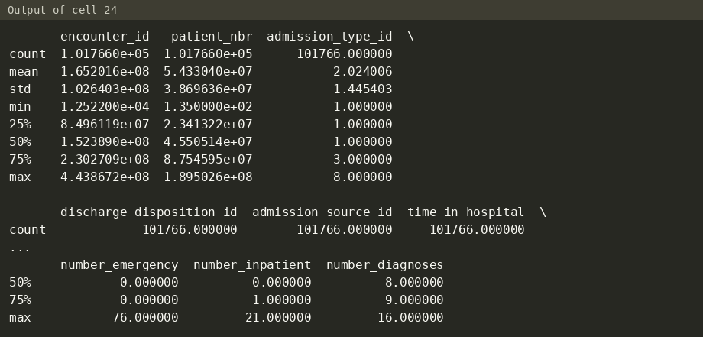
Figure 7-out: output (cell 24)
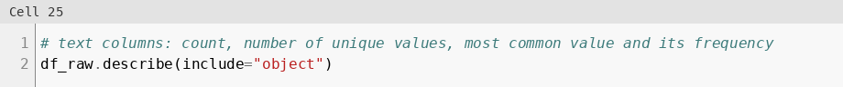
Figure 8: Summary of the text columns
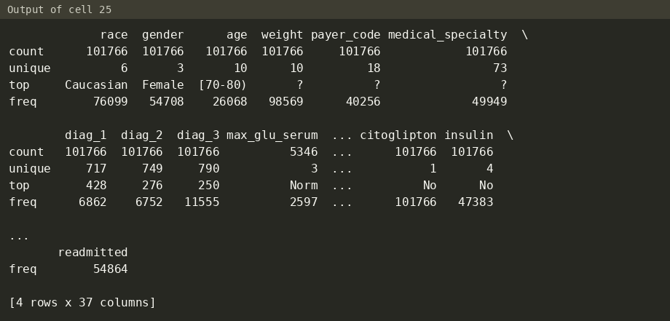
Figure 8-out: output (cell 25)

1.4 Problems found
"?" placeholders: The file writes "?" for unknown values. pandas does not treat "?" as missing, so it was counted directly. 7 columns have it: weight 98,569 rows (96.86%), medical_specialty 49,949 (49.08%), payer_code 40,256 (39.56%), race 2,273 (2.23%), diag_3 1,423, diag_2 358 and diag_1 21.
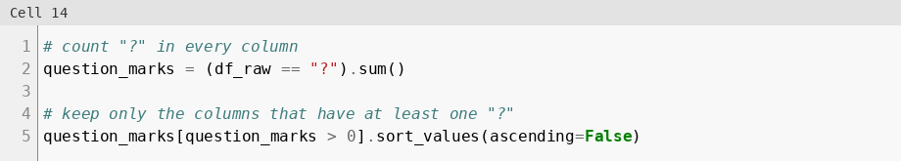
Figure 9: Count "?" placeholders per column
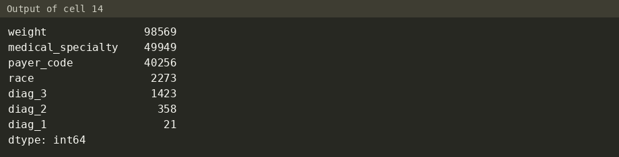
Figure 9-out: output (cell 14)
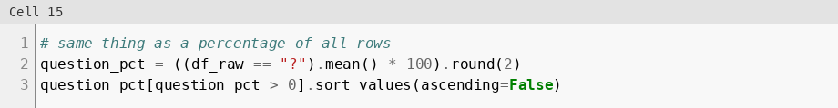
Figure 10: "?" placeholders as a percentage of rows
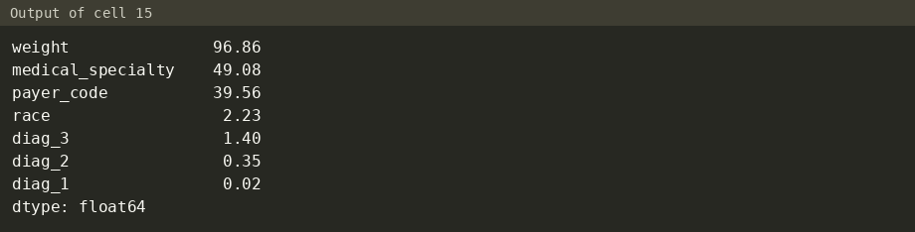
Figure 10-out: output (cell 15)
Missing values: max_glu_serum and A1Cresult hold the text None, which means the test was not done. pandas reads it as NaN: 96,420 and 84,748 rows. With "?" counted as missing too, weight (96.86%) and max_glu_serum (94.75%) are above 90%. A1Cresult is at 83.28%.
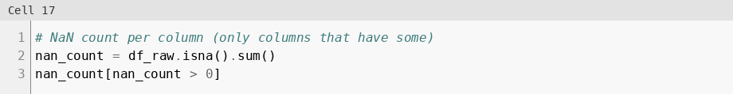
Figure 11: Count real NaN values per column
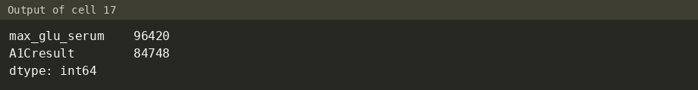
Figure 11-out: output (cell 17)
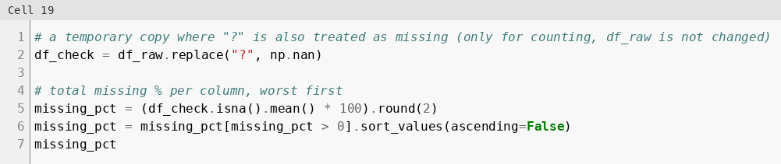
Figure 12: Total missing % per column (NaN and "?")
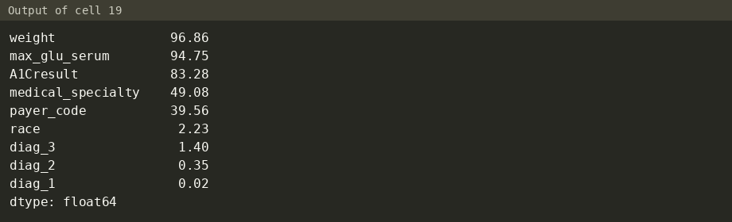
Figure 12-out: output (cell 19)
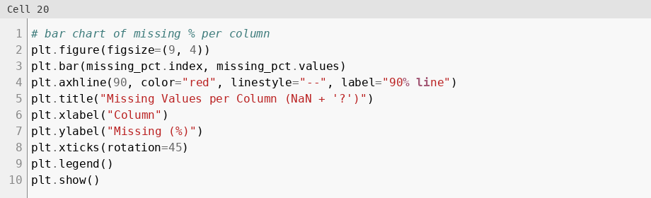
Figure 13: Bar chart of missing % per column
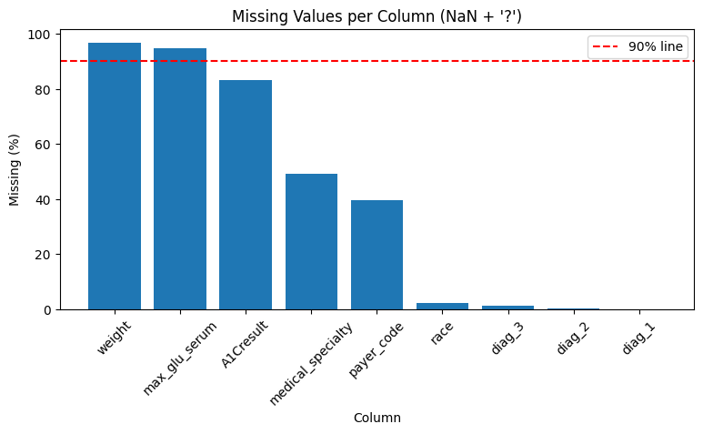
Figure 13-chart: output chart, Missing Values per Column (NaN + '?') (cell 20)
Constant columns: examide and citoglipton have one value (No) in every row (Figure 8-out). They cannot explain readmission.
Invalid gender: 3 rows have gender Unknown/Invalid.
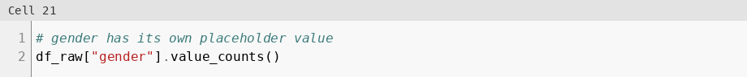
Figure 14: Value counts of gender
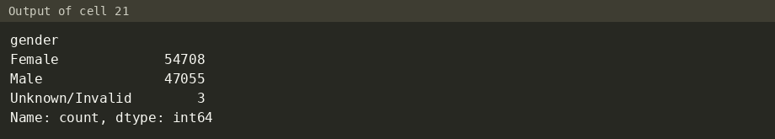
Figure 14-out: output (cell 21)
Repeated patients: The 101,766 encounters belong to only 71,518 patients. One patient has up to 40 encounters. There are no fully duplicated rows. Repeat visits of the same patient are not independent rows.
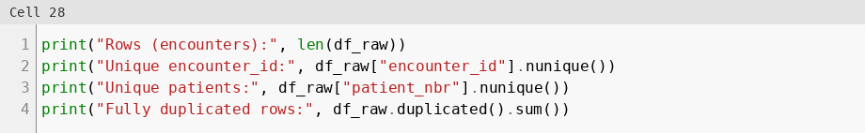
Figure 15: Encounters, unique patients and duplicated rows
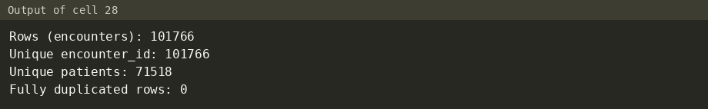
Figure 15-out: output (cell 28)
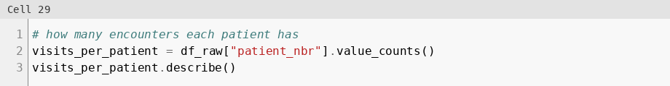
Figure 16: Encounters per patient
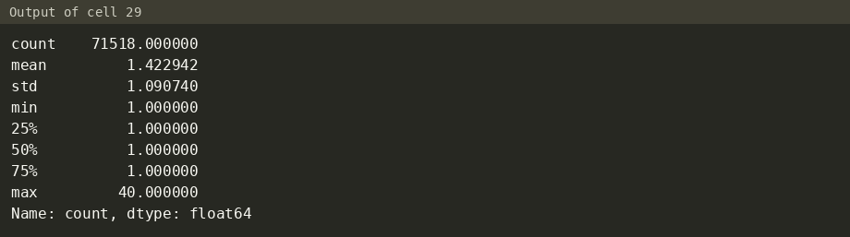
Figure 16-out: output (cell 29)
Outliers: Count columns such as number_emergency (max 76) and number_inpatient (max 21) sit far above their 75% value (Figure 7-out). They are checked with the IQR rule in Part 2, Step 9.
Class imbalance: readmitted has 3 classes: NO 54,864 (53.91%), >30 35,545 (34.93%) and <30 11,357 (11.16%). The question is about <30, so a binary target readmitted_30 was built: 11,357 encounters (11.16%) against 90,409 (88.84%). A model that always guesses "not readmitted" would be right 88.84% of the time and still find no readmitted patient, so accuracy alone is not a useful measure.
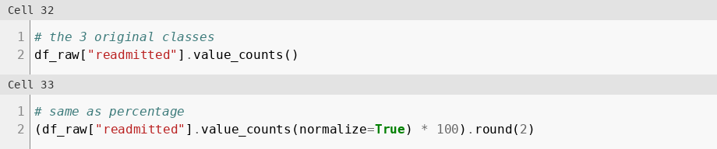
Figure 17: The three original readmitted classes, count and %
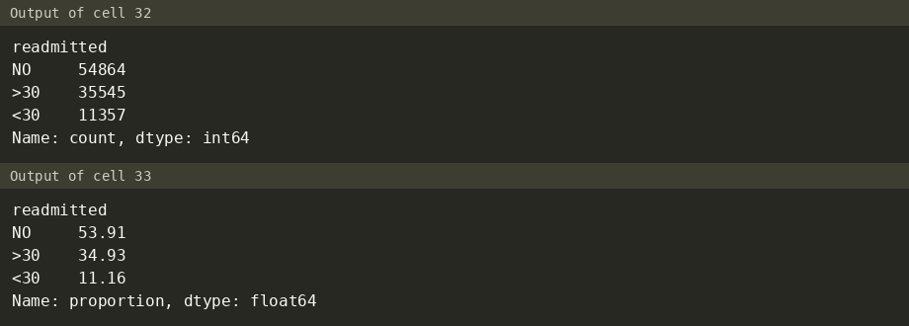
Figure 17-out: output (cells 32, 33)
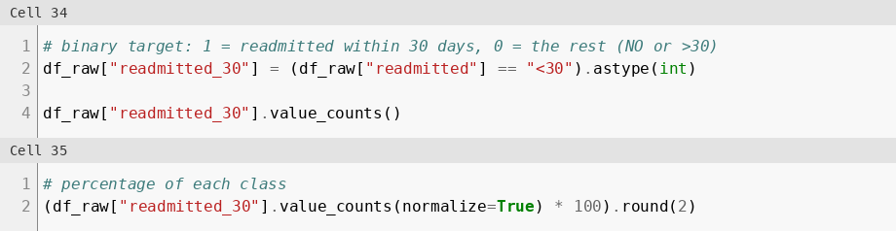
Figure 18: Binary target readmitted_30, count and %
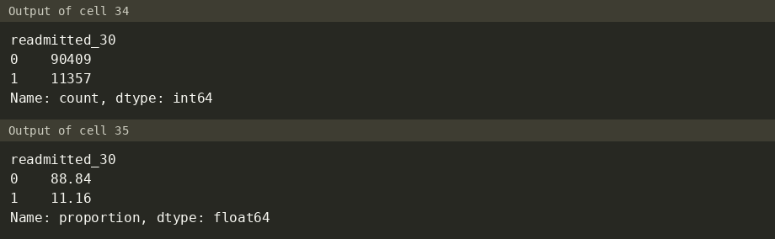
Figure 18-out: output (cells 34, 35)
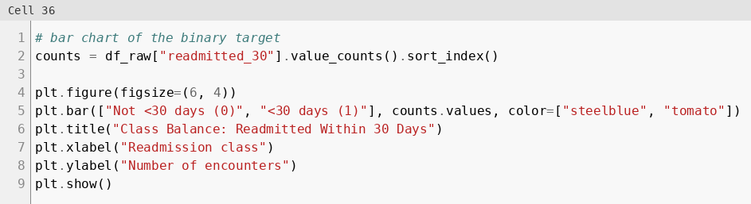
Figure 19: Bar chart of the binary target
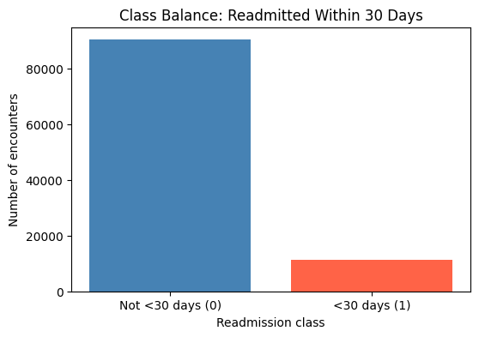
Figure 19-chart: output chart, Class Balance: Readmitted Within 30 Days (cell 36)

These are encounter counts. After cleaning (one encounter per patient) the target rate is 8.97% (Part 2, Step 13).
Summary of problems and where they are treated:
Problem | Evidence (saved output) | Treated in Part 2
"?" placeholders | 7 columns, weight 96.86% | Step 2
Columns over 90% missing | weight 96.86%, max_glu_serum 94.75% | Step 3
Constant columns | examide, citoglipton: 1 unique value | Step 4
Other missing values | A1Cresult 83.28%, medical_specialty 49.08%, payer_code 39.56%, race 2.23% | Step 5
Repeated patients | 101,766 encounters, 71,518 patients | Step 6
Invalid gender | 3 rows Unknown/Invalid | Step 8
Outliers | number_emergency max 76 with 75% = 0 | Step 9
Class imbalance | <30: 11.16% of encounters | Step 13 (target); Part 4 (class weights)

2. Data Cleaning and Transformation
Notebook Part 2. Input: diabetic_data.csv (101,766 rows x 50 columns). The cleaning produces two files:
Output file | Contents
data/cleaned_readable.csv | 69,970 rows x 51 columns. Real units and text labels, for EDA and Power BI.
data/cleaned.csv | 69,970 rows x 140 columns. Encoded and scaled, for modeling.

The table below is the cleaning log from the existing report. Each step after it shows the code, the saved output and the decisions it covers.
# | Decision | Reason | Effect
1 | Replace "?" with NaN | The file uses "?" for unknown values, which pandas does not detect as missing | 7 columns had "?"; 0 left after replacing
2 | Drop columns with more than 90% missing | Too little data to be useful; filling 90%+ of a column would be mostly guessing | Dropped weight (96.86% missing) and max_glu_serum (94.75%). 50 -> 48 columns
3 | Drop columns with only one value | A constant column cannot explain readmission | Dropped examide and citoglipton (every row = No). 48 -> 46 columns
4 | Fill A1Cresult NaN with "Not tested" | Missing here means the HbA1c test was not done, which is real information | 83.28% of raw rows
5 | Fill medical_specialty, payer_code, race NaN with "Unknown" | Too many missing to drop rows (49.08% and 39.56%), and race should never be guessed | Kept as their own category
6 | Keep one encounter per patient (the first, by smallest encounter_id) | Repeat visits of the same patient are not independent rows and could leak information between train and test sets. Same choice as the original study (Strack et al. 2014) | 101,766 -> 71,518 rows
7 | Remove discharges coded Expired / Hospice (IDs 11, 13, 14, 19, 20, 21) | These patients cannot be readmitted, so they would bias the model toward "not readmitted" | 1,545 rows removed. 71,518 -> 69,973
8 | Remove gender = Unknown/Invalid | Invalid placeholder value, only 3 rows | 69,973 -> 69,970 rows
9 | Cap outliers at Q3 + 1.5 * IQR (upper side only) | Capping keeps every patient but limits the pull of extreme values. Lower limits are 0 or below (nothing flagged), except number_diagnoses (1.5), where a value of 1 is a valid patient | time_in_hospital capped at 12 (1,403 rows), num_lab_procedures at 96 (98), num_procedures at 5 (3,845), num_medications at 35 (1,867), number_diagnoses at 13.5 (42)
10 | Do not cap number_outpatient, number_emergency, number_inpatient | Their Q1 = Q3 = 0, so IQR = 0 and the upper limit = 0. Capping would erase every past visit (9,119 / 5,100 / 8,191 rows), the most useful information | Left unchanged
11 | Group ICD-9 codes of diag_1/2/3 into 9 categories (Circulatory, Respiratory, Digestive, Diabetes, Injury, Musculoskeletal, Genitourinary, Neoplasms, Other) | ~700-800 raw codes per column are too many categories. ICD-9 chapter grouping from Strack et al. 2014. V/E codes and the few missing codes go to Other | New diag_1_group, diag_2_group, diag_3_group; raw columns dropped. Largest primary group: Circulatory (21,383 patients)
12 | Keep the 10 most common medical specialties, put the rest in "Other" | 71 specialties, most of them rare. One-hot encoding all of them would add many almost-empty columns | 71 -> 12 values (10 + Other + Unknown)
13 | New feature total_visits = outpatient + emergency + inpatient | One measure of how much hospital care was needed in the past year | mean 0.56, max 49
14 | New feature age_mid = middle of the age band ([70-80) -> 75) | Turns the text band into a number that can be scaled and tested | mean 65.44
15 | New feature num_active_meds = number of the 21 medicines not equal to No | How complex the diabetes treatment is | mean 1.19, max 6
16 | New feature num_med_changes = number of medicines with Up or Down | How much the treatment was adjusted during the stay | mean 0.26, max 4
17 | Target readmitted_30 = 1 if readmitted == "<30", else 0 | The project question is early (30-day) readmission | 6,277 positives (8.97%) vs 63,693 (91.03%)
18 | Save cleaned_readable.csv before encoding and scaling | EDA charts and Power BI need real units (days, years) and text labels | 69,970 x 51
19 | Label-encode gender (Male = 1), change (Ch = 1), diabetesMed (Yes = 1) | Only two values each | 0 / 1 columns
20 | Encode the 21 medicine columns as 0 = No, 1 = taken (Steady / Up / Down) | One-hot on 21 columns x 4 values would add ~60 mostly-empty columns. The Up / Down direction is already kept in num_med_changes | 0 / 1 columns
21 | One-hot encode race, payer_code, medical_specialty, A1Cresult, the 3 diagnosis groups, admission_type_id, discharge_disposition_id, admission_source_id (drop_first=True) | Categories with no natural order. The ID columns are codes, so they are converted to text first. drop_first removes one redundant column per group | 140 columns after encoding
22 | Drop encounter_id, patient_nbr, age (text), readmitted (text) from the model file | IDs carry no medical meaning; age and readmitted were replaced by age_mid and readmitted_30 | Not in cleaned.csv (still in cleaned_readable.csv)
23 | Standard-scale 12 numeric columns (mean 0, std 1) | Columns have very different ranges, and logistic regression is sensitive to scale. 0/1 columns and the target are not scaled | Verified mean = 0.0, std = 1.0

2.1 Missing values
This part handles the placeholders, missing values and the rows that should not be in the analysis.

Step 1: Start from the raw data
Done: Part 2 works on a copy of df_raw without the exploration target. Why: the raw table stays unchanged. Result: 101,766 rows x 50 columns.
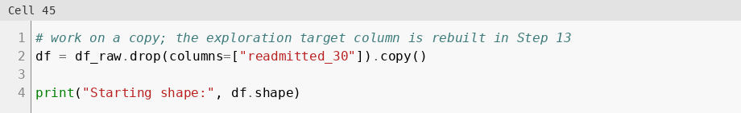
Figure 20: Start from a copy of the raw data
Figure 20-out: output (cell 45)

Step 2: Replace "?" with NaN (decision 1)
Done: every "?" became NaN. Why: pandas does not see "?" as missing. Result: 0 "?" left.
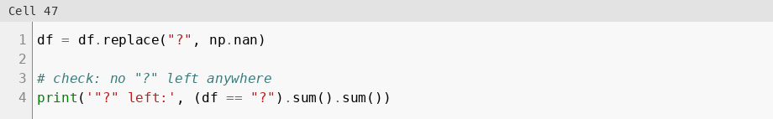
Figure 21: Replace "?" with NaN
Figure 21-out: output (cell 47)

Step 3: Drop columns with more than 90% missing (decision 2)
Done: columns above 90% missing were dropped. Why: filling 90% or more of a column would be mostly guessing. Result: weight (96.86%) and max_glu_serum (94.75%) dropped, 50 -> 48 columns.
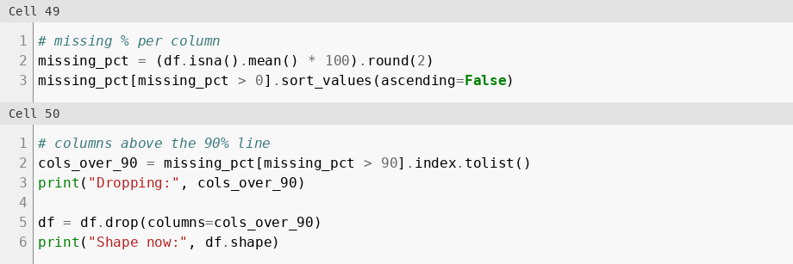
Figure 22: Drop columns with more than 90% missing
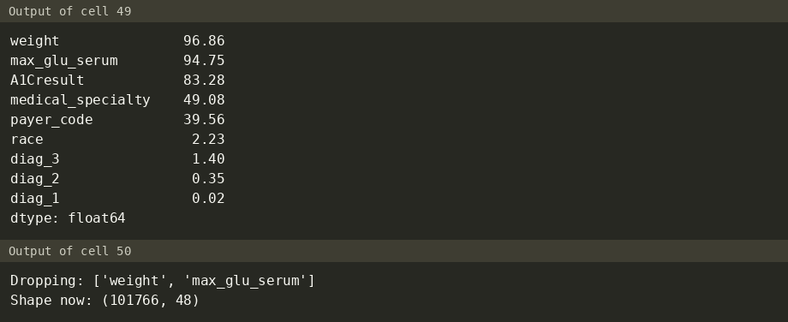
Figure 22-out: output (cells 49, 50)

Step 4: Drop columns with only one value (decision 3)
Done: examide and citoglipton were dropped. Why: a constant column cannot explain readmission. Result: 48 -> 46 columns.
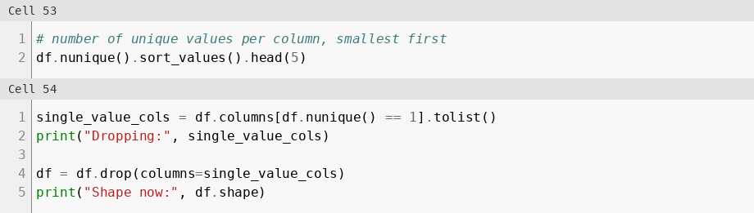
Figure 23: Drop columns with only one value
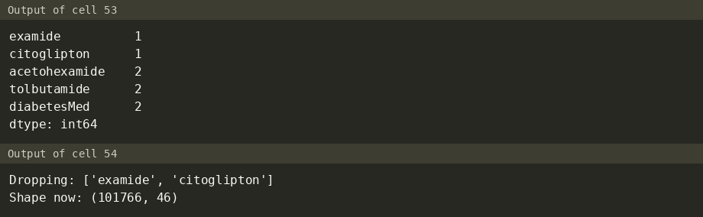
Figure 23-out: output (cells 53, 54)

Step 5: Fill the remaining missing values (decisions 4 and 5)
Done: A1Cresult NaN -> "Not tested". medical_specialty, payer_code and race NaN -> "Unknown". Why: a missing HbA1c result means the test was not done, which is real information. medical_specialty (49.08%) and payer_code (39.56%) have too many missing values to drop rows, and race should never be guessed.
Result: only diag_1 (21), diag_2 (358) and diag_3 (1,423) still have missing values. They become "Other" in Step 10.
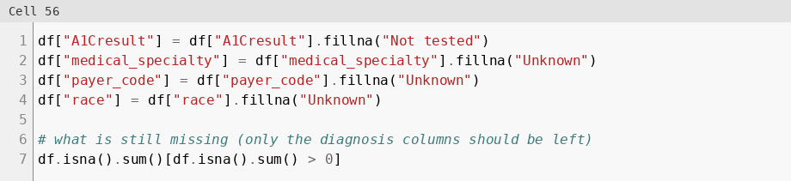
Figure 24: Fill the remaining missing values
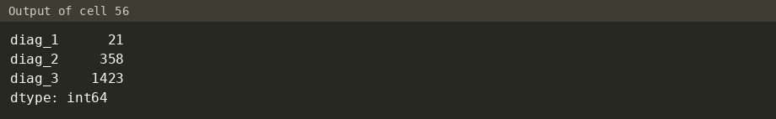
Figure 24-out: output (cell 56)

Step 6: Keep one encounter per patient (decision 6)
Done: rows were sorted by encounter_id and the first encounter of each patient was kept. Why: repeat visits of the same patient are not independent and could leak information between train and test sets. This is the same choice as the original study (Strack et al. 2014). Result: 101,766 -> 71,518 rows.
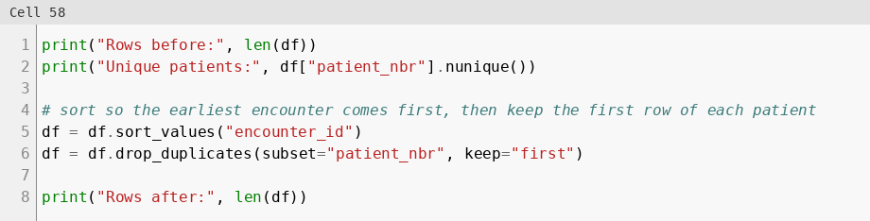
Figure 25: Keep the first encounter of each patient
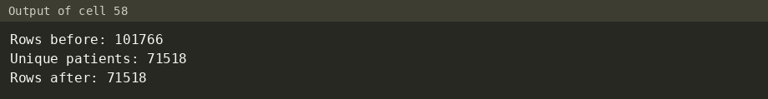
Figure 25-out: output (cell 58)

Step 7: Remove expired and hospice discharges (decision 7)
Done: discharge IDs 11, 13, 14, 19, 20 and 21 (Expired or Hospice) were removed. Why: these patients cannot be readmitted, so they would bias the model toward "not readmitted". Result: 1,545 rows removed, 71,518 -> 69,973.
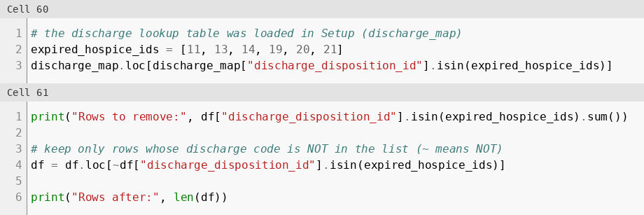
Figure 26: Remove expired and hospice discharges
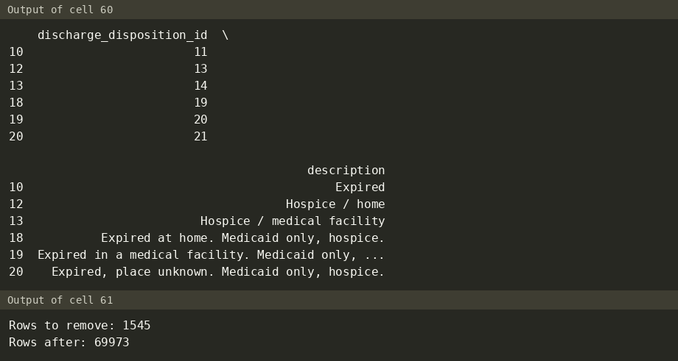
Figure 26-out: output (cells 60, 61)

Step 8: Remove invalid gender rows (decision 8)
Done: rows with gender Unknown/Invalid were removed. Why: it is a placeholder, not a value. Result: 3 rows removed, 69,973 -> 69,970.
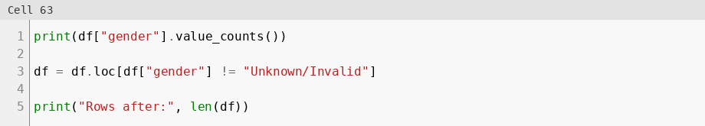
Figure 27: Remove invalid gender rows
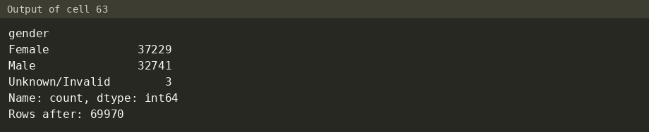
Figure 27-out: output (cell 63)

Row count flow
101,766 → 71,518 → 69,973 → 69,970
Stage | Rows | Step
Raw data | 101,766 | Part 1
One encounter per patient | 71,518 | Step 6
Expired / hospice removed | 69,973 | Step 7
Invalid gender removed | 69,970 | Step 8

2.2 Outlier detection and treatment

Step 9: Treat outliers with IQR (decisions 9 and 10)
Method: the IQR rule. A value above Q3 + 1.5 x IQR is an outlier. Outliers are capped at that upper limit instead of deleted, so every patient is kept.
- Upper side only: The lower limits are 0 or below (nothing flagged), except number_diagnoses (1.5), where a value of 1 is a valid patient.
- Three columns skipped: number_outpatient, number_emergency and number_inpatient have Q1 = Q3 = 0, so IQR = 0 and the upper limit is 0. Capping would erase every past visit (9,119 / 5,100 / 8,191 rows), the most useful information.
Column | Q1 | Q3 | Upper limit | Rows above | Action
time_in_hospital | 2 | 6 | 12 | 1,403 | Capped at 12
num_lab_procedures | 31 | 57 | 96 | 98 | Capped at 96
num_procedures | 0 | 2 | 5 | 3,845 | Capped at 5
num_medications | 10 | 20 | 35 | 1,867 | Capped at 35
number_diagnoses | 6 | 9 | 13.5 | 42 | Capped at 13.5
number_outpatient | 0 | 0 | 0 | 9,119 | Skipped (IQR = 0)
number_emergency | 0 | 0 | 0 | 5,100 | Skipped (IQR = 0)
number_inpatient | 0 | 0 | 0 | 8,191 | Skipped (IQR = 0)

Result: the new maximums in the last output match the caps (12, 96, 5, 35 and 13.5).
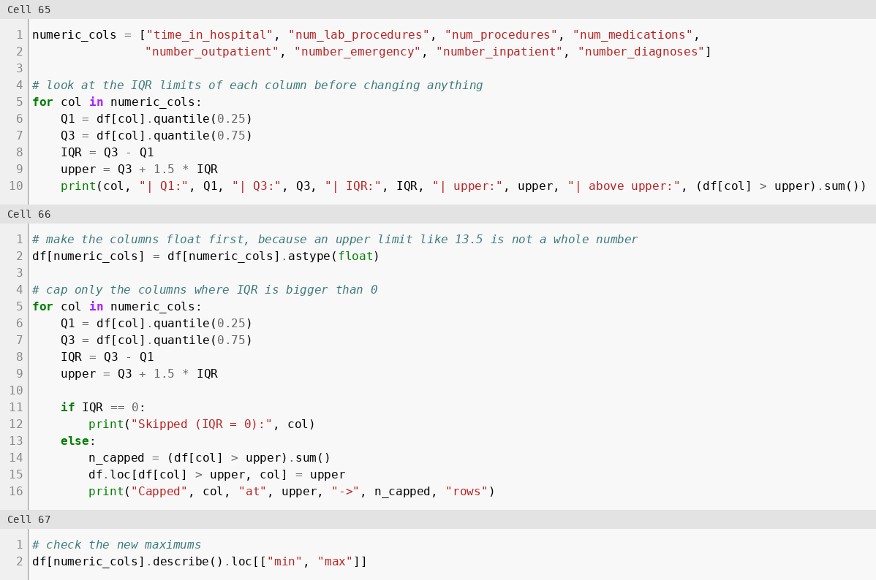
Figure 28: IQR limits, capping and new maximums
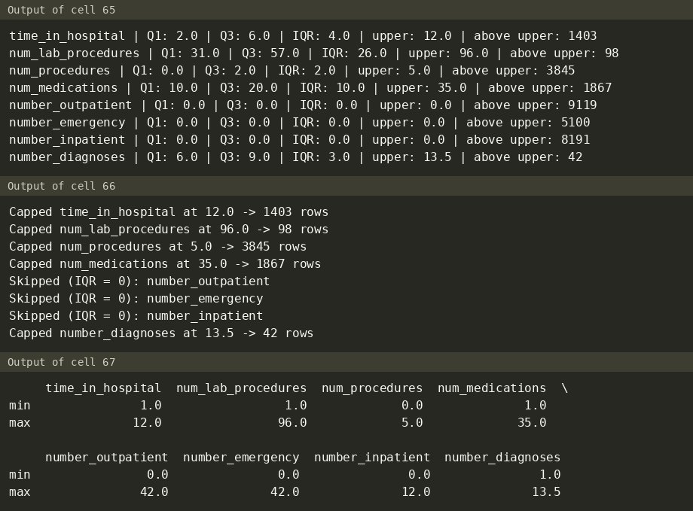
Figure 28-out: output (cells 65, 66, 67)

2.3 Data transformation: encoding, scaling and new features

Step 10: Group ICD-9 codes into diagnosis groups (decision 11)
Done: the function icd9_group maps each code of diag_1, diag_2 and diag_3 to one of 9 groups (Circulatory, Respiratory, Digestive, Diabetes, Injury, Musculoskeletal, Genitourinary, Neoplasms, Other). Why: about 700-800 raw codes per column are too many categories. The grouping follows the ICD-9 chapters used by Strack et al. 2014. V/E codes and the few missing codes go to Other. Result: new columns diag_1_group, diag_2_group, diag_3_group; the raw columns were dropped. The largest primary group is Circulatory (21,383 patients). Cell 69 only defines the function and has no output.
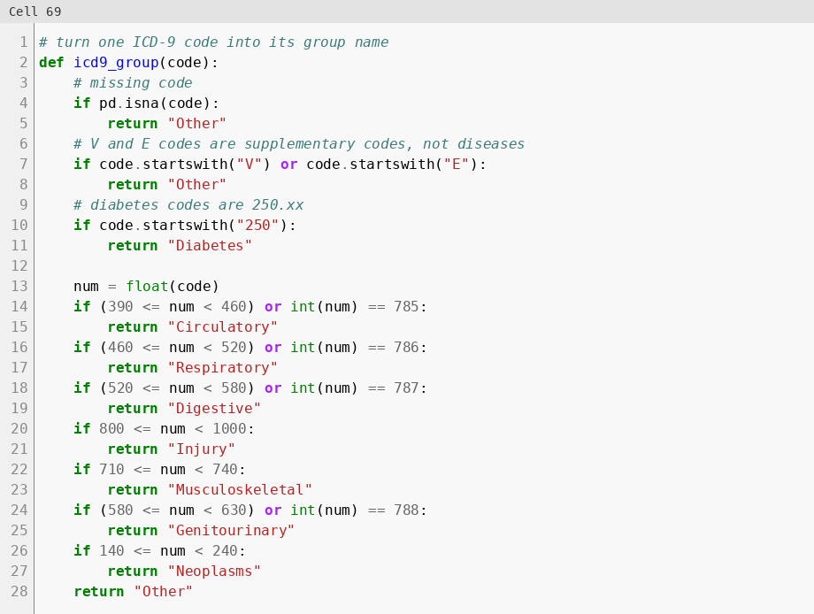
Figure 29 (part 1 of 2): Group ICD-9 codes into 9 diagnosis groups
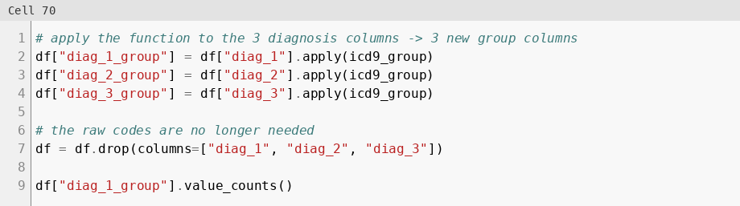
Figure 29 (part 2 of 2): Group ICD-9 codes into 9 diagnosis groups
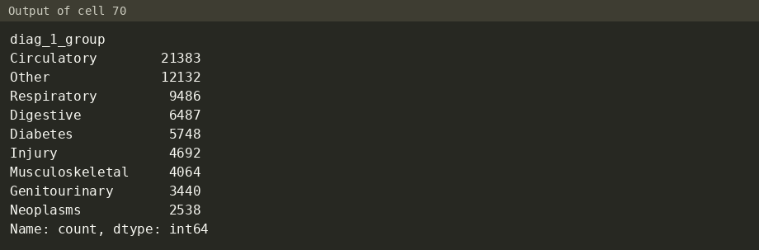
Figure 29-out: output (cells 69, 70)

Step 11: Group rare medical specialties (decision 12)
Done: the 10 most common specialties were kept and the rest became "Other". Why: most of the 71 specialties are rare, and one-hot encoding all of them would add many almost empty columns. Result: 71 -> 12 values (10 + Other + Unknown).
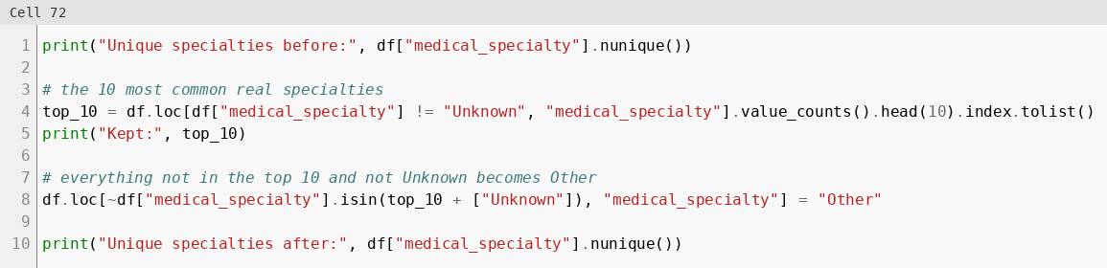
Figure 30: Group rare medical specialties into Other
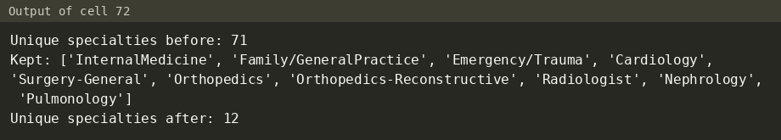
Figure 30-out: output (cell 72)

Step 12: Create new features (decisions 13 to 16)
Done: four features were built from domain knowledge:
Feature | How | Why | Result
total_visits | outpatient + emergency + inpatient visits | how much hospital care was needed in the past year | mean 0.56, max 49
age_mid | middle of the age band, [70-80) -> 75 | turns the text band into a number | mean 65.44
num_active_meds | number of the 21 medicines not equal to No | how complex the treatment is | mean 1.19, max 6
num_med_changes | number of medicines with Up or Down | how much the treatment was adjusted | mean 0.26, max 4

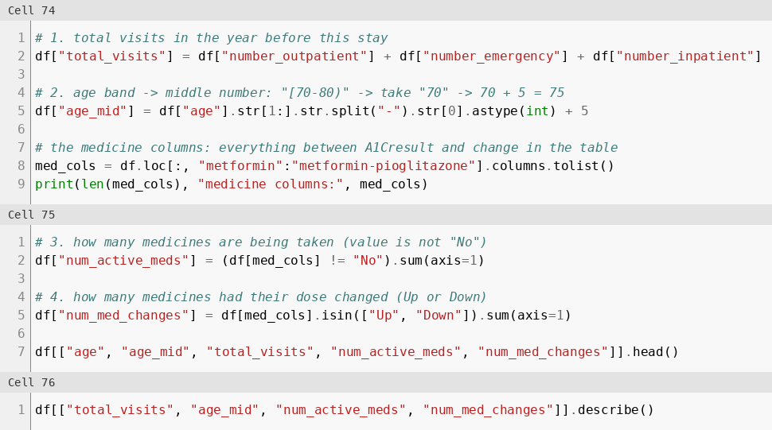
Figure 31: Create total_visits, age_mid, num_active_meds, num_med_changes
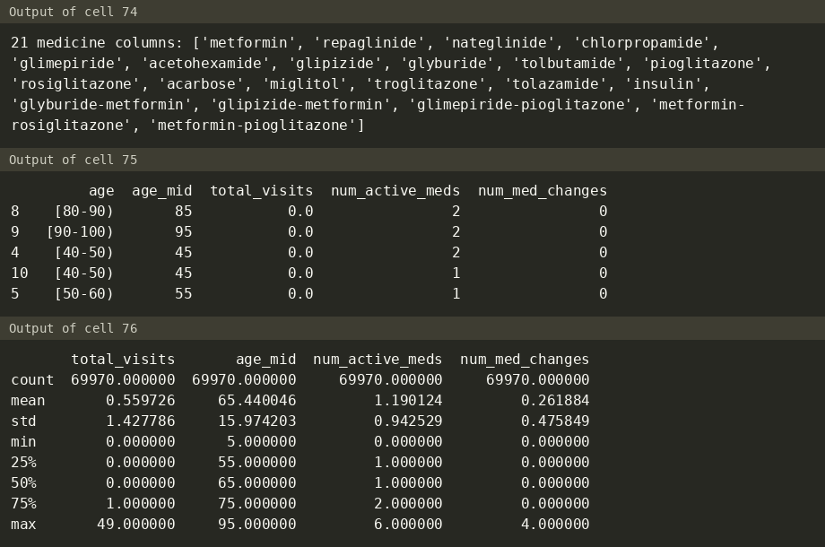
Figure 31-out: output (cells 74, 75, 76)

Step 13: Create the target (decision 17)
Done: readmitted_30 = 1 if readmitted is "<30", else 0. Why: the project question is 30-day readmission. Result: 6,277 positives (8.97%) against 63,693 (91.03%).
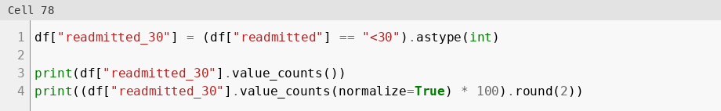
Figure 32: Create the target readmitted_30
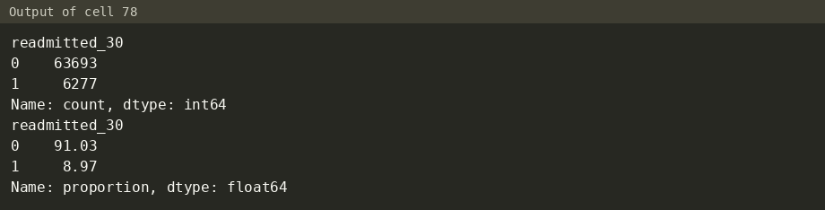
Figure 32-out: output (cell 78)

Step 14: Save the readable file (decision 18)
Done: cleaned_readable.csv was saved before encoding and scaling. Why: EDA charts and Power BI need real units (days, years) and text labels. Result: 69,970 x 51, 0 missing values.
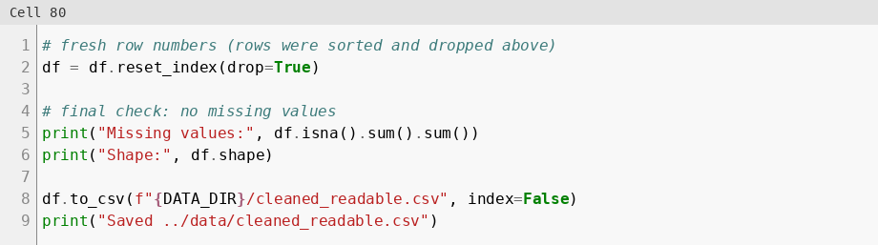
Figure 33: Save the readable file cleaned_readable.csv
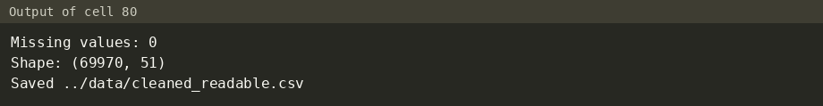
Figure 33-out: output (cell 80)

Step 15: Encode categorical columns (decisions 19 to 22)
- Label encoding for two-value columns: gender (Male = 1), change (Ch = 1), diabetesMed (Yes = 1).
- Medicine columns (21): 0 = No, 1 = taken (Steady, Up or Down). The Up / Down direction is already kept in num_med_changes.
- One-hot encoding (drop_first=True) for categories with no order: race, payer_code, medical_specialty, A1Cresult, the 3 diagnosis groups and the 3 ID columns. The ID columns are turned into text first.
- Dropped: encounter_id, patient_nbr, age (text) and readmitted (text). IDs carry no medical meaning, and age and readmitted were replaced by age_mid and readmitted_30.
Result: 69,970 rows x 140 columns.
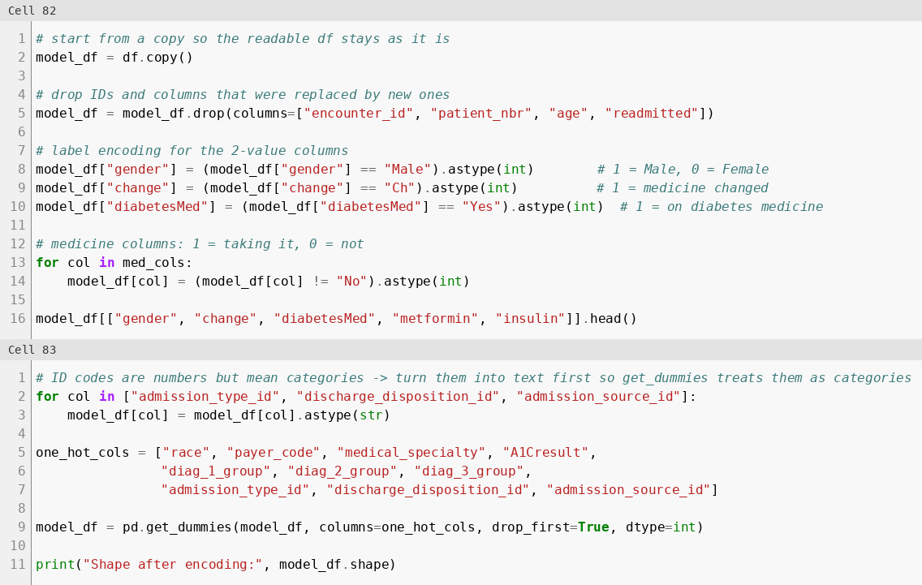
Figure 34: Label and one-hot encode the categorical columns
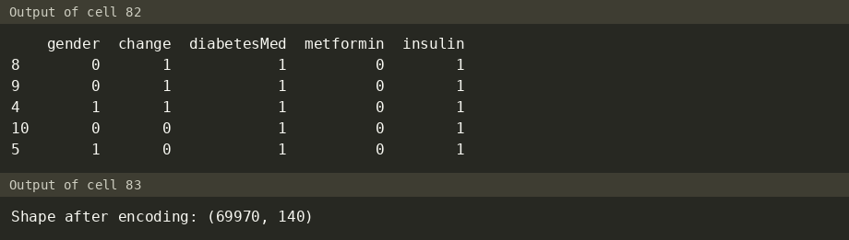
Figure 34-out: output (cells 82, 83)

Step 16: Scale numeric columns (decision 23)
Done: StandardScaler was applied to 12 numeric columns. The 0/1 columns and the target were not scaled. Why: the columns have very different ranges, and logistic regression is sensitive to scale. Result: every scaled column has mean 0.0 and std 1.0 (a mean of -0.0 is 0 rounded to 2 decimals).
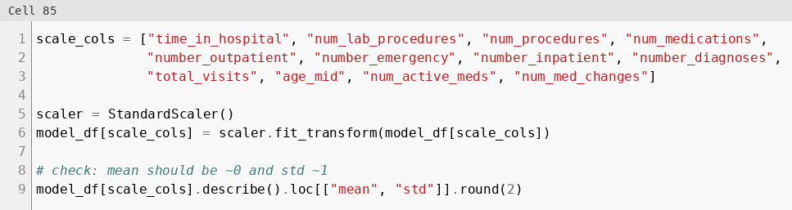
Figure 35: Standard-scale 12 numeric columns and check mean and std
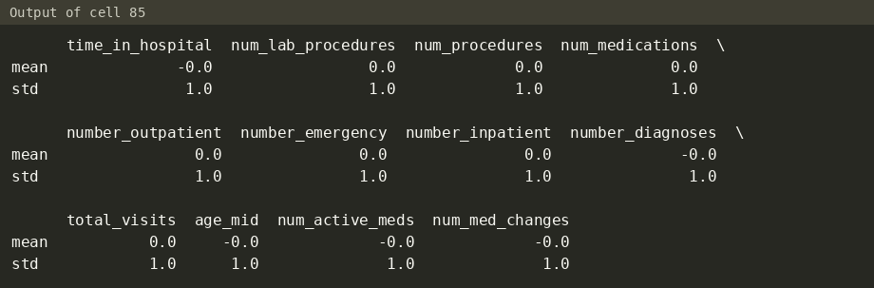
Figure 35-out: output (cell 85)
Known limitation. The scaler is fit on all 69,970 rows before the train/test split in notebook 04, so mean and standard deviation leak a tiny amount of test-set information. This is accepted because the task asks for scaling in the cleaning step.

Step 17: Save cleaned.csv
Done: a final check before saving the model file. Result: 0 missing values, 69,970 x 140, target rate 8.97%.
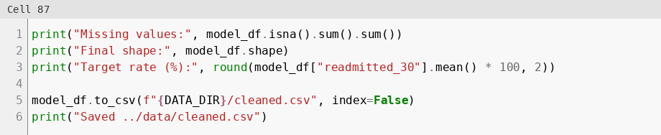
Figure 36: Final check and save cleaned.csv
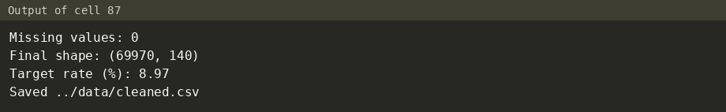
Figure 36-out: output (cell 87)

3. Exploratory Data Analysis
Notebook Part 3. Input: the readable table df from Part 2 (69,970 patients, one encounter each, real units). Overall 30-day readmission rate: 8.97% (6,277 of 69,970 patients).

3.1 Descriptive statistics
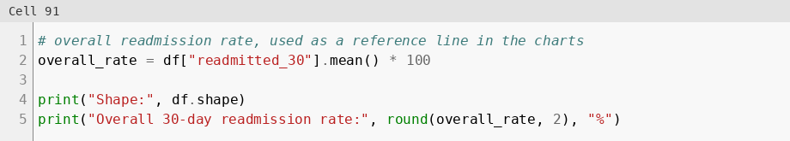
Figure 37: Shape and overall 30-day readmission rate
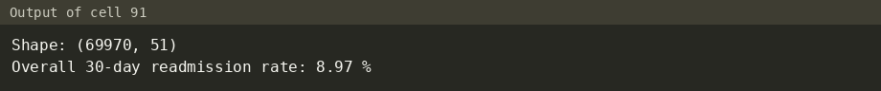
Figure 37-out: output (cell 91)
Numeric columns. The mean stay is 4.24 days, the mean age (middle of band) is 65.44 years and the mean number of medications is 15.43. Prior visits are mostly 0: the median of number_outpatient, number_emergency and number_inpatient is 0.
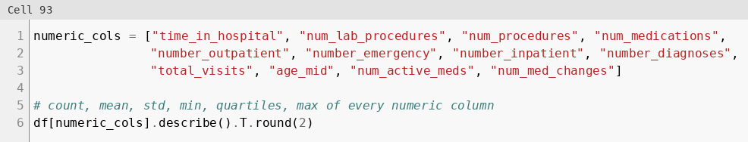
Figure 38: Describe table of the numeric columns
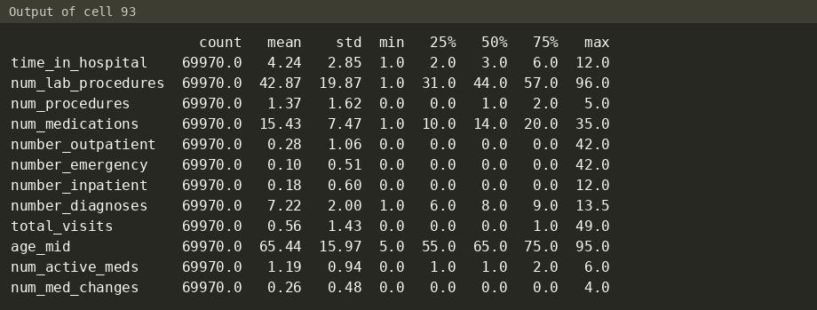
Figure 38-out: output (cell 93)
Categorical columns. The most common values are Caucasian (52,292), Female (37,229), age [70-80) (17,748), A1Cresult "Not tested" (57,125) and Circulatory as primary diagnosis (21,383). medical_specialty is Unknown for 33,637 patients.
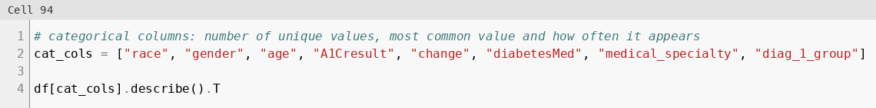
Figure 39: Describe table of the categorical columns
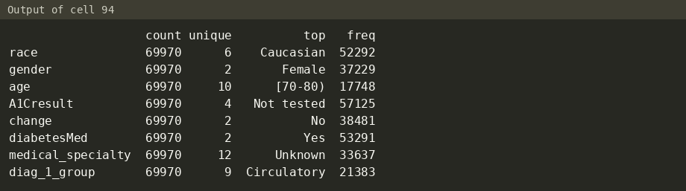
Figure 39-out: output (cell 94)
Readmitted vs not readmitted. Readmitted patients had longer stays (4.76 vs 4.19 days), more medications (16.37 vs 15.33), more lab procedures (44.90 vs 42.67) and more prior inpatient visits (0.37 vs 0.16). Each difference that matters is tested in 3.3.
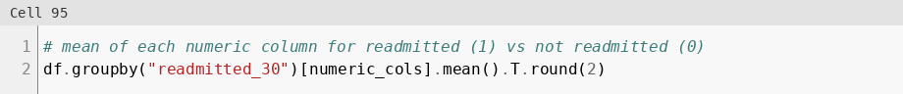
Figure 40: Mean of each numeric column for readmitted vs not
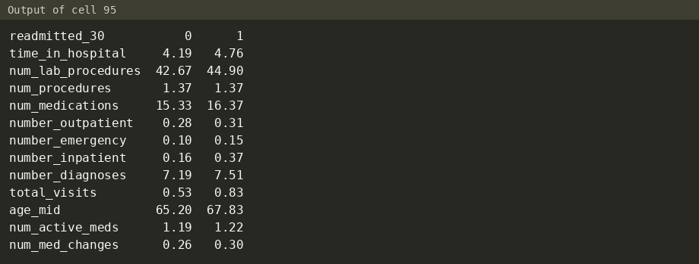
Figure 40-out: output (cell 95)

3.2 Visualizations
All charts were made with Matplotlib and Seaborn. Each chart is the PNG saved in the notebook output. The readmission rate charts by group are shown with the insights in 3.3.

Distributions
Histograms. time_in_hospital and total_visits are right-skewed: most stays are short and most patients had no prior visits. age_mid is left-skewed: most patients are 50 or older. The bar at 12 days comes from the IQR cap. number_diagnoses has a tall spike at 9.
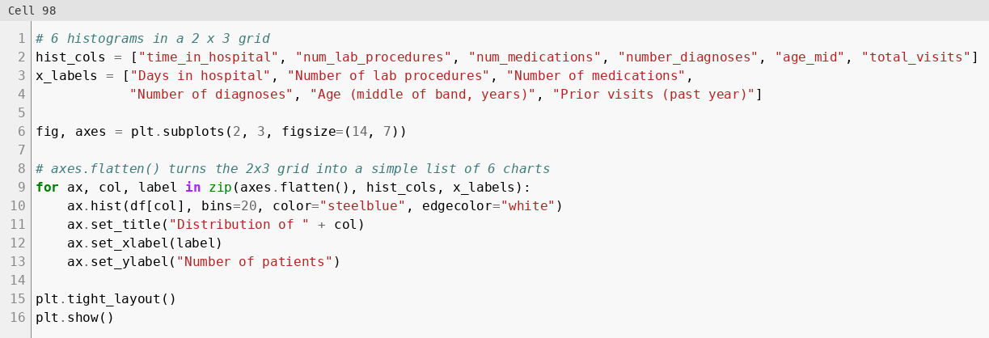
Figure 41: Histograms of six numeric columns
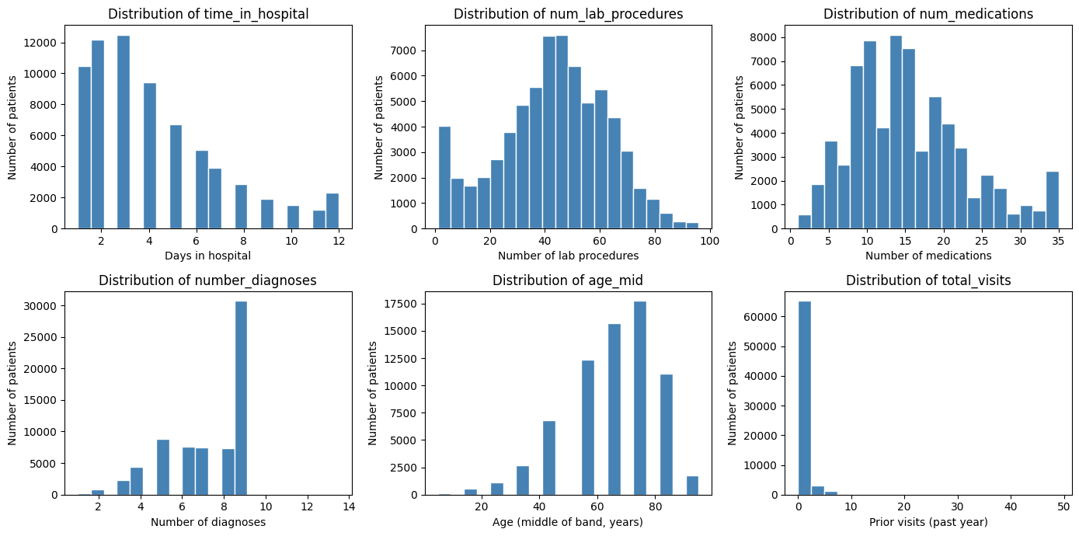
Figure 41-chart: output chart, Histograms of six numeric columns (cell 98)
Density plot. The number of medications has the same shape for both groups. The readmitted group has a slightly higher mean (16.37 vs 15.33).
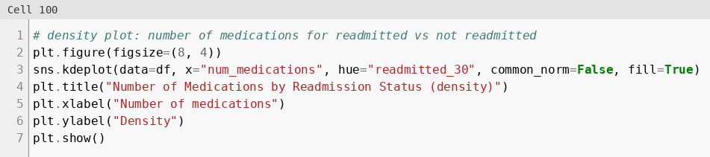
Figure 42: Density plot of medications by readmission status
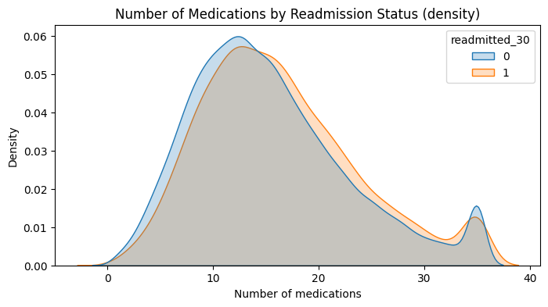
Figure 42-chart: output chart, Number of Medications by Readmission Status (density) (cell 100)

Relationships between variables
Scatter plot (random sample of 3,000 patients). Longer stays come with more medications. Readmitted and non-readmitted patients overlap.
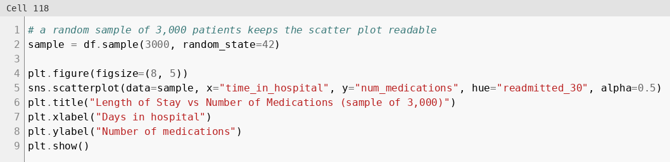
Figure 43: Scatter plot of stay vs medications
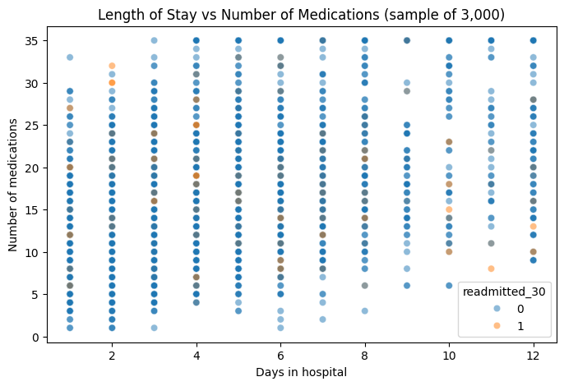
Figure 43-chart: output chart, Length of Stay vs Number of Medications (sample of 3,000) (cell 118)
Pair plot of four numeric columns on the same sample. The two groups overlap almost completely in every pair, so no single pair of variables separates them.
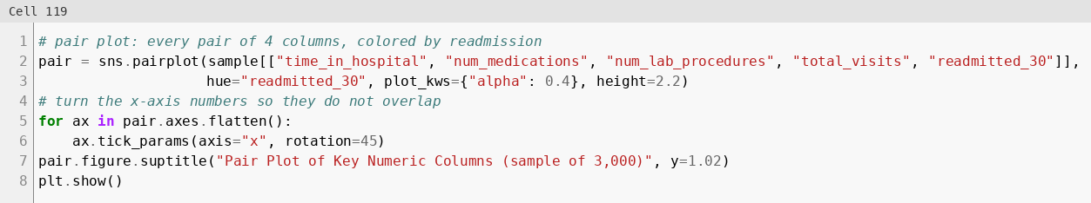
Figure 44: Pair plot of four numeric columns
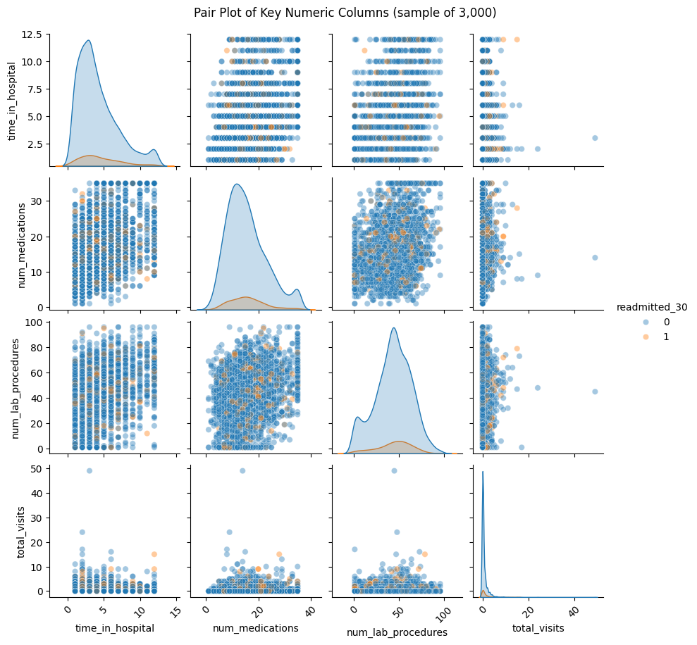
Figure 44-chart: output chart, Pair Plot of Key Numeric Columns (sample of 3,000) (cell 119)

Correlations
Heatmap and correlation with the target. All correlations with readmitted_30 are weak. The highest are number_inpatient (0.100), total_visits (0.059) and time_in_hospital (0.057).
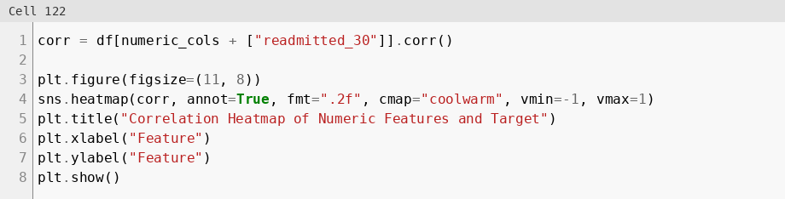
Figure 45: Correlation heatmap
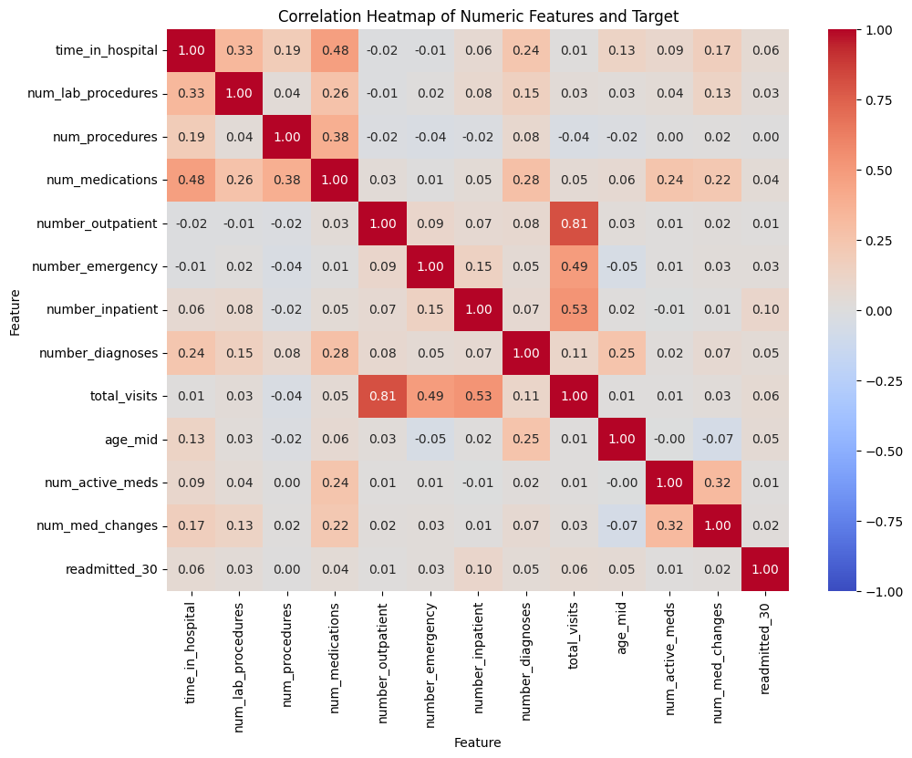
Figure 45-chart: output chart, Correlation Heatmap of Numeric Features and Target (cell 122)
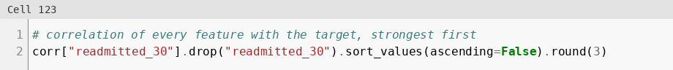
Figure 46: Correlation of each feature with the target
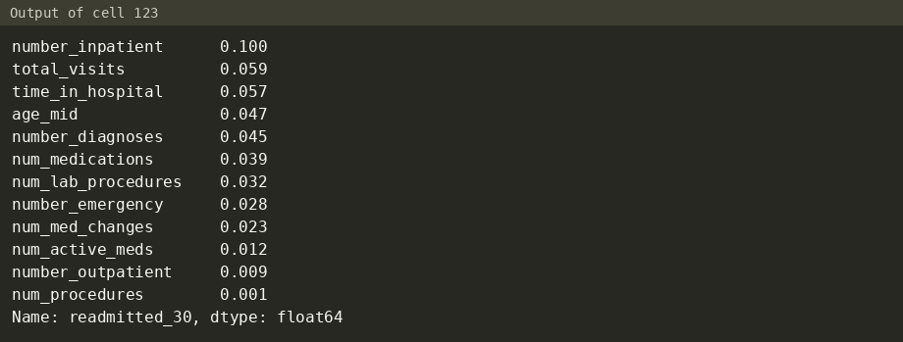
Figure 46-out: output (cell 123)

3.3 Key insights
These insights are sections 2.1 to 2.8 of the existing report. Each one is followed by the code and output that support it.

Insight 1: Prior inpatient visits are the strongest signal
Inpatient visits in the year before | Patients | Readmitted <30 days
0 | 61,779 | 8.12%
1 | 5,794 | 12.89%
2 | 1,501 | 18.52%
3+ | 896 | 26.45%

- The t-test is significant (p ≈ 4.7e-62). Readmitted patients averaged 0.369 prior inpatient visits vs 0.157 for the rest.
- number_inpatient has the highest correlation with the target (0.100).
- So what: patients with 2 or more admissions in the past year should be first in line for discharge follow-up.
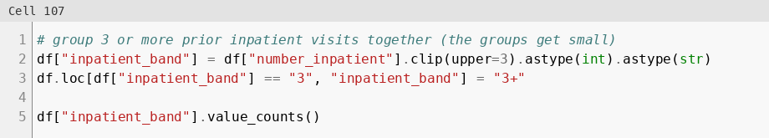
Figure 47: Group prior inpatient visits into bands
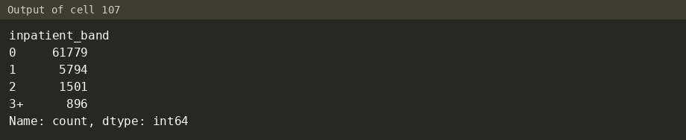
Figure 47-out: output (cell 107)
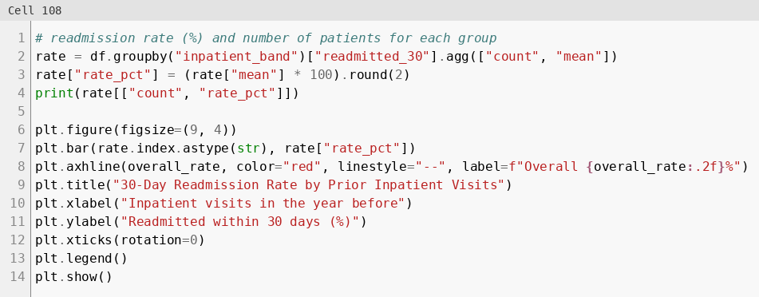
Figure 48: Readmission rate by prior inpatient visits
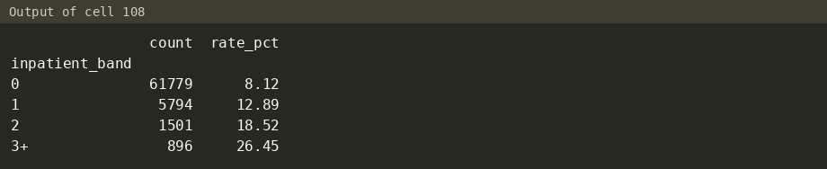
Figure 48-out: output (cell 108)
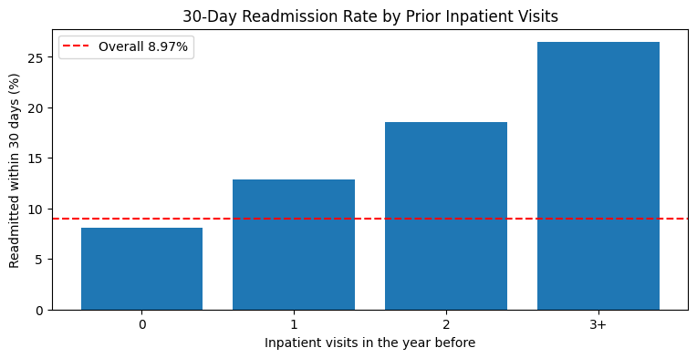
Figure 48-chart: output chart, 30-Day Readmission Rate by Prior Inpatient Visits (cell 108)
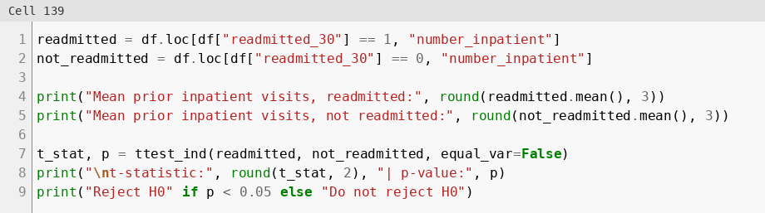
Figure 49: Welch t-test on prior inpatient visits
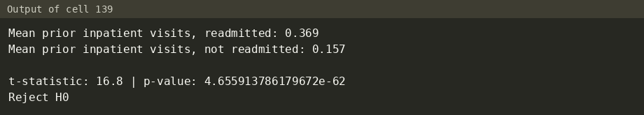
Figure 49-out: output (cell 139)

Insight 2: Longer stays carry higher risk
- The rate rises from 6.54% for 1-day stays to 12.32% for 8-day stays (12.28%-12.30% at 9-10 days).
- The t-test is significant (p ≈ 2.6e-47). Mean stay was 4.76 days for readmitted vs 4.19 days for the rest.
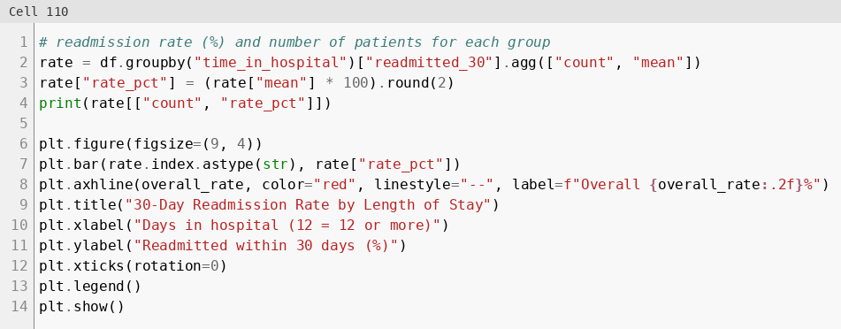
Figure 50: Readmission rate by length of stay
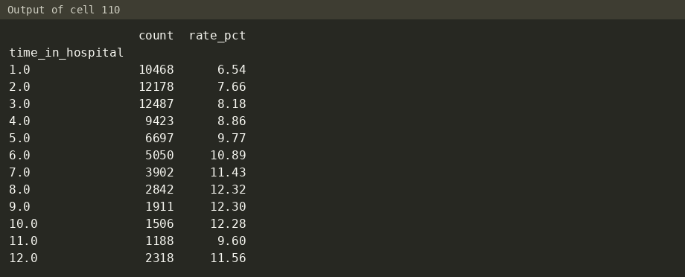
Figure 50-out: output (cell 110)
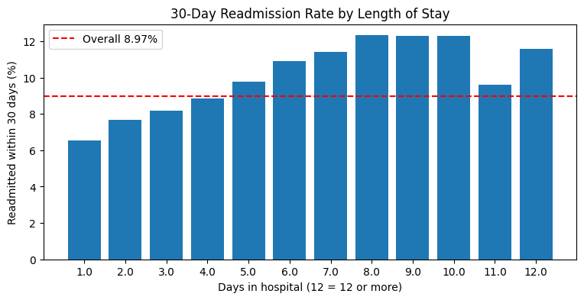
Figure 50-chart: output chart, 30-Day Readmission Rate by Length of Stay (cell 110)
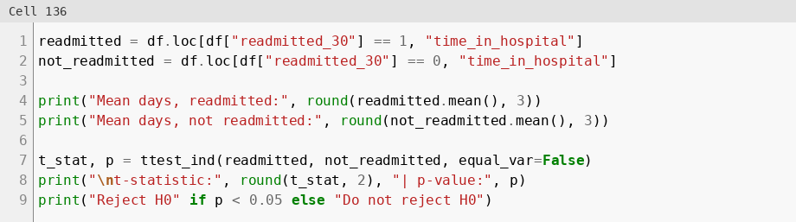
Figure 51: Welch t-test on length of stay
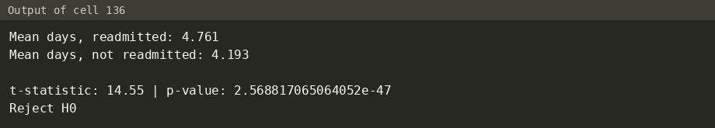
Figure 51-out: output (cell 136)

Insight 3: Older patients are at higher risk
- Ages 70-80: 10.24%, ages 80-90: 10.76% (the highest bands).
- Ages 30-60 sit around 7% (6.98%-7.41%).
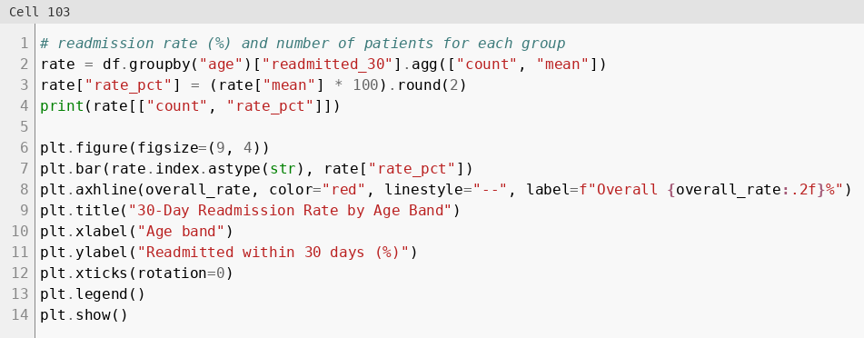
Figure 52: Readmission rate by age band
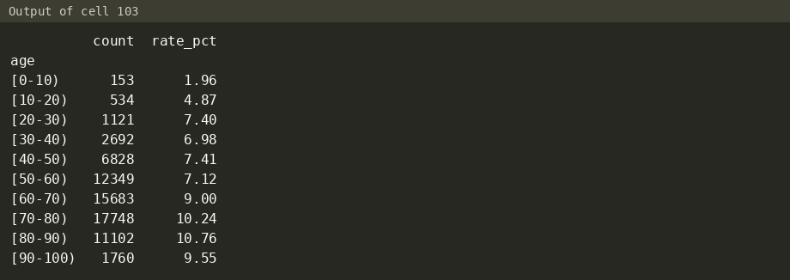
Figure 52-out: output (cell 103)
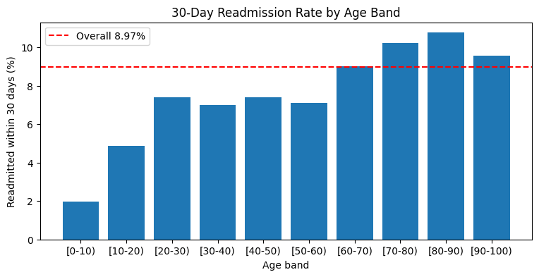
Figure 52-chart: output chart, 30-Day Readmission Rate by Age Band (cell 103)

Insight 4: Primary diagnosis matters
- Highest: Injury 10.78%, Circulatory 9.67%, Diabetes 9.12%.
- Lowest: Respiratory 7.28%, Digestive 8.02%.
- Circulatory is also the largest group (21,383 patients, 31% of all).
- The chi-square test is significant (χ² = 73.7, dof = 8, p ≈ 9.0e-13).
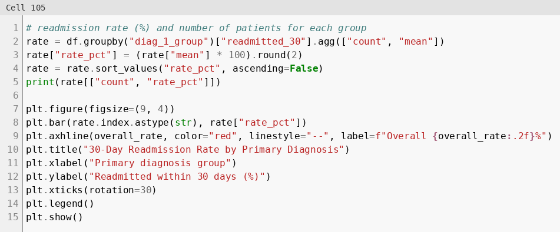
Figure 53: Readmission rate by primary diagnosis group
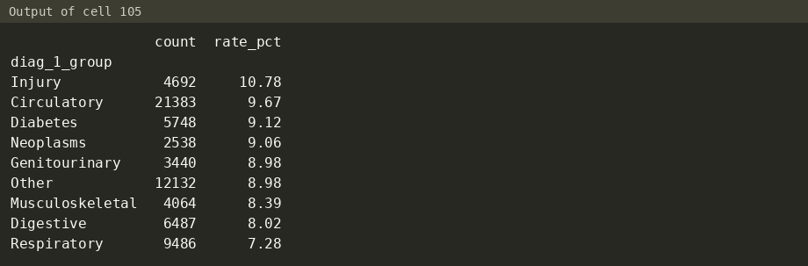
Figure 53-out: output (cell 105)
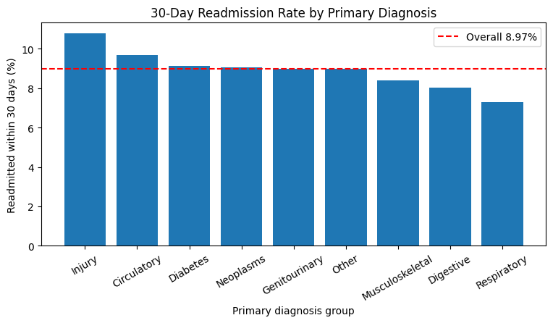
Figure 53-chart: output chart, 30-Day Readmission Rate by Primary Diagnosis (cell 105)
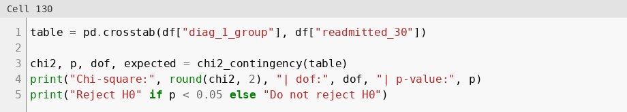
Figure 54: Chi-square test, diagnosis group vs readmission
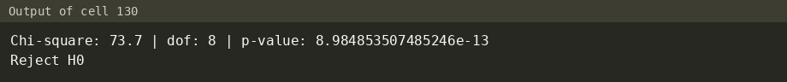
Figure 54-out: output (cell 130)

Insight 5: Medication factors are small but real
- Medication changed during the stay: 9.44% vs 8.59% not changed (χ² = 15.0, p = 0.0001).
- On diabetes medication: 9.42% vs 7.55% not on it.
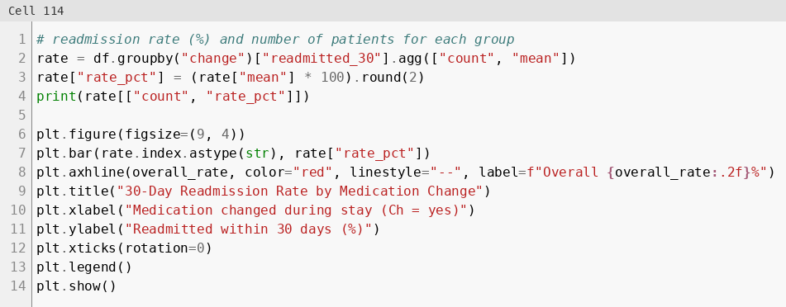
Figure 55: Readmission rate by medication change
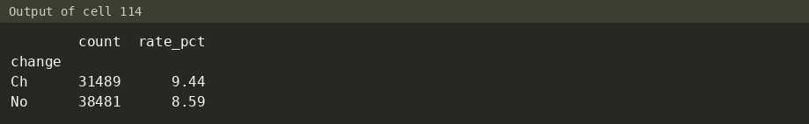
Figure 55-out: output (cell 114)
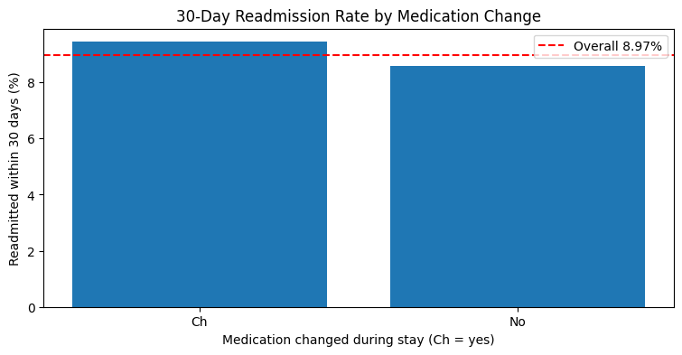
Figure 55-chart: output chart, 30-Day Readmission Rate by Medication Change (cell 114)
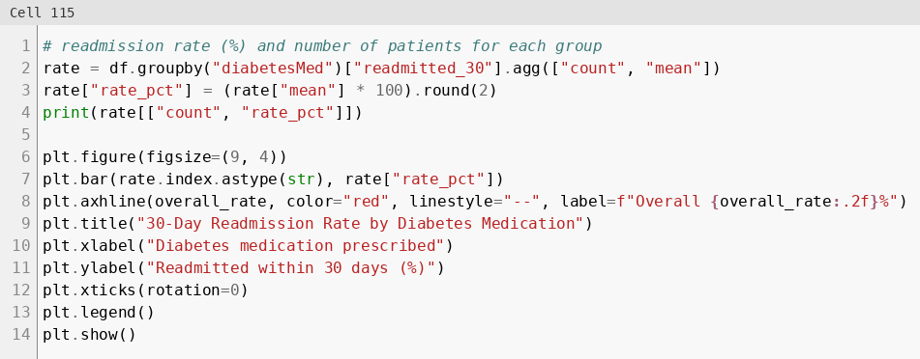
Figure 56: Readmission rate by diabetes medication
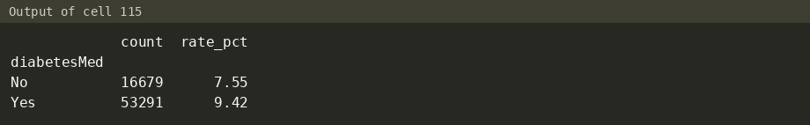
Figure 56-out: output (cell 115)
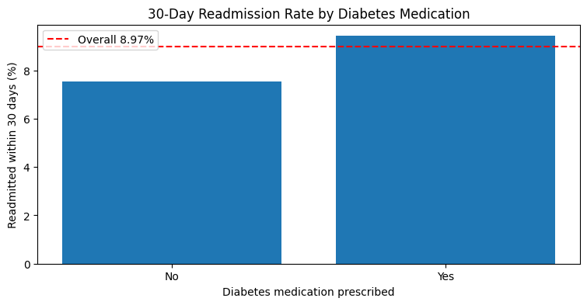
Figure 56-chart: output chart, 30-Day Readmission Rate by Diabetes Medication (cell 115)
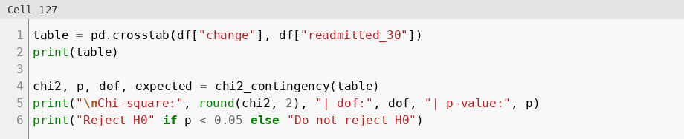
Figure 57: Chi-square test, medication change vs readmission
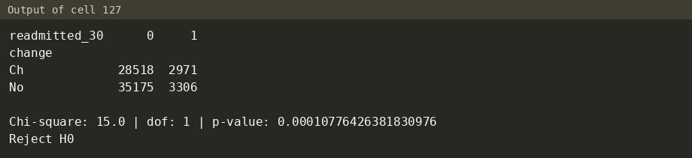
Figure 57-out: output (cell 127)

Insight 6: HbA1c testing showed no significant effect
- Rates: >7 = 8.59%, >8 = 8.16%, Norm = 8.63%, Not tested = 9.10%.
- Chi-square: χ² = 7.27, dof = 3, p = 0.064 > 0.05, so not significant.
- 57,125 patients (82%) were never tested, so this result says little about the test itself.
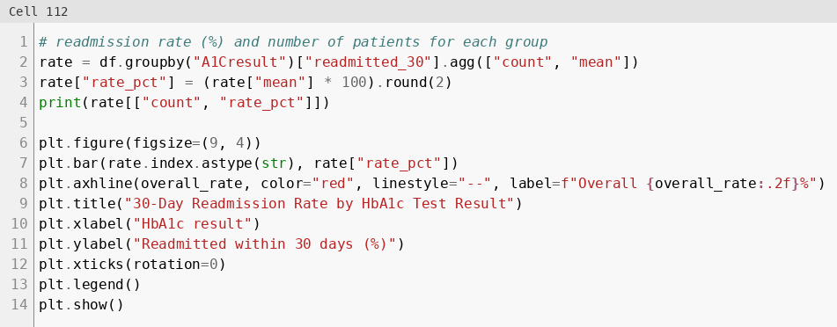
Figure 58: Readmission rate by HbA1c result
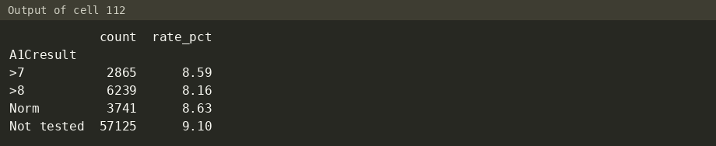
Figure 58-out: output (cell 112)
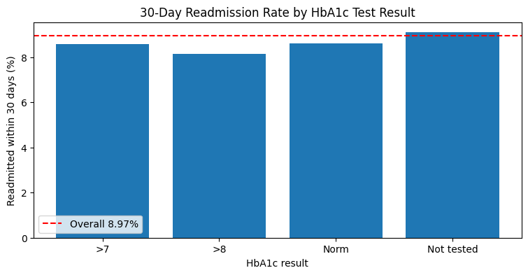
Figure 58-chart: output chart, 30-Day Readmission Rate by HbA1c Test Result (cell 112)
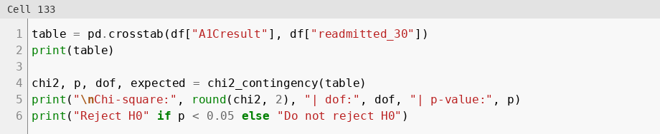
Figure 59: Chi-square test, HbA1c result vs readmission
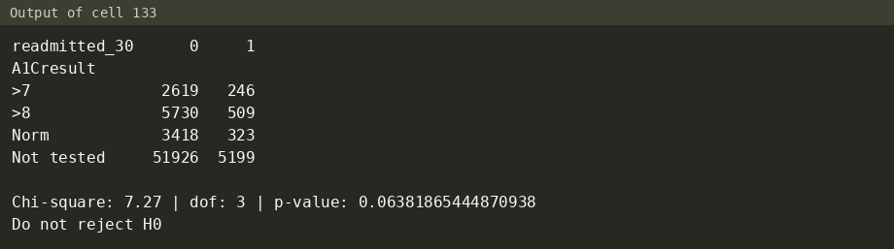
Figure 59-out: output (cell 133)

Insight 7: No single variable separates the groups
- All correlations with the target are weak (max 0.100, Figure 46-out).
- Scatter and pair plots show readmitted and non-readmitted patients overlapping almost completely (Figure 43-chart and Figure 44-chart).
- Expectation for modeling: a model will need many features together, and precision on the positive class will be low.

Insight 8: Hypothesis test summary (alpha = 0.05)
Chi-square tests compare two categorical variables. Welch t-tests compare the mean of a numeric variable between readmitted and not readmitted patients and do not assume equal variances.
# | Test | Variables | Statistic | p-value | Result
1 | Chi-square | change vs readmitted_30 | χ² = 15.0 | 0.0001 | Significant
2 | Chi-square | diag_1_group vs readmitted_30 | χ² = 73.7 | 9.0e-13 | Significant
3 | Chi-square | A1Cresult vs readmitted_30 | χ² = 7.27 | 0.064 | Not significant
4 | Welch t-test | time_in_hospital | t = 14.55 | 2.6e-47 | Significant
5 | Welch t-test | number_inpatient | t = 16.80 | 4.7e-62 | Significant

Caution: with about 70,000 patients even small differences become significant. Effect sizes (the rate gaps above) matter more than p-values.
What this means for decisions and further analysis:
- Use prior inpatient visits first when choosing patients for discharge follow-up.
- Length of stay, age and primary diagnosis add smaller differences in risk.
- HbA1c results cannot guide this decision in this data, because most patients were never tested.
- A prediction model must combine many features, and its precision on the readmitted class will be low.

4. Conclusion

4.1 Process documentation
Dataset overview. UCI Diabetes 130-US Hospitals for Years 1999-2008. diabetic_data.csv has one row per hospital encounter (101,766 rows x 50 columns). IDS_mapping.csv holds the lookup tables for the admission type, discharge disposition and admission source codes. The target is readmission within 30 days (readmitted = "<30").
Data cleaning and transformation. 23 decisions, each with a reason and an effect (section 2). The "?" placeholders became NaN. Four columns were dropped (two over 90% missing, two constant). The rest of the missing values were filled with "Not tested" or "Unknown". One encounter per patient was kept, and expired, hospice and invalid gender rows were removed: 101,766 → 71,518 → 69,973 → 69,970 rows. Outliers were capped with the IQR rule. ICD-9 codes were grouped, rare specialties combined and four features created. The model file was encoded (140 columns) and 12 numeric columns were scaled.
EDA results and key findings. The 30-day readmission rate is 8.97%. Prior inpatient visits are the strongest signal (8.12% for 0 visits up to 26.45% for 3 or more). Longer stays, older age and some diagnoses (Injury, Circulatory) carry higher risk. Medication change has a small but significant effect. HbA1c testing has no significant effect. All correlations with the target are weak (max 0.100).
Where the documentation lives. The notebook explains every step in markdown. The notebook also refers to docs/cleaning_log.md (every cleaning decision) and docs/insights.md (EDA insights). This report collects all of it.

4.2 Code structure
The code is one Jupyter notebook with 189 cells (95 code, 94 markdown). It runs top to bottom. Everything is imported and loaded once in Setup, and each part reuses the variables of the part before it.
Part | What it does | Main variables
Setup | imports, paths, load all files | df_raw, lookup tables
1. Exploration | look at the raw data, no changes | df_raw
2. Cleaning | clean, build features, encode, scale | df (readable), model_df (encoded + scaled)
3. EDA | charts, group rates, hypothesis tests | df
4. Modeling | logistic regression and decision tree | results, top_features

- Markdown before each step. Each part opens with a markdown cell that lists its input, output and steps. Each step has a heading ("Step N: ...") and a short explanation before the code.
- Results explained after the code. "What we see" cells explain the output, and each hypothesis test has an "Interpretation" cell.
- Comments in the code explain the reason for each line that is not obvious, for example "# keep only rows whose discharge code is NOT in the list (~ means NOT)" (Figure 26) and "# make the columns float first, because an upper limit like 13.5 is not a whole number" (Figure 28).
- Repeatable results. The sample for the scatter and pair plots and the train/test split use random_state=42. The data folder is set once (DATA_DIR = "../data").

5. Version Control and Deliverables

5.1 Git and GitHub
Git is used to track the project. The repository is published on GitHub at https://github.com/ManilBista/healthcare-readmission-analysis. It holds the notebook, the cleaned datasets, the documentation and the README, so each change can be traced and the analysis can be repeated.

5.2 Repository organization
The tree lists only the folders and files named in the existing report or the notebook.
<repository root>/
├── data/
│ ├── diabetic_data.csv raw data (input)
│ ├── IDS_mapping.csv ID lookup tables (input)
│ ├── cleaned_readable.csv 69,970 x 51, for EDA and Power BI
│ ├── cleaned.csv 69,970 x 140, encoded and scaled
│ ├── model_metrics.csv model results (Part 4)
│ ├── top_features.csv top 10 features per model (Part 4)
│ └── powerbi/
│ ├── patients.csv
│ ├── readmission_by_group.csv
│ ├── model_metrics.csv
│ └── top_features.csv
├── docs/
│ ├── cleaning_log.md
│ ├── insights.md
├── notebooks/
│ └── diabetes_readmission_analysis.ipynb the project notebook, Parts 1-5
└── sql/
└── load_data.py
The notebook reads and writes through ../data, so it sits one folder below the root. The task also requires a README in the root (5.3).

5.3 README
The README describes the project and how to run it:
- Project: title, question (30-day readmission) and a short summary of the findings.
- Data: source (UCI Diabetes 130-US Hospitals, 1999-2008) and where to put diabetic_data.csv and IDS_mapping.csv (data/).
- Setup: Python 3 with numpy, pandas, matplotlib, seaborn, scipy and scikit-learn (the imports of the Setup cell).
- Run: open the notebook in notebooks/ and run all cells top to bottom.
- Outputs: the cleaned files in data/ and the Power BI files in data/powerbi/.
- Folder structure and documentation: the tree in 5.2 and links to the files in docs/.

5.4 Deliverables
Task deliverable | Covered by
Notebook: data cleaning and transformation steps | Notebook Part 2, Steps 1-17 (report section 2)
Notebook: EDA visualizations and summaries | Notebook Part 3, Steps 2-7 (report sections 3.1 and 3.2)
Notebook: insights and feature selection | Part 3, Step 8 (key insights); columns dropped in Part 2, Steps 3, 4 and 15; top features in Part 4, Step 7 (report 3.3 and Appendix)
Cleaned datasets | data/cleaned_readable.csv, data/cleaned.csv
Well-structured, commented code | Notebook Setup and Parts 1-5 (report section 4.2)
Git integration and GitHub repository with all project files | https://github.com/ManilBista/healthcare-readmission-analysis (report sections 5.1 and 5.2)
Clear and concise documentation | docs/cleaning_log.md, docs/insights.md, docs/dashboard_plan.md and this report
README with setup instructions | README.md in the repository root (report section 5.3)

