**S.MAHALAKSHMI**

**au812921106024**

**solaimaha4@gmail.com**

USING IOT

**ENVIRONMENTAL MONITORING**

INNOVATION

***Data collections:***

Time-series of all India averaged (top panel) annual and (bottom panels) seasonal a mean, b maximum, and c minimum surface air temperatures between 1951 and 2015. Estimates are derived from the IMD daily gridded station data. Recent changes are computed based on linear trends (dashed red line) over the 30-year period 1986–2015. The rate of warming during this period in °C per decade is shown below the trend

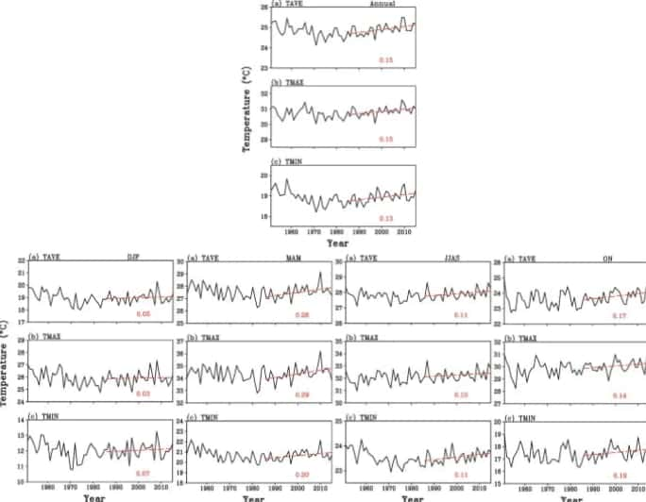

These long-term changes in surface air temperature over India during the twentieth century also broadly agree with earlier assessments (e.g. Rupa Kumar et al. 1994; Sen Roy and Balling 2005; Kothawale and Rupa Kumar 2005; Srivastava et al. 2009; Kothawale et al. 2010a; Jain and Kumar 2012; Rai et al. 2012; Vinnarasi et al. 2017; Kothawale et al. 2016; Kulkarni et al. 2017; Srivastava et al. 2017, 2019). Indian annual mean land surface air temperatures have warmed by 0.6 °C century−1 between 1901 and 2018 (Srivastava et al. 2019). All India mean annual tropospheric temperature measured by radiosonde stations also showed an increasing trend from the surface to 500 hPa during the period 1971–2015 (Kothawale and Singh 2017). A similar warming trend is revealed by dendroclimatic studies over the eastern Himalaya including Sikkim and Bhutan in recent decades (Krusic et al. 2015; Yadava et al. 2015; Borgaonkar et al. 2018). The Dew Point (or frost point if the temperature is < 0.0 °C is the saturation temperature of a parcel of air, i.e. the point at which water condenses out. It is the temperature at which an object would need to be for dew to form on it (dew forms because certain objects - like cars - cool more rapidly than the air, enabling them to reach the dew point). It is directly proportional to the specific humidity, and very well correlated to the absolute humidity. In everyday terms, high dew points are more uncomfortable as sweating is less effective.

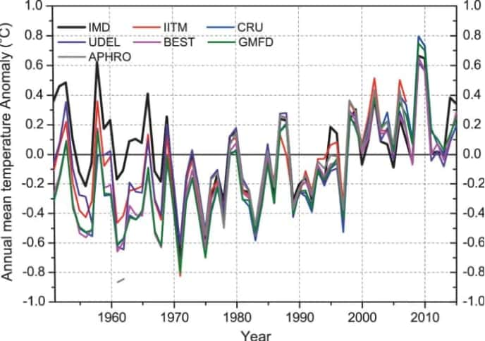

Relative Humidity, on the other hand, is rather more abstract and has a very technical definition: the ratio of the partial pressure of water vapour in the air to the saturated vapour pressure of that water. The saturated vapour pressure is proportional to the air temperature, and the partial pressure indicates how much water vapour the air contains, so at a given temperature, the RH is entirely dependent on this partial pressure, making the RH useful in determining the extent to which the air is water-saturated. For example: When it rains the relative humidity will increase, but the dew point may not, as the temperature will usually fall as well. If the dew point is the same when the RH increases, the air has the same amount of water but it is cooler, so it is more saturated, as less water vapour can exist in cooler air.



Simply and concisely: Dew point is a rough measure of how much water vapour is physically in the air; relative humidity is just a measure of the degree to which the air is full of water vapour (i.e. its saturation). One is an absolute measure, the other is relative.