1. Write a query to insert a new employee into the Employees table with values (1, 'John', 'HR', 50000).

2. Write a query to insert multiple rows into a table in a single query.

3. Write an INSERT query where only some columns are provided (not all).

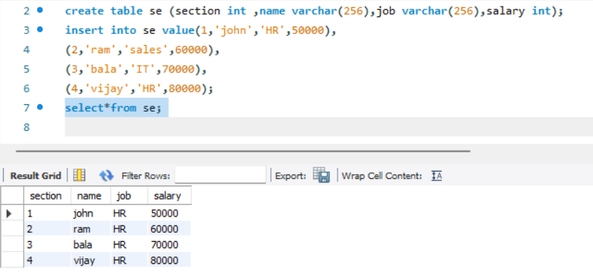

4. Write a query to update the salary of an employee with ID = 101 to 60000.

5. Update the department of all employees from 'Sales' to 'Marketing'.

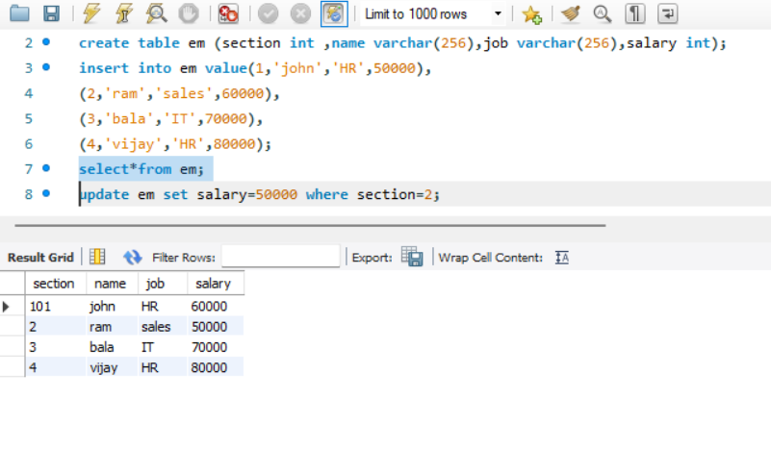

6. Increase salary by 10% for all employees in the 'IT' department.

7. Write a query to update multiple columns in a table using a single statement.