q1.

create a database bookshop

create a collection books

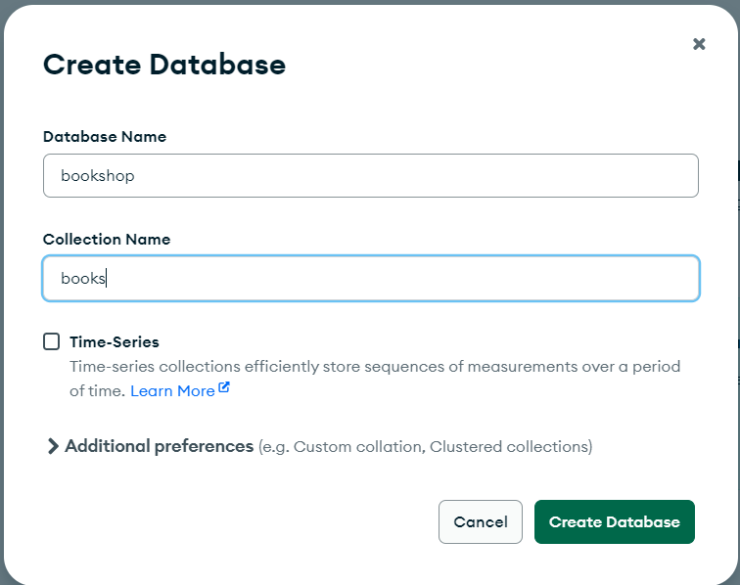

insert the following data

db.books.insertMany([

{

"title": "The Hobbit",

"author": "J.R.R. Tolkien",

"published_year": 1937,

"genres": ["Fantasy", "Adventure"],

"pages": 310,

"available": true,

"rating": 4.8

},

{

"title": "1984",

"author": "George Orwell",

"published_year": 1949,

"genres": ["Dystopian", "Political Fiction"],

"pages": 328,

"available": true,

"rating": 4.7

},

{

"title": "To Kill a Mockingbird",

"author": "Harper Lee",

"published_year": 1960,

"genres": ["Southern Gothic", "Drama"],

"pages": 281,

"available": false,

"rating": 4.6

},

{

"title": "The Great Gatsby",

"author": "F. Scott Fitzgerald",

"published_year": 1925,

"genres": ["Tragedy"],

"pages": 180,

"available": true,

"rating": 4.4

},

{

"title": "Brave New World",

"author": "Aldous Huxley",

"published_year": 1932,

"genres": ["Science Fiction", "Dystopian"],

"pages": 311,

"available": true,

"rating": 4.2

}

])

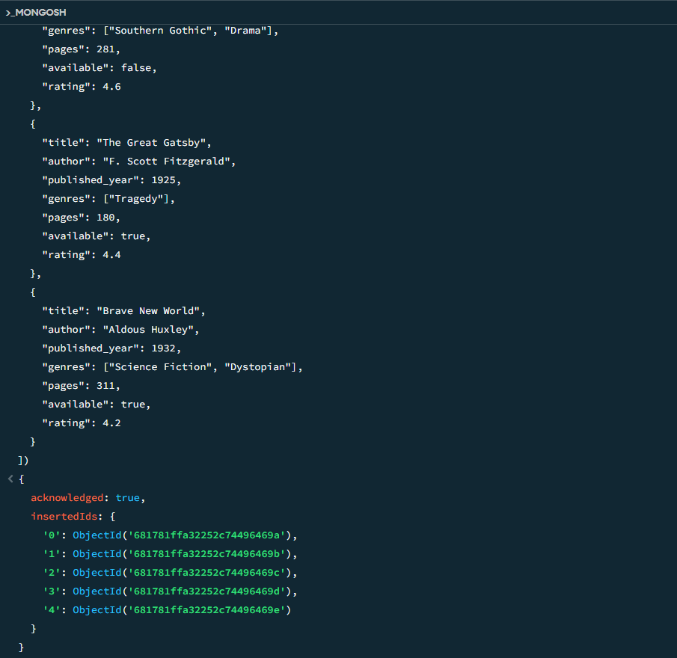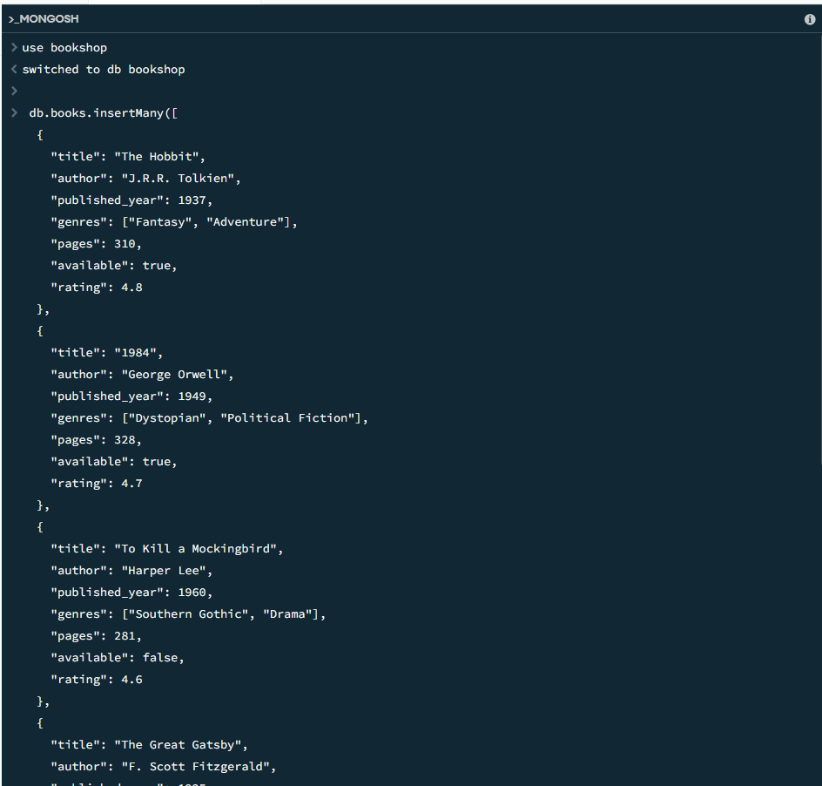

Find all books:

db.books.find()

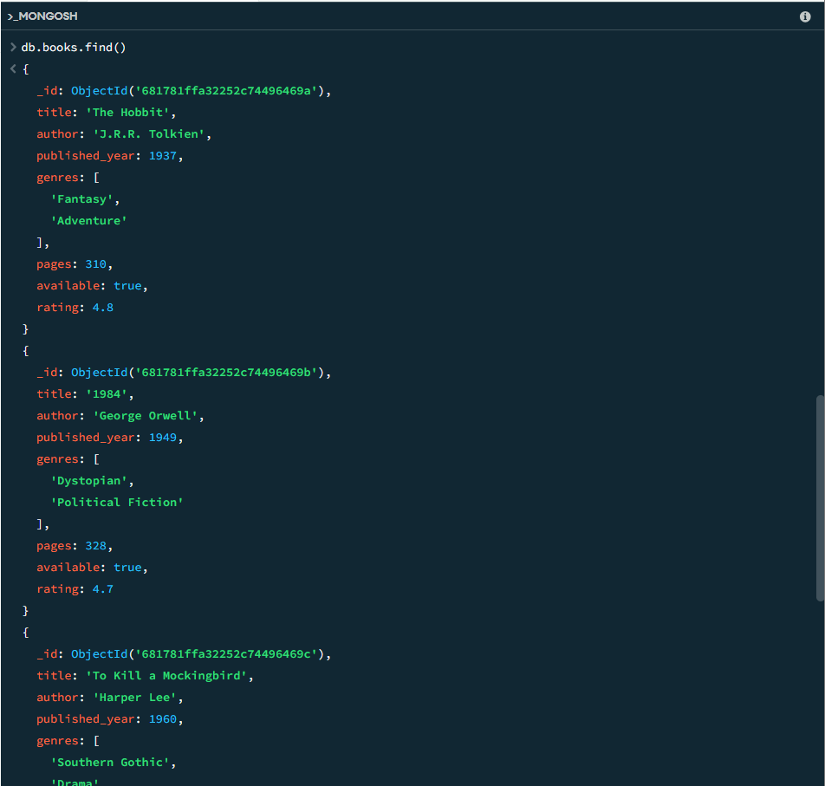

Find all books published after 1950:

db.books.find({published_year:{$gt:1950}})

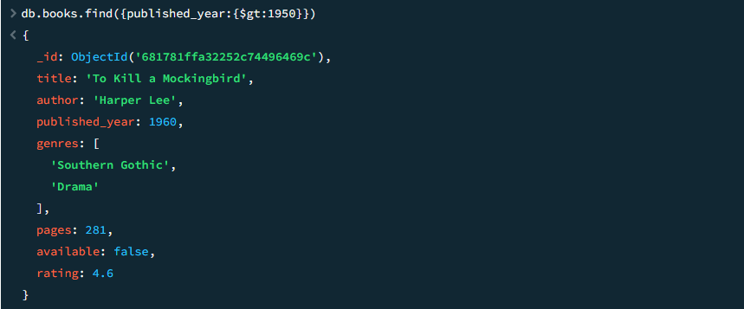

Find the avilable books:

db.books.find({available:true})

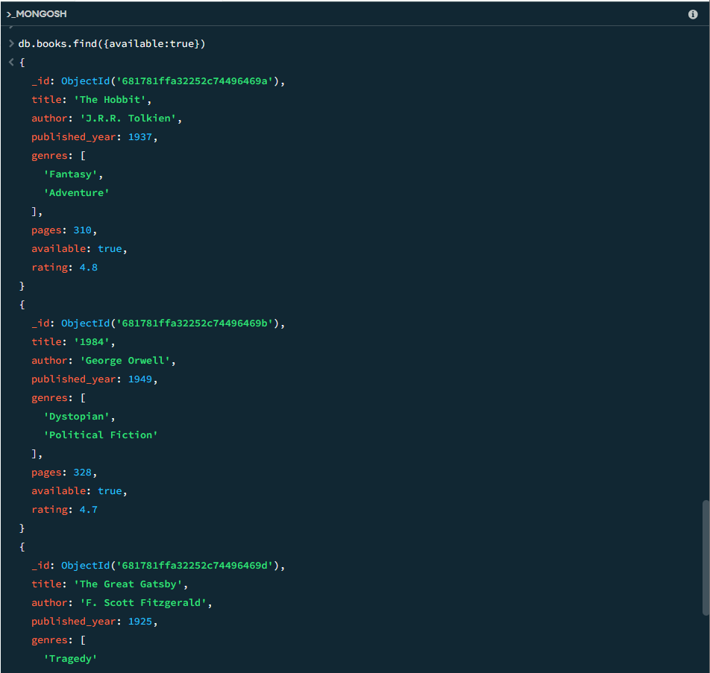

Find all books that belong to the "Dystopian" genre:

db.books.find({'genres':'Dystopian'})

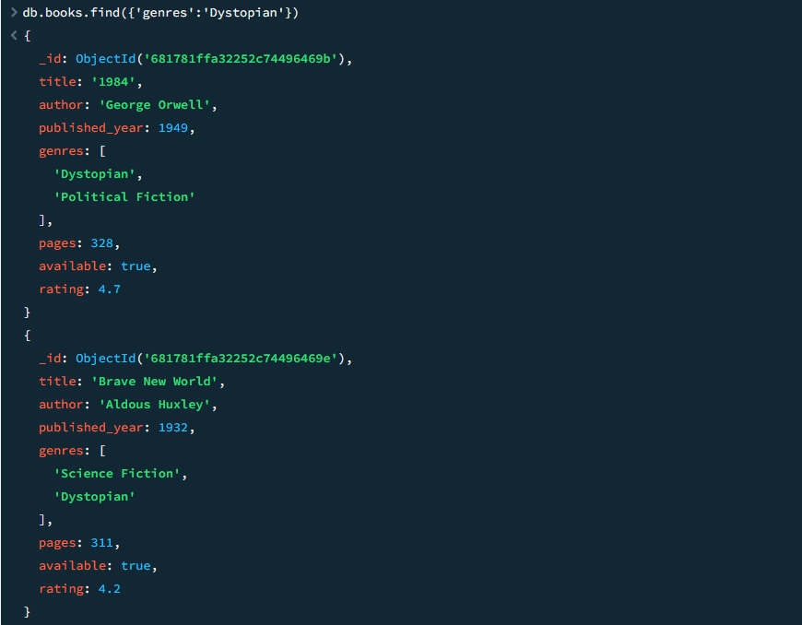

Find the books which published after 1960 and had rating more than 4.0:

db.books.find(

{published_year: {$gt: 1960}, rating: {$gt: 4.0}},

{title: 1, author: 1, _id: 0}

)

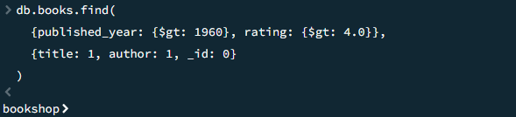

Project only title and author fields:

Update the book "1984" to set available: false:

db.books.updateOne(

{title: "1984"},

{$set: {available: false}}

)

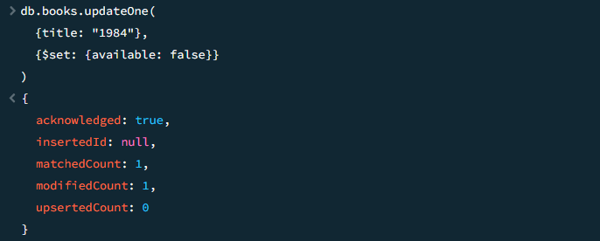

Increase the rating of "Brave New World" by +0.1:

db.books.updateOne(

{title: "Brave New World"},

{$inc: {rating: 0.1}}

)

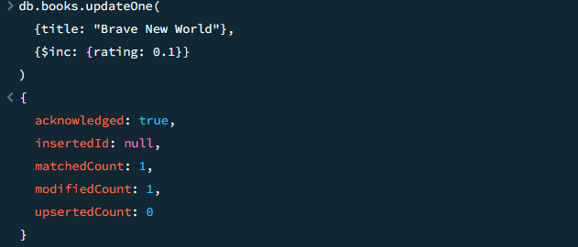

Add a new genre "Classic" to "The Great Gatsby":

db.books.updateOne(

{title: "The Great Gatsby"},

{$addToSet: {genres: "Classic"}}

)

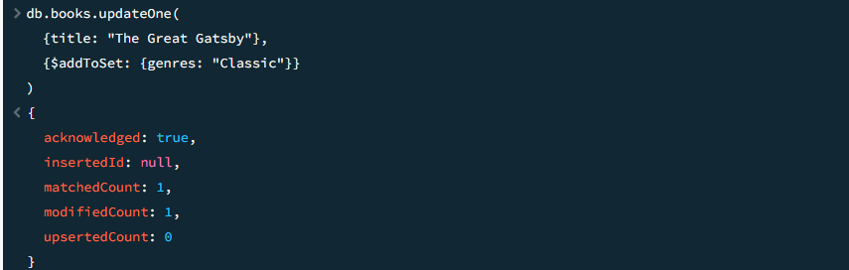

Sort books by published_year ascending:

db.books.find().sort({published_year: 1})

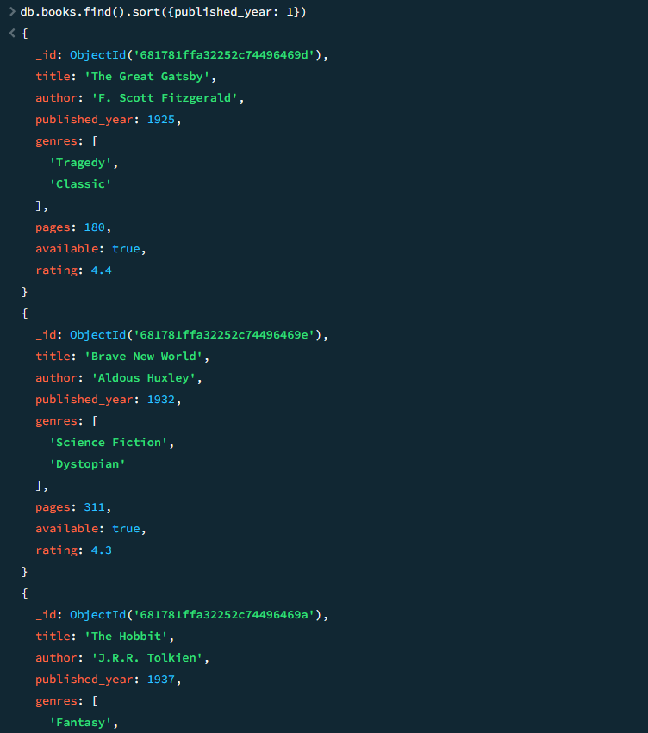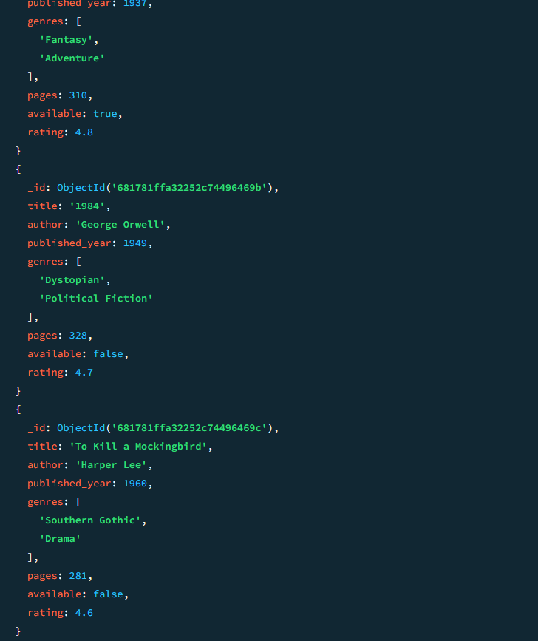

Sort books by rating descending:

db.books.find().sort({rating: -1})

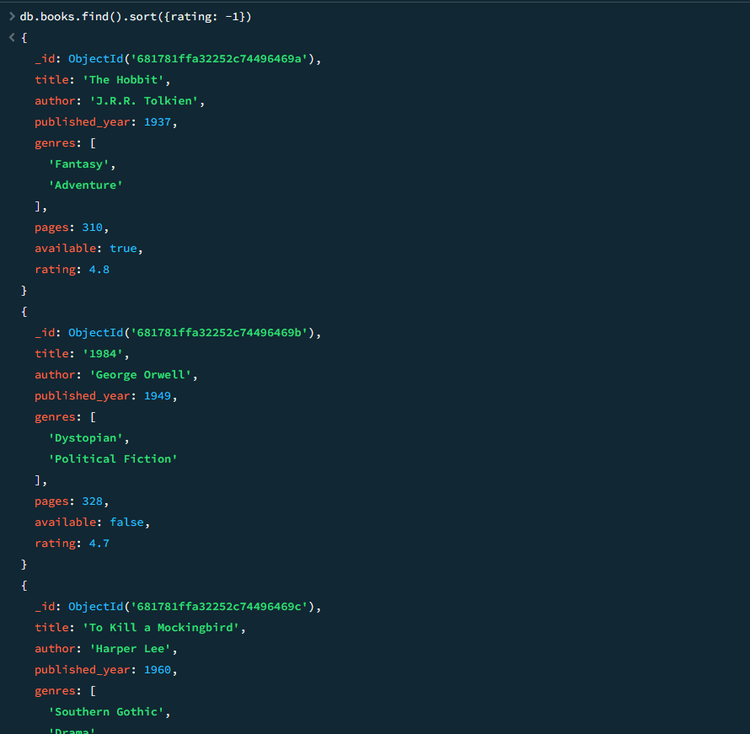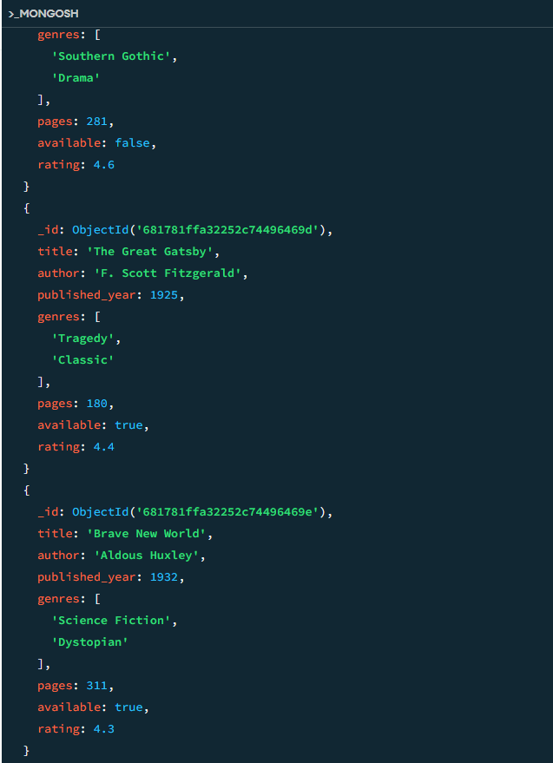

Delete all books with a rating lower than 4.5:

db.books.deleteMany({rating: {$lt: 4.5}})

