in unidb=> create collection=>degrees

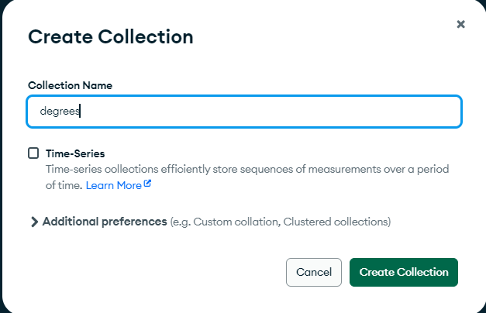

//add data

{

"_id": {

"$oid": "680ee94ab6eca57c4ed6ea42"

},

"name": "BIT",

"duration": 3

}

{

"_id": {

"$oid": "680ee986b6eca57c4ed6ea43"

},

"name": "B.Sc in IT",

"duration": 4

}

{

"_id": {

"$oid": "680eeacbb6eca57c4ed6ea44"

},

"name": "B.Sc in Environmental Science",

"duration": 4

}

{

"_id": {

"$oid": "680eeaddb6eca57c4ed6ea45"

},

"name": "B.Sc in Environmental ScienceApplied Mathematics",

"duration": 3

}

{

"_id": {

"$oid": "680eeae9b6eca57c4ed6ea46"

},

"name": "B.Sc in Computer Science",

"duration": 4

}

--------------------------------------------------------------------------------------------------------------------

// in shell

use unidb

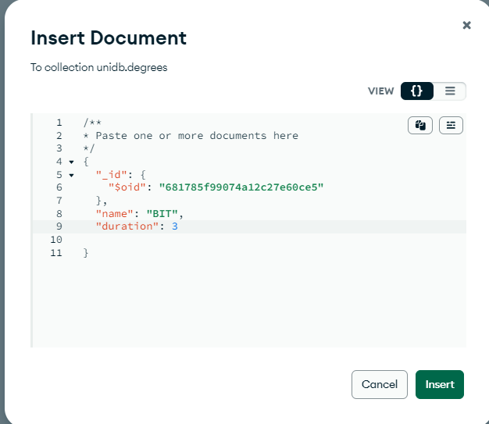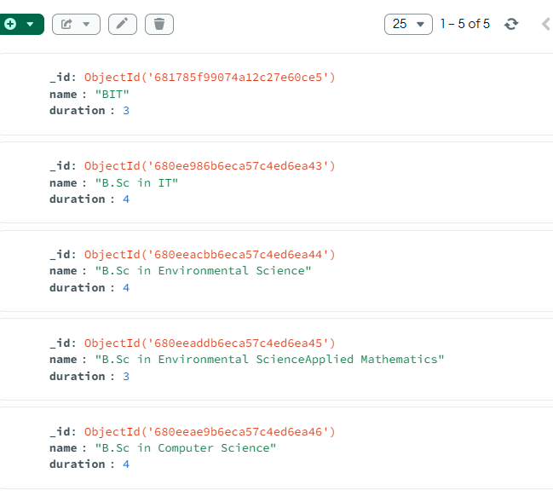

db.degrees.deleteOne({_id:ObjectId('680ee94ab6eca57c4ed6ea42')})

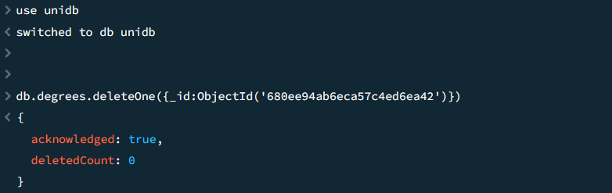

db.degrees.find().projection(['name'])

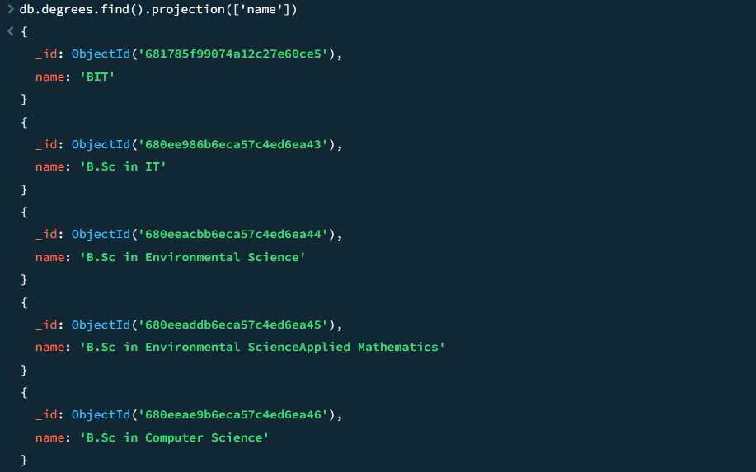

db.degrees.find().projection([{'name':1},{'_id':-1}])

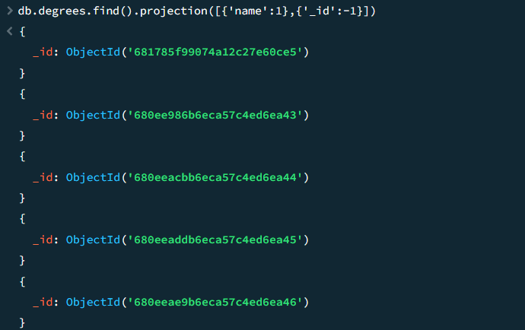

db.degrees.find().projection(['name','duration'])

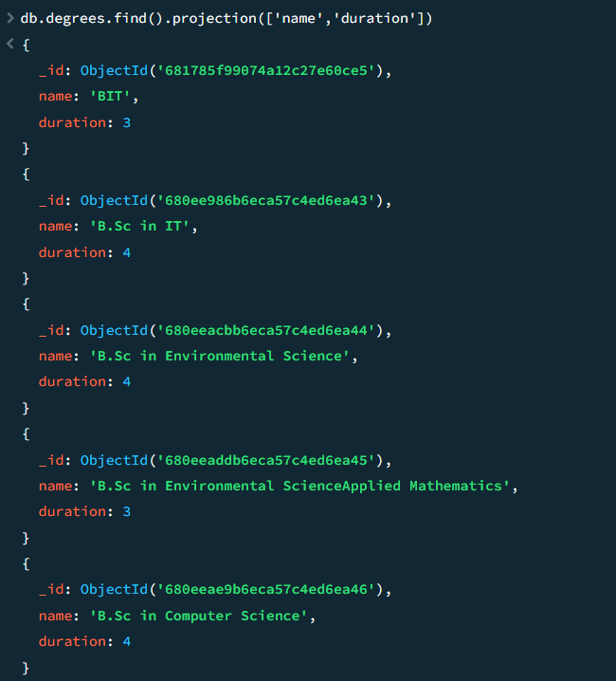

db.degrees.find({},{name:1,_id:0}).pretty()

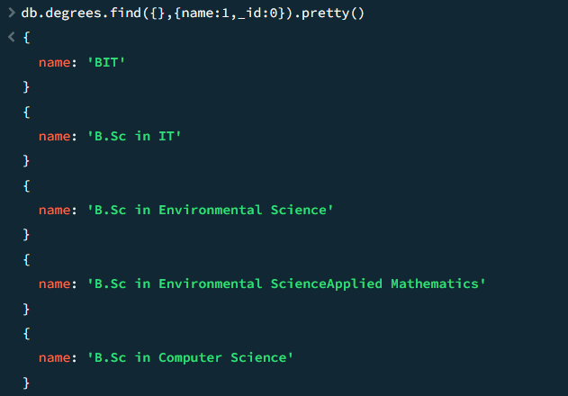

db.degrees.deleteMany({duration:{$lt:4}})

db.degrees.find({},{name:1,_id:0}).pretty()

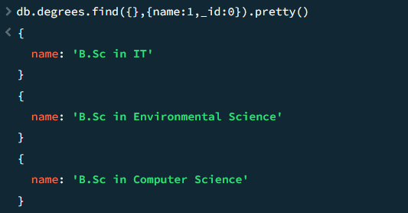

-----------------------------------------------------------------------------------------------------------------------

// after that refresh degrees and add data

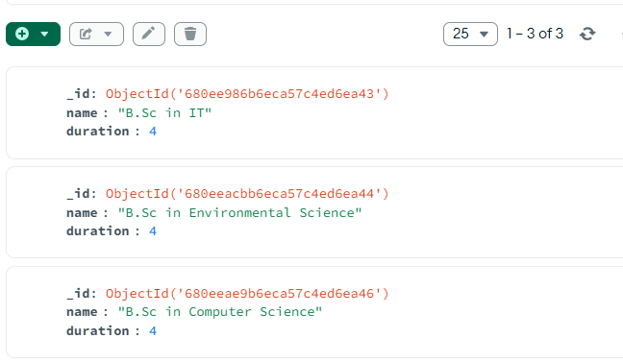

{

"_id": {

"$oid": "680eeffcb6eca57c4ed6ea48"

},

"name": "FGHIJG",

"duration": 1

}

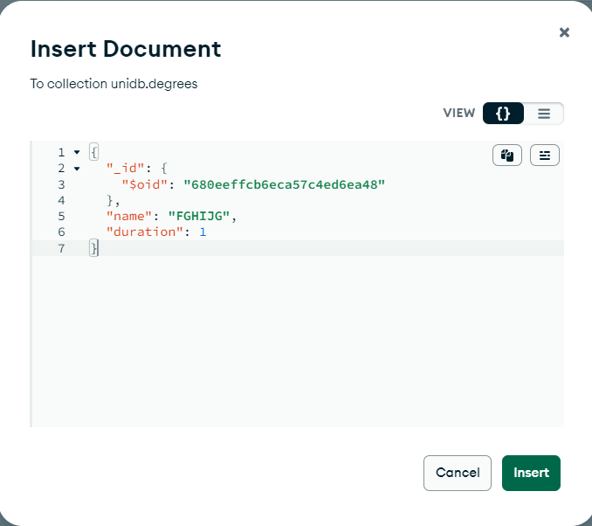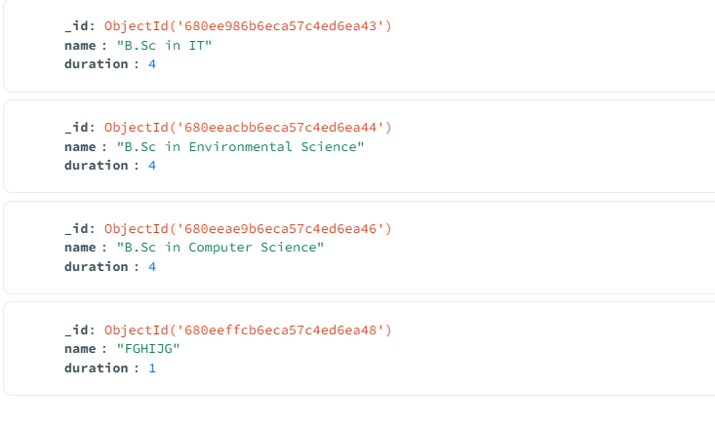

---------------------------------------------------------------------------------------------------------------------------------

//after that go to shell

db.degrees.updateOne({_id:ObjectId('680eeffcb6eca57c4ed6ea48')},{$set:{name:'BIT',duration:3}})

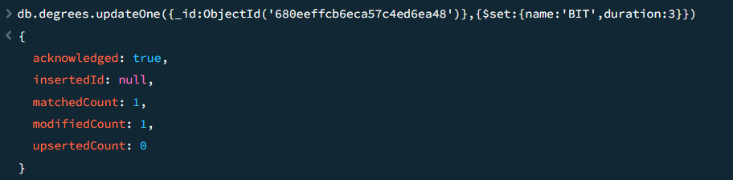

db.degrees.findOne({_id:ObjectId('680eeffcb6eca57c4ed6ea48')})

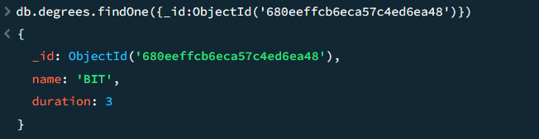

db.degrees.updateMany({duration:{$gte:4}},{$inc:{duration:1}})

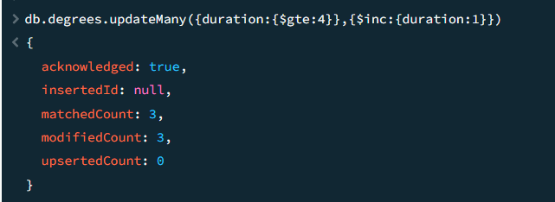

db.degrees.find()

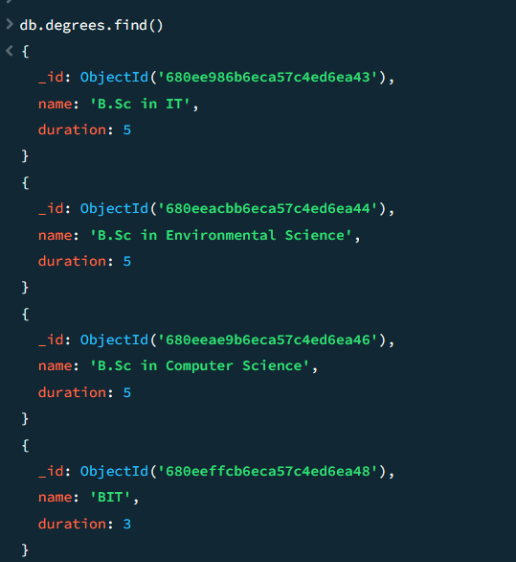

db.students.updateOne({regno:'2021IT001'},{$push:{skills:'PHP'}})

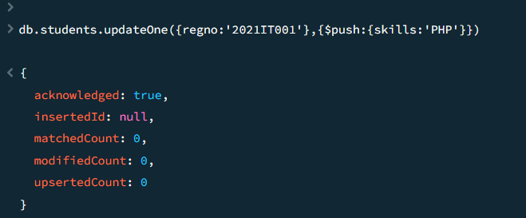

db.students.findOne({regno:'2021IT001'})

