A PROJECT REPORT ON
HELICOPTER EMERGENCY LANDING PLACE SUGGESTION SYSTEM
HELPS
Submitted in partial fulfillment for the award of the degree of
Bachelor of Technology in CSE AI ML
by
Manimeganath Amancherla – 23BAI1278
Vishnu Achyut Managoli – 23BAI1437
Kadiri Neha Reddy – 23BAI1109

SCHOOL OF COMPUTER SCIENCE AND ENGINEERING
Vellore Institute of Technology Chennai
October 2026

HELICOPTER EMERGENCY LANDING PLACE SUGGESTION SYSTEM
A project report submitted in partial fulfillment of the requirements for the award of the degree of Bachelor of Technology in Computer Science and Engineering – Artificial Intelligence and Machine Learning
Submitted by
Manimeganath Amancherla – 23BAI1278
Vishnu Achyut Managoli – 23BAI1437
Kadiri Neha Reddy – 23BAI1109
Under the guidance of
Dr. Poonkodi M – 51360 – Assistant Professor Senior Grade 2
School of Computer Science and Engineering
Vellore Institute of Technology Chennai
October 2026

DECLARATION
I hereby declare that the project report entitled "Helicopter Emergency Landing Place Suggestion System" submitted for the award of the degree of Bachelor of Technology at Vellore Institute of Technology, Chennai, is a record of bonafide work carried out by me under the supervision of Dr. Poonkodi M.
I further declare that the work reported in this document has not been submitted, either in part or in full, for the award of any other degree or diploma at this or any other institution.
Place: Chennai
Date: 21st October 2026
Signature of the Candidate: MANIMEGHANATH A
Name: Manimeghanath A
Registration Number: 23BAI1278

School of Computer Science and Engineering

CERTIFICATE
This is to certify that the report entitled "Helicopter Emergency Landing Place Suggestion System" was prepared and submitted by Manimeghanath A(23BAI1278) to Vellore Institute of Technology, Chennai, in partial fulfillment of the requirements for the award of the degree of Bachelor of Technology in Computer Science and Engineering – Artificial Intelligence and Machine Learning. The work is a bonafide record carried out under my guidance and, in my opinion, meets the standards required for submission.
Signature of the Guide: ____________________
Name: Dr. Poonkodi M
Designation: Assistant Professor Senior Grade 2
Date:
Signature of Examiner 1: ____________________
Signature of Examiner 2: ____________________

Approved by the Head of Department
Name: Dr. Tulasi Prasad Sariki
Department: Computer Science and Engineering – Artificial Intelligence and Machine Learning
Date: __________

ABSTRACT
The Helicopter Emergency Landing Place Suggestion System (HELPS) is a geospatial decision support system to minimize the time and workload for emergency landing site identification. The system decouples terrain analysis (computationally intensive operation) from mission-time decision making. The satellite imagery, a digital elevation model, restricted-area information and geographic information system layers are normalized and converted to re-usable terrain knowledge in the offline stage. The candidate terrain is represented as a set of connected Terrain Objects that have attributes of surface type, geometry, vegetation, water presence, accessibility and infrastructure context. A multi-threshold slope analysis is then performed to subdivide each object into Operational Zones and then calculate a pole of inaccessibility and maximum inscribed-circle radius for safe footprint assessment.
At time of emergency, the online pipeline fetches operational zones in the vicinity of the helicopter and checks them against operational limits of the models, weather and wind conditions, landing footprint and mission priority. Infeasible locations are removed using mandatory constraints, and a ranking engine (configured) provides explainable locations with coordinates, suitability scores and factors. The architecture is independent of a particular aircraft, enables local processing and controlled access to the data, and enables the database and ranking strategy to change independently of each other. HELPS is not a stand-alone flight-control system, but rather a system to support pilots. The resulting problem, requirements, architecture, data model, processing methodology, validation strategy, risks, limitations and phased implementation roadmap that resulted from the system design are documented in this report.
This webinar explores how satellite information can be utilized to support geospatial decision making for helicopter emergency landings, covering the creation and use of digital elevation models and slope analysis, as well as the definition of operational zones, development of a spatial database and mission-aware ranking.
Keywords: helicopter emergency landing, geospatial decision support, terrain knowledge, satellite imagery, slope analysis, operational zones, landing footprint, explainable ranking

ACKNOWLEDGEMENT
I thank Dr. Poonkodi M, Assistant Professor Senior Grade 2, School of Computer Science and Engineering, Vellore Institute of Technology Chennai, for her guidance and feedback during this project. I am grateful to the department and project coordinators for the facilities and academic support provided. I also thank my teammates, Vishnu Achyut Managoli and Kadiri Neha Reddy, for their contributions, and my family and friends for their encouragement throughout the work.

Place: Chennai
Date:
Manimeghanath A

CONTENTS
DECLARATION i
CERTIFICATE ii
ABSTRACT iii
ACKNOWLEDGEMENT iv
CONTENTS v
LIST OF FIGURES ix
LIST OF TABLES x
LIST OF ACRONYMS xi
Chapter 1 1
INTRODUCTION 1
1.1 Project Context 1
1.2 Problem Statement 1
1.3 Objectives 1
1.4 Scope 1
1.5 Report Organization 2
Chapter 2 3
BACKGROUND AND TECHNOLOGY REVIEW 3
2.1 Geospatial Data for Terrain Understanding 3
2.2 Spatial Databases 3
2.3 Terrain Representation 4
2.4 Research and Engineering Gap 4
2.5 Helicopter Emergency Landing Research 4
2.6 Land-Cover Classification and Obstacle Detection 4
2.7 Digital Elevation Models and Terrain Analysis 5
2.8 Terrain Representation and Spatial Algorithms 5
Chapter 3 6
SYSTEM REQUIREMENTS AND ANALYSIS 6
3.1 Stakeholders 6
3.2 Assumptions and Constraints 7
Chapter 4 8
SYSTEM ARCHITECTURE AND DESIGN PHILOSOPHY 8
4.1 Core Design Principles 8
Chapter 5 10
PROBLEM UNDERSTANDING 10
5.1 Background 10
5.2 Problem Statement 10
5.3 Challenges in Helicopter Emergency Landing 11
5.4 Limitations of Existing Navigation and Landing Systems 11
5.5 Importance of Terrain Understanding 12
5.6 Project Objectives 12
5.7 Project Scope 12
5.8 Assumptions 13
5.9 Limitations 13
5.10 Chapter Summary 14
Chapter 6 15
DESIGN PHILOSOPHY 15
6.1 Vision of HELPS 15
6.2 Design Principles 15
6.3 Terrain-First Philosophy 16
6.4 Helicopter-Independent Terrain Knowledge 16
6.5 Pilot-Centric Decision Support 16
6.6 Explainable Recommendation Strategy 16
6.7 Confidentiality and Local Processing 16
6.8 Adaptability to Different Geographic Regions 17
6.9 Scalability Towards Real-Time Deployment 17
6.10 Chapter Summary 17
Chapter 7 18
OVERALL SYSTEM ARCHITECTURE 18
7.1 System Overview 18
7.2 Terrain Knowledge Generation Pipeline 18
7.3 Helicopter Landing Recommendation Pipeline 18
7.4 Terrain Knowledge Integration 19
7.5 End-to-End Data Flow 19
Chapter 8 20
TERRAIN KNOWLEDGE GENERATION 20
Module 1: Data Acquisition 20
Module 2: Candidate Terrain Identification 24
Module 3: Terrain Characterization 28
Module 4: Slope Analysis & Operational Zone Generation 31
Module 5: Operational Zone Environmental Context Analysis 34
Chapter 9 38
TERRAIN KNOWLEDGE DATABASE 38
9.1 Overview 38
9.2 Inputs 39
9.3 Methodology 39
Chapter 10 42
HELICOPTER LANDING RECOMMENDATION PIPELINE 42
10.1 Overview 42
10.2 Inputs 42
10.3 Methodology 43
Module 1: Helicopter Input Processing 43
Module 2: Nearby Operational Zone Retrieval 43
Module 3: Weather & Operational Feasibility Assessment 44
Module 4: Operational Constraint Matching 45
Module 5: Landing Footprint Validation 45
Module 6: Mission-Aware Ranking Engine 46
Module 7: Recommendation Generation 47
10.4 Outputs 48
10.5 Validation & Limitations 48
Chapter 11 49
DESIGN DECISIONS AND ENGINEERING COMPONENTS 49
11.1 Terrain Representation 49
11.2 Connected Terrain Extraction 49
11.3 Multi-Threshold Slope Representation 49
11.4 Operational Zone Representation 50
11.5 Landing Reference Point Selection 50
11.6 Landing Footprint Validation 51
11.7 Environmental Context Representation 51
11.8 Configurable Recommendation Framework 52
11.9 Separation of Knowledge Generation and Recommendation 52
11.10 Chapter Summary 52
Chapter 12 53
SYSTEM DEVELOPMENT PHASES 53
12.1 Development Philosophy 53
12.2 Phase 1: Geospatial Data Infrastructure 53
12.3 Phase 2: Candidate Terrain Generation 53
12.4 Phase 3: Terrain Characterization 54
12.5 Phase 4: Operational Zone Generation 54
12.6 Phase 5: Terrain Knowledge Database 55
12.7 Phase 6: Helicopter Recommendation Engine 55
12.8 Phase 7: User Interface and System Integration 55
12.9 Phase 8: System Optimization and Enhancement 56
12.10 Chapter Summary 56
Chapter 13 58
TESTING AND VALIDATION 58
13.1 Validation Objectives 58
13.2 Safety and Assurance 59
13.3 Project Outcomes and Interpretation 59
Chapter 14 60
CONCLUSION AND FUTURE WORK 60
14.1 Conclusion 60
14.2 Future Work 60
REFERENCES 61
APPENDIX 1 63
RISK REGISTER 63
APPENDIX 2 64
CORE DATA DICTIONARY 64
APPENDIX 3 65
PRE-SUBMISSION CHECKLIST 65

LIST OF FIGURES
Figure 4.1 Overall two-stage architecture of HELPS
Figure 4.2 Terrain knowledge generation pipeline
Figure 4.3 Mission-time recommendation pipeline
Figure 9.1 Hierarchical terrain knowledge database model
Figure 11.1 Complete footprint containment including internal exclusions
Figure 13.1 Validation strategy

LIST OF TABLES
Table 2.1 External geospatial data sources
Table 3.1 Functional requirements
Table 3.2 Non-functional requirements
Table 13.1 Validation matrix
Table 12.1 Development phase outputs
Table A.1 Risk register
Table A.2 Core data dictionary

LIST OF ACRONYMS
Acronym | Meaning
AOI | Area of Interest
API | Application Programming Interface
CRS | Coordinate Reference System
DEM | Digital Elevation Model
GIS | Geographic Information System
HELPS | Helicopter Emergency Landing Place Suggestion System
MIR | Maximum Inscribed Circle Radius
MSI | Multispectral Instrument
OSM | OpenStreetMap
POI | Pole of Inaccessibility
SRTM | Shuttle Radar Topography Mission

Chapter 1

INTRODUCTION

1.1 Project Context

Helicopter crews may be forced to land outside of established facilities during medical evacuation, search and rescue, disaster response, and other remote situations. In the event of an emergency, the pilot will have to operate the aircraft and evaluate the unknown terrain. Many factors influence the selection, including slope, surface conditions, obstacles, available access clearance, and responder access. HELPS bundles these terrain factors into one resource for the crew to compare a small set of locations that are manageable.

1.2 Problem Statement

A map provides the pilot with the location of terrain and infrastructure but the pilot must still interpret the information on the map against the aircraft and the emergency. HELPS' task is to address the question: How is it possible to transform geospatial information into connected regions of terrain that can be measured and then evaluate those regions rapidly for a specific helicopter?
The output should be explanations of why each alternative satisfies the set checks and of the order of the feasible alternatives.

1.3 Objectives

Generate terrain knowledge that is independent of helicopters from satellite imagery, elevation models, restricted-area data and GIS layers. • Determine what connected candidate terrain is and describe its geometry, surface, vegetation, water and accessibility. • Define Operational Zones, and calculate representative points and boundary-clearances. Nearby zone retrieval, filtering and ranking for proximity, weather, wind, mission context and landing-footprint limitations. Make such rankings and explanations of recommendations that the pilot remains the final decision-maker.

1.4 Scope

The current project is the result of the offline Terrain Knowledge Generation Pipeline and the mission-time Helicopter Landing Recommendation Pipeline. It encompasses terrain extraction, terrain characterization, generation of zones based on terrain slope, spatial storage of terrain, aircraft constraint matching, footprint validation and ranking with explainable results. Flight control, automatic landing, on-board obstacle avoidance and flight-path execution are not part of this project. Completion does not mean flight certification, it is merely an academic decision support project.

1.5 Report Organization
Chapters 1 and 2 present the problem and an overview of the supporting technologies. Chapter 3 specifies the requirements, and Chapter 4 is a summary of the architecture. Chapter 5 and Chapter 6 provide a more detailed explanation of the operational problem and design principles. Chapter 7 is a connection between two pipelines and Chapters 8 and 9 outline the generation and storage of terrain knowledge. Chapter 10 provides an explanation of helicopter-specific recommendation and Chapter 11 contains notes on the engineering decisions. The development phases are described in chapter 12, testing and validation are presented in chapter 13 and the report is concluded in chapter 14. The appendices include the Risk Register, Data Dictionary and Submission Checks.

Chapter 2

BACKGROUND AND TECHNOLOGY REVIEW

2.1 Geospatial Data for Terrain Understanding
HELPS is a merging of complementary datasets for remote-sensing, elevation and map data. Multispectral earth-observation imagery can be used for land-use and land-cover classification and digital elevation models are used as the foundation for slope, aspect, relief, visibility, and terrain-form analysis. Spatial resolution, training data, model selection, and how the features derived from the data are interpreted are all factors that affect the accuracy of classification, as revealed by reviews and comparative studies (Hosseiny et al., 2022; Mountrakis & Heydari, 2023; Vali et al., 2020). The scale, the size of a sampling window, the resolution of DEMs, and the algorithm used for calculating the slope are also important factors in terrain analysis (Arrell et al., 2007; Dal & Görüm, 2023; Jones, 1998; Zhou & Liu, 2004).
Table 2.1 External geospatial data sources
Dataset | Role in HELPS | Design consideration
Sentinel-2 MSI | Land-cover, vegetation, surface, and water interpretation | Cloud cover, acquisition date, and mixed pixels must be checked.
SRTM DEM | Elevation and local slope derivation | Resolution limits small-feature detection and requires careful resampling.
OpenStreetMap | Roads, buildings, infrastructure, and contextual features | Completeness and update recency vary geographically.
Restricted-area repository | Exclusion of legally or operationally prohibited locations | Requires authoritative ownership and regular updates.
Weather service | Mission-time wind, visibility, and precipitation context | Service failure and observation staleness require explicit handling.

2.2 Spatial Databases

A spatial database does include geometry as a first-class data type and has spatial indexes and functions for spatial queries. This model is suitable for HELPS, as there is a need to retrieve polygons within search area, determine area containment and compute distance to areas of interest, while also maintaining relations between areas of interest, Terrain Objects, Operational Zones, and environmental context during the mission. The database should also include the resolution, source, and date of updates, and accuracy indicators for each of the derived terrain attributes, which can be used to interpret the data.

2.3 Terrain Representation

Terrain Objects maintain continuity of the candidate land object rather than considering all the pixels as individual options. Then, distance, intersection and containment checks can be performed using polygon geometry. Operational Zones, based on slope, preserve local variations in a larger object. The representative point is the inaccessible pole, which is the internal point that is as far away as possible from the nearest boundary (including the boundary of holes). It is not a measure of surface strength or flight safety but rather its clearance radius can be used for the geometric footprint evaluation.

2.4 Research and Engineering Gap

HELPS has the challenge of integration, terrain extraction, aircraft constraints, and explanation should be a single traceable workflow. The project allows for storage of terrain knowledge outside a helicopter profile, and uses the profile during the recommendation process. This means no need to create a separate terrain data base for each of the aircraft. The expensive raster and polygon operations are performed in the pre-processing stage, and explicit rejection reasons allow for the filtering process to be viewed.

2.5 Helicopter Emergency Landing Research

The studies of autorotation following engine-out show that the problem of emergency landing is a constrained dynamic and control problem. In 2013, Meng and Chen (2013) treated safe autorotation as a nonlinear optimal-control problem with a six degree-of-freedom rigid-body helicopter model. Their results confirm the necessity for HELPS to be kept as a layer of decisions support: terrain recommendations have to account for operational and state limits of the aircraft, but not be used instead of flight dynamics assessment or pilot control.

2.6 Land-Cover Classification and Obstacle Detection

Research on remote sensing classification offers a number of possibilities for identifying potential terrain and obstacle classes. Vali et al. (2020) provide a review of deep-learning approaches to land-use and land-cover classification for multispectral and hyperspectral data, highlighting issues of data resolution and limitation, ground-truth density, and data fusion. Mountrakis and Heydari (2023) compare a large archive of Landsat with the deep networks, and Hosseiny et al. (2022) discuss the interpretable machine learning techniques based on Sentinel-2 and auxiliary data. Ren et al. (2018) demonstrate that the performance of Faster R-CNN can be boosted through a few simple modifications of the anchors, the use of higher resolution feature maps, and the incorporation of context and rotation-based augmentation for smaller obstacle-like objects. Combining these studies, an accurate, interpretable, and explicit classification pipeline is provided that elucidates the resolution limits.

2.7 Digital Elevation Models and Terrain Analysis

The uncertainty in DEM products comes from their sampling, their interpolation, the resolution of the DEM, its orientation, terrain morphology, and from the quality of the source data. The total DEM error is considered as a sum of the sampling error, interpolation error, and terrain-representation error by Chen and Yue (2010). Aguilar et al. (2010) model vertical error in LiDAR-derived DEMs, Jones (1998) and Zhou and Liu (2004) compare slope algorithms, and quantify the effects of DEM properties. Also, Dal and Görüm (2023) and Arrell et al. (2007) demonstrate that landform classification varies with analysis scale and window size. These results support the rationale behind the HELPS requirements in the following ways: it is essential to preserve provenance information, to avoid an over-confident sense of precision, to use manufactured slopes for testing, and to relate derived zones with confidence and resolution metadata.

2.8 Terrain Representation and Spatial Algorithms
The multi-resolution terrain representation is performed using morphology-preserving TINs in Zheng et al. (2017); and Shi and Xue (2016) optimize viewshed and coverage analysis based on DEMs. For extracting continuous objects from binary masks, Suzuki et al. (2003) present an efficient connected-component labeling algorithm. Garcia-Castellanos and Lombardo (2007) describe the "pole of inaccessibility" algorithm for determining the point farthest from a polygonal boundary, which HELPS extends to zones of operation to maximize the clearance from a boundary for conservative landing-footprint validation.

Chapter 3

SYSTEM REQUIREMENTS AND ANALYSIS

3.1 Stakeholders
Primary stakeholders include helicopter pilots and crew, emergency-response coordinators, geospatial-data administrators, system maintainers, aviation safety reviewers, and organizations responsible for restricted-area data. Each stakeholder requires a different view: concise ranked guidance for pilots, data provenance and update controls for administrators, and traceable rules and evidence for reviewers.
Table 3.1 Functional requirements
ID | Functional requirement | Priority
FR-01 | Accept an AOI and acquire or register required geospatial datasets. | High
FR-02 | Standardize coordinate systems, extents, resolutions, and formats. | High
FR-03 | Classify terrain and remove permanent obstacles and restricted areas. | High
FR-04 | Generate connected Terrain Objects and polygon geometry. | High
FR-05 | Characterize surface, geometry, vegetation, water, accessibility, and infrastructure. | High
FR-06 | Generate Operational Zones for multiple slope thresholds. | High
FR-07 | Compute the pole of inaccessibility and maximum inscribed-circle radius. | High
FR-08 | Retrieve nearby zones using helicopter position and search radius. | High
FR-09 | Evaluate weather, helicopter limits, and footprint containment. | High
FR-10 | Rank feasible locations and return explainable recommendations. | High

Table 3.2 Non-functional requirements
ID | Non-functional requirement | Rationale
NFR-01 | Mission-time queries should use indexed, precomputed terrain knowledge. | Reduces latency under emergency conditions.
NFR-02 | All recommendations must include reasons, scores, and relevant constraints. | Supports explainability and pilot trust.
NFR-03 | The system must fail safely when data is missing, stale, inconsistent, or outside coverage. | Prevents false confidence.
NFR-04 | Terrain knowledge and aircraft profiles must be separately versioned. | Supports reuse and controlled updates.
NFR-05 | Sensitive operational data should support local processing and access control. | Protects organizational confidentiality.
NFR-06 | The architecture must support new regions, aircraft models, and scoring policies without reworking the core data model. | Improves maintainability and scalability.

3.2 Assumptions and Constraints
- The source datasets cover the selected AOI and can be transformed into a common coordinate reference system.
- Terrain is treated as sufficiently static between scheduled knowledge-base updates.
- Helicopter operational specifications and weather observations are available and validated.
- Publicly available imagery and elevation products may not resolve all small obstacles or transient hazards.
- The recommendation is advisory and cannot substitute for pilot observation, procedures, or regulatory requirements.

Chapter 4

SYSTEM ARCHITECTURE AND DESIGN PHILOSOPHY
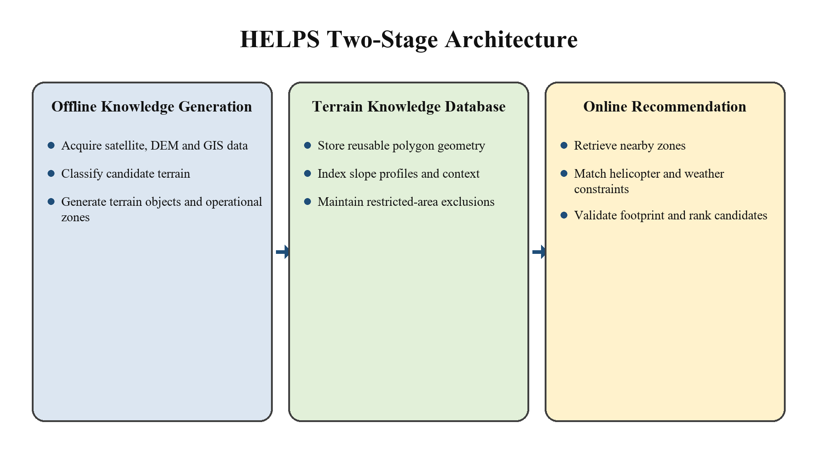
Figure 4.1 Overall two-stage architecture of HELPS
HELPS uses the two stages shown in Figure 4.1. The offline stage standardizes source data, extracts terrain, and stores zones with their attributes and provenance. The mission-time stage queries those zones and checks them against the active helicopter profile, weather, and mission. Only candidates that satisfy the mandatory conditions reach ranking. Chapters 7 to 10 describe how information passes between these stages.

4.1 Core Design Principles
- Terrain-first analysis: characterize land before applying aircraft-specific rules.
- Helicopter-independent knowledge: reuse one knowledge base across different aircraft profiles.
- Progressive filtering: reduce the candidate set through explicit mandatory checks.
- Explainable ranking: preserve the factors that determine each final score.
- Pilot-centric operation: present alternatives and evidence without autonomous control.
- Local and confidential processing: support restricted operational environments.
- Modularity: isolate data acquisition, terrain analysis, storage, retrieval, validation, and ranking.
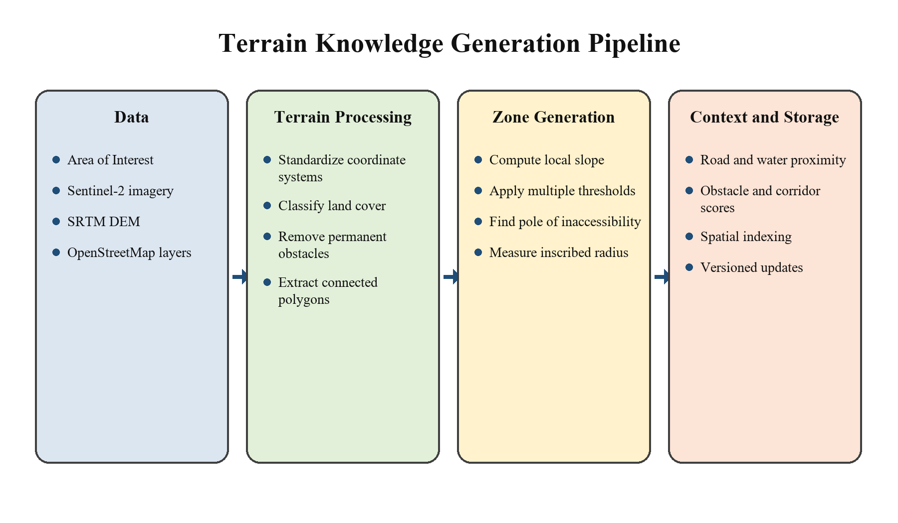
Figure 4.2 Terrain knowledge generation pipeline
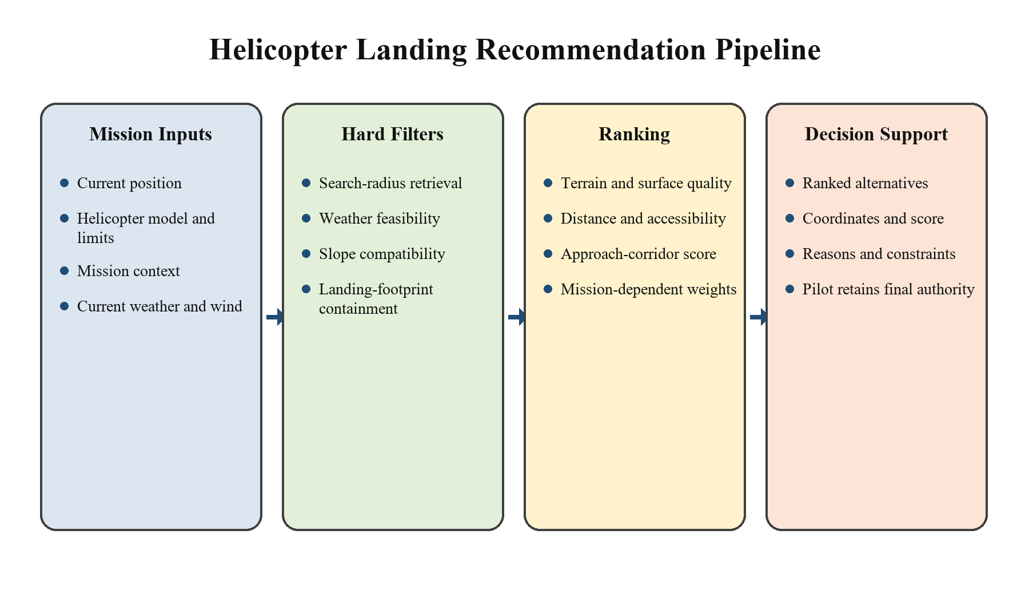
Figure 4.3 Mission-time recommendation pipeline

Chapter 5

PROBLEM UNDERSTANDING

5.1 Background

The project emphasizes operations in which the preparation of a helipad may be unknown or unavailable. A landing area may be a piece of open ground in these types of settings and is not necessarily a facility. Support for decisions, therefore, must provide information about the ground itself: its useful area extent, ground slope, surface properties and surrounding impediences. In an emergency there is less time to check these elements. Even if a pilot can see a clearing, he may not be able to determine if the helicopter will fit, if the surface is level enough, and if there are features around him that will not allow for an approach. HELPS aid to that assessment by providing the terrain information prior to the assessment and by offering alternative options to the aircraft when required. Complementary observations are obtained from the satellite imagery and elevation models and GIS layers. Imagery provides surface cover description, the DEM provides support for slope analysis and vector layers provide mapped buildings, roads, water and exclusions. The project merges these sources, and at the same time preserves the dates and resolution limits of them, as an apparent ground-clearing in a dataset can be different from the ground actually measured in a mission.

5.2 Problem Statement

The main challenge is to determine and contrast possible landing sites, considering the helicopter and the emergency. A point on a map is not enough: the usable area around this point must have the required footprint and meet the configured operational limits. Terrain assessment is a combination of several questions. In what way are the lands connected? Is the usable part less than or equal to the slope limit? Is there any water, structures or other exclusions? Is it possible to draw the necessary clearance circle without crossing the boundary? HELPS does not have a ranking score that can mask a missing mandatory check, and it provides answers to the questions in a specific order. Navigation and terrain-awareness provide useful geospatial information. HELPS includes a workflow specific to the project, which takes this context and outputs candidate polygons, evaluates using the set of helicopter constraints, and clarifies the alternatives. Helicopters have varying footprints, slopes and operating limitations. It would be problematic to store aircraft-specific decisions directly in terrain records because this would mean maintaining one database for each aircraft, and repeating most of the analysis. HELPS stores the description of the terrain separately, and uses the chosen profile at query time. All this separation is done through its Terrain Knowledge Database to complete the system. Terrain Objects represent contiguous candidate land and the Operational Zones represent contiguous areas at configured slope limits. These stored entities are used to evaluate the aircraft without a re-computation of the source terrain analysis. This allows for a traceable path to the zone, source data and applied rules for each recommendation. The ranked list can be compared and the pilot is still on the desk to assess the situation and select a landing spot.

5.3 Challenges in Helicopter Emergency Landing

The first one is a lack of decision time. The system should focus the terrain search, avoiding the need for the pilot to read all the raster layers or all the polygons. Precomputed geometry and indexed retrieval decreases the amount of work done on every retrieved. The second one is the problem of incomplete observation. Ditches, wires, soft surfaces, or temporary obstacles, which are not included in the data, may be present in the open-looking ground. There are also different types of aircraft constraints, and a polygon with a good shape for one type may not be good shape for another type. The report considers these two issues as distinct ones, namely data confidence and operational compatibility. The resulting workflow looks at continuity, slope, clearance and context, then compares preferences. It also retains the reasons that lead to exclusion so that the user can differentiate between a failure of a constraint and lack of information.

5.4 Limitations of Existing Navigation and Landing Systems
Navigation systems can be used for positioning, planning a route, displaying terrain and giving obstacle awareness. The project is not based on the premise that no existing product does not provide landing site assistance. HELPS, on the other hand, specifies the particular integration required for this project: reusable terrain polygons linked to the aircraft-specific checks and an explainable ranked output. A display does not stand alone, it still needs to be interpreted. HELPS associates terrain with measurable attributes to allow the same evaluation rules to be consistently applied to each candidate. The filtering sequence takes into account slope compatibility, minimum area, boundary clearance and complete footprint containment. Afterwards, environmental context provides an opportunity for comparing the candidates that are still alive. The re-use of the knowledge layer also eliminates the need to process the source data on each aircraft request. It is possible to update the dataset or change aircraft-profile data separately, as long as their versions are noted with the recommendation.

5.5 Importance of Terrain Understanding

The first place where things appear to be empty is a starting point. The useable shape of the ground, local slope, ground surface characteristics and obstacles within and surrounding the ground are all factors in landing assessment. HELPS thus describes candidate terrain prior to applying a helicopter profile. Terrain understanding in this project refers to delineating sets of connected regions, transforming sets of connected regions into polygons, quantifying attributes of the polygons and segmenting polygons based on slope limits. The geometric and operational checks are maintained and the roads, water and nearby structures serve as context. This knowledge can be re-used in any helicopter profile. If the required clearance radius changes, it will not require reprocessing the imagery and DEM, but rather it will impact the mission time evaluation.

5.6 Project Objectives
The objective of HELPS is to turn geospatial data into reusable terrain knowledge and use that knowledge to support helicopter emergency-landing decisions.
The specific objectives of the system are:
- Develop a Terrain Knowledge Generation Pipeline capable of analyzing satellite imagery, Digital Elevation Models (DEM), and GIS datasets to identify candidate terrain.
- Generate a helicopter-independent terrain knowledge database by extracting geometric, environmental, and operational characteristics of each terrain object.
- Create operational zones based on multi-threshold terrain slope analysis while preserving terrain information for different helicopter capabilities.
- Develop a Helicopter Landing Recommendation Pipeline that evaluates terrain knowledge using helicopter-specific operational constraints such as landing footprint, allowable slope, and mission requirements.
- Provide explainable and ranked landing recommendations supported by terrain characteristics, environmental analysis, and operational evidence rather than unexplained suggestions.
- Assist pilots in reducing decision time and cognitive workload during emergency situations while ensuring that the pilot remains the final decision-maker.

5.7 Project Scope
The completed project includes terrain knowledge generation and helicopter-specific recommendation for emergency landing scenarios using geospatial source data.
The system focuses on:
- Generating terrain knowledge from satellite imagery, Digital Elevation Models (DEM), and GIS datasets.
- Identifying candidate terrain by eliminating regions containing permanent obstacles.
- Characterizing terrain using geometric, surface, environmental, and accessibility features.
- Generating operational zones through multi-threshold slope analysis.
- Constructing a reusable, helicopter-independent Terrain Knowledge Database.
- Evaluating terrain using helicopter-specific operational constraints to produce ranked emergency landing recommendations.
- Provide a locally deployable decision-support application with controlled access to mission information and explicit handling of external data services.
Configured restricted-area polygons are excluded before candidate terrain is stored. Their source and update date remain part of the dataset provenance. The completeness of this exclusion depends on the supplied restriction data; the presence of a candidate is not independent evidence of legal permission.
The current scope does not include autonomous flight control, automatic landing, real-time satellite imagery acquisition, or direct integration with onboard avionics.

5.8 Assumptions
The system is developed based on the following assumptions:
- Satellite imagery, DEM, and GIS datasets are available for the selected Area of Interest (AOI).
- Terrain conditions are assumed to remain relatively static between successive Terrain
Knowledge Generation cycles.
- Helicopter operational specifications, such as rotor diameter, landing footprint, allowable slope, and safety clearance, are available during the recommendation phase.
- Weather and wind information can be obtained from reliable external sources when generating recommendations.
- The system operates as a decision-support tool, and the pilot retains full authority over the final landing decision.
- Public geospatial data supports regional screening, while small hazards and surface bearing capacity require additional observation.

5.9 Limitations
The completed project has the following limits on how its output can be interpreted.
The system primarily relies on publicly available geospatial datasets, whose spatial resolution and update frequency may limit terrain accuracy. Dynamic environmental conditions such as temporary obstacles, moving vehicles, wildlife, recent construction, or vegetation changes are not considered unless reflected in updated datasets.
The approach-corridor attribute describes surrounding openness rather than a dynamically feasible flight trajectory. Weather and wind are evaluated during recommendation and are not treated as permanent terrain properties. A nearby zone is not necessarily reachable under autorotation or other emergency flight conditions.
HELPS is designed as a decision-support system and does not replace pilot judgment. The recommendations generated by the system are intended to assist situational awareness and reduce decision-making time, while the pilot remains responsible for evaluating operational safety and selecting the final landing location.

5.10 Chapter Summary
The operational problem requires both advance preparation and rapid aircraft-specific evaluation. HELPS addresses it by storing terrain knowledge first and applying mission inputs later. This separates the work that can be reused from the checks that change with each request.
The key constraints concern usable geometry, slope, surface conditions, surrounding hazards, and the selected aircraft profile. These constraints define the filtering sequence developed in the following chapters.
The output remains a set of explained alternatives for pilot assessment. Its usefulness depends on the quality and freshness of the source information and the correctness of the configured limits.

Chapter 6

DESIGN PHILOSOPHY

6.1 Vision of HELPS

The goal of HELPS is to have the ground information available prior to an emergency and then to compare available landing sites for the chosen helicopter. The project does not rely on any limitations of aircraft to store terrain geometry and measurements. This means that the same zone can then be assessed using different profiles without having to redo the imagery and elevation processing. The pilot is given alternative options which include coordinates, constraints and supporting factors. This application does not send flight-control signals nor make the ultimate decision to land. The architecture also forms a foundation to extend coverage to other regions, as well as to bring in better source data. These extensions maintain the separation between terrain description and mission time evaluation.

6.2 Design Principles
The following principles guided the completed system.
- Terrain-First Architecture: The system first develops a comprehensive understanding of the terrain before considering helicopter-specific operational constraints. This separation prevents repeated terrain analysis for different helicopter platforms.
- Helicopter-Independent Knowledge Generation: All terrain analysis is performed independently of any specific helicopter. Helicopter characteristics are considered only during the recommendation phase, allowing a single Terrain Knowledge Database to support multiple aircraft types.
- Progressive Terrain Characterization: Instead of immediately rejecting terrain based on helicopter limitations, HELPS progressively extracts and stores terrain characteristics such as geometry, slope, surface composition, environmental context, and accessibility. This preserves valuable information for future evaluation.
- Explainable Recommendations: Store the applied limits, rejection reasons, and ranking contributions so that the output can be inspected.
- Pilot-Centric Decision Support: HELPS is designed to assist pilots, not replace them. The system provides objective terrain analysis while ensuring that the final operational decision always remains with the pilot.
- Confidential and Local Deployment: Process stored terrain and mission inputs locally. Acquire external source data through controlled interfaces and identify which requests leave the local environment.
- Modular Design: Give acquisition, terrain analysis, storage, filtering, and ranking defined inputs and outputs so that each can be maintained independently.
- Restriction Handling: Exclude the configured restricted-area geometry before terrain storage and retain the version of the exclusions used.

6.3 Terrain-First Philosophy

Processing in terrain records what is present and how it is shaped prior to application of a helicopter profile. This prevents the necessary terrain being lost only because it is not suitable to one aircraft. The decision for the particular aircraft is taken at a later stage based on the measurements stored on the aircraft.

6.4 Helicopter-Independent Terrain Knowledge

Terrain Objects, their slope-based Operational Zones and context to evaluate are stored in the database. Aircraft specifications are kept as separate records. A combination of these is the recommendation request, a request that lets profile changes without altering the underlying terrain geometry.

6.5 Pilot-Centric Decision Support

It can be compared by using the ranked list and pinpointing locations on a map. It provides the pilot with information on available evidence and leaves final judgement of the situation and landing decision to him/her.

6.6 Explainable Recommendation Strategy

Each recommendation lists the zone and representative coordinates, distance from the helicopter, constraints used and factors which affected the score. If the mandatory check fails, the candidate is removed prior to ranking; if the check is ok, but the score is pretty low, it merely shows a preference between those remaining for ranking.

6.7 Confidentiality and Local Processing

Terrain processing and recommendation are done on local data sets. Information about the mission and aircraft profiles are thus kept within the deployment environment. Imagery, GIS updates and weather, if available, all require external OEM to be acquired, even if done locally.

6.8 Adaptability to Different Geographic Regions

A workflow region becomes a new region in the program through its AoI perimeter and source data.AOI perimeter and source data constitute a new region in the program entering the same workflow. The processing sequence is the same but the coverage, projection, resolution and classification assumptions should be verified for that area. Equal accuracy is not guaranteed on a geographic basis.

6.9 Scalability Towards Real-Time Deployment

A mission-time workload of limit to just retrieval, constraint checks and ranking because the terrain data is pre computed. It is possible to separate using spatial indexes and cached source inputs. Response time could be improved by either faster source updates or by adding more environmental feeds, that could be done within the same interfaces, but the impact of this still needs to be measured.

6.10 Chapter Summary
The design is based on distinguishing the terrain knowledge from the decisions made by the aircraft. The two stages are linked by polygon geometry and measured attributes and recorded provenance. This separation facilitates maintenance and explanation updates to the source data update the terrain records, aircraft changes update the aircraft profiles and priorities influence the ranking of missions. The mandatory checks are independent of the preferences along the entire workflow.

Chapter 7

OVERALL SYSTEM ARCHITECTURE

7.1 System Overview
HELPS consists of two connected pipelines. Terrain Knowledge Generation processes an AOI into stored terrain entities. Helicopter Landing Recommendation evaluates those entities for the current aircraft and mission.
The Terrain Knowledge Database is the interface between them. It contains Terrain Objects, Operational Zones, representative points, and environmental context. The mission-time pipeline reads these records rather than processing raw imagery or DEM cells for every request.
The architecture shown in Chapter 4 applies throughout the project. The following sections describe the responsibilities of each pipeline and the information exchanged at their boundary.

7.2 Terrain Knowledge Generation Pipeline
The terrain pipeline begins with an AOI and the source imagery, DEM, GIS layers, and configured restrictions. It aligns these inputs to a common spatial reference and processing extent. Restricted and unsuitable regions are removed before connected candidate terrain is converted into Terrain Objects.
Terrain Characterization adds area, dimensions, surface composition, vegetation, water, and accessibility attributes. DEM-derived slope is then segmented at the configured limits. Connected regions within each threshold become Operational Zones, each linked to its parent Terrain Object.
For every zone, the pipeline stores its full polygon, pole of inaccessibility, maximum inscribed-circle radius, and threshold. Environmental Context Analysis adds road distance, water proximity, surrounding obstacles, and an openness-based corridor score. The completed records and their source metadata form the Terrain Knowledge Database described in Chapter 9.

7.3 Helicopter Landing Recommendation Pipeline
The recommendation pipeline begins with helicopter coordinates, the selected model and operational profile, mission priorities, and current weather. It retrieves nearby Operational Zones through a spatial query and compares the environmental observations with the profile limits.
Candidates then pass through mandatory slope, area, clearance-radius, and full-footprint checks. A failed check removes the zone before scoring. The Mission-Aware Ranking Engine orders the feasible survivors and returns the top alternatives with their coordinates, score components, and explanations. Chapter 10 describes the seven modules in this order.

7.4 Terrain Knowledge Integration
The database is the shared contract between the two pipelines. Terrain ID and Zone ID connect geometry to characteristics, slope thresholds, and environmental context. Dataset identifiers, source dates, coordinate systems, and processing settings allow a recommendation to be traced to the terrain knowledge used.
Source-data updates regenerate the affected terrain records; aircraft-profile or mission-weight changes affect the recommendation stage. Missing mandatory attributes remain unknown and cannot be silently replaced with favorable values. This keeps a lack of observation distinct from a passed constraint.

7.5 End-to-End Data Flow
Data flows from the AOI and source layers to standardized inputs, connected Terrain Objects, characterized terrain, slope-specific Operational Zones, and the stored knowledge base. A mission request then flows through profile processing, nearby-zone retrieval, weather feasibility, operational matching, footprint validation, ranking, and recommendation generation.
Each stage retains the identifiers needed by the next. Rejection records explain where candidates leave the pipeline, while final recommendations retain their input versions and factor values. If no candidate passes all mandatory checks, the output reports that result instead of relaxing the limits to force a recommendation.

Chapter 8

TERRAIN KNOWLEDGE GENERATION

Module 1: Data Acquisition

8.1.1 Overview
Data Acquisition prepares the geospatial inputs for the selected AOI. It collects satellite imagery, elevation data, GIS features, restriction boundaries, and their metadata so that the later modules can interpret both the terrain and the limits of the observations.
Imagery supports surface and vegetation interpretation, the DEM supplies elevation for slope analysis, and GIS layers describe mapped infrastructure and water. The AOI establishes the common processing boundary.
Source inputs are acquired or registered when a region is processed and refreshed when an updated observation is required. Their acquisition dates and processing versions are retained with the resulting terrain knowledge.

8.1.2 Inputs
Input | Purpose
AOI boundary and metadata | Define the processing extent and spatial reference.
Satellite imagery and quality layers | Describe observed surface cover and identify unusable or uncertain observations.
Digital elevation model | Supply elevation for local slope and terrain analysis.
GIS and restriction layers | Describe mapped roads, buildings, water, infrastructure, and configured exclusions.

8.1.3 Methodology
The Data Acquisition module is implemented through a sequence of standardized stages to ensure that all geospatial datasets required for terrain analysis are collected, processed, and organized consistently. Each stage prepares the necessary inputs for the subsequent modules while maintaining spatial consistency across all datasets.

Step 1: Define the Area of Interest (AOI)
Objective: Define the geographical region for which terrain knowledge will be generated.
The AOI establishes the common spatial boundary for all datasets used throughout the Terrain Knowledge Generation Pipeline.
Implementation
- Select the geographical region to be analyzed.
- Represent the AOI as a polygon or multipolygon with a declared CRS; derive its bounding box for source-data queries.
- Assign a unique AOI identifier.
- Store the corresponding Coordinate Reference System (CRS).
- Use the AOI as the reference boundary for acquiring all geospatial datasets.
Engineering Decision: Use the supplied AOI polygon as the processing boundary. Its bounding box supports acquisition queries, while clipping preserves the actual AOI shape.
Polygon and multipolygon boundaries preserve the geographic extent selected for terrain analysis.
Output
- AOI Definition
- Bounding Box Coordinates
- CRS Information

Step 2: Acquire Satellite Imagery
Objective: Acquire high-resolution satellite imagery of the selected AOI for identifying terrain features such as open land, vegetation, water bodies, and man-made structures.
Implementation
- Query the selected AOI from the satellite imagery provider.
- Select imagery for the required observation date and screen its cloud and quality information.
- Clip the imagery to the AOI boundary.
- Store the processed imagery in GeoTIFF format.
- Record acquisition metadata for future reference.
Engineering Decision: Sentinel-2 MSI is selected for Version 1 because it provides free access, global coverage, regular updates, and adequate spatial resolution for large-scale terrain analysis.
Output
- Satellite Imagery
- Image Metadata

Step 3: Restricted Area Exclusion
Objective: Remove regions where helicopter landing is prohibited due to operational, legal, or security restrictions.
Implementation
- Load the predefined Restricted Area database.
- Identify intersections between Restricted Areas and Candidate Terrain.
- Remove restricted regions from further processing.
- Preserve the remaining terrain for analysis, subject to the coverage and validity of the supplied restrictions.
Typical Restricted Areas include:
- Airport runways
- Military installations
- International border-sensitive regions
- Government-protected facilities
- Critical infrastructure
- Permanently designated no-landing zones
Engineering Decision: Apply configured restrictions during terrain generation to keep excluded regions out of the stored candidates. Record the restriction version so the affected records can be regenerated when exclusions change.
Output: Candidate terrain with the configured restriction geometry removed.

Step 4: Acquire Digital Elevation Model (DEM)
Objective: Acquire elevation data required for terrain geometry analysis and slope computation.
Implementation
- Download DEM tiles covering the AOI.
- Merge multiple tiles if necessary.
- Clip the DEM to the AOI boundary.
- Store the processed DEM in GeoTIFF format.
- Verify spatial alignment with the satellite imagery.
Engineering Decision: The agreed pipeline uses a 30 m SRTM DEM as an elevation source for regional slope screening. Resampling aligns it with other layers but does not create finer terrain detail. Zone geometry and slope values must be interpreted at the source DEM resolution.
Output
- Digital Elevation Model
- Elevation Metadata

Step 5: Acquire GIS Datasets
Objective: Acquire supporting geospatial information describing infrastructure and environmental features.
Implementation
- Retrieve GIS layers for the selected AOI.
- Collect road networks, water bodies, rivers, and administrative boundaries.
- Validate the completeness of each layer.
- Convert datasets into a common spatial format.
Engineering Decision: OpenStreetMap supplies open GIS context in a form compatible with vector processing. Coverage and completeness vary by location, so layer availability and update dates are recorded rather than assumed.
Output
- GIS Layers
- Feature Metadata

Step 6: Dataset Standardization
Objective: Ensure that all acquired datasets share a common spatial reference and are ready for integrated analysis.
Implementation
- Transform all datasets to a common CRS.
- Clip every dataset to the AOI boundary.
- Verify spatial alignment.
- Standardize file formats and metadata.
- Perform quality and completeness checks.
Engineering Decision: Standardizing all datasets before terrain analysis eliminates spatial inconsistencies and simplifies processing in subsequent modules.
Output
- Standardized Geospatial Dataset Package

Step 7: Dataset Organization
Objective: Organize the processed datasets using a standardized directory structure for efficient retrieval and management.
Implementation
- Create a dedicated directory for each AOI.
- Store Satellite, DEM, GIS, and Metadata separately.
- Maintain consistent naming conventions.
- Record dataset versions and acquisition dates.
Engineering Decision: A standardized directory structure improves maintainability, reproducibility, and simplifies data access for downstream modules.
Output
- Organized AOI Dataset Repository

Module 2: Candidate Terrain Identification

8.2.1 Overview
Candidate Terrain Identification removes mapped obstacles and unsuitable surface classes, then groups the remaining land into connected regions. These regions are candidates for further analysis, not confirmed landing sites.
The module does not apply a specific helicopter profile. It preserves the remaining terrain for characterization, slope segmentation, and later aircraft-specific evaluation.
A Terrain Object is a contiguous candidate region represented by a polygon and a unique identifier. Its boundary includes internal exclusions where present.
The object identifier and geometry pass to Terrain Characterization, which adds measurements without changing the identity of the region.

8.2.2 Inputs
The Candidate Terrain Identification module requires the standardized datasets generated by the Data Acquisition module.
Input | Purpose
Satellite imagery | Classify observed land cover and visible terrain features.
DEM | Support terrain structure and elevation interpretation.
GIS layers | Supply mapped buildings, water, roads, and other exclusions.
AOI metadata | Define the processing boundary, CRS, and source versions.

8.2.3 Methodology
The module classifies the observed terrain, creates obstacle and exclusion masks, and forms connected components from the remaining candidate pixels. Polygonization makes those components available for measurement and storage.
The methodology consists of the following stages:

Step 1: Terrain Classification
Objective: Classify every region within the Area of Interest into meaningful terrain categories that describe the physical nature of the land.
Implementation
- Process the satellite imagery covering the AOI.
- Classify terrain into predefined land-cover categories.
- Generate a terrain classification map where each pixel belongs to a specific terrain class.
- Typical terrain classes include:
- Grassland
- Bare Soil
- Agricultural Land
- Sparse Vegetation
- Dense Vegetation / Forest
- Water Bodies
- Urban / Built-up Areas
- Rocky Terrain
Engineering Decision: The system first determines what each region represents before deciding whether it should be considered. Separating terrain classification from obstacle removal creates a modular pipeline and allows future support for additional terrain categories without modifying downstream modules.
Output: A classified terrain map of the selected AOI.

Step 2: Permanent Obstacle Identification
Objective: Identify terrain regions that are permanently unsuitable for helicopter landing.
Implementation
Using the classified terrain map together with GIS information, identify regions occupied by:
- Buildings
- Dense forests
- Mountains / Cliff faces
- Large water bodies
- Urban infrastructure
- Other permanent obstacles
These regions are marked as non-candidate terrain and excluded from further processing.
Engineering Decision: This stage uses the obstacles represented in the source data. Temporary structures, vehicles, and other transient hazards remain limitations of the output unless an updated observation captures them.
Output: Obstacle mask representing permanently unsuitable terrain.

Step 3: Candidate Terrain Extraction
Objective: Extract terrain regions that remain after removing permanent obstacles.
Implementation
- Remove obstacle pixels using the generated obstacle mask.
- Preserve only terrain classes that remain physically available.
- Ignore helicopter-specific requirements during this stage.
- Generate a binary candidate terrain map.
Engineering Decision HELPS intentionally avoids applying helicopter constraints during terrain extraction. This ensures that the generated terrain knowledge remains helicopter-independent and reusable across multiple aircraft platforms.
Output: Binary Candidate Terrain Map.

Step 4: Connected Terrain Formation
Objective: Identify continuous terrain regions by grouping neighboring candidate pixels into individual terrain objects.
Implementation
- Perform connected component analysis on the binary terrain map.
- Merge adjacent candidate pixels belonging to the same continuous land region.
- Assign a unique Terrain ID to every connected region.
Disconnected regions are treated as independent Terrain Objects.
Engineering Decision: Terrain is represented as continuous connected regions instead of individual pixels. This significantly reduces computational complexity and establishes the fundamental spatial entity used throughout HELPS.
Output: Connected Terrain Objects.

Step 5: Terrain Polygon Generation
Objective: Convert connected terrain regions into geospatial polygons.
Implementation
- Extract the boundary of every connected terrain region.
- Generate polygon geometry representing the terrain extent.
- Store polygon coordinates together with the Terrain ID.
These polygons provide the spatial representation used throughout subsequent modules.
Engineering Decision Polygon representation preserves the complete geometry of each terrain object while enabling efficient spatial queries and geometric analysis.
Output: Terrain Object Polygons.

Step 6: Terrain Object Storage
Objective: Store the extracted Terrain Objects within the Terrain Knowledge Database.
Implementation
For each Terrain Object, store:
- Terrain ID
- Polygon Geometry
- Bounding Box
- AOI Reference
- Metadata
Only the geometric representation is stored at this stage. Terrain characteristics and operational properties are extracted in the following modules.
Engineering Decision: Separating terrain geometry from terrain characteristics keeps the database normalized and allows each subsequent module to incrementally enrich the Terrain Object without duplicating information.
Output: Terrain Object Repository.

Module 3: Terrain Characterization
Terrain Characterization adds descriptive measurements to the Terrain Objects extracted in Module 2.

8.3.1 Overview
For each Terrain Object, this module measures geometry, surface composition, vegetation, water presence, and accessibility. These attributes describe the region before it is evaluated for a particular helicopter.
The measurements are linked to the Terrain ID and stored with their source metadata. Aircraft-specific limits are applied later, allowing the measurements to be reused.

8.3.2 Inputs
Input | Purpose
Terrain Objects | Supply the boundaries and identifiers generated by Module 2.
Satellite imagery | Support surface cover, vegetation, and water interpretation.
DEM | Supply elevation information for terrain attributes.
GIS layers | Provide infrastructure, accessibility, and environmental context.

8.3.3 Methodology
The module extracts each attribute from the relevant source and stores it against the Terrain ID. Values that cannot be derived reliably remain explicitly unknown.
The methodology consists of the following stages:

Step 1: Geometric Characterization
Objective: Extract the fundamental geometric properties of each Terrain Object.
Implementation
For every Terrain Object, compute:
- Total Area
- Maximum Length
- Maximum Width
- Bounding Box
- Polygon Geometry
Engineering Decision: Geometric properties form the basis for subsequent analyses, including operational zone generation and landing footprint validation.
Output: Geometric characteristics of the Terrain Object.

Step 2: Surface Characterization
Objective: Determine the dominant surface type of each Terrain Object.
Implementation: Analyse the classified terrain map to determine the primary surface composition, such as:
- Bare Soil
- Grassland
- Agricultural Land
- Rocky Terrain
- Water Body
Store the dominant surface type together with its proportional coverage.
Engineering Decision: Surface characteristics influence helicopter landing feasibility and provide additional context during recommendation generation.
Output: Surface type information.

Step 3: Vegetation Analysis
Objective: Estimate the vegetation density present within each Terrain Object.
Implementation
- Analyze vegetation coverage using satellite imagery.
- Compute vegetation density for the Terrain Object.
- Store the overall vegetation percentage.
Engineering Decision: Vegetation cover is a descriptive attribute. It is not a direct measurement of vegetation height, surface firmness, or rotor clearance.
Output: Vegetation density.

Step 4: Water Presence Analysis
Objective: Identify the presence of water bodies or water channels intersecting the Terrain Object.
Implementation
- Detect water bodies using GIS layers and satellite imagery.
- Determine whether water exists within the Terrain Object.
- Record the extent and location of water presence.
Engineering Decision: Major excluded water areas remain outside candidate geometry. Any residual water signal or mapped intersection is retained for review and aircraft-specific evaluation, rather than being silently treated as dry ground.
Output: Water presence information.

Step 5: Accessibility Analysis
Objective: Measure the accessibility of each Terrain Object.
Implementation
Compute:
- Distance to nearest road
- Road connectivity
- Nearby infrastructure
Engineering Decision: Accessibility is an operational characteristic useful for emergency response, rescue operations, and recommendation ranking.
Output: Accessibility attributes.

Step 6: Terrain Characteristic Storage
Objective: Store all extracted characteristics in the Terrain Knowledge Database.
Implementation: Associate the extracted attributes with the corresponding Terrain ID without modifying its geometry.
Store:
- Geometric Properties
- Surface Type
- Vegetation Density
- Water Presence
- Accessibility Attributes
Engineering Decision: Separating terrain geometry from terrain characteristics maintains database normalization and allows additional characteristics to be incorporated without altering the Terrain Object representation.
Output: Enriched Terrain Objects ready for Operational Zone Generation.

Module 4: Slope Analysis & Operational Zone Generation

8.4.1 Overview
Slope Analysis and Operational Zone Generation subdivides each Terrain Object into connected regions that satisfy configured slope thresholds. Local slope is derived from the DEM rather than inferred from polygon size or visual openness.
Threshold-specific zones preserve the relationship between geometry and the selected slope limit. An aircraft query can select compatible zones from the stored records without repeating the DEM analysis.
Each zone retains its parent Terrain ID, polygon geometry, threshold, representative point, and clearance measurements. The threshold and dataset version are part of its identity.

8.4.2 Inputs
Input | Purpose
Terrain Objects | Define the candidate polygons within which zones are generated.
Terrain characteristics | Provide the measurements recorded in Module 3.
DEM | Supply the elevation grid used to compute local slope.

8.4.3 Methodology
Slope computation is followed by threshold segmentation, connected-zone extraction, geometric characterization, representative-point computation, and storage. The steps below describe this sequence.

Step 1: Terrain Slope Computation
Objective: Compute the terrain slope for every location within a Terrain Object using the Digital Elevation Model (DEM).
Implementation
- Extract DEM values corresponding to each Terrain Object.
- Compute the local terrain slope for every DEM cell.
- Generate a continuous slope raster representing the terrain.
Engineering Decision: Instead of assigning a single average slope to an entire Terrain Object, HELPS computes cell-level slope information to preserve local terrain variations and enable more accurate operational zone extraction.
Output: Slope Raster.

Step 2: Multi-Threshold Slope Segmentation
Objective: Generate terrain regions satisfying different slope thresholds.
Implementation: Segment the slope raster using predefined thresholds:
- ≤ 0°
- ≤ 2°
- ≤ 4°
- ≤ 6°
- ≤ 8°
- ≤ 10°
- ≤ 12°
- ≤ 15°
Each threshold produces a binary mask of cells at or below that limit. The thresholds shown here define the project segmentation scheme, not universal helicopter operating limits. A zero-degree mask depends on numerical precision and does not establish a surveyed level surface.
Engineering Decision: HELPS stores multiple slope representations instead of a single threshold. This allows helicopters with different allowable slope limits to reuse the same terrain knowledge without recomputing slope information.
Output: Multi-threshold slope masks.

Step 3: Connected Operational Zone Extraction
Objective: Extract contiguous regions that satisfy each slope threshold.
Implementation
- Perform connected component analysis on every slope mask.
- Separate disconnected regions into independent Operational Zones.
- Remove zones smaller than the minimum globally acceptable landing area.
- Split zones where internal water channels or excluded regions create disconnected land.
Engineering Decision: Each connected region is treated as an independent Operational Zone because different parts of the same Terrain Object may exhibit significantly different operational characteristics.
Output: Operational Zone candidates.

Step 4: Operational Zone Characterization
Objective: Extract geometric properties for every Operational Zone.
Implementation: For every Operational Zone, compute:
- Zone Area
- Maximum Length
- Maximum Width
- Polygon Geometry
- Bounding Box
- Associated Slope Threshold
These characteristics provide the geometric information required during helicopter-specific evaluation.
Engineering Decision: Each Operational Zone is independently characterized to support accurate landing footprint validation and helicopter-specific filtering.
Output: Characterized Operational Zones.

Step 5: Pole of Inaccessibility Computation
Objective: Determine the internal point with maximum boundary clearance for geometric footprint assessment.
Implementation
- Compute the Pole of Inaccessibility for every Operational Zone polygon.
- Measure its distance from the nearest polygon boundary.
- Store the point as the representative reference location for the zone.
Engineering Decision: The pole of inaccessibility maximizes boundary clearance within the polygon, including internal holes. It is a geometric reference point; the result does not independently establish surface condition or approach safety.
Output: Representative Landing Point for every Operational Zone.

Step 6: Operational Zone Storage
Objective: Store all Operational Zones within the Terrain Knowledge Database.
Implementation: For every Operational Zone, store:
- Zone ID
- Parent Terrain ID
- Polygon Geometry
- Slope Threshold
- Area
- Length
- Width
- Bounding Box
- Pole of Inaccessibility
- Boundary Clearance Distance
- Maximum Inscribed Circle Radius (distance from that point to the nearest boundary)
Engineering Decision: Operational Zones are stored independently from Terrain Objects, allowing multiple zones with different slope characteristics to exist within the same terrain.
This hierarchical representation enables efficient helicopter-specific evaluation while avoiding redundant terrain processing.
Output: Operational Zone Repository.

Module 5: Operational Zone Environmental Context Analysis

8.5.1 Overview
Environmental Context Analysis records the surroundings of each Operational Zone. It describes road access, nearby water, mapped obstacles, and surrounding openness so that the recommendation pipeline can compare feasible alternatives.
Context records remain linked to the Zone ID and their source metadata. They supplement the slope and footprint checks and do not override a failed mandatory constraint.

8.5.2 Inputs
Input | Purpose
Operational Zones | Supply zone boundaries and identifiers from Module 4.
Satellite imagery | Support interpretation of the surrounding land cover.
GIS layers | Supply mapped roads, water, buildings, and infrastructure.
Terrain characteristics | Provide context inherited from the parent Terrain Object.

8.5.3 Methodology
The methodology consists of the following stages:

Step 1: Accessibility Analysis
Objective: Evaluate how easily each Operational Zone can be accessed after an emergency landing.
Implementation
- Identify the nearest road or transportation network.
- Compute the distance from the Operational Zone to the nearest accessible road.
- Record accessibility information for rescue and recovery operations.
Engineering Decision: Road distance supports rescue and recovery planning. It is a ranking attribute unless the active mission configuration explicitly makes an accessibility requirement mandatory.
Output
- Distance to Nearest Road
- Accessibility Attributes

Step 2: Water Proximity Analysis
Objective: Determine the influence of nearby water bodies on helicopter operations.
Implementation
- Detect water bodies surrounding the Operational Zone.
- Measure the proximity of water features to the zone boundary.
- Identify water channels intersecting or immediately adjacent to the zone.
Engineering Decision: Rather than rejecting zones near water, HELPS stores water proximity as contextual information that can influence recommendation scores based on operational requirements.
Output
- Water Proximity Information
- Water Interaction Attributes

Step 3: Surrounding Obstacle Analysis
Objective: Evaluate obstacles surrounding the Operational Zone that may affect helicopter approach and departure.
Implementation
- Define an analysis buffer around each Operational Zone.
- Analyze the surrounding region for trees, buildings, towers, cliffs, and other obstacles.
- Estimate the obstacle density and distribution within the buffer region.
Engineering Decision: Operational safety depends not only on the landing surface but also on the surrounding environment. Therefore, obstacle analysis extends beyond the zone boundary to provide a more realistic operational assessment.
Output
- Obstacle Density
- Surrounding Obstacle Information

Step 4: Approach Corridor Analysis
Objective: Estimate the openness of the surrounding terrain to support safe helicopter approach and departure.
Implementation
- Analyze the terrain surrounding the Operational Zone.
- Evaluate the availability of unobstructed space around the zone.
- Compute an Approach Corridor Score representing the overall openness of the surrounding environment.
Engineering Decision: The corridor score is a proxy for surrounding openness. It does not define a cleared approach path or evaluate aircraft flight dynamics; those limits remain visible when the score is presented.
Output
- Approach Corridor Score

Step 5: Environmental Context Storage
Objective: Associate the extracted environmental context with each Operational Zone.
Implementation: Store the following attributes:
- Distance to Nearest Road
- Water Proximity
- Obstacle Density
- Approach Corridor Score
- Environmental Metadata
Engineering Decision: Separating environmental context from geometric and topographical characteristics maintains a modular database structure while enabling helicopter-specific recommendation algorithms to selectively utilize contextual information.
Output: Operational Zones enriched with environmental context.

Chapter 9

TERRAIN KNOWLEDGE DATABASE

9.1 Overview
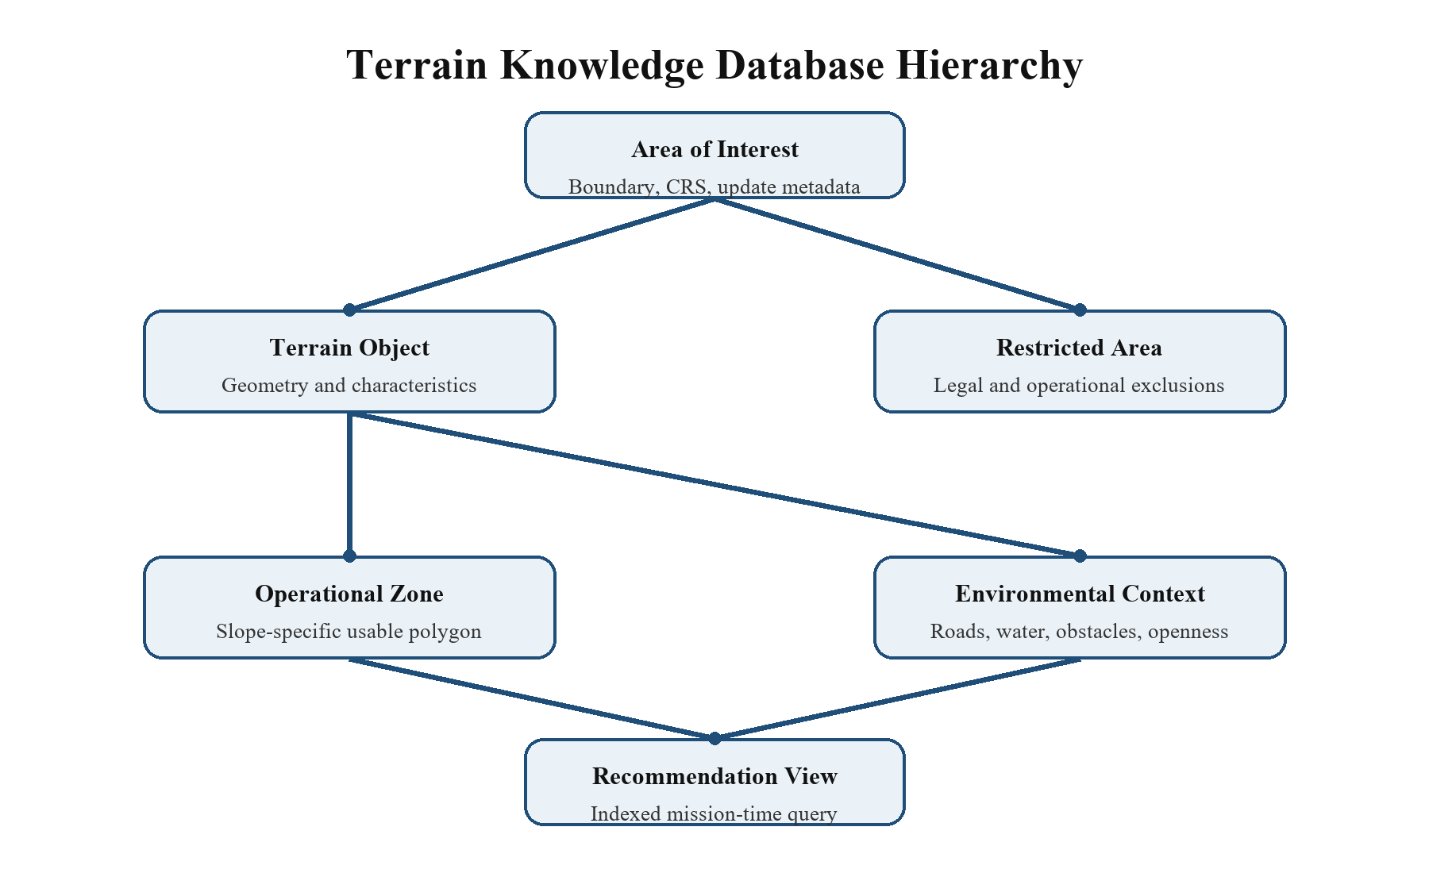
Figure 9.1 Hierarchical terrain knowledge database model
The Terrain Knowledge Database stores the processed entities produced by the offline pipeline. Terrain Objects, their characteristics, Operational Zones, and context records are connected through identifiers. Restriction boundaries and their versions remain traceable. Raw inputs stay in the source repository and are referenced through metadata rather than duplicated in every terrain record.
One AOI contains multiple Terrain Objects, and each object can contain several threshold-specific Operational Zones. This hierarchy lets a query retrieve the relevant zones together with their parent attributes. Dataset and threshold identifiers distinguish geometries that may overlap because they represent different slope limits.

9.2 Inputs
Entity | Source
Terrain Objects | Candidate Terrain Identification, Module 2
Terrain characteristics | Terrain Characterization, Module 3
Operational Zones and geometry | Slope Analysis and Operational Zone Generation, Module 4
Environmental context | Environmental Context Analysis, Module 5
Provenance and exclusions | Data Acquisition and the configured restriction layers

9.3 Methodology
The Terrain Knowledge Database is populated incrementally as each module of the Terrain Knowledge Generation Pipeline completes. Instead of duplicating information, HELPS follows a normalized hierarchical storage model, where every module enriches previously generated entities.
The methodology consists of the following stages:

Step 1: Store Terrain Objects
For every Terrain Object, store:
- Terrain ID
- Polygon Geometry
- Bounding Box
- AOI Reference

Step 2: Store Terrain Characteristics
Associate the following attributes with the corresponding Terrain Object:
- Area
- Length
- Width
- Surface Type
- Vegetation Density
- Water Presence
- Accessibility Attributes

Step 3: Store Operational Zones
Each Terrain Object may contain multiple Operational Zones corresponding to different slope thresholds.
For every Operational Zone, store:
- Zone ID
- Parent Terrain ID
- Polygon Geometry
- Slope Threshold
- Area
- Length
- Width
- Pole of Inaccessibility
- Maximum Inscribed Circle Radius

Step 4: Establish Relationships
Each Terrain Object refers to one AOI, and each Operational Zone refers to one parent Terrain Object. Figure 9.1 shows these relationships. Context records refer to the zone they describe; source and dataset identifiers preserve provenance across updates.
This structure enables efficient retrieval of all zones belonging to a terrain object while preserving normalization.

Step 5: Indexing & Query Optimization
Create indexes on:
- AOI ID
- Terrain ID
- Zone ID
- Spatial Geometry
- Slope Threshold
These indexes improve retrieval performance during the Helicopter Landing Recommendation Pipeline.

9.4 Outputs
The output of this module is a fully populated Terrain Knowledge Database containing structured, helicopter-independent terrain information that can be queried efficiently during emergency landing recommendation.

9.5 Validation and Limitations
Database validation ensures referential integrity between Terrain Objects and Operational Zones, verifies the consistency of stored geometries, and confirms the correctness of spatial indexing. Since the database stores processed terrain knowledge, any changes in the underlying geospatial datasets require regeneration of the affected terrain information.

Chapter 10

HELICOPTER LANDING RECOMMENDATION PIPELINE

10.1 Overview
The Helicopter Landing Recommendation Pipeline uses stored terrain knowledge with the current position, selected helicopter profile, mission priorities, and weather. It retrieves nearby Operational Zones and evaluates them through the seven modules below.
The pipeline applies mandatory constraints before scoring. A candidate must pass weather feasibility, aircraft compatibility, and complete footprint containment to reach ranking. Passing these data-based checks establishes compatibility with the configured rules, not a guarantee of a safe real-world landing.
The recommendation process follows seven sequential modules:
- Module 1: Helicopter Input Processing
- Module 2: Nearby Operational Zone Retrieval
- Module 3: Weather & Operational Feasibility Assessment
- Module 4: Operational Constraint Matching
- Module 5: Landing Footprint Validation
- Module 6: Mission-Aware Ranking Engine
- Module 7: Recommendation Generation

10.2 Inputs
Input | Purpose
Current coordinates | Locate nearby Operational Zones and compute proximity.
Helicopter model and profile | Supply configured slope, footprint, clearance, and weather limits.
Mission context | Select the preference weights used after mandatory filtering.
Weather and wind | Evaluate mandatory feasibility and retain eligible ranking factors.
Terrain Knowledge Database | Supply versioned zones, geometry, characteristics, and context.

10.3 Methodology
Each module receives a defined candidate set and returns either a reduced set or an explicit no-recommendation status. Rejection reasons are retained for explanation. Ranking begins only after mandatory checks have passed.
The sequence is input processing, nearby-zone retrieval, weather feasibility, operational constraint matching, footprint validation, mission-aware ranking, and recommendation generation.

Module 1: Helicopter Input Processing
Objective: Collect all helicopter-specific information required for evaluating Operational Zones.
Implementation
- Acquire the helicopter's current GPS coordinates.
- Identify the helicopter model.
- Retrieve helicopter-specific operational specifications.
- Load mission objectives and operational priorities.
- Obtain current weather and wind information.
- Construct the Helicopter Operational Profile used throughout the recommendation process.
Engineering Decision: Separating helicopter-specific information from terrain knowledge enables HELPS to support multiple helicopter platforms without modifying the Terrain Knowledge Database.
Output: Helicopter Operational Profile.

Module 2: Nearby Operational Zone Retrieval
Objective: Retrieve all Operational Zones located within the helicopter's operational search region from the Terrain Knowledge Database. This reduces the search space by limiting the evaluation to geographically relevant landing candidates.
Implementation
- Use the helicopter's current GPS coordinates as the reference point.
- Define a configurable operational search radius around the helicopter.
- Perform a spatial query to retrieve Operational Zones within the configured search region.
- Compute the distance between the helicopter's current location and the Pole of Inaccessibility of each retrieved Operational Zone.
- Retrieve the terrain characteristics and environmental context linked to each zone.
- Construct the initial candidate set for subsequent evaluation modules.
Engineering Decision: Retrieve the precomputed zone geometry and attributes to avoid repeating terrain processing. A radius query establishes proximity only; it does not prove reachability under the aircraft's current flight state.
Output
Candidate Operational Zone Set containing:
- Operational Zone ID
- Parent Terrain ID
- Pole of Inaccessibility
- Distance from Helicopter
- Terrain Characteristics
- Environmental Context

Module 3: Weather & Operational Feasibility Assessment
Objective: Compare current environmental observations with the active helicopter limits and retain the observation time and coverage for subsequent evaluation.
Implementation
- Retrieve the current weather and wind conditions for the operational area.
- Compare the environmental conditions against the helicopter's operational weather limits.
- Evaluate parameters such as:
- Wind Speed
- Wind Direction
- Visibility
- Rainfall Intensity
- Temperature (if applicable)
- Other helicopter-specific operational weather limits
- If any mandatory operational limit is violated, terminate the recommendation process.
- Otherwise, associate the weather observations and their provenance with the candidate set for ranking.
Engineering Decision: Weather is first a mandatory feasibility check. Missing, stale, or out-of-limit mandatory observations produce an unavailable or infeasible status. Weather may influence ranking only after those checks pass; a favorable score cannot compensate for an exceeded operating limit.
Output
- Operationally Feasible Candidate Operational Zones
- Weather Assessment Report

Module 4: Operational Constraint Matching
Objective: Evaluate each candidate Operational Zone against the helicopter's operational limitations to eliminate zones that are physically unsuitable for landing. This module ensures that only Operational Zones satisfying the helicopter's mandatory operational constraints are forwarded for detailed landing validation.
Implementation
- Retrieve the operational limits from the active Helicopter Operational Profile.
- Compare the helicopter's maximum allowable landing slope with the stored slope threshold of each Operational Zone.
- Verify that the Operational Zone provides at least the minimum landing area required by the helicopter.
- Compare the Maximum Inscribed Circle Radius of the Operational Zone against the helicopter's required landing clearance radius.
- Reject Operational Zones that fail any mandatory operational constraint.
- Forward the remaining Operational Zones to the Landing Footprint Validation module.
Engineering Decision: HELPS performs operational constraint matching using precomputed Operational Zones rather than recomputing terrain characteristics during every query. Since Operational Zones are already classified according to multiple slope thresholds, helicopters with different operational limitations can efficiently retrieve compatible zones without repeating computationally expensive terrain analysis.
Output: Operationally Compatible Operational Zones.

Module 5: Landing Footprint Validation
Objective: Verify that the helicopter can be safely accommodated within the selected Operational Zone while maintaining the required safety clearance from surrounding boundaries.
Implementation
- Use the Pole of Inaccessibility as the initial candidate landing point.
- Construct the helicopter's landing footprint using its required landing clearance radius.
- Position the landing footprint at the Pole of Inaccessibility.
- Verify that the landing footprint lies entirely within the Operational Zone polygon.
- Ensure that the required safety buffer is maintained from all zone boundaries.
- Reject Operational Zones that cannot safely accommodate the helicopter's landing footprint.
Engineering Decision: Use the pole of inaccessibility as the initial reference point because it provides maximum geometric clearance. Confirm containment of the actual clearance circle against the full polygon, including holes, instead of relying on area or a bounding rectangle alone.
Output: Landing Validated Operational Zones.

Module 6: Mission-Aware Ranking Engine
Objective: Evaluate all operationally feasible landing locations and rank them according to mission requirements, operational priorities, and environmental context to generate the most suitable emergency landing recommendations.
Implementation
- Retrieve the validated Operational Zones from the previous module.
- Extract the static terrain characteristics and linked environmental context for each validated zone.
- Incorporate the current weather and wind conditions.
- Identify the active mission context and corresponding operational priorities.
- Compute a configurable Suitability Score for each Operational Zone.
- Rank the Operational Zones according to the computed suitability score.
- Forward the ranked list to the Recommendation Generation module.
For the feasible candidate set F, the configurable score is S(z) = sum(w_j * f_j(z)), for z in F. Here f_j is a normalized preference factor and w_j is its mission weight, with w_j >= 0 and sum(w_j) = 1. Favorable directions are made consistent before aggregation; for example, shorter distance receives a higher normalized proximity value. This is a relative comparison score, not a probability of landing success.
- Static Terrain Features include:
- Distance from Helicopter
- Distance to Nearest Road
- Accessibility
- Surface Type
- Vegetation Density
- Water Proximity
- Approach Corridor Score
- Dynamic Weather Conditions include:
- Wind Speed & Direction
- Visibility
- Rainfall
- Other operational weather parameters
- Mission Context adapts the ranking strategy according to the current mission objective. Examples include:
- Medical evacuation: give greater preference to access for ground responders among candidates that have passed the mandatory checks.
- Engine failure: compare feasible nearby alternatives while recognizing that flight-state reachability requires a separate operational assessment.
- Fuel emergency: give greater preference to proximity while retaining every mandatory constraint.
Engineering Decision: Unlike previous modules, the Mission-Aware Ranking Engine does not reject Operational Zones. Instead, it assigns a relative suitability score to each operationally feasible location. This separation between mandatory operational validation and preference-based ranking improves explainability and allows the ranking strategy to be adapted for different mission profiles without modifying the core recommendation pipeline.
Output: Ranked Operational Zones with Suitability Scores.

Module 7: Recommendation Generation
Objective: Generate the final set of landing recommendations and present them in an interpretable format for pilot decision support.
Implementation
- Select the highest-ranked Operational Zones.
- Generate the Top-K landing recommendations.
- Associate each recommendation with its supporting information.
- Present the recommended landing point using the Pole of Inaccessibility coordinates.
- Include the suitability score and the factors contributing to the recommendation.
- Display all recommendations in descending order of suitability.
Each recommendation includes:
- Operational Zone ID
- Landing Coordinates
- Distance from Helicopter
- Suitability Score
- Terrain Characteristics
- Environmental Context
- Recommendation Explanation
Engineering Decision: Present several feasible alternatives and their explanations so the pilot can compare them against the situation. The application does not select or execute a flight path.
Output: Ranked and Explainable Emergency Landing Recommendations.

10.4 Outputs
The Helicopter Landing Recommendation Pipeline produces a prioritized list of operationally feasible emergency landing locations. Each recommendation includes the validated landing point, operational suitability score, terrain characteristics, environmental context, and supporting information that explains why the location was recommended. The output is intended to assist the pilot in making informed emergency landing decisions while retaining full pilot authority over the final selection.

10.5 Validation & Limitations
The recommendation pipeline is validated by verifying that every recommended Operational Zone satisfies all mandatory helicopter operational constraints before ranking.
The correctness of the recommendations depends on the accuracy of the Terrain Knowledge Database, helicopter operational specifications, and environmental data used during evaluation.
Since HELPS is a decision support system, it does not account for dynamic obstacles, rapidly changing environmental conditions, or pilot judgment during the final approach. The recommendations should therefore be treated as operational guidance rather than autonomous landing commands.

Chapter 11

DESIGN DECISIONS AND ENGINEERING COMPONENTS

11.1 Terrain Representation
One of the fundamental design decisions in HELPS is representing the terrain as Terrain Objects instead of processing raw satellite imagery or Digital Elevation Models during every recommendation request. Each Terrain Object represents a physically continuous candidate terrain identified during the Terrain Knowledge Generation Pipeline and serves as the primary spatial entity within the Terrain Knowledge Database.
Terrain Objects are stored as polygon geometries, enabling efficient spatial queries, geometric analysis, and database storage. This representation eliminates repeated terrain processing, improves computational efficiency, and allows the same terrain knowledge to be reused across multiple helicopter platforms and mission scenarios.
Engineering Decision: Representing terrain as reusable polygon-based Terrain Objects separates terrain knowledge generation from helicopter recommendation, resulting in a modular, scalable, and computationally efficient system.

11.2 Connected Terrain Extraction
Identifying isolated land pixels is insufficient for helicopter landing assessment, as helicopters require continuous usable terrain rather than scattered land patches. Therefore, HELPS groups adjacent candidate terrain pixels into connected regions, where each region represents a single Terrain Object.
This approach preserves the actual spatial continuity of the terrain, enables accurate geometric analysis, and forms the foundation for subsequent processes such as terrain characterization, slope analysis, and operational zone generation.
Engineering Decision: HELPS represents terrain as connected regions instead of individual pixels to ensure that every Terrain Object corresponds to a physically continuous land area suitable for further operational evaluation. This significantly reduces computational complexity while providing a meaningful representation of the terrain.

11.3 Multi-Threshold Slope Representation
The project stores zones for multiple slope limits rather than assigning one average slope to an entire Terrain Object. The configured scheme includes limits of 0, 2, 4, 6, 8, 10, 12, and 15 degrees. These values organize terrain knowledge; the selected aircraft profile supplies the applicable operating limit. Cumulative threshold masks can overlap, so queries and counts retain the threshold identifier and avoid treating repeated coverage as distinct land area.
By storing Operational Zones corresponding to each slope threshold, the same terrain knowledge can support helicopters with different allowable landing slope limits without recomputing terrain characteristics. This enables efficient helicopter-specific evaluation while maintaining a single reusable Terrain Knowledge Database.
Engineering Decision: HELPS stores multiple slope-based Operational Zones rather than a single terrain slope value. This preserves terrain variability, supports multiple helicopter platforms, and eliminates repeated slope analysis during the recommendation phase.

11.4 Operational Zone Representation
A single Terrain Object may contain multiple regions with different slope characteristics, making the entire terrain unsuitable to be represented by a single landing location. HELPS therefore divides each Terrain Object into one or more Operational Zones, where each zone represents a contiguous region satisfying a specific slope threshold.
Operational Zones are stored independently while maintaining their relationship with the parent Terrain Object. This hierarchical representation preserves terrain variability, avoids redundant terrain analysis, and enables efficient helicopter-specific retrieval during the recommendation process.
Engineering Decision: HELPS adopts a hierarchical Terrain Object–Operational Zone model instead of representing each terrain with a single landing point. This allows multiple helicopters with different operational capabilities to evaluate the same terrain independently while maintaining a normalized and scalable Terrain Knowledge Database.

11.5 Landing Reference Point Selection
A centroid is an area-weighted geometric centre and can fall outside a concave polygon or within an excluded hole. HELPS uses the pole of inaccessibility as the initial reference point because it maximizes distance to the nearest boundary within the usable polygon.
The corresponding maximum inscribed-circle radius describes how large a circle fits at that point. The aircraft's required radius includes its footprint and the configured clearance margin. This geometric comparison supports screening; it does not measure ground bearing strength, unseen obstacles, or flight-path clearance.
Engineering Decision: Use maximum boundary clearance to select a reproducible geometric reference point and validate it against the complete zone polygon.

11.6 Landing Footprint Validation
A location with sufficient area is not necessarily suitable for helicopter landing. The helicopter's landing footprint, including the required safety clearance around the aircraft, must fit completely within the Operational Zone without intersecting its boundaries or internal exclusion regions.
The pipeline places the required clearance circle at the representative point and checks that the entire circle is covered by the usable polygon. Exterior boundaries and interior holes are included. A candidate is rejected when the circle extends beyond usable ground, even if its total polygon area exceeds the minimum area requirement.
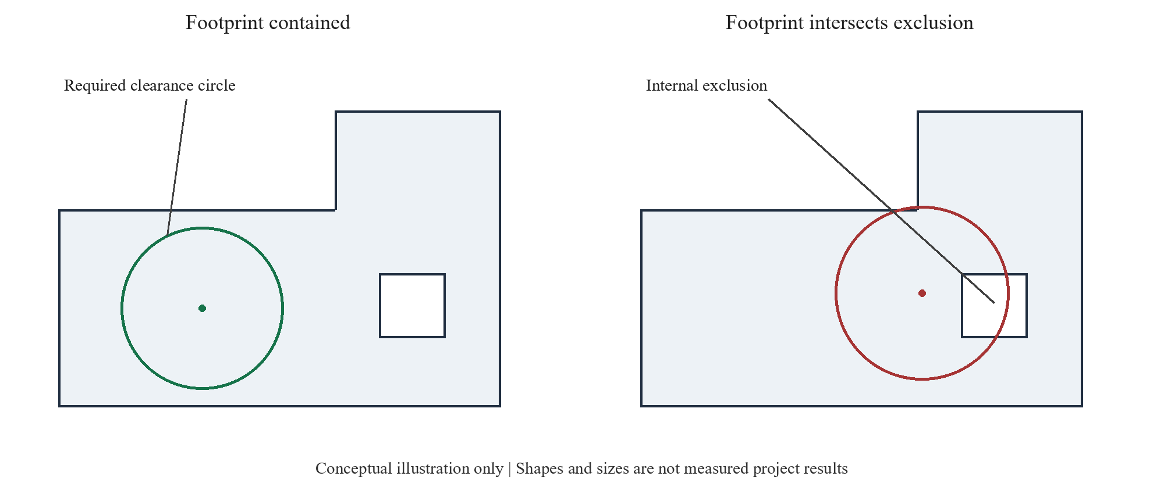
Figure 11.1 Complete footprint containment including internal exclusions
Figure 11.1 illustrates the containment rule. Both the outer boundary and every internal exclusion belong to the geometric test. The diagram is schematic and does not represent a measured landing site.
Engineering Decision: Treat footprint containment as a mandatory geometric check after initial area, slope, and radius screening. Define the numerical tolerance in the projected CRS and retain it with the processing configuration.

11.7 Environmental Context Representation
Terrain geometry alone is insufficient to determine the operational suitability of a landing location. Factors such as surrounding obstacles, accessibility, nearby water bodies, and available approach space significantly influence the practicality and safety of helicopter operations. HELPS therefore associates each Operational Zone with an Environmental Context, providing additional information about its surroundings without modifying the underlying terrain representation.
This separation enables environmental attributes to influence recommendation quality while preserving the helicopter-independent nature of the Terrain Knowledge Database.
Engineering Decision: HELPS stores environmental information as a separate contextual layer rather than embedding it within terrain geometry. This improves modularity, simplifies future extensions, and enables different recommendation strategies without modifying the terrain representation.

11.8 Configurable Recommendation Framework
Mission priorities affect preferences among feasible locations. For example, road access can matter more during medical evacuation, whereas proximity can matter more during a fuel emergency. These preferences do not alter the aircraft limits applied earlier in the pipeline.
The scoring configuration combines normalized terrain, distance, context, and eligible weather factors. The output retains the factor values and weights so that the ordering can be explained and reproduced.
Engineering Decision: HELPS separates the recommendation strategy from terrain knowledge generation by adopting a configurable scoring framework. This enables future integration of alternative ranking techniques, mission-specific priorities, and optimization algorithms without requiring architectural changes.

11.9 Separation of Knowledge Generation and Recommendation
One of the key architectural decisions in HELPS is the separation of Terrain Knowledge Generation from the Helicopter Landing Recommendation Pipeline. Terrain analysis is performed once to generate reusable terrain knowledge, which is stored within the Terrain Knowledge Database. During recommendation, the system queries this precomputed knowledge instead of repeating computationally expensive terrain analysis.
This separation improves computational efficiency, reduces response time, supports multiple helicopter platforms, and enables the Terrain Knowledge Database to be updated independently of the recommendation engine.
Engineering Decision: HELPS adopts a two-stage architecture consisting of offline terrain knowledge generation and online helicopter recommendation. This modular design improves scalability, reusability, maintainability, and overall system performance.

11.10 Chapter Summary
The engineering choices link each recommendation to a usable polygon, a slope threshold, a representative point, and an aircraft profile. Precomputation reduces repeated work, while the separation of filters and scores makes the decision sequence clear. The main tradeoff is that stored knowledge is only as current and detailed as its source data.

Chapter 12

SYSTEM DEVELOPMENT PHASES

12.1 Development Philosophy
The project was organized into phases that connected source-data preparation to the final recommendation workflow. Each phase produced an output consumed by the next, making the interfaces between terrain processing, storage, and recommendation explicit.
The phase sequence below records the development structure of the completed project. The terrain pipeline and recommendation pipeline were kept separate so that source-data processing and aircraft-specific evaluation could be maintained independently.

12.2 Phase 1: Geospatial Data Infrastructure
Phase objective
Establish the geospatial data acquisition and preprocessing pipeline required for terrain analysis.
Development activities
- Implement Area of Interest (AOI) selection.
- Acquire satellite imagery, DEM, GIS datasets, and Restricted Area Layers.
- Standardize coordinate reference systems.
- Align dataset resolutions and spatial extents.
- Organize datasets into the standardized project structure.
Phase output
A standardized geospatial dataset package containing all required datasets for a selected Area of Interest.

12.3 Phase 2: Candidate Terrain Generation
Phase objective
Identify physically continuous terrain suitable for further analysis.
Development activities
- Perform terrain classification.
- Detect permanent obstacles.
- Exclude restricted operational areas.
- Perform connected terrain extraction.
- Generate Terrain Objects.
Phase output
A collection of Terrain Objects representing candidate terrain within the selected Area of Interest.

12.4 Phase 3: Terrain Characterization
Phase objective
Extract descriptive characteristics for every Terrain Object.
Development activities
- Compute geometric properties.
- Determine surface characteristics.
- Analyze vegetation density.
- Detect water presence.
- Compute accessibility attributes.
Phase output
Terrain Objects enriched with geometric, environmental, and accessibility characteristics.

12.5 Phase 4: Operational Zone Generation
Phase objective
Generate helicopter-independent Operational Zones from Terrain Objects.
Development activities
- Compute terrain slope from DEM.
- Generate multi-threshold slope maps.
- Extract connected Operational Zones.
- Generate polygon geometries.
- Compute the Pole of Inaccessibility.
- Compute the Maximum Inscribed Circle Radius.
- Associate Environmental Context with every Operational Zone.
Phase output
Operational Zones representing physically feasible landing regions together with their geometric and environmental properties.

12.6 Phase 5: Terrain Knowledge Database
Phase objective
Organize all generated terrain knowledge into a reusable database.
Development activities
- Design the Terrain Knowledge Database.
- Store Terrain Objects and their characteristics.
- Store Operational Zones.
- Store Environmental Context.
- Establish relationships between all entities.
Phase output
A fully populated Terrain Knowledge Database capable of supporting helicopter recommendation queries.

12.7 Phase 6: Helicopter Recommendation Engine
Phase objective
Develop the recommendation pipeline that evaluates Operational Zones for specific helicopter missions.
Development activities
- Develop helicopter input processing.
- Implement Operational Zone retrieval.
- Integrate weather and operational feasibility assessment.
- Implement operational constraint matching.
- Perform landing footprint validation.
- Develop the Mission-Aware Ranking Engine.
- Generate explainable landing recommendations.
Phase output
A complete Helicopter Landing Recommendation Engine capable of producing ranked emergency landing recommendations.

12.8 Phase 7: User Interface and System Integration
Phase objective
Integrate all system components into a unified application.
Development activities
- Develop the local user interface.
- Integrate the Terrain Knowledge Database.
- Connect the recommendation engine.
- Visualize Operational Zones and recommendations on maps.
- Display supporting recommendation information and suitability scores.
Phase output
A fully integrated HELPS prototype providing end-to-end emergency landing recommendations.

12.9 Phase 8: System Optimization and Enhancement
Phase objective
Improve the performance, scalability, and usability of the integrated system.
Development activities
- Optimize spatial database queries.
- Improve recommendation response time.
- Optimize data storage and retrieval.
- Enhance ranking strategies.
- Prepare the architecture for future feature integration.
Phase output
A consolidated local decision-support framework with configuration, provenance, and performance considerations documented for subsequent deployment assessment.

12.10 Chapter Summary
The development sequence connected standardized source inputs to terrain entities, zone geometry, a spatial knowledge database, and the recommendation interface. Table 12.1 summarizes the role of each phase. Operational deployment and flight certification remain separate from completion of the academic project.
Table 12.1 Development phase outputs
Phase | Output
1 Geospatial data infrastructure | Standardized AOI inputs and metadata.
2 Candidate terrain generation | Connected Terrain Objects with identifiers and polygons.
3 Terrain characterization | Geometry, surface, vegetation, water, and accessibility attributes.
4 Operational zone generation | Slope-specific zones with representative points and clearance radii.
5 Terrain knowledge database | Linked terrain, zone, context, and provenance records.
6 Recommendation engine | Aircraft-specific mandatory filtering and mission-aware ranking.
7 Interface and integration | Map-based presentation of ranked alternatives and explanations.
8 Optimization and consolidation | Documented configuration, storage, and performance considerations.
Key Takeaways
- Modular development enables each subsystem to be developed and validated independently.
- Terrain knowledge is generated once and reused across multiple recommendation requests.
- Each phase produces a measurable deliverable, ensuring systematic project progress.
- The phase sequence connects raw geospatial inputs to the completed recommendation workflow.
- The phased architecture supports future scalability, maintainability, and integration of advanced capabilities without major architectural changes.

Chapter 13

TESTING AND VALIDATION
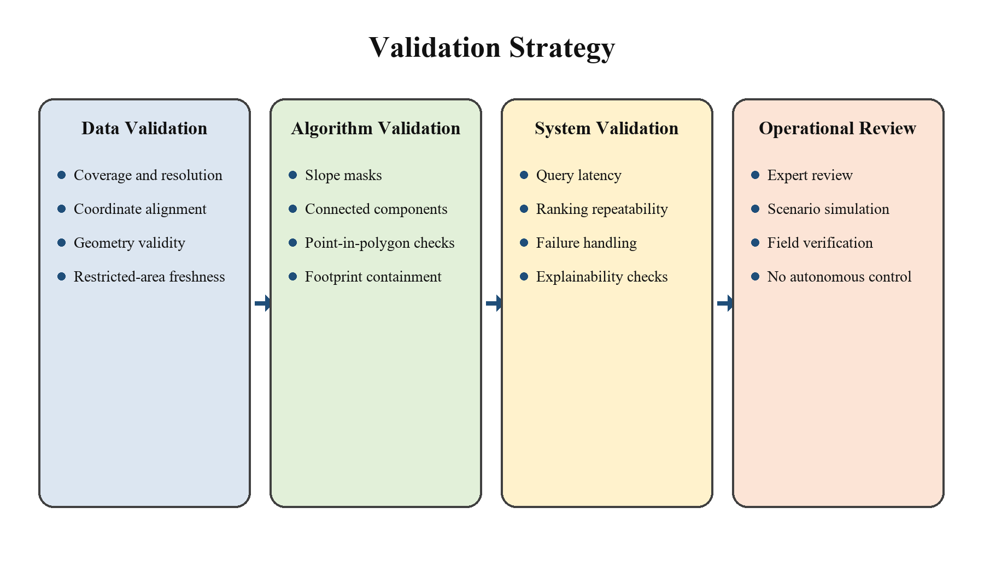
Figure 13.1 Validation strategy

13.1 Validation Objectives
Validation in HELPS follows the processing chain: source coverage and alignment, terrain classification, zone geometry, aircraft constraints, footprint containment, and ranking. Table 13.1 defines the checks and the evidence associated with each stage. Software and geometry checks establish consistency with the implemented rules; they do not establish field safety or pilot performance. No flight-test results, classification accuracy percentage, or emergency response-time improvement is inferred from these checks.
Table 13.1 Validation matrix
Test area | Method | Acceptance evidence
Dataset ingestion | Use AOIs with known extents, coordinate systems, and deliberate missing tiles. | Correct coverage checks, reprojection, logging, and safe rejection of incomplete inputs.
Terrain classification | Compare selected samples against manually reviewed imagery. | Documented confusion matrix and class-specific error analysis.
Slope computation | Evaluate synthetic surfaces and surveyed reference points. | Slope values remain within a defined tolerance and preserve local variation.
Operational-zone extraction | Test regular, concave, fragmented, and holed polygons. | Valid geometries, expected connected components, and no orphan database records.
Footprint validation | Use boundary and near-boundary cases for different helicopter radii. | Candidates pass only when the entire safety circle is contained in the usable polygon.
Ranking | Use fixed candidate sets and mission-weight configurations. | Deterministic order, explainable score components, and sensitivity analysis.
Performance | Measure indexed retrieval and end-to-end response on increasing AOI sizes. | Latency and throughput satisfy documented operational targets.
Human factors | Conduct scenario-based review with qualified aviation users. | Recommendations are understandable, do not obscure uncertainty, and support rapid comparison.

13.2 Safety and Assurance
Recommendations retain the dataset version, observation times, aircraft profile, applied checks, and score components. Missing mandatory inputs prevent a normal recommendation. Audit records connect each result to its inputs and filtering decisions.

13.3 Project Outcomes and Interpretation
The completed project links reusable terrain objects and zones to aircraft-specific filtering, footprint validation, and explained ranking. An empty feasible set produces an explicit no-candidate result. Software completion alone does not establish measured classification accuracy, pilot benefit, response latency, or landing success.

Chapter 14

CONCLUSION AND FUTURE WORK

14.1 Conclusion
The completed HELPS project organizes helicopter emergency-landing assistance around two stages: terrain knowledge generation and helicopter-specific recommendation. Terrain Objects preserve connected candidate land, while slope-based Operational Zones provide geometry and measurements that can be reused across aircraft profiles. The mission-time pipeline retrieves these zones, applies mandatory conditions, validates the required footprint, and ranks the remaining alternatives with explanations.
The project's contribution is the connection between reusable terrain knowledge and a traceable decision process. It keeps source-data processing separate from mission inputs and distinguishes mandatory constraints from ranking preferences. Its conclusions are limited to the decision-support workflow described in this report. Small or temporary hazards, surface strength, aircraft reachability, and pilot decisions remain outside what a stored polygon and score can establish.

14.2 Future Work
- Integrate higher-resolution elevation and obstacle datasets where available.
- Develop confidence and uncertainty measures for every stored attribute and recommendation.
- Add real-time hazard feeds, airspace restrictions, and weather nowcasting with freshness monitoring.
- Evaluate learning-to-rank or optimization methods while retaining transparent rule-based safety filters.
- Model directional approach and departure corridors instead of a single openness score.
- Support incremental database updates and automated detection of changed terrain.
- Conduct human-factors studies and simulator trials with qualified helicopter pilots.
- Define certification, cybersecurity, access-control, and assurance processes for operational deployment.

REFERENCES
Aguilar, F. J., Mills, J. P., Delgado, J., Aguilar, M. A., Negreiros, J. G., & Pérez, J. L. (2010). Modelling vertical error in LiDAR-derived digital elevation models. ISPRS Journal of Photogrammetry and Remote Sensing, 65(1), 103-110. https://doi.org/10.1016/j.isprsjprs.2009.09.003
Arrell, K. E., Fisher, P. F., Tate, N. J., & Bastin, L. (2007). A fuzzy c-means classification of elevation derivatives to extract the morphometric classification of landforms in Snowdonia, Wales. Computers & Geosciences, 33(11), 1366-1381. https://doi.org/10.1016/j.cageo.2007.05.005
Chen, C., & Yue, T. (2010). A method of DEM construction and related error analysis. Computers & Geosciences, 36(6), 717-725. https://doi.org/10.1016/j.cageo.2009.12.001
Dal, N., & Görüm, T. (2023). Uncertainties related to scale and sampling window size in defining macro landforms. Coğrafya Dergisi - Journal of Geography, 46, 157-171. https://doi.org/10.26650/JGEOG2023-1265064
Garcia-Castellanos, D., & Lombardo, U. (2007). Poles of inaccessibility: A calculation algorithm for the remotest places on Earth. Scottish Geographical Journal, 123(3), 227-233. https://doi.org/10.1080/14702540801897809
Hosseiny, B., Abdi, A. M., & Jamali, S. (2022). Urban land use and land cover classification with interpretable machine learning: A case study using Sentinel-2 and auxiliary data. Remote Sensing Applications: Society and Environment, 28, 100843. https://doi.org/10.1016/j.rsase.2022.100843
Jones, K. H. (1998). A comparison of algorithms used to compute hill slope as a property of the DEM. Computers & Geosciences, 24(4), 315-323.
Meng, W., & Chen, R. (2013). Study of helicopter autorotation landing following engine failure based on a six-degree-of-freedom rigid-body dynamic model. Chinese Journal of Aeronautics, 26(6), 1380-1388. https://doi.org/10.1016/j.cja.2013.07.041
Mountrakis, G., & Heydari, S. S. (2023). Harvesting the Landsat archive for land cover land use classification using deep neural networks: Comparison with traditional classifiers and multi-sensor benefits. ISPRS Journal of Photogrammetry and Remote Sensing, 200, 106-119. https://doi.org/10.1016/j.isprsjprs.2023.05.005
Ren, Y., Zhu, C., & Xiao, S. (2018). Small object detection in optical remote sensing images via modified Faster R-CNN. Applied Sciences, 8(5), 813. https://doi.org/10.3390/app8050813
Shi, X., & Xue, B. (2016). Deriving a minimum set of viewpoints for maximum coverage over any given digital elevation model data. International Journal of Digital Earth, 9(12), 1153-1167. https://doi.org/10.1080/17538947.2016.1207718
Suzuki, K., Horiba, I., & Sugie, N. (2003). Linear-time connected-component labeling based on sequential local operations. Computer Vision and Image Understanding, 89(1), 1-23. https://doi.org/10.1016/S1077-3142(02)00030-9
Vali, A., Comai, S., & Matteucci, M. (2020). Deep learning for land use and land cover classification based on hyperspectral and multispectral Earth observation data: A review. Remote Sensing, 12(15), 2495. https://doi.org/10.3390/rs12152495
Zheng, X., Xiong, H., Gong, J., & Yue, L. (2017). A morphologically preserved multi-resolution TIN surface modeling and visualization method for virtual globes. ISPRS Journal of Photogrammetry and Remote Sensing, 129, 41-54. https://doi.org/10.1016/j.isprsjprs.2017.04.013
Zhou, Q., & Liu, X. (2004). Analysis of errors of derived slope and aspect related to DEM data properties. Computers & Geosciences, 30(4), 369-378. https://doi.org/10.1016/j.cageo.2003.07.005

APPENDIX 1

RISK REGISTER
Table A.1 Risk register
Risk | Impact | Mitigation
Outdated or incomplete map data | Suitable zones may be missed or unsafe features may be absent. | Track provenance and freshness; combine sources; require local verification.
DEM resolution limits | Small ridges, ditches, and abrupt gradients may be smoothed. | Use higher-resolution DEMs where possible and record uncertainty.
Weather feed unavailable | Dynamic feasibility cannot be established. | Fail safely or present a degraded status without a final suitability claim.
Incorrect aircraft profile | Slope and clearance checks may be invalid. | Version, validate, and authorize all operational profiles.
Ranking bias | Weights may overemphasize convenience over safety. | Keep mandatory filters separate; review weights with domain experts.
Pilot overreliance | Decision support may be mistaken for landing clearance. | Use explicit advisories, confidence indicators, and human-factors testing.
Restricted-area updates delayed | A prohibited location may remain queryable. | Use authoritative updates, expiry rules, and pre-mission synchronization.

APPENDIX 2

CORE DATA DICTIONARY
Table A.2 Core data dictionary
Entity | Key attributes | Purpose
Area of Interest | AOI identifier, boundary, CRS, timestamps | Defines the geographic processing extent.
Terrain Object | Terrain identifier, polygon, bounding box, surface and context attributes | Represents physically continuous candidate terrain.
Operational Zone | Zone identifier, parent terrain, threshold, polygon, area, dimensions | Represents a contiguous slope-compatible region.
Representative Point | Coordinates, method, computation timestamp | Provides the most internally separated point for footprint evaluation.
Environmental Context | Road distance, water proximity, obstacles, corridor score | Describes operational surroundings.
Helicopter Profile | Model, rotor/footprint requirement, slope and weather limits | Defines aircraft-specific mandatory constraints.
Recommendation | Zone, score, rank, explanations, data versions | Presents an auditable mission-time alternative.

