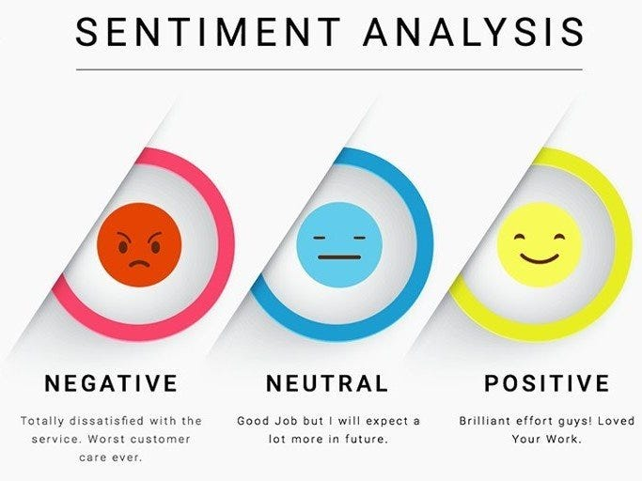

**Sentiment Analysis for Marketing**

**Introduction:**

Sentiment analysis is a powerful tool in the field of marketing that allows businesses to gain insights into how customers perceive their products, services, and brand. By analysing customer reviews, social media posts, and other forms of user-generated content, sentiment analysis helps marketers understand the emotional tone expressed in text data, whether it's positive, negative, or neutral. This technology leverages artificial intelligence and natural language processing to automate the process of gauging customer sentiment, enabling data-driven decision-making and more effective marketing strategies.

In this introductory exploration of sentiment analysis for marketing, we will delve into the following key aspects:

**Understanding Customer Sentiment:**

Sentiment analysis categorizes text data into different sentiment categories, providing businesses with a clear understanding of customer opinions and emotions. Marketers can use this information to assess customer satisfaction, identify areas for improvement, and tailor their marketing efforts accordingly.

**Data Sources:**

Sentiment analysis draws from a wide range of unstructured text data sources, including customer reviews, social media conversations, blogs, forums, surveys, and customer support interactions. These sources offer a rich dataset for evaluating customer feedback and sentiment.

**Marketing Benefits:**

**Product Enhancement:**

By analysing sentiment, businesses can pinpoint specific strengths and weaknesses of their products and services, helping them refine their offerings and improve customer satisfaction.

**Brand Reputation Management:**

Monitoring sentiment on social media and other platforms enables companies to manage their brand reputation effectively. It allows them to address negative sentiment and leverage positive sentiment for marketing purposes.

**Customer Feedback Analysis:**

Sentiment analysis simplifies the task of processing vast amounts of customer feedback, allowing marketers to extract actionable insights regarding customer preferences and pain points.

**Competitor Analysis:**

Sentiment analysis can also be applied to assess public sentiment toward competitors, providing valuable insights for competitive positioning and strategy development.

**AI and NLP Technologies:**

Artificial intelligence and natural language processing technologies play a pivotal role in sentiment analysis. Advanced machine learning models, such as recurrent neural networks, convolutional neural networks, and transformer models, are employed to understand the nuances and context of text data. NLP techniques like tokenization and part-of-speech tagging are used for data preprocessing and analysis.

**Challenges and Limitations:**

**Context Comprehension**:

Understanding context, sarcasm, and irony can pose challenges for sentiment analysis models.

**Multilingual and Cross-Cultural Considerations**:

Effective sentiment analysis must work across various languages and cultural contexts.

**Data Imbalance:**

Datasets often exhibit imbalances in the distribution of positive, negative, and neutral sentiments, which can impact model performance.

**Tools and Platforms:**

Various AI tools and platforms offer sentiment analysis capabilities, including Python libraries (NLTK, spaCy), cloud-based services (Google Cloud Natural Language API, Microsoft Azure Text Analytics), and open-source machine learning frameworks (Scikit-Learn, Hugging Face Transformers).

**Dataset Link:** [**https://www.kaggle.com/datasets/crowdflower/twitter-airline-sentiment**](https://www.kaggle.com/datasets/crowdflower/twitter-airline-sentiment)

**Given dataset:**

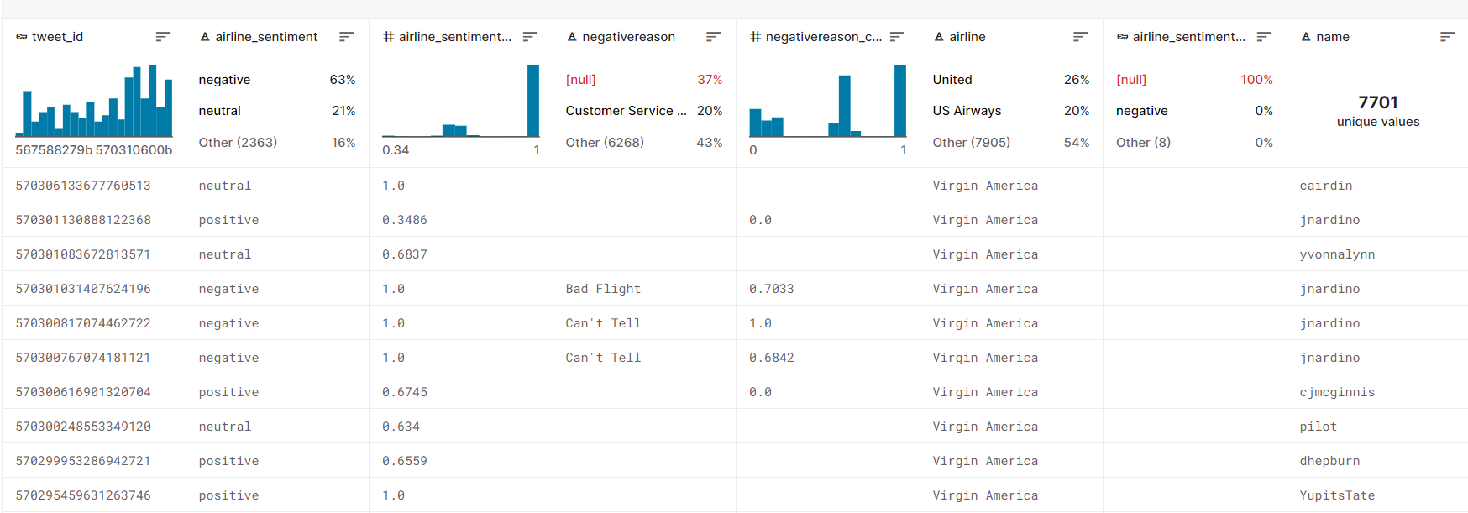

[14640 rows x 15 columns]

**Some tools and software commonly used in the process:**

**1.Programming Language**:

Python is the most popular language for machine learning due toits extensive libraries and frameworks , libraries likeNumPy,pandas, scikit-learn, and more.

**2. Integrated Development Environment (IDE):**

Choose an IDE for coding and running machine learning experiments. Some popular options include Jupyter Notebook, GoogleColab, or traditional IDEs like PyCharm.

**3. Machine Learning Libraries:**

You'll need various machine learning libraries, including: - scikit-learn for building and evaluating machine learning models. - TensorFlow or PyTorch for deep learning, if needed. - XGBoost, LightGBM, or CatBoost for gradient boosting models.

**4. Data Visualization Tools:**

Tools like Matplotlib, Seaborn, or Plotly are essential for data exploration and visualization.

**5. Data Preprocessing Tools:**

Libraries like pandas help with data cleaning, manipulation, and preprocessing.

**6. Data Collection and Storage**:

Depending on your data source, you might need web scraping tools (e.g., Beautiful Soup or Scrapy) or databases (e.g., SQLite, PostgreSQL) for data storage.

**7. Version Control:**

Version control systems like Git are valuable for tracking changes in your code and collaborating with others.

**8. Notebooks and Documentation:**

Tools for documenting your work, such as Jupyter Notebooks or Markdown for creating README files and documentation.

**9. Hyperparameter Tuning:**

Tools like GridSearch CV or Randomized Search CV from scikit-learn can help with hyperparameter tuning.

**10. Web Development Tools (for Deployment):**

If you plan to create a web application for model deployment, knowledge of web development tools like Flask or Django for backend development, and HTML, CSS, and JavaScript for the front-end can be useful.

**11. Cloud Services (for Scalability):**

For large-scale applications, cloud platforms like AWS, Google Cloud, or Azure can provide scalable computing and storage resources.

**12.External Data Sources (if applicable):**

Depending on your project's scope, you might require tools to access external data sources, such as APIs or data scraping tools.

**13. Data Annotation and Labeling Tools (if applicable):**

For specialized projects, tools for data annotation and labeling may be necessary, such as Label box or Supervisely.

**Design thinking**

**1.Empathize:**

* Understand the needs and challenges of all stakeholders involved in the house price prediction process, including homebuyers, sellers, real estate professionals, appraisers, and investors.
* Conduct interviews and surveys to gather insights on what user’s value in property valuation and what information is most critical for their decision-making.

**2.Define:**

* Clearly articulate the problem statement, such as "How might we predict house prices more accurately and transparently using machine learning?"
* Identify the key goals and success criteria for the project, such as increasing prediction accuracy, reducing bias, or improving user trust in the valuation process.

**3.Ideate:**

* Brainstorm creative solutions and data sources that can enhance the accuracy and transparency of house price predictions.
* Encourage interdisciplinary collaboration to generate a wide range of ideas, including the use of alternative data, new algorithms, or improved visualization techniques.

**4.Prototype:**

* Create prototype machine learning models based on the ideas generated during the ideation phase.
* Test and iterate on these prototypes to determine which approaches are most promising in terms of accuracy and usability.

**5.Test:**

* Gather feedback from users and stakeholders by testing the machine learning models with real-world data and scenarios.
* Assess how well the models meet the defined goals and success criteria, and make adjustments based on user feedback.

**6.Implement:**

* Develop a production-ready machine learning solution for predicting house prices, integrating the best-performing algorithms and data sources.
* Implement transparency measures, such as model interpretability tools, to ensure users understand how predictions are generated.

**7.Evaluate:**

Continuously monitor the performance of the machine learning model after implementation to ensure it remains accurate and relevant in a changing real estate market.

**8.Iterate:**

* Apply an iterative approach to refine the machine learning model based on ongoing feedback and changing user needs.
* Continuously seek ways to enhance prediction accuracy, transparency, and user satisfaction.

**9.Scale and Deploy:**

* Once the machine learning model has been optimized and validated, deploy it at scale to serve a broader audience, such as real estate professionals, investors, and homeowners.
* Ensure the model is accessible through user-friendly interfaces and integrates seamlessly into real estate workflows.

**10.Educate and Train:**

* Provide training and educational resources to help users understand how the machine learning model works, what factors it considers, and its limitations.
* Foster a culture of data literacy among stakeholders to enhance trust in the technology.

**DESIGN INTO INNOVATION**

**1. Data Collection:**

Gather a comprehensive dataset that includes features such as location, size, age, amenities, nearby schools, crime rates, and other relevant variables.

**2.Data Preprocessing:**

Clean the data by handling missing values, outliers, and encoding categorical variables. Standardize or normalize numerical features as necessary.

**PYTHON PROGRAM:**

from PIL import Image

from sklearn import svm

from sklearn.feature_extraction.text import TfidfTransformer

from sklearn.feature_extraction.text import TfidfVectorizer

from sklearn.metrics import accuracy_score

from sklearn.metrics import roc_curve

from sklearn.naive_bayes import MultinomialNB

from sklearn.neighbors import KNeighborsClassifier

from wordcloud import WordCloud, STOPWORDS, ImageColorGenerator

import collections

import matplotlib as mpl

import matplotlib.pyplot as plt

import numpy as np

import operator

import pandas as pd

tweets = pd.read_csv('Tweets.csv')

tweets.head()

**#Output**

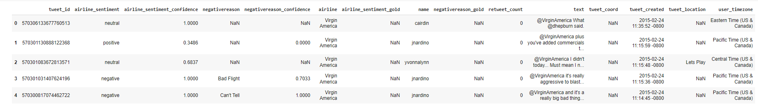

tweets['negativereason_gold'].value_counts()

**#Output**

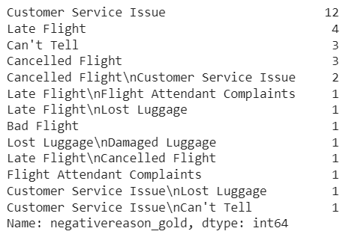

tweets['airline_sentiment_gold'].value_counts()

**#Output**

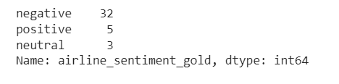

tweets['retweet_count'].value_counts()

**#Output**

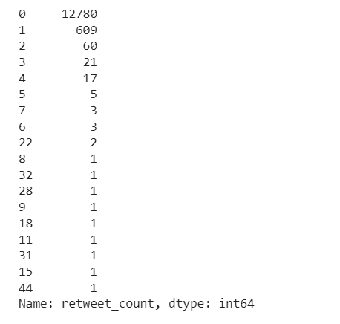

tweets.drop('negativereason_gold', axis=1, inplace=True)

tweets.drop('airline_sentiment_gold', axis=1, inplace=True)

tweets.drop('retweet_count', axis=1, inplace=True)

tweets.drop('tweet_coord', axis=1, inplace=True)

tweets.drop('tweet_location', axis=1, inplace=True)

tweets.drop('tweet_created', axis=1, inplace=True)

tweets.drop('user_timezone', axis=1, inplace=True)

tweets.drop('name', axis=1, inplace=True)

list(tweets.columns)

**#Output**

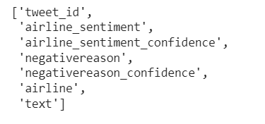

unmeaningful = ['i', 'you', 'me', 'to', 'the', 'a', 'my', 'is', 'in', 'and', 'for', 'on', 'of',

'your', 'so', 'was', 'have', 'it', 'at', 'with', 'that', 'from', 'do', 'get',

'but', 'this', 'can', 'just', 'they', 'we', 'are', 'an', 'be', "i'm", 'will',

'if', 'had', 'our', 'about', 'there', 'has', 'been', '-', 'by', 'like', 'or',

'as', 'he', 'she', 'it', 'us', 'has' ,"i've", "it's", "don't", 'would', 'am',

'flight', 'customer', 'any', 'very', "didn't", "you've", 'thing', 'take',

'other', 'u', '', ' ']

def clean_text(str_in):

res = ""

str_in = str_in.lower()

str_arr = str_in.split(' ')

for word in str_arr:

word = word.lower()

if '@' in word or word == '' or word[:1] == '&':

continue

if word.lower() in unmeaningful:

continue

if word.isnumeric():

continue

res = res + " " + word

return res

tweets["text"] = tweets["text"].apply(clean_text)

tweets.head(5)

**#Output**

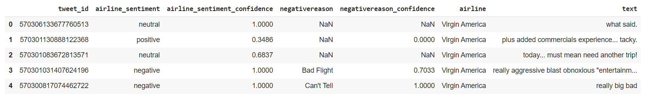

data = tweets

data['airline_sentiment'] = data['airline_sentiment'].astype('category')

X = data['text']

y = data['airline_sentiment']

X_train, X_test, y_train, y_test = train_test_split(X, y, test_size=0.2, random_state=42)

tokenizer = BertTokenizer.from_pretrained('bert-base-uncased')

X_train_encodings = tokenizer(list(X_train), padding=True, truncation=True, return_tensors='pt', max_length=128)

X_test_encodings = tokenizer(list(X_test), padding=True, truncation=True, return_tensors='pt', max_length=128)

y_train_encodings = torch.tensor(y_train.cat.codes.values)

y_test_encodings = torch.tensor(y_test.cat.codes.values)

class SentimentDataset(Dataset):

def __init__(self, encodings, labels):

self.encodings = encodings

self.labels = labels

def __getitem__(self, idx):

item = {key: val[idx] for key, val in self.encodings.items()}

item['labels'] = self.labels[idx]

return item

def __len__(self):

return len(self.labels)

train_dataset = SentimentDataset(X_train_encodings, y_train_encodings)

test_dataset = SentimentDataset(X_test_encodings, y_test_encodings)

model = BertForSequenceClassification.from_pretrained('bert-base-uncased', num_labels=3)

optimizer = AdamW(model.parameters(), lr=1e-5)

**#Output**



device = torch.device('cuda' if torch.cuda.is_available() else 'cpu')

model.to(device)

train_loader = DataLoader(train_dataset, batch_size=32, shuffle=True)

model.train()

**#Output**

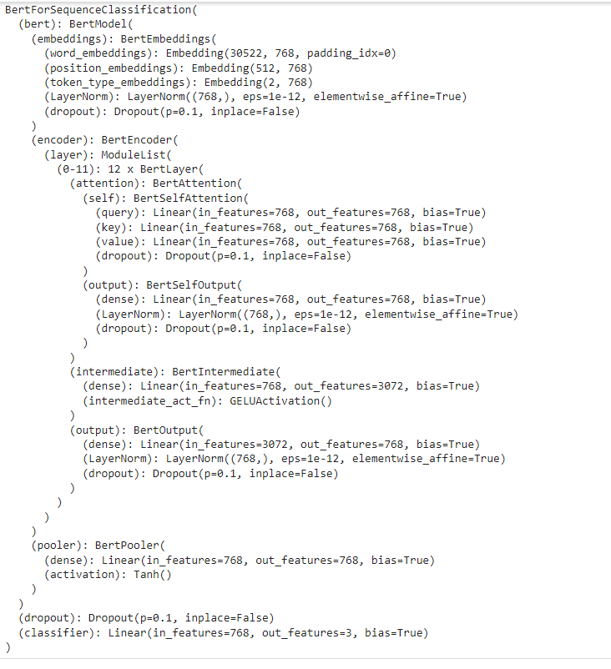

model.eval()

test_loader = DataLoader(test_dataset, batch_size=64)

predictions = []

for batch in test_loader:

input_ids = batch['input_ids'].to(device)

attention_mask = batch['attention_mask'].to(device)

with torch.no_grad():

outputs = model(input_ids, attention_mask=attention_mask)

logits = outputs.logits

predicted_labels = F.softmax(logits, dim=1).argmax(dim=1)

predictions.extend(predicted_labels.cpu().numpy())

accuracy = accuracy_score(y_test_encodings, predictions)

print("Accuracy:", accuracy)

print(classification_report(y_test_encodings, predictions))

**#Output**

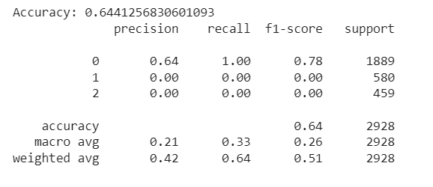

sentiment_counts = data['airline_sentiment'].value_counts()

plt.figure(figsize=(8, 5))

plt.bar(sentiment_counts.index, sentiment_counts.values, color=['red', 'green', 'blue'])

plt.title('Sentiment Distribution')

plt.xlabel('Sentiment')

plt.ylabel('Count')

plt.show()

**#Output**

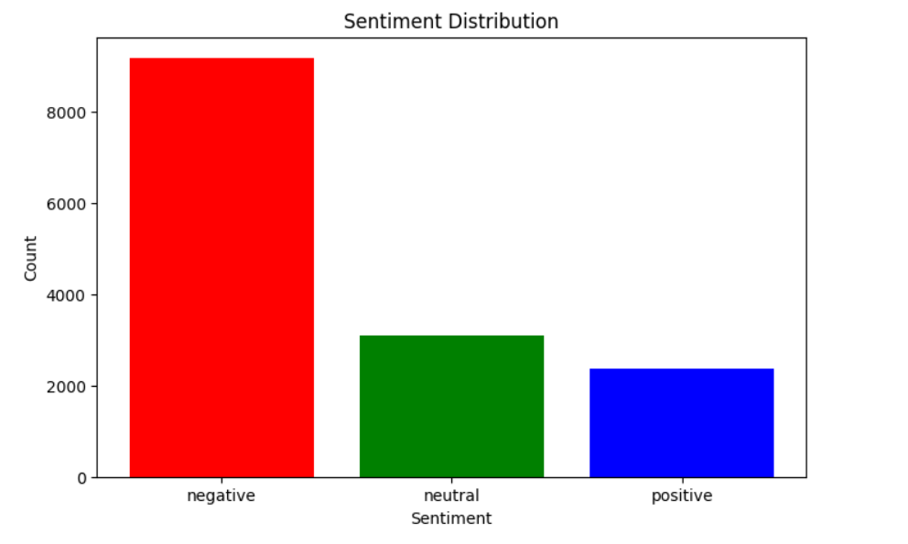

**Feature Selection:**

Identify the most relevant features that influence sentiment in marketing, such as specific keywords, customer demographics, time of posting, or product attributes.

1. **Interpretability:**

Ensure that the sentiment analysis model provides explanations or insights into how specific features or keywords influence sentiment.

Make sure stakeholders, such as marketing teams, can understand and interpret how each factor contributes to the sentiment predictions.

1. **Deployment:**

Deploy the sentiment analysis model within your marketing infrastructure, such as through a web application, API, or dashboard.

Allow users to input text data (customer feedback, reviews, social media comments), and have the model provide sentiment predictions and explanations.

1. **Monitoring and Maintenance:**

Continuously monitor the performance of the sentiment analysis model in real-time, as marketing data and customer sentiments change rapidly.

Regularly retrain the model with new data to ensure its predictions remain accurate and relevant.

1. **Ethical Considerations:**

Ensure that the sentiment analysis model does not introduce or perpetuate biases in marketing decisions. Implement fairness and transparency measures to avoid discrimination.

Regularly audit the model to identify and address any potential ethical concerns.

1. **Innovation:**

Explore innovative approaches to sentiment analysis, such as incorporating additional data sources (e.g., social trends, competitor performance, market data) to improve the accuracy of predictions.

Stay updated with the latest developments in NLP and sentiment analysis techniques to enhance the model's performance.

**ADVANTAGES:**

* **Accuracy:**
  + Just as machine learning provides accurate house price predictions by considering multiple factors, it can also deliver precise sentiment analysis by examining various data sources and nuances in customer sentiment, leading to more accurate insights for marketing decisions.
* **Complex Data Handling:**
  + Machine learning's ability to handle complex, non-linear relationships is valuable in understanding intricate language expressions and contextual nuances in sentiment analysis. It helps uncover patterns and interactions among different factors impacting customer

sentiment.

* **Continuous Learning:**
  + For marketing, continuous learning ensures that sentiment analysis models remain up-to-date with changing consumer behavior and market trends, allowing businesses to adapt their strategies in response to evolving sentiment.
* **Efficiency:**
  + Efficient sentiment analysis is crucial for understanding how marketing campaigns are received and can help marketing teams make real-time adjustments to their strategies for better results.
* **Data Integration:**
  + Just as integrating a wide range of data sources is beneficial for assessing house prices comprehensively, it also applies to marketing. Integrating diverse data sources helps marketers gain a more complete understanding of customer sentiment and its influencing factors.
* **Reduced Bias**:
  + Machine learning can reduce human bias in both house price valuation and sentiment analysis. In marketing, this leads to more objective and data-driven decisions that can resonate better with the target audience.
* **Market Insights:**
  + Just as machine learning offers insights into housing market trends, it can provide valuable insights into customer behavior and market trends, helping businesses make informed marketing decisions.
* **Risk Assessment**:
  + Machine learning can assess the risks associated with marketing campaigns, helping marketers identify potential issues and opportunities for improving their strategies.
* **Transparency**:
  + Transparent explanations for predictions are essential in both property valuation and marketing to build trust among stakeholders. Clear explanations help in understanding why certain marketing decisions are made based on sentiment analysis.
* **Scalability:**
  + Scalability is advantageous for assessing property values in large portfolios, and it also applies to marketing, where scaling sentiment analysis across a wide customer base is beneficial for decision-making.
* **Time and Cost Savings:**
  + Time and cost savings are relevant to marketing as well. Automated sentiment analysis can save time and resources compared to manual analysis of customer feedback and market trends.
* **Customization**:
  + Customization allows machine learning models to cater to specific markets and customer segments, just as it can be tailored to specific types of properties in the context of real estate. Top of Form

**Disadvantages:**

* **Data Quality:**
  + Just as in property valuation, data quality is paramount in sentiment analysis. Noisy or biased data can lead to incorrect insights.
* **Subjectivity:**
  + Sentiment analysis models may struggle with highly subjective or ambiguous language, such as sarcasm, irony, or nuanced expressions.
* **Contextual Understanding:**
  + Understanding context is challenging for machines, and sentiment analysis may sometimes misinterpret the sentiment of a statement without considering the context.
* **Cultural and Language Variations:**
  + Sentiment analysis models may perform differently in different languages and cultures, requiring adaptation and fine-tuning.
* **Data Volume and Variety:**
  + Gathering and managing diverse data sources, including social media, reviews, and customer feedback, can be complex and resource-intensive.
* **Model Overfitting:**
  + Overfitting can occur when models are too finely tuned to training data, leading to poor generalization to new data.
* **Lack of Explanation:**
  + Some advanced machine learning models, like deep learning, are often considered as "black boxes" and may not provide clear explanations for their predictions, which can be a challenge in marketing decision-making.
* **Scalability:**
  + As the volume of data grows, scaling sentiment analysis to handle large datasets can be computationally demanding and require significant infrastructure.
* **Human Validation:**
* In some cases, human validation and expert review are necessary to ensure the accuracy and relevance of sentiment analysis results.

**CONCLUSION:**

Predicting customer sentiment in marketing using machine learning is a transformative and promising approach that has the potential to revolutionize the way businesses engage with their audience. Throughout this exploration, we have uncovered the remarkable capabilities of machine learning in providing more accurate, data-driven, and nuanced insights into customer sentiments. As we conclude, several key takeaways and implications emerge:

**Improved Decision-Making**:

Machine learning models consider a multitude of factors, including various data sources, to offer more accurate and comprehensive sentiment analysis. This empowers businesses to make informed decisions, create targeted marketing strategies, and respond to customer feedback effectively.

**Data-Driven Insights:**

These models provide valuable insights into customer behavior, market trends, and factors influencing sentiment. This information is invaluable for marketers, enabling them to tailor their campaigns, enhance customer satisfaction, and adapt to changing market conditions.

**Efficient Marketing**:

Increased accuracy in sentiment analysis leads to more efficient marketing strategies, with content that resonates with the target audience. This contributes to higher engagement, conversion rates, and overall marketing efficiency.

**Challenges and Considerations**:

Sentiment analysis using machine learning is not without its challenges. Data quality, model interpretability, and ethical considerations are vital factors for responsible deployment. Addressing these issues is essential for ethical and transparent marketing practices.

**Continual Advancement:**

The field of machine learning is continually evolving, and as it does, the accuracy and capabilities of sentiment analysis models will continue to improve. With access to more data and enhanced algorithms, we can expect even more sophisticated insights in the future.

In conclusion, the application of machine learning in predicting sentiment analysis for marketing is a groundbreaking development with significant implications. It empowers businesses to better understand and engage with their customers, create more effective marketing strategies, and enhance the customer experience. However, it is crucial to approach this technology with a clear understanding of its potential and limitations, ensuring that its benefits are harnessed responsibly for the betterment of the marketing industry and customer relationships as a whole. As machine learning continues to advance, we can look forward to a future where marketing becomes increasingly data-informed and customer-centric.