By: Mani Tahriri

Static Website Documentation

**Foreword:**

In this project we are going to design a website and do the documentations related to it.

There are seven main sections:

1. Project Management Plan

2. Requirements and Specification

3. Analysis

4. Design

5. Implementation

6. Test and Documentation

**Section one**

**Project Management Plan**

The project management plan consists of the organization of project management. For project management we use 3 main applications, ***Trello*** is giving an interface to set the planning task, undergoing task, done tasks, and other related information that gathered during the projects. ***Monday*** application provide the above mentioned abilities with better interface design. finally, ***MeisterTask*** Which is enable the project manager to visualize the content of each task. These 3 applications have desktop and mobile app which is provide better control on tasks and other sections.

**Section 2**

**Project Requirement**

The goal of this project is to create a static website by using HTML, CSS, and Javascript. The website should be responsive and during this project third party javascript (framework and Library) are not recommended.

The requirements are including:

* The first page which we call it index page
  + Navigation bar
  + Company logo
  + footer
* Services
  + Detail of Gallery in separated page
  + Request information page
* About us
* Gallery
  + Modal in gallery
* Contact page to
  + request information with javascript form validation and drop-down menu

**Section three**

**Task organization**

Based on the requirements of project which detailed in previous section we need to organize the tasks. Tasks are categorized under each page. For example, the tasks in index page are different from the tasks in Gallery page. Next we assign a number to each task which indicates the priority of each task. The priority divided to two sections:

* **Urgent**: these tasks are very important to do as soon as possible because they perform important role in design of the backbone of each page. If the urgent task is not commit the casual task cannot play their role in the interface.
* **Casual**: these tasks are considered as add-on function in the webpage. Casual tasks are mainly concentrate on design of the page, flexibility in term of responsive, and visual elements that make the interface more interesting for the user.

The reason that we decide to divide the priority of the task is time management. If the urgent task takes longer than expected time to Finnish we can use the dedicated time of casual task to commit them. In other word, we use our time to commit urgent task, and then, if we got available time slot we move to casual task.

**Difficulty Level of tasks**

Difficulty level is a conceptual metric to find how much time should be dedicated to each task. In this project we design three difficulty level. However, at the end we found out that all tasks are grouped in two levels only.

* **Hard**: this label given to tasks in the occasion that we do not have enough knowledge on how to commit the task. Learning is the key element in these tasks. Most of the times we must dedicate additional time to learning in order to find what are the best practice to perform them.
* **Medium**: this tasks are those that writer previously has done similar task so we have little knowledge on how to do it. Although it is required to search and collaborate with others to perform it properly.
* **Smooth**: these tasks are referring to fact that we have idea on how to do it and we have little bit of confidence on commit it.

**Task incident**

On the main table of task there is a column of incident. The incident tag given to the tasks that we have problem to perform it. There two type of incident as follows:

* ***Time exceed:*** this tag is given to task that cannot performed during expected time. But they committed somehow. It means we add time to this task in order to make it possible. In some cases, we perform learning task beside it.

Example scenario: we give 2 hours to perform a task. But the task didn’t finish during 2hours, then we decide to add 1 hour of learning task in order to understand how to fix it.

* ***Commit problem:*** this tag is given to incident of task which cannot finished during project time. Based on the intensive given time by project owner we couldn’t spend more time on it. So we deliver it as a status that it has. We mark it as commit problem so later on we know that this task has problem and we need to fix it in case that we have available time slot.

Task and Dedication Time

Initially, in order to organize the project, it is divided to smaller tasks. The tasks are in relation with pages that explained in the requirement section. As result, each page can have many tasks.

Note: few elements or task are similar in all pages, for example menu, logo, footer, etc. in order to prevent repeating the same task in different pages, or copy and paste code from one page to another, we introduce *template.html* page. As it illustrated in next figure, the template page is created first and connected to custom.css file. The template page consists of navbar, logo, footer, main div and simply everything that should repeated in all pages.

Custom.CSS

Témplate

Index

Aboutus

Contact

Gallery

**Table of Tasks:**

In next, you can see the tasks of this project. The maximum dedicated time to

|  |  |  |  |  |  |  |  |  |  |
| --- | --- | --- | --- | --- | --- | --- | --- | --- | --- |
| Task | time | Page | Timing | | Difficulty Level | | | Task Incident | |
|  | | | Urgent | Casual | Hard | Medium | Smooth | Time  Exceed | Commit Problem |
| Learn Bootstrap | 4 | Total | y |  | y |  |  |  |  |
| Learn CSS Grid | 4 | Total | y |  |  | y |  |  |  |
| Learn flex CSS | 4 | Total | y |  | y |  |  |  |  |
| Learn Javascript Validation Form | 4 | Total |  | y |  |  |  |  | y |
| Header and Navbar backbone | 1 | Template | y |  |  | y |  | y |  |
| Footer in general | 1 | Template | y |  | y |  |  |  |  |
| Social Media icon from Font Awesome | 2 | Template | y |  | y |  |  | y |  |
| Navbar Menu Placing | 2 | Template | y |  | y |  |  |  |  |
| Menu Hover behavior | 1 | Template | y |  | y |  |  |  |  |
| Responsive Navbar | 3 | Template |  | y | y |  |  |  |  |
| Logo design | 1 | Template |  | y |  |  | y |  |  |
| Place Logo in left of Navbar | 2 | Template | y |  |  |  | y |  |  |
| Design main DIV | 2 | Index | y |  |  | y |  |  |  |
| Carousel with CSS | 4 | Index | y |  | y |  |  |  |  |
| Embed Video | 2 | About Us | y |  |  | y |  |  |  |
| DIV Design for text | 2 | About Us | y |  |  |  | y |  |  |
| Main DIV of Modal | 2 | Gallery |  | y |  | y |  |  |  |
| Hover Modal | 2 | Gallery |  | y |  |  | y |  |  |
| Full Screen the pic in Modal | 4 | Gallery | y |  | y |  |  |  |  |
| Separate JavaScript | 3 | Gallery | y |  | y |  |  |  | y |
| Services Expand Menu on Hover | 4 | Services | y |  | y |  |  | y |  |
| Create 3 pages for Services | 4 | Services | y |  |  |  | y |  |  |
| Request Services Form | 2 | Services | y |  |  |  |  |  | y |
| Validation Services form with JavaScript | 4 | Services |  |  |  |  |  |  | y |
| Create the form | 2 | Contact Us | y |  |  |  |  |  | y |
| JavaScript Validation | 3 | Contact Us |  |  |  |  |  |  | y |
|  |  |  |  |  |  |  |  |  |  |

**Commit Problem Cases:**

Refer to the above table there 6 task which marked with commit problem in incident section. There is explanation of why these tasks are not able to commit. The reason that commit problem acquired is time. The time dedicated to project was not equal to task time. So the writer decides to leave them on the situation that they been.

Next item in incident section is Time Exceed section. There are three tasks has marked with exceeded time.

* ***Header Navbar:*** The backbone of navbar was really challenging. Firstly, we refer to normal CSS to create it, but by the time passing we found out that it is not flexible to responsive condition. Finally, we decide to do it all over again with Bootstrap. 2 hours of time extension was enough to commit this task.
* ***Social Media from Font Awesome:*** the problem refers to the fact that Font Awesome use its own JavaScript to create special characters. The extension time of 2 hours is dedicated to this task. The result was acceptable. We use CSS code to design font Awesome Characters which used in Footer.
* ***Service Expand Menu on Services Page:*** in the services page, we create a hover dropdown menu on mouse hover. The extension time was 2 hours again. The reason is back to the fact that we did not intended to use JavaScript. Finally, the CSS code was successful and the task performed by CSS to behave as a dropdown menu on hover situation.

Based on the above explanation we draw another table which focuses on timing. Based on the experience we need 73 hours to commit this project.

|  |  |
| --- | --- |
| Page Tasks | Time |
| Learning | 16 hours |
| Template Page | 13 hours |
| Index | 6 hours |
| About Us | 4 hours |
| Gallery | 11 hours |
| Services | 14 hours |
| Contact Us | 5 hours |
| Extended Time | 6 hours |
|  |  |
| Total | 73 hours |

Testing

In this section we cover the testing. Testing is happen based on the page. First is template page.

The place of logo the active page and the Carousel is appear in the screen shot of google chrome. 

The same page if narrowed down will update properly, so it is responsive web design.

Nest is footer, in next picture you will see the differences between full screen and mobile mode of footer.

Nest is footer, in next picture you will see the differences between full screen and mobile mode of footer. 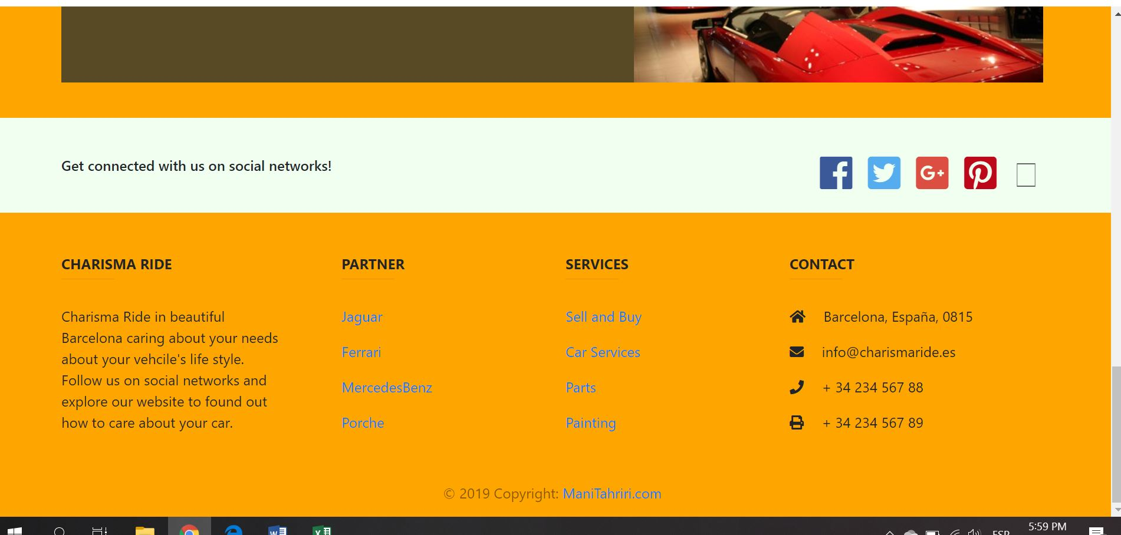

And in mobile format is behave good.

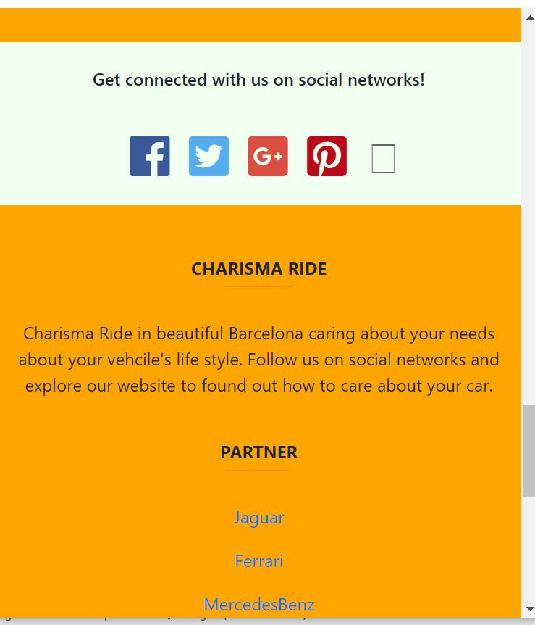

This above screen shot got by firefox. The result was the same in all browsers.

Next is gallery page.

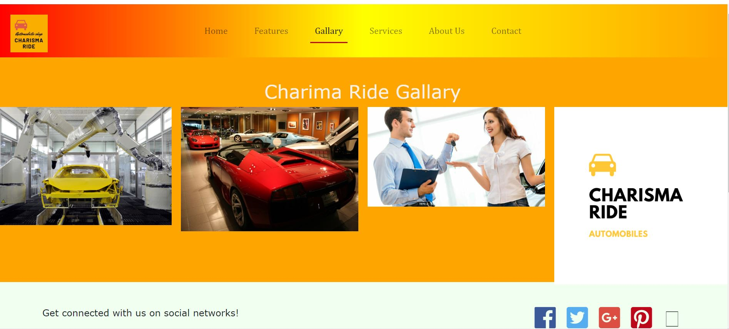

Screen shot taken in IE 11, and same page in mobile tablet dimension in google chrome is on next. 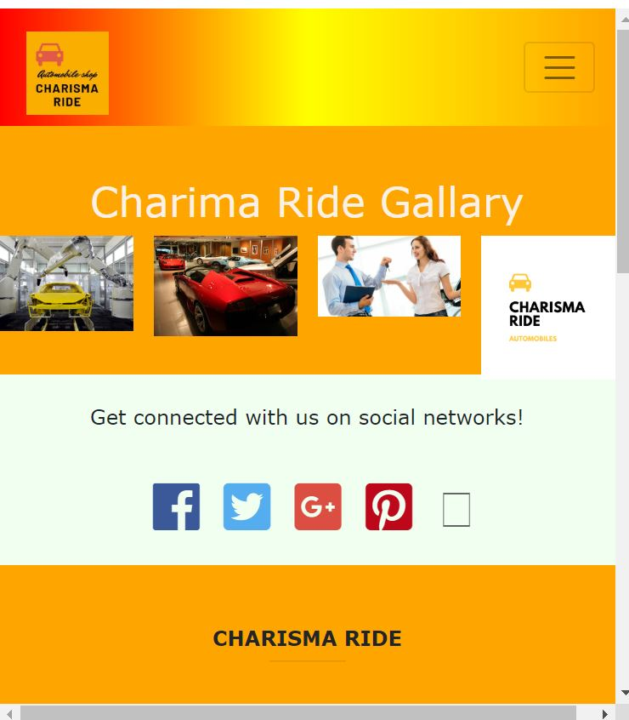

Next is YouTube embed video

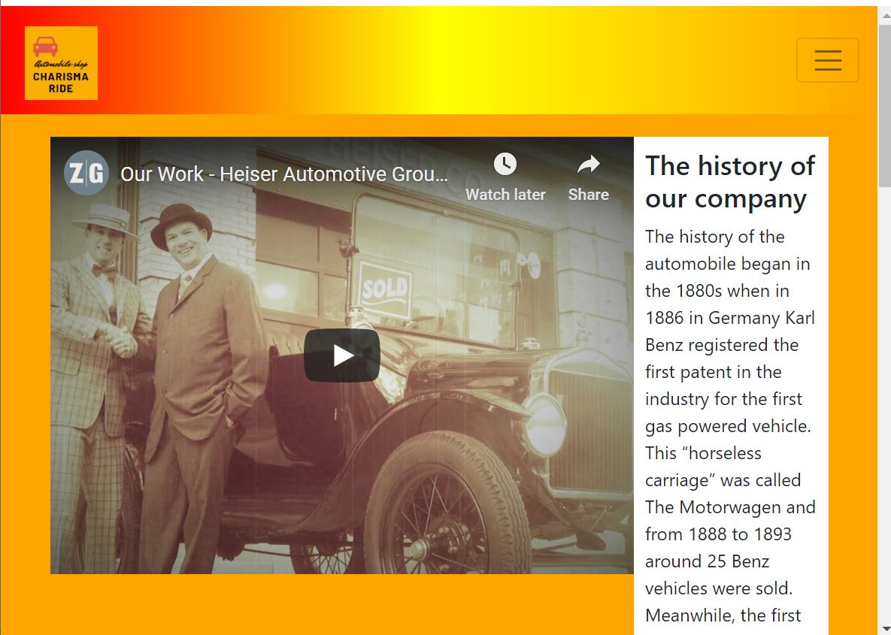

It shows on tablet mode. Except the text beside the video, all the elements are responsive.

Testing Result:

During the testing we make sure that everything is working properly in all well-known browsers (Chrome, Firefox, IE 11, Edge, and Safari). There are two issue: 1- no touching function on mobile phone for menu button. And wrapping problem for text beside the video.