Git Repository Information: https://github.com/Manimozhi91/AnnaFirm/tree/master

Repository Name : [**AnnaFirm**](https://github.com/Manimozhi91/AnnaFirm)

Repository URL : <https://github.com/Manimozhi91/AnnaFirm.git>

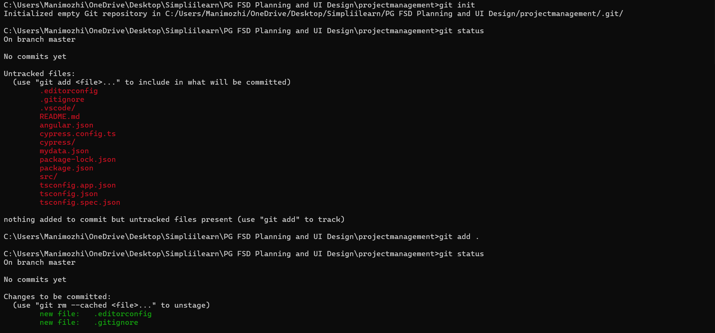

Source code is in branch master: https://github.com/Manimozhi91/AnnaFirm/tree/master

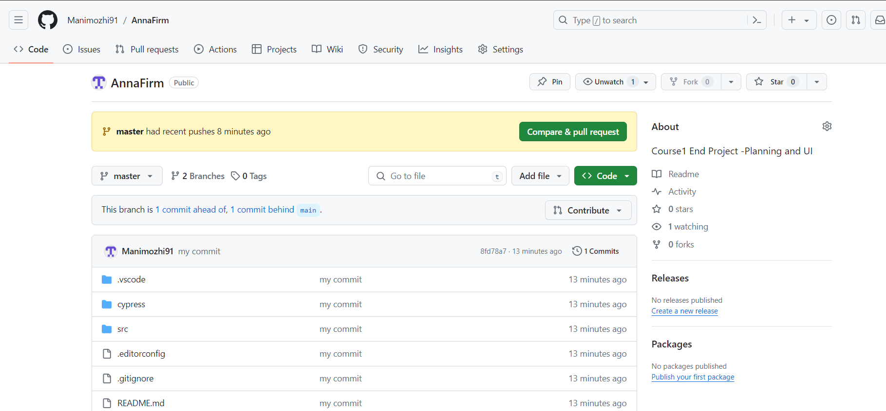

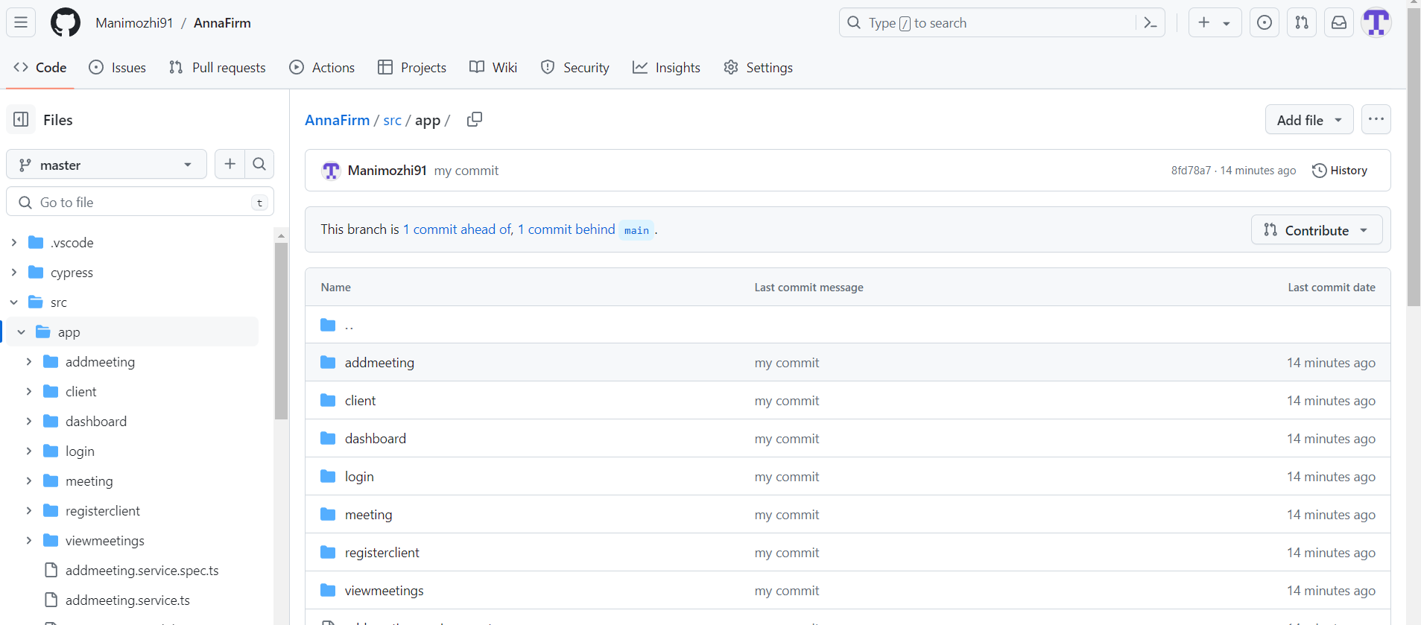

Sample code

