Screenshots From Creating instance to output after deployment

Creating Instance:

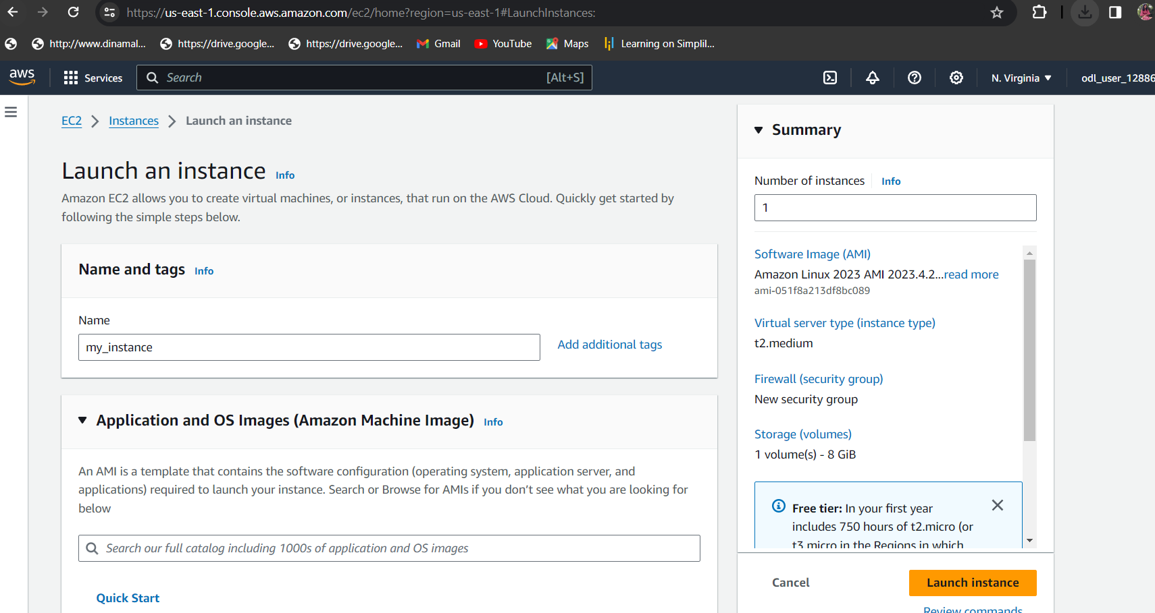

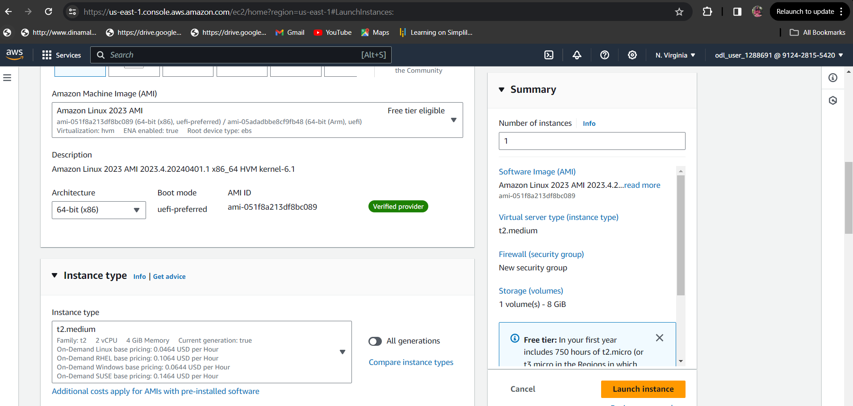

Creating key pairs:

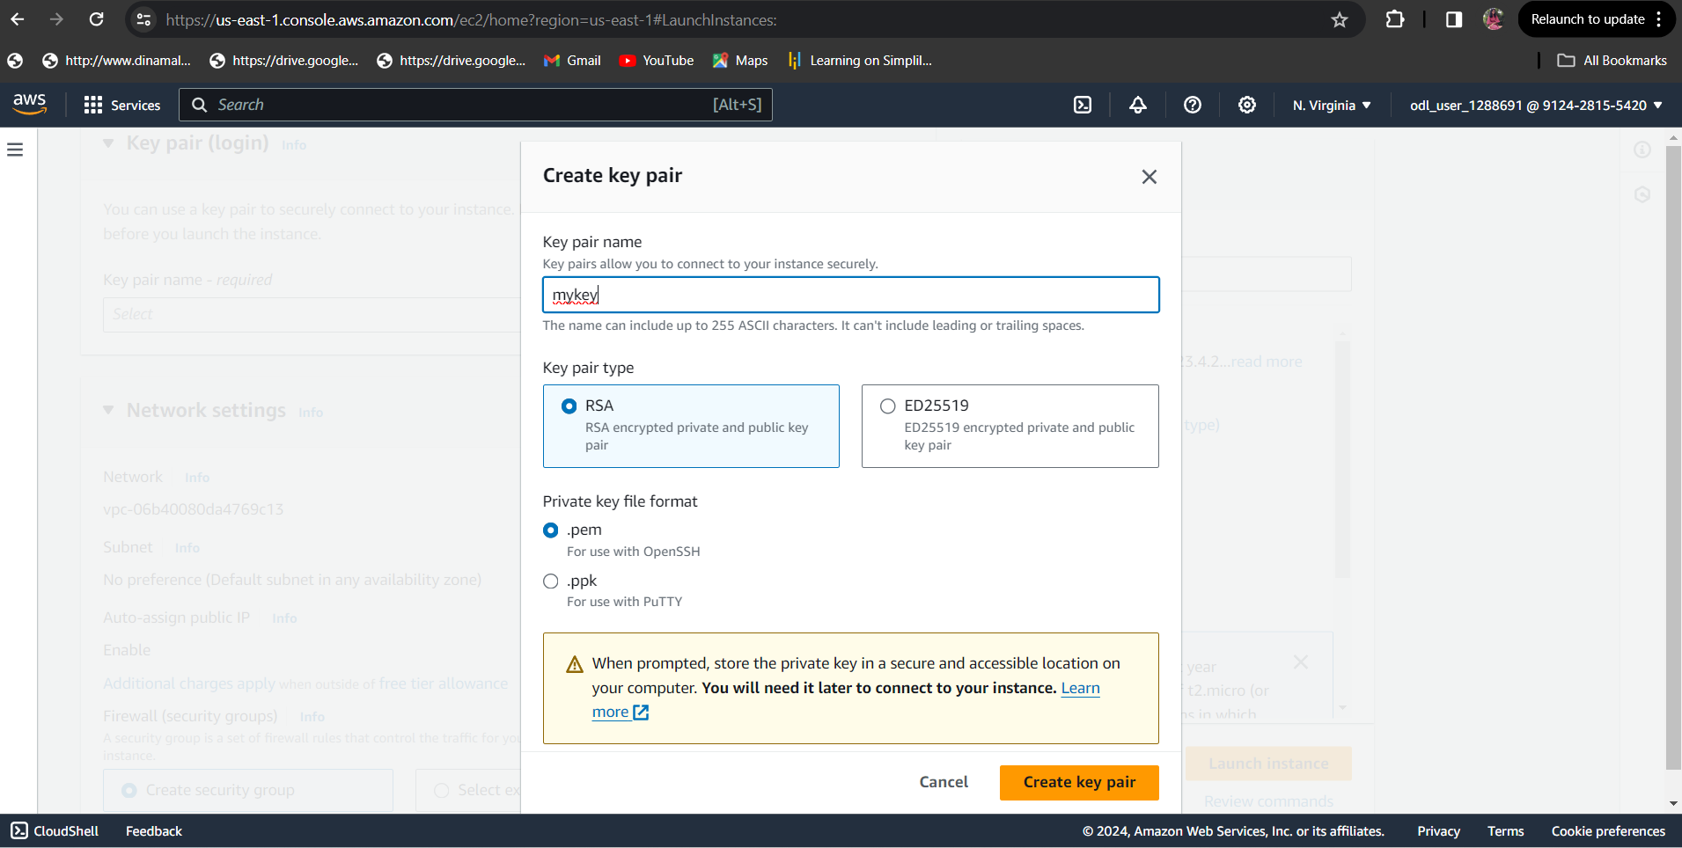

Setting Inbound Rules to open the ports :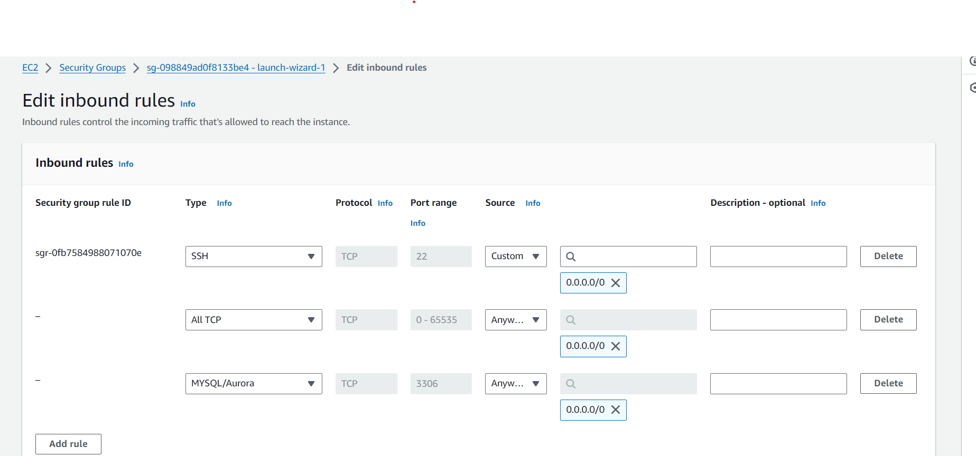

Start instance

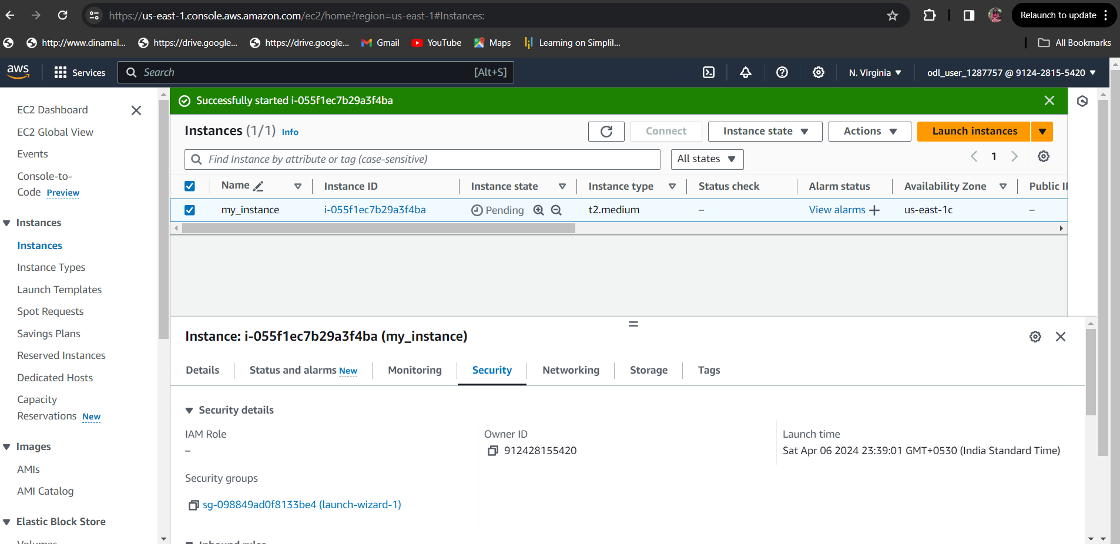

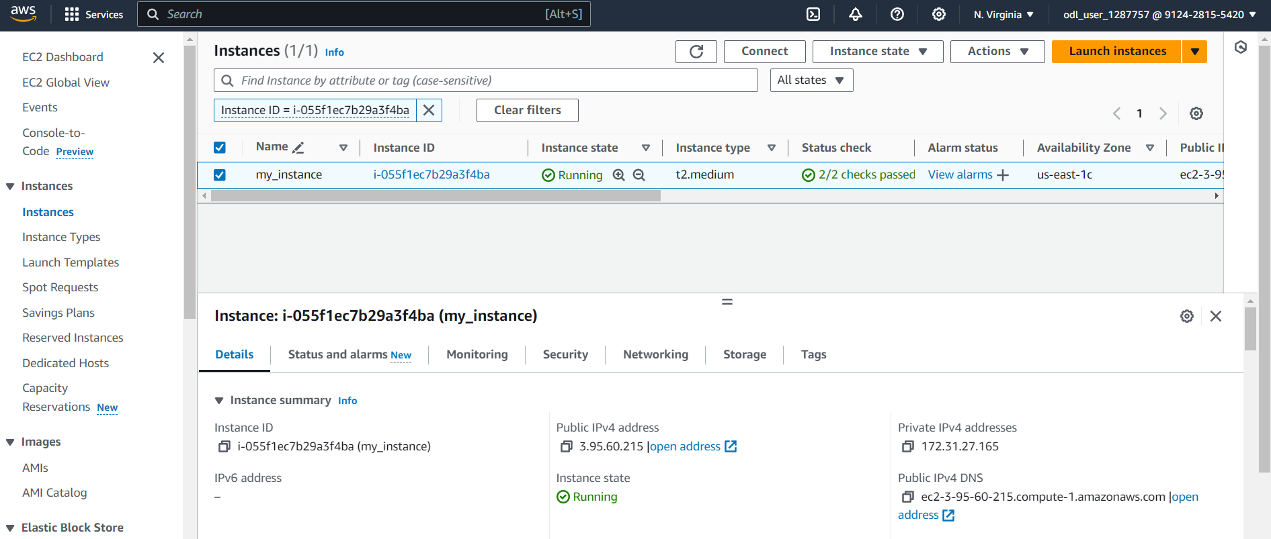

Instance with Ip Information

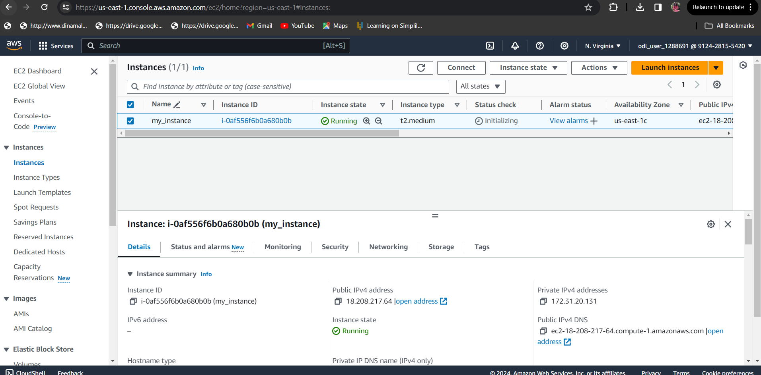

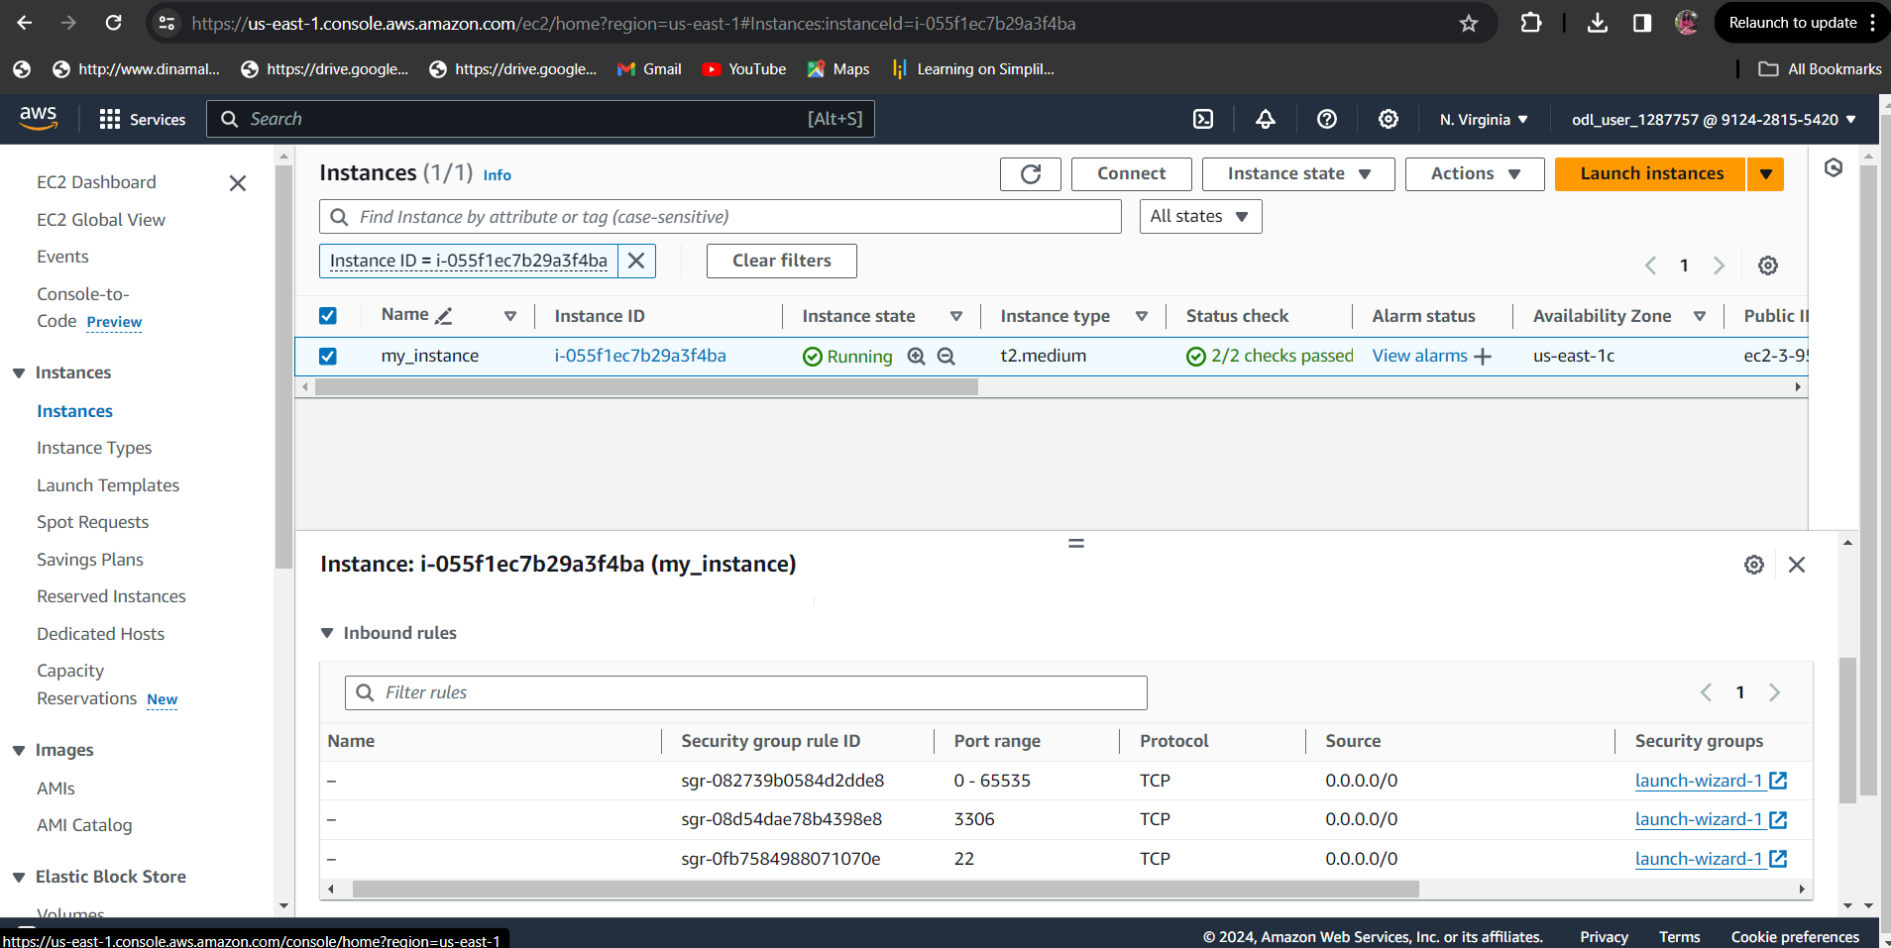

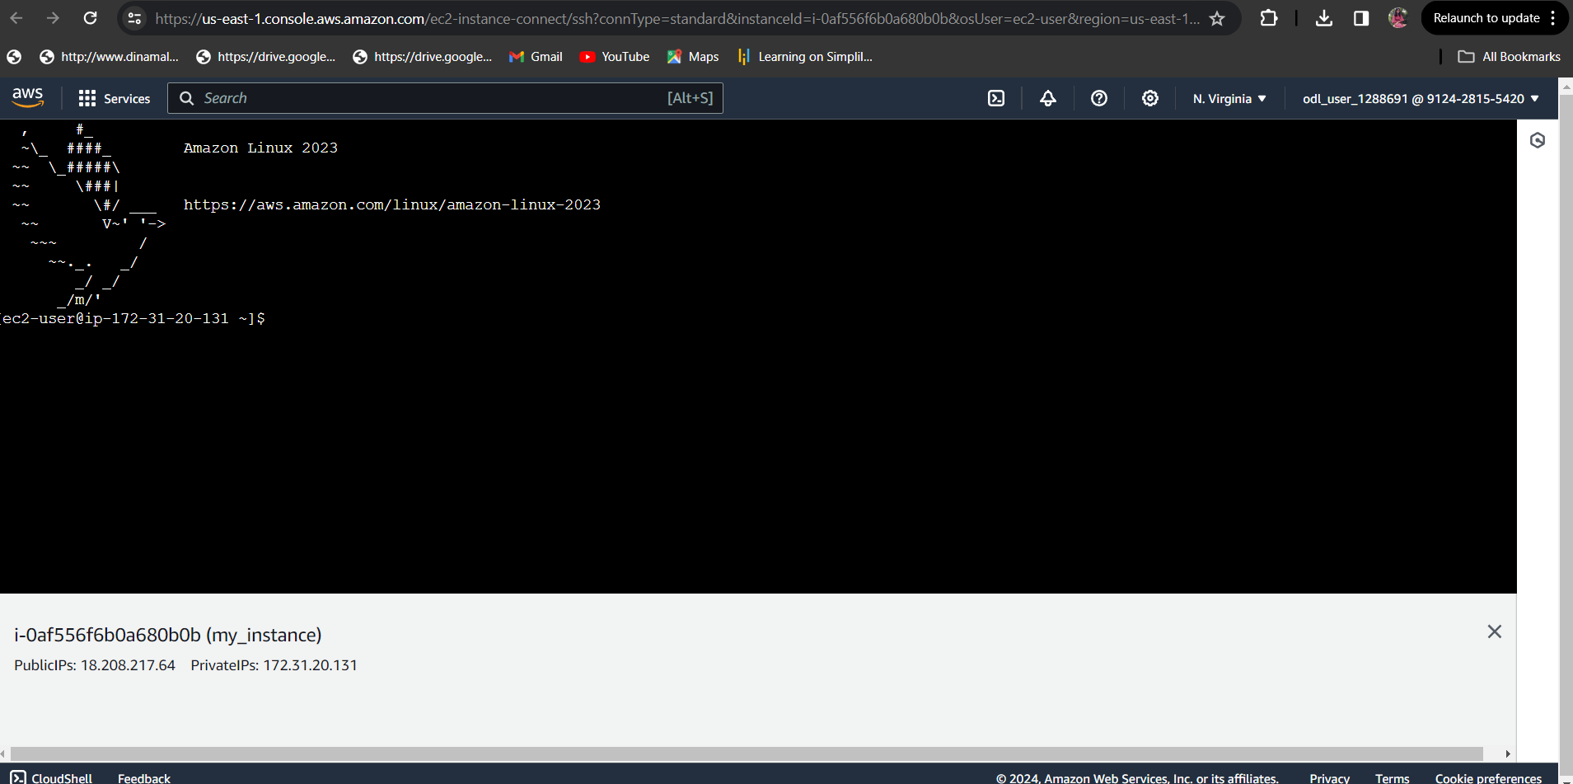

Installing required softwares in Ec2 instance

Run the following commands to install the required softwares in EC2 instance

sudo yum install git -y

sudo yum install java-21

sudo wget -O /etc/yum.repos.d/jenkins.repo [https://pkg.jenkins.io/redhat/jenkins.repo](https://pkg.jenkins.io/redhat/jenkins.repo%20)

sudo rpm --import https://pkg.jenkins.io/redhat-stable/jenkins.io-2023.key

sudo yum install jenkins

sudo service jenkins start

sudo cat /var/lib/jenkins/secrets/initialAdminPassword

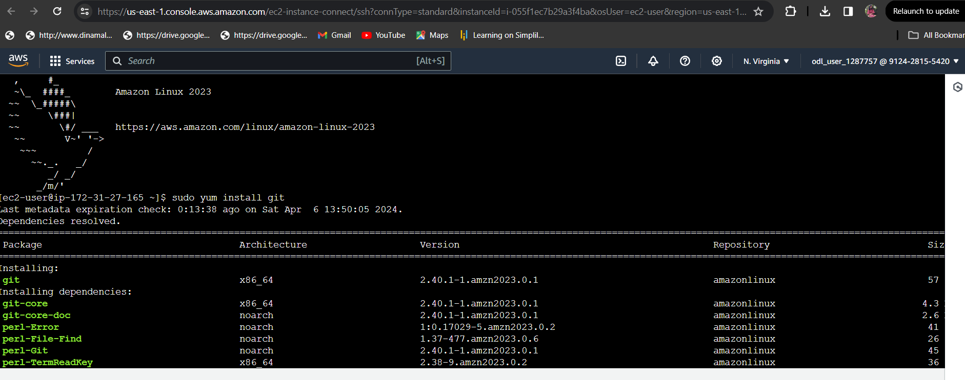

Jenkins installation and starting services:

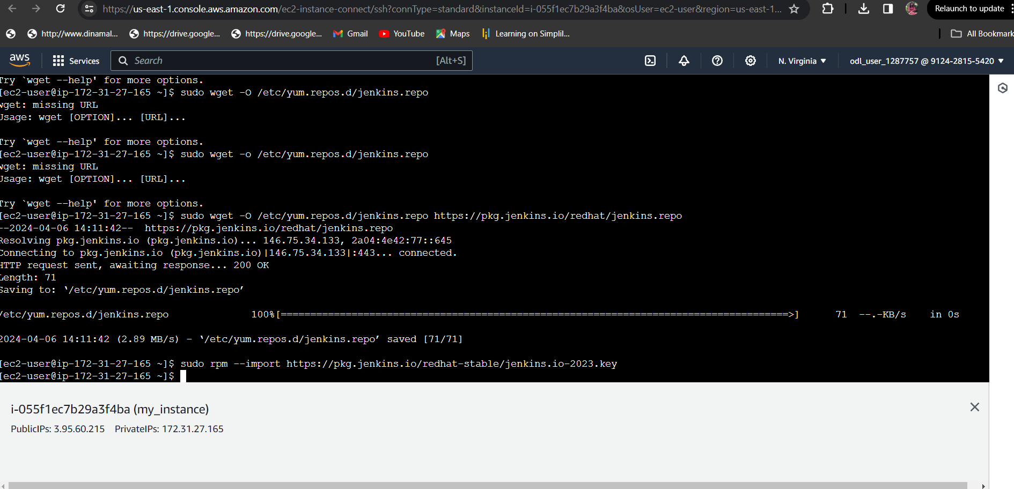

Accessing e2c and docker compose

sudo curl -L https://github.com/docker/compose/releases/latest/download/docker-compose-$(uname -s)-$(uname -m) -o /usr/local/bin/docker-compose

sudo chmod +x /usr/local/bin/docker-compose

docker-compose version

Now we will create the docker service and group and usermode

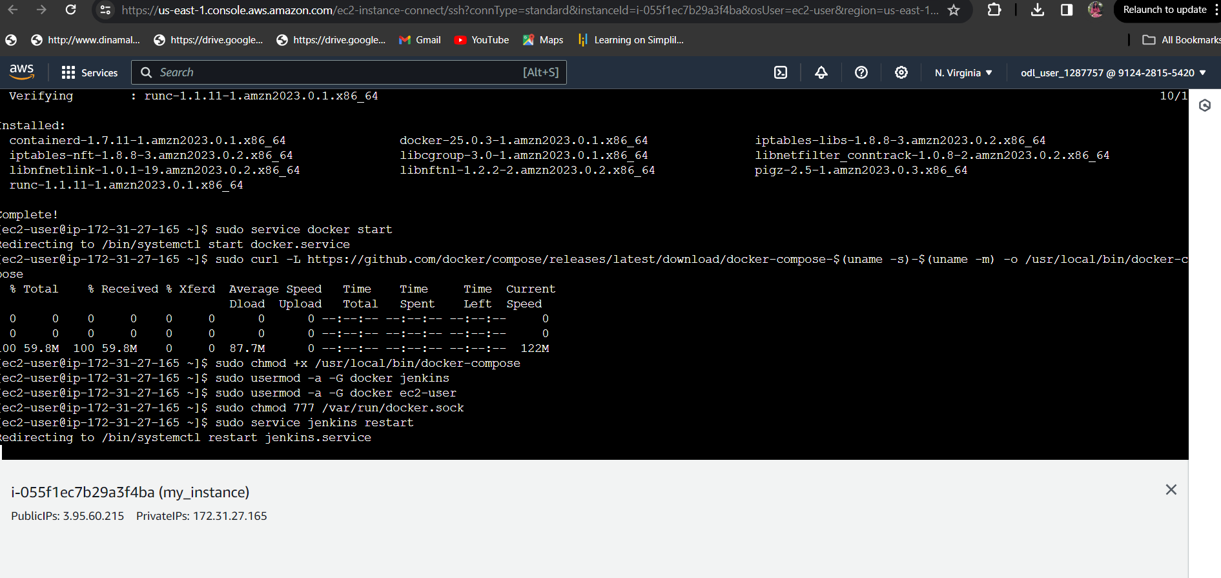

Jenkins Login

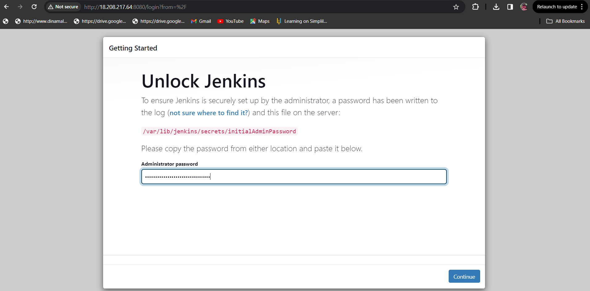

Add Maven tool in Jenkins

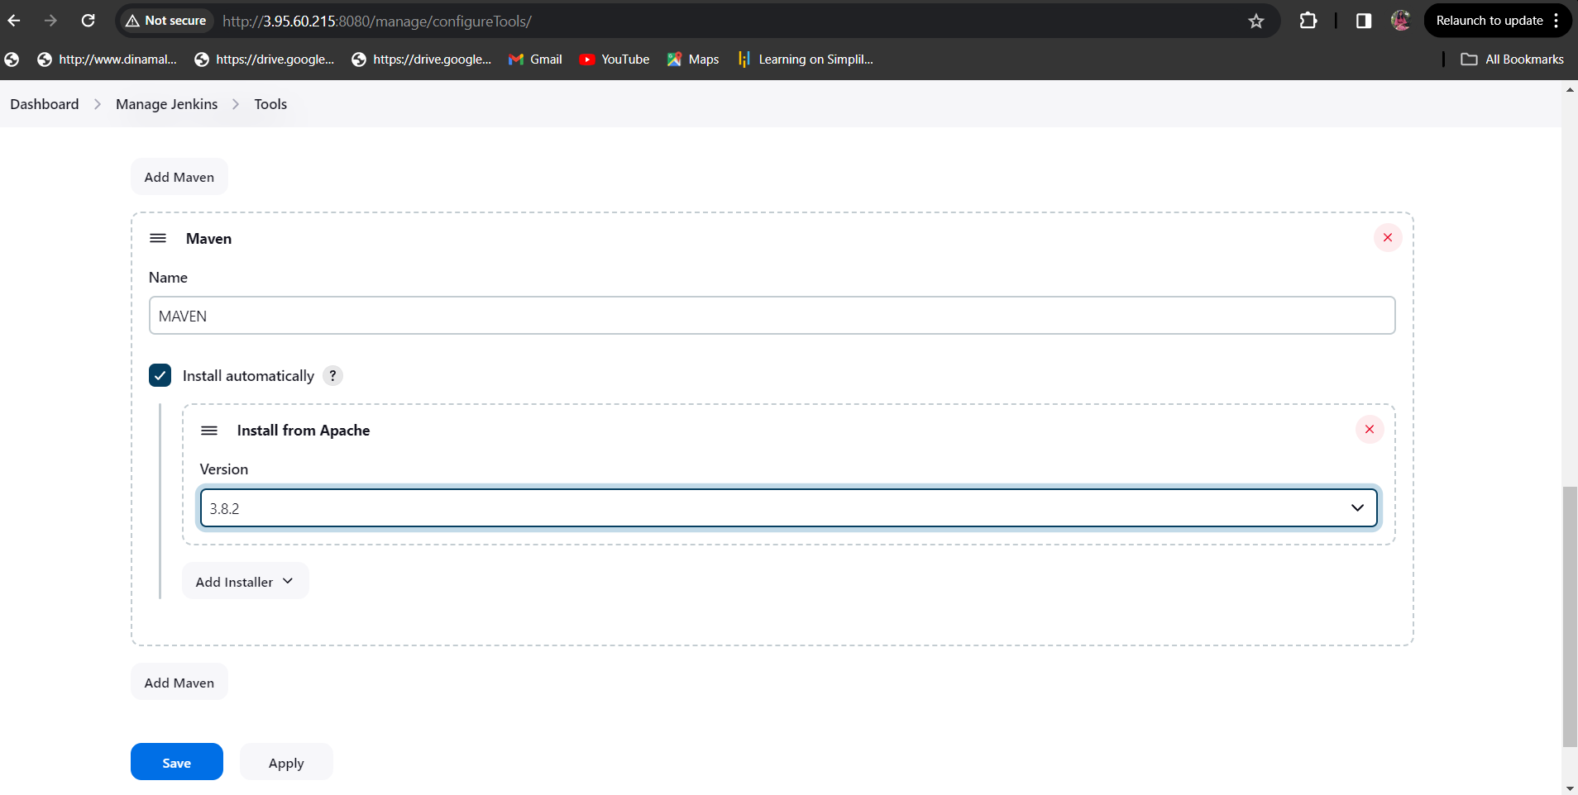

Configuring pipeline for Petclinic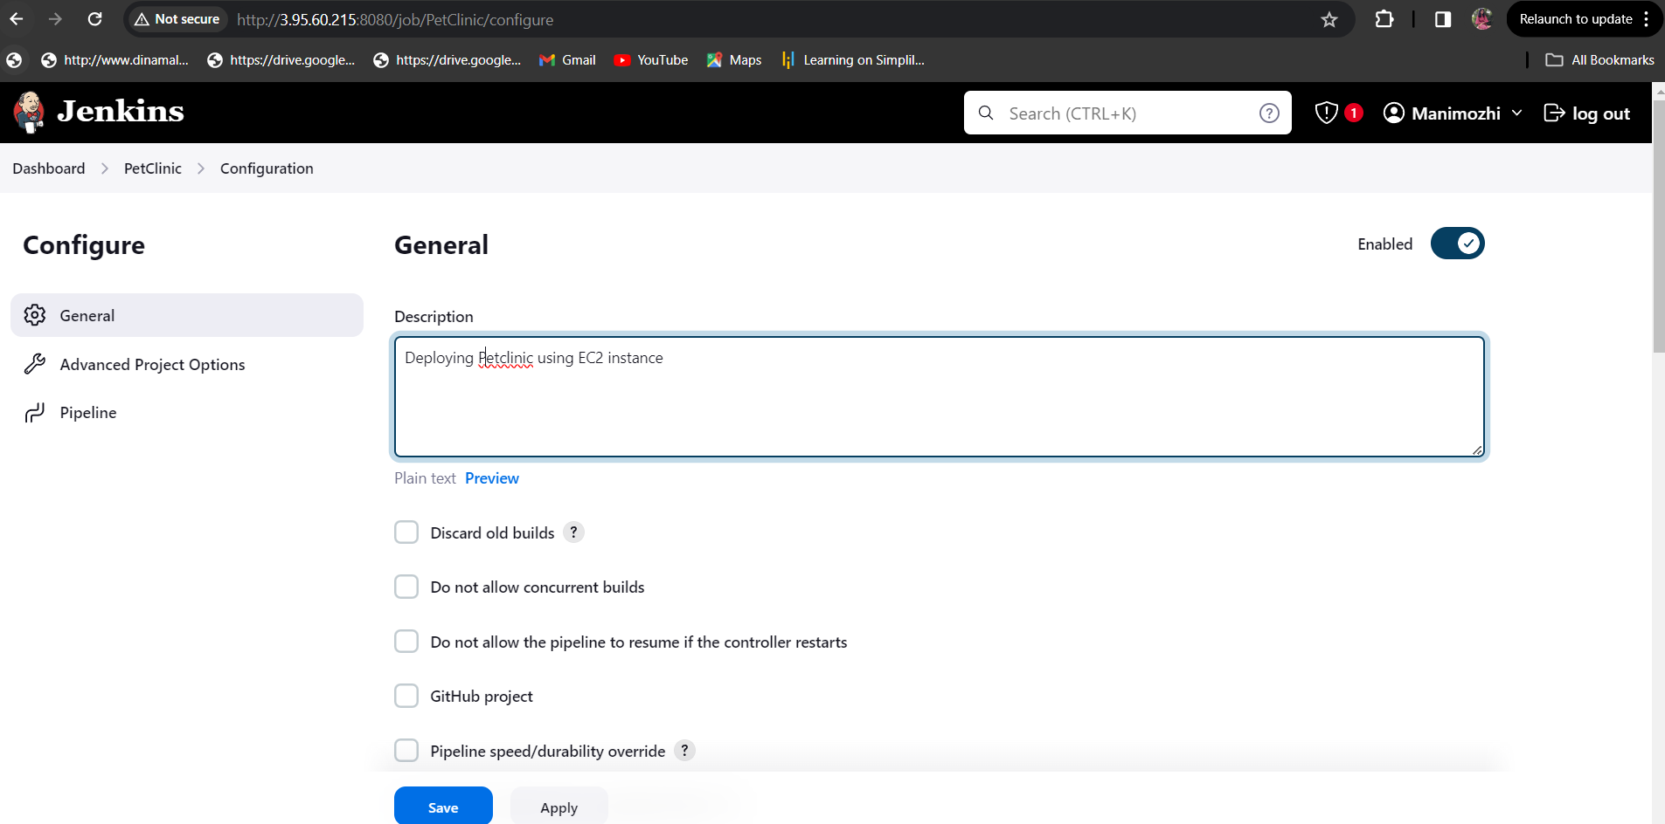

Configuring git repository url to pipeline :

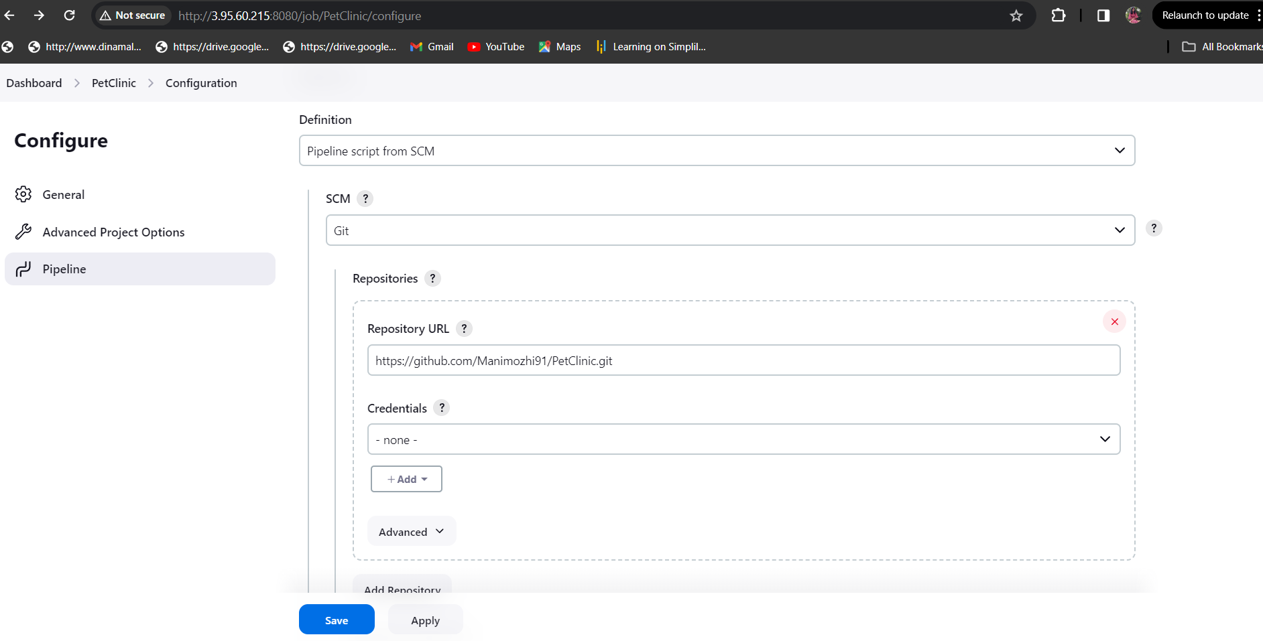

After build

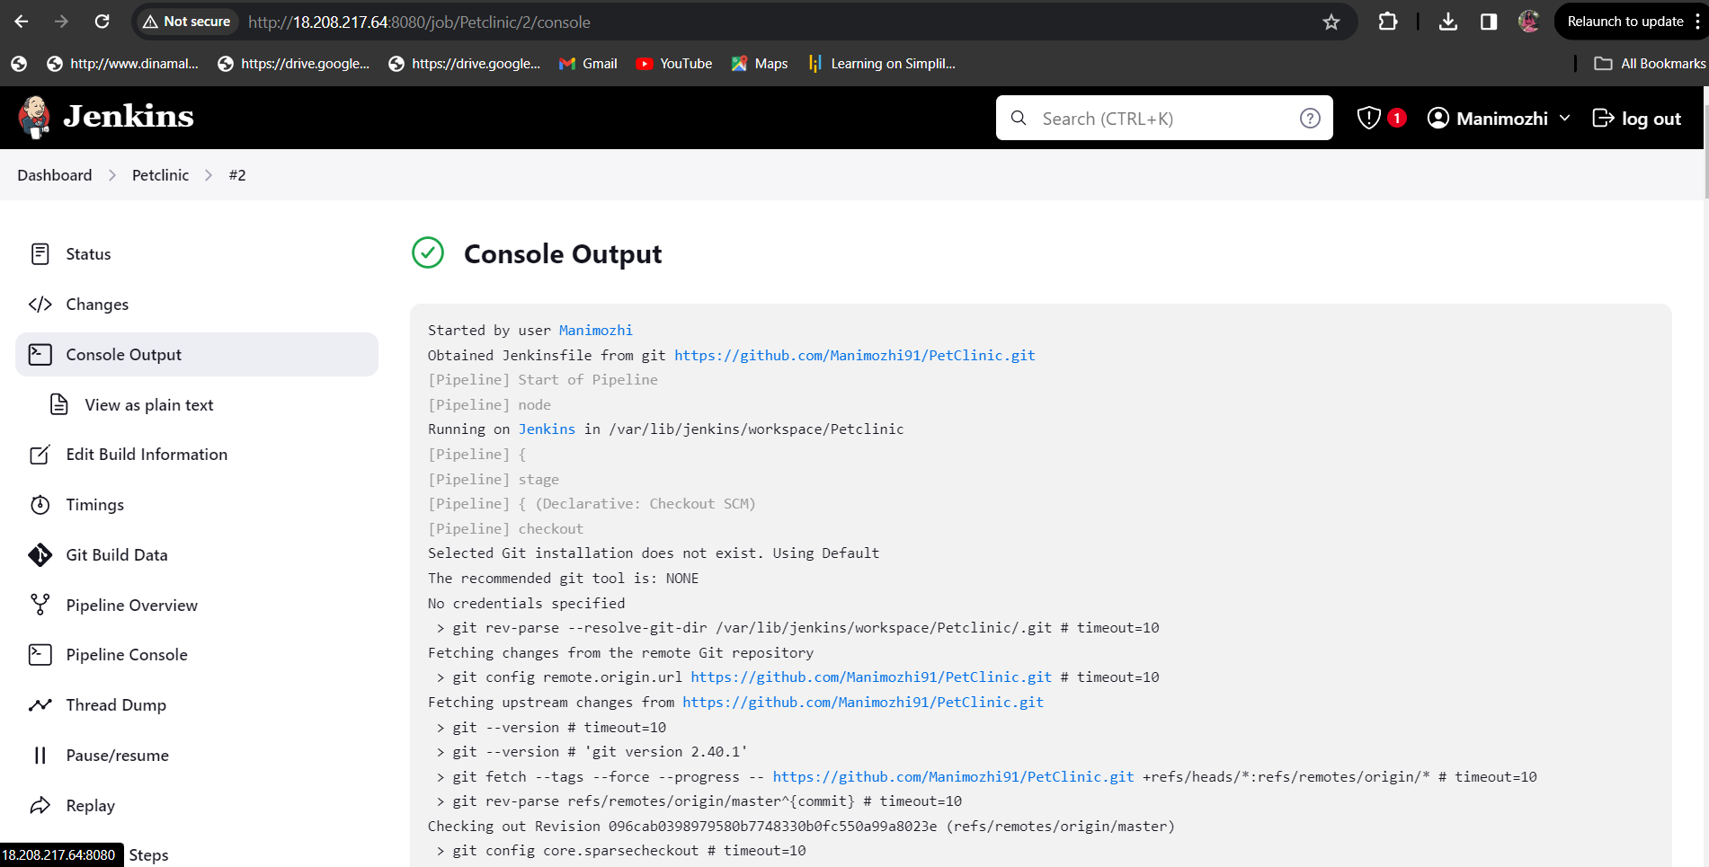

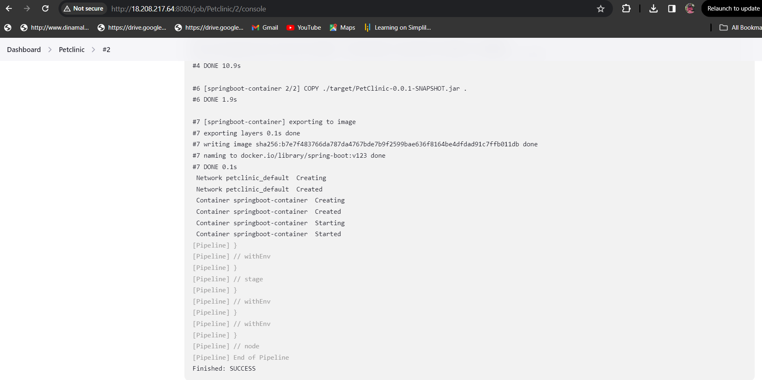

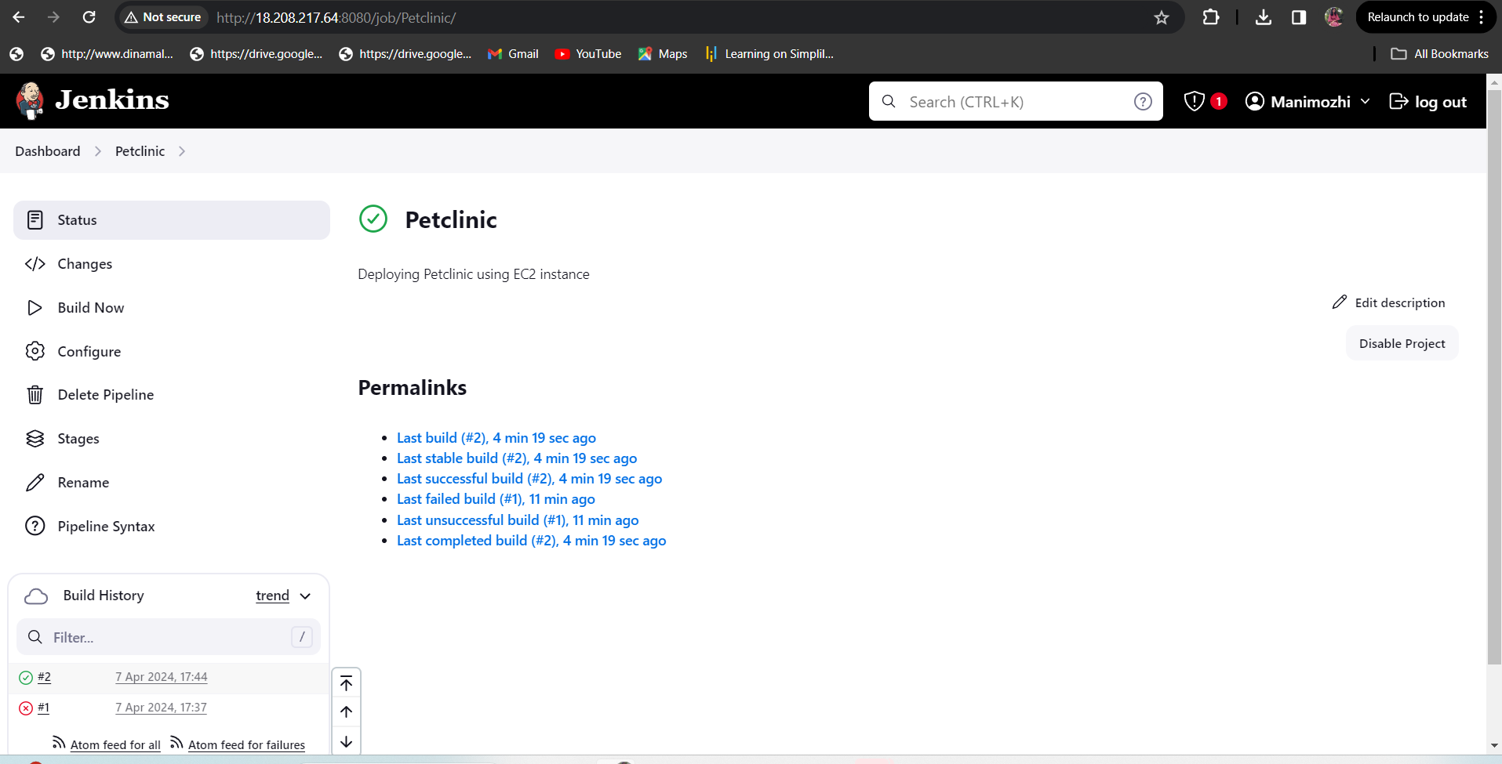

OUTPUT:

Application deployed successfully in port 9090

http://18.208.217.64:9090/

