*Zumba App ScreenShots*

GIT Repo: https://github.com/Manimozhi91/ZumbaaApp.git

Repo contents:

Project2DB—To create database and tables required for the given project

War generated for the Appication developed(ZumbaApp.war)

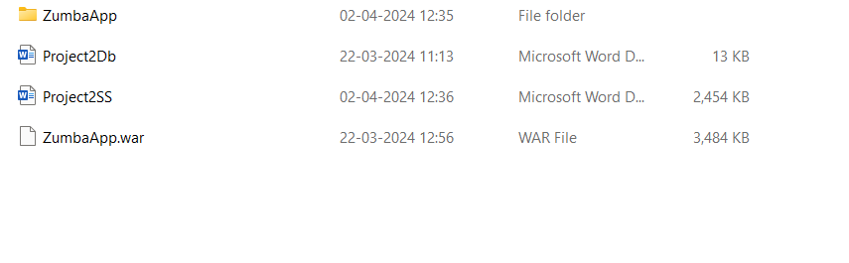

HomePage: http://localhost:8090/ZumbaApp/

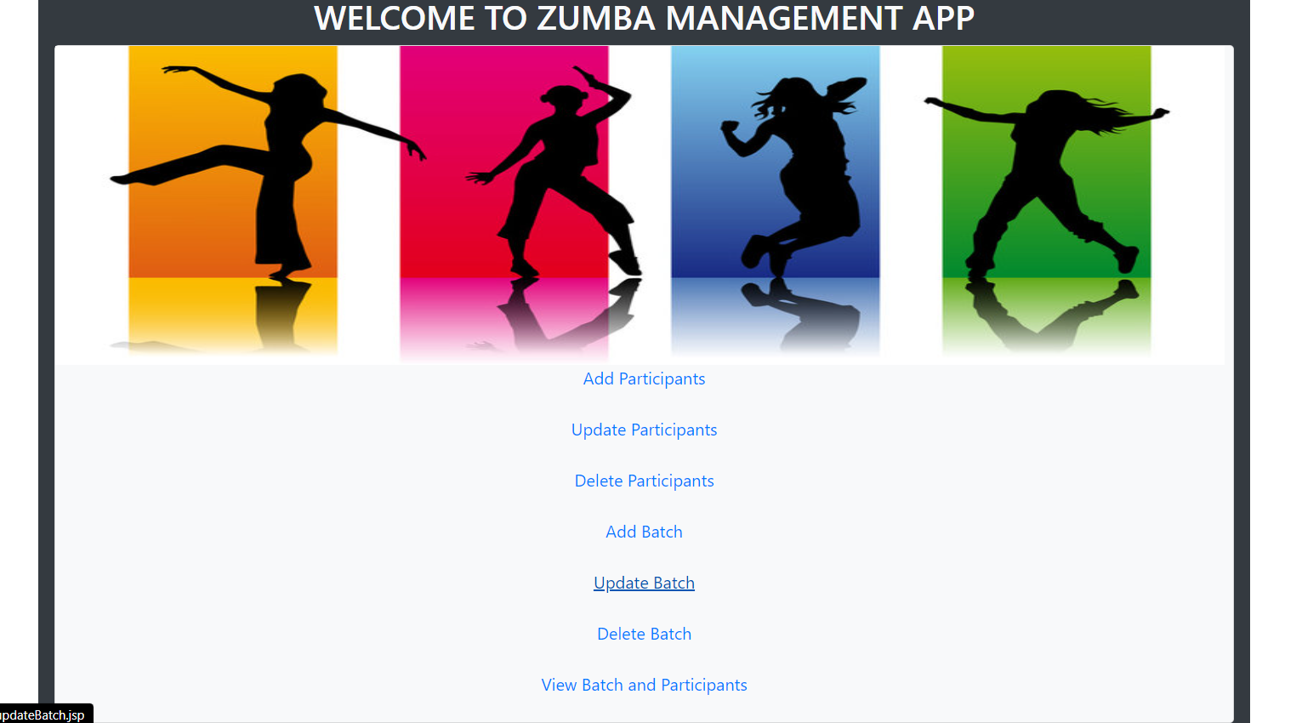

Add Participants: http://localhost:8090/ZumbaApp/addParticipants.jsp

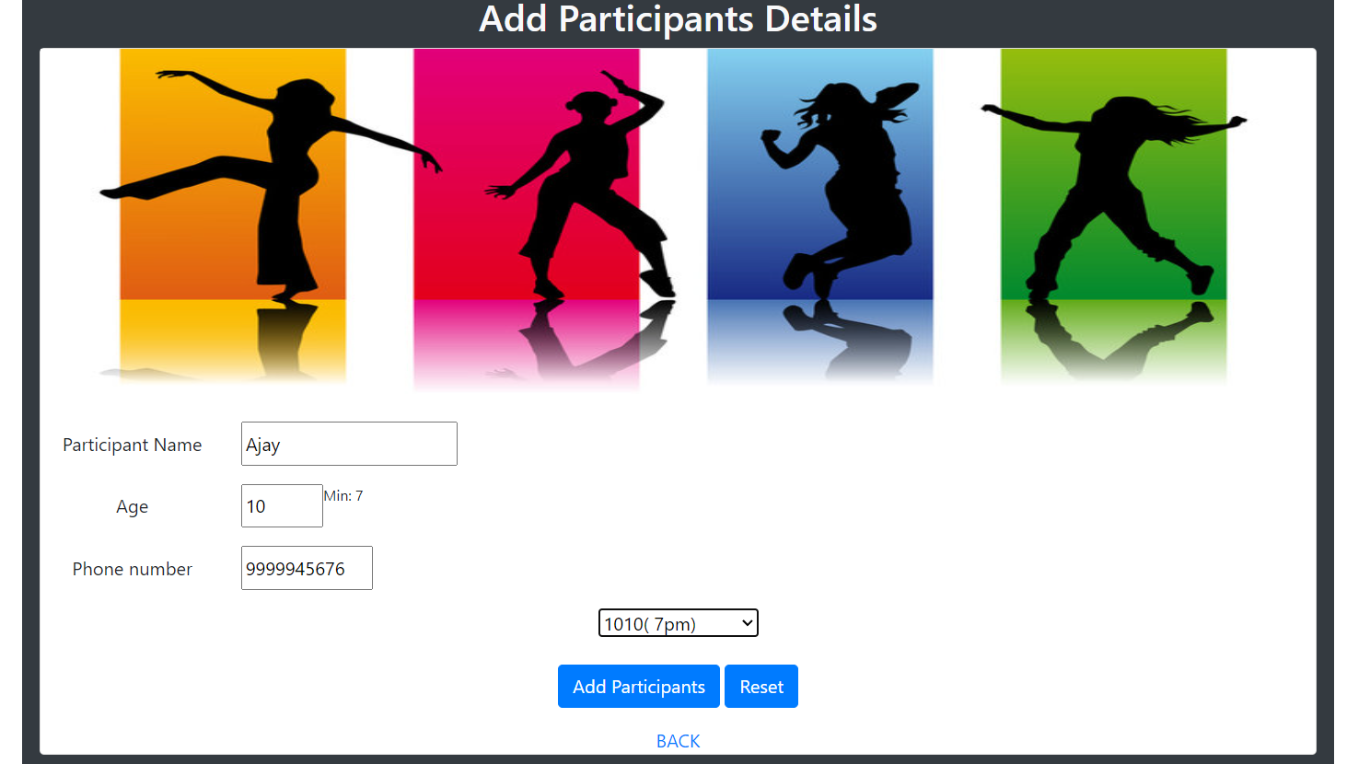

Update Participants: http://localhost:8090/ZumbaApp/ParticipantsContoller

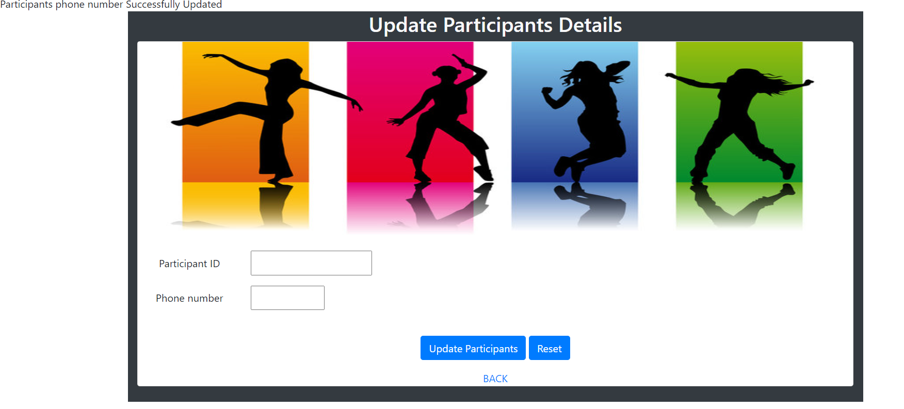

Delete Participants: http://localhost:8090/ZumbaApp/ParticipantsContoller

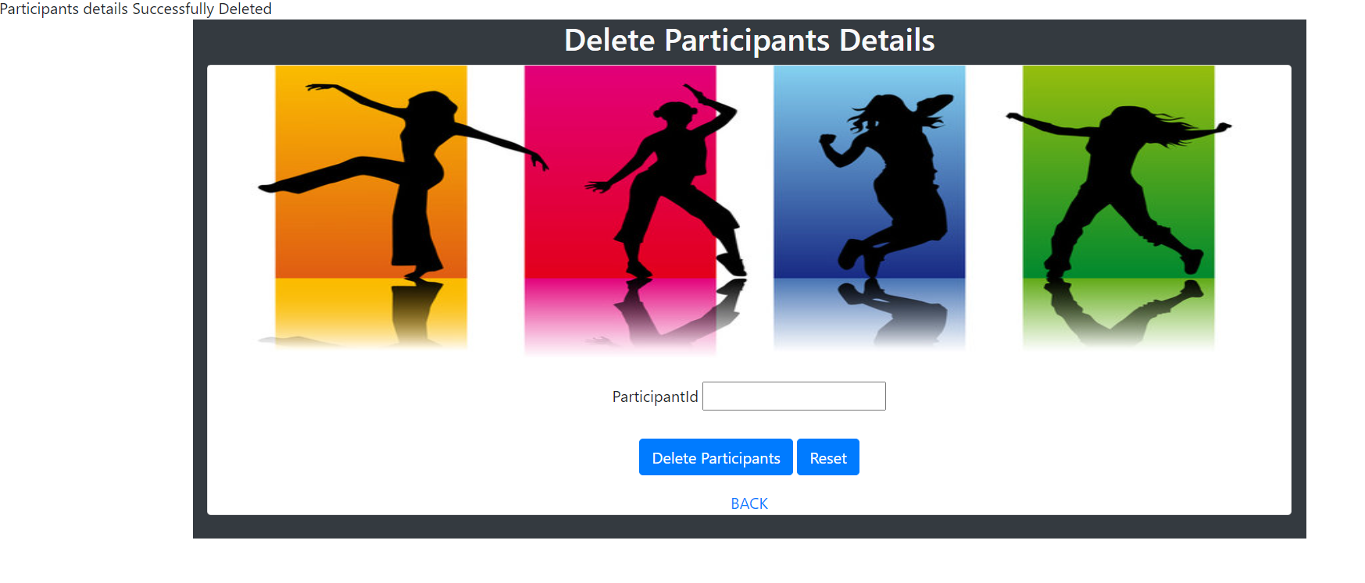

Add Batch: http://localhost:8090/ZumbaApp/BatchController

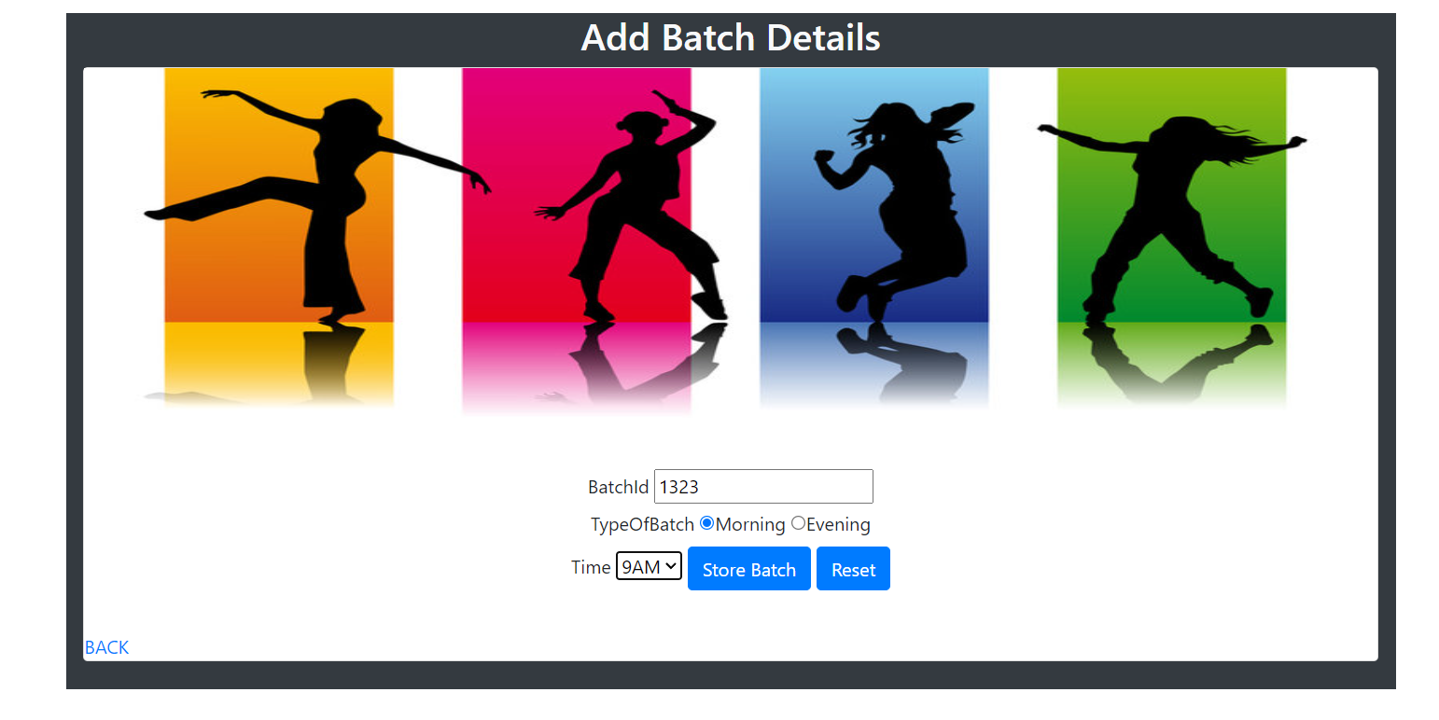

Update Batch: http://localhost:8090/ZumbaApp/updateBatch.jsp

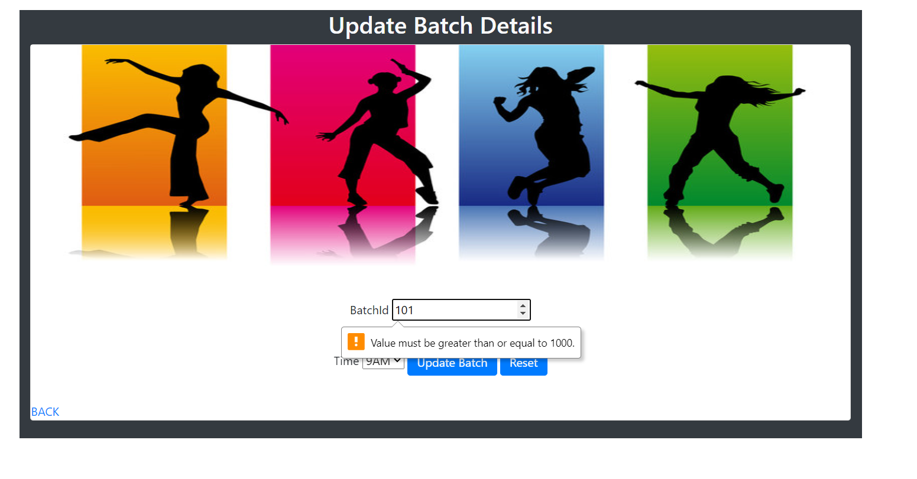

Delete Batch: http://localhost:8090/ZumbaApp/BatchController

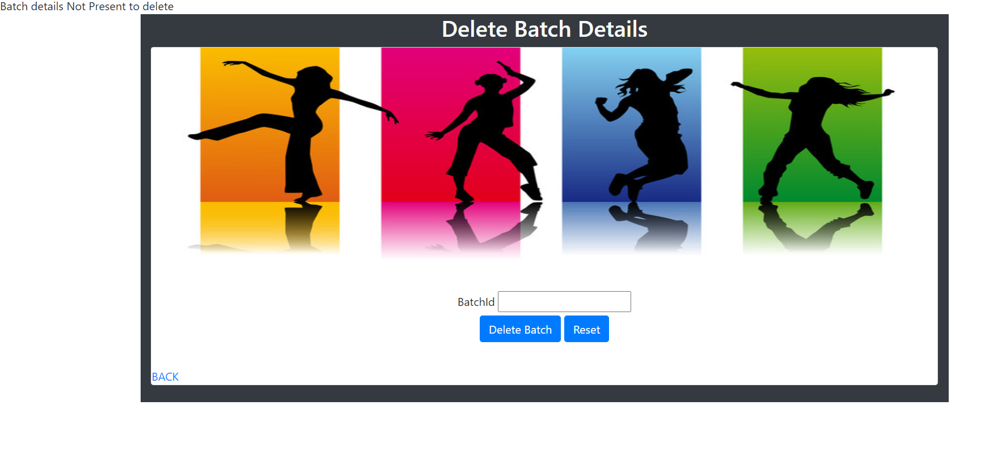

View Batch and Participants :http://localhost:8090/ZumbaApp/batchAndParticipants.jsp

