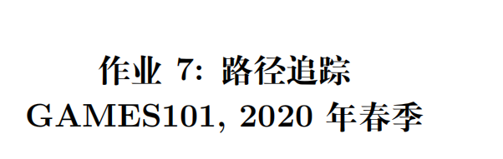
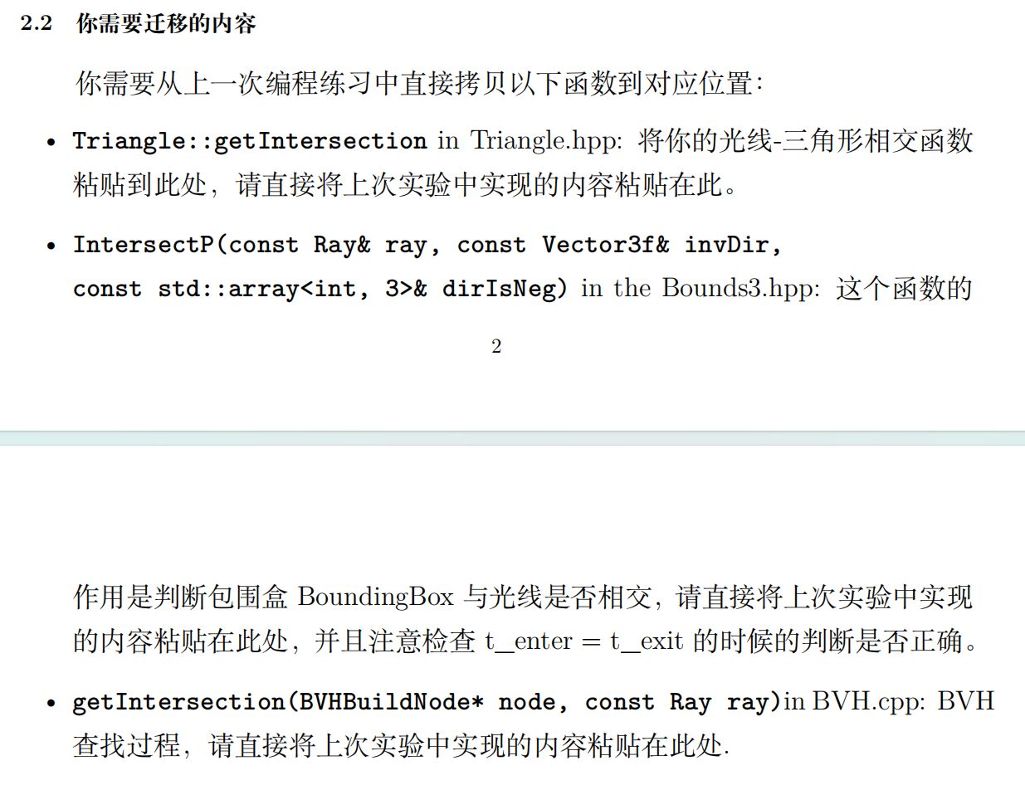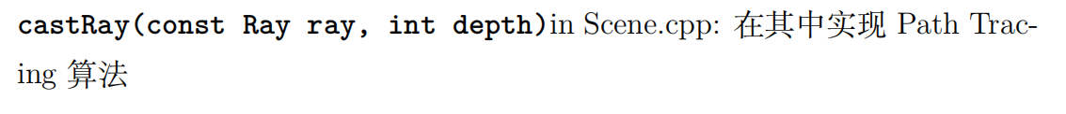
一开始还以为是自己castRay写错了，在网上查了半天，结果是IntersectP需要考虑误差

首先修改Render（）成多线程
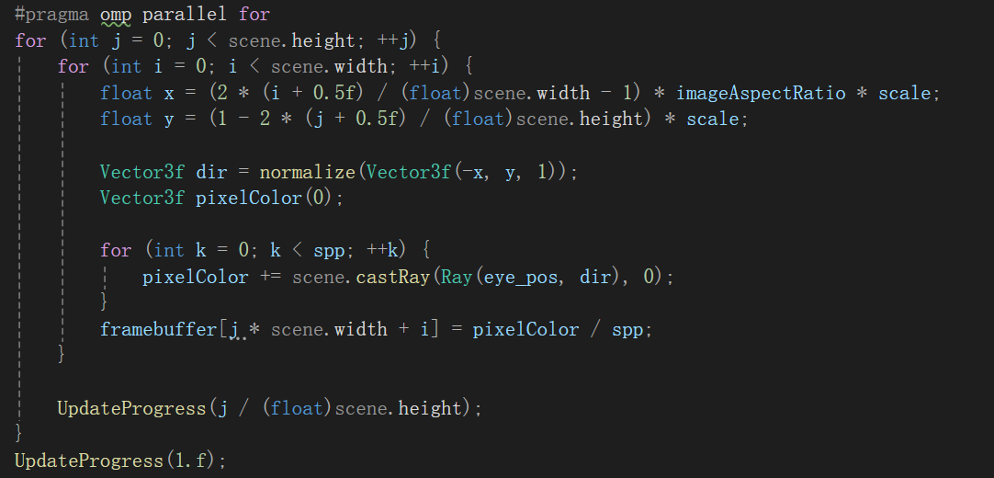
其实只是打开了openmp（十三分钟变成六秒了）
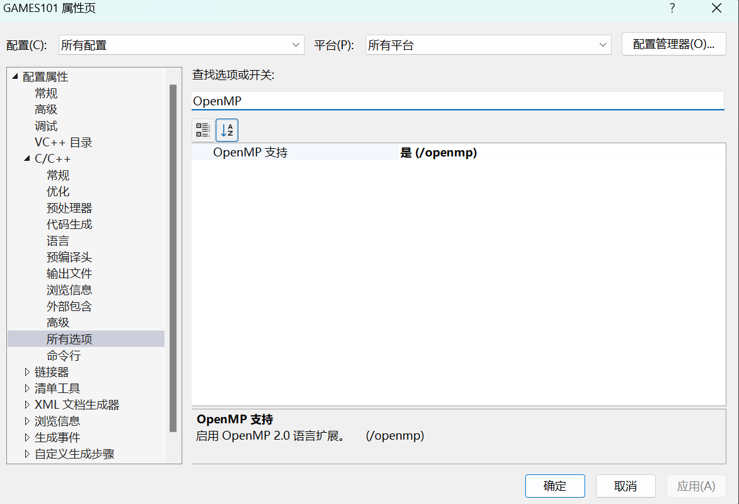
右键解决方案点击属性

但是OpenMP会导致原来的m++访问出错，所以要绕开m，直接计算像素位置
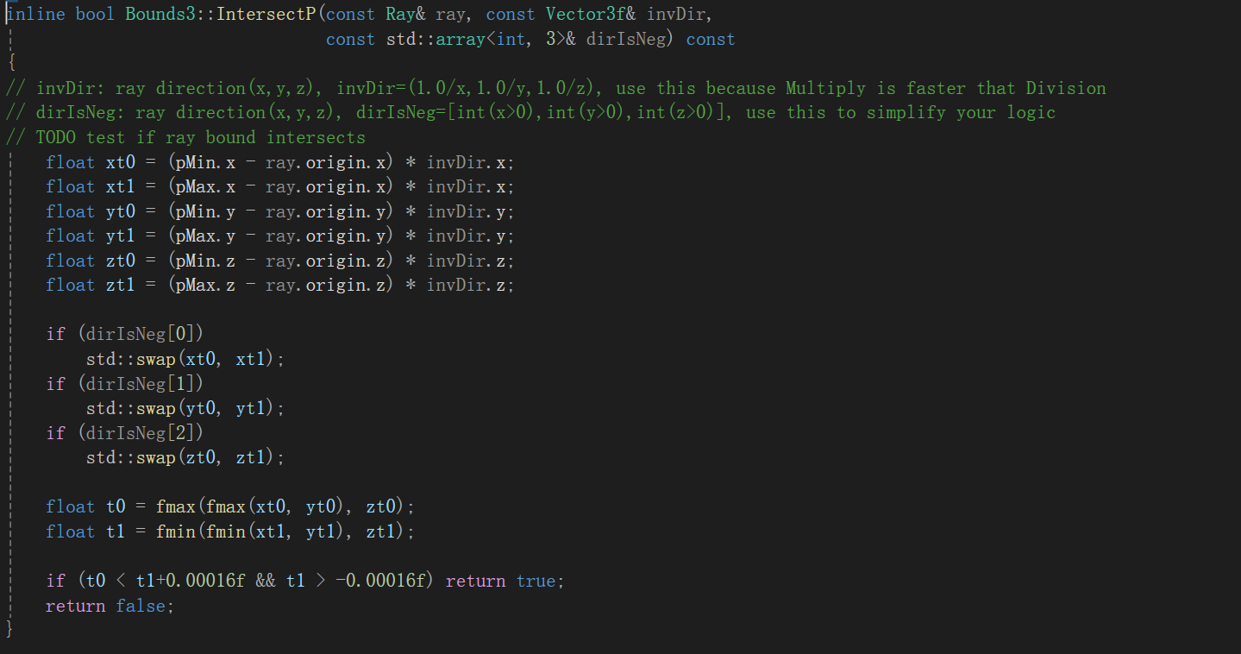
因为场景中存在平面，不好比较tmin和tmax，所以tmax要加上一个0.00016f
这位置硬控我好久，不加会变成

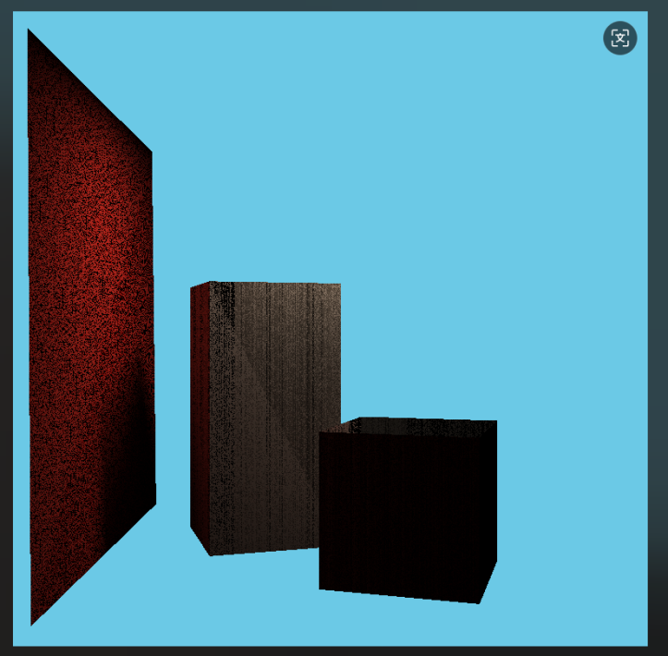
getIntersection不需要修改

然后是这次的代码
// Implementation of Path Tracing
Vector3f Scene::castRay(const Ray& ray, int depth) const {
Intersection insec = intersect(ray);
if (insec.happened) {
Vector3f hitPoint = insec.coords;
Vector3f hitNormal = insec.normal;
Vector3f wo = normalize(ray.direction);
Vector3f L_dir(0), L_indir(0);

// 交点偏移（防止自相交）
Vector3f offsetPoint = (dotProduct(wo, hitNormal) < 0) ?hitPoint + hitNormal * EPSILON :hitPoint - hitNormal * EPSILON;

// 采样光源
float pdf_light;
Intersection lightInsec;
sampleLight(lightInsec, pdf_light);

Vector3f x = lightInsec.coords;
Vector3f ws = normalize(x - hitPoint);
float distance = (x - hitPoint).norm();
Vector3f NN = lightInsec.normal;
Vector3f emit = lightInsec.emit;
// Add the declaration of `offsetPoint` before its usage in the `castRay` method.
Vector3f offsetPoint = (dotProduct(wo, hitNormal) < 0) ? hitPoint + hitNormal * EPSILON : hitPoint - hitNormal * EPSILON;
Ray shadowRay(offsetPoint, ws);
Intersection shadowInsec = intersect(shadowRay);
if (shadowInsec.happened &&
std::abs(shadowInsec.distance - distance) < 1e-2) {
float dist2 = distance * distance;
L_dir = emit *
insec.m->eval(wo, ws, hitNormal) *
dotProduct(ws, hitNormal) *
dotProduct(-ws, NN) /
(dist2 * pdf_light);
}

// 俄罗斯轮盘采样间接光
float ksi = get_random_float(); // 0~1 的随机数
if (ksi < RussianRoulette) {
Vector3f wi= normalize(insec.m->sample(wo, hitNormal));
Ray reflRay(offsetPoint, wi);
Intersection reflInsec = intersect(reflRay);

if (reflInsec.happened && reflInsec.m != nullptr &&
!reflInsec.m->hasEmission()) {
float pdf = insec.m->pdf(wo, wi, hitNormal);
if (pdf > EPSILON) {
L_indir = castRay(reflRay, depth + 1) *
insec.m->eval(wo, wi, hitNormal) *
dotProduct(wi, hitNormal) /
(pdf * RussianRoulette);
}
}
}

return insec.m->getEmission() + L_dir + L_indir;
}

// 没有命中，返回背景色
return backgroundColor;
}
只需要按照步骤一步一步来即可
得到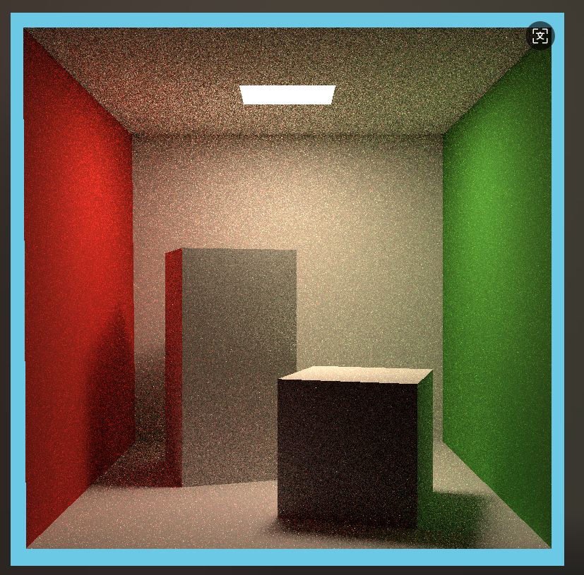
Spp=16

还跑了一张spp=512的
