SPOTIFY 2023 SONG ANALYTICS REPORT
Music Analysis, Platform Comparison, Artist Impact, Temporal Trends and Cross-Platform Presence

Dataset: Spotify 2023 | 953 songs | 24 original variables

1. Executive Summary
This report analyses the Spotify 2023 song dataset to identify patterns associated with streaming success and to examine how popular songs differ in audio characteristics, artist involvement and cross-platform presence. The analysis combines descriptive statistics, Spearman correlation, grouped comparisons and a multiple linear regression on log-transformed Spotify streams.
The dataset contains 953 records. One record has a non-numeric stream value, leaving 952 songs with usable Spotify stream counts for stream-based analysis. There are 50 missing Shazam-chart values and 95 missing musical-key values. No exact duplicate rows were found.
The strongest platform-level association with Spotify streams is Spotify playlist inclusion (Spearman ρ=0.83), followed by Deezer playlist inclusion (ρ=0.74) and Apple playlist inclusion (ρ=0.67). These measures should not be interpreted as causal drivers because playlist exposure and streaming success can influence each other and may both reflect underlying popularity.
Audio features by themselves have limited explanatory power in this dataset. A regression using the seven audio features, BPM, artist count and release year explains about 9.7% of the variation in log streams. Artist count and release year are statistically associated with the outcome in this model, while most individual audio features are not statistically strong predictors after the other variables are controlled.

2. Dataset Description and Preparation
The dataset contains track-level information covering song identity, artists, release date, Spotify performance, Apple performance, Deezer performance, Shazam chart presence and audio characteristics. The main target variable for success analysis is Spotify streams.
Area | Variables used | Purpose
Spotify performance | streams, in_spotify_playlists, in_spotify_charts | Measure streaming success and Spotify exposure
Apple | in_apple_playlists, in_apple_charts | Compare Apple platform presence
Deezer | in_deezer_playlists, in_deezer_charts | Compare Deezer platform presence
Shazam | in_shazam_charts | Measure discovery/chart presence
Artist | artist(s)_name, artist_count | Examine artist involvement
Time | released_year, released_month, released_day | Identify temporal changes
Audio | BPM, danceability, valence, energy, acousticness, instrumentalness, liveness, speechiness | Identify musical characteristics
Data preparation decisions:
- Numeric conversion was applied to stream and platform fields stored as text.
- The single malformed stream entry was excluded from stream-based calculations rather than being guessed or manually fabricated.
- Missing Shazam and key values were retained as missing; they were not replaced with zero because absence of a recorded value is not necessarily a zero measurement.
- Spearman correlation was selected because streaming variables are highly skewed and the relationship may not be linear.
- Spotify streams were analysed on a logarithmic scale in regression to reduce the influence of extremely large stream counts.

3. Music Analysis: Audio Features
The average song has a BPM of 122.55, danceability of 66.98%, energy of 64.27%, valence of 51.41%, and acousticness of 27.08%. Instrumentalness is very low on average (1.58%), indicating that the dataset is dominated by vocal rather than instrumental tracks.
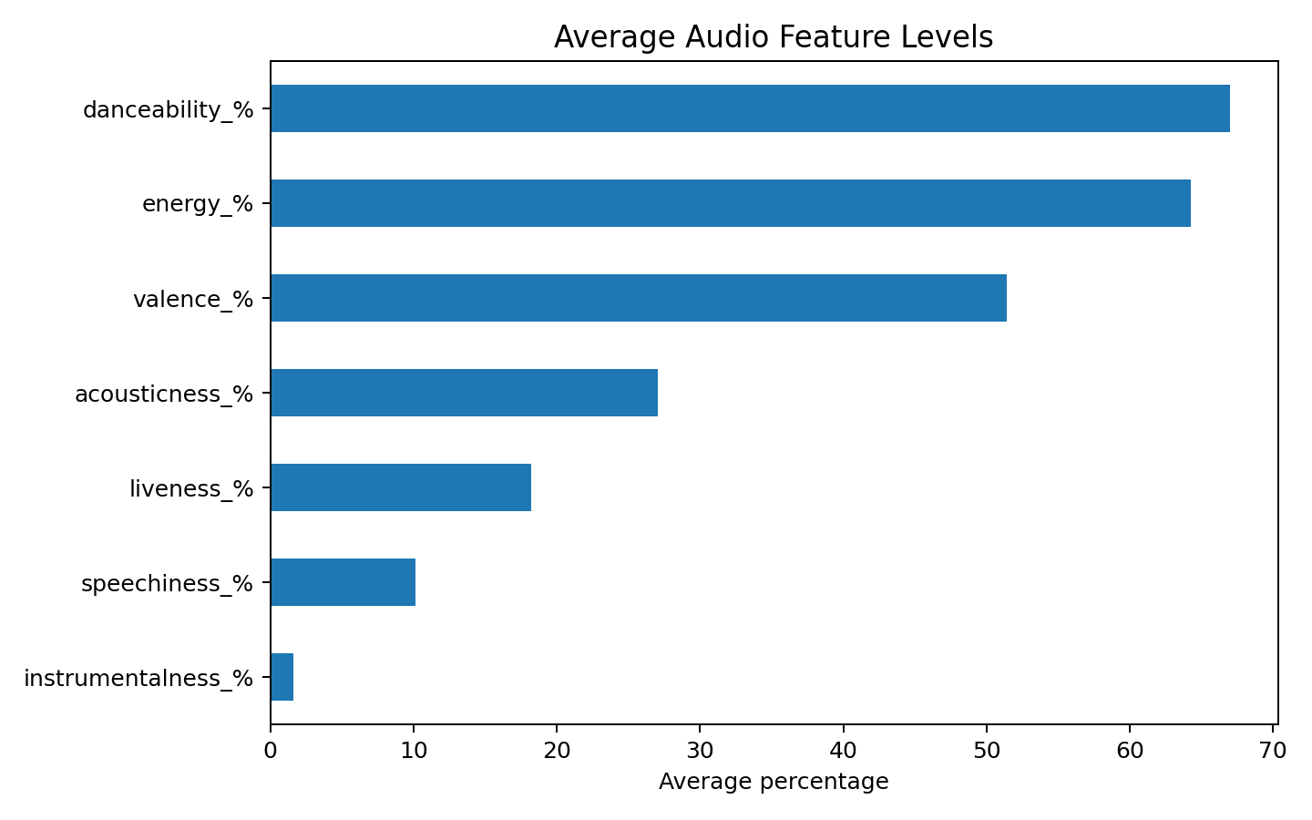
Figure 1. Average audio-feature levels across the 953-song dataset.
The feature relationships show that danceability and valence are moderately positively associated (Spearman ρ=0.40), while energy and acousticness have a moderate inverse/feature relationship in the dataset (absolute association about 0.48).
When songs are divided into four equal groups by Spotify streams, the highest-stream quartile has lower average danceability and speechiness than the lower quartiles, while the differences in energy and valence are comparatively small. This indicates that there is no single simple audio-feature recipe for streaming success.
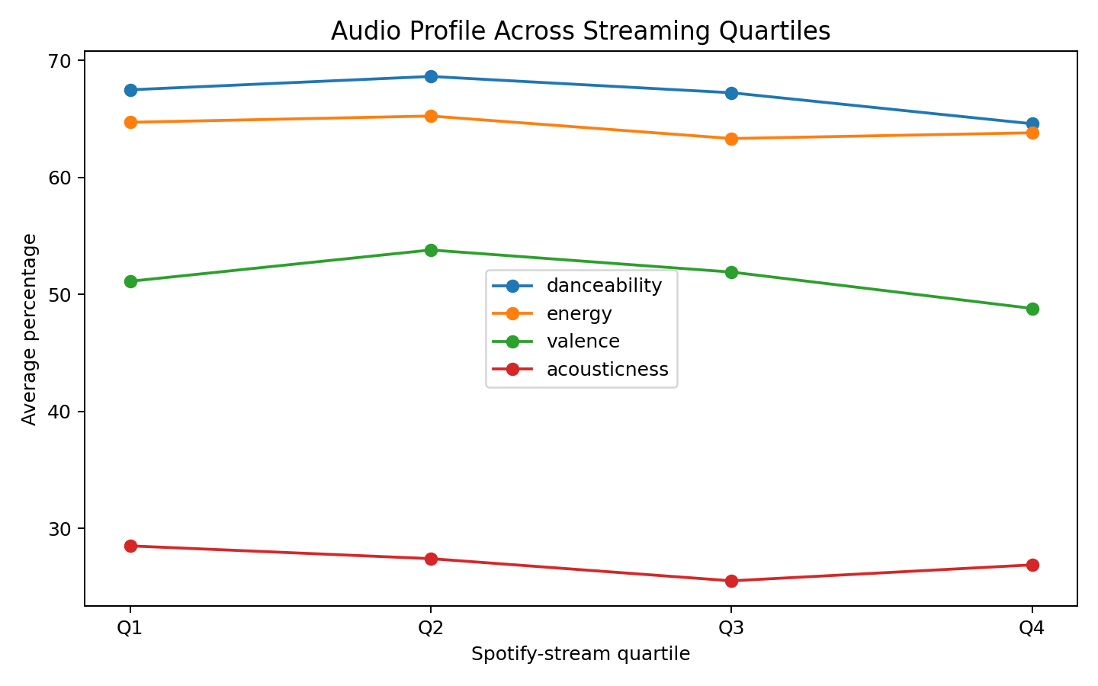
Figure 2. Average audio characteristics across Spotify-stream quartiles.
The Spearman correlations between individual audio features and Spotify streams are generally weak. Speechiness has the strongest negative association among the audio features (ρ=-0.11), followed by danceability (ρ=-0.08). BPM is essentially unrelated to streams in this sample (ρ=0.00). These are associations, not evidence that changing an audio feature would cause a change in streams.

4. Platform Comparison
Because the dataset does not provide comparable stream counts for Apple Music or Deezer, direct platform-to-platform stream comparisons would be misleading. Instead, the analysis compares each platform's playlist/chart indicator with Spotify streams and examines correlations between platform measures.
Platform measure | Spearman ρ with Spotify streams
Spotify playlists | 0.832
Deezer playlists | 0.739
Apple playlists | 0.668
Apple charts | 0.335
Spotify charts | 0.255
Deezer charts | 0.228
Shazam charts | 0.201
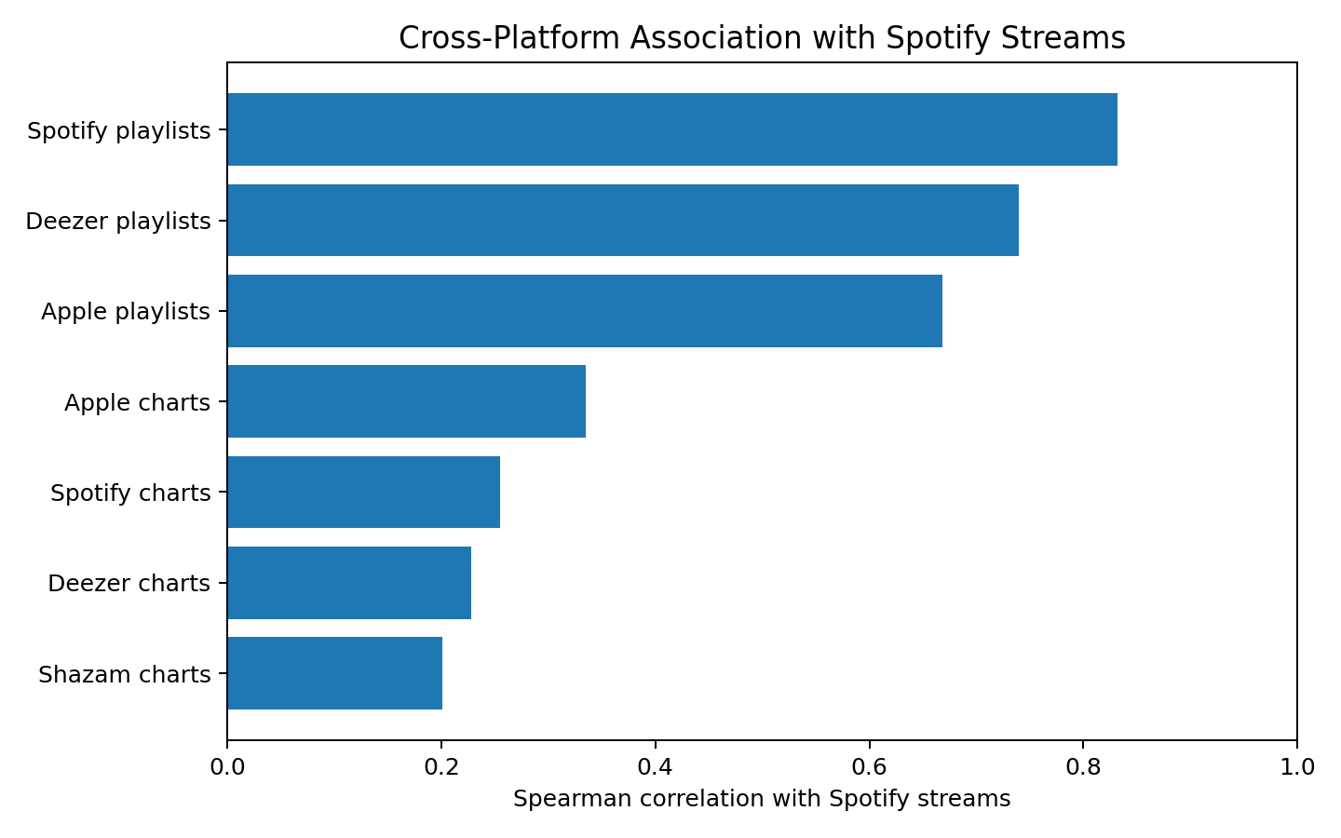
Figure 3. Association between cross-platform indicators and Spotify streams.
Spotify playlist presence shows the strongest association with Spotify streams. The playlist variables on Spotify, Apple and Deezer also correlate with one another, suggesting that playlist exposure is a broad indicator of song visibility. Chart measures generally show weaker associations with Spotify streams than playlist measures in this dataset.

5. Artist Impact
Artist involvement is represented by artist_count, the number of credited artists on a track. There are 587 single-artist tracks, 254 two-artist tracks and 85 three-artist tracks; higher artist counts are comparatively rare.
Artist count | Songs | Average streams | Median streams
1 | 586 | 568.2M | 333.6M
2 | 254 | 462.5M | 249.4M
3 | 85 | 381.3M | 231.3M
4 | 15 | 306.1M | 159.2M
5 | 5 | 144.8M | 133.8M
6 | 3 | 87.5M | 120.8M
7 | 2 | 339.1M | 339.1M
8 | 2 | 173.2M | 173.2M
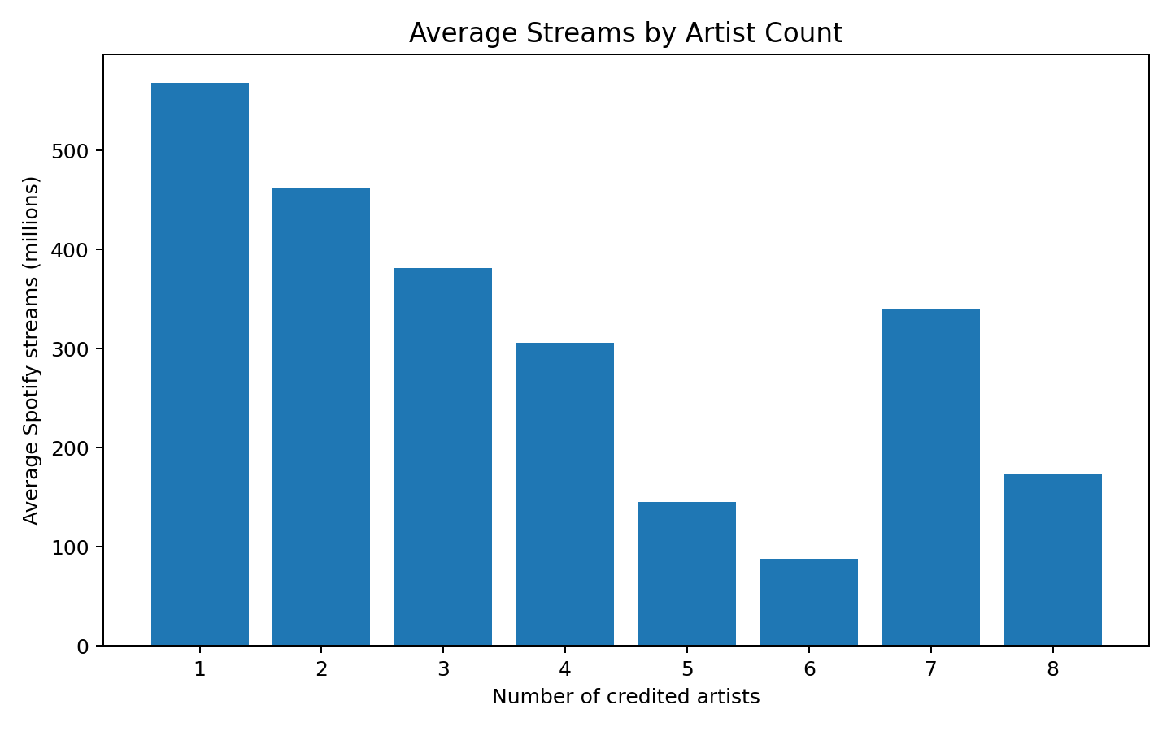
Figure 4. Average Spotify streams by number of credited artists.
Artist count has a negative Spearman association with streams (ρ=-0.16). In this dataset, single-artist tracks have the highest average and median streams among the common artist-count groups. However, this should not be interpreted as evidence that collaborations reduce success: artist count may be confounded by release year, genre, artist popularity, marketing and the composition of the sample.
The dataset also contains repeated appearances by major artists. The most frequently represented artists include Bad Bunny, Taylor Swift and The Weeknd. Frequency of appearance and average song performance are different concepts, so both should be considered separately when evaluating artist impact.

6. Temporal Trends
The release-year distribution is highly uneven: 402 songs were released in 2022, 175 in 2023 and 119 in 2021. Older years contain far fewer observations. Therefore, comparisons across very early years should be treated cautiously.
Year | Songs | Avg streams | Danceability | Energy | Valence | Acousticness
2019 | 36 | 1052.0M | 60.7% | 59.6% | 40.4% | 35.8%
2020 | 37 | 937.9M | 67.4% | 66.4% | 51.0% | 23.0%
2021 | 119 | 620.2M | 68.2% | 63.9% | 52.5% | 25.3%
2022 | 402 | 289.6M | 68.7% | 63.6% | 51.5% | 27.4%
2023 | 175 | 147.5M | 70.0% | 68.2% | 55.1% | 25.3%
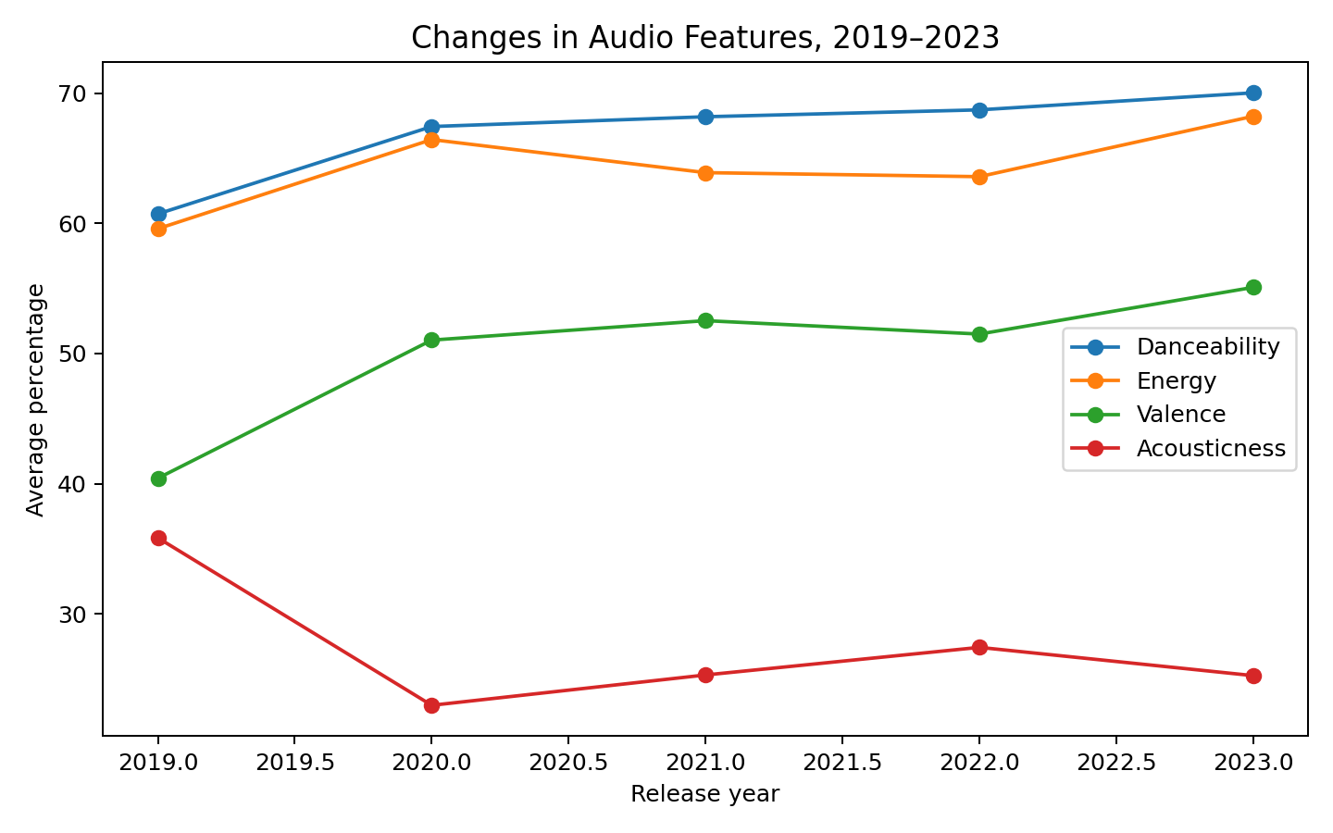
Figure 5. Changes in selected audio features for songs released from 2019 to 2023.
From 2019 to 2023, average danceability increased from 60.7% to 70.0%, energy increased from 59.6% to 68.2%, and valence increased from 40.4% to 55.1%. Average acousticness decreased from 35.8% to 25.3%. BPM increased from approximately 118.4 to 124.1. These patterns suggest that the more recent portion of the dataset is, on average, more dance-oriented, energetic and positive, with lower acousticness.
Average streams decline for newer release years in this dataset because older songs have had substantially more time to accumulate streams. This is a key survivorship/exposure effect and should not be interpreted as evidence that newer music is intrinsically less successful.

7. Cross-Platform Presence
Cross-platform presence is investigated through relationships among playlist, chart and Shazam indicators. Spotify playlist inclusion is strongly associated with Deezer playlist inclusion (ρ=0.85) and Apple playlist inclusion (ρ=0.78). This indicates that songs with greater playlist visibility on one major service often have greater playlist visibility elsewhere.
Spotify chart position/count has a stronger association with Shazam chart presence (ρ=0.57) than with Spotify playlist count. This is consistent with the idea that chart activity and discovery activity represent a different dimension of song visibility from sustained playlist coverage.
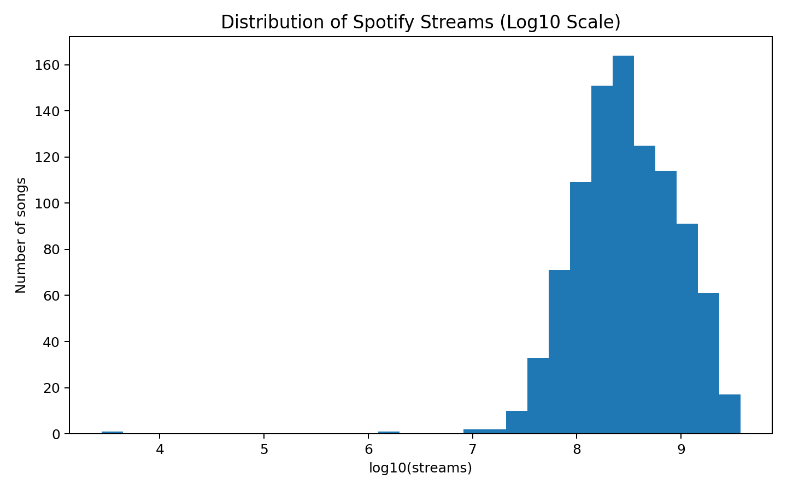
Figure 6. Distribution of Spotify streams; logarithmic scale used because streaming counts are highly skewed.

8. Statistical Modelling and Method Justification
A multiple linear regression was fitted with log(1 + Spotify streams) as the dependent variable. Independent variables included the seven audio features, BPM, artist count and release year. Log transformation was used because stream counts range from thousands to billions and are strongly right-skewed.
The model R² is 0.097 and adjusted R² is 0.087. Thus, approximately 9.7% of the variation in log streams is explained by the variables included in this model.
Variable | Coefficient | p-value
acousticness_% | -0.0038 | 0.0310
artist_count | -0.1710 | 0.0000
released_year | -0.0258 | 0.0000
The regression should be viewed as an explanatory association model rather than a causal model. Important omitted variables include genre, label promotion, marketing expenditure, social-media reach, country/market, playlist placement quality and artist fan-base size. In addition, several platform variables are likely downstream indicators of popularity and were not included in the audio-only regression to avoid mixing explanatory features with outcome-related exposure measures.

9. Key Findings for Music-Industry Decision-Making
- Playlist visibility is strongly associated with streaming success, particularly Spotify playlist inclusion. This makes playlist reach a useful monitoring KPI, although the relationship is not necessarily causal.
- There is no single dominant audio feature that explains streaming success. Audio characteristics should therefore be considered alongside artist, release, marketing and platform-distribution factors.
- The recent sample shows higher average danceability, energy and valence and lower acousticness than the 2019 sample.
- Single-artist tracks have higher average streams than multi-artist tracks in this dataset, but the result is observational and may reflect confounding.
- Cross-platform playlist indicators move together, suggesting that broad distribution and visibility across services are associated with stronger overall presence.
- Older releases have higher accumulated streams on average; release age must be controlled when comparing song performance.

10. Practical Recommendations
- Track playlist penetration across Spotify, Apple and Deezer as a visibility dashboard rather than relying on Spotify streams alone.
- Use release-year-adjusted benchmarks when evaluating new songs so recently released tracks are not unfairly compared with older catalogue songs.
- Use audio features for segmentation and audience profiling, not as a standalone predictor of commercial success.
- For collaborations, evaluate artist-pair combinations, fan overlap and campaign exposure rather than assuming that a larger artist count produces better or worse outcomes.
- Build a future predictive model with additional variables such as genre, artist follower count, social engagement, marketing spend, playlist tier and geographic market.
- Monitor Shazam and chart indicators separately because they appear to capture discovery/chart activity that is not identical to playlist exposure.

11. Limitations
- The dataset is a snapshot of the most-streamed Spotify songs and is not a random sample of all music released in 2023.
- Apple and Deezer stream counts are not supplied, so platform comparisons use playlist and chart indicators rather than direct stream-to-stream comparisons.
- One stream field is malformed and was excluded from stream-based calculations.
- The distribution of release years is highly uneven, with many more observations from 2021–2023 than from earlier years.
- Correlations and regression coefficients do not establish causation.
- Artist count is only a simple measure of artist involvement and does not capture artist popularity, label support, feature prominence or collaboration quality.

12. Conclusion
The analysis demonstrates that streaming success is multidimensional. The strongest observable relationships in this dataset come from platform visibility measures, especially playlist inclusion, while individual audio features show comparatively weak relationships with Spotify streams. The musical profile of recent releases also changes over time, with higher average danceability, energy and valence and lower acousticness between 2019 and 2023. Artist involvement is associated with streaming performance, but the observed relationship should not be interpreted independently of release age and other omitted factors.
For music-industry decision-making, the evidence supports a combined approach: monitor cross-platform visibility, adjust performance comparisons for release age, use audio features for audience and catalogue segmentation, and incorporate richer artist, marketing and audience variables in future predictive models.

Appendix A – Main Python Methodology
import pandas as pd
import numpy as np
import statsmodels.api as sm
df = pd.read_csv("spotify-2023.csv", encoding="latin1")
# Convert numeric fields stored as text
for c in ["streams", "in_deezer_playlists", "in_shazam_charts"]:
df[c + "_num"] = pd.to_numeric(
df[c].astype(str).str.replace(",", "").str.strip(),
errors="coerce"
)
# Remove the one malformed stream value for stream-based analysis
df_stream = df[df["streams_num"].notna()].copy()
# Spearman correlations
corr = df_stream.corr(numeric_only=True, method="spearman")
# Log-stream regression
df_stream["log_streams"] = np.log1p(df_stream["streams_num"])
features = [
"bpm", "danceability_%", "valence_%", "energy_%",
"acousticness_%", "instrumentalness_%",
"liveness_%", "speechiness_%", "artist_count",
"released_year"
]
X = sm.add_constant(df_stream[features])
y = df_stream["log_streams"]
model = sm.OLS(y, X, missing="drop").fit()
print(model.summary())

