LMMS(Linux Multimedia Studio) SOEN -6471 Winter 2014
Due: March 10th, 3 marks, done individually
Identify a Substantial Pattern
Note: Each group member must do this part individually. However, you should hand-in each project member’s pattern in a single document. The header at the top of each page should be Project Name – Student Name and Number – Design Pattern Name.
Note: for it to be substantial, you might report on a couple patterns. E.g., how factory and adapter work together in the system.
In a maximum of one page -> Pattern must be a recognized pattern. Include a reference to a book or reputable website that describes the pattern. Provide a brief diagram showing the interacting classes (the actual classes from your system). Write up why the pattern is need and what its role is in the system. Describe any reverse engineering tools used. Sequence diagrams may be helpful.
In maximum of one page, for your design pattern: Copy-and-paste the class, method, and attributes declarations (and anything else that is necessary) directly from the source code. Do not include code that is unnecessary (be selective, you will lose marks for large dumps of source code.)

LMMS
Name: Pavleen Kaur Batra
ID: 9754733

Composite Design Pattern
Composite Pattern provides standard interface , for composing the repetitive objects in a hierarchy. Composite pattern is a good choice to handle the complexity, by using the related multiple objects having homogeneous code.
The Composite Pattern implementation in LMMS application
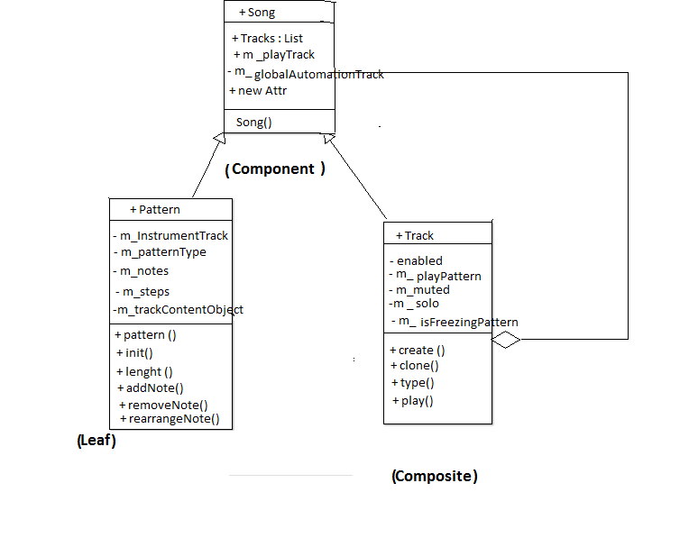
1 ) Song (Component) : This is a component that defines an interface for an object in Track and we could find song containing tracks under song classes with method void song::playTrack( track * _trackToPlay ) to play any particular track containing in the song class and it also calls the pattern object methods with m_patternToPlay( NULL ), for playing any particular pattern in the song class.

2) Pattern (Leaf) : the Leaf is implementing playPattern() and isFreezingPattern() methods , the playPattern method instantiates the new Pattern which is used to play the track. and it comes under song class and part of song class

3) Track (Composite) : This object is the child of Song class, and this class contains methods void trackContentObject::movePosition which moves tracks in the song class for updating the song class with tracks .And this track object can be a composition in the composite hierarchy tree.
Source code illustrating LMMS implementation of the Composite design pattern
( Component ) : Song
void song::playTrack( track * _trackToPlay )
{
if( isStopped() == false )
{
stop(); // Play Track Statement//
}
}
song::song() :
TrackContainer(),
m_globalAutomationTrack( dynamic_cast<AutomationTrack *>(
track::create( track::HiddenAutomationTrack,
this ) ) ),
m_trackToPlay( NULL ), // calling Track from Song Class//
m_patternToPlay( NULL ), // calling Pattern from Song class //
{
}
( Leaf ): Pattern
void song::playPattern( pattern * _patternToPlay, bool _loop )
{
if( isStopped() == false )
{
stop(); // Play Pattern Statement //
}
}
bool song::isFreezingPattern() const
{
return isPlaying() && // FreezingPattern a child of Song//
}
(Composite) : Track
void trackContentObject::movePosition( const MidiTime & _pos )
{
if( m_startPosition != _pos )
{
// Track related to Song class with getSong method //
}
}

LMMS
Name: Sardar Maninder Singh
ID: 6555519
Observer Design Pattern
The “Observer pattern assumes that the object containing the data is separate from the objects that display the data, and that these display objects observe changes in data. When we implement observer pattern we refer to the data as the subject and each of the displays as observers. Each of these observers registers its interest in the data by calling a public method in the subject. Then each observer has a known Common interface that the subject calls when the data changes.”
Reference: 1.)[http://sourcemaking.com/design_patterns/observer].
2.)[ Head First Design Patterns, O'REILLY Publications.]
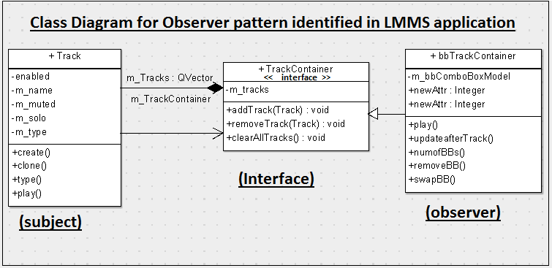
The Observer Pattern implementation in the LMMS application clearly goes with the way the design pattern is explained in the book mentioned above. Here the object that has the data is Track and the object that displays the data is bbTrackContainer. Both
bbTrackContainer and Track are different objects with no knowledge of each other (as shown in the above class diagram) hence maintaining separation of concerns.
- TrackContainer(interface): This is an interface that exposes methods which must be implemented by the Observer (bbTrackContainer). The Subject (Track) has knowledge of only TrackContainer through which it calls the methods on bbTrackContainer, whenever tracks are loaded from the server.
- Track (Subject): This class plays the role of Subject in this implementation. It gets tracks from the server and informs observers (bbTrackContainer) that Tracks have been loaded. Track does so by calling the updateAfterTrackAdd() method exposed by the TrackContainer interface and implemented by Track.
- bbTrackContainer (Observer):This object is an observer in the implementation of this pattern. It registers with the TrackContainer through the context object by calling the updateAfterTrackAdd() method. It implements the TrackContainer interface so that it may receive notifications (ultimately from Track) of loading of Track.
Source code illustrating LMMS implementation of the Observer design pattern
Interface: (TrackContainer)
void TrackContainer::addTrack( track * _track )
{
// add track statements//
}
}
void TrackContainer::removeTrack( track * _track )
{
// Remove track Statements//
}
}
void TrackContainer::updateAfterTrackAdd() //Update Method//
{
}
void TrackContainer::clearAllTracks()
{
//Clear All Track statements//
}
Subject: (Track)
track * track::create( TrackTypes _tt, TrackContainer * _tc )
{
//Track Creation Statements//
_tc->updateAfterTrackAdd();

return t;
}

Observer:(bbTrackContainer)
bool bbTrackContainer::play( midiTime _start, fpp_t _frames, f_cnt_t _offset, int _tco_num )
{
//Play statements//
}
void bbTrackContainer::updateAfterTrackAdd()
{
// Update statements//
}

