Created the spring boot application with Avro schema:
Video for reference:
https://www.youtube.com/watch?v=u0kRK-qbopk&ab_channel=JavaTechie
for Avro plugin:
https://www.youtube.com/watch?v=Y6SKOPPjFhA&ab_channel=CodeWithDilip

In this package, I’ve added the “avro-base” dependency which allows us to create Avro in custom folder otherwise if you use “avro” along then it will only create Arvo class in “src/main” folder.
This plugin provides the core functionality for Avro support, allowing for more flexibility in how you configure and use Avro within your project.

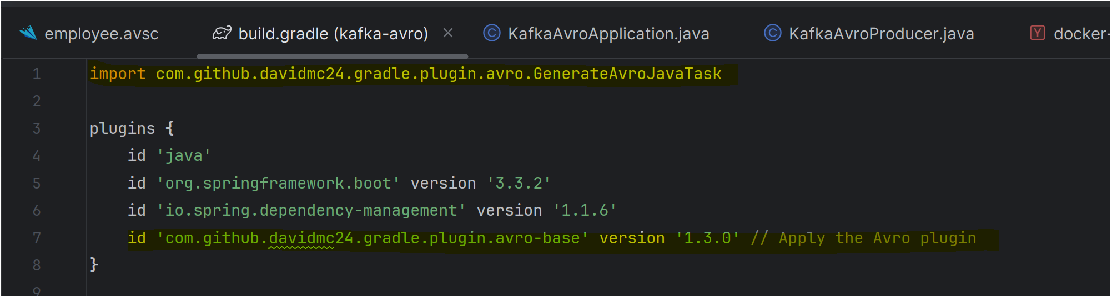

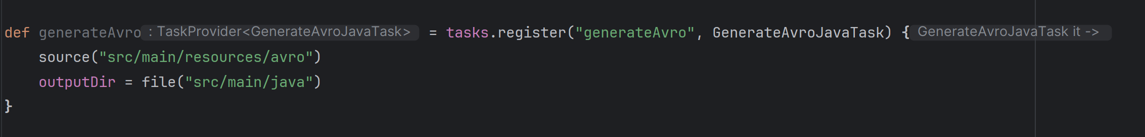

We are creating “employee.avsc” file inside “src/main/resources/avro” folder

And in below screenshot, we are telling them to create the Avro class inside the “ca.sunlife.kafka.avro.dto” folder.
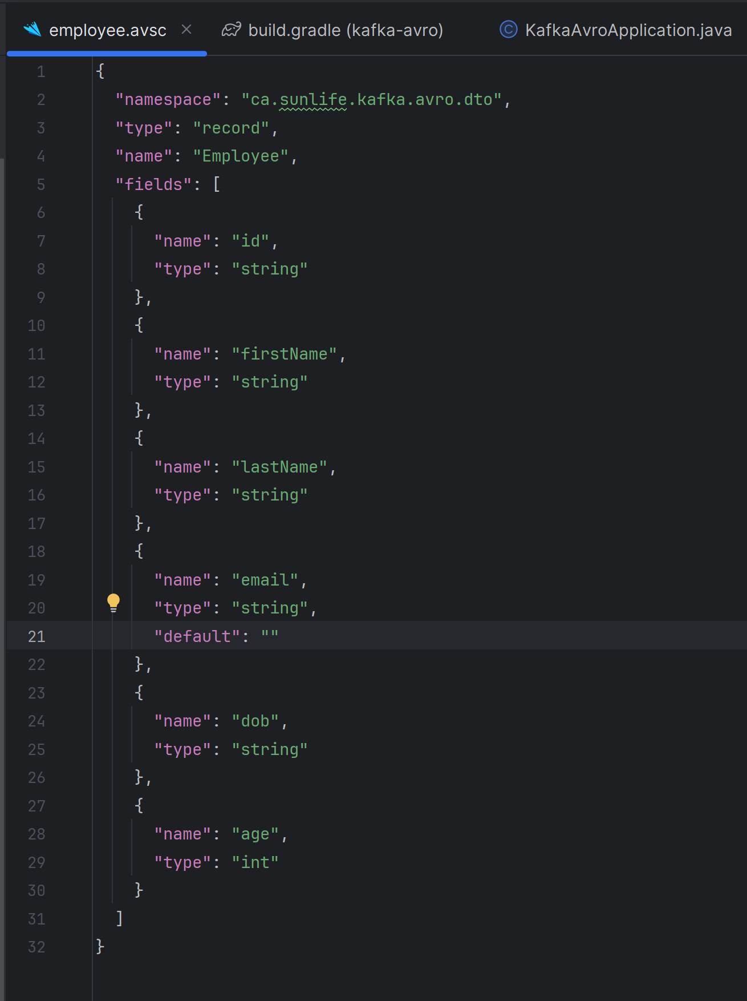
Did the basic configuration required for running spring boot project for Avro.

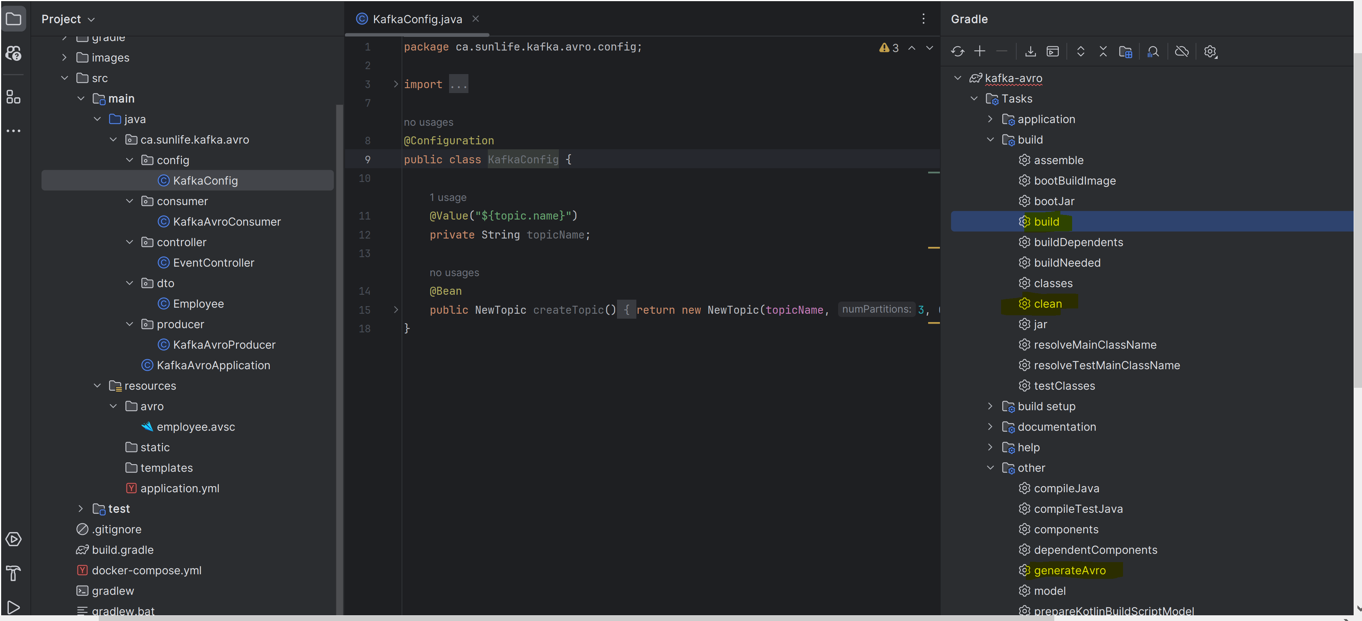

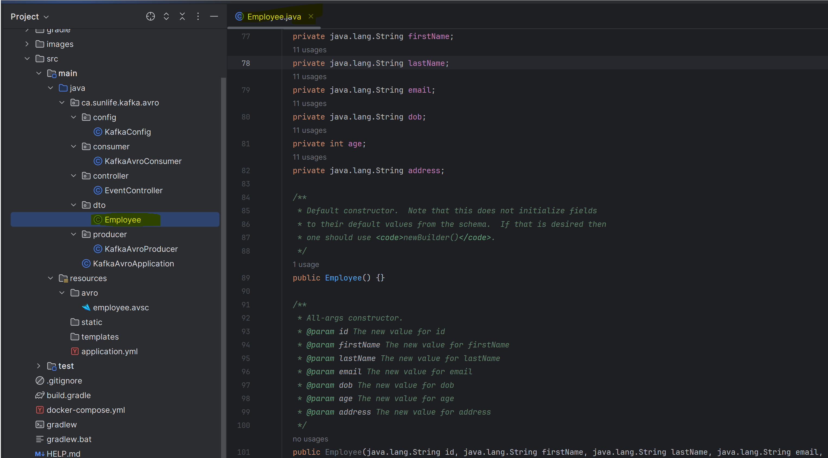

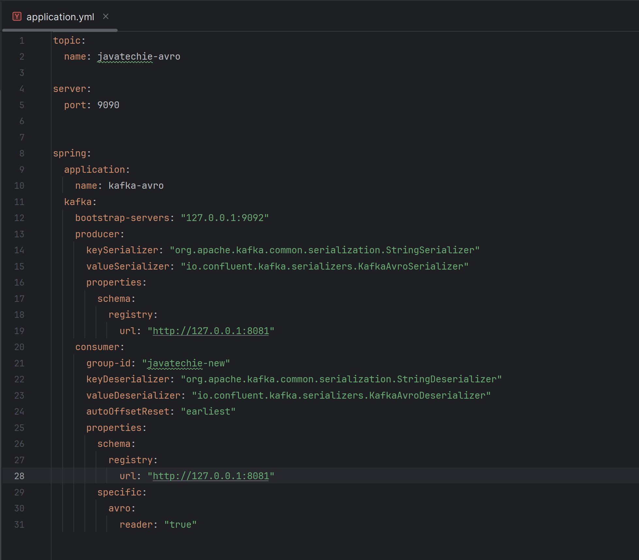

I am able to produce/consume the data.
Let’s play with schema-registry:
Update the current schema:
Current schema:
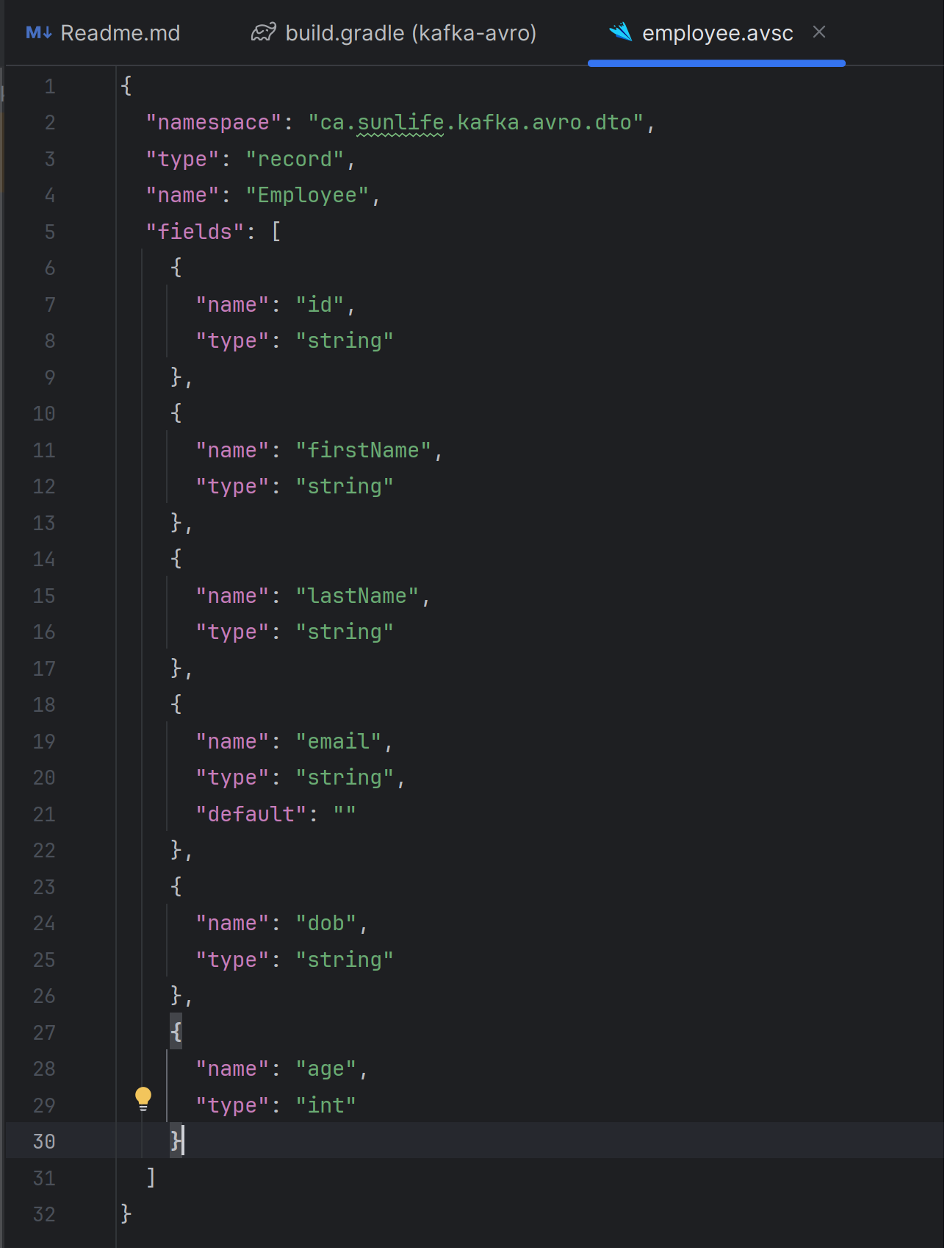

Add new field in schema:

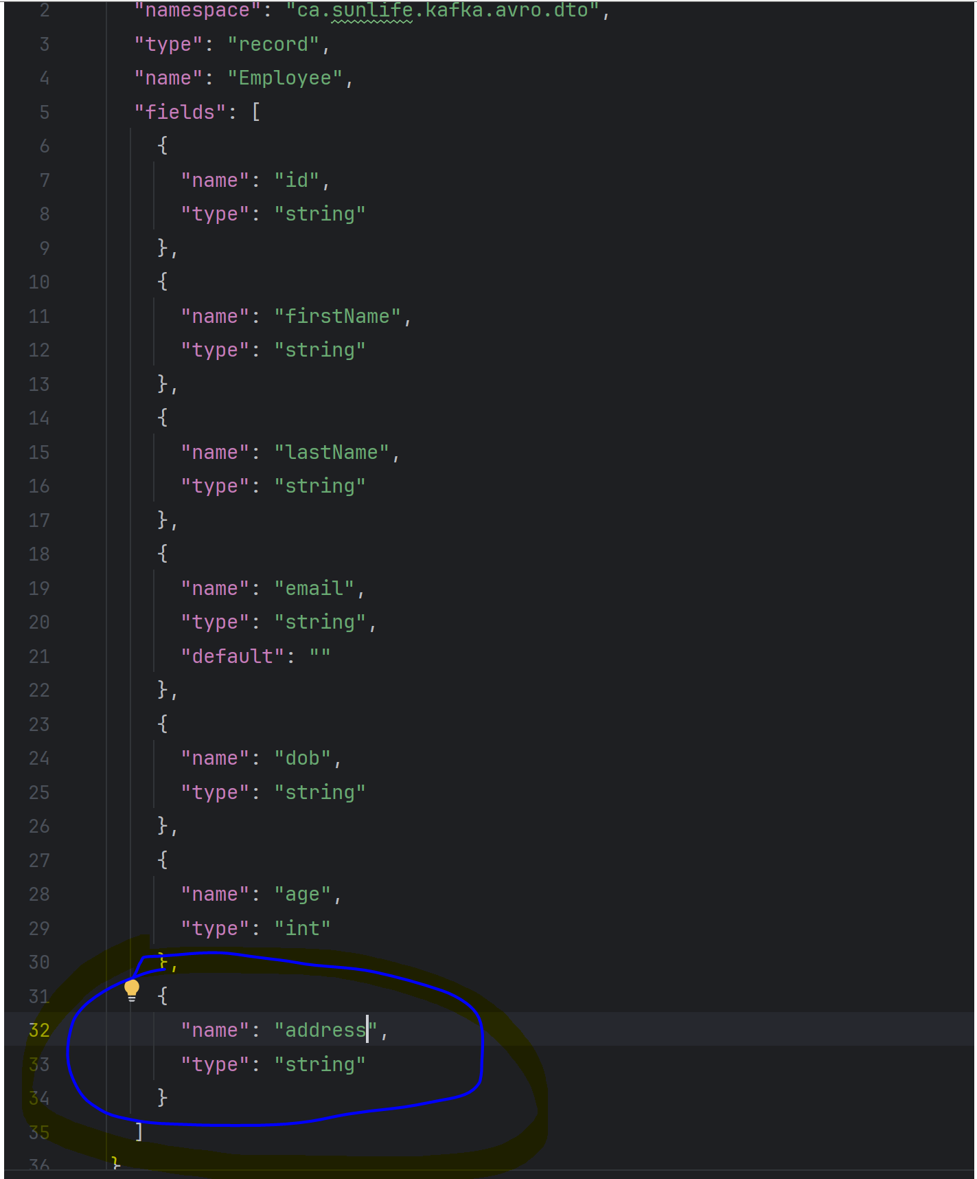

Run clean, build plugin:

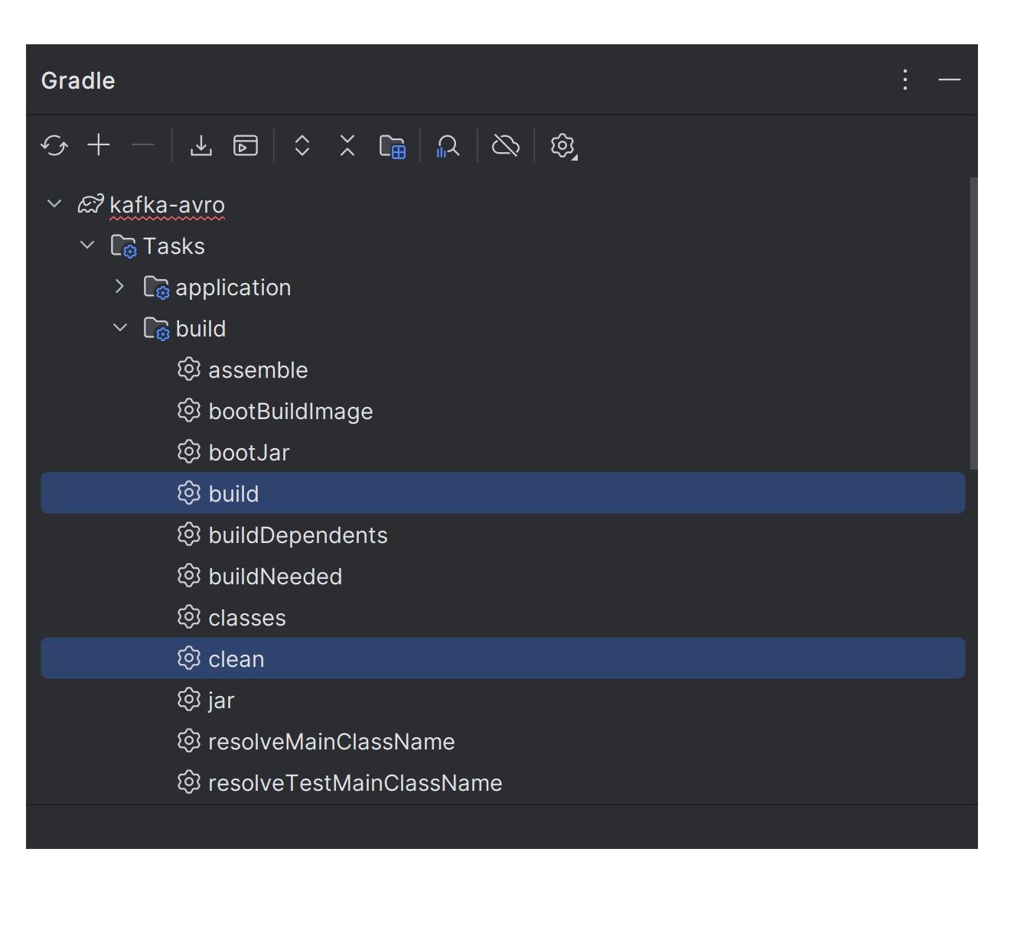
Now, now run generate Avro task which we have defined in our build.gradle:

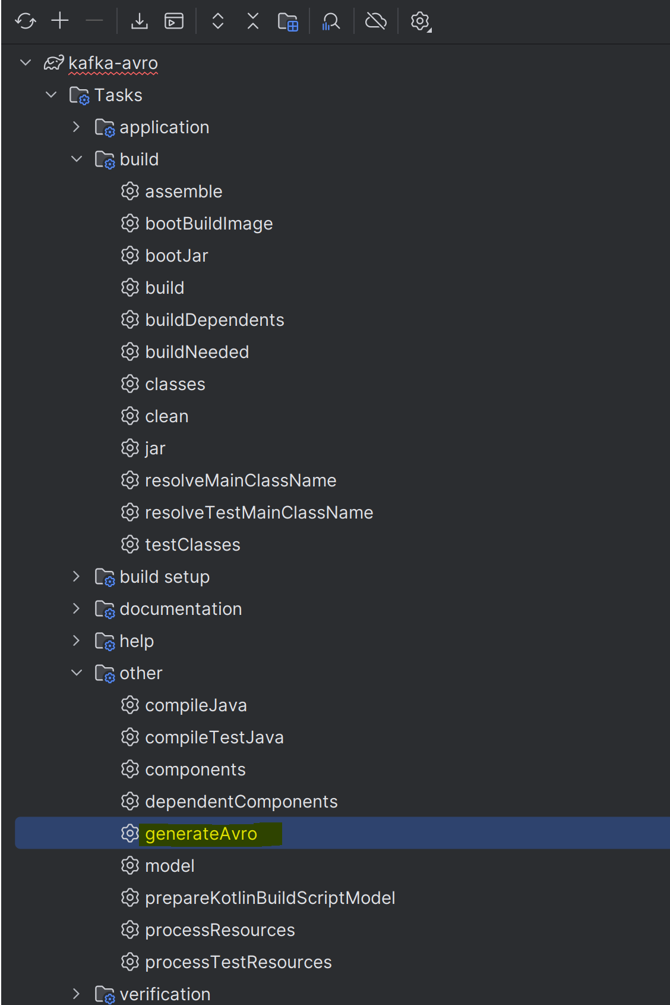
Check either your employee class is updated or not as we have added a new field.

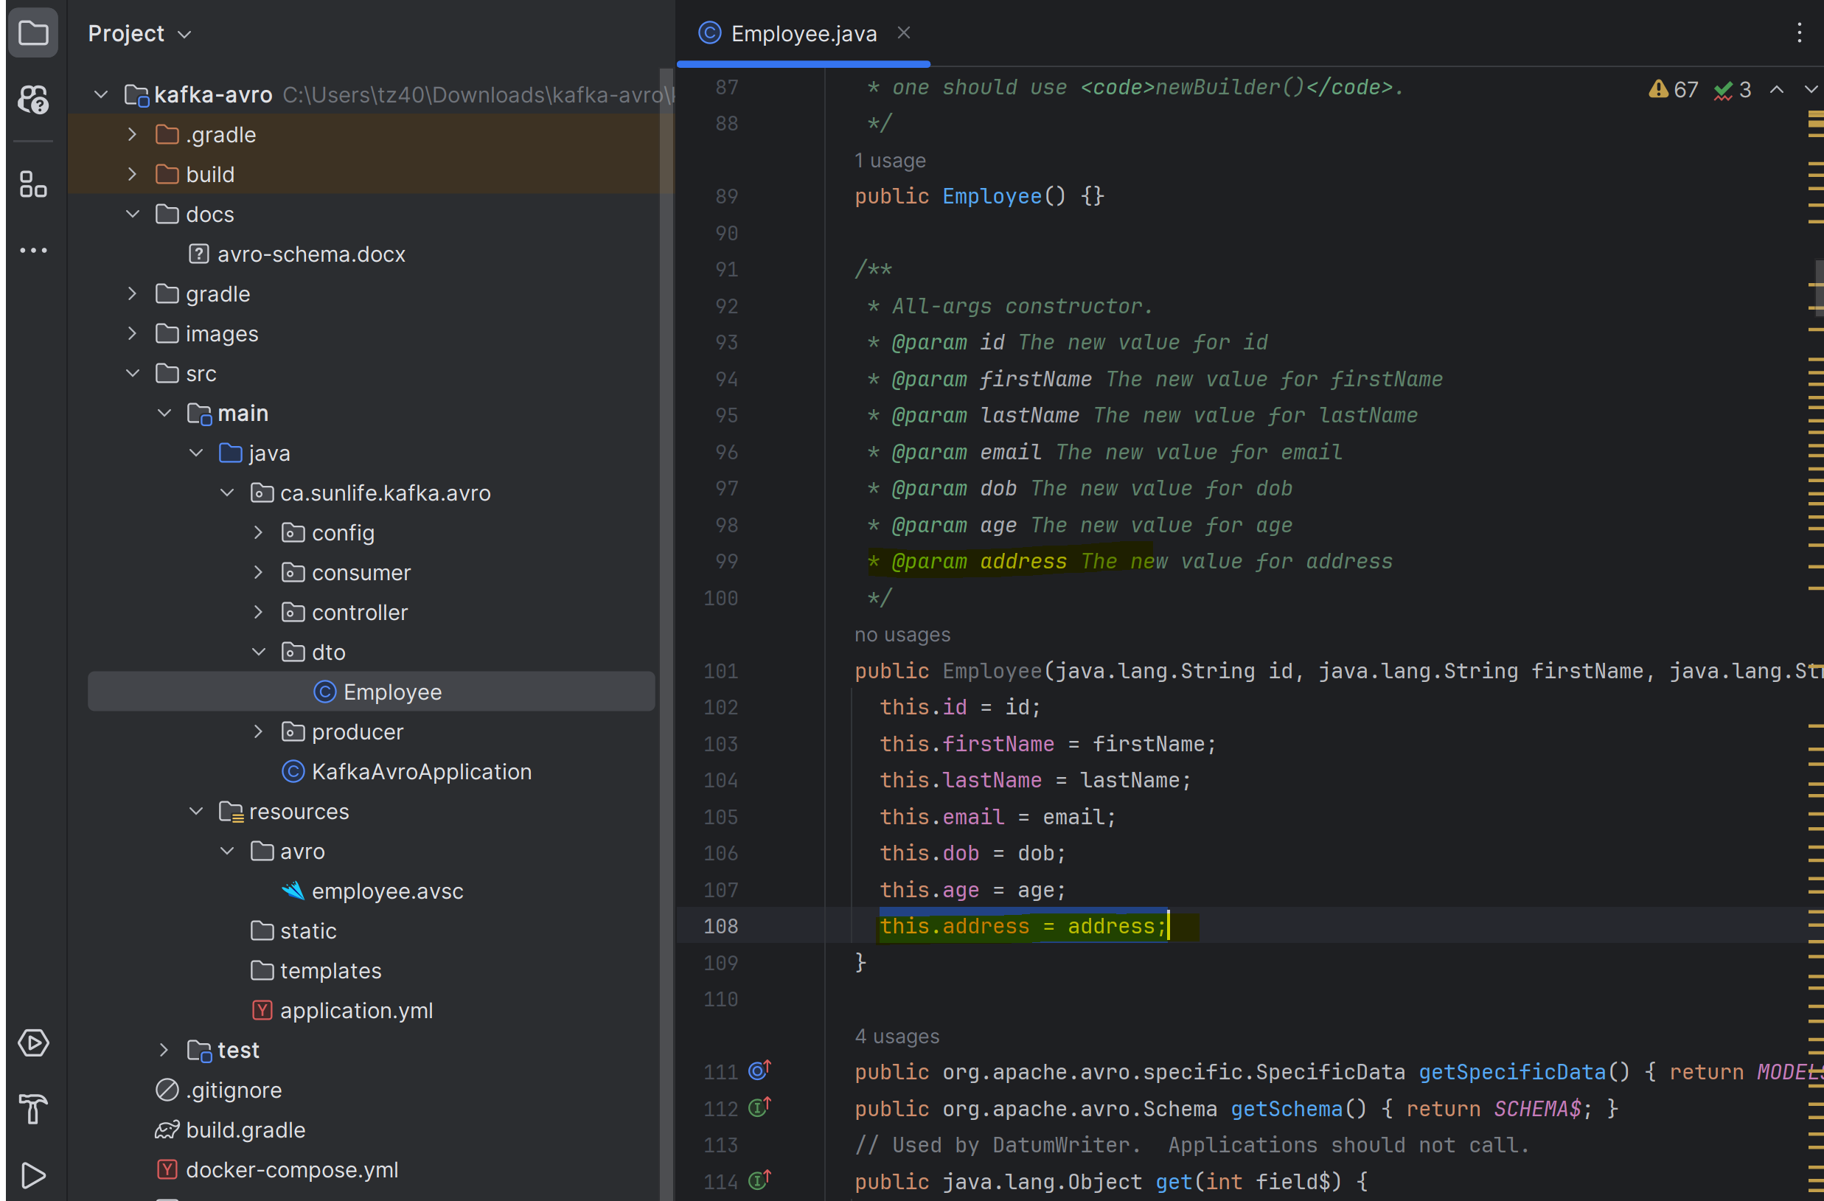

Run the spring boot app and try to send payload:
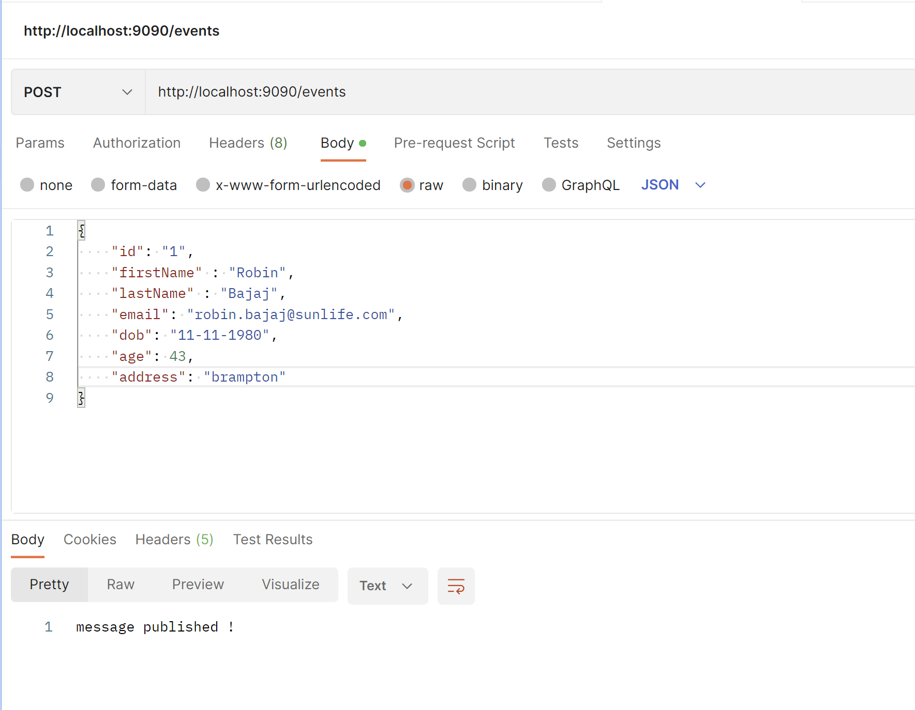

Even if you remove the new added field “address” and recreate the Avro class and try to send the data again, it will send the data:
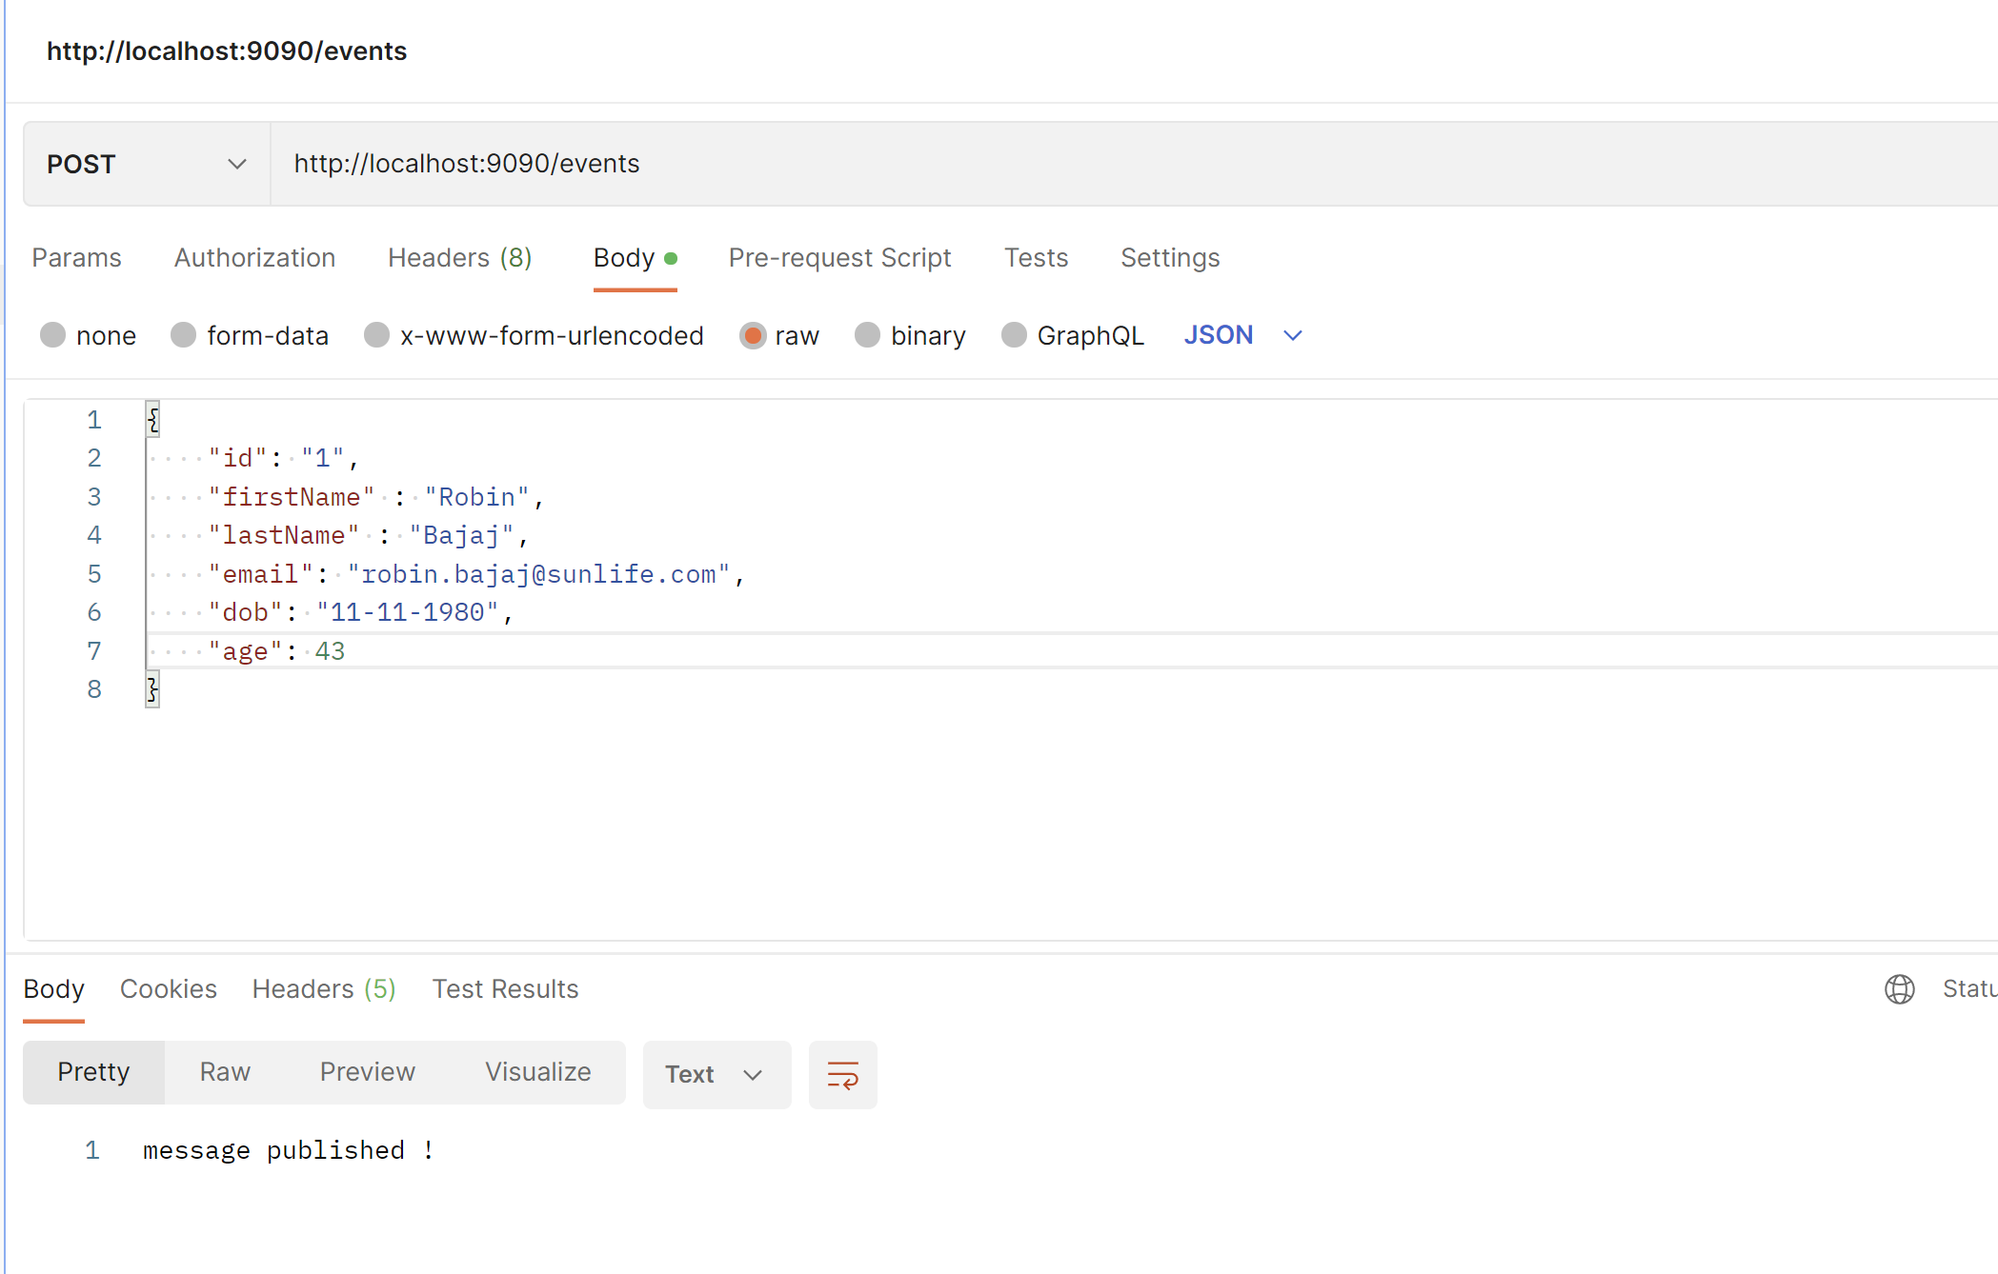

In topic, you can see this:

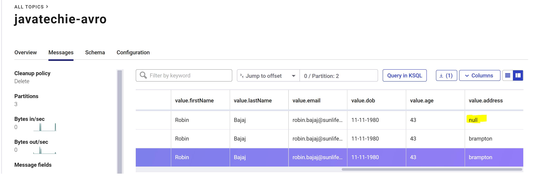

Even in schema drop-down you can see 2 schema registers:

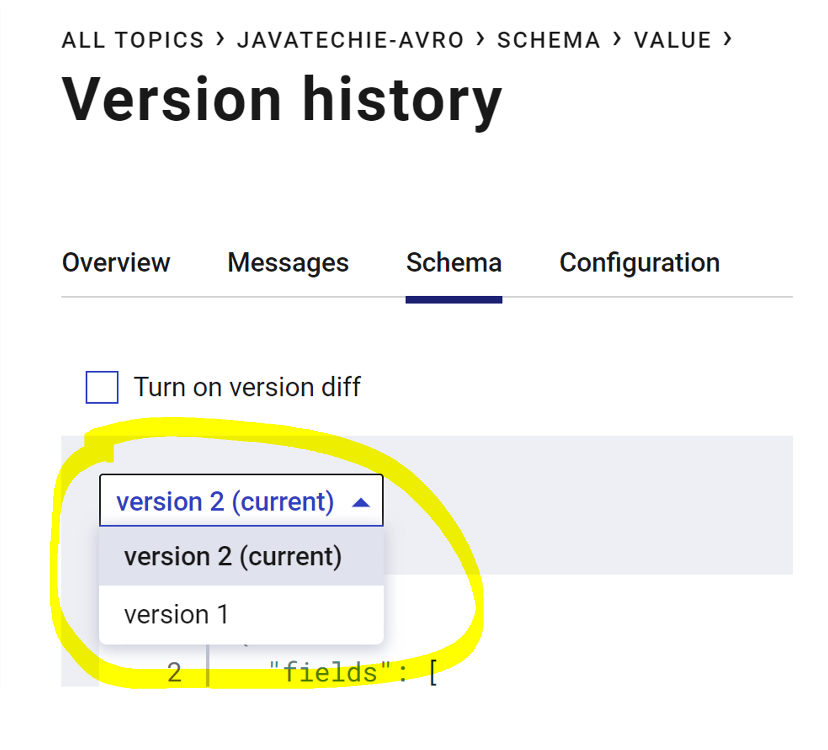

You can even clearly seen the difference between these 2 schema registers:

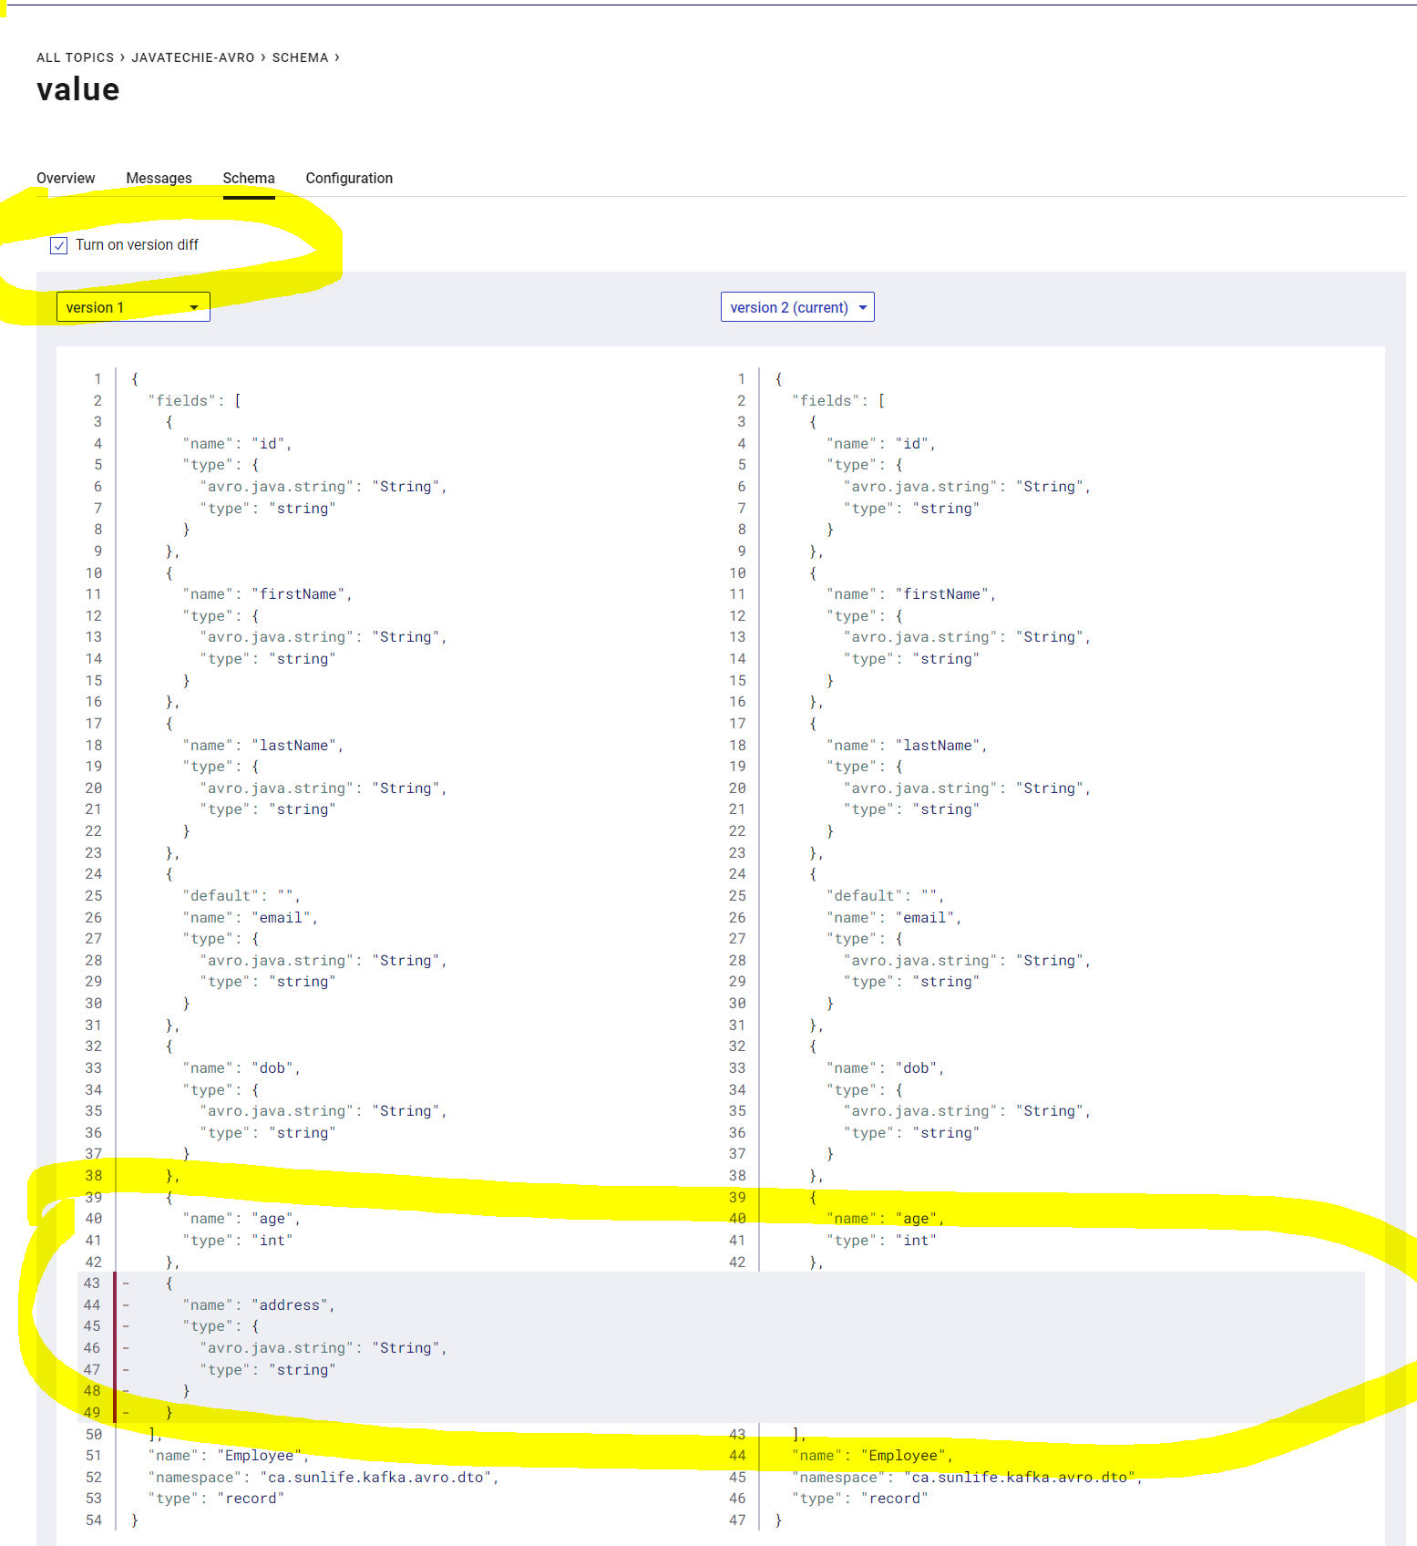

Sometime, you can also observe this schema compatible issue which I was also facing:

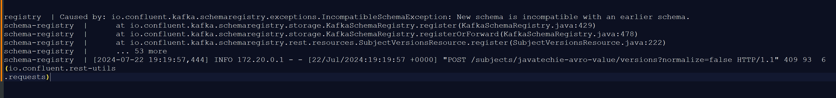

To fix this, check the compatibility for your topic:
Command:
curl -X GET http://localhost:8081/config/javatechie-avro-value

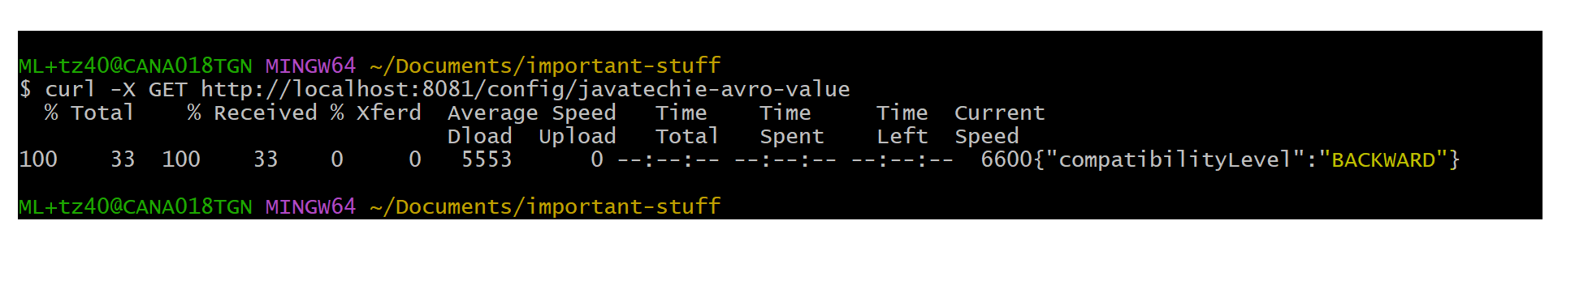
If it is not set to backward, then set it and try to send the data again:
Command to set the compatibility:
curl -X PUT -H "Content-Type:application/json" --data '{"compatibility": "BACKWARD"}' http://localhost:8081/config/javatechie-avro-value
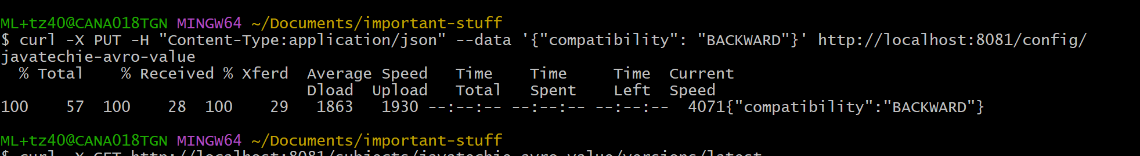

Below error sometimes you will get:

Now change the compatibility level to backward:

And make sure the field you are adding new should have default value like we are adding postalCode and address:

Clean, build the plugin and also generate the Avro class again and try to send data.

