**Triple Band Antenna**

**Antenna Parameters**

|  |  |  |
| --- | --- | --- |
| **Name** | **Description** | **Value (mm)** |
| Wg | Ground plane width | 21.43 |
| Lg | Ground plane length | 12.50 |
| Wf | Feed line width | 2.392 |
| Lf | Feed line length | 14.58 |
| W1 | Width of the large loop | 19.48 |
| W2 | Width of the inner loop | 10.24 |
| H1 | Height of the large loop | 19.10 |
| H2 | Height of the inner loop | 9.995 |
| H3 | Height of the monopole element | 6.158 |
| L1 | Length of the meander section of the inner loop | 5.156 |
| L2 | Distance between meander section and lines of the inner loop | 2.710 |
| Wl1 | Line width of the large loop | 2.083 |
| Wl2 | Line width of the inner loop | 520.8 |
| Wl3 | Line width of the monopole | 1.042 |
| Lde | Dielectric extension above ground plane length | 22.19 |
| H | Substrate height | 1.5 mm |

**Antenna Structure:**

Top Side Bottom Side

 

Top:

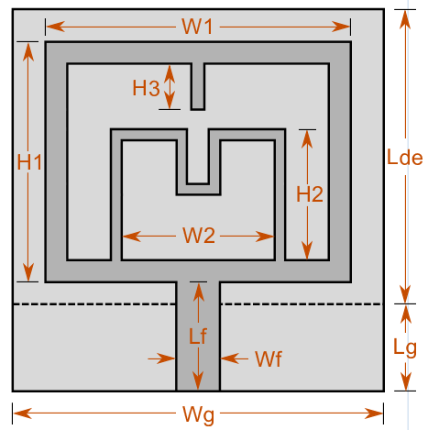 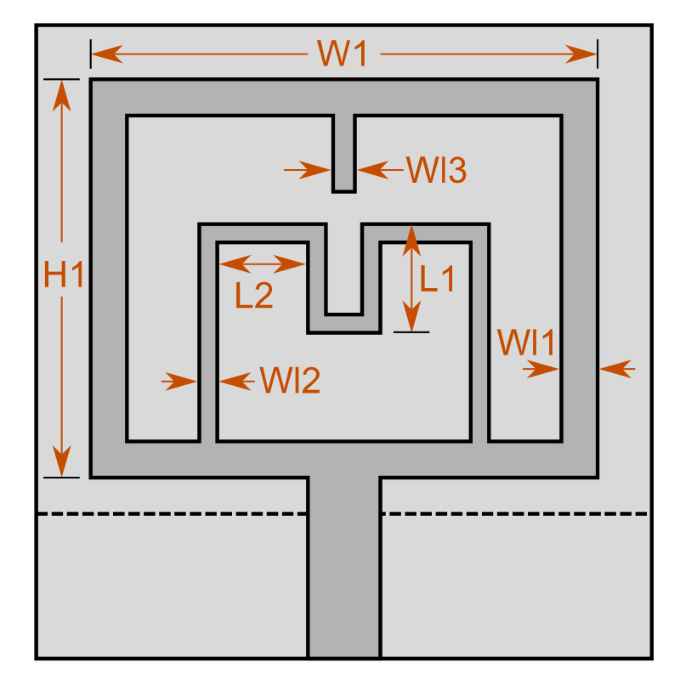

Bottom:

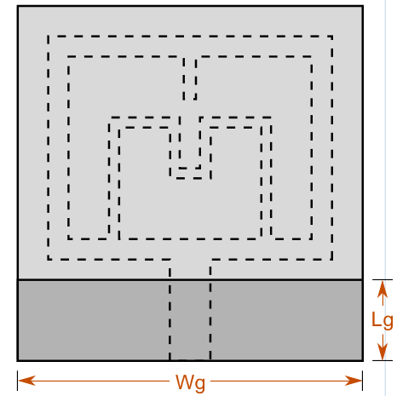

Results:

S Paremeter (S11) or Return Loss

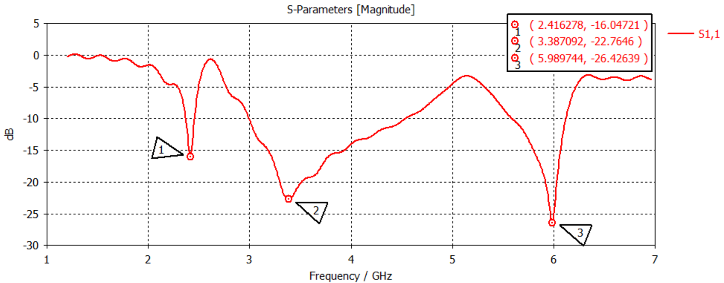

Bandwidth from S11:

At 2.4 GHz

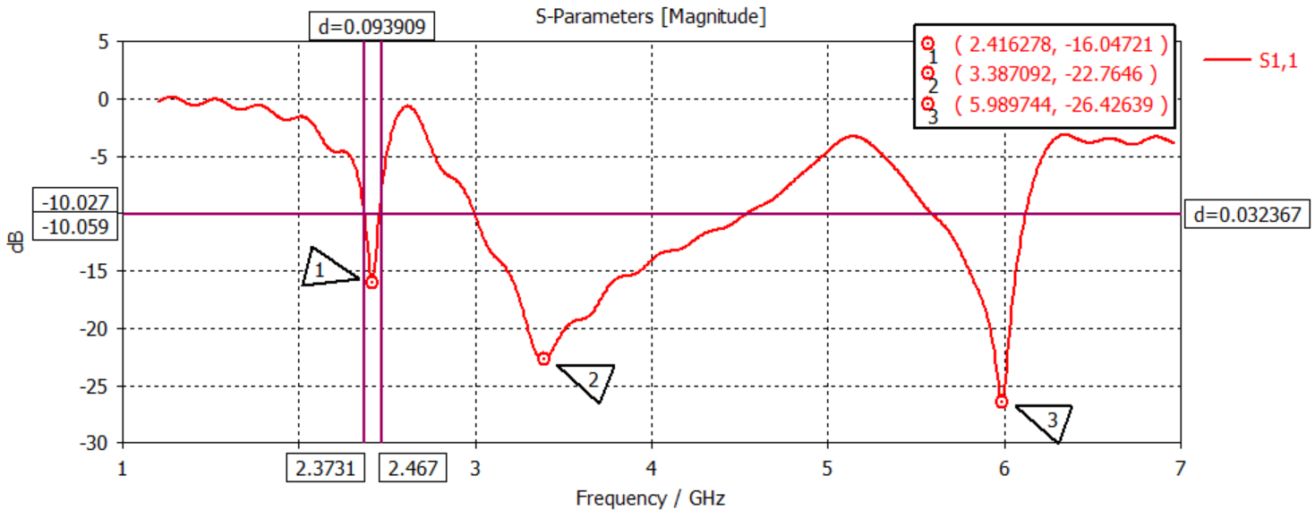

At 3.3 GHz

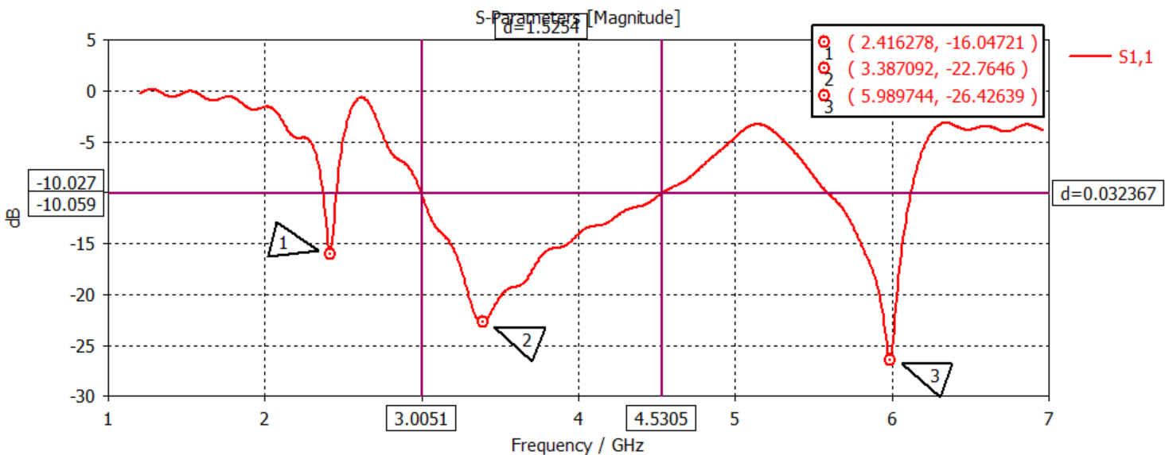

At 5.9 GHz

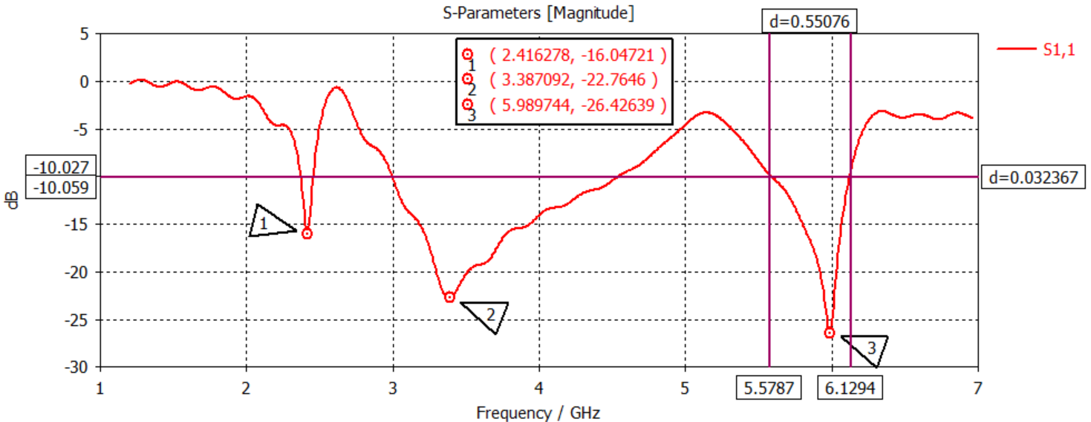

VSWR:

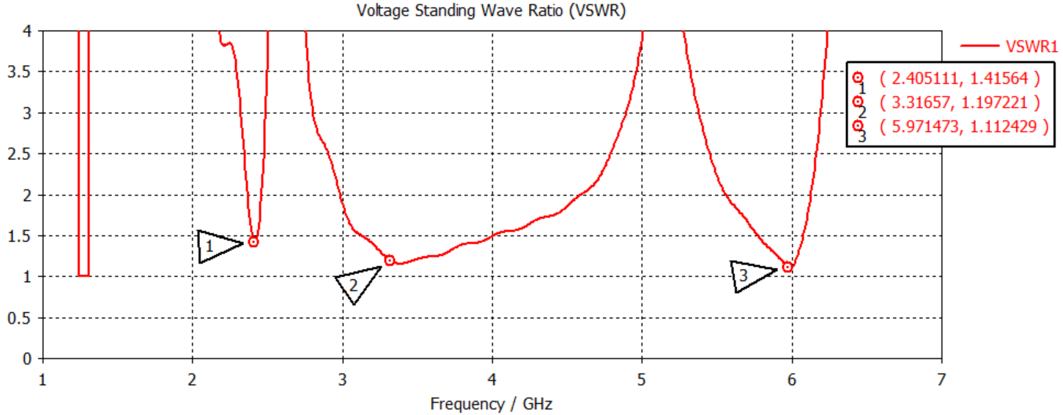

Port Signals

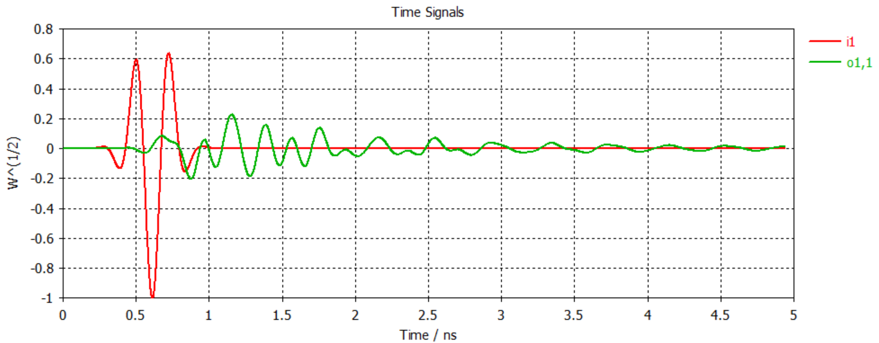

Z Parameters

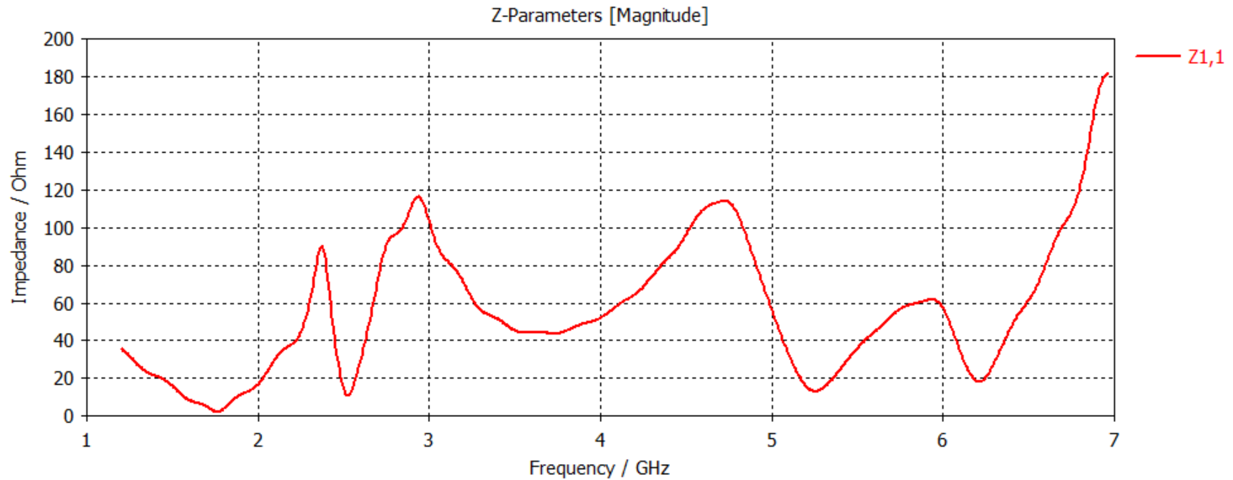

Efficiencies:

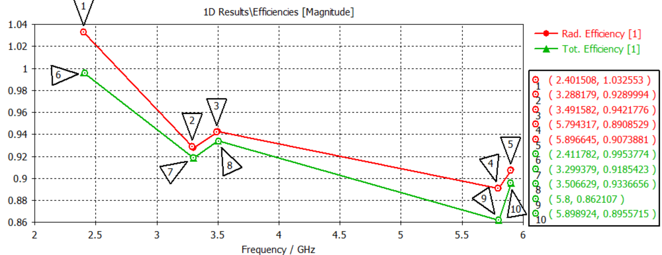

Far field:

3D Pattern & Gain At 2.4 GHz

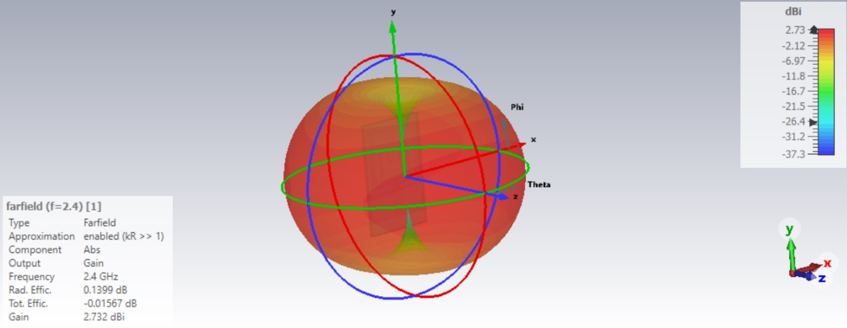

3D Pattern & Gain At 3.3 GHz

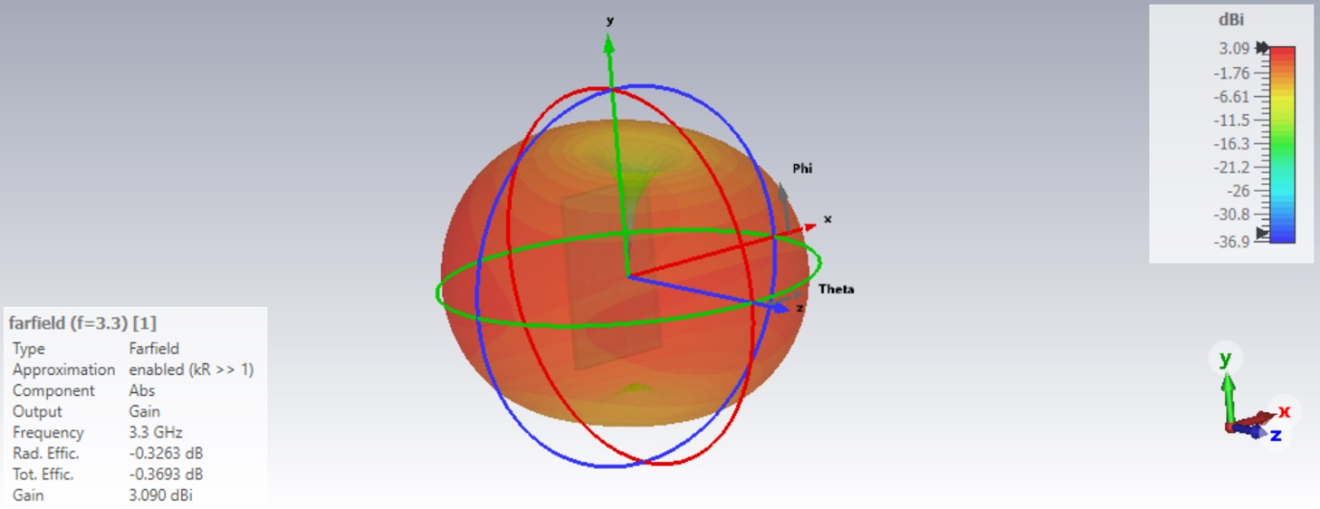

3D Pattern & Gain At 5.9 GHz

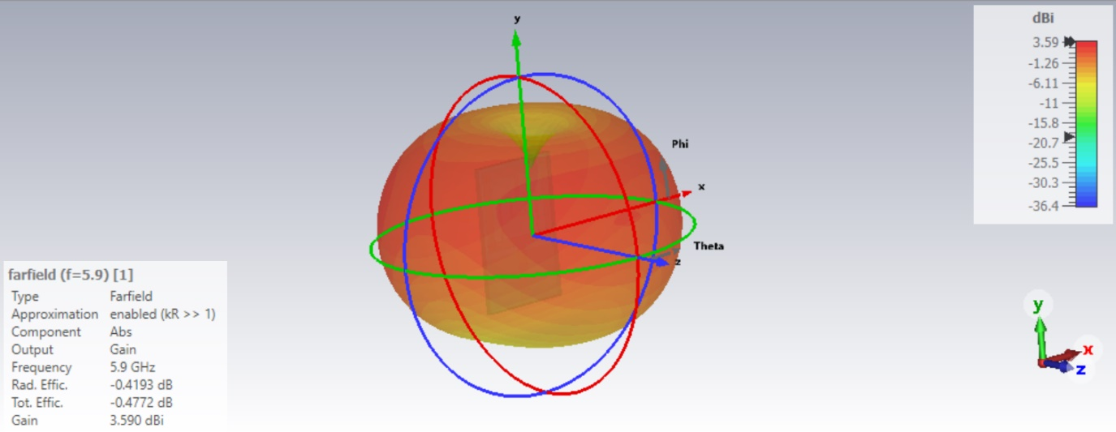

Polar Pattern & Gain At 2.4 GHz

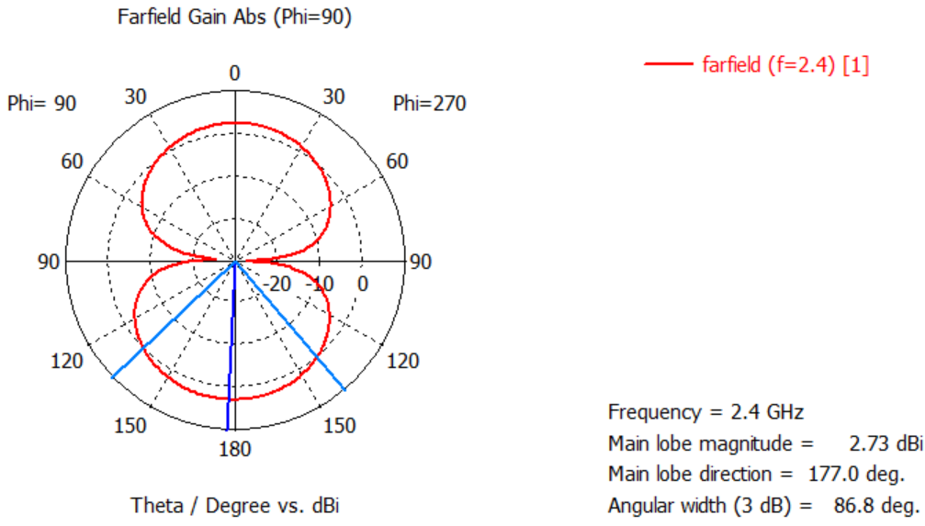

Polar Pattern & Gain At 3.3 GHz

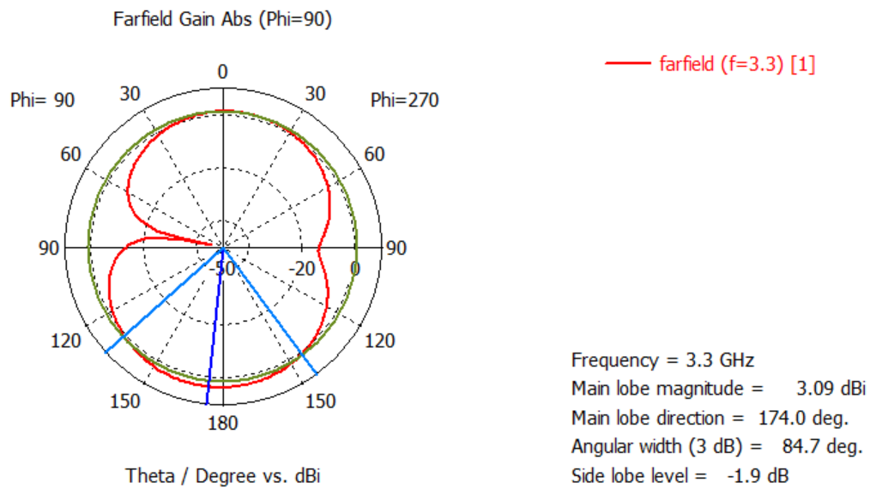

Polar Pattern & Gain At 5.9 GHz

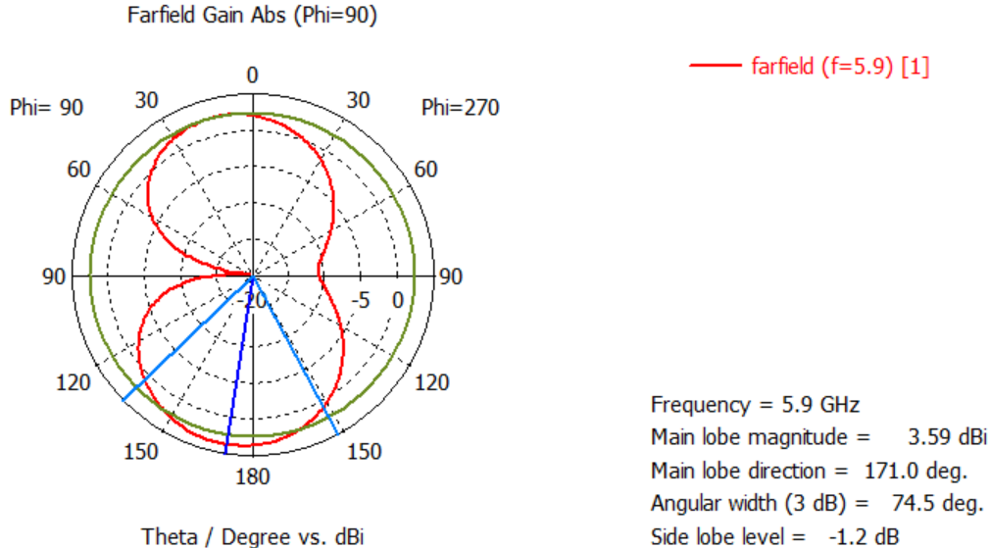

3D Pattern & Directivity At 2.4 GHz

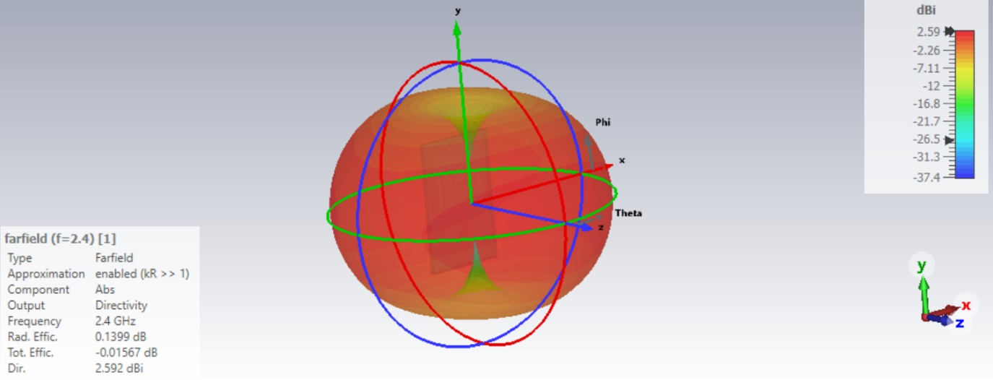

3D Pattern & Directivity At 3.3 GHz

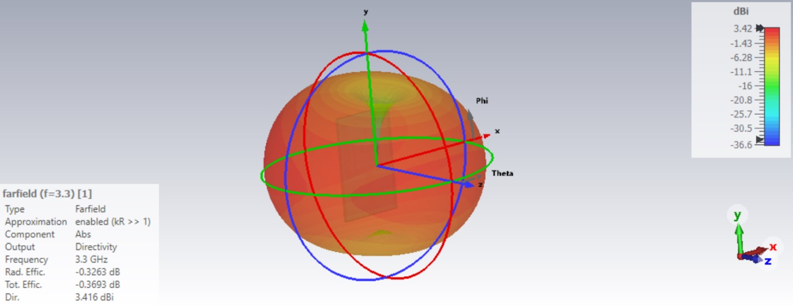

3D Pattern & Directivity At 5.9 GHz

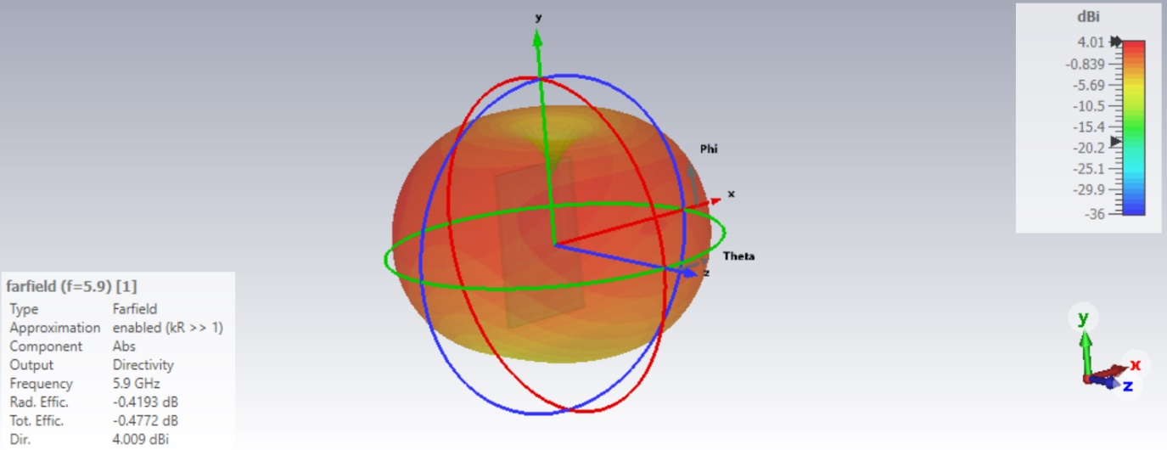

Surface Current Distribution/Current Density At 2.4 GHz

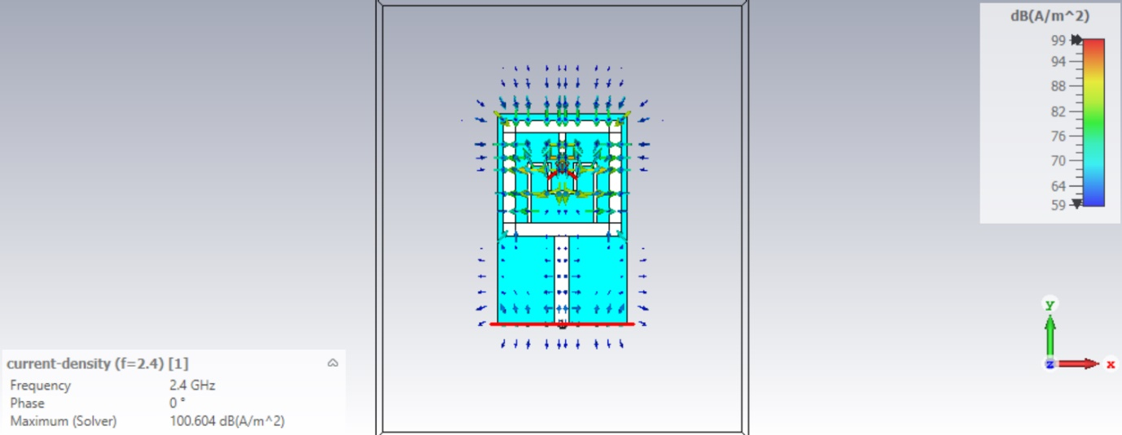

Surface Current Distribution/Current Density At 3.3 GHz

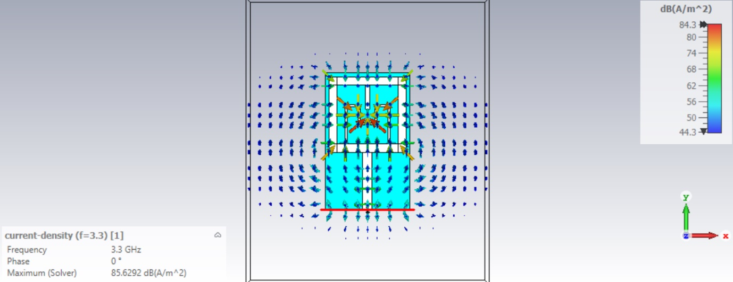

Surface Current Distribution/Current Density At 5.9 GHz

