Felodipine ER — PK-Sim Work Summary
Oct 21, 2026 · Nikita Ramwani

Purpose and links
Felodipine ER (Plendil 10 mg, BCS II) is MBBE drug 2: we used the OSP PK-Sim model to map which release-rate changes (Weibull T50 × shape) still pass bioequivalence. PK-Sim work finished on 2026-10-16; 27 fasted formulations were simulated.
What | Link / location
OSP felodipine model (source) | Open-Systems-Pharmacology/Felodipine-Model
OSP PBPK model library | OSP-PBPK-Model-Library
FDA product-specific guidance (felodipine ER) | PSG Felodipine ER tablet
Plendil label (2012) | FDA label 019834s025
Explainer deck (v14) | offline copy in docs/
PBPK vs PopPK discussion deck | offline copy in docs/
PK-Sim project (local installation) | Felodipine_ER_colon50.pksim5
Project notes (all decisions) | project notes (not included)
Build scope / decision log | planning notes (not included)
PK-Sim exports | Felodipine-BCSII/pksim-releaserate-cqa-er/
Sweep results | output_sweep_coarse/, output_sweep_2d/, output_sweep_2d_fedcv/, output_tablets1994/
Overrides to re-enter after Configure | reference/ER_tablet_10mg_sim_overrides.csv

The model
We used the OSP library's whole-body PBPK model of felodipine, built in PK-Sim. OSP built it as a CYP3A4 victim drug for DDI work, not for formulation work (source). The values below come from the master snapshot (reference/OSP-Felodipine-Model-master-snapshot.json); "fitted" means OSP fitted it with its parameter identification PI_IV+Solution+ER+DDI_additionalCL_3 (2022-08-10).
Model structure. PK-Sim's whole-body model has about 15 organs linked by blood flow. The gut is a chain of segments that the drug passes through after an oral dose (stomach, small-intestine segments, colon). It dissolves from the tablet, crosses the gut wall, can be metabolised by gut-wall CYP3A4, and then reaches the liver through the portal vein.
Part | Setting | Value | Origin
Drug | Molecular weight | 384.25 g/mol | DrugBank
Drug | Lipophilicity (logP) | 4.51 | fitted
Drug | Fraction unbound, plasma | 0.0036 (0.36%) | Ushimura 2010
Drug | Solubility (FaSSIF, pH 6.5) | 12 µg/mL | Söderlind 2010
Distribution | Partition coefficients | Rodgers & Rowland | PK-Sim method
Distribution | Cell permeability | PK-Sim Standard | PK-Sim method
Elimination | CYP3A4 Michaelis–Menten (liver + gut wall) | Km 2.81 µM; kcat 205 /min | Km: Walsky 2004; kcat fitted
Elimination | Unspecific hepatic clearance | 12.8 /min | fitted
Absorption | Gut-wall permeability ("P mucosa") | 0.0892 cm/min | OSP override, set on the simulation
ER tablet | Weibull dissolution | T50 286.9 min, lag 18.7 min, shape 0.764 | fitted
IR tablet | Weibull dissolution | T50 46.5 min, lag 0, shape 0.888 | fitted
Individual | European ICRP 2002 | male, 30 y; CYP3A4 turnover half-life 36 h; modified P-gp | OSP
Data it was built on. OSP fitted it to IV, oral solution, IR and ER data from 13 studies, including Edgar 1987, Bailey 1996/2003, Gelal 2005, Blychert 1990 and Lundahl 1997, plus an itraconazole DDI (Jalava 1997). OSP's acceptance test is that predictions fall within 2-fold of observed.
How well it does for our use. On the 4 ER 10 mg training studies, the shipped model predicts Cmax at 0.78 of observed (geometric mean) and AUC at 1.03. The IV check (Lundahl 1997) shows CL ×1.27, Vss ×1.61 and t½ ×1.42. Model bioavailability is about 0.20 against about 0.15 observed. Oral AUC comes out right only because these errors cancel.

What we changed in the model
We made one physiology change: CYP3A4 in the colon, set to 50% of the small-intestine level. Everything else is the shipped OSP model.
- Colonic CYP3A4 = 0.036 (50% of the SI level of 0.073) in all large-intestine segments. The shipped model has no colonic CYP3A4, so drug released late from the ER tablet escaped gut first pass and the 12–24 h tail ran high.
- We did not refit the Weibull. A refit gave T50 296 ± 52 min and shape 0.89 ± 0.08, but Cmax stayed at 0.77–0.79, so we kept OSP's values.
- We accept the Cmax bias of about 0.79. It comes from disposition (see the IV check above), not from release, so it largely cancels in a test/reference ratio.
Colonic CYP3A4 | Bioavailability F | Cmax pred/obs | AUC pred/obs | 12–24 h tail, training
0 (shipped) | ~0.20 | 0.789 | 1.089 | 1.83
10% of SI | 0.200 | 0.789 | 1.068 | 1.49
25% of SI | 0.186 | 0.788 | 1.054 | 1.27
50% of SI (chosen) | 0.176 | 0.787 | 1.042 | 1.12
Pred/obs values are geometric means over all 10 fasted ER 10 mg studies. Observed F is about 0.15.
PK-Sim gotcha. OSP stores 23 values on the simulation itself. These are 22 gut-wall permeabilities (0.0891674187 cm/min) and the tablet time delay factor (0.0695415108). Configure drops them; Clone keeps them. Converting to a population dropped all 23, so we re-entered them by hand. The full list is in reference/ER_tablet_10mg_sim_overrides.csv.

Population
We used one virtual population of 100 healthy Europeans (Pop_felo_100) for every run. Each test formulation was a clone of Pop_ref, so test and reference are paired on the same 100 subjects.
Item | Value
Base individual | European_colonCYP3A4_50 (OSP European ICRP 2002, 30 y male, CYP3A4 36 h, plus colonic CYP3A4 at 50%)
Size | 100 subjects (50 female / 50 male)
Age | 18.2–54.7 y (requested 18–55)
Weight | 41–98 kg
BMI | 19–30 kg/m² (requested 18.5–30)
Dose | 10 mg ER tablet, single dose, fasted, 3.5 mL/kg water
Simulation length | 0–96 h
Why 100, not 24 | Trials need about 54 subjects, and resampling those from 24 physiologies would duplicate subjects heavily
Reference run (Pop_ref), between-subject spread:
PK parameter | Individual (30 y male) | Pop median | Pop geo-mean | Range | Between-subject %CV
Cmax (nM) | 4.59 | 5.26 | 5.16 | 1.65–10.98 | 35%
tmax (h) | 3.0 | 2.75 | 2.71 | 1.9–3.75 | 15%
AUC0–96 (µM·min) | 4.38 | 5.18 | 5.16 | 1.39–12.98 | 39%
The population runs about 1.15× above the individual, because half the subjects are lighter women on a fixed 10 mg dose.
Within-subject %CV (added in the BE trial simulation, not by PK-Sim). These come from the UK MHRA public assessment report for Felodipine/Delofine XL vs the originator (MHRA PAR).
Study | Cmax %CV | AUC %CV | Used for
10 mg fasting, 2×2 | 35.7% | 24.3% (AUC0–∞) | Primary ABE, n = 54
10 mg fed, 2×2 | 36.5% | 22.2% (AUC0–∞) | Fed sensitivity, n = 56
10 mg steady state, replicate | 21.6% | 14.9% (AUCτ) | Not used
2.5 mg fasting, 4-period replicate | 30.8% (CVwR ≈ 34%) | 28.9% | RSABE / ABEL, n = 24
Cmax is highly variable (over 30%), and AUC is not. That is about 3× metformin's 12%.

Scenarios we ran in PK-Sim
We ran PK-Sim from 2026-10-13 to 2026-10-16: model checks on one individual first, then population runs. The 27-formulation fasted sweep is the main product.
# | Date | Scenario | Subjects | What it showed
1 | 10-13 | Shipped ER and IR vs observed data (4 training + 6 test ER 10 mg studies) | Individual | ER Cmax 0.78 of observed, AUC 1.03
2 | 10-13 | IR particle-radius scan (solubility fixed at 12 µg/mL) | Individual | No radius beats the Weibull, so the particle-size CQA was dropped
3 | 10-14 | ER Weibull refit (parameter identification) | Individual | T50 296 min, shape 0.89; Cmax still 0.77–0.79, so not adopted
4 | 10-14 | Disposition check: IV 1.5 mg and oral solution | Individual | CL ×1.27, Vss ×1.61; errors cancel in oral AUC
5 | 10-14 | Colonic CYP3A4 at 0 / 10 / 25 / 50% of SI | Individual | 50% fixes the late tail; locked as the reference
6 | 10-15 | Fasted reference Pop_ref | 100 | Between-subject CV: Cmax 35%, AUC 39%
7 | 10-15 | Coarse cross: 6 T50 values + 6 shape values | 100 each | Cmax drives BE; AUC passes almost everywhere
8 | 10-16 | 2-D fill (10 runs) + 4 edge runs | 100 each | Safe space is a diagonal band, not a box
9 | 10-16 | Fed reference Pop_fed_ref (high-fat breakfast at dose time) | 100 | Fed/fasted Cmax 0.96 vs 1.6–2.8 observed: the model cannot show the food effect
10 | 10-16 | Abrahamsson 1994 tablets A / B / C | 100 each | Mean-curve peaks within 1.25-fold of observed
Tablets A/B/C (external check). These are three tablets on the same HPMC platform as Plendil, with Weibulls fitted to the paper's in-vivo dissolution.
Tablet | Weibull T50 | Shape | Model peak | Observed peak | Model / observed
A (fast) | 102 min | 1.18 | 11.4 nM | 9.5 nM | 1.20
B | 363 min | 0.94 | 4.8 nM | 5.0 nM | 0.96
C (slow) | 1185 min | 1.10 | 2.1 nM | 2.3 nM | 0.91
The model gets the slow-side Cmax ratio B/C within 6%. It overstates the fast-side ratio A/B by 24%, so the safe space's short-T50 edge is conservative.
Fed decision. On 10-16 the decision was to claim the fasted safe space only and treat fed as a sensitivity. Re-running the BE trial simulation with the fed within-subject CV (36.5%, n = 56) left the safe space unchanged.

Matrix sweep: T50 × shape, BA and power
At the reference shape (0.764), a test tablet passes ABE with 80% power only when its T50 stays within 4.37–5.23 h (×0.91–1.09 of the reference 4.78 h). Cmax decides everything; AUC passes almost everywhere.
How it was run. We varied the ER Weibull T50 and shape and kept lag 18.68 min, giving 27 formulations, each simulated in the same 100 subjects. Relative BA is the paired test/reference geometric-mean ratio (GMR). Power is the share of 1000 simulated trials that pass. The trials are a 2×2 ABE with n = 54 and within-subject CV of 35.7% (Cmax) and 25.3% (AUC0–t), plus RSABE / ABEL on Cmax with n = 24 (CVwR 34%). Scripts: felo_02_be_sweep.jl and felo_03_safespace_2d.jl; results in output_sweep_2d/.
T50, h (min) | Shape | Rel. BA Cmax (GMR) | Rel. BA AUC0–t (GMR) | ABE power Cmax | ABE power AUC0–t | ABE power joint | RSABE power (FDA) | ABEL power (EMA)
2.39 (143) | 0.764 | 1.488 | 1.040 | 0.00 | 0.99 | 0.00 | 0.00 | 0.00
3.35 (201) | 0.764 | 1.229 | 1.026 | 0.10 | 1.00 | 0.08 | 0.29 | 0.20
4.07 (244) | 0.6 | 1.189 | 0.970 | 0.19 | 0.99 | 0.18 | 0.45 | 0.33
4.07 (244) | 0.764 | 1.099 | 1.013 | 0.62 | 1.00 | 0.59 | 0.81 | 0.73
4.07 (244) | 0.9 | 1.116 | 1.032 | 0.52 | 0.99 | 0.49 | 0.75 | 0.66
4.07 (244) | 1.0 | 1.149 | 1.040 | 0.35 | 0.99 | 0.32 | 0.62 | 0.52
4.07 (244) | 1.2 | 1.243 | 1.050 | 0.07 | 0.98 | 0.06 | 0.25 | 0.14
4.42 (265) | 0.764 | 1.047 | 1.007 | 0.84 | 1.00 | 0.83 | 0.94 | 0.91
4.78 (287) | 0.5 | 1.229 | 0.904 | 0.10 | 0.80 | 0.06 | 0.29 | 0.19
4.78 (287) | 0.6 | 1.094 | 0.951 | 0.64 | 0.97 | 0.61 | 0.82 | 0.74
4.78 (287) — reference | 0.764 | 1.000 | 1.000 | 0.90 | 1.00 | 0.90 | 0.97 | 0.95
4.78 (287) | 0.9 | 1.010 | 1.022 | 0.89 | 1.00 | 0.89 | 0.97 | 0.94
4.78 (287) | 1.0 | 1.037 | 1.032 | 0.86 | 0.99 | 0.85 | 0.95 | 0.92
4.78 (287) | 1.2 | 1.119 | 1.045 | 0.50 | 0.98 | 0.46 | 0.74 | 0.65
4.78 (287) | 1.5 | 1.269 | 1.055 | 0.03 | 0.97 | 0.03 | 0.17 | 0.10
5.26 (316) | 0.764 | 0.946 | 0.991 | 0.79 | 1.00 | 0.79 | 0.91 | 0.87
5.74 (344) | 0.6 | 0.996 | 0.927 | 0.90 | 0.91 | 0.82 | 0.97 | 0.94
5.74 (344) | 0.764 | 0.898 | 0.981 | 0.52 | 1.00 | 0.54 | 0.76 | 0.67
5.74 (344) | 0.9 | 0.901 | 1.008 | 0.53 | 1.00 | 0.55 | 0.76 | 0.68
5.74 (344) | 1.0 | 0.922 | 1.020 | 0.67 | 1.00 | 0.67 | 0.85 | 0.79
5.74 (344) | 1.2 | 0.990 | 1.036 | 0.90 | 0.99 | 0.88 | 0.97 | 0.94
6.31 (379) | 0.6 | 0.947 | 0.913 | 0.79 | 0.85 | 0.69 | 0.92 | 0.88
6.31 (379) | 1.0 | 0.865 | 1.012 | 0.30 | 1.00 | 0.31 | 0.58 | 0.44
6.31 (379) | 1.2 | 0.927 | 1.030 | 0.70 | 0.99 | 0.70 | 0.88 | 0.81
6.88 (413) | 1.2 | 0.873 | 1.023 | 0.35 | 1.00 | 0.36 | 0.62 | 0.49
7.17 (430) | 0.764 | 0.786 | 0.952 | 0.03 | 0.97 | 0.03 | 0.14 | 0.09
9.56 (574) | 0.764 | 0.659 | 0.904 | 0.00 | 0.81 | 0.00 | 0.00 | 0.00
Safe space (T50 range with power ≥ 0.80, interpolated across the 27 runs):
Shape | ABE, n = 54 | FDA RSABE, n = 24 | EMA ABEL, n = 24
0.6 | 5.25–5.84 h | 4.73–≥6.31 h | 4.90–≥6.31 h
0.764 (ref) | 4.37–5.23 h | 4.07–5.63 h | 4.19–5.46 h
0.9 | 4.47–5.28 h | 4.16–5.66 h | 4.29–5.49 h
1.0 | 4.67–5.49 h | 4.36–5.87 h | 4.49–5.70 h
1.2 | 5.24–6.10 h | 4.90–6.50 h | 5.04–6.33 h
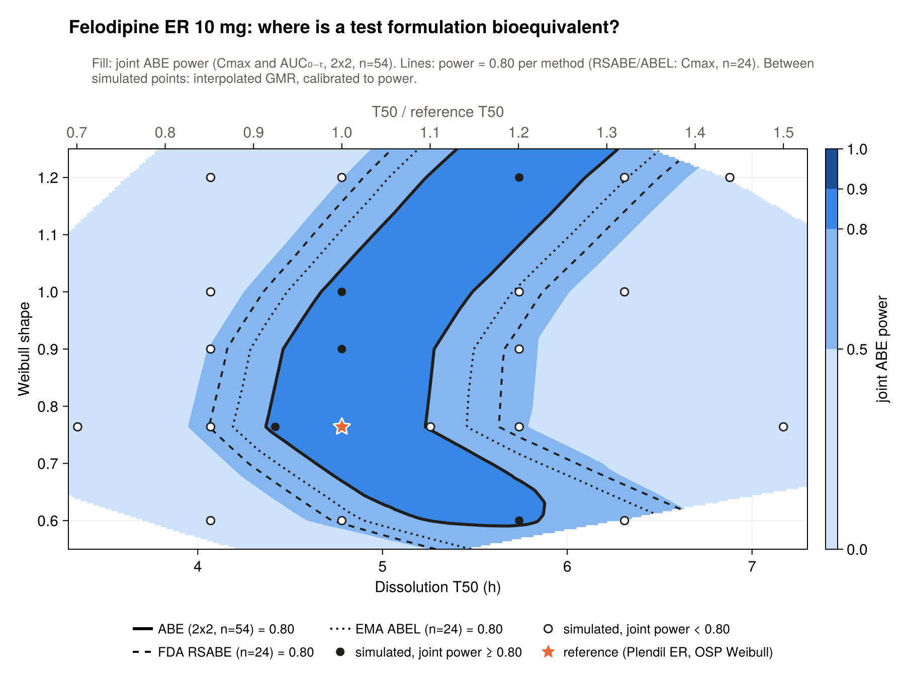
PBPK (PK-Sim) only. Fill: joint ABE power (Cmax and AUC0–t, 2×2, n = 54). Lines: power = 0.80 for ABE (solid), FDA RSABE (dashed) and EMA ABEL (dotted). Dots: the 27 simulated formulations, filled where joint power ≥ 0.80. Star: reference.
The safe space is a diagonal band, not a box. At a fixed T50, Cmax is U-shaped in shape and lowest near 0.8, so a slower T50 can be offset by moving shape away from 0.8. "≥ 6.31 h" means the edge lies beyond the last simulated point. The figure is output_sweep_2d/fig_safespace_2d_joint.png.

Key findings and open items
The PK-Sim work is finished; next steps reuse these 27 runs without new simulations.
- The safe space is narrow on T50. At the reference shape it is ±9% (4.37–5.23 h). RSABE / ABEL widen each side by about 0.2–0.4 h.
- Cmax is the binding metric. AUC0–t power is at least 0.85 in every run except the 4.78 h / shape 0.5 and 9.56 h runs (0.80–0.81).
- Known model limits: Cmax runs at 0.79 of observed because of disposition. The model can't represent the fed effect. The fast-side Cmax sensitivity is overstated by about 25%, which makes that edge conservative.
- Gates: #3 (fed) is closed as a sensitivity only; #4 (in-vitro dissolution link) is closed as "consistent, approximate".
Open:
- ☐ Choose the next step: NCA on sampled data, a joint PopPK model, a richer absorption model, sparse sampling, or a write-up
- ☐ Decide whether to report the PBPK vs PopPK divergence as it stands or improve the PopPK model first
- ☐ Literature: colon vs small-intestine CYP3A4 ratio (supports the 50% choice); Blychert 1990 market vs trial tablets
- ☐ Record the exact PK-Sim meal template used in Pop_fed_ref (no screenshot was kept)

