STRATEGIC PLANNING REPORT
Data-Driven Delivery Time Optimisation for an Urban Food Delivery Platform
A logistics data analysis using Python
Prepared by: Maniratan Raj
Course / Module: Logistics Data Analysis
Date: October 2026

1. Executive Summary
Last-mile delivery is the most expensive and most visible part of a food-delivery service. Customers judge the service by one number: how long the food takes to arrive. This report sets out a strategic plan for using data science in Python to understand why some deliveries are slow, to predict delivery time before it happens, and to support better decisions on courier allocation and delivery promises.
The plan is built around a realistic scenario, an urban food-delivery platform that wants to improve its on-time delivery rate, and is supported by an analysis of a real dataset of 1,000 delivery orders (Food_Delivery_Times.csv). The preliminary analysis already produced useful findings:
- Only 58.5% of orders arrive within the assumed 60-minute target; the average delivery takes 56.73 minutes.
- Distance is the strongest driver of delivery time (correlation 0.78). Each extra kilometre adds about 3 minutes.
- High traffic adds about 12 minutes compared with low traffic, and snowy weather pushes the on-time rate down to 40.2%.
- A simple Linear Regression model predicts delivery time with an average error of about 5.9 minutes (R² = 0.826) and outperformed a Random Forest model on this dataset.
The report defines the scenario and KPIs (Sections 2 to 4), summarises the supporting research (Section 5), describes the data and data science methods (Sections 6 and 7), presents the end-to-end roadmap (Section 8), reports the preliminary results (Section 9), illustrates the approach with Python code (Section 10), and concludes with the expected outcomes and their effect on logistics decisions (Sections 11 to 13).

2. Project Definition

2.1 Logistics scenario
The scenario is an urban food-delivery platform that connects restaurants, couriers and customers. Orders are delivered by three types of courier vehicle (bike, scooter and car) across a city where traffic and weather change throughout the day. The platform promises customers that food will arrive within a target time, which is assumed in this report to be 60 minutes from order placement.
Late deliveries are costly. They lead to complaints, refunds, cold food and lost repeat customers, and they put pressure on couriers and restaurant partners. At the same time, the platform has limited resources: a fixed number of couriers, and little ability to speed up traffic or change the weather. The challenge is therefore to make better use of the data the platform already collects.
The scenario combines two common logistics problems: delivery performance management (understanding and reducing delays) and resource allocation (deciding which courier and which time buffer to use for each order).

2.2 Problem statement
The platform does not know which factors cause deliveries to be late, how large their effects are, or how long a new order is likely to take. As a result, delivery estimates are inaccurate, courier assignment is not data-driven, and on-time performance cannot be improved in a targeted way.

2.3 Scope
The project covers last-mile delivery performance for individual orders: analysing historical delivery data, defining performance KPIs, predicting delivery time, and recommending how the results can support dispatch and customer-promise decisions. It does not cover menu pricing, restaurant selection, customer demand forecasting or vehicle purchasing.

3. Project Objectives
The project has one overall aim: to improve the reliability and efficiency of food deliveries using data. This aim is broken into five specific objectives.
- Describe current delivery performance using clear KPIs (average delivery time, on-time rate and time per kilometre).
- Identify the factors that most strongly affect delivery time, such as distance, traffic, weather, preparation time, time of day, vehicle type and courier experience.
- Predict delivery time for a new order with an average error of about 5 minutes or better, so that customers can be given accurate delivery estimates.
- Segment orders and courier situations (for example, short fast orders versus long-distance orders in bad conditions) to target improvements where they matter most.
- Recommend practical operational decisions, such as time buffers, courier allocation and restaurant coordination, based on the evidence.

4. Key Performance Indicators
Four KPIs were chosen because each is directly tied to the scenario (on-time, efficient delivery), can be calculated from the available data, and can be tracked over time. The current values were calculated from the dataset in the Python notebook. The targets are illustrative and would need to be agreed with the operations team.
KPI | Definition and formula | Current value | Illustrative target
Average delivery time | Mean of Delivery_Time_min across all orders | 56.73 min | 52 min or less
On-time delivery rate | Share of orders delivered within 60 minutes: orders ≤ 60 min ÷ total orders × 100 | 58.5% | 70% or more
Delivery minutes per km | Total delivery minutes ÷ total kilometres travelled | 5.64 min/km | 5.2 min/km or less
High-traffic delay | Average delivery time in high traffic minus average delivery time in low traffic | 11.92 min | 8 min or less

Why these KPIs matter. The average delivery time shows overall speed, but it can hide problems, so the on-time rate is added to show how many customers are actually let down. Delivery minutes per km measures efficiency independently of trip length, so long and short orders can be compared fairly. The high-traffic delay quantifies how strongly one external condition affects the service, which shows where buffers or extra couriers are needed.
A fifth, model-based KPI is used to track the quality of the prediction system: the mean absolute error (MAE) of predicted versus actual delivery time, currently 5.9 minutes.
Delivery minutes per km is calculated as total minutes divided by total kilometres (5.64). Averaging the ratio for each order separately gives a higher figure (8.07) because very short trips contain fixed preparation and pick-up time. The total-based version is the fairer measure.

5. Background Research

5.1 The importance of last-mile delivery
Last-mile delivery, the final leg from a distribution point to the customer, is widely described as the costliest stage of the supply chain. Industry estimates put it at between 41% and 53% of total supply chain costs, even though it covers the shortest distance (Armstrong, 2025). These figures come from industry sources, so they should be read as estimates rather than exact measurements. For food delivery the pressure is higher still, because the product is perishable and customers expect fast, predictable service.

5.2 Factors that influence delivery time
Previous studies agree that distance, traffic and weather are major drivers of delivery time. An analysis of 41,944 orders from Indian cities using regression found that traffic congestion and adverse weather significantly reduce delivery efficiency, and that the effect of distance is not purely linear (Chang, 2025). A multiple linear regression study of an Indian delivery platform also identified regional traffic conditions, service ratings and weather as the most significant factors (ICEMCI, 2025). Garg and Ayaan (2025) report that heavy traffic is strongly associated with longer delivery times and that conditions such as storms or fog cause clear delays. These findings match the patterns found in the dataset used in this report.

5.3 Machine learning for delivery time prediction
Regression-based machine learning is the standard approach to predicting delivery time. Yalçınkaya and Hızıroğlu (2024) compared Linear Regression, Decision Trees, Random Forests and XGBRegressor on a public food-delivery dataset using MAE, RMSE and R², and found that XGBRegressor performed best. Garg and Ayaan (2025) compared several algorithms on data from Indian cities and found LightGBM to be the strongest, with an R² of 0.76. These studies show that tree-based ensemble methods are often competitive on large datasets. In this project the simpler Linear Regression model performed better than Random Forest (R² of 0.826 compared with 0.767). This suggests that, on a small dataset where delivery time is mostly a straight-line function of distance, simpler models can be just as good and are easier to explain.

5.4 Optimisation and route planning
Prediction is most useful when it feeds into decisions. Jazemi et al. (2023) review the literature on vehicle routing problems in urban last-mile delivery and group the research into crowdshipping, parcel lockers, delivery by sidekicks and delivery to optional points. Another review of the field organises last-mile studies into optimisation models, machine learning approaches and mixed methods that combine the two (Optimization and Machine Learning Applied to Last-Mile Logistics: A Review, n.d.). This supports the approach taken in this report: first predict delivery time, then use the predictions as inputs for optimisation, for example in courier assignment.

5.5 Data used
The analysis uses the Food_Delivery_Times.csv dataset, a publicly available food-delivery dataset with 1,000 orders and nine columns (Kaggle, n.d.). It is small compared with the datasets in the studies above, which is acknowledged as a limitation in Section 12.

6. Data Description
The dataset contains 1,000 delivery orders. The target variable is Delivery_Time_min; all other columns are possible explanatory factors.
Column | Type | Description
Order_ID | Identifier | Unique order number (used only as a label)
Distance_km | Numeric | Delivery distance in kilometres (0.59 to 19.99)
Weather | Category | Clear, Rainy, Foggy, Snowy or Windy
Traffic_Level | Category | Low, Medium or High
Time_of_Day | Category | Morning, Afternoon, Evening or Night
Vehicle_Type | Category | Bike, Scooter or Car
Preparation_Time_min | Numeric | Restaurant preparation time in minutes (5 to 29)
Courier_Experience_yrs | Numeric | Courier experience in years (0 to 9)
Delivery_Time_min | Numeric (target) | Total delivery time in minutes (8 to 153)

Data quality. The data has no duplicate rows, and no impossible values (such as zero or negative distances and times). Four columns had 30 missing values each: Weather, Traffic_Level, Time_of_Day and Courier_Experience_yrs. Missing categories were filled with the most common value (the mode), and missing courier experience with the median. Because only 3% of each column was affected, this simple method keeps the data intact without changing the results noticeably. In a real project, the better option would be to fix the data collection process so the values are not missing in the first place.

7. Data Science Methods
Four families of data science techniques are relevant to this scenario. Each answers a different business question.

7.1 Regression
Regression predicts a number from other variables. Here it predicts delivery time from distance, traffic, weather, preparation time and other factors. Linear Regression assigns a weight to each factor, which makes it easy to explain (for example, “each kilometre adds about 3 minutes”). Random Forest builds many decision trees and averages them, which can capture more complex patterns. Both are evaluated with the mean absolute error (MAE), the root mean squared error (RMSE) and R², which shows how much of the variation in delivery time the model explains.

7.2 Classification
Classification predicts a category instead of a number. The same features can be used to predict whether an order will be on time or late (the on-time flag used in the KPIs). This helps operations teams flag high-risk orders before they become late.

7.3 Clustering
Clustering groups similar records without using a target. K-Means clustering on distance, preparation time and delivery time could separate orders into groups such as short fast orders, long-distance orders, and slow orders in bad conditions. Each group can then be given its own operational policy. Features must first be standardised, because K-Means is sensitive to the scale of the variables.

7.4 Optimisation
Optimisation chooses the best action under constraints. Once delivery times can be predicted for each order and courier combination, a courier assignment problem can be solved to minimise the total predicted delivery time while respecting limits on how many orders each courier can carry. For multi-stop routes, vehicle routing methods (for example, using Google OR-Tools) can be used.

7.5 How the methods connect to the KPIs
Technique | Business question | Python tools | KPI affected
Regression | How long will this order take? | scikit-learn | Prediction MAE, average delivery time
Classification | Will this order be late? | scikit-learn | On-time rate
Clustering | Which types of orders and conditions are problematic? | scikit-learn | High-traffic delay, on-time rate
Optimisation | Which courier should get which order? | SciPy, OR-Tools | Minutes per km, average delivery time

8. Strategic Roadmap
The analysis follows an end-to-end process of seven phases. Each phase produces an output that is used by the next one.
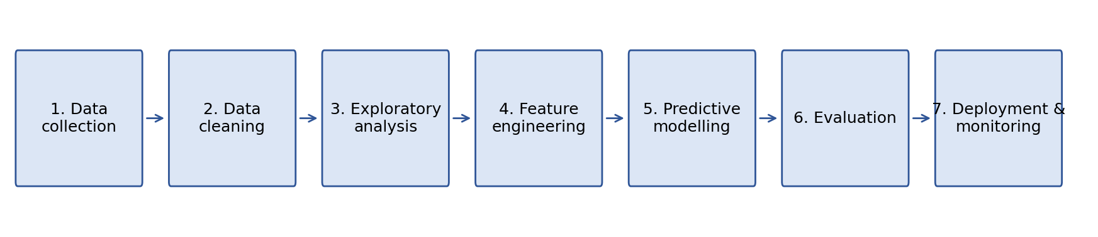
Figure 1. End-to-end analysis process
Phase | Main activities | Python tools | Output
1. Data collection | Gather order records (distance, weather, traffic, time, vehicle, preparation time, courier, delivery time) from the platform database or CSV exports | pandas | Raw dataset
2. Data cleaning | Check shape, types and duplicates; fill missing values; validate values; detect and review outliers | pandas, NumPy | Clean dataset
3. Exploratory analysis | Compare delivery time by weather, traffic, time of day and vehicle; calculate correlations; plot distributions and relationships | pandas, matplotlib, seaborn | Key insights and charts
4. Feature engineering | Convert categories to numeric columns (one-hot encoding); create the on-time flag; remove columns that leak the answer | pandas | Model-ready features
5. Predictive modelling | Split data 80/20; train Linear Regression and Random Forest; (proposed) cluster orders and test an assignment optimisation | scikit-learn, SciPy | Trained models
6. Evaluation | Compare models with MAE, RMSE and R²; analyse errors on long-distance orders; check feature importance | scikit-learn | Model comparison
7. Deployment and monitoring | Serve predictions as delivery estimates; track KPIs weekly; retrain as new data arrives | Python script or API, dashboard | Live KPI tracking

Feasibility. The approach is realistic. It needs only open-source Python libraries, runs on an ordinary laptop, and uses data that platforms already collect. The dataset is small enough for the full pipeline to run in seconds. The main practical requirements are access to clean historical data and agreement from operations on the KPI targets. Phases 1 to 6 have already been completed on the available dataset; clustering and optimisation in Phase 5 are proposed next steps, and Phase 7 depends on integration with the platform’s systems.

9. Preliminary Results
This section reports the results of the analysis carried out in the accompanying Python notebook (logistics_analysis.ipynb). All figures are calculated from the cleaned dataset.

9.1 Overview of delivery time
Delivery times range from 8 to 153 minutes with a mean of 56.73 minutes and a median of 55.5 minutes. Using the interquartile range (IQR) rule, six orders (0.6%) exceed the upper limit of 116 minutes. All six are long-distance deliveries of 14.8 to 19 km, where delivery times are naturally higher (orders of 14.8 km or more average about 79 minutes). No invalid values were found, so these orders were kept as genuine slow deliveries.

9.2 Factors affecting delivery time
Distance shows a strong positive relationship with delivery time (correlation 0.781). Preparation time has a moderate positive relationship (0.307), and courier experience has a very weak negative one (−0.089), so experience alone is not a strong driver of speed.
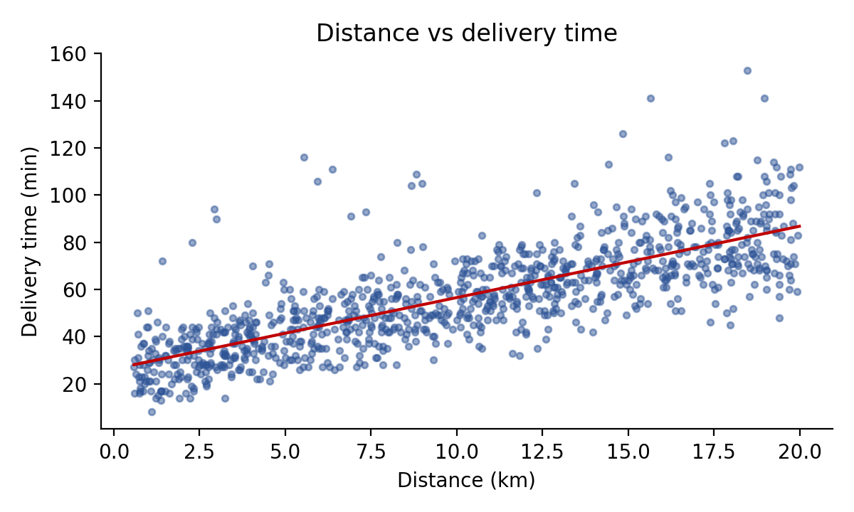
Figure 2. Distance against delivery time, with trend line
Weather has a clear effect. Snowy conditions average 67.1 minutes, compared with 53.2 minutes in clear weather, a difference of almost 14 minutes. Rainy and foggy conditions average close to 60 minutes.
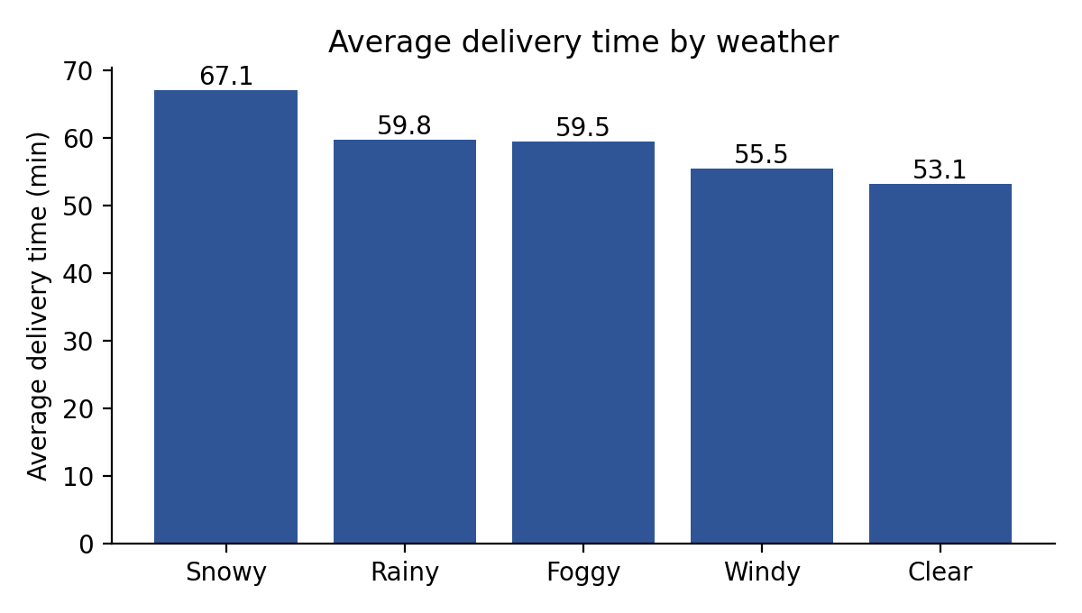
Figure 3. Average delivery time by weather
Traffic has a similar effect: high traffic averages 64.8 minutes, medium traffic 56.5 minutes and low traffic 52.9 minutes, a gap of 11.9 minutes between high and low.
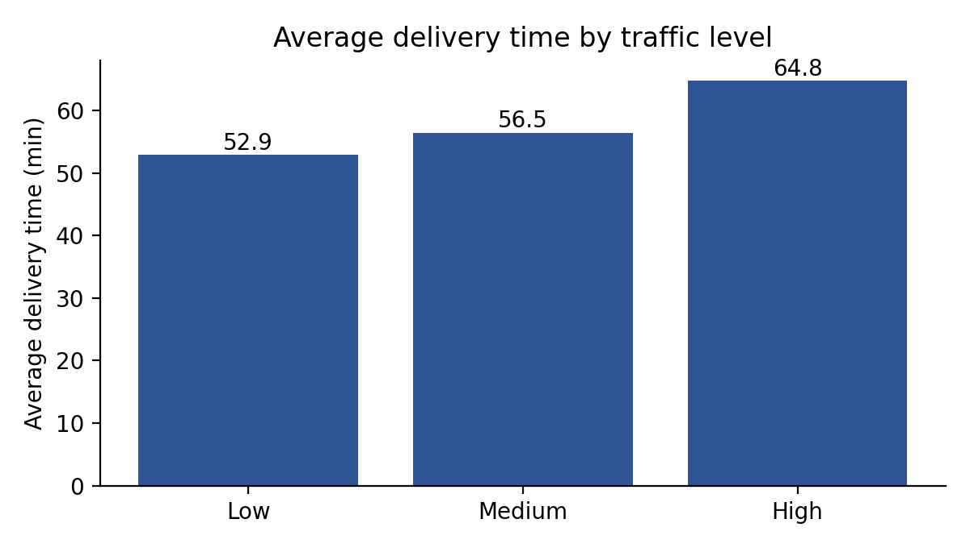
Figure 4. Average delivery time by traffic level
Time of day and vehicle type have only small effects. Evening orders are slowest at 57.5 minutes and night orders fastest at 55.2 minutes. Cars average 58.2 minutes, bikes 56.6 minutes and scooters 56.1 minutes.

9.3 KPI results
Only 58.5% of orders meet the 60-minute target, so roughly four in ten orders are late. The on-time rate varies a great deal with conditions: 63.7% in low traffic but only 45.7% in high traffic, and 64.4% in clear weather but only 40.2% in snow.
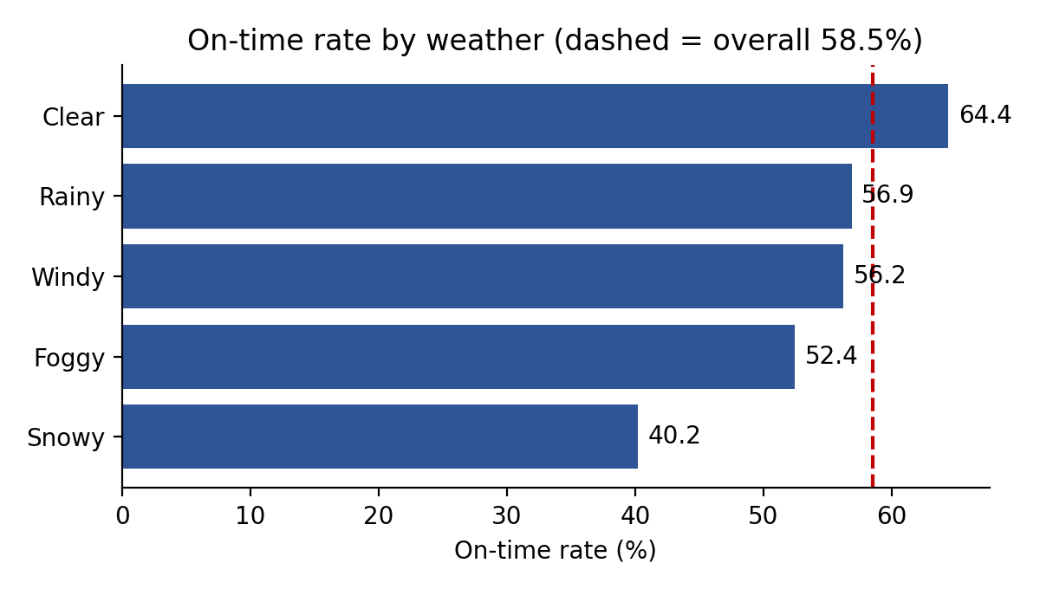
Figure 5. On-time delivery rate by weather

9.4 Predictive model results
Delivery time was predicted from all factors except the order ID and the target itself. The on-time flag was also excluded because it is calculated from the target and would leak the answer. The data was split into 800 training orders and 200 test orders. Results on the test set:
Model | MAE (min) | RMSE (min) | R²
Linear Regression | 5.90 | 8.83 | 0.826
Random Forest | 7.02 | 10.22 | 0.767

Linear Regression performed better. On average its predictions are about 6 minutes away from the actual delivery time and it explains about 83% of the variation in delivery time. The model coefficients are easy to interpret: each additional kilometre adds about 3.0 minutes, each additional minute of preparation adds about 1 minute, and snowy weather adds about 9 minutes compared with clear weather. Low traffic reduces delivery time by about 11 minutes compared with high traffic, all other factors being equal.
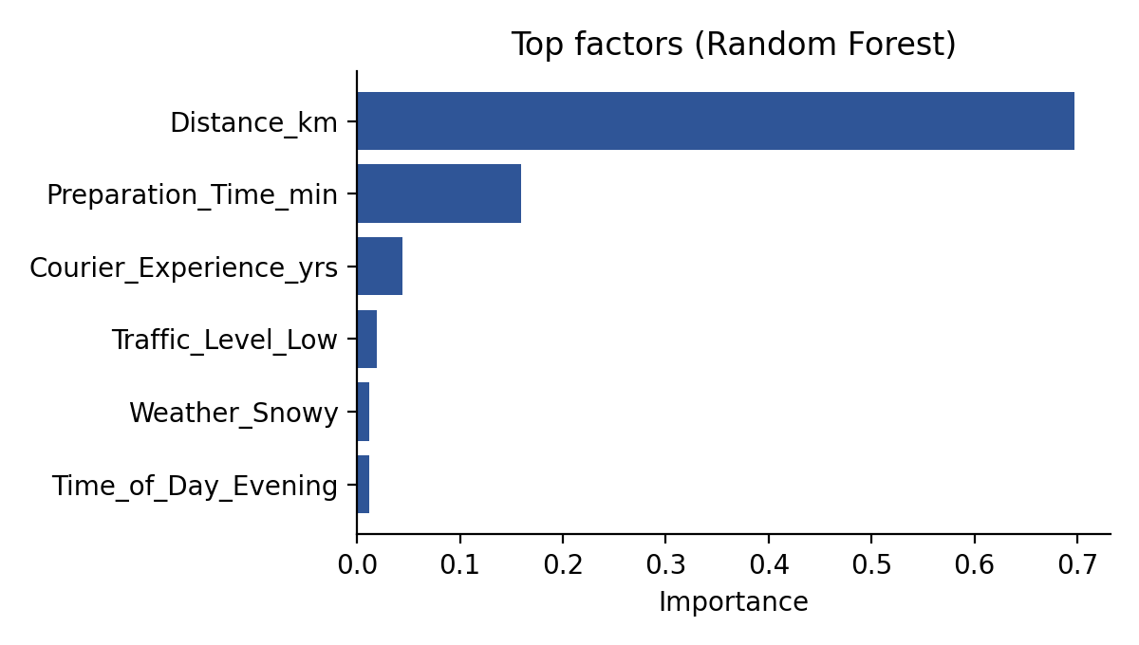
Figure 6. Most important factors in the Random Forest model
Distance is by far the most important factor (importance about 0.70), followed by preparation time (0.16) and courier experience (0.04). The model is less accurate for long trips: for test orders of 14.8 km or more (55 orders), the average error is 8.9 minutes, compared with 4.8 minutes for shorter orders. Long deliveries are therefore the hardest to predict, and estimates for them should include a wider safety margin.

10. Python Code Illustrations
The snippets below illustrate how each phase is carried out. Sections 10.1 to 10.3 are taken from the working notebook. Sections 10.4 and 10.5 are proposed next steps and have not yet been run on the dataset.

10.1 Data loading and cleaning (implemented)
import pandas as pd, numpy as np

df = pd.read_csv("Food_Delivery_Times.csv")
print(df.shape, df.duplicated().sum())
print(df.isnull().sum())

# Fill missing categories with the mode, experience with the median
for col in ["Weather", "Traffic_Level", "Time_of_Day"]:
df[col] = df[col].fillna(df[col].mode()[0])
df["Courier_Experience_yrs"] = df["Courier_Experience_yrs"].fillna(
df["Courier_Experience_yrs"].median())

# Outlier check with the IQR rule
Q1, Q3 = df["Delivery_Time_min"].quantile([0.25, 0.75])
upper = Q3 + 1.5 * (Q3 - Q1)
outliers = df[df["Delivery_Time_min"] > upper] # 6 orders

10.2 Exploratory analysis and KPIs (implemented)
ON_TIME_TARGET = 60 # minutes (assumed service-level target)

avg_time = df["Delivery_Time_min"].mean()
on_time_pct = (df["Delivery_Time_min"] <= ON_TIME_TARGET).mean() * 100
min_per_km = df["Delivery_Time_min"].sum() / df["Distance_km"].sum()

traffic = df.groupby("Traffic_Level")["Delivery_Time_min"].mean()
traffic_delay = traffic["High"] - traffic["Low"]

# On-time rate by weather
df["On_Time"] = df["Delivery_Time_min"] <= ON_TIME_TARGET
print((df.groupby("Weather")["On_Time"].mean() * 100).round(1))

10.3 Predictive modelling (implemented)
from sklearn.model_selection import train_test_split
from sklearn.linear_model import LinearRegression
from sklearn.ensemble import RandomForestRegressor
from sklearn.metrics import mean_absolute_error, r2_score
from sklearn.metrics import mean_squared_error

y = df["Delivery_Time_min"]
# Drop the ID, the target and On_Time (On_Time is derived from the target)
X = pd.get_dummies(
df.drop(columns=["Order_ID", "Delivery_Time_min", "On_Time"]),
drop_first=True)

X_train, X_test, y_train, y_test = train_test_split(
X, y, test_size=0.2, random_state=42)

rf = RandomForestRegressor(n_estimators=200, random_state=42)
models = {"Linear Regression": LinearRegression(), "Random Forest": rf}

for name, model in models.items():
model.fit(X_train, y_train)
pred = model.predict(X_test)
print(name,
"MAE:", round(mean_absolute_error(y_test, pred), 2),
"RMSE:", round(np.sqrt(mean_squared_error(y_test, pred)), 2),
"R2:", round(r2_score(y_test, pred), 3))

10.4 Clustering orders (proposed)
from sklearn.preprocessing import StandardScaler
from sklearn.cluster import KMeans

cols = ["Distance_km", "Preparation_Time_min", "Delivery_Time_min"]
X_scaled = StandardScaler().fit_transform(df[cols])

kmeans = KMeans(n_clusters=3, random_state=42, n_init=10)
df["Cluster"] = kmeans.fit_predict(X_scaled)

# Describe each cluster to decide on a policy for it
print(df.groupby("Cluster")[cols].mean().round(1))
print(df.groupby("Cluster")["On_Time"].mean().round(2))

10.5 Courier assignment (proposed, pseudocode)
# Goal: assign each waiting order to one courier so that the total
# predicted delivery time is as small as possible

for each order i and each available courier j:
cost[i][j] = model.predict(features(order i, courier j))

# Solve the assignment problem (each order gets exactly one courier)
from scipy.optimize import linear_sum_assignment
rows, cols = linear_sum_assignment(cost)

dispatch_plan = list(zip(rows, cols))

# Evaluate: compare mean predicted time with the current rule
# (e.g. nearest courier) and report the change in on-time rate

11. Expected Outcomes and Impact on Decision-Making
The analysis is intended to support operational decisions, not just to describe the past. The table below links each finding to a decision and the benefit it is expected to bring. These benefits are expectations that should be tested, for example with a pilot, and are not guaranteed results.
Finding | Decision it supports | Expected benefit
Distance adds about 3 minutes per km and is the main driver of delivery time | Use distance in delivery estimates, and prefer nearby couriers when assigning orders | More accurate delivery promises; shorter average delivery time
High traffic adds about 12 minutes; snow lowers the on-time rate to 40.2% | Add time buffers to estimates and schedule extra couriers in bad weather or heavy traffic | Higher on-time rate; fewer complaints in difficult conditions
Preparation time has a moderate effect on delivery time | Dispatch couriers according to expected restaurant readiness, and flag slow restaurants | Less courier waiting time; better minutes per km
Courier experience has only a weak effect | Do not rely on experience alone when assigning couriers; focus on distance and conditions | Avoids misdirected allocation and training effort
Prediction error is larger for long trips (8.9 minutes) | Give longer-distance orders a wider estimate range or limit the delivery radius | Fewer broken promises on long deliveries

Taken together, the project would let the platform move from reacting to late deliveries to anticipating them. A prediction model gives each new order a realistic delivery estimate, the KPIs show whether performance is improving, and the findings show where intervention is most valuable: long trips, high traffic and bad weather.
Success should be monitored through the KPIs in Section 4. After any change (for example, a new buffer rule), the on-time rate and the prediction MAE should be compared with the baseline values reported here.

12. Limitations and Risks
- Small dataset. With 1,000 orders, results may not generalise to a whole city, and more complex models may not show their advantage until more data is available.
- Assumed target. The 60-minute on-time target is an assumption. A different service-level target would change the on-time KPIs.
- Association, not causation. The analysis shows relationships between factors and delivery time; it does not prove that changing one factor will cause a particular change.
- Imputed values. About 3% of four columns were filled with the mode or median, which may slightly distort the results for those columns.
- Missing information. The dataset does not include restaurant, customer location, route or order size, which limits the optimisation that can be tested and the accuracy of predictions.
- Proposed methods not yet tested. Clustering and courier assignment are described and illustrated in code, but their results are not reported here.

13. Conclusion
This report defined a realistic logistics scenario, an urban food-delivery platform that wants to improve its on-time performance, and proposed a data science approach in Python to address it. Four KPIs (average delivery time, on-time delivery rate, delivery minutes per kilometre and high-traffic delay) were defined and calculated, and the background research showed that distance, traffic and weather are the main drivers of delivery time, and that regression and optimisation are well-established tools for this problem.
The preliminary analysis showed that only 58.5% of orders arrive within 60 minutes, that distance is the dominant factor, and that high traffic and snow cause the largest drops in on-time performance. A simple Linear Regression model predicts delivery time to within about 6 minutes on average, and it performed better than a Random Forest on this dataset.
The next steps are to test clustering and courier-assignment optimisation, to repeat the analysis on a larger dataset, and to pilot the prediction model as a live delivery-time estimate. If these steps confirm the preliminary findings, the platform will have the evidence to set realistic delivery promises, allocate couriers more efficiently and target its improvements where they matter most.

References
Armstrong. (2025, January 14). Last-mile logistics explained: Why the final leg is the hardest. https://appstage.goarmstrong.com/resources/industry/last-mile-logistics-explained
Chang. (2025). Analysis of influencing factors of food delivery time. Advances in Economics, Business and Management Research. https://econpapers.repec.org/bookchap/spradvbcp/978-94-6463-888-2_5f86.htm
Garg, & Ayaan. (2025). Food delivery time prediction in Indian cities using machine learning models. arXiv:2503.15177. https://arxiv.org/html/2503.15177v1
ICEMCI. (2025). Determinants of food-delivery timeliness: An empirical test using multiple linear regression. Proceedings of the 2025 7th International Conference on Economic Management and Cultural Industry. Atlantis Press. https://www.atlantis-press.com/proceedings/icemci-25/126018550
Jazemi, R., Alidadiani, E., Ahn, K., & Jang, J. (2023). A review of literature on vehicle routing problems of last-mile delivery in urban areas. Applied Sciences, 13(24), 13015. https://doi.org/10.3390/app132413015
Kaggle. (n.d.). Food delivery time [Data set]. https://www.kaggle.com/datasets/rajatkumar30/food-delivery-time
Optimization and machine learning applied to last-mile logistics: A review. (n.d.). https://deustoteka.deusto.es/items/0a00fb49-3784-45f0-bade-9b89fb6110f7
Yalçınkaya, & Hızıroğlu. (2024). A comparative analysis of machine learning models for time prediction in food delivery operations. https://acikerisim.bakircay.edu.tr/items/d593d156-6e65-45db-aa95-765ce197d2af

