GRIDLY
Professional Deandloper & User Guide
Version 1.0.52.2 Community Preview
A modern grid, card, dashboard, media, and data-experience platform for WinForms
Preparation date: 11.06.2026
Updated on: 23.06.2026
Document purpose: This guide has been updated to the Gridly 1.0.52.2 Community Preview level based on the v29 Ultimate customer catalog and developer guide. The Core/Examples split, TestApp, new view modes, theme, localization, media playback, FixedFree resize, and GitHub publishing process are included.

Quick Feature Summary
Feature | When is it used? | Benefit
Details / Card / Dashboard / DetailCard | Same andriyi farkli user tiplerine gore gostermek icin | Tek bilesenle coklu view
Poster / Gallery / MediaTile / FilmStrip | Album, film, fotograf, dokuman and medya kutuphaneleri icin | Gorsel agirlikli deneyim
Filtering / Query Language / Search | Hizli and gelismis arama gerektiginde | Guclu andri kesfi
Profiles / State / Layout | Kullanici/rol/makine bazli ekran duzeni icin | Kurumsal kisisellestirme
Theme / Accessibility / Localization | Light/Dark/System/çoklu dil gerektiginde | Profesyonel, okunabilir and global UI
Virtual / UltraFast / Cache | 10K, 100K, 1M+ andri senaryolarinda | Performans and dusuk bellek kullanimi

Contents - Static Section List
1. What Is Gridly?
2. Architectural Overview
3. Designer-First Standard
4. Installation and Your First Gridly
5. Column System
6. Data Binding
7. Details
8. Card
9. Dashboard
10. DetailCard
11. Poster
12. Gallery
13. MediaTile
14. FilmStrip
15. PropertyCard
16. GroupCard
17. Kanban
18. HeatMap
19. KPI Dashboard
20. MiniChart Columns
21. Filtering System
22. Query Language
23. Quick Filter
24. Advanced Filter
25. Sorting
26. Grouping
27. Conditional Formatting
28. Card Visuals
29. Card Actions
30. Checkbox Layout
31. Cell Oandrflow
32. Row Height
33. Profiles
34. Profile Migration
35. Layout Import/Export
36. Expression
37. Formula Columns
38. Change Tracking
39. Event Bus
40. Action Pipeline
41. Copy System
42. Export
43. Virtual Mode
44. UltraFast Mode
45. Stress Test
46. Theme Engine
47. Accessibility
48. High DPI
49. Localization
50. FixedFree Resize
51. Media Playback
52. Image Cache
53. Search Everywhere
54. Command Palette
55. Inline Editing
56. Drag & Drop
57. Multi View Sync
58. State Management
59. Plugin System
60. Data Profiling
61. Smart Suggestions
62. Audix Showcase
63. AOI Support Desk Showcase
64. Line Workspace Showcase
65. Bilge Defter Showcase
66. Example Center
67. GitHub Community Preview
68. Troubleshooting
69. Roadmap

1. What Is Gridly?

What is it?
Gridly, WinForms uygulamalarinda tek bir kontrol ile tablo, kart, dashboard, medya galerisi and analiz odakli andri deneyimi sunmayi hedefleyen modern bir UI bilesenidir. Klasik DataGridView andya ObjectListView kullanildiginda her ekran icin tekrar edilen filter, theme, export, kart, profil and performans kodlari Gridly altinda teklesir.

When should it be used?
- Same andri kaynagi farkli user tiplerine gore farkli gorunmeliyse.
- Operator ekranlari sade, admin ekranlari detailli olacaksa.
- Kart, dashboard, poster andya medya viewu tek altyapida isteniyorsa.
- Tema, dil, profil and export ayni standartta yonetilecekse.

When should it not be used?
- Sadece cok basit iki columnlu and hic filter gerektirmeyen bir liste icin.
- Tamamen web tabanli UI kullanilan projelerde.
- Gercek zamanli 3D/oyun tarzi cizim ihtiyacinda.

Benefits
- Tek kontrol ile coklu view.
- Kurumsal standartlarda theme and profil.
- Gorsel agirlikli medya and dashboard destegi.
- Buyuk andri icin virtual and cache stratejileri.

Design and performance notes
- Gridly bir tablo kontrolu olarak baslayabilir ama proje buyudukce uygulama andri deneyimi katmanina donusur.
- Community Preview asamasinda API isimleri olgunlasmaya devam edebilir.
- GitHub yayininda ornekler TestApp altinda, core ise temiz DLL olarak tutulmalidir.
// Ornek 1: En basit Gridly kullanimi
var grid = new GridlyView();
grid.Dock = DockStyle.Fill;
grid.ViewMode = GridlyViewMode.Details;
grid.SetObjects(customerList);
Controls.Add(grid);
// Ornek 2: Operator icin sade dashboard
grid.ViewMode = GridlyViewMode.Dashboard;
grid.ShowQuickFilter = true;
grid.CardVisualInfoGetter = row => BuildStatusVisual((TicketRow)row);
// Ornek 3: Audix gibi medya uygulamasi
gridAlbums.ViewMode = GridlyViewMode.MediaTile;
gridAlbums.MediaImageScaleMode = GridlyMediaImageScaleMode.Cover;
gridAlbums.SetObjects(albumList);
// Ornek 4: Factory monitor icin HeatMap
gridMachines.ViewMode = GridlyViewMode.HeatMap;
gridMachines.HeatValueGetter = row => ((MachineRow)row).UtilizationPercent;
// Ornek 5: Kullanici layout profili
grid.Profiles.Scope = GridlyProfileScope.ForCurrentUser("Technician");
grid.Profiles.LoadOrDefault("TicketList");

2. Architectural Overview
Gridly 5.0 foundation, profile and runtime stability akışı.
Screenshot note: The available screenshots were reviewed, but none could be confirmed as a clear and accurate representation of the 'core Gridly view' for this architectural section. To avoid misdirection, the image was removed.

What is it?
Gridly mimarisi GridlyView ana kontrolu etrafinda kolon modeli, render motoru, tema, lokalizasyon, filtre, profil, export, event bus ve medya motoru gibi alt sistemlerden olusur. Uygulama gelistiricisi veri ve davranis tanimlar; Gridly cizim ve etkilesim ayrintilarini yonetir.

When should it be used?
- Birden fazla projede ayni grid davranisi isteniyorsa.
- Temaya uyumlu popup, dialog, filter and export ekranlari gerekiyorsa.
- Plugin andya eandnt bus ile genisletilebilir mimari isteniyorsa.

When should it not be used?
- Tek formda tek liste and hic tekrar kullanilmayan basit prototiplerde.

Benefits
- Form kodu sade kalir.
- Tema, dil, export and profil tek merkezden yonetilir.
- Core/Example ayrimi ile GitHub yayininda temiz mimari saglanir.

Design and performance notes
- Gridly DLL icinde ornek ekran kalintisi bulunmamalidir.
- Tüm sample senaryolari samples/Gridly.TestApp altinda tutulmalidir.
- Core API tek kaynak prensibiyle korunmalidir.
// Ornek 1: Cekirdek kullanim
public partial class MainForm : Form
{
public MainForm()
{
InitializeComponent();
gridlyView1.Theme = GridlyTheme.Auto;
gridlyView1.UseFiltering = true;
}
}
// Ornek 2: Facade yaklasimi
grid.Profiles.Save("DefaultLayout");
grid.Exporting.ExportCsv("rows.csv", GridlyExportOptions.VisibleRows());
grid.Events.Publish("RefreshRequested", new { Source = "Toolbar" });
// Ornek 3: Tema + dil + medya birlikte
GridlyLocalization.Use("tr");
grid.Theme = GridlyTheme.Dark;
grid.ViewMode = GridlyViewMode.Poster;
grid.MediaShowPlaybackState = true;
// Ornek 4: Plugin kaydi
grid.Plugins.Add(new TicketHeatmapPlugin());
grid.Plugins.Add(new ExportAuditPlugin(logger));
// Ornek 5: Core/Examples ayrimi
// src/Gridly -> sadece kontrol ve API
// samples/TestApp -> tum ornekler, showcase formlari, developer center

3. Designer-First Standard

What is it?
Screenshot note: This section explains a conceptual and structural standard, so no mandatory screenshot is used in this release.
Gridly projelerinde WinForms kontrollerinin Designer.cs icinde tanimlanmasi resmi standarttir. Runtime kontrol olusturma tamamen yasak degildir; fakat kalici formlar, paneller, butonlar, GridlyView kontrolleri ve dil secim ekranlari tasarim zamaninda gorunur olmali, event ve veri mantigi form .cs tarafinda kalmalidir.

When should it be used?
- Bakimi kolay WinForms uygulamalari gelistiriliyorsa.
- Tasarim zamaninda kontrol yerlesimi gormek isteniyorsa.
- Farkli gelistiriciler ayni formu duzenleyecekse.

When should it not be used?
- Dinamik editor, popup andya gecici kontrol gibi kisa omurlu UI uretimlerinde.

Benefits
- Designer bozulmalari azalir.
- Form bakimi kolaylasir.
- Runtime null reference and handle olusmadan BeginInvoke hatalari azalir.

Design and performance notes
- Designer.cs icinde is mantigi yazilmamalidir.
- Eandnt baglama and andri yukleme Form_Load andya Configure metodlarinda olmalidir.
- Butun yeni TestApp formlari bu standarda uymali.
// Ornek 1: Dogru - Designer.cs icinde kontrol alani
private Gridly.Core.GridlyView gridTickets;
private System.Windows.Forms.Panel topPanel;
private System.Windows.Forms.Button btnRefresh;
// Ornek 2: Dogru - Form.cs icinde davranis
private void TicketForm_Load(object sender, EventArgs e)
{
ConfigureTicketGrid();
LoadTickets();
}
// Ornek 3: Kacinilmasi onerilen runtime kontrol uretimi
// var grid = new GridlyView();
// Controls.Add(grid); // Kalici ana grid icin Designer.cs tercih edilir.
// Ornek 4: Designer-safe kolon konfigurasyonu
private void ConfigureTicketGrid()
{
gridTickets.Columns.Clear();
gridTickets.Columns.Add(new GridlyColumn { Text = "Hat", AspectName = "LineName" });
gridTickets.Columns.Add(new GridlyColumn { Text = "Durum", AspectName = "Status" });
}
// Ornek 5: Dil secim formu standardi
// StartupLanguageForm.Designer.cs -> tum Label, ComboBox, CheckBox, Button tanimlari
// StartupLanguageForm.cs -> secim kaydetme ve GridlyLocalization.Use(...)

4. Installation and Your First Gridly

What is it?
Screenshot note: This installation section intentionally stays code- and step-focused instead of using a potentially misleading UI screenshot.
Gridly DLL andya kaynak proje referansi olarak kullanilabilir. GitHub Community Preview icin onerilen yapi src/Gridly altinda cekirdek, samples/Gridly.TestApp altinda ornekler, docs altinda dokumantasyondur.

When should it be used?
- Yeni bir WinForms ekraninda Gridly kullanilacaksa.
- DataGridView/ObjectListView gecisi yapilacaksa.
- GitHub reposundan kaynak kod ile deneme yapilacaksa.

When should it not be used?
- Sadece NuGet paketine bagli otomatik yukleme bekleniyorsa; Community Preview asamasinda kaynak veya DLL referansi daha dogrudur.

Benefits
- Hizli baslangic.
- Aşamalı migrasyon.
- Temiz repo yapisi.

Design and performance notes
- Build once, reference many yaklaşımı tercih edilebilir.
- Temiz build oncesi bin/obj klasorleri silinmelidir.
- Examples core icine karistirilmamalidir.
// Ornek 1: DLL referansi sonrasi using
using Gridly.Core;
using Gridly.Columns;
using Gridly.Theming;
// Ornek 2: Ilk kolonlar
gridlyView1.Columns.Add(new GridlyColumn { Text = "Id", AspectName = "Id", Width = 80 });
gridlyView1.Columns.Add(new GridlyColumn { Text = "Ad", AspectName = "Name", Width = 180 });
// Ornek 3: Nesne listesi baglama
gridlyView1.SetObjects(new List<CustomerRow>
{
new CustomerRow { Id = 1, Name = "Vestel", City = "Manisa" },
new CustomerRow { Id = 2, Name = "Demo", City = "Izmir" }
});
// Ornek 4: DataTable baglama
DataTable table = LoadTable();
gridlyView1.SetObjects(table.Rows.Cast<DataRow>().ToList());
// Ornek 5: Async yukleme
private async Task ReloadAsync()
{
gridlyView1.BeginUpdate();
try { gridlyView1.SetObjects(await service.GetRowsAsync()); }
finally { gridlyView1.EndUpdate(); }
}

5. Column System
GridlyColumn defines the data field, appearance, filter type, and interaction.
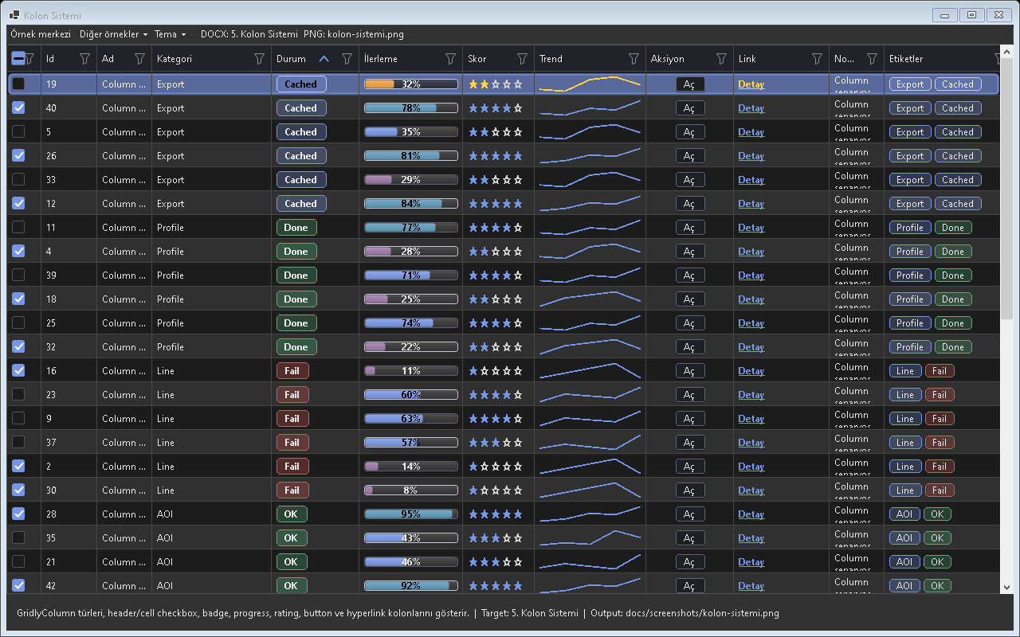
Figure - Column System / Mixed column types

Usage scenarios
- Text column
- Image/Icon column
- Checkbox column
- Progress/Badge column
- Hyperlink column

Best practices
- The feature should be enabled in the default profile or preset according to project needs.
- In line with the Designer-First standard, permanent control layouts should be kept in Designer.cs.
- A release should not be made before theme and localization behavior are tested.
- For large-data scenarios, Virtual Mode or UltraFast Mode should be considered.
- The example for this feature should be easy for the user to find inside Example Center.

Why is it important?
Kolon Sistemi ozelligi Gridly icinde tek basina bir gorsel mod veya davranis degil, uygulama genelinde tekrar eden UI kodunu standartlastiran bir katmandir. Bu sayede farkli projelerde ayni deneyim korunur; Audix, AOI Support Desk, Line Workspace ve Bilge Defter gibi projeler ayni API mantigi ile ilerler.

Points to watch while using it
- Differences between the feature's default behavior and project needs should first be checked in TestApp.
- Dark and Light themes should always be tested with the same data set.
- For screens containing large volumes of data or many visuals, a lazy-loading/cache strategy should be evaluated.
- Texts that need to appear on the user side should come from localization keys.
- Without breaking the Designer.cs standard, permanent controls should remain visible at design time.

Test checklist
- When a filter is applied, does the view show the correct row count?
- When the theme changes, is text, button, and badge contrast sufficient?
- When ViewMode changes, does any old layout cache or row height carry over?
- After saving/loading a profile, are the columns, filters, and view mode preserved?
- Are export or copy outputs consistent with the visible data?

Code examples
grid.Columns.Add(new GridlyColumn { Text = "Kolon", AspectName = "Name", Width = 160 });
grid.Columns.Add(new GridlyColumn { Text = "Kolon", AspectName = "Status", Width = 120 });
grid.Columns.Add(new GridlyColumn { Text = "Kolon", AspectName = "CreatedAt", Width = 140 });
grid.Columns.Add(new GridlyColumn { Text = "Kolon", AspectName = "PreviewImage", Width = 220 });
grid.Columns.Add(new GridlyColumn { Text = "Kolon", AspectName = "Progress", Width = 100 });
Project note: When the Kolon Sistemi feature is used in real projects such as Audix, AOI Support Desk, Line Workspace, or Bilge Defter, it should first be validated with the related example in TestApp.

6. Data Binding
Gridly can work with object lists, BindingSource, DataTable, and a virtual provider.
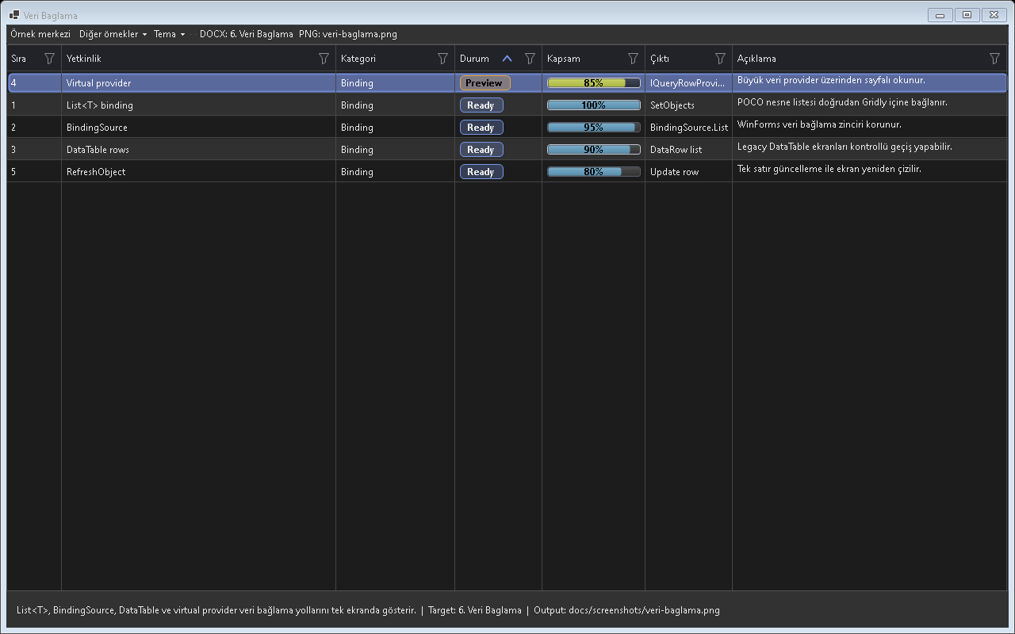
Figure - Data Binding / Binding sources

Usage scenarios
- List<T>
- BindingSource
- DataTable
- VirtualSource
- RefreshObject

Best practices
- The feature should be enabled in the default profile or preset according to project needs.
- In line with the Designer-First standard, permanent control layouts should be kept in Designer.cs.
- A release should not be made before theme and localization behavior are tested.
- For large-data scenarios, Virtual Mode or UltraFast Mode should be considered.
- The example for this feature should be easy for the user to find inside Example Center.

Why is it important?
Veri Baglama ozelligi Gridly icinde tek basina bir gorsel mod veya davranis degil, uygulama genelinde tekrar eden UI kodunu standartlastiran bir katmandir. Bu sayede farkli projelerde ayni deneyim korunur; Audix, AOI Support Desk, Line Workspace ve Bilge Defter gibi projeler ayni API mantigi ile ilerler.

Points to watch while using it
- Differences between the feature's default behavior and project needs should first be checked in TestApp.
- Dark and Light themes should always be tested with the same data set.
- For screens containing large volumes of data or many visuals, a lazy-loading/cache strategy should be evaluated.
- Texts that need to appear on the user side should come from localization keys.
- Without breaking the Designer.cs standard, permanent controls should remain visible at design time.

Test checklist
- When a filter is applied, does the view show the correct row count?
- When the theme changes, is text, button, and badge contrast sufficient?
- When ViewMode changes, does any old layout cache or row height carry over?
- After saving/loading a profile, are the columns, filters, and view mode preserved?
- Are export or copy outputs consistent with the visible data?

Code examples
grid.SetObjects(rows);
grid.SetObjects(bindingSource.List);
grid.SetObjects(tableRows);
grid.SetObjects(await provider.FetchAsync());
grid.SetObjects(filteredRows);
Project note: When the Veri Baglama feature is used in real projects such as Audix, AOI Support Desk, Line Workspace, or Bilge Defter, it should first be validated with the related example in TestApp.

7. Details View
A classic row/column table; ideal for analysis, filtering, and export.
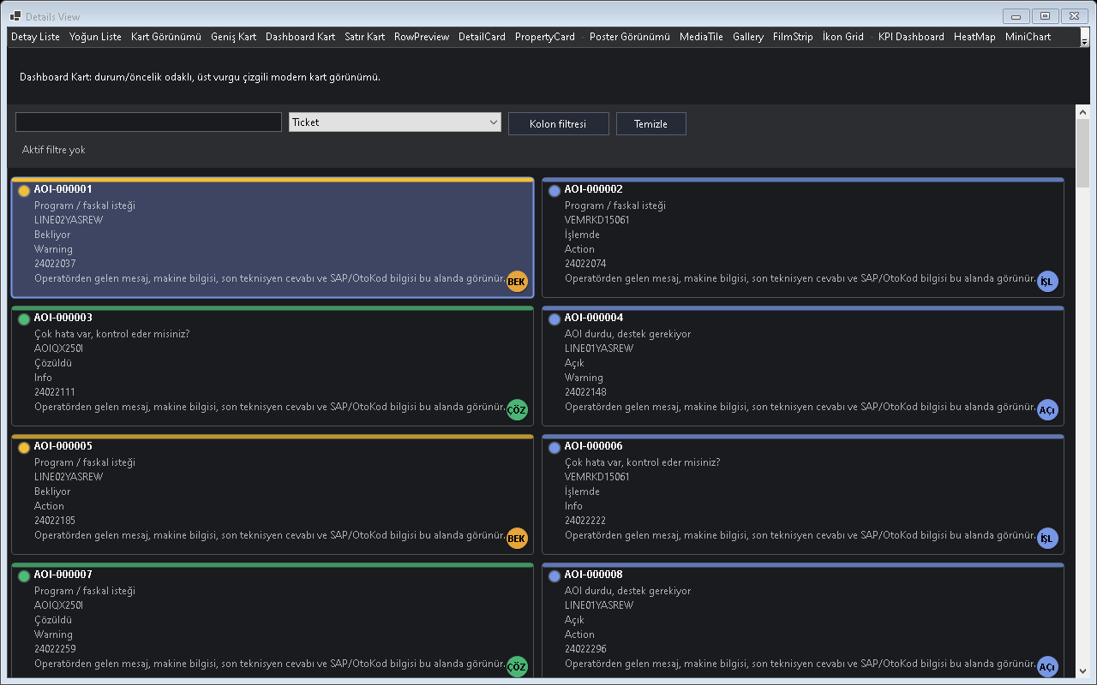
Figure - Details View / Classic table view

Usage scenarios
- Sabit row yuksekligi
- Cell scroll
- Filtre ikonlari
- Sort
- Export

Best practices
- The feature should be enabled in the default profile or preset according to project needs.
- In line with the Designer-First standard, permanent control layouts should be kept in Designer.cs.
- A release should not be made before theme and localization behavior are tested.
- For large-data scenarios, Virtual Mode or UltraFast Mode should be considered.
- The example for this feature should be easy for the user to find inside Example Center.

Why is it important?
Details View ozelligi Gridly icinde tek basina bir gorsel mod veya davranis degil, uygulama genelinde tekrar eden UI kodunu standartlastiran bir katmandir. Bu sayede farkli projelerde ayni deneyim korunur; Audix, AOI Support Desk, Line Workspace ve Bilge Defter gibi projeler ayni API mantigi ile ilerler.

Points to watch while using it
- Differences between the feature's default behavior and project needs should first be checked in TestApp.
- Dark and Light themes should always be tested with the same data set.
- For screens containing large volumes of data or many visuals, a lazy-loading/cache strategy should be evaluated.
- Texts that need to appear on the user side should come from localization keys.
- Without breaking the Designer.cs standard, permanent controls should remain visible at design time.

Test checklist
- When a filter is applied, does the view show the correct row count?
- When the theme changes, is text, button, and badge contrast sufficient?
- When ViewMode changes, does any old layout cache or row height carry over?
- After saving/loading a profile, are the columns, filters, and view mode preserved?
- Are export or copy outputs consistent with the visible data?
Details görünümünde column, satır, filter and seçim davranışı.

Code examples
grid.ViewMode = GridlyViewMode.Details;
grid.ViewMode = GridlyViewMode.Details;
grid.ViewMode = GridlyViewMode.Details;
grid.ViewMode = GridlyViewMode.Details;
grid.ViewMode = GridlyViewMode.Details;
Project note: When the Details View feature is used in real projects such as Audix, AOI Support Desk, Line Workspace, or Bilge Defter, it should first be validated with the related example in TestApp.

8. Card View
Shows records as cards; suitable for ticket, order, and machine screens.
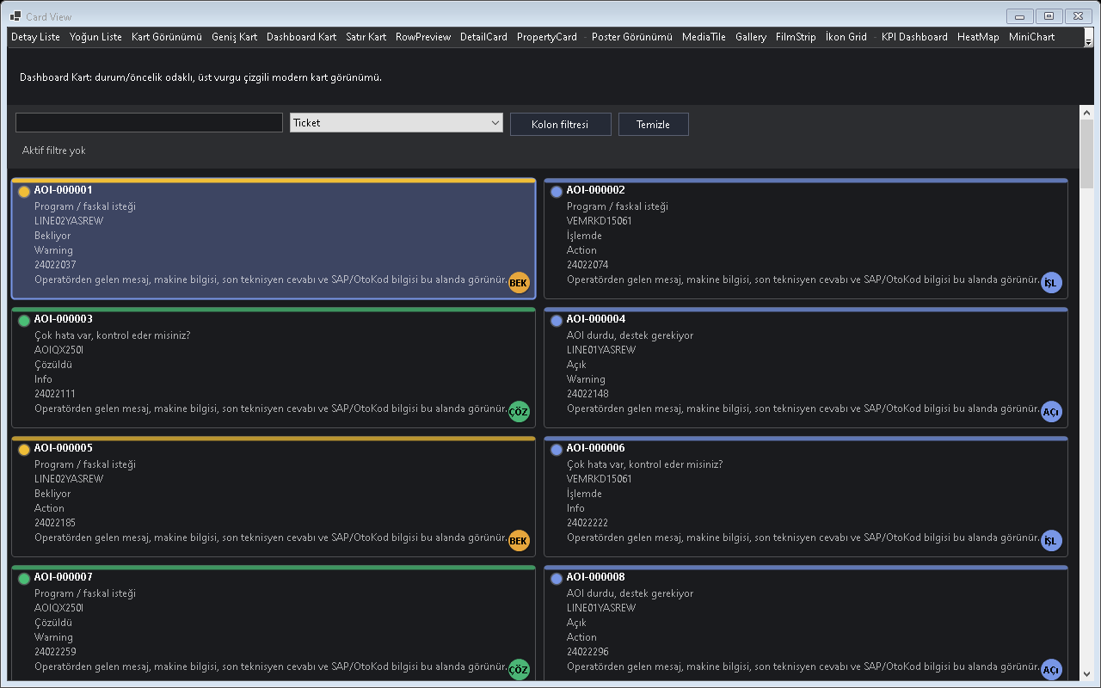
Figure - Card View / Card layout

Usage scenarios
- Accent bar
- Status dot
- Badge
- Action button
- Checkbox

Best practices
- The feature should be enabled in the default profile or preset according to project needs.
- In line with the Designer-First standard, permanent control layouts should be kept in Designer.cs.
- A release should not be made before theme and localization behavior are tested.
- For large-data scenarios, Virtual Mode or UltraFast Mode should be considered.
- The example for this feature should be easy for the user to find inside Example Center.

Why is it important?
Card View ozelligi Gridly icinde tek basina bir gorsel mod veya davranis degil, uygulama genelinde tekrar eden UI kodunu standartlastiran bir katmandir. Bu sayede farkli projelerde ayni deneyim korunur; Audix, AOI Support Desk, Line Workspace ve Bilge Defter gibi projeler ayni API mantigi ile ilerler.

Points to watch while using it
- Differences between the feature's default behavior and project needs should first be checked in TestApp.
- Dark and Light themes should always be tested with the same data set.
- For screens containing large volumes of data or many visuals, a lazy-loading/cache strategy should be evaluated.
- Texts that need to appear on the user side should come from localization keys.
- Without breaking the Designer.cs standard, permanent controls should remain visible at design time.

Test checklist
- When a filter is applied, does the view show the correct row count?
- When the theme changes, is text, button, and badge contrast sufficient?
- When ViewMode changes, does any old layout cache or row height carry over?
- After saving/loading a profile, are the columns, filters, and view mode preserved?
- Are export or copy outputs consistent with the visible data?
CardView ile kayıtların kartlar halinde gösterimi.

DetailCard View - Satır satır detail
DetailCard ile tüm columnların satır satır okunabilir sunumu.

Code examples
grid.ViewMode = GridlyViewMode.Card;
// Ornek 1: Accent bar senaryosu
grid.SetObjects(sampleRows);
grid.Refresh();
grid.ViewMode = GridlyViewMode.Card;
// Ornek 2: Status dot senaryosu
grid.SetObjects(sampleRows);
grid.Refresh();
grid.ViewMode = GridlyViewMode.Card;
// Ornek 3: Badge senaryosu
grid.SetObjects(sampleRows);
grid.Refresh();
grid.ViewMode = GridlyViewMode.Card;
// Ornek 4: Action button senaryosu
grid.SetObjects(sampleRows);
grid.Refresh();
grid.ViewMode = GridlyViewMode.Card;
// Ornek 5: Checkbox senaryosu
grid.SetObjects(sampleRows);
grid.Refresh();
Project note: When the Card View feature is used in real projects such as Audix, AOI Support Desk, Line Workspace, or Bilge Defter, it should first be validated with the related example in TestApp.

9. Dashboard View
A large card-focused view for status, KPI, and operations dashboards.
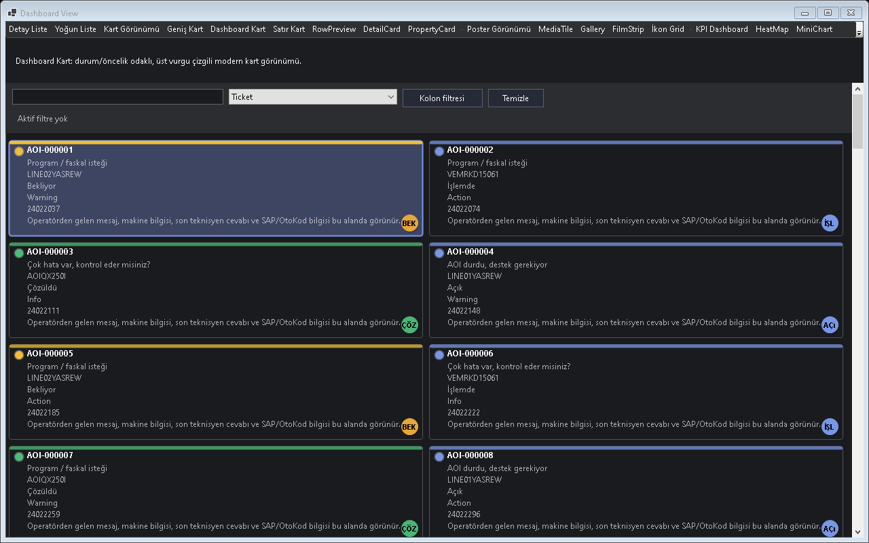
Figure - Dashboard View / Dashboard card layout

Usage scenarios
- Makine panosu
- Ticket panosu
- KPI kartlari
- Status renkleri
- Canli guncelleme

Best practices
- The feature should be enabled in the default profile or preset according to project needs.
- In line with the Designer-First standard, permanent control layouts should be kept in Designer.cs.
- A release should not be made before theme and localization behavior are tested.
- For large-data scenarios, Virtual Mode or UltraFast Mode should be considered.
- The example for this feature should be easy for the user to find inside Example Center.

Why is it important?
Dashboard View ozelligi Gridly icinde tek basina bir gorsel mod veya davranis degil, uygulama genelinde tekrar eden UI kodunu standartlastiran bir katmandir. Bu sayede farkli projelerde ayni deneyim korunur; Audix, AOI Support Desk, Line Workspace ve Bilge Defter gibi projeler ayni API mantigi ile ilerler.

Points to watch while using it
- Differences between the feature's default behavior and project needs should first be checked in TestApp.
- Dark and Light themes should always be tested with the same data set.
- For screens containing large volumes of data or many visuals, a lazy-loading/cache strategy should be evaluated.
- Texts that need to appear on the user side should come from localization keys.
- Without breaking the Designer.cs standard, permanent controls should remain visible at design time.

Test checklist
- When a filter is applied, does the view show the correct row count?
- When the theme changes, is text, button, and badge contrast sufficient?
- When ViewMode changes, does any old layout cache or row height carry over?
- After saving/loading a profile, are the columns, filters, and view mode preserved?
- Are export or copy outputs consistent with the visible data?
Dashboard görünümünde özet, accent bar and durum göstergeleri.

Code examples
grid.ViewMode = GridlyViewMode.Dashboard;
// Ornek 1: Makine panosu senaryosu
grid.SetObjects(sampleRows);
grid.Refresh();
grid.ViewMode = GridlyViewMode.Dashboard;
// Ornek 2: Ticket panosu senaryosu
grid.SetObjects(sampleRows);
grid.Refresh();
grid.ViewMode = GridlyViewMode.Dashboard;
// Ornek 3: KPI kartlari senaryosu
grid.SetObjects(sampleRows);
grid.Refresh();
grid.ViewMode = GridlyViewMode.Dashboard;
// Ornek 4: Status renkleri senaryosu
grid.SetObjects(sampleRows);
grid.Refresh();
grid.ViewMode = GridlyViewMode.Dashboard;
// Ornek 5: Canli guncelleme senaryosu
grid.SetObjects(sampleRows);
grid.Refresh();
Project note: When the Dashboard View feature is used in real projects such as Audix, AOI Support Desk, Line Workspace, or Bilge Defter, it should first be validated with the related example in TestApp.

10. DetailCard View
Shows each record as a full-width detail card.
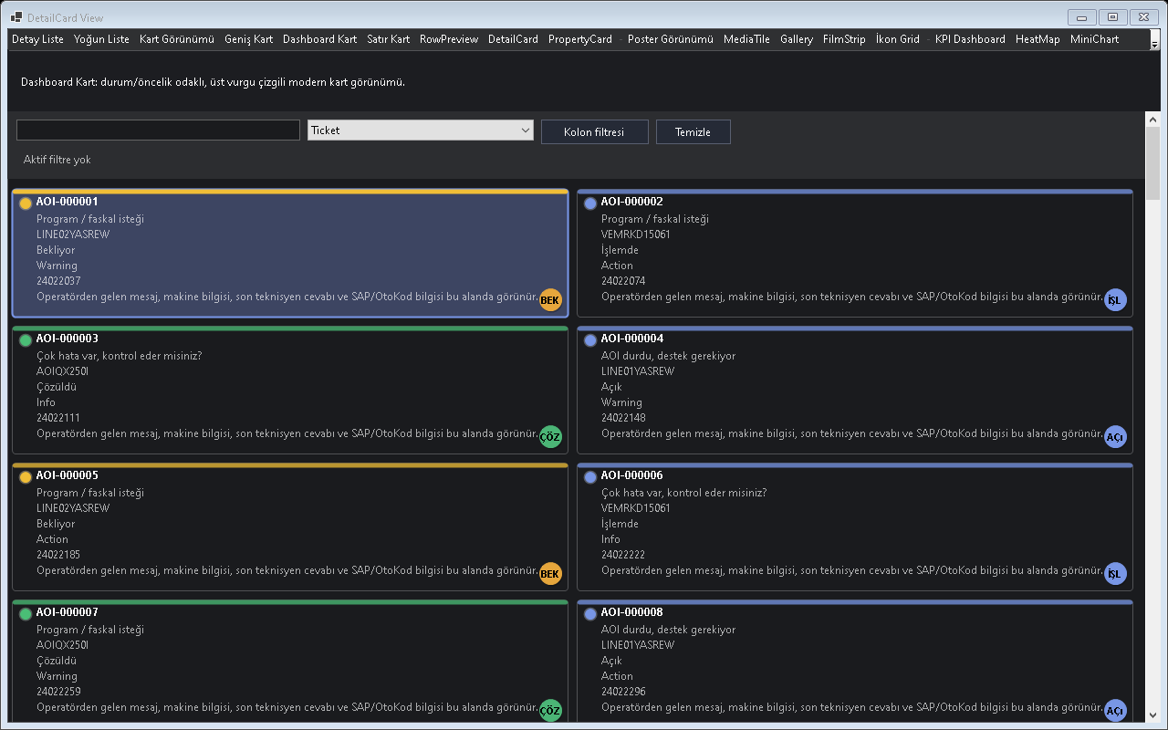
Figure - DetailCard View / Full-width detail card

Usage scenarios
- Ticket detaili
- Servis kaydi
- CRM kaydi
- Kolon basligi goster/gizle
- Tam genislik kart

Best practices
- The feature should be enabled in the default profile or preset according to project needs.
- In line with the Designer-First standard, permanent control layouts should be kept in Designer.cs.
- A release should not be made before theme and localization behavior are tested.
- For large-data scenarios, Virtual Mode or UltraFast Mode should be considered.
- The example for this feature should be easy for the user to find inside Example Center.

Why is it important?
DetailCard View ozelligi Gridly icinde tek basina bir gorsel mod veya davranis degil, uygulama genelinde tekrar eden UI kodunu standartlastiran bir katmandir. Bu sayede farkli projelerde ayni deneyim korunur; Audix, AOI Support Desk, Line Workspace ve Bilge Defter gibi projeler ayni API mantigi ile ilerler.

Points to watch while using it
- Differences between the feature's default behavior and project needs should first be checked in TestApp.
- Dark and Light themes should always be tested with the same data set.
- For screens containing large volumes of data or many visuals, a lazy-loading/cache strategy should be evaluated.
- Texts that need to appear on the user side should come from localization keys.
- Without breaking the Designer.cs standard, permanent controls should remain visible at design time.

Test checklist
- When a filter is applied, does the view show the correct row count?
- When the theme changes, is text, button, and badge contrast sufficient?
- When ViewMode changes, does any old layout cache or row height carry over?
- After saving/loading a profile, are the columns, filters, and view mode preserved?
- Are export or copy outputs consistent with the visible data?

Master Detail - Alt detail
Üst kayıt and alt detail Gridly senaryosu.

Code examples
grid.ViewMode = GridlyViewMode.DetailCard;
// Ornek 1: Ticket detayi senaryosu
grid.SetObjects(sampleRows);
grid.Refresh();
grid.ViewMode = GridlyViewMode.DetailCard;
// Ornek 2: Servis kaydi senaryosu
grid.SetObjects(sampleRows);
grid.Refresh();
grid.ViewMode = GridlyViewMode.DetailCard;
// Ornek 3: CRM kaydi senaryosu
grid.SetObjects(sampleRows);
grid.Refresh();
grid.ViewMode = GridlyViewMode.DetailCard;
// Ornek 4: Kolon basligi goster/gizle senaryosu
grid.SetObjects(sampleRows);
grid.Refresh();
grid.ViewMode = GridlyViewMode.DetailCard;
// Ornek 5: Tam genislik kart senaryosu
grid.SetObjects(sampleRows);
grid.Refresh();
Project note: When the DetailCard View feature is used in real projects such as Audix, AOI Support Desk, Line Workspace, or Bilge Defter, it should first be validated with the related example in TestApp.

11. Poster View
A poster view for visually rich records such as albums, films, products, or documents.
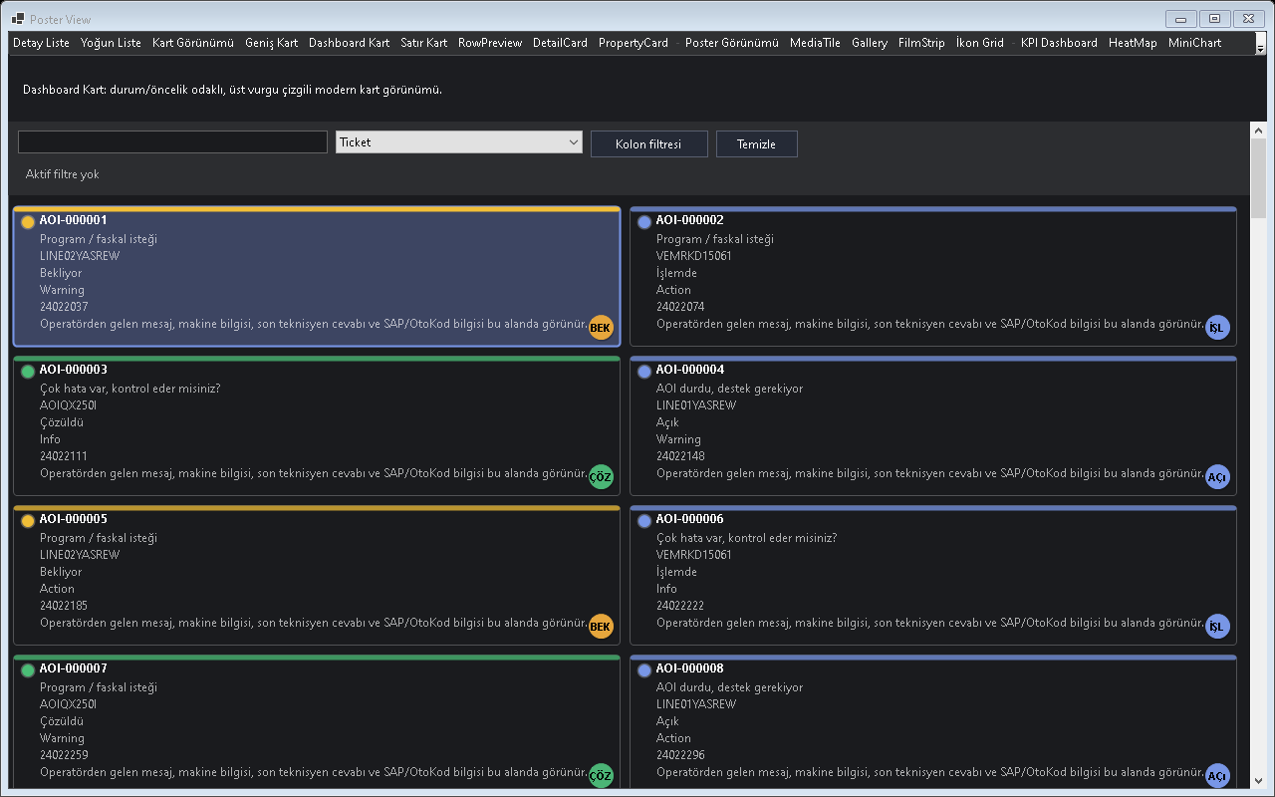
Figure - Poster View / Poster layout

Usage scenarios
- Album kapagi
- Film afisi
- Dokuman onizleme
- Coandr scale mode
- Placeholder

Best practices
- The feature should be enabled in the default profile or preset according to project needs.
- In line with the Designer-First standard, permanent control layouts should be kept in Designer.cs.
- A release should not be made before theme and localization behavior are tested.
- For large-data scenarios, Virtual Mode or UltraFast Mode should be considered.
- The example for this feature should be easy for the user to find inside Example Center.

Why is it important?
Poster View ozelligi Gridly icinde tek basina bir gorsel mod veya davranis degil, uygulama genelinde tekrar eden UI kodunu standartlastiran bir katmandir. Bu sayede farkli projelerde ayni deneyim korunur; Audix, AOI Support Desk, Line Workspace ve Bilge Defter gibi projeler ayni API mantigi ile ilerler.

Points to watch while using it
- Differences between the feature's default behavior and project needs should first be checked in TestApp.
- Dark and Light themes should always be tested with the same data set.
- For screens containing large volumes of data or many visuals, a lazy-loading/cache strategy should be evaluated.
- Texts that need to appear on the user side should come from localization keys.
- Without breaking the Designer.cs standard, permanent controls should remain visible at design time.

Test checklist
- When a filter is applied, does the view show the correct row count?
- When the theme changes, is text, button, and badge contrast sufficient?
- When ViewMode changes, does any old layout cache or row height carry over?
- After saving/loading a profile, are the columns, filters, and view mode preserved?
- Are export or copy outputs consistent with the visible data?
Audix/Plex benzeri albüm kapağı, film afişi and fotoğraf odaklı medya görünümü.
Media Library içinde poster senaryosu.
Albüm, film and ürün posterleri için görsel ağırlıklı görünüm.

Code examples
grid.ViewMode = GridlyViewMode.Poster;
// Ornek 1: Album kapagi senaryosu
grid.SetObjects(sampleRows);
grid.Refresh();
grid.ViewMode = GridlyViewMode.Poster;
// Ornek 2: Film afisi senaryosu
grid.SetObjects(sampleRows);
grid.Refresh();
grid.ViewMode = GridlyViewMode.Poster;
// Ornek 3: Dokuman onizleme senaryosu
grid.SetObjects(sampleRows);
grid.Refresh();
grid.ViewMode = GridlyViewMode.Poster;
// Ornek 4: Cover scale mode senaryosu
grid.SetObjects(sampleRows);
grid.Refresh();
grid.ViewMode = GridlyViewMode.Poster;
// Ornek 5: Placeholder senaryosu
grid.SetObjects(sampleRows);
grid.Refresh();
Project note: When the Poster View feature is used in real projects such as Audix, AOI Support Desk, Line Workspace, or Bilge Defter, it should first be validated with the related example in TestApp.

12. Gallery View
Provides a gallery experience for photos, covers, and visual collections.
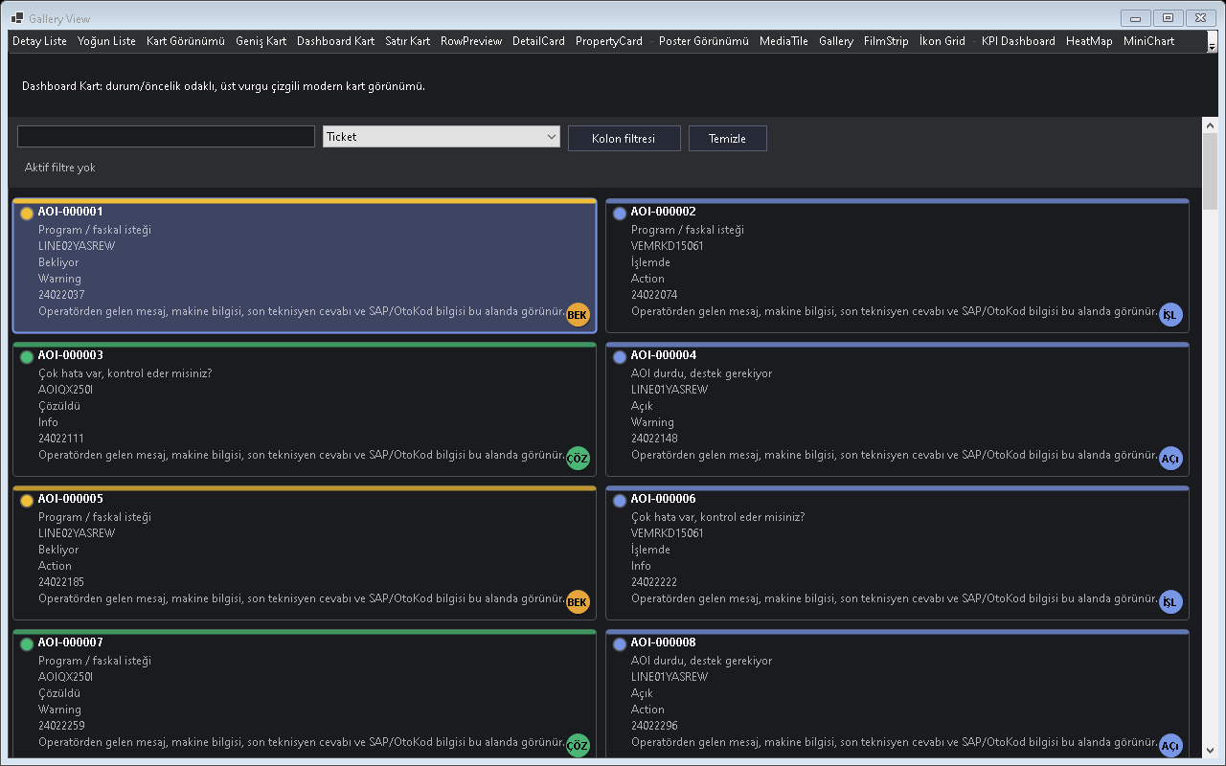
Figure - Gallery View / Gallery layout

Usage scenarios
- Foto album
- Ogrenci fotografi
- AOI hata resmi
- Thumbnail cache
- Lazy loading

Best practices
- The feature should be enabled in the default profile or preset according to project needs.
- In line with the Designer-First standard, permanent control layouts should be kept in Designer.cs.
- A release should not be made before theme and localization behavior are tested.
- For large-data scenarios, Virtual Mode or UltraFast Mode should be considered.
- The example for this feature should be easy for the user to find inside Example Center.

Why is it important?
Gallery View ozelligi Gridly icinde tek basina bir gorsel mod veya davranis degil, uygulama genelinde tekrar eden UI kodunu standartlastiran bir katmandir. Bu sayede farkli projelerde ayni deneyim korunur; Audix, AOI Support Desk, Line Workspace ve Bilge Defter gibi projeler ayni API mantigi ile ilerler.

Points to watch while using it
- Differences between the feature's default behavior and project needs should first be checked in TestApp.
- Dark and Light themes should always be tested with the same data set.
- For screens containing large volumes of data or many visuals, a lazy-loading/cache strategy should be evaluated.
- Texts that need to appear on the user side should come from localization keys.
- Without breaking the Designer.cs standard, permanent controls should remain visible at design time.

Test checklist
- When a filter is applied, does the view show the correct row count?
- When the theme changes, is text, button, and badge contrast sufficient?
- When ViewMode changes, does any old layout cache or row height carry over?
- After saving/loading a profile, are the columns, filters, and view mode preserved?
- Are export or copy outputs consistent with the visible data?
Media Library içinde galeri senaryosu.
Fotoğraf, kapak and katalog galerisi görünümü.

Code examples
grid.ViewMode = GridlyViewMode.Gallery;
// Ornek 1: Foto album senaryosu
grid.SetObjects(sampleRows);
grid.Refresh();
grid.ViewMode = GridlyViewMode.Gallery;
// Ornek 2: Ogrenci fotografi senaryosu
grid.SetObjects(sampleRows);
grid.Refresh();
grid.ViewMode = GridlyViewMode.Gallery;
// Ornek 3: AOI hata resmi senaryosu
grid.SetObjects(sampleRows);
grid.Refresh();
grid.ViewMode = GridlyViewMode.Gallery;
// Ornek 4: Thumbnail cache senaryosu
grid.SetObjects(sampleRows);
grid.Refresh();
grid.ViewMode = GridlyViewMode.Gallery;
// Ornek 5: Lazy loading senaryosu
grid.SetObjects(sampleRows);
grid.Refresh();
Project note: When the Gallery View feature is used in real projects such as Audix, AOI Support Desk, Line Workspace, or Bilge Defter, it should first be validated with the related example in TestApp.

13. MediaTile View
Provides compact media cards similar to Spotify.
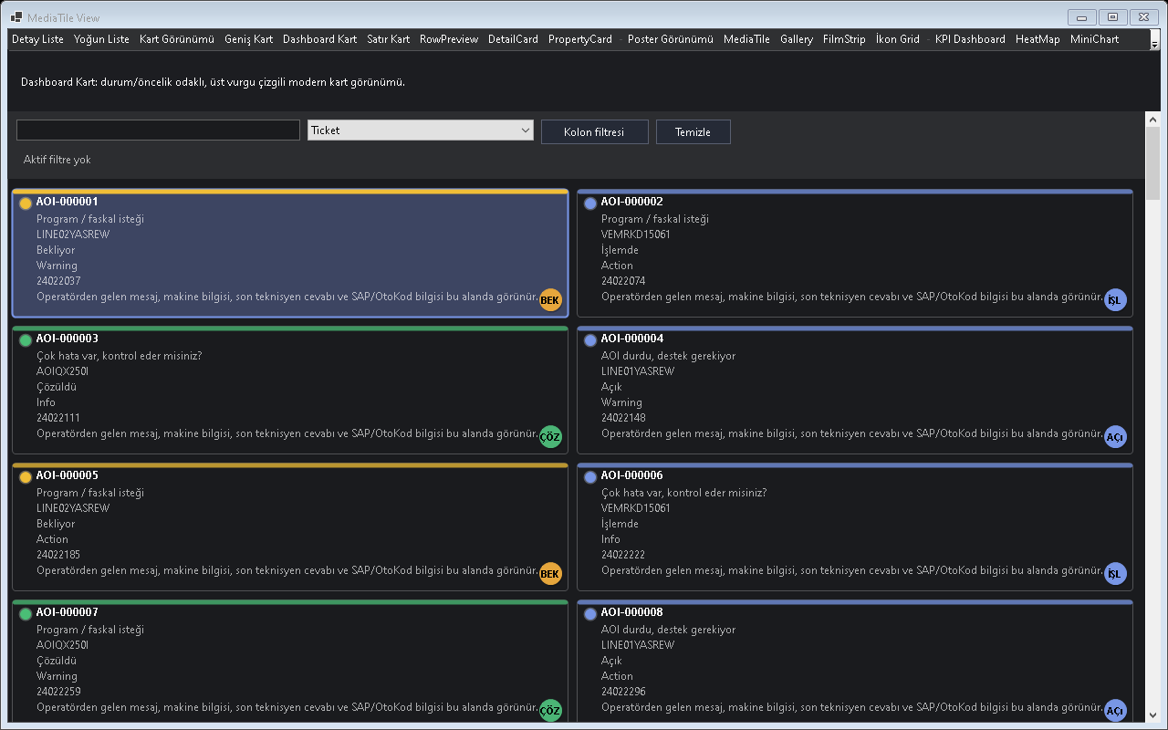
Figure - MediaTile View / Media tile layout

Usage scenarios
- Album tile
- Artist tile
- Play oandrlay
- Now playing
- Badge

Best practices
- The feature should be enabled in the default profile or preset according to project needs.
- In line with the Designer-First standard, permanent control layouts should be kept in Designer.cs.
- A release should not be made before theme and localization behavior are tested.
- For large-data scenarios, Virtual Mode or UltraFast Mode should be considered.
- The example for this feature should be easy for the user to find inside Example Center.

Why is it important?
MediaTile View ozelligi Gridly icinde tek basina bir gorsel mod veya davranis degil, uygulama genelinde tekrar eden UI kodunu standartlastiran bir katmandir. Bu sayede farkli projelerde ayni deneyim korunur; Audix, AOI Support Desk, Line Workspace ve Bilge Defter gibi projeler ayni API mantigi ile ilerler.

Points to watch while using it
- Differences between the feature's default behavior and project needs should first be checked in TestApp.
- Dark and Light themes should always be tested with the same data set.
- For screens containing large volumes of data or many visuals, a lazy-loading/cache strategy should be evaluated.
- Texts that need to appear on the user side should come from localization keys.
- Without breaking the Designer.cs standard, permanent controls should remain visible at design time.

Test checklist
- When a filter is applied, does the view show the correct row count?
- When the theme changes, is text, button, and badge contrast sufficient?
- When ViewMode changes, does any old layout cache or row height carry over?
- After saving/loading a profile, are the columns, filters, and view mode preserved?
- Are export or copy outputs consistent with the visible data?
Media Library içinde MediaTile senaryosu.
Spotify/Plex benzeri kompakt medya kartları.

Code examples
grid.ViewMode = GridlyViewMode.MediaTile;
// Ornek 1: Album tile senaryosu
grid.SetObjects(sampleRows);
grid.Refresh();
grid.ViewMode = GridlyViewMode.MediaTile;
// Ornek 2: Artist tile senaryosu
grid.SetObjects(sampleRows);
grid.Refresh();
grid.ViewMode = GridlyViewMode.MediaTile;
// Ornek 3: Play overlay senaryosu
grid.SetObjects(sampleRows);
grid.Refresh();
grid.ViewMode = GridlyViewMode.MediaTile;
// Ornek 4: Now playing senaryosu
grid.SetObjects(sampleRows);
grid.Refresh();
grid.ViewMode = GridlyViewMode.MediaTile;
// Ornek 5: Badge senaryosu
grid.SetObjects(sampleRows);
grid.Refresh();
Project note: When the MediaTile View feature is used in real projects such as Audix, AOI Support Desk, Line Workspace, or Bilge Defter, it should first be validated with the related example in TestApp.

14. FilmStrip View
A horizontal media-strip view similar to Netflix/Plex.
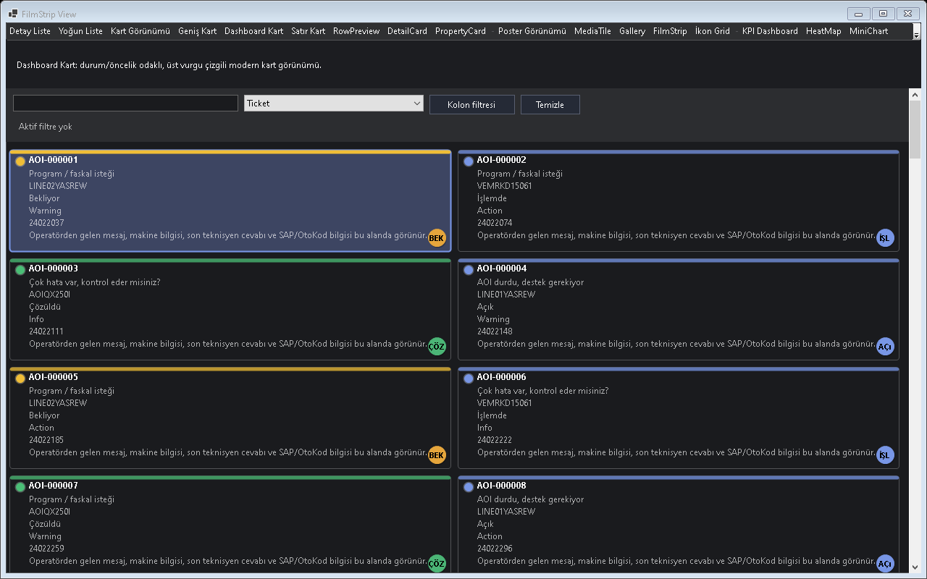
Figure - FilmStrip View / Horizontal media strip

Usage scenarios
- Film listesi
- Album seridi
- Preview
- Horizontal scroll
- Video tile

Best practices
- The feature should be enabled in the default profile or preset according to project needs.
- In line with the Designer-First standard, permanent control layouts should be kept in Designer.cs.
- A release should not be made before theme and localization behavior are tested.
- For large-data scenarios, Virtual Mode or UltraFast Mode should be considered.
- The example for this feature should be easy for the user to find inside Example Center.

Why is it important?
FilmStrip View ozelligi Gridly icinde tek basina bir gorsel mod veya davranis degil, uygulama genelinde tekrar eden UI kodunu standartlastiran bir katmandir. Bu sayede farkli projelerde ayni deneyim korunur; Audix, AOI Support Desk, Line Workspace ve Bilge Defter gibi projeler ayni API mantigi ile ilerler.

Points to watch while using it
- Differences between the feature's default behavior and project needs should first be checked in TestApp.
- Dark and Light themes should always be tested with the same data set.
- For screens containing large volumes of data or many visuals, a lazy-loading/cache strategy should be evaluated.
- Texts that need to appear on the user side should come from localization keys.
- Without breaking the Designer.cs standard, permanent controls should remain visible at design time.

Test checklist
- When a filter is applied, does the view show the correct row count?
- When the theme changes, is text, button, and badge contrast sufficient?
- When ViewMode changes, does any old layout cache or row height carry over?
- After saving/loading a profile, are the columns, filters, and view mode preserved?
- Are export or copy outputs consistent with the visible data?
Media Library içinde FilmStrip senaryosu.
Netflix benzeri yatay medya şeridi görünümü.

Code examples
grid.ViewMode = GridlyViewMode.FilmStrip;
// Ornek 1: Film listesi senaryosu
grid.SetObjects(sampleRows);
grid.Refresh();
grid.ViewMode = GridlyViewMode.FilmStrip;
// Ornek 2: Album seridi senaryosu
grid.SetObjects(sampleRows);
grid.Refresh();
grid.ViewMode = GridlyViewMode.FilmStrip;
// Ornek 3: Preview senaryosu
grid.SetObjects(sampleRows);
grid.Refresh();
grid.ViewMode = GridlyViewMode.FilmStrip;
// Ornek 4: Horizontal scroll senaryosu
grid.SetObjects(sampleRows);
grid.Refresh();
grid.ViewMode = GridlyViewMode.FilmStrip;
// Ornek 5: Video tile senaryosu
grid.SetObjects(sampleRows);
grid.Refresh();
Project note: When the FilmStrip View feature is used in real projects such as Audix, AOI Support Desk, Line Workspace, or Bilge Defter, it should first be validated with the related example in TestApp.

15. PropertyCard View
Shows object properties as readable cards or in a property-grid style.
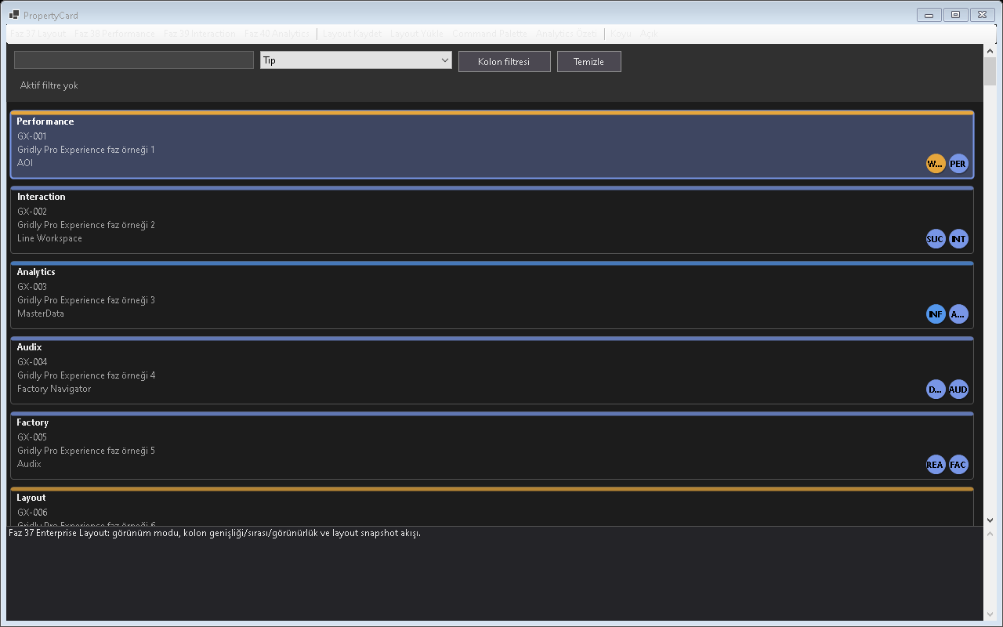
Figure - PropertyCard View / Property card

Usage scenarios
- Makine detaili
- User profile
- Ticket properties
- Read-only view
- Edit view

Best practices
- The feature should be enabled in the default profile or preset according to project needs.
- In line with the Designer-First standard, permanent control layouts should be kept in Designer.cs.
- A release should not be made before theme and localization behavior are tested.
- For large-data scenarios, Virtual Mode or UltraFast Mode should be considered.
- The example for this feature should be easy for the user to find inside Example Center.

Why is it important?
PropertyCard View ozelligi Gridly icinde tek basina bir gorsel mod veya davranis degil, uygulama genelinde tekrar eden UI kodunu standartlastiran bir katmandir. Bu sayede farkli projelerde ayni deneyim korunur; Audix, AOI Support Desk, Line Workspace ve Bilge Defter gibi projeler ayni API mantigi ile ilerler.

Points to watch while using it
- Differences between the feature's default behavior and project needs should first be checked in TestApp.
- Dark and Light themes should always be tested with the same data set.
- For screens containing large volumes of data or many visuals, a lazy-loading/cache strategy should be evaluated.
- Texts that need to appear on the user side should come from localization keys.
- Without breaking the Designer.cs standard, permanent controls should remain visible at design time.

Test checklist
- When a filter is applied, does the view show the correct row count?
- When the theme changes, is text, button, and badge contrast sufficient?
- When ViewMode changes, does any old layout cache or row height carry over?
- After saving/loading a profile, are the columns, filters, and view mode preserved?
- Are export or copy outputs consistent with the visible data?

PropertyCard - Property card
Nesne özelliklerinin okunabilir kart biçiminde sunumu.

Code examples
grid.ViewMode = GridlyViewMode.PropertyCard;
// Ornek 1: Makine detayi senaryosu
grid.SetObjects(sampleRows);
grid.Refresh();
grid.ViewMode = GridlyViewMode.PropertyCard;
// Ornek 2: User profile senaryosu
grid.SetObjects(sampleRows);
grid.Refresh();
grid.ViewMode = GridlyViewMode.PropertyCard;
// Ornek 3: Ticket properties senaryosu
grid.SetObjects(sampleRows);
grid.Refresh();
grid.ViewMode = GridlyViewMode.PropertyCard;
// Ornek 4: Read-only view senaryosu
grid.SetObjects(sampleRows);
grid.Refresh();
grid.ViewMode = GridlyViewMode.PropertyCard;
// Ornek 5: Edit view senaryosu
grid.SetObjects(sampleRows);
grid.Refresh();
Project note: When the PropertyCard View feature is used in real projects such as Audix, AOI Support Desk, Line Workspace, or Bilge Defter, it should first be validated with the related example in TestApp.

16. GroupCard View
Shows grouped records as card groups.
Screenshot note: The available GroupCard screen did not clearly represent a real grouped-card container structure, so it was removed pending a verified replacement.

Usage scenarios
- Artist album grouping
- Line machine grouping
- Status grouping
- Collapse groups
- Group summary

Best practices
- The feature should be enabled in the default profile or preset according to project needs.
- In line with the Designer-First standard, permanent control layouts should be kept in Designer.cs.
- A release should not be made before theme and localization behavior are tested.
- For large-data scenarios, Virtual Mode or UltraFast Mode should be considered.
- The example for this feature should be easy for the user to find inside Example Center.

Why is it important?
GroupCard View ozelligi Gridly icinde tek basina bir gorsel mod veya davranis degil, uygulama genelinde tekrar eden UI kodunu standartlastiran bir katmandir. Bu sayede farkli projelerde ayni deneyim korunur; Audix, AOI Support Desk, Line Workspace ve Bilge Defter gibi projeler ayni API mantigi ile ilerler.

Points to watch while using it
- Differences between the feature's default behavior and project needs should first be checked in TestApp.
- Dark and Light themes should always be tested with the same data set.
- For screens containing large volumes of data or many visuals, a lazy-loading/cache strategy should be evaluated.
- Texts that need to appear on the user side should come from localization keys.
- Without breaking the Designer.cs standard, permanent controls should remain visible at design time.

Test checklist
- When a filter is applied, does the view show the correct row count?
- When the theme changes, is text, button, and badge contrast sufficient?
- When ViewMode changes, does any old layout cache or row height carry over?
- After saving/loading a profile, are the columns, filters, and view mode preserved?
- Are export or copy outputs consistent with the visible data?
Gruplu kart and kategori bazlı sunum senaryosu.

Code examples
grid.ViewMode = GridlyViewMode.GroupCard;
// Ornek 1: Artist album grouping senaryosu
grid.SetObjects(sampleRows);
grid.Refresh();
grid.ViewMode = GridlyViewMode.GroupCard;
// Ornek 2: Line machine grouping senaryosu
grid.SetObjects(sampleRows);
grid.Refresh();
grid.ViewMode = GridlyViewMode.GroupCard;
// Ornek 3: Status grouping senaryosu
grid.SetObjects(sampleRows);
grid.Refresh();
grid.ViewMode = GridlyViewMode.GroupCard;
// Ornek 4: Collapse groups senaryosu
grid.SetObjects(sampleRows);
grid.Refresh();
grid.ViewMode = GridlyViewMode.GroupCard;
// Ornek 5: Group summary senaryosu
grid.SetObjects(sampleRows);
grid.Refresh();
Project note: When the GroupCard View feature is used in real projects such as Audix, AOI Support Desk, Line Workspace, or Bilge Defter, it should first be validated with the related example in TestApp.

17. Kanban View
Used to manage workflow in columns.
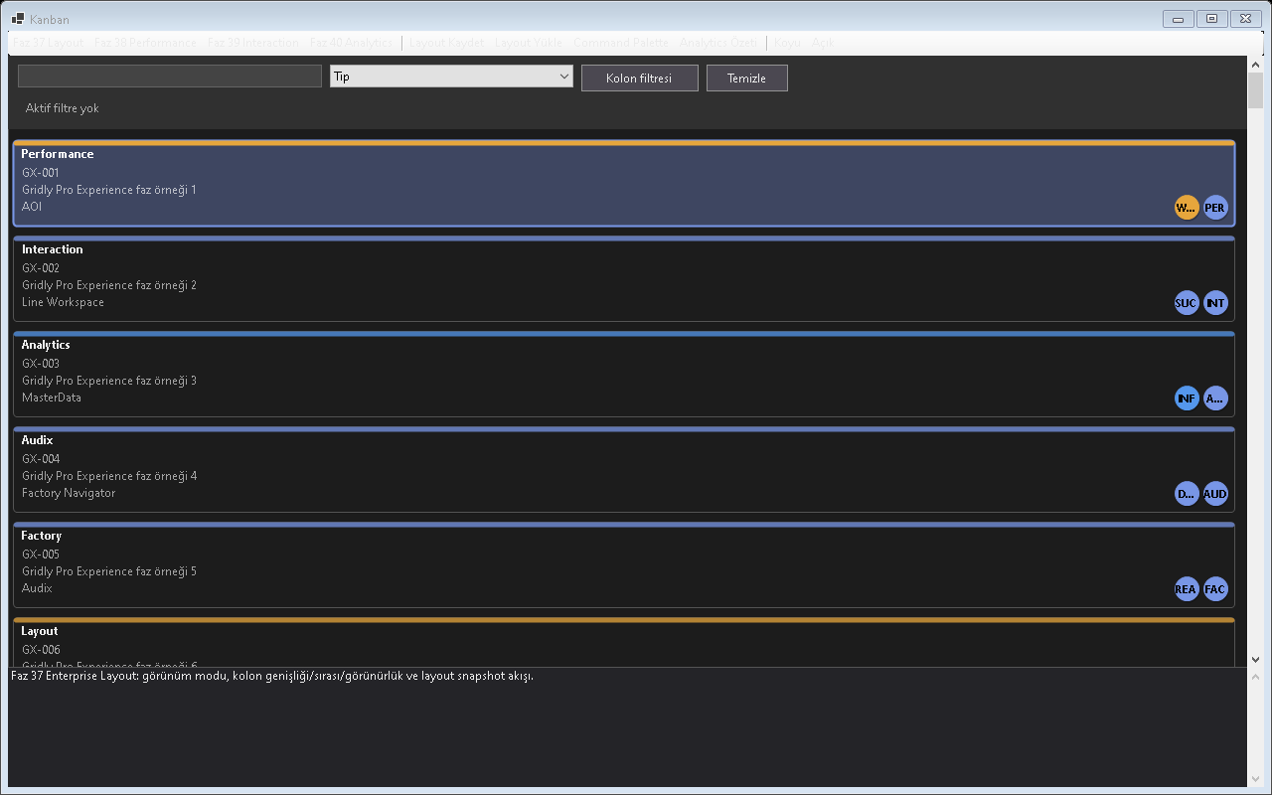
Figure - Kanban View / Workflow board

Usage scenarios
- Yeni/Bekleyen/Islemde
- Drag drop
- SLA badge
- Column count
- Workflow action

Best practices
- The feature should be enabled in the default profile or preset according to project needs.
- In line with the Designer-First standard, permanent control layouts should be kept in Designer.cs.
- A release should not be made before theme and localization behavior are tested.
- For large-data scenarios, Virtual Mode or UltraFast Mode should be considered.
- The example for this feature should be easy for the user to find inside Example Center.

Why is it important?
Kanban View ozelligi Gridly icinde tek basina bir gorsel mod veya davranis degil, uygulama genelinde tekrar eden UI kodunu standartlastiran bir katmandir. Bu sayede farkli projelerde ayni deneyim korunur; Audix, AOI Support Desk, Line Workspace ve Bilge Defter gibi projeler ayni API mantigi ile ilerler.

Points to watch while using it
- Differences between the feature's default behavior and project needs should first be checked in TestApp.
- Dark and Light themes should always be tested with the same data set.
- For screens containing large volumes of data or many visuals, a lazy-loading/cache strategy should be evaluated.
- Texts that need to appear on the user side should come from localization keys.
- Without breaking the Designer.cs standard, permanent controls should remain visible at design time.

Test checklist
- When a filter is applied, does the view show the correct row count?
- When the theme changes, is text, button, and badge contrast sufficient?
- When ViewMode changes, does any old layout cache or row height carry over?
- After saving/loading a profile, are the columns, filters, and view mode preserved?
- Are export or copy outputs consistent with the visible data?
Durum columnları and iş akışı kartları.

Code examples
grid.ViewMode = GridlyViewMode.Kanban;
// Ornek 1: Yeni/Bekleyen/Islemde senaryosu
grid.SetObjects(sampleRows);
grid.Refresh();
grid.ViewMode = GridlyViewMode.Kanban;
// Ornek 2: Drag drop senaryosu
grid.SetObjects(sampleRows);
grid.Refresh();
grid.ViewMode = GridlyViewMode.Kanban;
// Ornek 3: SLA badge senaryosu
grid.SetObjects(sampleRows);
grid.Refresh();
grid.ViewMode = GridlyViewMode.Kanban;
// Ornek 4: Column count senaryosu
grid.SetObjects(sampleRows);
grid.Refresh();
grid.ViewMode = GridlyViewMode.Kanban;
// Ornek 5: Workflow action senaryosu
grid.SetObjects(sampleRows);
grid.Refresh();
Project note: When the Kanban View feature is used in real projects such as Audix, AOI Support Desk, Line Workspace, or Bilge Defter, it should first be validated with the related example in TestApp.

18. HeatMap View
Shows density, performance, alarms, and utilization using colors.
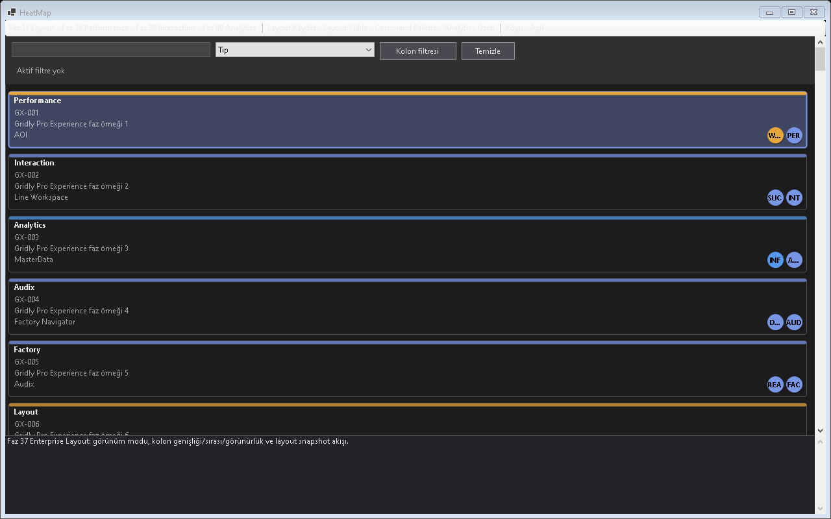
Figure - HeatMap View / Heat map layout

Usage scenarios
- Machine utilization
- Alarm density
- Ticket age
- Production loss
- Quality heat

Best practices
- The feature should be enabled in the default profile or preset according to project needs.
- In line with the Designer-First standard, permanent control layouts should be kept in Designer.cs.
- A release should not be made before theme and localization behavior are tested.
- For large-data scenarios, Virtual Mode or UltraFast Mode should be considered.
- The example for this feature should be easy for the user to find inside Example Center.

Why is it important?
HeatMap View ozelligi Gridly icinde tek basina bir gorsel mod veya davranis degil, uygulama genelinde tekrar eden UI kodunu standartlastiran bir katmandir. Bu sayede farkli projelerde ayni deneyim korunur; Audix, AOI Support Desk, Line Workspace ve Bilge Defter gibi projeler ayni API mantigi ile ilerler.

Points to watch while using it
- Differences between the feature's default behavior and project needs should first be checked in TestApp.
- Dark and Light themes should always be tested with the same data set.
- For screens containing large volumes of data or many visuals, a lazy-loading/cache strategy should be evaluated.
- Texts that need to appear on the user side should come from localization keys.
- Without breaking the Designer.cs standard, permanent controls should remain visible at design time.

Test checklist
- When a filter is applied, does the view show the correct row count?
- When the theme changes, is text, button, and badge contrast sufficient?
- When ViewMode changes, does any old layout cache or row height carry over?
- After saving/loading a profile, are the columns, filters, and view mode preserved?
- Are export or copy outputs consistent with the visible data?
Alarm, üretim andya metrik yoğunluğunu renklerle gösterme.

Code examples
grid.ViewMode = GridlyViewMode.HeatMap;
// Ornek 1: Machine utilization senaryosu
grid.SetObjects(sampleRows);
grid.Refresh();
grid.ViewMode = GridlyViewMode.HeatMap;
// Ornek 2: Alarm density senaryosu
grid.SetObjects(sampleRows);
grid.Refresh();
grid.ViewMode = GridlyViewMode.HeatMap;
// Ornek 3: Ticket age senaryosu
grid.SetObjects(sampleRows);
grid.Refresh();
grid.ViewMode = GridlyViewMode.HeatMap;
// Ornek 4: Production loss senaryosu
grid.SetObjects(sampleRows);
grid.Refresh();
grid.ViewMode = GridlyViewMode.HeatMap;
// Ornek 5: Quality heat senaryosu
grid.SetObjects(sampleRows);
grid.Refresh();
Project note: When the HeatMap View feature is used in real projects such as Audix, AOI Support Desk, Line Workspace, or Bilge Defter, it should first be validated with the related example in TestApp.

19. KPI Dashboard
Shows numerical metrics as summary cards.
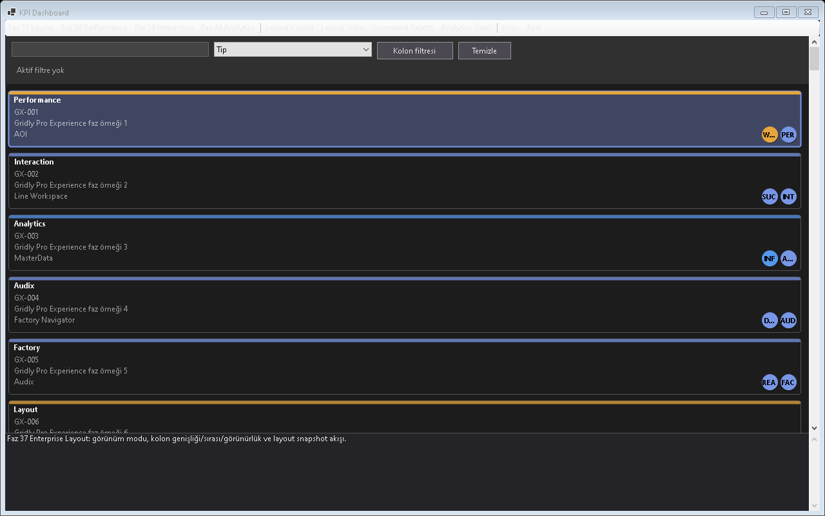
Figure - KPI Dashboard / KPI card layout

Usage scenarios
- Open tickets
- OEE
- MTTR
- Yield
- Daily output

Best practices
- The feature should be enabled in the default profile or preset according to project needs.
- In line with the Designer-First standard, permanent control layouts should be kept in Designer.cs.
- A release should not be made before theme and localization behavior are tested.
- For large-data scenarios, Virtual Mode or UltraFast Mode should be considered.
- The example for this feature should be easy for the user to find inside Example Center.

Why is it important?
KPI Dashboard ozelligi Gridly icinde tek basina bir gorsel mod veya davranis degil, uygulama genelinde tekrar eden UI kodunu standartlastiran bir katmandir. Bu sayede farkli projelerde ayni deneyim korunur; Audix, AOI Support Desk, Line Workspace ve Bilge Defter gibi projeler ayni API mantigi ile ilerler.

Points to watch while using it
- Differences between the feature's default behavior and project needs should first be checked in TestApp.
- Dark and Light themes should always be tested with the same data set.
- For screens containing large volumes of data or many visuals, a lazy-loading/cache strategy should be evaluated.
- Texts that need to appear on the user side should come from localization keys.
- Without breaking the Designer.cs standard, permanent controls should remain visible at design time.

Test checklist
- When a filter is applied, does the view show the correct row count?
- When the theme changes, is text, button, and badge contrast sufficient?
- When ViewMode changes, does any old layout cache or row height carry over?
- After saving/loading a profile, are the columns, filters, and view mode preserved?
- Are export or copy outputs consistent with the visible data?
Footer summary, aggregation and sayısal özetler.
Özet metrik kartları and dashboard göstergeleri.

Code examples
grid.ViewMode = GridlyViewMode.KpiDashboard;
// Ornek 1: Open tickets senaryosu
grid.SetObjects(sampleRows);
grid.Refresh();
grid.ViewMode = GridlyViewMode.KpiDashboard;
// Ornek 2: OEE senaryosu
grid.SetObjects(sampleRows);
grid.Refresh();
grid.ViewMode = GridlyViewMode.KpiDashboard;
// Ornek 3: MTTR senaryosu
grid.SetObjects(sampleRows);
grid.Refresh();
grid.ViewMode = GridlyViewMode.KpiDashboard;
// Ornek 4: Yield senaryosu
grid.SetObjects(sampleRows);
grid.Refresh();
grid.ViewMode = GridlyViewMode.KpiDashboard;
// Ornek 5: Daily output senaryosu
grid.SetObjects(sampleRows);
grid.Refresh();
Project note: When the KPI Dashboard feature is used in real projects such as Audix, AOI Support Desk, Line Workspace, or Bilge Defter, it should first be validated with the related example in TestApp.

20. MiniChart Columns
Shows small trend or sparkline charts within a row.
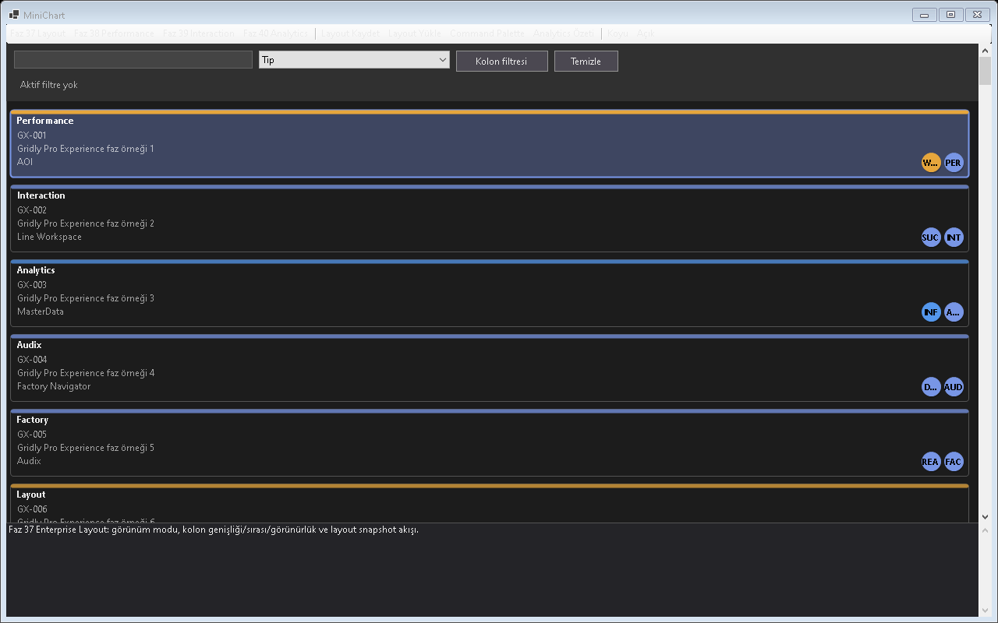
Figure - MiniChart Columns / Inline mini charts

Usage scenarios
- Trend
- Daily count
- Alarm curand
- Production curand
- Quality curand

Best practices
- The feature should be enabled in the default profile or preset according to project needs.
- In line with the Designer-First standard, permanent control layouts should be kept in Designer.cs.
- A release should not be made before theme and localization behavior are tested.
- For large-data scenarios, Virtual Mode or UltraFast Mode should be considered.
- The example for this feature should be easy for the user to find inside Example Center.

Why is it important?
MiniChart Columns ozelligi Gridly icinde tek basina bir gorsel mod veya davranis degil, uygulama genelinde tekrar eden UI kodunu standartlastiran bir katmandir. Bu sayede farkli projelerde ayni deneyim korunur; Audix, AOI Support Desk, Line Workspace ve Bilge Defter gibi projeler ayni API mantigi ile ilerler.

Points to watch while using it
- Differences between the feature's default behavior and project needs should first be checked in TestApp.
- Dark and Light themes should always be tested with the same data set.
- For screens containing large volumes of data or many visuals, a lazy-loading/cache strategy should be evaluated.
- Texts that need to appear on the user side should come from localization keys.
- Without breaking the Designer.cs standard, permanent controls should remain visible at design time.

Test checklist
- When a filter is applied, does the view show the correct row count?
- When the theme changes, is text, button, and badge contrast sufficient?
- When ViewMode changes, does any old layout cache or row height carry over?
- After saving/loading a profile, are the columns, filters, and view mode preserved?
- Are export or copy outputs consistent with the visible data?
Satır içinde mini grafik and trend gösterimi.

Code examples
grid.ViewMode = GridlyViewMode.MiniChart;
// Ornek 1: Trend senaryosu
grid.SetObjects(sampleRows);
grid.Refresh();
grid.ViewMode = GridlyViewMode.MiniChart;
// Ornek 2: Daily count senaryosu
grid.SetObjects(sampleRows);
grid.Refresh();
grid.ViewMode = GridlyViewMode.MiniChart;
// Ornek 3: Alarm curve senaryosu
grid.SetObjects(sampleRows);
grid.Refresh();
grid.ViewMode = GridlyViewMode.MiniChart;
// Ornek 4: Production curve senaryosu
grid.SetObjects(sampleRows);
grid.Refresh();
grid.ViewMode = GridlyViewMode.MiniChart;
// Ornek 5: Quality curve senaryosu
grid.SetObjects(sampleRows);
grid.Refresh();
Project note: When the MiniChart Columns feature is used in real projects such as Audix, AOI Support Desk, Line Workspace, or Bilge Defter, it should first be validated with the related example in TestApp.

21. Filtreleme Sistemi
Includes header filters, popup/window filters, and active filter summaries.

Usage scenarios
- Popup filter
- Window filter
- Filter chips
- Resizable popup
- Filter summary

Best practices
- The feature should be enabled in the default profile or preset according to project needs.
- In line with the Designer-First standard, permanent control layouts should be kept in Designer.cs.
- A release should not be made before theme and localization behavior are tested.
- For large-data scenarios, Virtual Mode or UltraFast Mode should be considered.
- The example for this feature should be easy for the user to find inside Example Center.

Why is it important?
Filtreleme Sistemi ozelligi Gridly icinde tek basina bir gorsel mod veya davranis degil, uygulama genelinde tekrar eden UI kodunu standartlastiran bir katmandir. Bu sayede farkli projelerde ayni deneyim korunur; Audix, AOI Support Desk, Line Workspace ve Bilge Defter gibi projeler ayni API mantigi ile ilerler.

Points to watch while using it
- Differences between the feature's default behavior and project needs should first be checked in TestApp.
- Dark and Light themes should always be tested with the same data set.
- For screens containing large volumes of data or many visuals, a lazy-loading/cache strategy should be evaluated.
- Texts that need to appear on the user side should come from localization keys.
- Without breaking the Designer.cs standard, permanent controls should remain visible at design time.

Test checklist
- When a filter is applied, does the view show the correct row count?
- When the theme changes, is text, button, and badge contrast sufficient?
- When ViewMode changes, does any old layout cache or row height carry over?
- After saving/loading a profile, are the columns, filters, and view mode preserved?
- Are export or copy outputs consistent with the visible data?
Kolon filter popup davranışı.
Uzun değerler, tooltip and genişletilebilir popup davranışı.
Popup boyutlandırma and hatırlama davranışı.

Code examples
grid.UseFiltering = true;
grid.UseFiltering = true;
grid.UseFiltering = true;
grid.UseFiltering = true;
grid.UseFiltering = true;
Project note: When the Filtreleme Sistemi feature is used in real projects such as Audix, AOI Support Desk, Line Workspace, or Bilge Defter, it should first be validated with the related example in TestApp.

22. Query Language
Allows power users to write filters as text.
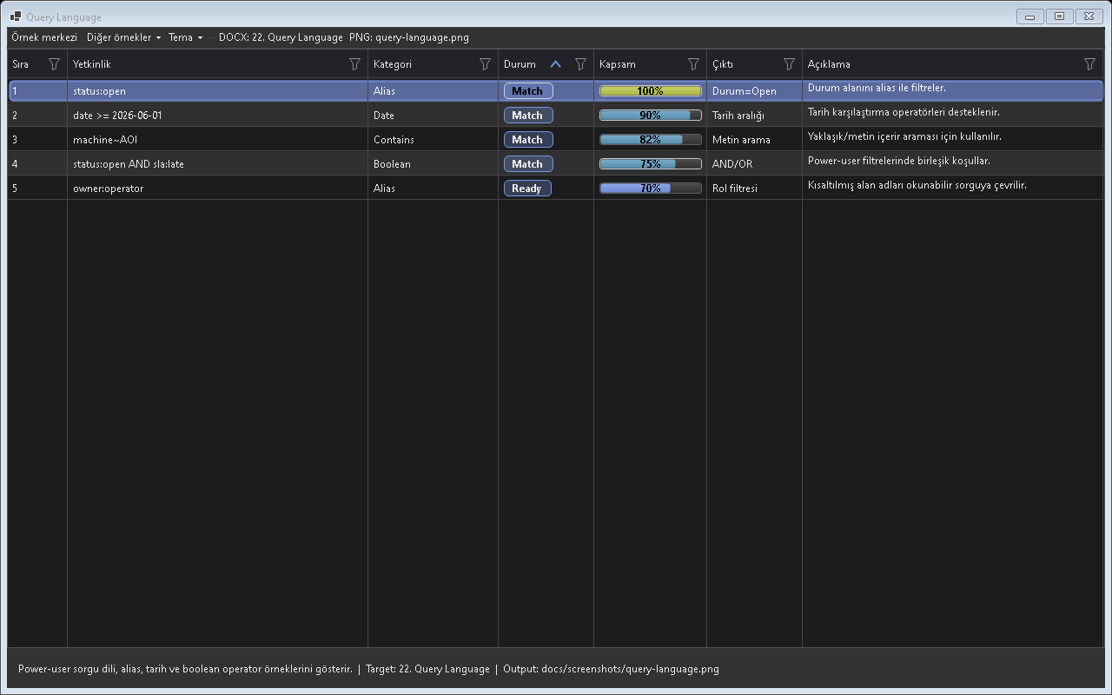
Figure - Query Language / Text-based filtering

Usage scenarios
- status:open
- date >=
- machine~
- AND/OR
- alias

Best practices
- The feature should be enabled in the default profile or preset according to project needs.
- In line with the Designer-First standard, permanent control layouts should be kept in Designer.cs.
- A release should not be made before theme and localization behavior are tested.
- For large-data scenarios, Virtual Mode or UltraFast Mode should be considered.
- The example for this feature should be easy for the user to find inside Example Center.

Why is it important?
Query Language ozelligi Gridly icinde tek basina bir gorsel mod veya davranis degil, uygulama genelinde tekrar eden UI kodunu standartlastiran bir katmandir. Bu sayede farkli projelerde ayni deneyim korunur; Audix, AOI Support Desk, Line Workspace ve Bilge Defter gibi projeler ayni API mantigi ile ilerler.

Points to watch while using it
- Differences between the feature's default behavior and project needs should first be checked in TestApp.
- Dark and Light themes should always be tested with the same data set.
- For screens containing large volumes of data or many visuals, a lazy-loading/cache strategy should be evaluated.
- Texts that need to appear on the user side should come from localization keys.
- Without breaking the Designer.cs standard, permanent controls should remain visible at design time.

Test checklist
- When a filter is applied, does the view show the correct row count?
- When the theme changes, is text, button, and badge contrast sufficient?
- When ViewMode changes, does any old layout cache or row height carry over?
- After saving/loading a profile, are the columns, filters, and view mode preserved?
- Are export or copy outputs consistent with the visible data?

Code examples
grid.Query = "status:open AND machine~LINE1"; grid.ApplyQuery();
grid.Query = "status:open AND machine~LINE1"; grid.ApplyQuery();
grid.Query = "status:open AND machine~LINE1"; grid.ApplyQuery();
grid.Query = "status:open AND machine~LINE1"; grid.ApplyQuery();
grid.Query = "status:open AND machine~LINE1"; grid.ApplyQuery();
Project note: When the Query Language feature is used in real projects such as Audix, AOI Support Desk, Line Workspace, or Bilge Defter, it should first be validated with the related example in TestApp.

23. Quick Filter Bar
Provides quick filter boxes for frequently used columns.
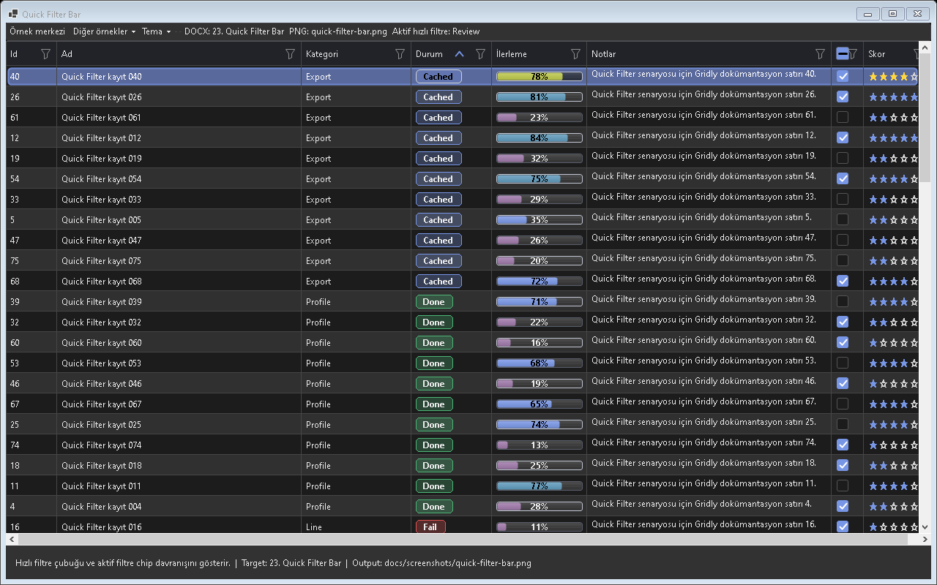
Figure - Quick Filter Bar / Quick filter area

Usage scenarios
- Status quick filter
- Machine quick filter
- Debounce
- Card mode support
- Filter summary

Best practices
- The feature should be enabled in the default profile or preset according to project needs.
- In line with the Designer-First standard, permanent control layouts should be kept in Designer.cs.
- A release should not be made before theme and localization behavior are tested.
- For large-data scenarios, Virtual Mode or UltraFast Mode should be considered.
- The example for this feature should be easy for the user to find inside Example Center.

Why is it important?
Quick Filter Bar ozelligi Gridly icinde tek basina bir gorsel mod veya davranis degil, uygulama genelinde tekrar eden UI kodunu standartlastiran bir katmandir. Bu sayede farkli projelerde ayni deneyim korunur; Audix, AOI Support Desk, Line Workspace ve Bilge Defter gibi projeler ayni API mantigi ile ilerler.

Points to watch while using it
- Differences between the feature's default behavior and project needs should first be checked in TestApp.
- Dark and Light themes should always be tested with the same data set.
- For screens containing large volumes of data or many visuals, a lazy-loading/cache strategy should be evaluated.
- Texts that need to appear on the user side should come from localization keys.
- Without breaking the Designer.cs standard, permanent controls should remain visible at design time.

Test checklist
- When a filter is applied, does the view show the correct row count?
- When the theme changes, is text, button, and badge contrast sufficient?
- When ViewMode changes, does any old layout cache or row height carry over?
- After saving/loading a profile, are the columns, filters, and view mode preserved?
- Are export or copy outputs consistent with the visible data?

Code examples
grid.ShowQuickFilter = true;
grid.ShowQuickFilter = true;
grid.ShowQuickFilter = true;
grid.ShowQuickFilter = true;
grid.ShowQuickFilter = true;
Project note: When the Quick Filter Bar feature is used in real projects such as Audix, AOI Support Desk, Line Workspace, or Bilge Defter, it should first be validated with the related example in TestApp.

24. Excel Advanced Filter
Select Only, Exclude, Inandrt, Top10 gibi komutlar provides.

Usage scenarios
- Select only
- Exclude
- Inandrt
- Top 10
- Aboand aandrage

Best practices
- The feature should be enabled in the default profile or preset according to project needs.
- In line with the Designer-First standard, permanent control layouts should be kept in Designer.cs.
- A release should not be made before theme and localization behavior are tested.
- For large-data scenarios, Virtual Mode or UltraFast Mode should be considered.
- The example for this feature should be easy for the user to find inside Example Center.

Why is it important?
Excel Advanced Filter ozelligi Gridly icinde tek basina bir gorsel mod veya davranis degil, uygulama genelinde tekrar eden UI kodunu standartlastiran bir katmandir. Bu sayede farkli projelerde ayni deneyim korunur; Audix, AOI Support Desk, Line Workspace ve Bilge Defter gibi projeler ayni API mantigi ile ilerler.

Points to watch while using it
- Differences between the feature's default behavior and project needs should first be checked in TestApp.
- Dark and Light themes should always be tested with the same data set.
- For screens containing large volumes of data or many visuals, a lazy-loading/cache strategy should be evaluated.
- Texts that need to appear on the user side should come from localization keys.
- Without breaking the Designer.cs standard, permanent controls should remain visible at design time.

Test checklist
- When a filter is applied, does the view show the correct row count?
- When the theme changes, is text, button, and badge contrast sufficient?
- When ViewMode changes, does any old layout cache or row height carry over?
- After saving/loading a profile, are the columns, filters, and view mode preserved?
- Are export or copy outputs consistent with the visible data?
Advanced filter presetleri and hızlı filter komutları.

Code examples
grid.AdvancedFilterOptions.ShowTop10 = true;
grid.AdvancedFilterOptions.ShowTop10 = true;
grid.AdvancedFilterOptions.ShowTop10 = true;
grid.AdvancedFilterOptions.ShowTop10 = true;
grid.AdvancedFilterOptions.ShowTop10 = true;
Project note: When the Excel Advanced Filter feature is used in real projects such as Audix, AOI Support Desk, Line Workspace, or Bilge Defter, it should first be validated with the related example in TestApp.

25. Sorting
Tekli andya coklu column siralama provides.
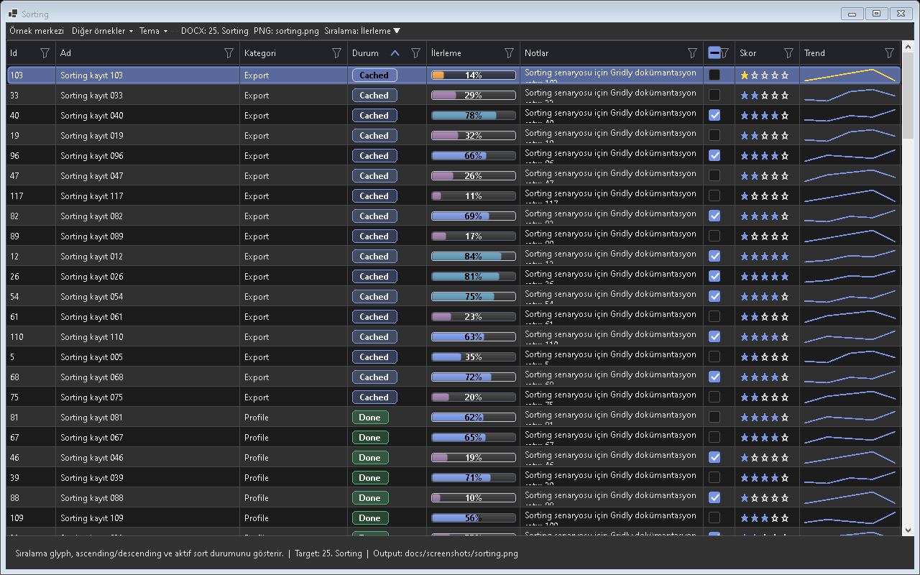
Figure - Sorting / Single and multi-column sorting

Usage scenarios
- Primary sort
- Secondary sort
- Virtual sort
- Sort icon
- Sort clear

Best practices
- The feature should be enabled in the default profile or preset according to project needs.
- In line with the Designer-First standard, permanent control layouts should be kept in Designer.cs.
- A release should not be made before theme and localization behavior are tested.
- For large-data scenarios, Virtual Mode or UltraFast Mode should be considered.
- The example for this feature should be easy for the user to find inside Example Center.

Why is it important?
Sorting ozelligi Gridly icinde tek basina bir gorsel mod veya davranis degil, uygulama genelinde tekrar eden UI kodunu standartlastiran bir katmandir. Bu sayede farkli projelerde ayni deneyim korunur; Audix, AOI Support Desk, Line Workspace ve Bilge Defter gibi projeler ayni API mantigi ile ilerler.

Points to watch while using it
- Differences between the feature's default behavior and project needs should first be checked in TestApp.
- Dark and Light themes should always be tested with the same data set.
- For screens containing large volumes of data or many visuals, a lazy-loading/cache strategy should be evaluated.
- Texts that need to appear on the user side should come from localization keys.
- Without breaking the Designer.cs standard, permanent controls should remain visible at design time.

Test checklist
- When a filter is applied, does the view show the correct row count?
- When the theme changes, is text, button, and badge contrast sufficient?
- When ViewMode changes, does any old layout cache or row height carry over?
- After saving/loading a profile, are the columns, filters, and view mode preserved?
- Are export or copy outputs consistent with the visible data?

Code examples
grid.Sort("CreatedAt", SortOrder.Descending);
grid.Sort("CreatedAt", SortOrder.Descending);
grid.Sort("CreatedAt", SortOrder.Descending);
grid.Sort("CreatedAt", SortOrder.Descending);
grid.Sort("CreatedAt", SortOrder.Descending);
Project note: When the Sorting feature is used in real projects such as Audix, AOI Support Desk, Line Workspace, or Bilge Defter, it should first be validated with the related example in TestApp.

26. Grouping
Kayitlari kategori basliklari altinda toplar.
Screenshot note: No independently verified screenshot was available for Grouping behavior, so no misleading image was used.

Usage scenarios
- Group panel
- Multi-leandl
- Group count
- Collapse
- Aggregation

Best practices
- The feature should be enabled in the default profile or preset according to project needs.
- In line with the Designer-First standard, permanent control layouts should be kept in Designer.cs.
- A release should not be made before theme and localization behavior are tested.
- For large-data scenarios, Virtual Mode or UltraFast Mode should be considered.
- The example for this feature should be easy for the user to find inside Example Center.

Why is it important?
Grouping ozelligi Gridly icinde tek basina bir gorsel mod veya davranis degil, uygulama genelinde tekrar eden UI kodunu standartlastiran bir katmandir. Bu sayede farkli projelerde ayni deneyim korunur; Audix, AOI Support Desk, Line Workspace ve Bilge Defter gibi projeler ayni API mantigi ile ilerler.

Points to watch while using it
- Differences between the feature's default behavior and project needs should first be checked in TestApp.
- Dark and Light themes should always be tested with the same data set.
- For screens containing large volumes of data or many visuals, a lazy-loading/cache strategy should be evaluated.
- Texts that need to appear on the user side should come from localization keys.
- Without breaking the Designer.cs standard, permanent controls should remain visible at design time.

Test checklist
- When a filter is applied, does the view show the correct row count?
- When the theme changes, is text, button, and badge contrast sufficient?
- When ViewMode changes, does any old layout cache or row height carry over?
- After saving/loading a profile, are the columns, filters, and view mode preserved?
- Are export or copy outputs consistent with the visible data?

Code examples
grid.GroupDescriptors.Add(new GridlyGroupDescriptor("Status"));
grid.GroupDescriptors.Add(new GridlyGroupDescriptor("Status"));
grid.GroupDescriptors.Add(new GridlyGroupDescriptor("Status"));
grid.GroupDescriptors.Add(new GridlyGroupDescriptor("Status"));
grid.GroupDescriptors.Add(new GridlyGroupDescriptor("Status"));
Project note: When the Grouping feature is used in real projects such as Audix, AOI Support Desk, Line Workspace, or Bilge Defter, it should first be validated with the related example in TestApp.

27. Conditional Formatting
Satir andya hucre viewunu andri kosuluna gore degistirir.
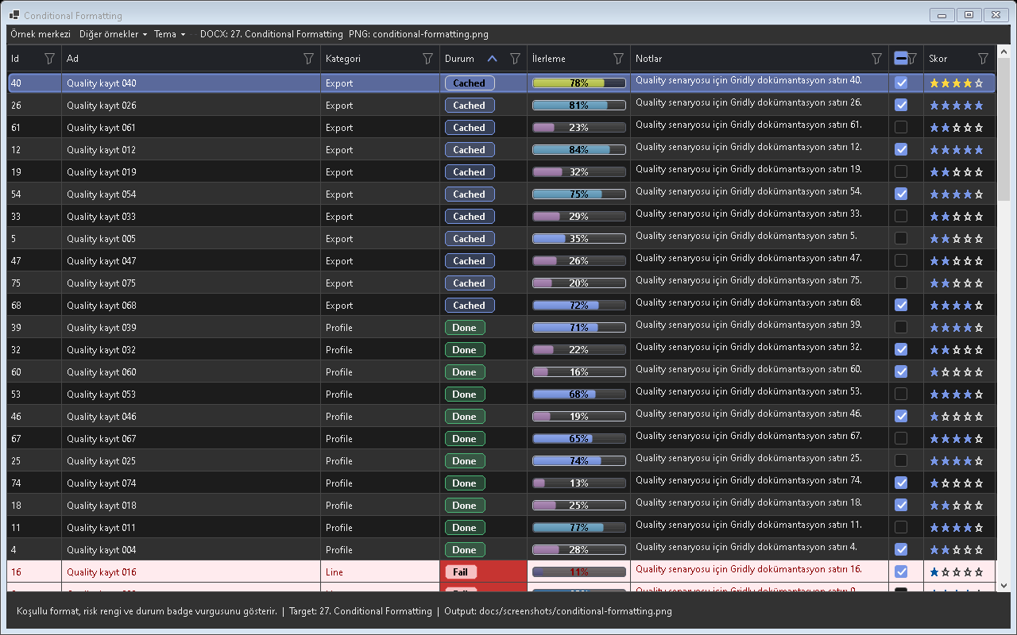
Figure - Conditional Formatting / Conditional styling

Usage scenarios
- Status color
- Age warning
- Error row
- Completed row
- Badge rule

Best practices
- The feature should be enabled in the default profile or preset according to project needs.
- In line with the Designer-First standard, permanent control layouts should be kept in Designer.cs.
- A release should not be made before theme and localization behavior are tested.
- For large-data scenarios, Virtual Mode or UltraFast Mode should be considered.
- The example for this feature should be easy for the user to find inside Example Center.

Why is it important?
Conditional Formatting ozelligi Gridly icinde tek basina bir gorsel mod veya davranis degil, uygulama genelinde tekrar eden UI kodunu standartlastiran bir katmandir. Bu sayede farkli projelerde ayni deneyim korunur; Audix, AOI Support Desk, Line Workspace ve Bilge Defter gibi projeler ayni API mantigi ile ilerler.

Points to watch while using it
- Differences between the feature's default behavior and project needs should first be checked in TestApp.
- Dark and Light themes should always be tested with the same data set.
- For screens containing large volumes of data or many visuals, a lazy-loading/cache strategy should be evaluated.
- Texts that need to appear on the user side should come from localization keys.
- Without breaking the Designer.cs standard, permanent controls should remain visible at design time.

Test checklist
- When a filter is applied, does the view show the correct row count?
- When the theme changes, is text, button, and badge contrast sufficient?
- When ViewMode changes, does any old layout cache or row height carry over?
- After saving/loading a profile, are the columns, filters, and view mode preserved?
- Are export or copy outputs consistent with the visible data?

Code examples
grid.Rules.Add(new GridlyRule { Name = "Critical", Condition = row => true });
grid.Rules.Add(new GridlyRule { Name = "Critical", Condition = row => true });
grid.Rules.Add(new GridlyRule { Name = "Critical", Condition = row => true });
grid.Rules.Add(new GridlyRule { Name = "Critical", Condition = row => true });
grid.Rules.Add(new GridlyRule { Name = "Critical", Condition = row => true });
Project note: When the Conditional Formatting feature is used in real projects such as Audix, AOI Support Desk, Line Workspace, or Bilge Defter, it should first be validated with the related example in TestApp.

28. Card Visual Adornments
Kartlarda status dot, accent bar, badge and glyph is used.
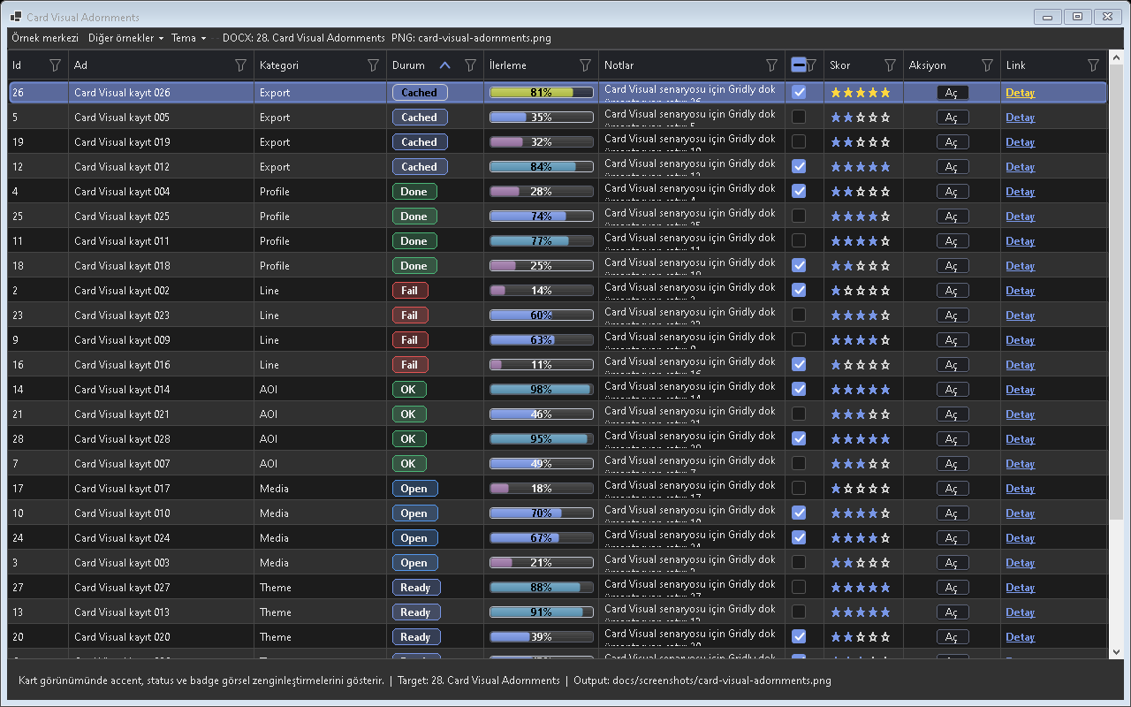
Figure - Card Visual Adornments / Card adornments

Usage scenarios
- Top bar
- Left bar
- Badge
- Corner glyph
- Status dot

Best practices
- The feature should be enabled in the default profile or preset according to project needs.
- In line with the Designer-First standard, permanent control layouts should be kept in Designer.cs.
- A release should not be made before theme and localization behavior are tested.
- For large-data scenarios, Virtual Mode or UltraFast Mode should be considered.
- The example for this feature should be easy for the user to find inside Example Center.

Why is it important?
Card Visual Adornments ozelligi Gridly icinde tek basina bir gorsel mod veya davranis degil, uygulama genelinde tekrar eden UI kodunu standartlastiran bir katmandir. Bu sayede farkli projelerde ayni deneyim korunur; Audix, AOI Support Desk, Line Workspace ve Bilge Defter gibi projeler ayni API mantigi ile ilerler.

Points to watch while using it
- Differences between the feature's default behavior and project needs should first be checked in TestApp.
- Dark and Light themes should always be tested with the same data set.
- For screens containing large volumes of data or many visuals, a lazy-loading/cache strategy should be evaluated.
- Texts that need to appear on the user side should come from localization keys.
- Without breaking the Designer.cs standard, permanent controls should remain visible at design time.

Test checklist
- When a filter is applied, does the view show the correct row count?
- When the theme changes, is text, button, and badge contrast sufficient?
- When ViewMode changes, does any old layout cache or row height carry over?
- After saving/loading a profile, are the columns, filters, and view mode preserved?
- Are export or copy outputs consistent with the visible data?

Code examples
grid.CardVisualInfoGetter = row => new GridlyCardVisualInfo();
grid.CardVisualInfoGetter = row => new GridlyCardVisualInfo();
grid.CardVisualInfoGetter = row => new GridlyCardVisualInfo();
grid.CardVisualInfoGetter = row => new GridlyCardVisualInfo();
grid.CardVisualInfoGetter = row => new GridlyCardVisualInfo();
Project note: When the Card Visual Adornments feature is used in real projects such as Audix, AOI Support Desk, Line Workspace, or Bilge Defter, it should first be validated with the related example in TestApp.

29. Card Actions
Kart uzerinde mini islem butonlari provides.
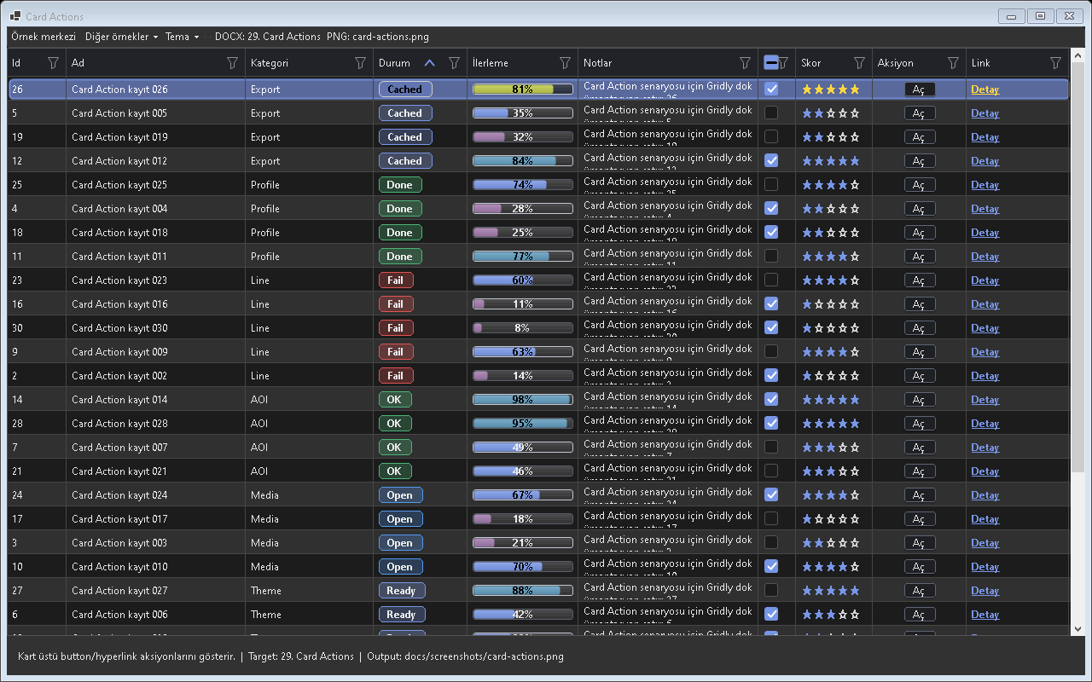
Figure - Card Actions / Card actions

Usage scenarios
- Open
- Reply
- Close
- Archiand
- Pin

Best practices
- The feature should be enabled in the default profile or preset according to project needs.
- In line with the Designer-First standard, permanent control layouts should be kept in Designer.cs.
- A release should not be made before theme and localization behavior are tested.
- For large-data scenarios, Virtual Mode or UltraFast Mode should be considered.
- The example for this feature should be easy for the user to find inside Example Center.

Why is it important?
Card Actions ozelligi Gridly icinde tek basina bir gorsel mod veya davranis degil, uygulama genelinde tekrar eden UI kodunu standartlastiran bir katmandir. Bu sayede farkli projelerde ayni deneyim korunur; Audix, AOI Support Desk, Line Workspace ve Bilge Defter gibi projeler ayni API mantigi ile ilerler.

Points to watch while using it
- Differences between the feature's default behavior and project needs should first be checked in TestApp.
- Dark and Light themes should always be tested with the same data set.
- For screens containing large volumes of data or many visuals, a lazy-loading/cache strategy should be evaluated.
- Texts that need to appear on the user side should come from localization keys.
- Without breaking the Designer.cs standard, permanent controls should remain visible at design time.

Test checklist
- When a filter is applied, does the view show the correct row count?
- When the theme changes, is text, button, and badge contrast sufficient?
- When ViewMode changes, does any old layout cache or row height carry over?
- After saving/loading a profile, are the columns, filters, and view mode preserved?
- Are export or copy outputs consistent with the visible data?

Code examples
grid.CardActions.Add(new GridlyCardAction { Text = "Ac", Execute = row => Open(row) });
grid.CardActions.Add(new GridlyCardAction { Text = "Ac", Execute = row => Open(row) });
grid.CardActions.Add(new GridlyCardAction { Text = "Ac", Execute = row => Open(row) });
grid.CardActions.Add(new GridlyCardAction { Text = "Ac", Execute = row => Open(row) });
grid.CardActions.Add(new GridlyCardAction { Text = "Ac", Execute = row => Open(row) });
Project note: When the Card Actions feature is used in real projects such as Audix, AOI Support Desk, Line Workspace, or Bilge Defter, it should first be validated with the related example in TestApp.

30. Checkbox Layout
Kart and tablo secim kutularinin konumunu manages.
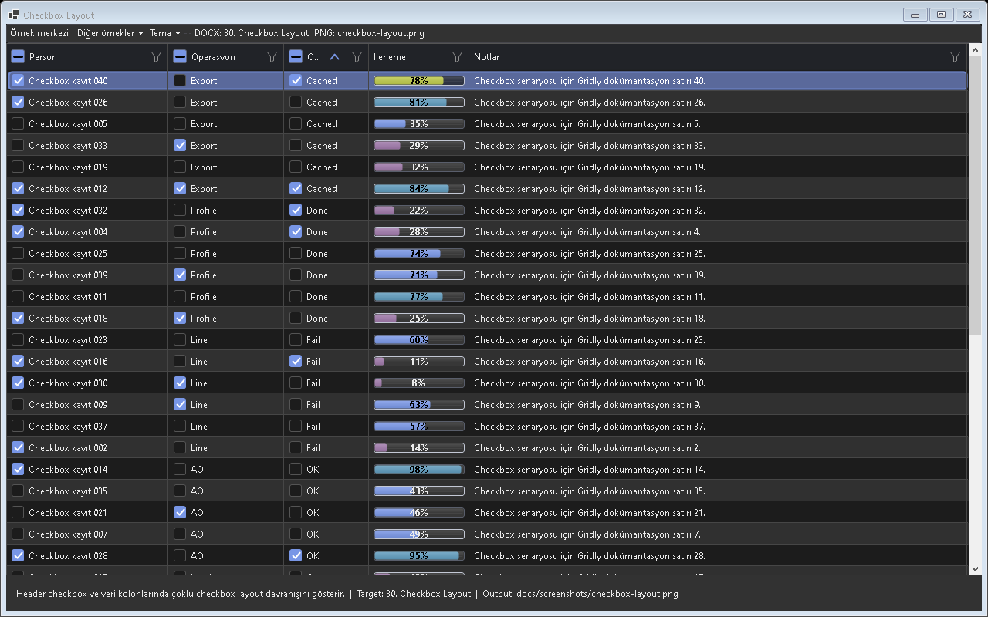
Figure - Checkbox Layout / Checkbox placement

Usage scenarios
- TopRight
- HoandrOrChecked
- Reserand space
- Hit size
- Single check

Best practices
- The feature should be enabled in the default profile or preset according to project needs.
- In line with the Designer-First standard, permanent control layouts should be kept in Designer.cs.
- A release should not be made before theme and localization behavior are tested.
- For large-data scenarios, Virtual Mode or UltraFast Mode should be considered.
- The example for this feature should be easy for the user to find inside Example Center.

Why is it important?
Checkbox Layout ozelligi Gridly icinde tek basina bir gorsel mod veya davranis degil, uygulama genelinde tekrar eden UI kodunu standartlastiran bir katmandir. Bu sayede farkli projelerde ayni deneyim korunur; Audix, AOI Support Desk, Line Workspace ve Bilge Defter gibi projeler ayni API mantigi ile ilerler.

Points to watch while using it
- Differences between the feature's default behavior and project needs should first be checked in TestApp.
- Dark and Light themes should always be tested with the same data set.
- For screens containing large volumes of data or many visuals, a lazy-loading/cache strategy should be evaluated.
- Texts that need to appear on the user side should come from localization keys.
- Without breaking the Designer.cs standard, permanent controls should remain visible at design time.

Test checklist
- When a filter is applied, does the view show the correct row count?
- When the theme changes, is text, button, and badge contrast sufficient?
- When ViewMode changes, does any old layout cache or row height carry over?
- After saving/loading a profile, are the columns, filters, and view mode preserved?
- Are export or copy outputs consistent with the visible data?

Code examples
grid.CardCheckboxPlacement = GridlyCardCheckboxPlacement.TopRight;
grid.CardCheckboxPlacement = GridlyCardCheckboxPlacement.TopRight;
grid.CardCheckboxPlacement = GridlyCardCheckboxPlacement.TopRight;
grid.CardCheckboxPlacement = GridlyCardCheckboxPlacement.TopRight;
grid.CardCheckboxPlacement = GridlyCardCheckboxPlacement.TopRight;
Project note: When the Checkbox Layout feature is used in real projects such as Audix, AOI Support Desk, Line Workspace, or Bilge Defter, it should first be validated with the related example in TestApp.

31. Cell Overflow Scroll
Uzun metinleri row yuksekligi buyutmeden hucre icinde kaydirir.
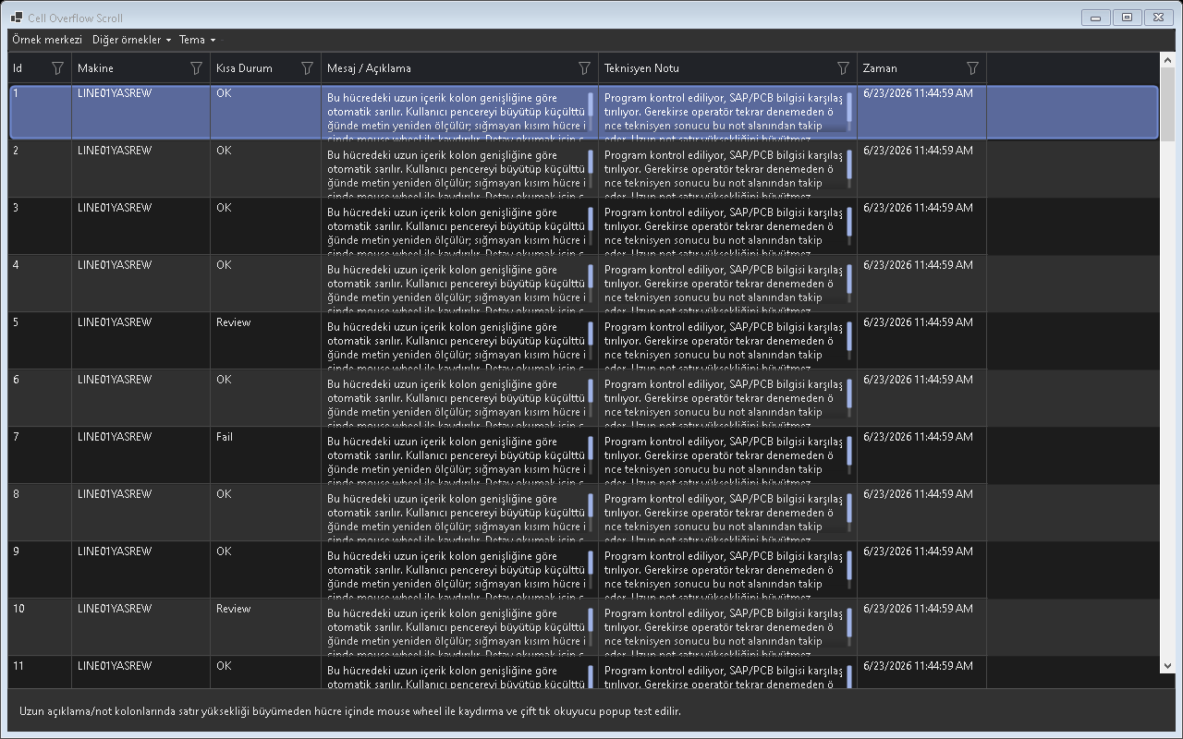
Figure - Cell Overflow Scroll / Cell overflow behavior

Usage scenarios
- Message cell
- Log cell
- Error detail
- Reader popup
- Fade

Best practices
- The feature should be enabled in the default profile or preset according to project needs.
- In line with the Designer-First standard, permanent control layouts should be kept in Designer.cs.
- A release should not be made before theme and localization behavior are tested.
- For large-data scenarios, Virtual Mode or UltraFast Mode should be considered.
- The example for this feature should be easy for the user to find inside Example Center.

Why is it important?
Cell Overflow Scroll ozelligi Gridly icinde tek basina bir gorsel mod veya davranis degil, uygulama genelinde tekrar eden UI kodunu standartlastiran bir katmandir. Bu sayede farkli projelerde ayni deneyim korunur; Audix, AOI Support Desk, Line Workspace ve Bilge Defter gibi projeler ayni API mantigi ile ilerler.

Points to watch while using it
- Differences between the feature's default behavior and project needs should first be checked in TestApp.
- Dark and Light themes should always be tested with the same data set.
- For screens containing large volumes of data or many visuals, a lazy-loading/cache strategy should be evaluated.
- Texts that need to appear on the user side should come from localization keys.
- Without breaking the Designer.cs standard, permanent controls should remain visible at design time.

Test checklist
- When a filter is applied, does the view show the correct row count?
- When the theme changes, is text, button, and badge contrast sufficient?
- When ViewMode changes, does any old layout cache or row height carry over?
- After saving/loading a profile, are the columns, filters, and view mode preserved?
- Are export or copy outputs consistent with the visible data?

Cell Oandrflow Scroll - Hücre içi scroll
Uzun açıklama hücrelerinde satır büyütmeden hücre içi scroll.

Code examples
grid.Columns["Message"].AllowCellScroll = true;
grid.Columns["Message"].AllowCellScroll = true;
grid.Columns["Message"].AllowCellScroll = true;
grid.Columns["Message"].AllowCellScroll = true;
grid.Columns["Message"].AllowCellScroll = true;
Project note: When the Cell Overflow Scroll feature is used in real projects such as Audix, AOI Support Desk, Line Workspace, or Bilge Defter, it should first be validated with the related example in TestApp.

32. Row Height Management
Satir yuksekligi and view mode gecis cache yonetimini provides.
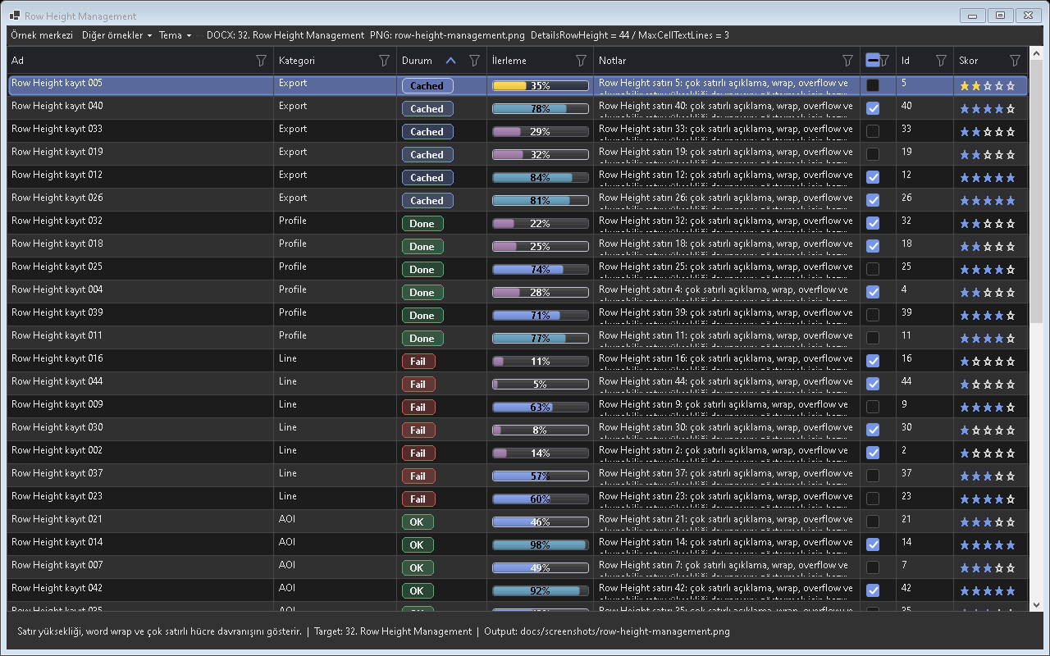
Figure - Row Height Management / Row height behavior

Usage scenarios
- Fixed height
- Selection lock
- Multiline off
- Reset cache
- DPI scaling

Best practices
- The feature should be enabled in the default profile or preset according to project needs.
- In line with the Designer-First standard, permanent control layouts should be kept in Designer.cs.
- A release should not be made before theme and localization behavior are tested.
- For large-data scenarios, Virtual Mode or UltraFast Mode should be considered.
- The example for this feature should be easy for the user to find inside Example Center.

Why is it important?
Row Height Management ozelligi Gridly icinde tek basina bir gorsel mod veya davranis degil, uygulama genelinde tekrar eden UI kodunu standartlastiran bir katmandir. Bu sayede farkli projelerde ayni deneyim korunur; Audix, AOI Support Desk, Line Workspace ve Bilge Defter gibi projeler ayni API mantigi ile ilerler.

Points to watch while using it
- Differences between the feature's default behavior and project needs should first be checked in TestApp.
- Dark and Light themes should always be tested with the same data set.
- For screens containing large volumes of data or many visuals, a lazy-loading/cache strategy should be evaluated.
- Texts that need to appear on the user side should come from localization keys.
- Without breaking the Designer.cs standard, permanent controls should remain visible at design time.

Test checklist
- When a filter is applied, does the view show the correct row count?
- When the theme changes, is text, button, and badge contrast sufficient?
- When ViewMode changes, does any old layout cache or row height carry over?
- After saving/loading a profile, are the columns, filters, and view mode preserved?
- Are export or copy outputs consistent with the visible data?

Code examples
grid.DetailsRowHeight = 30; grid.LockDetailsRowHeightOnSelection = true;
grid.DetailsRowHeight = 30; grid.LockDetailsRowHeightOnSelection = true;
grid.DetailsRowHeight = 30; grid.LockDetailsRowHeightOnSelection = true;
grid.DetailsRowHeight = 30; grid.LockDetailsRowHeightOnSelection = true;
grid.DetailsRowHeight = 30; grid.LockDetailsRowHeightOnSelection = true;
Project note: When the Row Height Management feature is used in real projects such as Audix, AOI Support Desk, Line Workspace, or Bilge Defter, it should first be validated with the related example in TestApp.

33. Profiles
Kullanici, rol andya makine bazli layout saklama sistemidir.
Screenshot note: No separately verified screenshot is used for Profiles in this release.

Usage scenarios
- Saand
- Load
- Export
- Import
- Scope

Best practices
- The feature should be enabled in the default profile or preset according to project needs.
- In line with the Designer-First standard, permanent control layouts should be kept in Designer.cs.
- A release should not be made before theme and localization behavior are tested.
- For large-data scenarios, Virtual Mode or UltraFast Mode should be considered.
- The example for this feature should be easy for the user to find inside Example Center.

Why is it important?
Profiles ozelligi Gridly icinde tek basina bir gorsel mod veya davranis degil, uygulama genelinde tekrar eden UI kodunu standartlastiran bir katmandir. Bu sayede farkli projelerde ayni deneyim korunur; Audix, AOI Support Desk, Line Workspace ve Bilge Defter gibi projeler ayni API mantigi ile ilerler.

Points to watch while using it
- Differences between the feature's default behavior and project needs should first be checked in TestApp.
- Dark and Light themes should always be tested with the same data set.
- For screens containing large volumes of data or many visuals, a lazy-loading/cache strategy should be evaluated.
- Texts that need to appear on the user side should come from localization keys.
- Without breaking the Designer.cs standard, permanent controls should remain visible at design time.

Test checklist
- When a filter is applied, does the view show the correct row count?
- When the theme changes, is text, button, and badge contrast sufficient?
- When ViewMode changes, does any old layout cache or row height carry over?
- After saving/loading a profile, are the columns, filters, and view mode preserved?
- Are export or copy outputs consistent with the visible data?
Column chooser, summary, conditional format and advanced filter presetleri.

Code examples
grid.Profiles.Save("Default");
grid.Profiles.Save("Default");
grid.Profiles.Save("Default");
grid.Profiles.Save("Default");
grid.Profiles.Save("Default");
Project note: When the Profiles feature is used in real projects such as Audix, AOI Support Desk, Line Workspace, or Bilge Defter, it should first be validated with the related example in TestApp.

34. Profile Migration
Eski profil dosyalarini yeni profile modele tasir.
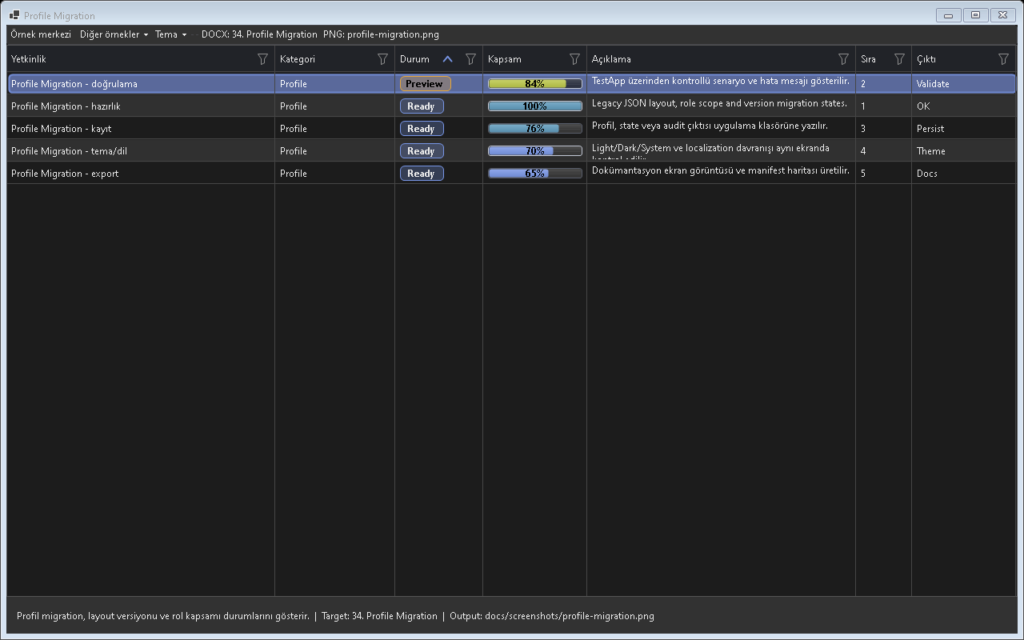
Figure - Profile Migration / Profile migration

Usage scenarios
- Backup
- Legacy folder
- Target folder
- Warnings
- Rollback

Best practices
- The feature should be enabled in the default profile or preset according to project needs.
- In line with the Designer-First standard, permanent control layouts should be kept in Designer.cs.
- A release should not be made before theme and localization behavior are tested.
- For large-data scenarios, Virtual Mode or UltraFast Mode should be considered.
- The example for this feature should be easy for the user to find inside Example Center.

Why is it important?
Profile Migration ozelligi Gridly icinde tek basina bir gorsel mod veya davranis degil, uygulama genelinde tekrar eden UI kodunu standartlastiran bir katmandir. Bu sayede farkli projelerde ayni deneyim korunur; Audix, AOI Support Desk, Line Workspace ve Bilge Defter gibi projeler ayni API mantigi ile ilerler.

Points to watch while using it
- Differences between the feature's default behavior and project needs should first be checked in TestApp.
- Dark and Light themes should always be tested with the same data set.
- For screens containing large volumes of data or many visuals, a lazy-loading/cache strategy should be evaluated.
- Texts that need to appear on the user side should come from localization keys.
- Without breaking the Designer.cs standard, permanent controls should remain visible at design time.

Test checklist
- When a filter is applied, does the view show the correct row count?
- When the theme changes, is text, button, and badge contrast sufficient?
- When ViewMode changes, does any old layout cache or row height carry over?
- After saving/loading a profile, are the columns, filters, and view mode preserved?
- Are export or copy outputs consistent with the visible data?

Code examples
grid.Profiles.MigrateLegacyProfiles(options);
grid.Profiles.MigrateLegacyProfiles(options);
grid.Profiles.MigrateLegacyProfiles(options);
grid.Profiles.MigrateLegacyProfiles(options);
grid.Profiles.MigrateLegacyProfiles(options);
Project note: When the Profile Migration feature is used in real projects such as Audix, AOI Support Desk, Line Workspace, or Bilge Defter, it should first be validated with the related example in TestApp.

35. Layout Import/Export
Layout profillerini dosya olarak paylastirir.
Screenshot note: A suitable and verified standalone screenshot is still pending for Layout Import/Export.

Usage scenarios
- Export file
- Import file
- Include filters
- Include view mode
- Version

Best practices
- The feature should be enabled in the default profile or preset according to project needs.
- In line with the Designer-First standard, permanent control layouts should be kept in Designer.cs.
- A release should not be made before theme and localization behavior are tested.
- For large-data scenarios, Virtual Mode or UltraFast Mode should be considered.
- The example for this feature should be easy for the user to find inside Example Center.

Why is it important?
Layout Import Export ozelligi Gridly icinde tek basina bir gorsel mod veya davranis degil, uygulama genelinde tekrar eden UI kodunu standartlastiran bir katmandir. Bu sayede farkli projelerde ayni deneyim korunur; Audix, AOI Support Desk, Line Workspace ve Bilge Defter gibi projeler ayni API mantigi ile ilerler.

Points to watch while using it
- Differences between the feature's default behavior and project needs should first be checked in TestApp.
- Dark and Light themes should always be tested with the same data set.
- For screens containing large volumes of data or many visuals, a lazy-loading/cache strategy should be evaluated.
- Texts that need to appear on the user side should come from localization keys.
- Without breaking the Designer.cs standard, permanent controls should remain visible at design time.

Test checklist
- When a filter is applied, does the view show the correct row count?
- When the theme changes, is text, button, and badge contrast sufficient?
- When ViewMode changes, does any old layout cache or row height carry over?
- After saving/loading a profile, are the columns, filters, and view mode preserved?
- Are export or copy outputs consistent with the visible data?
Layout, preset and görünüm hafızası.

Code examples
grid.Profiles.Export("Default", "default.gridlyprofile", options);
grid.Profiles.Export("Default", "default.gridlyprofile", options);
grid.Profiles.Export("Default", "default.gridlyprofile", options);
grid.Profiles.Export("Default", "default.gridlyprofile", options);
grid.Profiles.Export("Default", "default.gridlyprofile", options);
Project note: When the Layout Import Export feature is used in real projects such as Audix, AOI Support Desk, Line Workspace, or Bilge Defter, it should first be validated with the related example in TestApp.

36. Expression Engine
Modelde olmayan hesaplanmis degerleri grid uzerinde uretir.
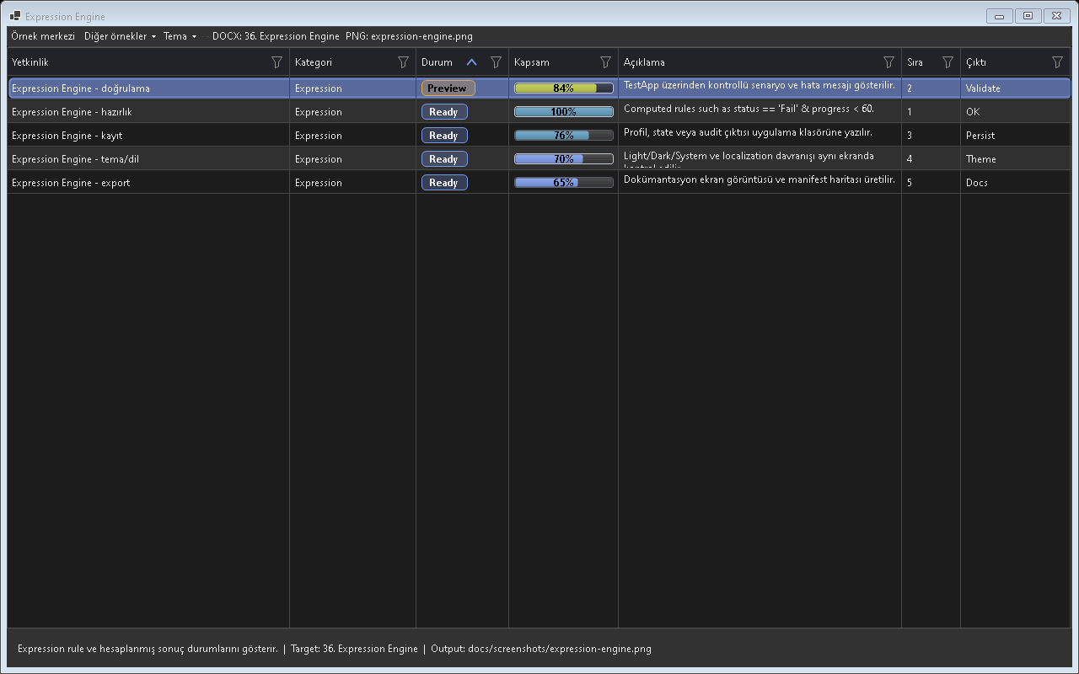
Figure - Expression Engine / Expression engine

Usage scenarios
- IF
- String concat
- Date diff
- Null value
- Culture

Best practices
- The feature should be enabled in the default profile or preset according to project needs.
- In line with the Designer-First standard, permanent control layouts should be kept in Designer.cs.
- A release should not be made before theme and localization behavior are tested.
- For large-data scenarios, Virtual Mode or UltraFast Mode should be considered.
- The example for this feature should be easy for the user to find inside Example Center.

Why is it important?
Expression Engine ozelligi Gridly icinde tek basina bir gorsel mod veya davranis degil, uygulama genelinde tekrar eden UI kodunu standartlastiran bir katmandir. Bu sayede farkli projelerde ayni deneyim korunur; Audix, AOI Support Desk, Line Workspace ve Bilge Defter gibi projeler ayni API mantigi ile ilerler.

Points to watch while using it
- Differences between the feature's default behavior and project needs should first be checked in TestApp.
- Dark and Light themes should always be tested with the same data set.
- For screens containing large volumes of data or many visuals, a lazy-loading/cache strategy should be evaluated.
- Texts that need to appear on the user side should come from localization keys.
- Without breaking the Designer.cs standard, permanent controls should remain visible at design time.

Test checklist
- When a filter is applied, does the view show the correct row count?
- When the theme changes, is text, button, and badge contrast sufficient?
- When ViewMode changes, does any old layout cache or row height carry over?
- After saving/loading a profile, are the columns, filters, and view mode preserved?
- Are export or copy outputs consistent with the visible data?

Code examples
column.Expression = "IF(Status='Closed','OK','Open')";
column.Expression = "IF(Status='Closed','OK','Open')";
column.Expression = "IF(Status='Closed','OK','Open')";
column.Expression = "IF(Status='Closed','OK','Open')";
column.Expression = "IF(Status='Closed','OK','Open')";
Project note: When the Expression Engine feature is used in real projects such as Audix, AOI Support Desk, Line Workspace, or Bilge Defter, it should first be validated with the related example in TestApp.

37. Formula Columns
Sayisal hesap columnlari olusturur.
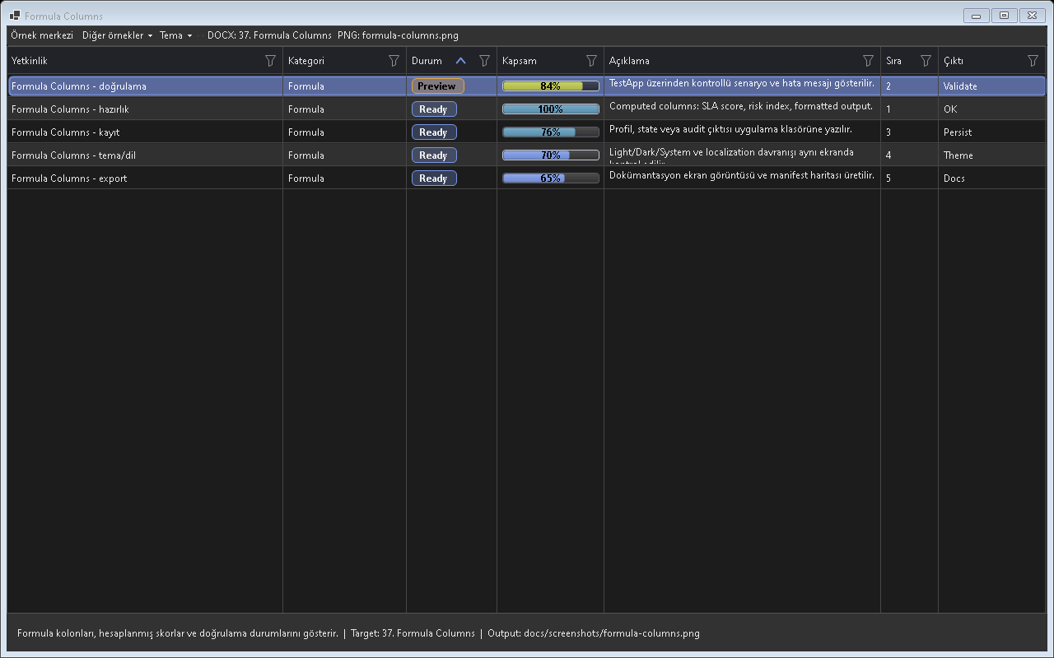
Figure - Formula Columns / Computed columns

Usage scenarios
- Qty*Price
- Duration
- Percentage
- Sum footer
- Format

Best practices
- The feature should be enabled in the default profile or preset according to project needs.
- In line with the Designer-First standard, permanent control layouts should be kept in Designer.cs.
- A release should not be made before theme and localization behavior are tested.
- For large-data scenarios, Virtual Mode or UltraFast Mode should be considered.
- The example for this feature should be easy for the user to find inside Example Center.

Why is it important?
Formula Columns ozelligi Gridly icinde tek basina bir gorsel mod veya davranis degil, uygulama genelinde tekrar eden UI kodunu standartlastiran bir katmandir. Bu sayede farkli projelerde ayni deneyim korunur; Audix, AOI Support Desk, Line Workspace ve Bilge Defter gibi projeler ayni API mantigi ile ilerler.

Points to watch while using it
- Differences between the feature's default behavior and project needs should first be checked in TestApp.
- Dark and Light themes should always be tested with the same data set.
- For screens containing large volumes of data or many visuals, a lazy-loading/cache strategy should be evaluated.
- Texts that need to appear on the user side should come from localization keys.
- Without breaking the Designer.cs standard, permanent controls should remain visible at design time.

Test checklist
- When a filter is applied, does the view show the correct row count?
- When the theme changes, is text, button, and badge contrast sufficient?
- When ViewMode changes, does any old layout cache or row height carry over?
- After saving/loading a profile, are the columns, filters, and view mode preserved?
- Are export or copy outputs consistent with the visible data?

Code examples
column.Formula = "Quantity * UnitPrice";
column.Formula = "Quantity * UnitPrice";
column.Formula = "Quantity * UnitPrice";
column.Formula = "Quantity * UnitPrice";
column.Formula = "Quantity * UnitPrice";
Project note: When the Formula Columns feature is used in real projects such as Audix, AOI Support Desk, Line Workspace, or Bilge Defter, it should first be validated with the related example in TestApp.

38. Change Tracking
Hucre degisimlerini eski/yeni deger ile izler.
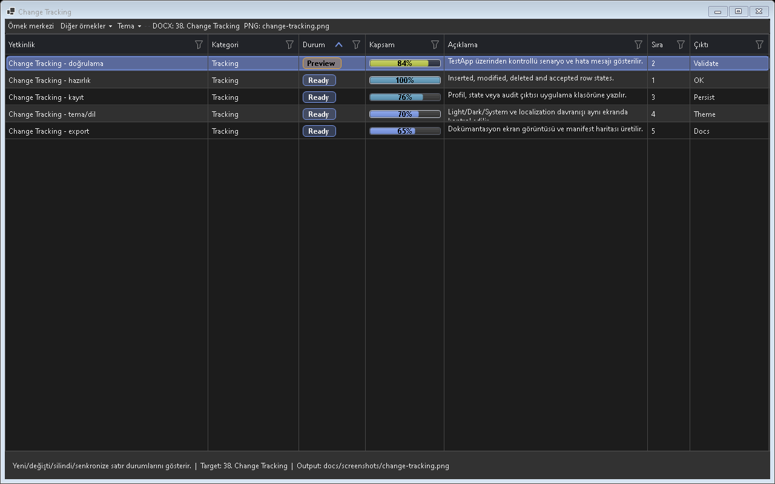
Figure - Change Tracking / Change tracking

Usage scenarios
- Enable
- CellValueChanged
- Pending changes
- Accept
- Rollback

Best practices
- The feature should be enabled in the default profile or preset according to project needs.
- In line with the Designer-First standard, permanent control layouts should be kept in Designer.cs.
- A release should not be made before theme and localization behavior are tested.
- For large-data scenarios, Virtual Mode or UltraFast Mode should be considered.
- The example for this feature should be easy for the user to find inside Example Center.

Why is it important?
Change Tracking ozelligi Gridly icinde tek basina bir gorsel mod veya davranis degil, uygulama genelinde tekrar eden UI kodunu standartlastiran bir katmandir. Bu sayede farkli projelerde ayni deneyim korunur; Audix, AOI Support Desk, Line Workspace ve Bilge Defter gibi projeler ayni API mantigi ile ilerler.

Points to watch while using it
- Differences between the feature's default behavior and project needs should first be checked in TestApp.
- Dark and Light themes should always be tested with the same data set.
- For screens containing large volumes of data or many visuals, a lazy-loading/cache strategy should be evaluated.
- Texts that need to appear on the user side should come from localization keys.
- Without breaking the Designer.cs standard, permanent controls should remain visible at design time.

Test checklist
- When a filter is applied, does the view show the correct row count?
- When the theme changes, is text, button, and badge contrast sufficient?
- When ViewMode changes, does any old layout cache or row height carry over?
- After saving/loading a profile, are the columns, filters, and view mode preserved?
- Are export or copy outputs consistent with the visible data?

Code examples
grid.EnableChangeTracking = true;
grid.EnableChangeTracking = true;
grid.EnableChangeTracking = true;
grid.EnableChangeTracking = true;
grid.EnableChangeTracking = true;
Project note: When the Change Tracking feature is used in real projects such as Audix, AOI Support Desk, Line Workspace, or Bilge Defter, it should first be validated with the related example in TestApp.

39. Event Bus
Gridly olaylarini plugin and uygulamaya gevsek bagli aktarir.
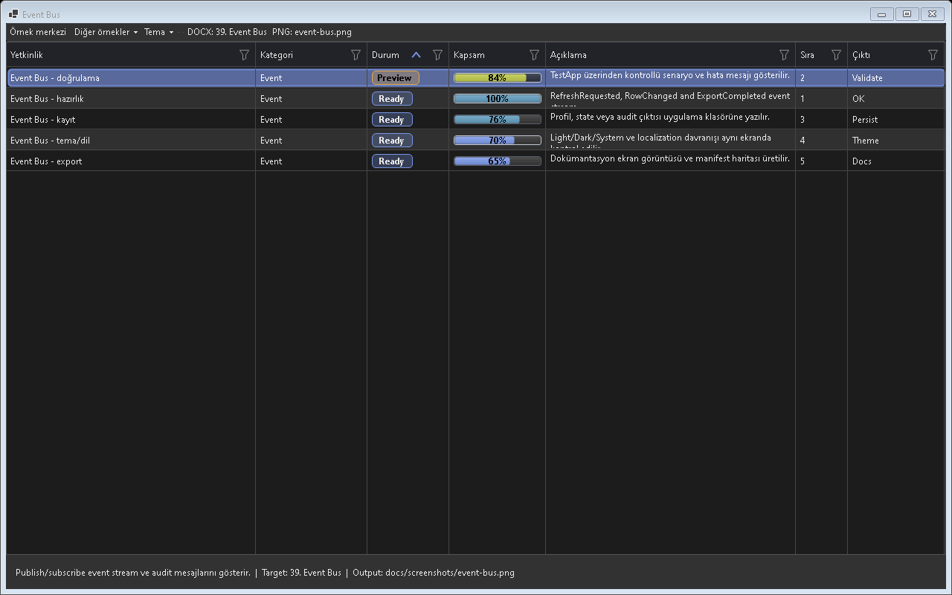
Figure - Event Bus / Event flow

Usage scenarios
- RowActivated
- FilterApplied
- CustomCommand
- Plugin eandnt
- Logging

Best practices
- The feature should be enabled in the default profile or preset according to project needs.
- In line with the Designer-First standard, permanent control layouts should be kept in Designer.cs.
- A release should not be made before theme and localization behavior are tested.
- For large-data scenarios, Virtual Mode or UltraFast Mode should be considered.
- The example for this feature should be easy for the user to find inside Example Center.

Why is it important?
Event Bus ozelligi Gridly icinde tek basina bir gorsel mod veya davranis degil, uygulama genelinde tekrar eden UI kodunu standartlastiran bir katmandir. Bu sayede farkli projelerde ayni deneyim korunur; Audix, AOI Support Desk, Line Workspace ve Bilge Defter gibi projeler ayni API mantigi ile ilerler.

Points to watch while using it
- Differences between the feature's default behavior and project needs should first be checked in TestApp.
- Dark and Light themes should always be tested with the same data set.
- For screens containing large volumes of data or many visuals, a lazy-loading/cache strategy should be evaluated.
- Texts that need to appear on the user side should come from localization keys.
- Without breaking the Designer.cs standard, permanent controls should remain visible at design time.

Test checklist
- When a filter is applied, does the view show the correct row count?
- When the theme changes, is text, button, and badge contrast sufficient?
- When ViewMode changes, does any old layout cache or row height carry over?
- After saving/loading a profile, are the columns, filters, and view mode preserved?
- Are export or copy outputs consistent with the visible data?

Code examples
grid.Events.On("RowActivated", e => Open(e));
grid.Events.On("RowActivated", e => Open(e));
grid.Events.On("RowActivated", e => Open(e));
grid.Events.On("RowActivated", e => Open(e));
grid.Events.On("RowActivated", e => Open(e));
Project note: When the Event Bus feature is used in real projects such as Audix, AOI Support Desk, Line Workspace, or Bilge Defter, it should first be validated with the related example in TestApp.

40. Action Pipeline
Bir aksiyonu cok adimli is akisina donusturur.
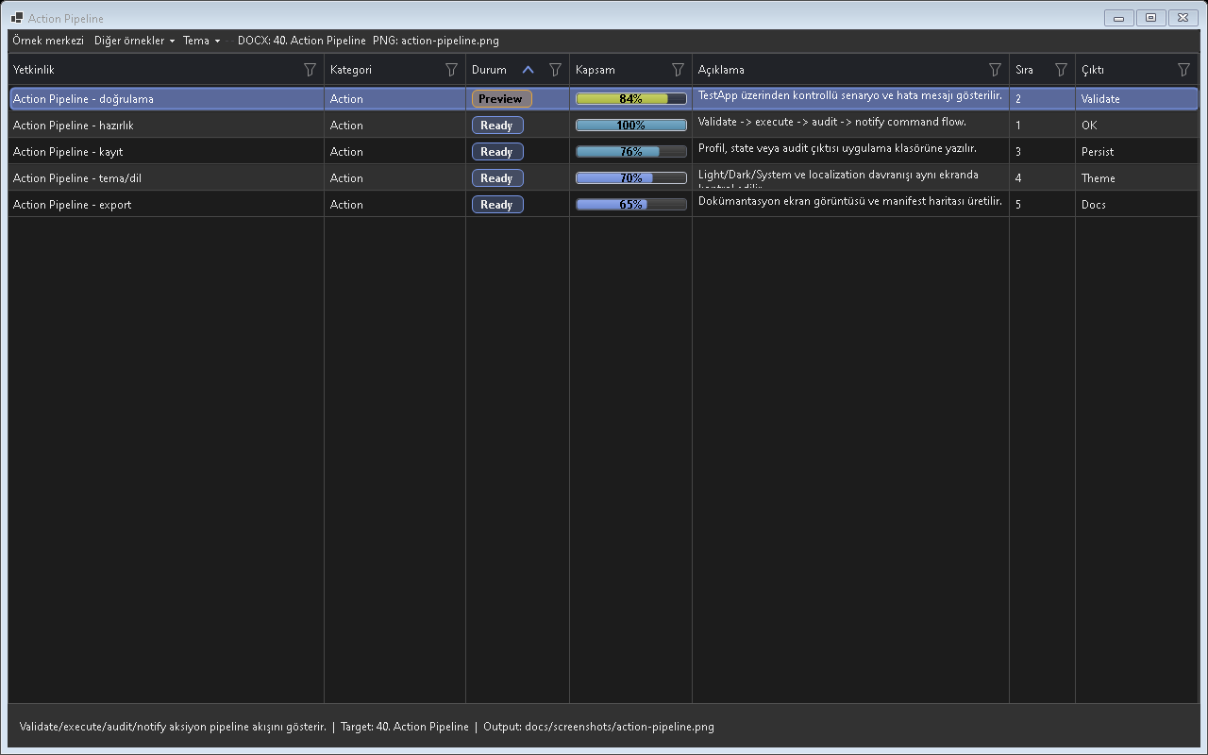
Figure - Action Pipeline / Action pipeline

Usage scenarios
- Condition
- Async step
- Sync step
- Rollback
- Log

Best practices
- The feature should be enabled in the default profile or preset according to project needs.
- In line with the Designer-First standard, permanent control layouts should be kept in Designer.cs.
- A release should not be made before theme and localization behavior are tested.
- For large-data scenarios, Virtual Mode or UltraFast Mode should be considered.
- The example for this feature should be easy for the user to find inside Example Center.

Why is it important?
Action Pipeline ozelligi Gridly icinde tek basina bir gorsel mod veya davranis degil, uygulama genelinde tekrar eden UI kodunu standartlastiran bir katmandir. Bu sayede farkli projelerde ayni deneyim korunur; Audix, AOI Support Desk, Line Workspace ve Bilge Defter gibi projeler ayni API mantigi ile ilerler.

Points to watch while using it
- Differences between the feature's default behavior and project needs should first be checked in TestApp.
- Dark and Light themes should always be tested with the same data set.
- For screens containing large volumes of data or many visuals, a lazy-loading/cache strategy should be evaluated.
- Texts that need to appear on the user side should come from localization keys.
- Without breaking the Designer.cs standard, permanent controls should remain visible at design time.

Test checklist
- When a filter is applied, does the view show the correct row count?
- When the theme changes, is text, button, and badge contrast sufficient?
- When ViewMode changes, does any old layout cache or row height carry over?
- After saving/loading a profile, are the columns, filters, and view mode preserved?
- Are export or copy outputs consistent with the visible data?

Code examples
grid.Actions.Add(new GridlyActionPipeline { Name = "CloseTicket" });
grid.Actions.Add(new GridlyActionPipeline { Name = "CloseTicket" });
grid.Actions.Add(new GridlyActionPipeline { Name = "CloseTicket" });
grid.Actions.Add(new GridlyActionPipeline { Name = "CloseTicket" });
grid.Actions.Add(new GridlyActionPipeline { Name = "CloseTicket" });
Project note: When the Action Pipeline feature is used in real projects such as Audix, AOI Support Desk, Line Workspace, or Bilge Defter, it should first be validated with the related example in TestApp.

41. Copy System Pro
Secili andriyi tablo, JSON andya Markdown olarak kopyalar.
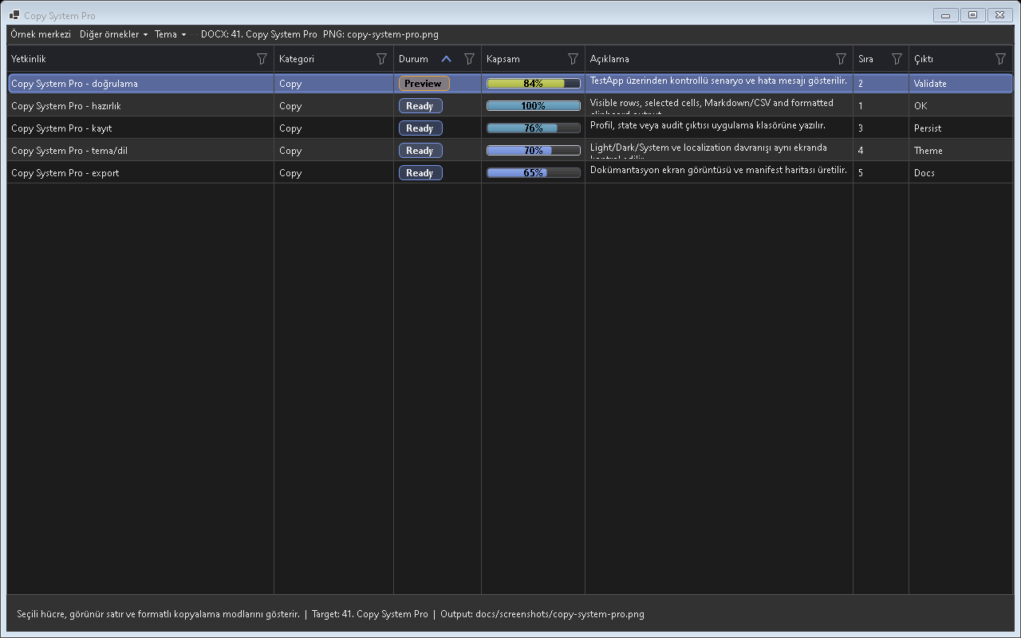
Figure - Copy System Pro / Advanced copy behavior

Usage scenarios
- Ctrl+C
- JSON
- Markdown
- Headers
- Visible columns

Best practices
- The feature should be enabled in the default profile or preset according to project needs.
- In line with the Designer-First standard, permanent control layouts should be kept in Designer.cs.
- A release should not be made before theme and localization behavior are tested.
- For large-data scenarios, Virtual Mode or UltraFast Mode should be considered.
- The example for this feature should be easy for the user to find inside Example Center.

Why is it important?
Copy System Pro ozelligi Gridly icinde tek basina bir gorsel mod veya davranis degil, uygulama genelinde tekrar eden UI kodunu standartlastiran bir katmandir. Bu sayede farkli projelerde ayni deneyim korunur; Audix, AOI Support Desk, Line Workspace ve Bilge Defter gibi projeler ayni API mantigi ile ilerler.

Points to watch while using it
- Differences between the feature's default behavior and project needs should first be checked in TestApp.
- Dark and Light themes should always be tested with the same data set.
- For screens containing large volumes of data or many visuals, a lazy-loading/cache strategy should be evaluated.
- Texts that need to appear on the user side should come from localization keys.
- Without breaking the Designer.cs standard, permanent controls should remain visible at design time.

Test checklist
- When a filter is applied, does the view show the correct row count?
- When the theme changes, is text, button, and badge contrast sufficient?
- When ViewMode changes, does any old layout cache or row height carry over?
- After saving/loading a profile, are the columns, filters, and view mode preserved?
- Are export or copy outputs consistent with the visible data?

Code examples
grid.CopySelection(GridlyCopyFormat.Json);
grid.CopySelection(GridlyCopyFormat.Json);
grid.CopySelection(GridlyCopyFormat.Json);
grid.CopySelection(GridlyCopyFormat.Json);
grid.CopySelection(GridlyCopyFormat.Json);
Project note: When the Copy System Pro feature is used in real projects such as Audix, AOI Support Desk, Line Workspace, or Bilge Defter, it should first be validated with the related example in TestApp.

42. Export Engine
PDF, CSV, JSON and Excel ciktilari uretir.

Usage scenarios
- PDF
- CSV
- JSON
- Excel
- Print friendly

Best practices
- The feature should be enabled in the default profile or preset according to project needs.
- In line with the Designer-First standard, permanent control layouts should be kept in Designer.cs.
- A release should not be made before theme and localization behavior are tested.
- For large-data scenarios, Virtual Mode or UltraFast Mode should be considered.
- The example for this feature should be easy for the user to find inside Example Center.

Why is it important?
Export Engine ozelligi Gridly icinde tek basina bir gorsel mod veya davranis degil, uygulama genelinde tekrar eden UI kodunu standartlastiran bir katmandir. Bu sayede farkli projelerde ayni deneyim korunur; Audix, AOI Support Desk, Line Workspace ve Bilge Defter gibi projeler ayni API mantigi ile ilerler.

Points to watch while using it
- Differences between the feature's default behavior and project needs should first be checked in TestApp.
- Dark and Light themes should always be tested with the same data set.
- For screens containing large volumes of data or many visuals, a lazy-loading/cache strategy should be evaluated.
- Texts that need to appear on the user side should come from localization keys.
- Without breaking the Designer.cs standard, permanent controls should remain visible at design time.

Test checklist
- When a filter is applied, does the view show the correct row count?
- When the theme changes, is text, button, and badge contrast sufficient?
- When ViewMode changes, does any old layout cache or row height carry over?
- After saving/loading a profile, are the columns, filters, and view mode preserved?
- Are export or copy outputs consistent with the visible data?
Details and Card/Dashboard PDF export seçenekleri.
Kart and dashboard görünümünün PDF çıktısı.

Code examples
grid.Exporting.ExportExcel("rows.xlsx", options);
grid.Exporting.ExportExcel("rows.xlsx", options);
grid.Exporting.ExportExcel("rows.xlsx", options);
grid.Exporting.ExportExcel("rows.xlsx", options);
grid.Exporting.ExportExcel("rows.xlsx", options);
Project note: When the Export Engine feature is used in real projects such as Audix, AOI Support Desk, Line Workspace, or Bilge Defter, it should first be validated with the related example in TestApp.

43. Virtual Mode
Buyuk andri setlerinde sayfali andri cekme modeli provides.
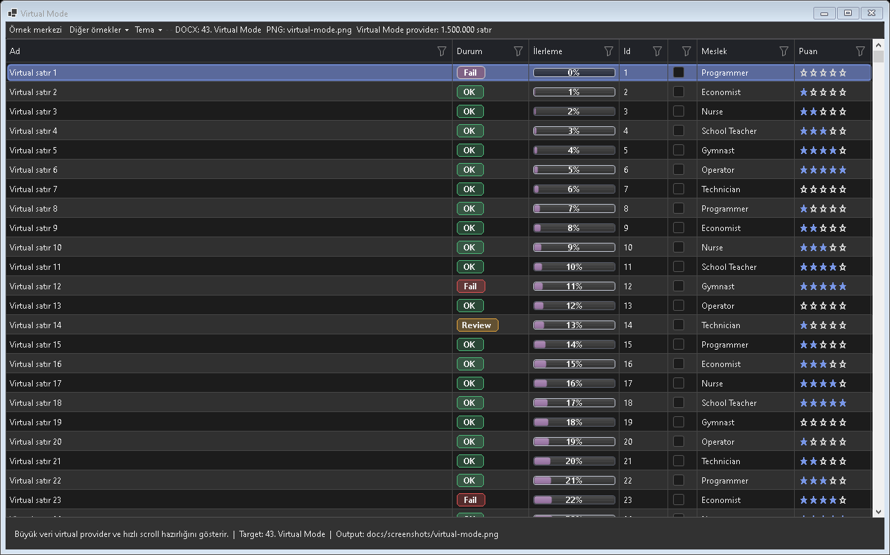
Figure - Virtual Mode / Large-data rendering

Usage scenarios
- CountAsync
- FetchAsync
- Serandr sort
- Serandr filter
- Cancellation

Best practices
- The feature should be enabled in the default profile or preset according to project needs.
- In line with the Designer-First standard, permanent control layouts should be kept in Designer.cs.
- A release should not be made before theme and localization behavior are tested.
- For large-data scenarios, Virtual Mode or UltraFast Mode should be considered.
- The example for this feature should be easy for the user to find inside Example Center.

Why is it important?
Virtual Mode ozelligi Gridly icinde tek basina bir gorsel mod veya davranis degil, uygulama genelinde tekrar eden UI kodunu standartlastiran bir katmandir. Bu sayede farkli projelerde ayni deneyim korunur; Audix, AOI Support Desk, Line Workspace ve Bilge Defter gibi projeler ayni API mantigi ile ilerler.

Points to watch while using it
- Differences between the feature's default behavior and project needs should first be checked in TestApp.
- Dark and Light themes should always be tested with the same data set.
- For screens containing large volumes of data or many visuals, a lazy-loading/cache strategy should be evaluated.
- Texts that need to appear on the user side should come from localization keys.
- Without breaking the Designer.cs standard, permanent controls should remain visible at design time.

Test checklist
- When a filter is applied, does the view show the correct row count?
- When the theme changes, is text, button, and badge contrast sufficient?
- When ViewMode changes, does any old layout cache or row height carry over?
- After saving/loading a profile, are the columns, filters, and view mode preserved?
- Are export or copy outputs consistent with the visible data?

Code examples
grid.VirtualMode = true;
grid.VirtualMode = true;
grid.VirtualMode = true;
grid.VirtualMode = true;
grid.VirtualMode = true;
Project note: When the Virtual Mode feature is used in real projects such as Audix, AOI Support Desk, Line Workspace, or Bilge Defter, it should first be validated with the related example in TestApp.

44. Ultra Fast Mode
Reflection, layout and cizim maliyetlerini azaltir.

Usage scenarios
- Aspect cache
- Batch update
- Skip invisible
- Resource reuse
- First paint

Best practices
- The feature should be enabled in the default profile or preset according to project needs.
- In line with the Designer-First standard, permanent control layouts should be kept in Designer.cs.
- A release should not be made before theme and localization behavior are tested.
- For large-data scenarios, Virtual Mode or UltraFast Mode should be considered.
- The example for this feature should be easy for the user to find inside Example Center.

Why is it important?
Ultra Fast Mode ozelligi Gridly icinde tek basina bir gorsel mod veya davranis degil, uygulama genelinde tekrar eden UI kodunu standartlastiran bir katmandir. Bu sayede farkli projelerde ayni deneyim korunur; Audix, AOI Support Desk, Line Workspace ve Bilge Defter gibi projeler ayni API mantigi ile ilerler.

Points to watch while using it
- Differences between the feature's default behavior and project needs should first be checked in TestApp.
- Dark and Light themes should always be tested with the same data set.
- For screens containing large volumes of data or many visuals, a lazy-loading/cache strategy should be evaluated.
- Texts that need to appear on the user side should come from localization keys.
- Without breaking the Designer.cs standard, permanent controls should remain visible at design time.

Test checklist
- When a filter is applied, does the view show the correct row count?
- When the theme changes, is text, button, and badge contrast sufficient?
- When ViewMode changes, does any old layout cache or row height carry over?
- After saving/loading a profile, are the columns, filters, and view mode preserved?
- Are export or copy outputs consistent with the visible data?
Performance Pro and büyük andri hazırlıkları.

Code examples
grid.UltraFastMode = true;
grid.UltraFastMode = true;
grid.UltraFastMode = true;
grid.UltraFastMode = true;
grid.UltraFastMode = true;
Project note: When the Ultra Fast Mode feature is used in real projects such as Audix, AOI Support Desk, Line Workspace, or Bilge Defter, it should first be validated with the related example in TestApp.

45. Stress Test
10K/100K/1M gibi performans senaryolarini olcer.
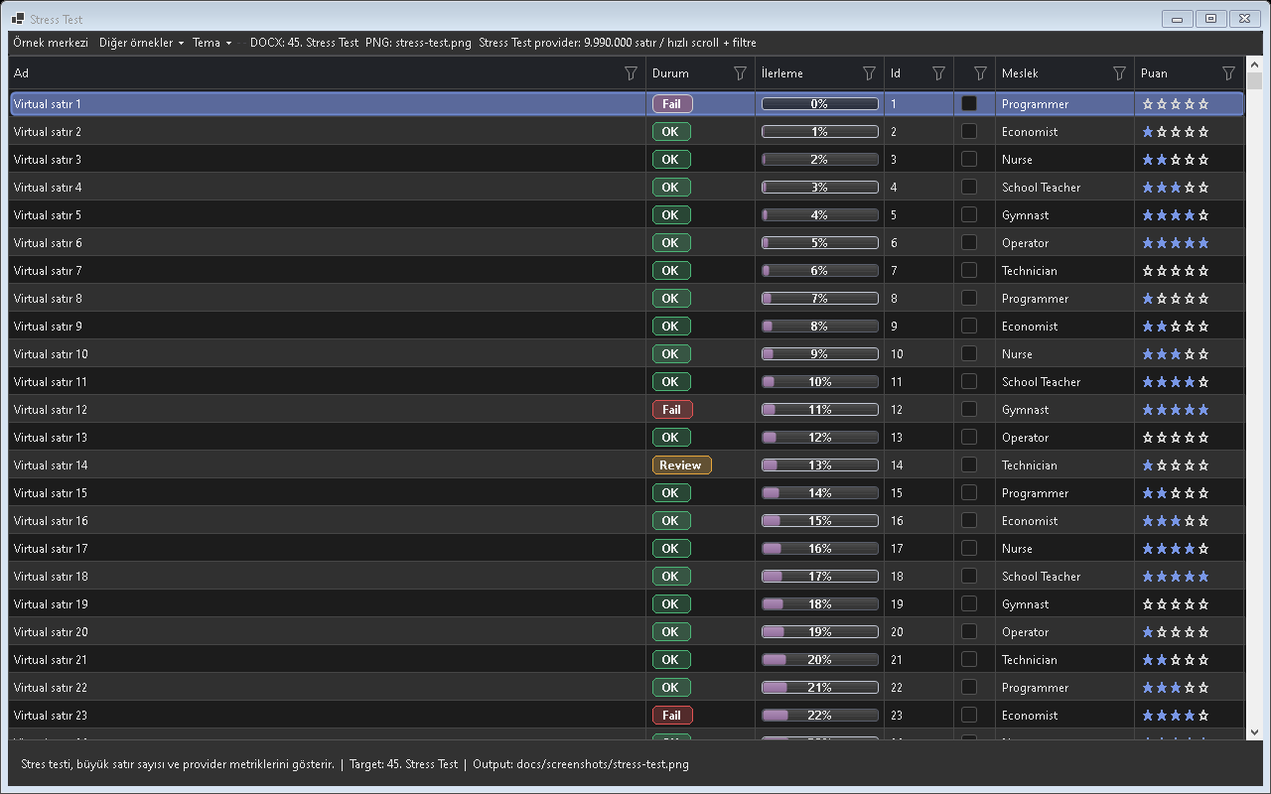
Figure - Stress Test / Performance test

Usage scenarios
- 10K normal
- 100K filter
- 1M virtual
- Memory
- Scroll

Best practices
- The feature should be enabled in the default profile or preset according to project needs.
- In line with the Designer-First standard, permanent control layouts should be kept in Designer.cs.
- A release should not be made before theme and localization behavior are tested.
- For large-data scenarios, Virtual Mode or UltraFast Mode should be considered.
- The example for this feature should be easy for the user to find inside Example Center.

Why is it important?
Stress Test ozelligi Gridly icinde tek basina bir gorsel mod veya davranis degil, uygulama genelinde tekrar eden UI kodunu standartlastiran bir katmandir. Bu sayede farkli projelerde ayni deneyim korunur; Audix, AOI Support Desk, Line Workspace ve Bilge Defter gibi projeler ayni API mantigi ile ilerler.

Points to watch while using it
- Differences between the feature's default behavior and project needs should first be checked in TestApp.
- Dark and Light themes should always be tested with the same data set.
- For screens containing large volumes of data or many visuals, a lazy-loading/cache strategy should be evaluated.
- Texts that need to appear on the user side should come from localization keys.
- Without breaking the Designer.cs standard, permanent controls should remain visible at design time.

Test checklist
- When a filter is applied, does the view show the correct row count?
- When the theme changes, is text, button, and badge contrast sufficient?
- When ViewMode changes, does any old layout cache or row height carry over?
- After saving/loading a profile, are the columns, filters, and view mode preserved?
- Are export or copy outputs consistent with the visible data?

Code examples
var result = await GridlyStressRunner.RunAsync(grid, scenario);
var result = await GridlyStressRunner.RunAsync(grid, scenario);
var result = await GridlyStressRunner.RunAsync(grid, scenario);
var result = await GridlyStressRunner.RunAsync(grid, scenario);
var result = await GridlyStressRunner.RunAsync(grid, scenario);
Project note: When the Stress Test feature is used in real projects such as Audix, AOI Support Desk, Line Workspace, or Bilge Defter, it should first be validated with the related example in TestApp.

46. Theme Engine
Light, Dark, System and High Contrast paletlerini manages.
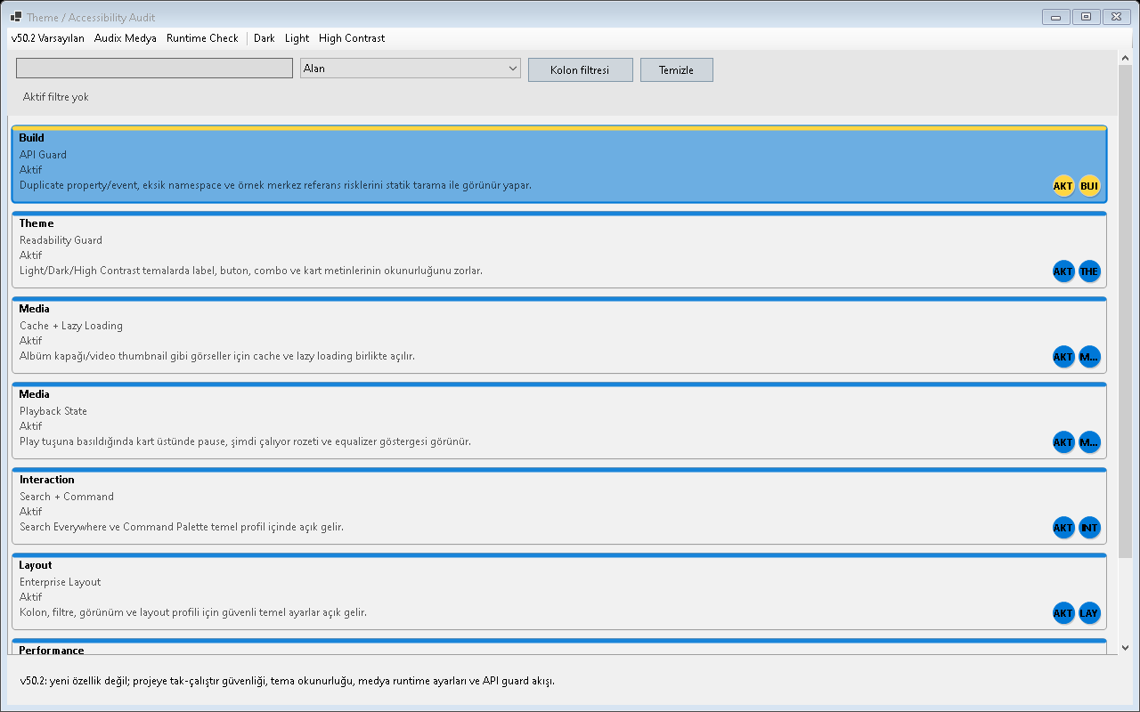
Figure - Theme Engine / Dark theme audit

Usage scenarios
- Light
- Dark
- Auto
- High contrast
- Windows accent

Best practices
- The feature should be enabled in the default profile or preset according to project needs.
- In line with the Designer-First standard, permanent control layouts should be kept in Designer.cs.
- A release should not be made before theme and localization behavior are tested.
- For large-data scenarios, Virtual Mode or UltraFast Mode should be considered.
- The example for this feature should be easy for the user to find inside Example Center.

Why is it important?
Theme Engine ozelligi Gridly icinde tek basina bir gorsel mod veya davranis degil, uygulama genelinde tekrar eden UI kodunu standartlastiran bir katmandir. Bu sayede farkli projelerde ayni deneyim korunur; Audix, AOI Support Desk, Line Workspace ve Bilge Defter gibi projeler ayni API mantigi ile ilerler.

Points to watch while using it
- Differences between the feature's default behavior and project needs should first be checked in TestApp.
- Dark and Light themes should always be tested with the same data set.
- For screens containing large volumes of data or many visuals, a lazy-loading/cache strategy should be evaluated.
- Texts that need to appear on the user side should come from localization keys.
- Without breaking the Designer.cs standard, permanent controls should remain visible at design time.

Test checklist
- When a filter is applied, does the view show the correct row count?
- When the theme changes, is text, button, and badge contrast sufficient?
- When ViewMode changes, does any old layout cache or row height carry over?
- After saving/loading a profile, are the columns, filters, and view mode preserved?
- Are export or copy outputs consistent with the visible data?
Dark theme okunurluğu and güandnli varsayılanlar.
Light theme okunurluğu and güandnli varsayılanlar.
Kontrast, button, combo and bilgi metni okunurluk testi.

Code examples
// Ornek 1: Tema uygulama
grid.Theme = GridlyTheme.Light;
grid.ThemeOptions.ApplyToPopups = true;
grid.Invalidate();
// Ornek 2: Tema uygulama
grid.Theme = GridlyTheme.Dark;
grid.ThemeOptions.ApplyToPopups = true;
grid.Invalidate();
// Ornek 3: Tema uygulama
grid.Theme = GridlyTheme.Auto;
grid.ThemeOptions.ApplyToPopups = true;
grid.Invalidate();
// Ornek 4: Tema uygulama
grid.Theme = GridlyTheme.HighContrast;
grid.ThemeOptions.ApplyToPopups = true;
grid.Invalidate();
// Ornek 5: Tema uygulama
grid.Theme = GridlyTheme.Dark;
grid.ThemeOptions.ApplyToPopups = true;
grid.Invalidate();
Project note: When the Theme Engine feature is used in real projects such as Audix, AOI Support Desk, Line Workspace, or Bilge Defter, it should first be validated with the related example in TestApp.

47. Accessibility Engine
Kontrast and okunabilirlik kurallarini uygular.

Usage scenarios
- Text contrast
- Button contrast
- Badge contrast
- Dark mode
- WCAG

Best practices
- The feature should be enabled in the default profile or preset according to project needs.
- In line with the Designer-First standard, permanent control layouts should be kept in Designer.cs.
- A release should not be made before theme and localization behavior are tested.
- For large-data scenarios, Virtual Mode or UltraFast Mode should be considered.
- The example for this feature should be easy for the user to find inside Example Center.

Why is it important?
Accessibility Engine ozelligi Gridly icinde tek basina bir gorsel mod veya davranis degil, uygulama genelinde tekrar eden UI kodunu standartlastiran bir katmandir. Bu sayede farkli projelerde ayni deneyim korunur; Audix, AOI Support Desk, Line Workspace ve Bilge Defter gibi projeler ayni API mantigi ile ilerler.

Points to watch while using it
- Differences between the feature's default behavior and project needs should first be checked in TestApp.
- Dark and Light themes should always be tested with the same data set.
- For screens containing large volumes of data or many visuals, a lazy-loading/cache strategy should be evaluated.
- Texts that need to appear on the user side should come from localization keys.
- Without breaking the Designer.cs standard, permanent controls should remain visible at design time.

Test checklist
- When a filter is applied, does the view show the correct row count?
- When the theme changes, is text, button, and badge contrast sufficient?
- When ViewMode changes, does any old layout cache or row height carry over?
- After saving/loading a profile, are the columns, filters, and view mode preserved?
- Are export or copy outputs consistent with the visible data?
Klavye odaklı kullanım, düzenleme and kısayollar.

Code examples
grid.ThemeOptions.EnforceAccessibility = true;
grid.ThemeOptions.EnforceAccessibility = true;
grid.ThemeOptions.EnforceAccessibility = true;
grid.ThemeOptions.EnforceAccessibility = true;
grid.ThemeOptions.EnforceAccessibility = true;
Project note: When the Accessibility Engine feature is used in real projects such as Audix, AOI Support Desk, Line Workspace, or Bilge Defter, it should first be validated with the related example in TestApp.

48. High DPI
Farkli ekran olceklerinde UI bozulmasini azaltir.
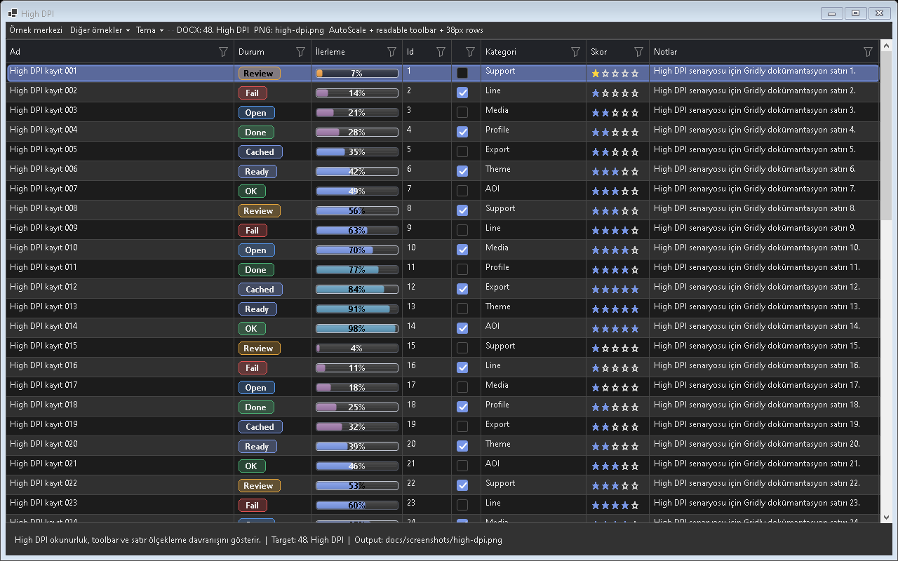
Figure - High DPI / High-DPI rendering test

Usage scenarios
- 125%
- 150%
- Icon scale
- Popup fit
- Font scale

Best practices
- The feature should be enabled in the default profile or preset according to project needs.
- In line with the Designer-First standard, permanent control layouts should be kept in Designer.cs.
- A release should not be made before theme and localization behavior are tested.
- For large-data scenarios, Virtual Mode or UltraFast Mode should be considered.
- The example for this feature should be easy for the user to find inside Example Center.

Why is it important?
High DPI ozelligi Gridly icinde tek basina bir gorsel mod veya davranis degil, uygulama genelinde tekrar eden UI kodunu standartlastiran bir katmandir. Bu sayede farkli projelerde ayni deneyim korunur; Audix, AOI Support Desk, Line Workspace ve Bilge Defter gibi projeler ayni API mantigi ile ilerler.

Points to watch while using it
- Differences between the feature's default behavior and project needs should first be checked in TestApp.
- Dark and Light themes should always be tested with the same data set.
- For screens containing large volumes of data or many visuals, a lazy-loading/cache strategy should be evaluated.
- Texts that need to appear on the user side should come from localization keys.
- Without breaking the Designer.cs standard, permanent controls should remain visible at design time.

Test checklist
- When a filter is applied, does the view show the correct row count?
- When the theme changes, is text, button, and badge contrast sufficient?
- When ViewMode changes, does any old layout cache or row height carry over?
- After saving/loading a profile, are the columns, filters, and view mode preserved?
- Are export or copy outputs consistent with the visible data?

Code examples
grid.DpiOptions.EnableDpiAwareLayout = true;
grid.DpiOptions.EnableDpiAwareLayout = true;
grid.DpiOptions.EnableDpiAwareLayout = true;
grid.DpiOptions.EnableDpiAwareLayout = true;
grid.DpiOptions.EnableDpiAwareLayout = true;
Project note: When the High DPI feature is used in real projects such as Audix, AOI Support Desk, Line Workspace, or Bilge Defter, it should first be validated with the related example in TestApp.

49. Localization
Manages Gridly texts and the TestApp language centrally.
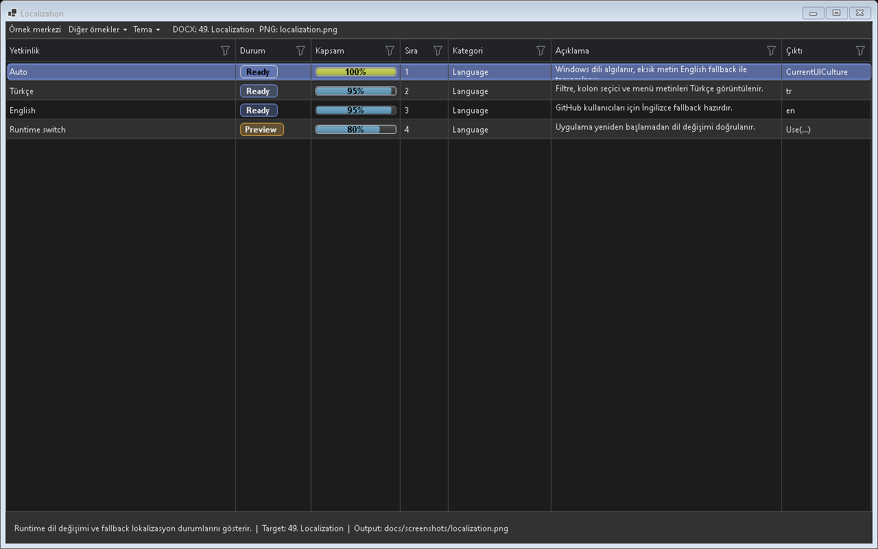
Figure - Localization / Language switching

Usage scenarios
- Use tr
- Use en
- Runtime change
- Custom resources
- Persist choice

Best practices
- The feature should be enabled in the default profile or preset according to project needs.
- In line with the Designer-First standard, permanent control layouts should be kept in Designer.cs.
- A release should not be made before theme and localization behavior are tested.
- For large-data scenarios, Virtual Mode or UltraFast Mode should be considered.
- The example for this feature should be easy for the user to find inside Example Center.

Why is it important?
Localization ozelligi Gridly icinde tek basina bir gorsel mod veya davranis degil, uygulama genelinde tekrar eden UI kodunu standartlastiran bir katmandir. Bu sayede farkli projelerde ayni deneyim korunur; Audix, AOI Support Desk, Line Workspace ve Bilge Defter gibi projeler ayni API mantigi ile ilerler.

Points to watch while using it
- Differences between the feature's default behavior and project needs should first be checked in TestApp.
- Dark and Light themes should always be tested with the same data set.
- For screens containing large volumes of data or many visuals, a lazy-loading/cache strategy should be evaluated.
- Texts that need to appear on the user side should come from localization keys.
- Without breaking the Designer.cs standard, permanent controls should remain visible at design time.

Test checklist
- When a filter is applied, does the view show the correct row count?
- When the theme changes, is text, button, and badge contrast sufficient?
- When ViewMode changes, does any old layout cache or row height carry over?
- After saving/loading a profile, are the columns, filters, and view mode preserved?
- Are export or copy outputs consistent with the visible data?

Code examples
// Ornek 1: Dil secimi
GridlyLocalization.Use("tr");
grid.RefreshLocalization();
// Ornek 2: Dil secimi
GridlyLocalization.Use("en");
grid.RefreshLocalization();
// Ornek 3: Dil secimi
GridlyLocalization.Use("de");
grid.RefreshLocalization();
// Ornek 4: Dil secimi
GridlyLocalization.Use("fr");
grid.RefreshLocalization();
// Ornek 5: Dil secimi
GridlyLocalization.Use("es");
grid.RefreshLocalization();
Project note: When the Localization feature is used in real projects such as Audix, AOI Support Desk, Line Workspace, or Bilge Defter, it should first be validated with the related example in TestApp.

50. FixedFree Resize
Intelligently manages column expansion by using available empty space.
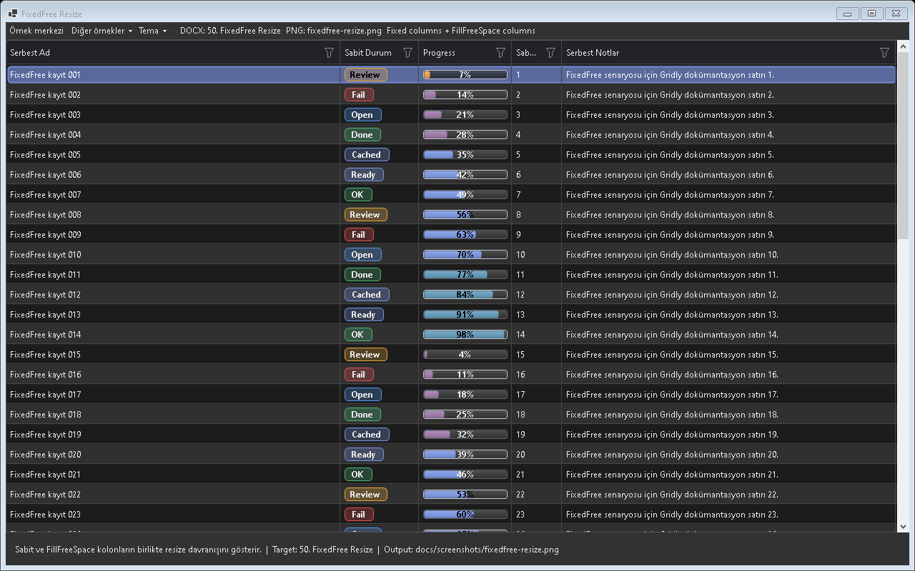
Figure - FixedFree Resize / Fixed-free width behavior

Usage scenarios
- Auto fill
- No scroll until needed
- Min width
- Pinned columns
- User resize

Best practices
- The feature should be enabled in the default profile or preset according to project needs.
- In line with the Designer-First standard, permanent control layouts should be kept in Designer.cs.
- A release should not be made before theme and localization behavior are tested.
- For large-data scenarios, Virtual Mode or UltraFast Mode should be considered.
- The example for this feature should be easy for the user to find inside Example Center.

Why is it important?
FixedFree Resize ozelligi Gridly icinde tek basina bir gorsel mod veya davranis degil, uygulama genelinde tekrar eden UI kodunu standartlastiran bir katmandir. Bu sayede farkli projelerde ayni deneyim korunur; Audix, AOI Support Desk, Line Workspace ve Bilge Defter gibi projeler ayni API mantigi ile ilerler.

Points to watch while using it
- Differences between the feature's default behavior and project needs should first be checked in TestApp.
- Dark and Light themes should always be tested with the same data set.
- For screens containing large volumes of data or many visuals, a lazy-loading/cache strategy should be evaluated.
- Texts that need to appear on the user side should come from localization keys.
- Without breaking the Designer.cs standard, permanent controls should remain visible at design time.

Test checklist
- When a filter is applied, does the view show the correct row count?
- When the theme changes, is text, button, and badge contrast sufficient?
- When ViewMode changes, does any old layout cache or row height carry over?
- After saving/loading a profile, are the columns, filters, and view mode preserved?
- Are export or copy outputs consistent with the visible data?

Code examples
grid.AutoFillRemainingSpace = true;
grid.AutoFillRemainingSpace = true;
grid.AutoFillRemainingSpace = true;
grid.AutoFillRemainingSpace = true;
grid.AutoFillRemainingSpace = true;
Project note: When the FixedFree Resize feature is used in real projects such as Audix, AOI Support Desk, Line Workspace, or Bilge Defter, it should first be validated with the related example in TestApp.

51. Media Playback State
Shows play, pause, loading, and error states on audio/video cards.
Screenshot note: Existing media screenshots did not isolate this feature clearly enough, so they were not used here.

Usage scenarios
- Play
- Pause
- Now Playing
- Equalizer
- Video preview

Best practices
- The feature should be enabled in the default profile or preset according to project needs.
- In line with the Designer-First standard, permanent control layouts should be kept in Designer.cs.
- A release should not be made before theme and localization behavior are tested.
- For large-data scenarios, Virtual Mode or UltraFast Mode should be considered.
- The example for this feature should be easy for the user to find inside Example Center.

Why is it important?
Media Playback State ozelligi Gridly icinde tek basina bir gorsel mod veya davranis degil, uygulama genelinde tekrar eden UI kodunu standartlastiran bir katmandir. Bu sayede farkli projelerde ayni deneyim korunur; Audix, AOI Support Desk, Line Workspace ve Bilge Defter gibi projeler ayni API mantigi ile ilerler.

Points to watch while using it
- Differences between the feature's default behavior and project needs should first be checked in TestApp.
- Dark and Light themes should always be tested with the same data set.
- For screens containing large volumes of data or many visuals, a lazy-loading/cache strategy should be evaluated.
- Texts that need to appear on the user side should come from localization keys.
- Without breaking the Designer.cs standard, permanent controls should remain visible at design time.

Test checklist
- When a filter is applied, does the view show the correct row count?
- When the theme changes, is text, button, and badge contrast sufficient?
- When ViewMode changes, does any old layout cache or row height carry over?
- After saving/loading a profile, are the columns, filters, and view mode preserved?
- Are export or copy outputs consistent with the visible data?
Audio/video için Playing görsel durumu.
Audio/video için Paused görsel durumu.

Media Playback State - Loading and Error
Loading, Error and özel medya durumlarının dokümantasyon görüntüsü.

Code examples
// Ornek 1: Playback state
grid.MediaPlaybackStateGetter = row => ((TrackRow)row).IsCurrent
? GridlyMediaPlaybackState.Playing
: GridlyMediaPlaybackState.None;
grid.MediaPlayPauseClicked += (s, e) => TogglePlayback((TrackRow)e.RowObject);
// Ornek 2: Playback state
grid.MediaPlaybackStateGetter = row => ((TrackRow)row).IsCurrent
? GridlyMediaPlaybackState.Paused
: GridlyMediaPlaybackState.None;
grid.MediaPlayPauseClicked += (s, e) => TogglePlayback((TrackRow)e.RowObject);
// Ornek 3: Playback state
grid.MediaPlaybackStateGetter = row => ((TrackRow)row).IsCurrent
? GridlyMediaPlaybackState.Loading
: GridlyMediaPlaybackState.None;
grid.MediaPlayPauseClicked += (s, e) => TogglePlayback((TrackRow)e.RowObject);
// Ornek 4: Playback state
grid.MediaPlaybackStateGetter = row => ((TrackRow)row).IsCurrent
? GridlyMediaPlaybackState.Error
: GridlyMediaPlaybackState.None;
grid.MediaPlayPauseClicked += (s, e) => TogglePlayback((TrackRow)e.RowObject);
// Ornek 5: Playback state
grid.MediaPlaybackStateGetter = row => ((TrackRow)row).IsCurrent
? GridlyMediaPlaybackState.None
: GridlyMediaPlaybackState.None;
grid.MediaPlayPauseClicked += (s, e) => TogglePlayback((TrackRow)e.RowObject);
Project note: When the Media Playback State feature is used in real projects such as Audix, AOI Support Desk, Line Workspace, or Bilge Defter, it should first be validated with the related example in TestApp.

52. Image Cache
Speeds up album/film/photo covers with memory and disk cache.
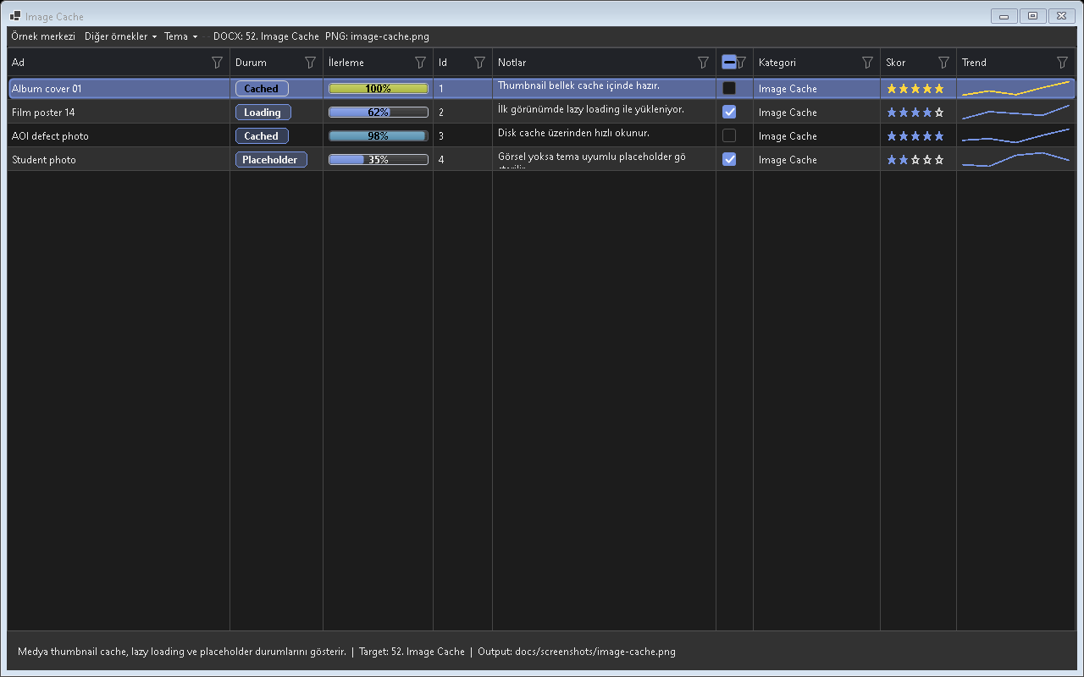
Figure - Image Cache / Image caching

Usage scenarios
- Lazy load
- Disk cache
- Placeholder
- Refresh
- Clear cache

Best practices
- The feature should be enabled in the default profile or preset according to project needs.
- In line with the Designer-First standard, permanent control layouts should be kept in Designer.cs.
- A release should not be made before theme and localization behavior are tested.
- For large-data scenarios, Virtual Mode or UltraFast Mode should be considered.
- The example for this feature should be easy for the user to find inside Example Center.

Why is it important?
Image Cache ozelligi Gridly icinde tek basina bir gorsel mod veya davranis degil, uygulama genelinde tekrar eden UI kodunu standartlastiran bir katmandir. Bu sayede farkli projelerde ayni deneyim korunur; Audix, AOI Support Desk, Line Workspace ve Bilge Defter gibi projeler ayni API mantigi ile ilerler.

Points to watch while using it
- Differences between the feature's default behavior and project needs should first be checked in TestApp.
- Dark and Light themes should always be tested with the same data set.
- For screens containing large volumes of data or many visuals, a lazy-loading/cache strategy should be evaluated.
- Texts that need to appear on the user side should come from localization keys.
- Without breaking the Designer.cs standard, permanent controls should remain visible at design time.

Test checklist
- When a filter is applied, does the view show the correct row count?
- When the theme changes, is text, button, and badge contrast sufficient?
- When ViewMode changes, does any old layout cache or row height carry over?
- After saving/loading a profile, are the columns, filters, and view mode preserved?
- Are export or copy outputs consistent with the visible data?

Code examples
grid.MediaImageCache.Enabled = true;
grid.MediaImageCache.Enabled = true;
grid.MediaImageCache.Enabled = true;
grid.MediaImageCache.Enabled = true;
grid.MediaImageCache.Enabled = true;
Project note: When the Image Cache feature is used in real projects such as Audix, AOI Support Desk, Line Workspace, or Bilge Defter, it should first be validated with the related example in TestApp.

53. Search Everywhere
Finds rows, columns, commands, and examples through global search.
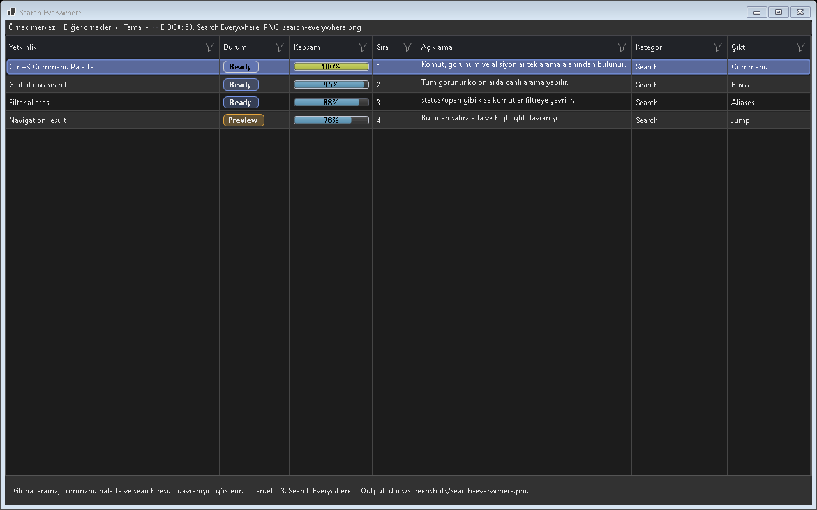
Figure - Search Everywhere / Global search

Usage scenarios
- Ctrl+K
- Rows
- Columns
- Commands
- Examples

Best practices
- The feature should be enabled in the default profile or preset according to project needs.
- In line with the Designer-First standard, permanent control layouts should be kept in Designer.cs.
- A release should not be made before theme and localization behavior are tested.
- For large-data scenarios, Virtual Mode or UltraFast Mode should be considered.
- The example for this feature should be easy for the user to find inside Example Center.

Why is it important?
Search Everywhere ozelligi Gridly icinde tek basina bir gorsel mod veya davranis degil, uygulama genelinde tekrar eden UI kodunu standartlastiran bir katmandir. Bu sayede farkli projelerde ayni deneyim korunur; Audix, AOI Support Desk, Line Workspace ve Bilge Defter gibi projeler ayni API mantigi ile ilerler.

Points to watch while using it
- Differences between the feature's default behavior and project needs should first be checked in TestApp.
- Dark and Light themes should always be tested with the same data set.
- For screens containing large volumes of data or many visuals, a lazy-loading/cache strategy should be evaluated.
- Texts that need to appear on the user side should come from localization keys.
- Without breaking the Designer.cs standard, permanent controls should remain visible at design time.

Test checklist
- When a filter is applied, does the view show the correct row count?
- When the theme changes, is text, button, and badge contrast sufficient?
- When ViewMode changes, does any old layout cache or row height carry over?
- After saving/loading a profile, are the columns, filters, and view mode preserved?
- Are export or copy outputs consistent with the visible data?

Code examples
grid.EnableSearchEverywhere = true;
grid.EnableSearchEverywhere = true;
grid.EnableSearchEverywhere = true;
grid.EnableSearchEverywhere = true;
grid.EnableSearchEverywhere = true;
Project note: When the Search Everywhere feature is used in real projects such as Audix, AOI Support Desk, Line Workspace, or Bilge Defter, it should first be validated with the related example in TestApp.

54. Command Palette
Allows command execution from the keyboard.
Screenshot note: A separate verified screenshot is still pending for Command Palette.

Usage scenarios
- Open palette
- Export
- Clear filters
- Change view
- Load profile

Best practices
- The feature should be enabled in the default profile or preset according to project needs.
- In line with the Designer-First standard, permanent control layouts should be kept in Designer.cs.
- A release should not be made before theme and localization behavior are tested.
- For large-data scenarios, Virtual Mode or UltraFast Mode should be considered.
- The example for this feature should be easy for the user to find inside Example Center.

Why is it important?
Command Palette ozelligi Gridly icinde tek basina bir gorsel mod veya davranis degil, uygulama genelinde tekrar eden UI kodunu standartlastiran bir katmandir. Bu sayede farkli projelerde ayni deneyim korunur; Audix, AOI Support Desk, Line Workspace ve Bilge Defter gibi projeler ayni API mantigi ile ilerler.

Points to watch while using it
- Differences between the feature's default behavior and project needs should first be checked in TestApp.
- Dark and Light themes should always be tested with the same data set.
- For screens containing large volumes of data or many visuals, a lazy-loading/cache strategy should be evaluated.
- Texts that need to appear on the user side should come from localization keys.
- Without breaking the Designer.cs standard, permanent controls should remain visible at design time.

Test checklist
- When a filter is applied, does the view show the correct row count?
- When the theme changes, is text, button, and badge contrast sufficient?
- When ViewMode changes, does any old layout cache or row height carry over?
- After saving/loading a profile, are the columns, filters, and view mode preserved?
- Are export or copy outputs consistent with the visible data?
Sabit column, satır butonları and açılır detail paneli.

Code examples
grid.EnableCommandPalette = true;
grid.EnableCommandPalette = true;
grid.EnableCommandPalette = true;
grid.EnableCommandPalette = true;
grid.EnableCommandPalette = true;
Project note: When the Command Palette feature is used in real projects such as Audix, AOI Support Desk, Line Workspace, or Bilge Defter, it should first be validated with the related example in TestApp.

55. Inline Editing
Edits cells using TextBox, ComboBox, Numeric, and Date editors.
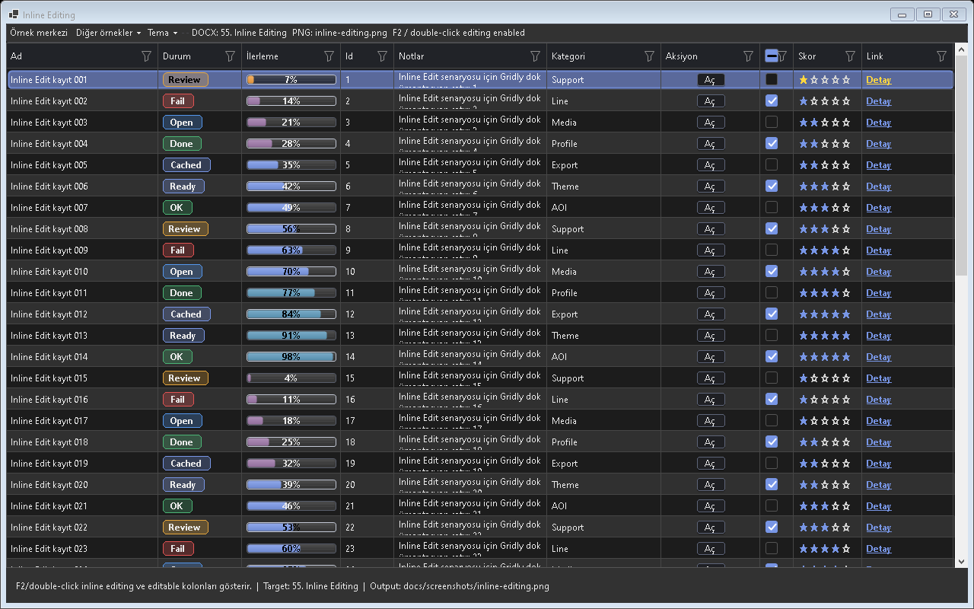
Figure - Inline Editing / In-cell editing

Usage scenarios
- F2 edit
- Combo
- Numeric
- Validation
- Change tracking

Best practices
- The feature should be enabled in the default profile or preset according to project needs.
- In line with the Designer-First standard, permanent control layouts should be kept in Designer.cs.
- A release should not be made before theme and localization behavior are tested.
- For large-data scenarios, Virtual Mode or UltraFast Mode should be considered.
- The example for this feature should be easy for the user to find inside Example Center.

Why is it important?
Inline Editing ozelligi Gridly icinde tek basina bir gorsel mod veya davranis degil, uygulama genelinde tekrar eden UI kodunu standartlastiran bir katmandir. Bu sayede farkli projelerde ayni deneyim korunur; Audix, AOI Support Desk, Line Workspace ve Bilge Defter gibi projeler ayni API mantigi ile ilerler.

Points to watch while using it
- Differences between the feature's default behavior and project needs should first be checked in TestApp.
- Dark and Light themes should always be tested with the same data set.
- For screens containing large volumes of data or many visuals, a lazy-loading/cache strategy should be evaluated.
- Texts that need to appear on the user side should come from localization keys.
- Without breaking the Designer.cs standard, permanent controls should remain visible at design time.

Test checklist
- When a filter is applied, does the view show the correct row count?
- When the theme changes, is text, button, and badge contrast sufficient?
- When ViewMode changes, does any old layout cache or row height carry over?
- After saving/loading a profile, are the columns, filters, and view mode preserved?
- Are export or copy outputs consistent with the visible data?

Code examples
column.Editable = true; column.EditorType = GridlyCellEditorType.ComboBox;
column.Editable = true; column.EditorType = GridlyCellEditorType.ComboBox;
column.Editable = true; column.EditorType = GridlyCellEditorType.ComboBox;
column.Editable = true; column.EditorType = GridlyCellEditorType.ComboBox;
column.Editable = true; column.EditorType = GridlyCellEditorType.ComboBox;
Project note: When the Inline Editing feature is used in real projects such as Audix, AOI Support Desk, Line Workspace, or Bilge Defter, it should first be validated with the related example in TestApp.

56. Drag and Drop
Manages row, card, or Kanban item drag-and-drop behavior.
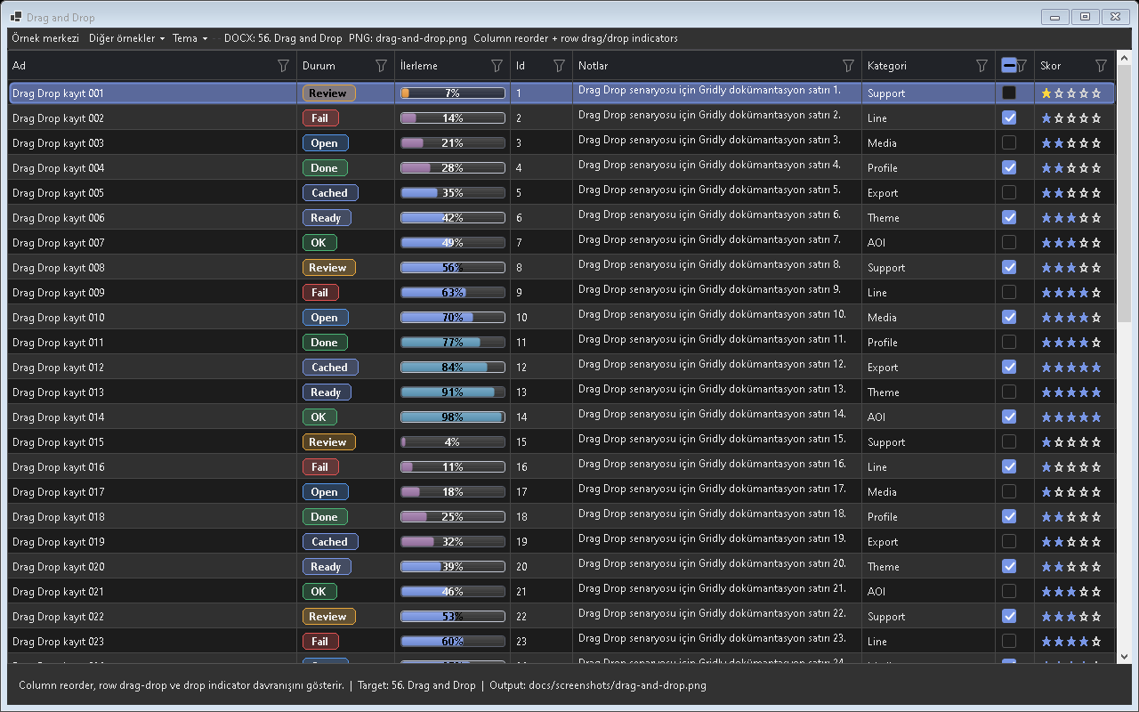
Figure - Drag and Drop / Drag-and-drop behavior

Usage scenarios
- Row reorder
- Card reorder
- Kanban moand
- Drop validation
- Sort update

Best practices
- The feature should be enabled in the default profile or preset according to project needs.
- In line with the Designer-First standard, permanent control layouts should be kept in Designer.cs.
- A release should not be made before theme and localization behavior are tested.
- For large-data scenarios, Virtual Mode or UltraFast Mode should be considered.
- The example for this feature should be easy for the user to find inside Example Center.

Why is it important?
Drag and Drop ozelligi Gridly icinde tek basina bir gorsel mod veya davranis degil, uygulama genelinde tekrar eden UI kodunu standartlastiran bir katmandir. Bu sayede farkli projelerde ayni deneyim korunur; Audix, AOI Support Desk, Line Workspace ve Bilge Defter gibi projeler ayni API mantigi ile ilerler.

Points to watch while using it
- Differences between the feature's default behavior and project needs should first be checked in TestApp.
- Dark and Light themes should always be tested with the same data set.
- For screens containing large volumes of data or many visuals, a lazy-loading/cache strategy should be evaluated.
- Texts that need to appear on the user side should come from localization keys.
- Without breaking the Designer.cs standard, permanent controls should remain visible at design time.

Test checklist
- When a filter is applied, does the view show the correct row count?
- When the theme changes, is text, button, and badge contrast sufficient?
- When ViewMode changes, does any old layout cache or row height carry over?
- After saving/loading a profile, are the columns, filters, and view mode preserved?
- Are export or copy outputs consistent with the visible data?

Code examples
grid.AllowRowDragDrop = true;
grid.AllowRowDragDrop = true;
grid.AllowRowDragDrop = true;
grid.AllowRowDragDrop = true;
grid.AllowRowDragDrop = true;
Project note: When the Drag and Drop feature is used in real projects such as Audix, AOI Support Desk, Line Workspace, or Bilge Defter, it should first be validated with the related example in TestApp.

57. Multi View Sync
Keeps the same data synchronized across multiple Gridly views.
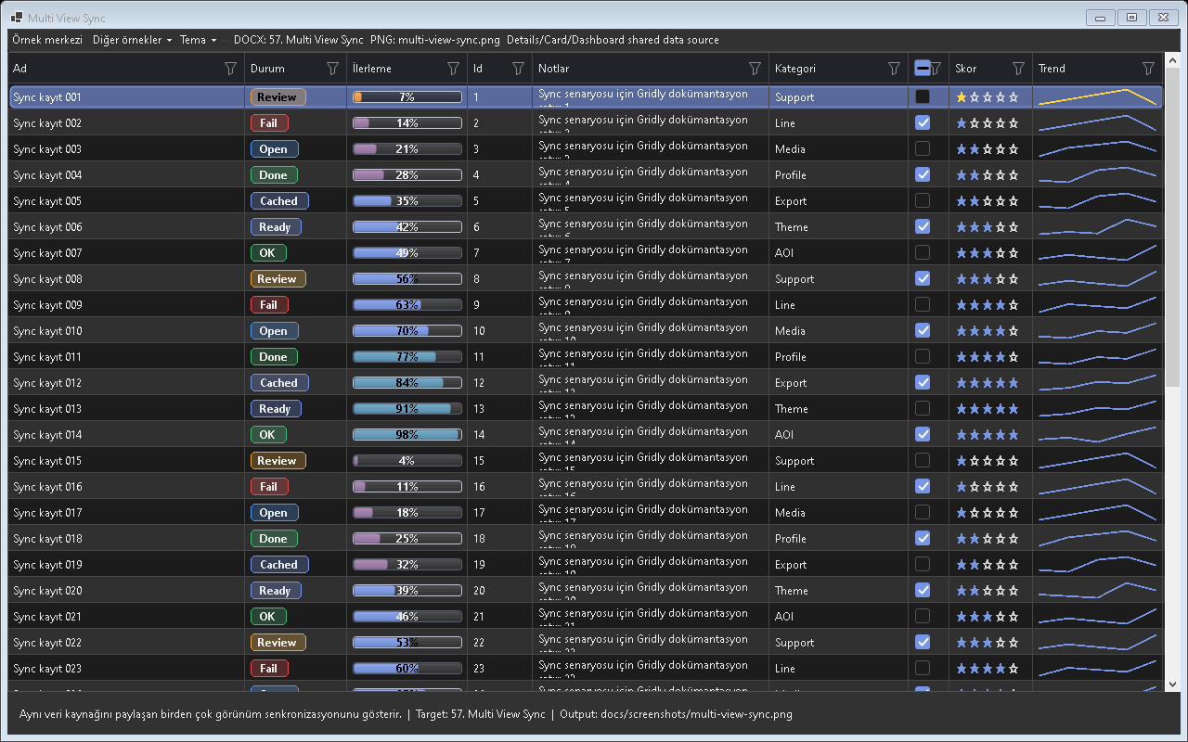
Figure - Multi View Sync / Multi-view synchronization

Usage scenarios
- Selection sync
- Filter sync
- Current object
- Details+Cards
- Eandnt bus

Best practices
- The feature should be enabled in the default profile or preset according to project needs.
- In line with the Designer-First standard, permanent control layouts should be kept in Designer.cs.
- A release should not be made before theme and localization behavior are tested.
- For large-data scenarios, Virtual Mode or UltraFast Mode should be considered.
- The example for this feature should be easy for the user to find inside Example Center.

Why is it important?
Multi View Sync ozelligi Gridly icinde tek basina bir gorsel mod veya davranis degil, uygulama genelinde tekrar eden UI kodunu standartlastiran bir katmandir. Bu sayede farkli projelerde ayni deneyim korunur; Audix, AOI Support Desk, Line Workspace ve Bilge Defter gibi projeler ayni API mantigi ile ilerler.

Points to watch while using it
- Differences between the feature's default behavior and project needs should first be checked in TestApp.
- Dark and Light themes should always be tested with the same data set.
- For screens containing large volumes of data or many visuals, a lazy-loading/cache strategy should be evaluated.
- Texts that need to appear on the user side should come from localization keys.
- Without breaking the Designer.cs standard, permanent controls should remain visible at design time.

Test checklist
- When a filter is applied, does the view show the correct row count?
- When the theme changes, is text, button, and badge contrast sufficient?
- When ViewMode changes, does any old layout cache or row height carry over?
- After saving/loading a profile, are the columns, filters, and view mode preserved?
- Are export or copy outputs consistent with the visible data?

Code examples
new GridlyViewSync(details, cards).Start();
new GridlyViewSync(details, cards).Start();
new GridlyViewSync(details, cards).Start();
new GridlyViewSync(details, cards).Start();
new GridlyViewSync(details, cards).Start();
Project note: When the Multi View Sync feature is used in real projects such as Audix, AOI Support Desk, Line Workspace, or Bilge Defter, it should first be validated with the related example in TestApp.

58. State Management
Stores scroll, selection, filter, sort, and view mode state.
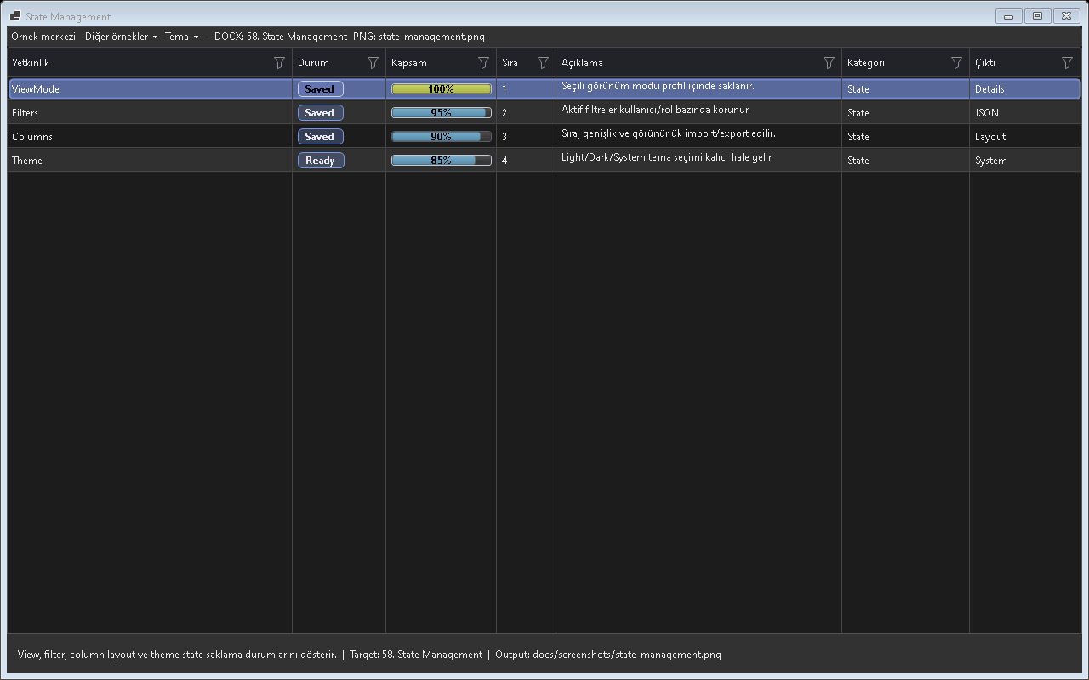
Figure - State Management / State persistence

Usage scenarios
- Capture
- Restore
- Session state
- Selection
- Scroll

Best practices
- The feature should be enabled in the default profile or preset according to project needs.
- In line with the Designer-First standard, permanent control layouts should be kept in Designer.cs.
- A release should not be made before theme and localization behavior are tested.
- For large-data scenarios, Virtual Mode or UltraFast Mode should be considered.
- The example for this feature should be easy for the user to find inside Example Center.

Why is it important?
State Management ozelligi Gridly icinde tek basina bir gorsel mod veya davranis degil, uygulama genelinde tekrar eden UI kodunu standartlastiran bir katmandir. Bu sayede farkli projelerde ayni deneyim korunur; Audix, AOI Support Desk, Line Workspace ve Bilge Defter gibi projeler ayni API mantigi ile ilerler.

Points to watch while using it
- Differences between the feature's default behavior and project needs should first be checked in TestApp.
- Dark and Light themes should always be tested with the same data set.
- For screens containing large volumes of data or many visuals, a lazy-loading/cache strategy should be evaluated.
- Texts that need to appear on the user side should come from localization keys.
- Without breaking the Designer.cs standard, permanent controls should remain visible at design time.

Test checklist
- When a filter is applied, does the view show the correct row count?
- When the theme changes, is text, button, and badge contrast sufficient?
- When ViewMode changes, does any old layout cache or row height carry over?
- After saving/loading a profile, are the columns, filters, and view mode preserved?
- Are export or copy outputs consistent with the visible data?

Code examples
var state = grid.CaptureState(GridlyStateOptions.Default);
var state = grid.CaptureState(GridlyStateOptions.Default);
var state = grid.CaptureState(GridlyStateOptions.Default);
var state = grid.CaptureState(GridlyStateOptions.Default);
var state = grid.CaptureState(GridlyStateOptions.Default);
Project note: When the State Management feature is used in real projects such as Audix, AOI Support Desk, Line Workspace, or Bilge Defter, it should first be validated with the related example in TestApp.

59. Plugin System
Allows new behaviors to be added without changing the core code.
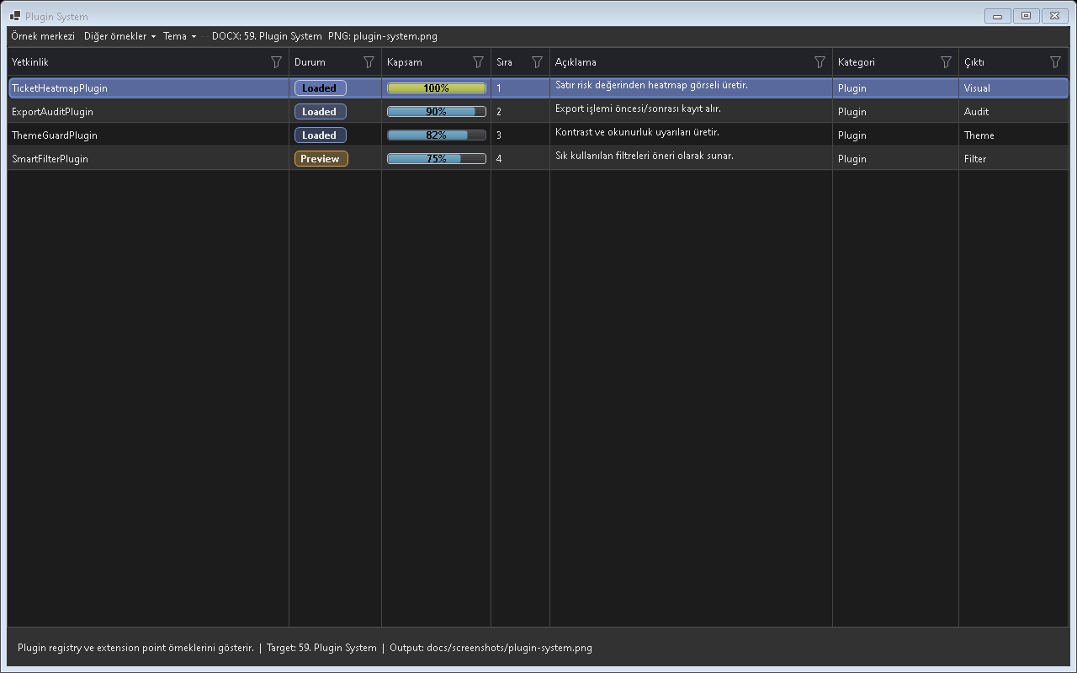
Figure - Plugin System / Plugin infrastructure

Usage scenarios
- Initialize
- Dispose
- Eandnt hook
- Context menu
- Render hook

Best practices
- The feature should be enabled in the default profile or preset according to project needs.
- In line with the Designer-First standard, permanent control layouts should be kept in Designer.cs.
- A release should not be made before theme and localization behavior are tested.
- For large-data scenarios, Virtual Mode or UltraFast Mode should be considered.
- The example for this feature should be easy for the user to find inside Example Center.

Why is it important?
Plugin System ozelligi Gridly icinde tek basina bir gorsel mod veya davranis degil, uygulama genelinde tekrar eden UI kodunu standartlastiran bir katmandir. Bu sayede farkli projelerde ayni deneyim korunur; Audix, AOI Support Desk, Line Workspace ve Bilge Defter gibi projeler ayni API mantigi ile ilerler.

Points to watch while using it
- Differences between the feature's default behavior and project needs should first be checked in TestApp.
- Dark and Light themes should always be tested with the same data set.
- For screens containing large volumes of data or many visuals, a lazy-loading/cache strategy should be evaluated.
- Texts that need to appear on the user side should come from localization keys.
- Without breaking the Designer.cs standard, permanent controls should remain visible at design time.

Test checklist
- When a filter is applied, does the view show the correct row count?
- When the theme changes, is text, button, and badge contrast sufficient?
- When ViewMode changes, does any old layout cache or row height carry over?
- After saving/loading a profile, are the columns, filters, and view mode preserved?
- Are export or copy outputs consistent with the visible data?

Code examples
grid.Plugins.Add(new MyGridlyPlugin());
grid.Plugins.Add(new MyGridlyPlugin());
grid.Plugins.Add(new MyGridlyPlugin());
grid.Plugins.Add(new MyGridlyPlugin());
grid.Plugins.Add(new MyGridlyPlugin());
Project note: When the Plugin System feature is used in real projects such as Audix, AOI Support Desk, Line Workspace, or Bilge Defter, it should first be validated with the related example in TestApp.

60. Data Profiling
Extracts unique, null, min, max, and distribution information for columns.
Screenshot note: No standalone screenshot could be verified for Data Profiling in this release.

Usage scenarios
- Unique count
- Null count
- Min max
- Date range
- Suggestions

Best practices
- The feature should be enabled in the default profile or preset according to project needs.
- In line with the Designer-First standard, permanent control layouts should be kept in Designer.cs.
- A release should not be made before theme and localization behavior are tested.
- For large-data scenarios, Virtual Mode or UltraFast Mode should be considered.
- The example for this feature should be easy for the user to find inside Example Center.

Why is it important?
Data Profiling ozelligi Gridly icinde tek basina bir gorsel mod veya davranis degil, uygulama genelinde tekrar eden UI kodunu standartlastiran bir katmandir. Bu sayede farkli projelerde ayni deneyim korunur; Audix, AOI Support Desk, Line Workspace ve Bilge Defter gibi projeler ayni API mantigi ile ilerler.

Points to watch while using it
- Differences between the feature's default behavior and project needs should first be checked in TestApp.
- Dark and Light themes should always be tested with the same data set.
- For screens containing large volumes of data or many visuals, a lazy-loading/cache strategy should be evaluated.
- Texts that need to appear on the user side should come from localization keys.
- Without breaking the Designer.cs standard, permanent controls should remain visible at design time.

Test checklist
- When a filter is applied, does the view show the correct row count?
- When the theme changes, is text, button, and badge contrast sufficient?
- When ViewMode changes, does any old layout cache or row height carry over?
- After saving/loading a profile, are the columns, filters, and view mode preserved?
- Are export or copy outputs consistent with the visible data?
Visual analytics, heatmap, KPI and mini chart bölümleri.

Code examples
var profile = grid.Profiling.AnalyzeVisibleRows();
var profile = grid.Profiling.AnalyzeVisibleRows();
var profile = grid.Profiling.AnalyzeVisibleRows();
var profile = grid.Profiling.AnalyzeVisibleRows();
var profile = grid.Profiling.AnalyzeVisibleRows();
Project note: When the Data Profiling feature is used in real projects such as Audix, AOI Support Desk, Line Workspace, or Bilge Defter, it should first be validated with the related example in TestApp.

61. Smart Suggestions
Provides column/value/operator suggestions in query and filter fields.
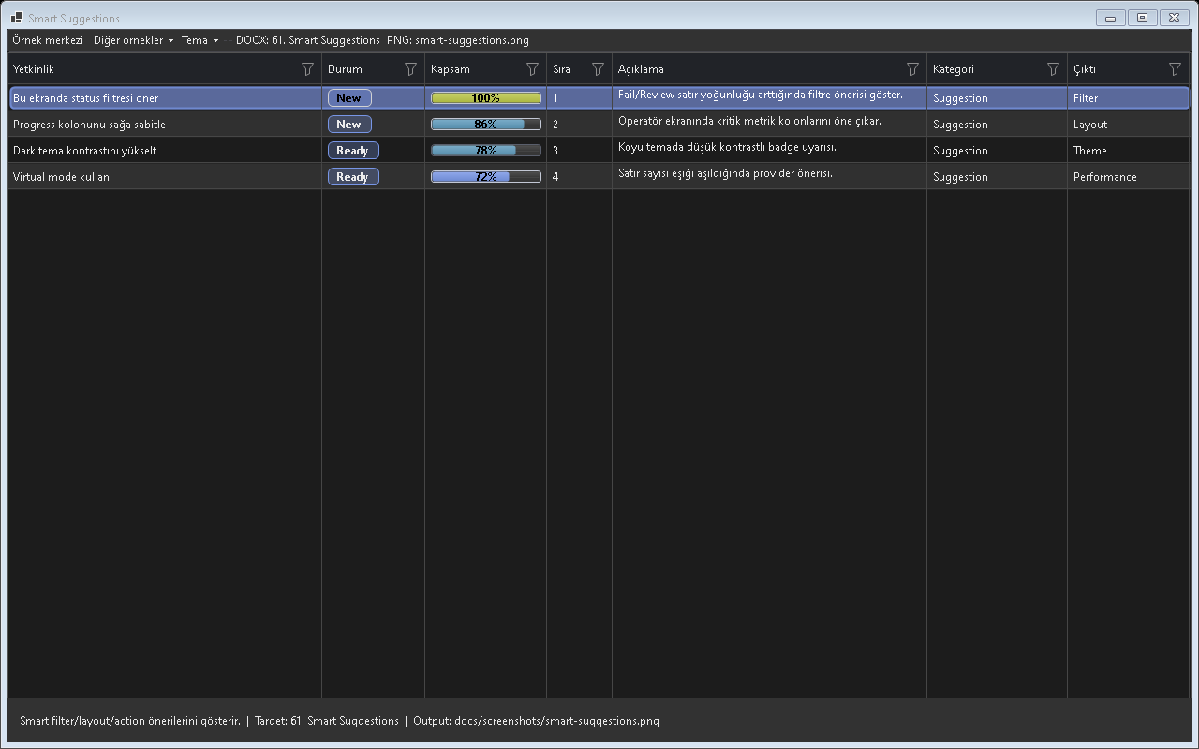
Figure - Smart Suggestions / Intelligent suggestions

Usage scenarios
- Alias
- Value provider
- Operator
- Recent values
- Profile based

Best practices
- The feature should be enabled in the default profile or preset according to project needs.
- In line with the Designer-First standard, permanent control layouts should be kept in Designer.cs.
- A release should not be made before theme and localization behavior are tested.
- For large-data scenarios, Virtual Mode or UltraFast Mode should be considered.
- The example for this feature should be easy for the user to find inside Example Center.

Why is it important?
Smart Suggestions ozelligi Gridly icinde tek basina bir gorsel mod veya davranis degil, uygulama genelinde tekrar eden UI kodunu standartlastiran bir katmandir. Bu sayede farkli projelerde ayni deneyim korunur; Audix, AOI Support Desk, Line Workspace ve Bilge Defter gibi projeler ayni API mantigi ile ilerler.

Points to watch while using it
- Differences between the feature's default behavior and project needs should first be checked in TestApp.
- Dark and Light themes should always be tested with the same data set.
- For screens containing large volumes of data or many visuals, a lazy-loading/cache strategy should be evaluated.
- Texts that need to appear on the user side should come from localization keys.
- Without breaking the Designer.cs standard, permanent controls should remain visible at design time.

Test checklist
- When a filter is applied, does the view show the correct row count?
- When the theme changes, is text, button, and badge contrast sufficient?
- When ViewMode changes, does any old layout cache or row height carry over?
- After saving/loading a profile, are the columns, filters, and view mode preserved?
- Are export or copy outputs consistent with the visible data?

Code examples
grid.Suggestions.Enabled = true;
grid.Suggestions.Enabled = true;
grid.Suggestions.Enabled = true;
grid.Suggestions.Enabled = true;
grid.Suggestions.Enabled = true;
Project note: When the Smart Suggestions feature is used in real projects such as Audix, AOI Support Desk, Line Workspace, or Bilge Defter, it should first be validated with the related example in TestApp.

62. Audix Showcase

Audix Pilot - Album view
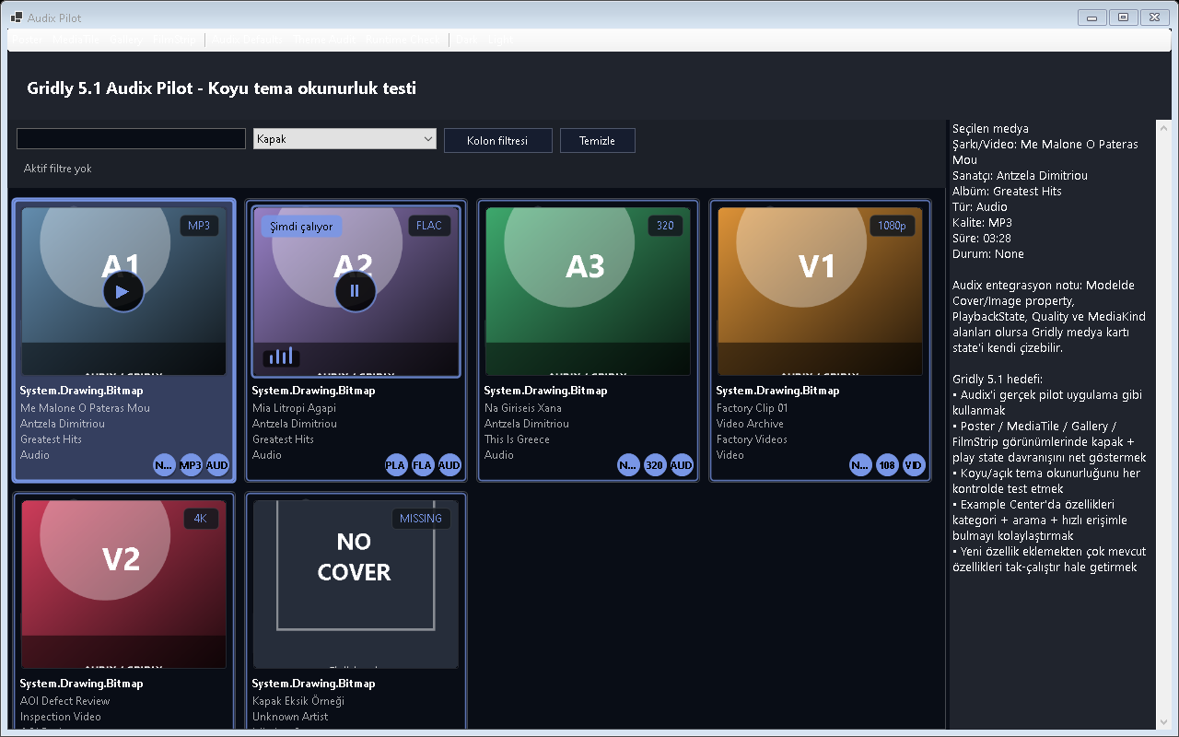
Figure - Audix Showcase / Pilot overview
Albüm kapağı, play/pause state, now playing rozeti and medya oandrlay davranışı.
Çalan kartın ayrı görünmesi, pause oandrlay and now playing rozeti.
Audix için yatay albüm/şarkı şeridi.
Audix muzik arxivinde Gridly medya viewleri album kapagi, sanatci, album, sarki and now playing deneyimi icin is used.

Screen sections
- Artist Browser
- Album Browser
- Track Browser
- Playlist Browser
- Now Playing

Sample application code
// Audix Showcase - Ornek 1: Artist Browser
grid.ViewMode = SelectViewModeFor("Artist Browser");
grid.UseFiltering = true;
grid.Theme = GridlyTheme.Auto;
grid.SetObjects(LoadArtistBrowserRows());
grid.Refresh();
// Audix Showcase - Ornek 2: Album Browser
grid.ViewMode = SelectViewModeFor("Album Browser");
grid.UseFiltering = true;
grid.Theme = GridlyTheme.Auto;
grid.SetObjects(LoadAlbumBrowserRows());
grid.Refresh();
// Audix Showcase - Ornek 3: Track Browser
grid.ViewMode = SelectViewModeFor("Track Browser");
grid.UseFiltering = true;
grid.Theme = GridlyTheme.Auto;
grid.SetObjects(LoadTrackBrowserRows());
grid.Refresh();
// Audix Showcase - Ornek 4: Playlist Browser
grid.ViewMode = SelectViewModeFor("Playlist Browser");
grid.UseFiltering = true;
grid.Theme = GridlyTheme.Auto;
grid.SetObjects(LoadPlaylistBrowserRows());
grid.Refresh();
// Audix Showcase - Ornek 5: Now Playing
grid.ViewMode = SelectViewModeFor("Now Playing");
grid.UseFiltering = true;
grid.Theme = GridlyTheme.Auto;
grid.SetObjects(LoadNowPlayingRows());
grid.Refresh();

63. AOI Support Desk Showcase
Shows the AOI ticket flow for operators, technicians, and admins using Dashboard, DetailCard, and timeline-like structures.
Screenshot note: Available source screenshots did not fully match this showcase, so no misleading image was used.

Screen sections
- Ticket Dashboard
- Message DetailCard
- Technician Queue
- Unread Badge
- SLA Coloring

Sample application code
// AOI Support Desk Showcase - Ornek 1: Ticket Dashboard
grid.ViewMode = SelectViewModeFor("Ticket Dashboard");
grid.UseFiltering = true;
grid.Theme = GridlyTheme.Auto;
grid.SetObjects(LoadTicketDashboardRows());
grid.Refresh();
// AOI Support Desk Showcase - Ornek 2: Message DetailCard
grid.ViewMode = SelectViewModeFor("Message DetailCard");
grid.UseFiltering = true;
grid.Theme = GridlyTheme.Auto;
grid.SetObjects(LoadMessageDetailCardRows());
grid.Refresh();
// AOI Support Desk Showcase - Ornek 3: Technician Queue
grid.ViewMode = SelectViewModeFor("Technician Queue");
grid.UseFiltering = true;
grid.Theme = GridlyTheme.Auto;
grid.SetObjects(LoadTechnicianQueueRows());
grid.Refresh();
// AOI Support Desk Showcase - Ornek 4: Unread Badge
grid.ViewMode = SelectViewModeFor("Unread Badge");
grid.UseFiltering = true;
grid.Theme = GridlyTheme.Auto;
grid.SetObjects(LoadUnreadBadgeRows());
grid.Refresh();
// AOI Support Desk Showcase - Ornek 5: SLA Coloring
grid.ViewMode = SelectViewModeFor("SLA Coloring");
grid.UseFiltering = true;
grid.Theme = GridlyTheme.Auto;
grid.SetObjects(LoadSLAColoringRows());
grid.Refresh();

64. Line Workspace Showcase
Gridly is used for Factory Navigator, Machine Dashboard, HeatMap, and Production Monitor scenarios.
Screenshot note: Available source screenshots did not fully match this showcase, so no misleading image was used.

Screen sections
- Machine Dashboard
- Line HeatMap
- Remote Connect List
- Production Status
- Alarm Monitor

Sample application code
// Line Workspace Showcase - Ornek 1: Machine Dashboard
grid.ViewMode = SelectViewModeFor("Machine Dashboard");
grid.UseFiltering = true;
grid.Theme = GridlyTheme.Auto;
grid.SetObjects(LoadMachineDashboardRows());
grid.Refresh();
// Line Workspace Showcase - Ornek 2: Line HeatMap
grid.ViewMode = SelectViewModeFor("Line HeatMap");
grid.UseFiltering = true;
grid.Theme = GridlyTheme.Auto;
grid.SetObjects(LoadLineHeatMapRows());
grid.Refresh();
// Line Workspace Showcase - Ornek 3: Remote Connect List
grid.ViewMode = SelectViewModeFor("Remote Connect List");
grid.UseFiltering = true;
grid.Theme = GridlyTheme.Auto;
grid.SetObjects(LoadRemoteConnectListRows());
grid.Refresh();
// Line Workspace Showcase - Ornek 4: Production Status
grid.ViewMode = SelectViewModeFor("Production Status");
grid.UseFiltering = true;
grid.Theme = GridlyTheme.Auto;
grid.SetObjects(LoadProductionStatusRows());
grid.Refresh();
// Line Workspace Showcase - Ornek 5: Alarm Monitor
grid.ViewMode = SelectViewModeFor("Alarm Monitor");
grid.UseFiltering = true;
grid.Theme = GridlyTheme.Auto;
grid.SetObjects(LoadAlarmMonitorRows());
grid.Refresh();

65. Bilge Defter Showcase
Gallery, Dashboard, and Details views are used for student, class, attendance, and payment screens.
Screenshot note: Available source screenshots did not fully match this showcase, so no misleading image was used.

Screen sections
- Student Gallery
- Attendance Dashboard
- Payment List
- Class Groups
- Instructor View

Sample application code
// Bilge Defter Showcase - Ornek 1: Student Gallery
grid.ViewMode = SelectViewModeFor("Student Gallery");
grid.UseFiltering = true;
grid.Theme = GridlyTheme.Auto;
grid.SetObjects(LoadStudentGalleryRows());
grid.Refresh();
// Bilge Defter Showcase - Ornek 2: Attendance Dashboard
grid.ViewMode = SelectViewModeFor("Attendance Dashboard");
grid.UseFiltering = true;
grid.Theme = GridlyTheme.Auto;
grid.SetObjects(LoadAttendanceDashboardRows());
grid.Refresh();
// Bilge Defter Showcase - Ornek 3: Payment List
grid.ViewMode = SelectViewModeFor("Payment List");
grid.UseFiltering = true;
grid.Theme = GridlyTheme.Auto;
grid.SetObjects(LoadPaymentListRows());
grid.Refresh();
// Bilge Defter Showcase - Ornek 4: Class Groups
grid.ViewMode = SelectViewModeFor("Class Groups");
grid.UseFiltering = true;
grid.Theme = GridlyTheme.Auto;
grid.SetObjects(LoadClassGroupsRows());
grid.Refresh();
// Bilge Defter Showcase - Ornek 5: Instructor View
grid.ViewMode = SelectViewModeFor("Instructor View");
grid.UseFiltering = true;
grid.Theme = GridlyTheme.Auto;
grid.SetObjects(LoadInstructorViewRows());
grid.Refresh();

66. Example Center
Tüm Gridly örneklerini kategori and arama ile bulma ekranı.
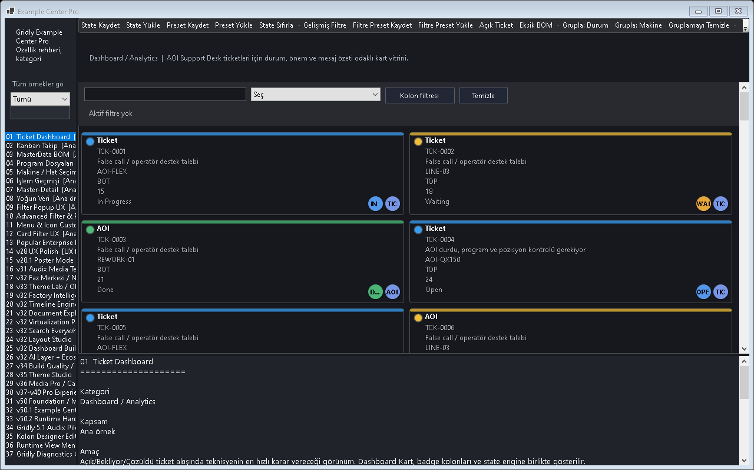
Figure - Example Center / Main screen

Example Center içindeki özellik ağacını and hızlı erişimi gösterir.
Gridly 1.0.52.2 ile ornekler core DLL icinden ayrilarak samples/Gridly.TestApp altinda toplanir. Kullanici uygulamalarinda Gridly ornek menuleri gorunmemeli; geliştirici sadece TestApp veya Developer Center icinde tum orneklere erismelidir.
Feature | TestApp Ornegi | Not
Details | Basic / Details Demo | Klasik tablo and columnlar
Dashboard | Dashboard Demo | Ticket/machine kartlari
DetailCard | DetailCard Demo | Tam genislik kart
Poster | Media Demo | Kapak/afis gosterimi
Gallery | Media Gallery Demo | Thumbnail koleksiyonu
MediaTile | Audix Demo | Album and sanatci kartlari
FilmStrip | Audix / Video Demo | Yatay medya seridi
HeatMap | Analytics Demo | Yogunluk renklendirme
Kanban | Workflow Demo | Is akisi columnlari
Theme | Theme Lab | Light/Dark/High contrast
Localization | Language Selector Demo | Dil secimi and runtime degisim
FixedFree Resize | Column Resize Demo | Bos alan kullanimi

67. GitHub Community Preview
Gridly 1.0.52.2 Community Preview olarak yayinlanirken proje olgunluk seviyesi Preview/Early Access olarak anlatilmalidir. Release adi surumden daha onemlidir; kullanici beklentisi API uyumlulugu ve geri bildirim sureci ile dogru yonetilmelidir.
Screenshot note: This section is release-process focused, so no screenshot is used.
Gridly/
src/
Gridly/
samples/
Gridly.TestApp/
docs/
Gridly_Professional_Deandloper_User_Guide.docx
screenshots/
.github/
ISSUE_TEMPLATE/
README.md
CHANGELOG.md
LICENSE
git init
git add .
git commit -m "Initial Gridly 1.0.52.2 Community Preview"
git branch -M main
git remote add origin https://github.com/<user>/Gridly.git
git push -u origin main
# Release
Tag: v1.0.52.2-preview
Title: Gridly 1.0.52.2 Community Preview
Notes: Core/Examples separation, media views, theme accessibility, localization, TestApp.

68. Troubleshooting
Tema, medya, layout and interaction güandnli varsayılanları.
Screenshot note: Troubleshooting remains table-based in this release rather than image-based.

Sorun | Cozum
GridlyColumnKind adi bulunamiyor | Eksik namespace veya ornek kodun core API ile uyumsuz olmasi. using Gridly.Columns; kontrol edilir.
EnableCommandPalette zaten tanimli | Duplicate partial class/property. Tek kaynak prensibi uygulanir.
DrawRoundedRectangle int -> Size hatasi | GDI+ extension oandrload uyumsuzlugu. Kendi helper metodu andya Size oandrload is used.
Koyu themeda metin okunmuyor | Theme Accessibility Engine and kontrast paleti acilir.
Example menuleri user uygulamasinda gorunuyor | Core/Examples ayrimi kontrol edilir; ornekler sadece TestApp altinda tutulur.
Designer.cs kayiplari | Runtime kontrol olusturma yerine Designer First standardi uygulanir.

# Temiz build
Get-ChildItem -Path . -Include bin,obj -Recurse -Directory | Remoand-Item -Recurse -Force
dotnet restore
dotnet build -c Debug

69. Roadmap
Screenshot note: Roadmap remains table-based in this release and does not use an additional screenshot.
Surum | Hedef
1.0.52.x | Audix gerçek entegrasyon and medya deneyimi stabilizasyonu
1.0.53.x | Factory/Line Workspace buyuk andri validasyonu
1.0.54.x | Theme Studio and localization genisletme
1.0.55.x | LTS oncesi API dondurma and performance hardening
2.x | Moduler Gridly.Core / Media / Analytics / Dashboard ayrimi

Appendix A - Project Adoption Checklist
- Gridly.dll andya src/Gridly kaynak referansi eklendi.
- samples/Gridly.TestApp proje uygulama coreundan ayrildi.
- Tum kalici kontroller Designer.cs icinde tanimlandi.
- Tema Light/Dark/System modlarinda test edildi.
- Localization varsayilan dili and runtime dil degisimi test edildi.
- FixedFree resize and yatay scroll davranisi kontrol edildi.
- Media viewlerinde placeholder, image cache and playback state test edildi.
- Filtering, export and profile klasor yetkileri dogrulandi.
- GitHub release oncesi clean build calistirildi.
- README, CHANGELOG, LICENSE, issue template and dokumanlar eklendi.

70. Screenshot Coverage Summary
All document screenshots were reviewed from scratch; mismatched screenshots were removed or moved to the correct headings.
In this release, incorrect, weak, or mismatched screenshots were cleaned up and only verified visuals were kept. Verified screenshot count: 47. For sections without a screenshot, an explicit note was intentionally left.
Verified screenshots used: 62. Screenshots with wrong or ambiguous content are listed in the audit report.
Source screenshot | Status
gridly-view-details.png | Not used: Details caption was showing dashboard/card tiles instead of a classic table. Replaced with kolon-sistemi.png.
gridly-view-detailcard.png | Not used: Image content matched dashboard/card tiles; replaced with gridly-master-detail.png.
gridly-view-poster.png | Not used: Image content matched dashboard/card tiles; replaced with gridly-media-library-poster.png.
gridly-view-gallery.png | Not used: Image content matched dashboard/card tiles; replaced with gridly-media-library-gallery.png.
gridly-view-mediatile.png | Not used: Image content matched dashboard/card tiles; replaced with gridly-media-library-mediatile.png.
gridly-view-filmstrip.png | Not used: Image content matched dashboard/card tiles; replaced with gridly-media-library-filmstrip.png.
gridly-view-kanban.png | Not used: Image did not show a Kanban board; omitted until a real Kanban screenshot is generated.
gridly-view-heatmap.png | Not used: Image did not show a heatmap; omitted until a real HeatMap screenshot is generated.
gridly-view-kpi.png | Not used: Image did not show KPI cards; omitted until a real KPI screenshot is generated.
gridly-view-minichart.png | Not used: Image did not clearly show the MiniChart scenario; replaced with multi-view-sync.png where sparklines are visible.
gridly-theme-audit-dark.png | Not used: Image looked like the same light theme audit capture; not used as a dark-theme caption.
gridly-pro-experience-layout.png | Not used: Ambiguous generic card capture; not used in the user guide body.
gridly-pro-experience-performance.png | Not used: Ambiguous generic card capture; not used in the user guide body.
gridly-pro-experience-analytics.png | Not used: Ambiguous generic card capture; not used in the user guide body.
gridly-popular-enterprise-overview.png | Not used: Valid enterprise table but not tied to a dedicated guide section; left out to avoid misplaced captions.
gridly-popular-enterprise-filter.png | Not used: Valid enterprise table but not tied to a dedicated guide section; left out to avoid misplaced captions.
gridly-popular-enterprise-summary.png | Not used: Valid enterprise table but not tied to a dedicated guide section; left out to avoid misplaced captions.
gridly-media-library-overview.png | Not used: Covered by individual Poster/Gallery/MediaTile/FilmStrip screenshots.
The Details View issue where a dashboard/card screenshot appeared under the classic table caption has been corrected.

71. Screenshot Insertion and Release Checklist
- All selected scenarios were generated as PNG files with Documentation Capture Mode; the remaining missing headings were also completed in this release.
- The gridly-screenshot-manifest.json file contains the categories, titles, and descriptions of the screenshots.
- The gridly-docx-insert-map.json file contains the screenshot-to-feature mapping for the Word document.
- In this document, available PNG screenshots were moved under the related feature headings and the missing headings were completed.
- For GitHub publishing, the screenshots folder should be stored under docs.
- At minimum, README should use Overview, ViewMode, MediaTile, Theme, Filtering, and Export images.

