CVR COLLEGE OF ENGINEERING
Department of Data Science
SOFTWARE ENGINEERING
LAB ACTIVITY RECORD
Software Personnel Management System (SPMS)
Student Name | Narsing Manisai
Roll Number | 25B81A6794
Branch / Section | DATA SCIENCE-B
Subject | Software Engineering
Academic Year | 2026
College | CVR COLLEGE OF ENGINEERING

Index
Part | Title | Contents
1 | Project Development Document | Aim, Problem Statement, Objectives, Modules, Results
2 | Software Requirements Specification (SRS) | Functional, Non-Functional, Hardware and Software Requirements
3 | Study and Usage of CASE Tool (StarUML) | UML diagrams of SPMS
4 | Software Testing Document | Unit, Integration, White Box and Black Box test cases

Part 1: Software Personnel Management System – Project Development Document

1. Aim
To design and develop a Software Personnel Management System that centralizes employee information and streamlines essential personnel-related activities. The system aims to improve the accuracy, accessibility, and efficiency of workforce administration through a structured and user-friendly application.

2. Problem Statement
Managing personnel information through manual records or disconnected files can lead to data duplication, inconsistent updates, time-consuming searches, and difficulty maintaining accurate employee records. Routine activities such as employee registration, department allocation, attendance tracking, and report preparation may require repeated manual effort. In addition, limited access controls can expose confidential personnel information to unauthorized users.
The proposed Software Personnel Management System addresses these issues by providing a centralized platform to store, update, retrieve, and manage personnel data. It organizes key administrative functions, applies role-based access, and supports reliable record maintenance and reporting.

3. Objectives
- Maintain a centralized and organized database of employee information.
- Enable authorized users to add, view, update, and manage personnel records.
- Organize employees by department, designation, and employment status.
- Record and monitor attendance and leave information.
- Reduce paperwork, repetitive data entry, and administrative processing time.
- Protect confidential information through authentication and role-based access.
- Generate clear reports to support personnel administration and decision-making.

4. Modules
User Authentication and Access Control
Provides secure login and assigns permissions according to user roles, such as administrator and authorized staff.
Employee Management
Supports employee registration and the maintenance of personal, professional, and contact details.
Department and Designation Management
Maintains department and job-role information and associates employees with the appropriate organizational units.
Attendance Management
Records employee attendance details and enables authorized users to review attendance history.
Leave Management
Allows leave requests to be recorded, reviewed, approved, or rejected, while maintaining leave records.
Search and Reporting
Enables quick retrieval of employee information and produces reports on personnel, departments, attendance, and leave.

5. Results
The Software Personnel Management System provides a centralized and structured approach to managing employee records and routine personnel operations. It is designed to reduce manual effort, improve data consistency, support controlled access to sensitive information, and make personnel details easier to retrieve. The resulting system offers a more efficient and dependable method of workforce administration.

Part 2: Software Requirements Specification (SRS)

1. Aim
The aim of this Software Requirements Specification (SRS) is to define the functional, non-functional, hardware, and software requirements of the Software Personnel Management System (SPMS). The document establishes a clear basis for designing, developing, testing, and evaluating a centralized application for maintaining employee information and managing routine personnel activities.

2. Functional Requirements
Functional requirements describe the services and operations the system shall provide. The system shall support the following functions:
FR-01: User Authentication
The system shall allow registered users to log in using valid credentials. It shall validate credentials, reject invalid login attempts, and provide a secure logout facility.
FR-02: Role-Based Access
The system shall distinguish user roles, at minimum an Administrator and an authorized Staff/HR user. It shall restrict screens and operations according to assigned permissions. Only authorized users shall access confidential personnel information.
FR-03: Employee Registration
The system shall allow authorized users to create employee records containing a unique employee ID and relevant details such as name, contact information, date of joining, department, designation, and employment status. Required fields shall be validated before saving.
FR-04: Employee Record Management
The system shall allow authorized users to view, update, and maintain employee records. It shall prevent duplicate employee IDs and retain accurate, consistent information.
FR-05: Department and Designation Management
The system shall allow authorized users to add, view, update, and manage department and designation details, and associate employees with the appropriate department and role.
FR-06: Attendance Management
The system shall allow authorized users to record and view attendance information, including employee identity, date, and attendance status. It shall prevent invalid or duplicate attendance entries for the same employee and date, subject to the configured attendance policy.
FR-07: Leave Management
The system shall allow employees or authorized users to submit and record leave requests. Authorized staff shall be able to review, approve, or reject requests and maintain the decision and leave dates in the system.
FR-08: Search and Filtering
The system shall provide search and filtering facilities to retrieve employee records using available fields such as employee ID, name, department, designation, or employment status.
FR-09: Reports
The system shall generate viewable reports for employee records, department-wise personnel, attendance, and leave information. Report data shall reflect the latest saved records and shall be accessible only to permitted users.
FR-10: Data Validation and Error Handling
The system shall validate user input, display meaningful error messages, and prevent incomplete or invalid data from being stored. It shall confirm successful operations, such as record creation or updates.
FR-11: Record Deactivation
The system shall support marking an employee as inactive or separated rather than permanently deleting historical personnel records, unless an authorized retention policy explicitly permits deletion.
FR-12: Audit and Activity Tracking
The system should record important administrative actions, including creation, modification, and status changes, with the responsible user and timestamp, where audit logging is implemented.

2.1 Primary Users
- Administrator: manages user accounts, access permissions, organizational details, and system-wide records.
- HR/Personnel Staff: maintains employee information and processes attendance, leave, and reports within assigned permissions.
- Employee (if enabled): views permitted personal information and submits leave requests. Employee self-service is optional and depends on the implemented project scope.

3. Non-Functional Requirements
Non-functional requirements define the quality attributes and operating constraints of the system.
NFR-01: Usability: The interface shall be clear, consistent, and easy to navigate. Common tasks such as searching for an employee or viewing a record should require minimal steps.
NFR-02: Performance: Under normal project deployment conditions, standard screens and search operations should respond within approximately 3 seconds for the expected user and data load. Report generation may take longer for large data sets.
NFR-03: Security: The system shall authenticate users, enforce role-based authorization, protect credentials using secure password hashing, and use encrypted connections (HTTPS) when deployed over a network.
NFR-04: Data Integrity: The system shall validate inputs and enforce appropriate database constraints, including unique employee identifiers and valid relationships between employees, departments, attendance, and leave records.
NFR-05: Reliability: The system shall handle invalid input and operational errors without corrupting stored records. Critical database operations should be completed consistently or rolled back when they fail.
NFR-06: Availability: The system should be available during the organization's defined working hours, subject to hosting and network availability.
NFR-07: Maintainability: The application should use a modular structure, readable code, and documented configuration so that defects can be corrected and features can be updated efficiently.
NFR-08: Scalability: The system should support the expected growth in employee records and users without requiring a complete redesign.
NFR-09: Compatibility: For a web-based implementation, the interface should work on current versions of commonly used browsers such as Chrome, Edge, and Firefox.
NFR-10: Backup and Recovery: The database should be backed up periodically. Authorized administrators should be able to restore data from a valid backup according to the deployment’s recovery procedure.
NFR-11: Privacy: The system shall collect and display only personnel information required for its stated purpose. Access to sensitive records shall be limited to authorized roles.
NFR-12: Portability: Application configuration and database setup should be documented to support deployment in another compatible environment.

4. Hardware Requirements
The following are recommended minimum requirements for a small academic or departmental deployment. Actual capacity may vary with the number of users, records, and hosting model.

4.1 Client System
- Processor: Dual-core processor or equivalent.
- RAM: 4 GB minimum.
- Storage: 500 MB of available space for browser cache and downloaded reports.
- Display: 1366 × 768 resolution or higher recommended.
- Network: Internet or local network connection to access the application.

4.2 Application/Database Server
- Processor: Dual-core 2.0 GHz or equivalent minimum.
- RAM: 8 GB recommended for a combined application and database server.
- Storage: 20 GB of available disk space minimum; additional capacity should be allocated for database growth and backups.
- Network: Reliable LAN or internet connectivity with appropriate firewall configuration.
- Backup: Separate storage location or managed backup facility for database backups.
Note: If the project is deployed on a single computer for demonstration, the client and server requirements may be satisfied by one system with at least a dual-core processor, 8 GB RAM, and sufficient free storage.

5. Software Requirements
The exact technology stack may be selected during implementation. The following specifies the required software environment without assuming a particular programming language or framework.
- Operating System: Windows 10/11 or a supported Linux distribution for development and deployment.
- Client Software: A modern web browser such as Google Chrome, Microsoft Edge, or Mozilla Firefox, if implemented as a web application.
- Application Runtime: A supported runtime environment appropriate to the selected programming language and framework.
- Backend Technology: A server-side programming language and framework to implement business logic, authentication, validation, and reporting.
- Frontend Technology: HTML, CSS, and JavaScript or an equivalent user-interface framework for a web-based implementation.
- Database Management System: A relational DBMS such as MySQL, PostgreSQL, or SQLite, selected according to deployment needs.
- Development Tools: A code editor or IDE, such as Visual Studio Code, and version-control software such as Git.
- Testing Tools: Unit and integration testing tools compatible with the selected language and framework.
- Deployment Software: A compatible web server or application server; HTTPS/TLS configuration is required for network deployment.

5.1 Assumptions and Constraints
- The system is intended for authorized organizational users and assumes that each user has an assigned account.
- Employee, attendance, and leave information must be entered accurately by authorized users or through validated system inputs.
- The selected technology stack, hosting environment, attendance policy, leave rules, and data-retention period must be finalized before production deployment.
- The system’s actual features shall be limited to those implemented and tested in the submitted project; optional employee self-service and advanced audit functions may be excluded from a basic prototype.

6. Result
This SRS defines the principal requirements for the Software Personnel Management System and provides a reference for its development, implementation, and testing. When implemented in accordance with these requirements, the system is expected to centralize personnel records, streamline employee and administrative operations, improve data consistency, and provide controlled access to workforce information. The completed application should be evaluated against the stated functional and non-functional requirements to verify that it meets the project objectives.

Part 3: Study and Usage of CASE Tool – StarUML

1. Aim
To study and use the Computer-Aided Software Engineering (CASE) tool StarUML to model the structure, behavior, and deployment of the Software Personnel Management System (SPMS) using standard Unified Modeling Language (UML) diagrams.

2. CASE Tool
Tool: StarUML
Description: StarUML is a software modeling tool used to create, edit, and organize UML diagrams. It helps represent system requirements, classes, interactions, workflows, and deployment architecture before or during software development.

3. Procedure
- Download and install StarUML from its official website.
- Launch StarUML and create a new project. Select or configure a UML project.
- Create a Use Case Diagram for SPMS. Add the actors Admin, HR Staff, and Employee, and connect them to relevant functions such as managing users, departments, employee records, attendance, leave requests, reports, and viewing personal details.
- Create a Class Diagram. Add the main classes User, Admin, HRStaff, Employee, Department, EmployeeRecord, Attendance, and LeaveRequest. Define relevant attributes, operations, inheritance, associations, and multiplicities.
- Create an Activity Diagram to represent a key workflow, such as employee leave application and approval. Include start and end nodes, actions, decision points, and control flows.
- Create a Deployment Diagram showing the client devices, application server, and database server, along with their communication connections.
- Review the diagrams for correct UML notation, meaningful names, complete relationships, and consistency with the SPMS requirements.
- Save the project in StarUML format and export the diagrams as image or PDF files for documentation.

4. Diagrams Prepared
Use Case Diagram: Shows how Admin, HR Staff, and Employee interact with the system functions.
Class Diagram: Shows the system’s classes, attributes, operations, and relationships.
Activity Diagram: Shows the sequence of activities and decisions in a personnel workflow, such as leave processing.
Deployment Diagram: Shows the physical deployment nodes and communication between client devices, application server, and database server.
Component Diagram: Shows the main components of the system (HR, Employee, Training Details, Company Details) and their dependencies.
Sequence Diagram: Shows the time-ordered message exchange between the employee, the database administrator (DBA), and the CEO.
State Chart Diagram: Shows the states an employee record passes through, from login to logout.

4.1 Use Case Diagram
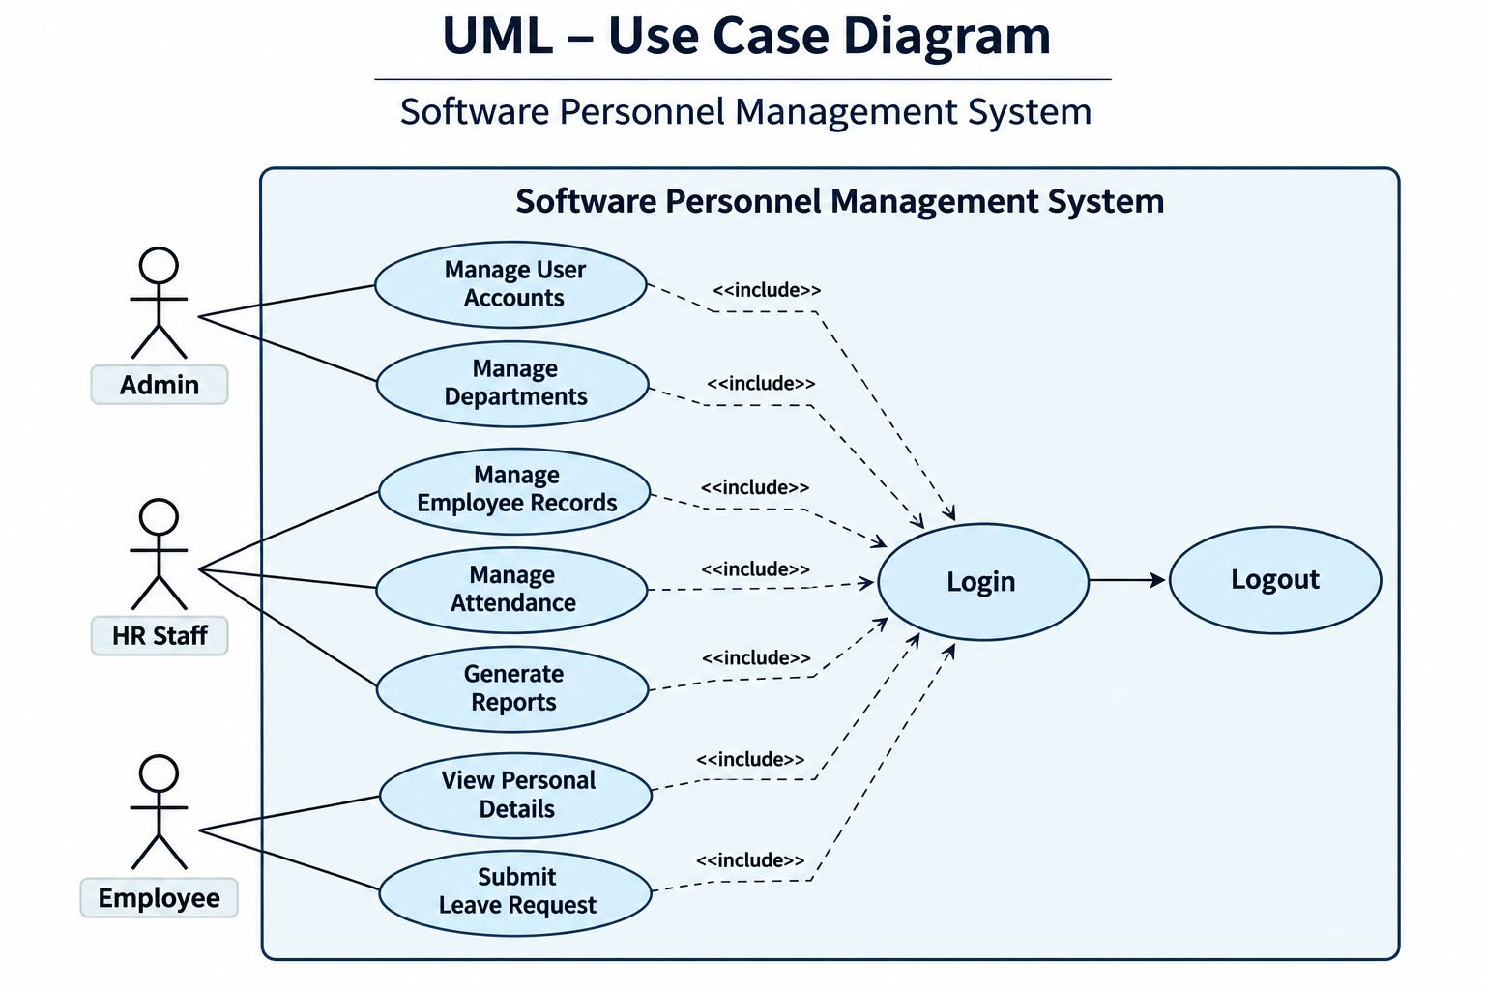
Figure 1: Use Case Diagram – Software Personnel Management System

4.2 Class Diagram
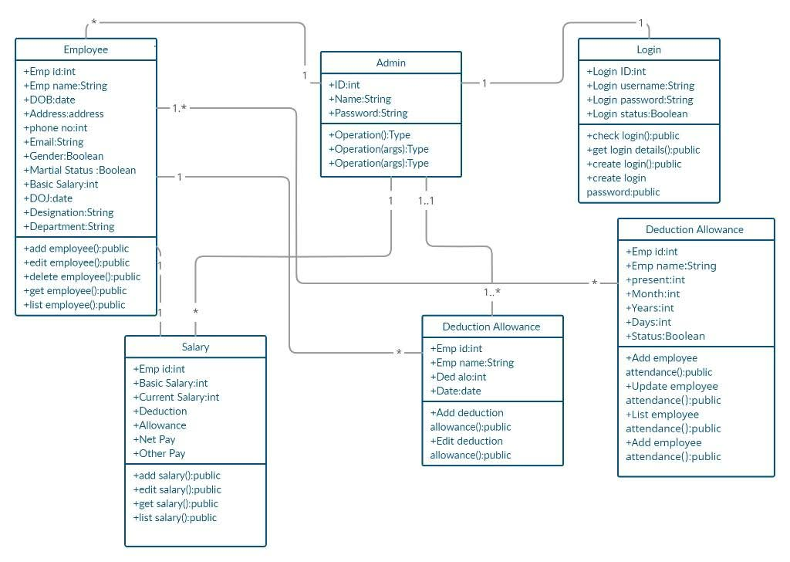
Figure 2: Class Diagram – Software Personnel Management System

4.3 Activity Diagram
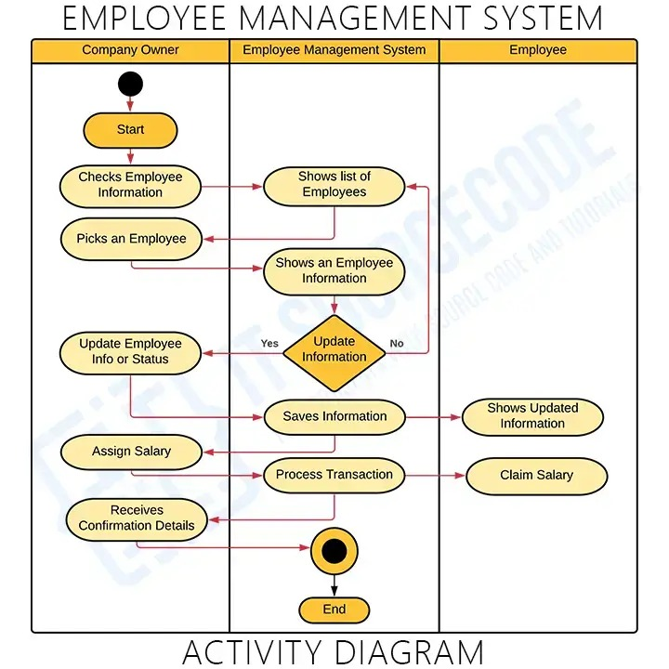
Figure 3: Activity Diagram – Employee Management System

4.4 Deployment Diagram
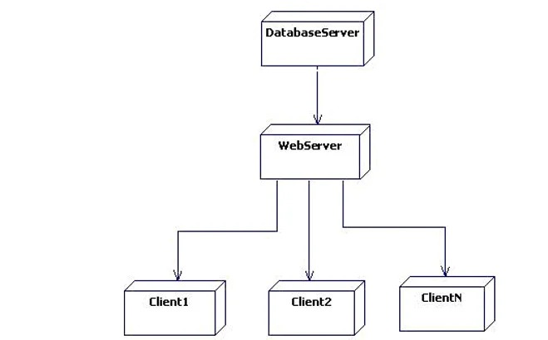
Figure 4: Deployment Diagram – Database Server, Web Server and Clients

4.5 Component Diagram
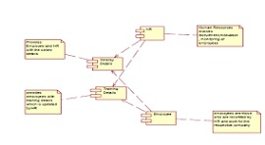
Figure 5: Component Diagram – Software Personnel Management System

4.6 Sequence Diagram
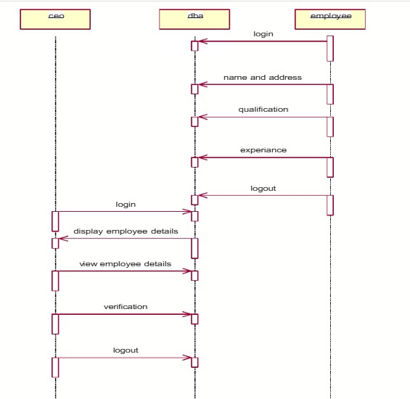
Figure 6: Sequence Diagram – Employee, DBA and CEO

4.7 State Chart Diagram
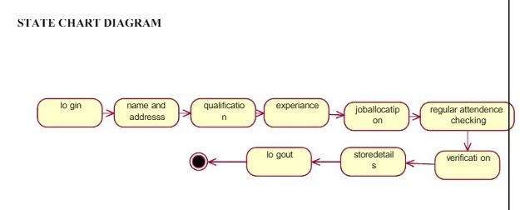
Figure 7: State Chart Diagram – Employee Record Flow

5. Advantages
- Provides a visual representation of system requirements and design.
- Supports creation of standardized and professional UML diagrams.
- Improves communication among developers and project stakeholders.
- Helps identify missing classes, relationships, and workflow steps at an early stage.
- Makes system designs easier to review, update, and maintain.
- Reduces documentation effort and supports better software planning.

6. Result
StarUML was studied and used to model the Software Personnel Management System. The Use Case, Class, Activity, and Deployment Diagrams were prepared to represent the system’s users, functional behavior, structural design, and deployment architecture. Thus, the CASE tool supported clear and organized UML-based system documentation.

Part 4: Software Testing Document

1. Aim
To define and apply a structured testing approach for the Software Personnel Management System (SPMS) by preparing test cases for Unit Testing, Integration Testing, White Box Testing, and Black Box Testing. The objective is to verify that individual modules, their interactions, internal logic, and externally visible functions satisfy the specified requirements.

2. Testing Approach
Testing is planned at multiple levels. Unit Testing checks individual functions or modules; Integration Testing checks data flow and interaction between connected modules; White Box Testing examines internal control flow, conditions, and validation paths; and Black Box Testing checks system behavior against inputs and expected outputs without relying on internal code.
Test data should be fictitious. Tests involving employee records, attendance, and leave must use authorized test accounts and a non-production database. A test is considered Passed only after the observed result matches the expected result. Record actual results and evidence during execution.

3. Test Cases

3.1 Unit Testing
Purpose: Verify the correctness of individual functions and modules independently, using controlled inputs and checking their outputs, state changes, and error handling.
Test ID | Module | Test Input / Condition | Expected Result
UT-01 | Authentication | Valid username and password | Credentials are accepted and an authenticated session is created.
UT-02 | Authentication | Incorrect password | Login is rejected; no authenticated session is created.
UT-03 | Employee validation | Required fields are empty | Validation identifies missing fields and prevents saving.
UT-04 | Employee ID validation | An employee ID already exists | Duplicate ID is rejected; existing record remains unchanged.
UT-05 | Department module | Create department with valid name/code | Department is saved and can be retrieved.
UT-06 | Attendance module | Record attendance for a valid employee and date | Attendance entry is stored with the correct employee, date, and status.
UT-07 | Attendance validation | Attempt a duplicate entry for the same employee/date | Duplicate attendance is prevented according to the configured policy.
UT-08 | Leave module | Submit leave with valid date range and reason | Leave request is created with the initial configured status.
UT-09 | Leave validation | End date is earlier than start date | Request is rejected with a validation message.
UT-10 | Report module | Generate a report for a valid filter | Only records matching the selected filter are returned.

3.2 Integration Testing
Purpose: Verify that modules exchange data correctly and that a transaction remains consistent across the application, business logic, and database.
Test ID | Integrated Modules | Test Scenario | Expected Result
IT-01 | Login → Role access | Log in as Admin, HR Staff, and Employee | Each role receives only its permitted screens and operations.
IT-02 | Employee → Department | Create an employee and assign an existing department | Employee record stores the correct department relationship.
IT-03 | Employee → Attendance | Record attendance for an existing employee | Attendance is linked to the correct employee and appears in that employee’s history.
IT-04 | Employee → Leave → HR | Submit a leave request, then review it as HR Staff | HR can retrieve the request and approve or reject it; the decision is saved.
IT-05 | Leave → Employee view | Approve or reject a submitted request | The updated status is visible to the relevant employee or authorized user.
IT-06 | Database → Reports | Update employee or attendance data and generate a report | The report reflects the latest committed data and correct filters.
IT-07 | Application → Database | Save a valid record, then retrieve it | Data persists accurately and is available after a new session.
IT-08 | Authorization → Data access | Attempt to access a restricted function using a lower-privilege role | The request is denied and restricted data is not disclosed.

3.3 White Box Testing
Purpose: Examine internal program structure and logic. The developer should review control-flow paths, decision outcomes, loops, exception handling, and security checks. The following checks are applicable to the implemented code.
Test ID | Code Area | White Box Technique / Path | Expected Result
WB-01 | Login decision logic | Exercise valid credentials, invalid credentials, and missing credentials branches. | All decision branches execute and produce the correct outcome.
WB-02 | Role authorization | Exercise allow and deny branches for each defined role. | Unauthorized paths cannot execute protected operations.
WB-03 | Employee input validation | Exercise required-field, valid-field, duplicate-ID, and invalid-format branches. | Each validation branch handles its condition correctly.
WB-04 | Leave date validation | Exercise start-before-end, start-equals-end (if allowed), and end-before-start conditions. | All date-condition branches follow the defined leave policy.
WB-05 | Database error handling | Simulate a failed insert/update or unavailable database connection. | Errors are handled safely; partial or inconsistent data is not committed.
WB-06 | Report filtering | Exercise empty filter, one filter, multiple filters, and no-match paths. | Each branch returns the correct result set without exposing unrelated records.

3.4 Black Box Testing
Purpose: Validate externally observable system behavior using specified inputs and expected outputs, without examining source code. Include valid, invalid, boundary, and unauthorized inputs.
Test ID | Feature | Input / Test Condition | Expected Result
BB-01 | Login form | Valid registered credentials | User is logged in and directed to the permitted dashboard.
BB-02 | Login form | Invalid credentials | Access is denied and a clear, non-revealing error is displayed.
BB-03 | Employee form | All mandatory fields contain valid values | Employee record is created successfully.
BB-04 | Employee form | Missing mandatory value or invalid email format | Record is not saved; field-level validation is shown.
BB-05 | Employee search | Search using an existing employee ID/name | The matching record is displayed to an authorized user.
BB-06 | Employee search | Search using a value with no match | A clear no-records-found result is displayed.
BB-07 | Attendance form | Valid employee, date, and attendance status | Attendance is recorded and displayed correctly.
BB-08 | Leave form | Valid leave dates and reason | Leave request is submitted and its status is displayed.
BB-09 | Leave form | Invalid date range or missing reason | Submission is blocked and validation feedback is displayed.
BB-10 | Access control | Employee attempts to open an Admin-only function | Access is denied without revealing protected information.
BB-11 | Reports | Select a valid date range or department filter | Report contains only records matching the selected criteria.
BB-12 | Logout | Select logout while authenticated | Session ends and protected pages require authentication again.

4. Test Execution and Validation
Execute the test cases against the implemented SPMS in a controlled test environment. For each case, record the execution date, tester, actual result, status (Pass/Fail/Blocked), and evidence or defect reference. Failed cases must be logged, corrected, and retested. Regression testing should be performed after changes to confirm that previously working functions remain unaffected.
Status | Definition
Pass | Actual result matches the expected result.
Fail | Actual result differs from the expected result; record a defect.
Blocked | Test cannot be executed because a dependency or environment is unavailable.
Not Run | Test has not yet been executed.

5. Result
The testing document establishes test coverage for the major SPMS functions and their interactions through Unit, Integration, White Box, and Black Box Testing. It provides expected outcomes for valid, invalid, boundary, and unauthorized scenarios and a consistent method for recording results. The system can be considered ready for acceptance only after the planned tests are executed, critical defects are resolved, and the recorded results demonstrate that the requirements are met.

