Project Report
On
product
MANAGEMENT SYSTEM

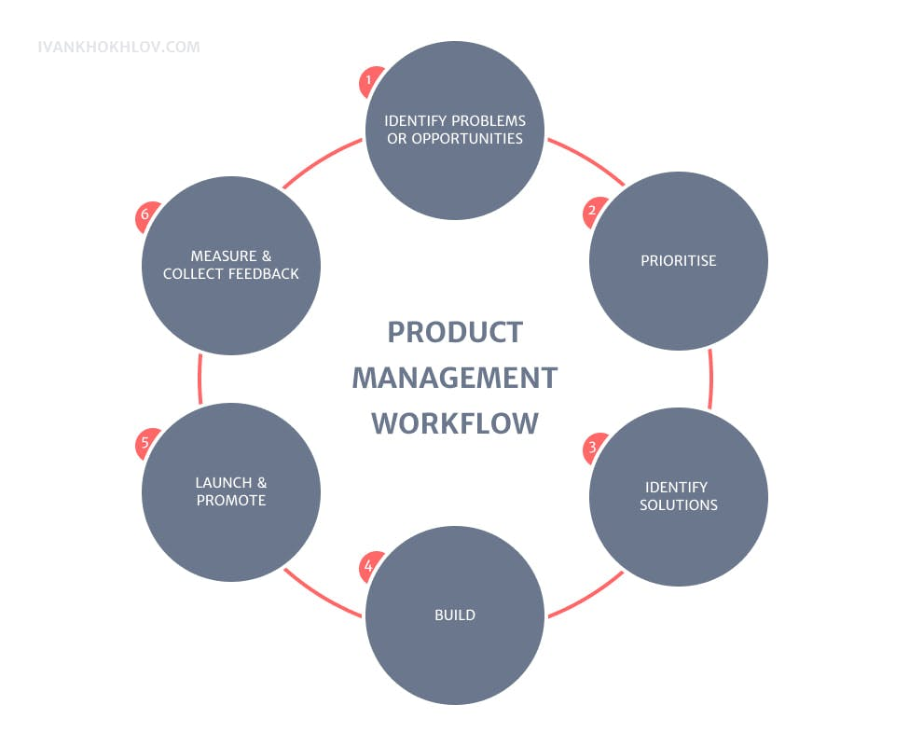

Submitted by: Manish Mandal Guided by: Ms Riya Jana

ACKNOWLEDGEMENT

We would like to express our gratitude to the following individuals and Indian Institute of Hardware and Technology for their contributions and support throughout the project:
The satisfaction that accompanies that the successful completion of any task would be incomplete without the mention of people whose ceaseless cooperation made it possible, whose constant guidance and encouragement crown all efforts with success.
I am grateful to my project guide Ms Riya Jana for the guidance, inspiration and constructive suggestions that was helpful for me in the preparation of this project.

Manish Mandal,
(Student of IIHT, Ultadanga)

SYNOPSIS

Project Name: Product Management System
Duration: 2 months
Project Mentor: Riya Jana
Project Manager: Manish Mandal
Description of the Project:
The Project aimed to develop a comprehensive software solution for managing healthcare operations efficiently. This project utilized HTML, CSS, Java 11, and MySQL database technologies to create a user-friendly and robust healthcare management system.

Accomplishments:
During the course of this project, Manish Mandal has demonstrated exemplary skills and accomplished the following milestones:

Successfully designed and implemented the user interface using HTML and CSS.
Developed functional modules using Java 11 to handle various aspects of healthcare operations.
Integrated a MySQL database to store and retrieve medical records securely.
Implemented data validation and error handling mechanisms to ensure the system's reliability and accuracy.

CONTENTS
1. Introduction
1.1 Purpose
1.2 Scope
1.3 Technologies used
1.4 Overview
2. Overall Description
2.1 Goals of Proposed System
2.2 Background
2.3 Project Requirements
2.4 User Characteristics
2.5 Constraints
2.6 Definition of Problems
2.7 Alternative Solutions
3. Feasibility Study
3.1 Technical Feasibility
3.2 Economical Feasibility
3.3 Operational Feasibility
3.4 Schedule Feasibility
4. Data Flow Diagrams
5. Entity Relationship Diagram
6. Data Tables
7. Snapshots
8. Conclusion
9. Bibliography

1. Introduction

  - Purpose
- The purpose of a Java HTML project on product management system could vary depending on the specific needs and goals of the project, but generally, it would involve creating a web-based application for managing products within a business or organization. Here are some potential purposes:

- Inventory Management: The project could aim to provide a platform for businesses to track and manage their inventory of products. This could include functionalities such as adding new products, updating existing ones, and keeping track of stock levels.
- Sales and Order Management: The system might facilitate the processing of sales orders, including features like creating new orders, managing customer information, and tracking order status.
- User Management: The system could have user authentication and authorization features to control access to different parts of the application. This would allow businesses to manage user accounts and permissions effectively.
- Integration with Other Systems: Depending on the requirements, the project might involve integrating with other systems such as accounting software, CRM systems, or e-commerce platforms.
- User Interface and Experience: A key purpose could be to provide a user-friendly interface for users to interact with the product management system. This would involve designing an intuitive UI using HTML, CSS, and JavaScript.
- Scalability and Performance: Ensuring that the system can handle a large number of products and users while maintaining performance is another important aspect of the project's purpose.
- Overall, the purpose of the project would be to create a robust and efficient system for managing products that meets the specific needs of the business or organization it's intended for. User’s Lab-test booking Confirmation through User’s Email

- The Software includes:
- Inserting Login Credentials of admin or a distributer’s
- Inserting Distributer’s Details
- Formation of Dashboard for User’s individually
- Distributer’s Login
- Distributer’s view of order details
- Monitoring of order view
- Login credentials for admin
- Fundamental process of appointment booking for Patients.
- Views of appointments.
- Views of Lab-tests.
- Views of Doctors registered.

  - Scope
This Software can be used by any Private or Government business companies as well as it can be use by all Users such as distributers. It is easy to use for both Admin of Companies and Distributers.

1.3) Technologies to be used
>Database Design (MYSQL)
>Server (Wampserver)
> Form Design (Eclipse)
> Coding (Eclipse)
> Testing (Eclipse)
> Reporting Tool (Chrome)

1.4) Overview
- The project is related to Business.
- It maintains two types of users.
- Main facilities in this project are:
  - Maintaining Login credentials of Users such as Admin and Distributers.
  - Maintaining Details of Users such as Admin and Distributers.
  - Maintaining Of Dashboards for Users such as Admin and Distributers.
  - Search Engine for companies.
  - Orders and product lists.
  - Others.

- Login Details are secured.
- In the User table, login credentials of all distributers of the company and in the info table login credentials of admin can be maintained.
- Only Administrator can see the all the order lists of the distributers.
- Distributer can only see their orders.

- Overall Description
2.1) Goals of proposed system
- Planned approach towards working: - The working in the organization will be well planned and organized. The data will be stored properly in data stores, which will help in retrieval of information as well as its storage.

- Accuracy: - The level of accuracy in the proposed system will be higher. All operation would be done correctly and it ensures that whatever information is coming from the centre is accurate.

- The reliability of the proposed system will be high due to the above stated reasons. The reason for the increased reliability of the system is that now there would be proper storage of information.

- No Redundancy: - In the proposed system utmost care would be that no information is repeated anywhere, in storage or otherwise. This would assure economic use of storage space and consistency in the data stored.

- Immediate retrieval of information: - The main objective of proposed system is to provide for a quick and efficient retrieval of information. Any type of information would be available whenever the user requires.

- Immediate storage of information: - In manual system there are many problems to store the largest amount of information.

- Easy to Operate: - The system should be easy to operate and should be such that it can be developed within a short period of time and fit in the limited budget of the user.

2.2) Background
In today's competitive business landscape, ensuring an optimal product management system while safeguarding the integrity and security of data is of paramount importance. This abstract highlights the significance of adopting a comprehensive approach that integrates product management, data handling, and security measures within organizations.

The first component of this approach focuses on enhancing the product management experience by leveraging technology and personalized features. It involves implementing user-friendly interfaces, streamlining product catalog management and inventory processes, and enabling seamless communication between team members and stakeholders. By prioritizing efficiency and user satisfaction, organizations can improve product lifecycle management, market responsiveness, and overall business outcomes.

The second component pertains to effective data management. Product management systems accumulate vast amounts of sensitive data, including product specifications, sales data, supplier information, and customer feedback. Efficient data management involves implementing databases such as MySQL. By employing these technologies, organizations can streamline data access, enhance decision-making processes, and ensure accurate tracking of product performance.

We introduce new features such as product lifecycle timelines, streamlined inventory management, and personalized dashboards that show detailed product history, supplier interactions, and sales performance metrics, enabling comprehensive analysis and future planning.

The final component addresses the critical issue of data security. Product data is highly valuable and susceptible to breaches, which can result in significant financial losses and damage to reputation. To ensure data security, product management software employs measures such as password protection and encryption to safeguard sensitive information.

We emphasize the importance of adopting a holistic approach that integrates product management, data handling, and security in business settings. By prioritizing user satisfaction, optimizing data management processes, and implementing robust security measures, organizations can enhance product development, improve market outcomes, and safeguard critical business information.

The database stores product information and includes the following background functions:

- Product lifecycle records (specifications, development stages, feedback, etc.).
- Personalized product management dashboards.
- Product lifecycle timelines to track development stages, changes, and associated team members.
- Comprehensive analysis of product performance, market feedback, and supplier interactions.
- User-friendly interfaces for booking production slots or resources with required specifications.
- Managerial interface where managers can individually see their respective product portfolios with specific IDs.

This integrated approach ensures a seamless and secure product management experience, driving business success and maintaining data integrity.

2.3) Project Requirements
Hardware Required
Processor | RAM |  | Disk Space
Core i5 or i7 | 64 bit or more |  | 1 TB
Software Requirements
Operating System |  | Database
Windows 8, 9, 10 or above |  | My SQL

2.4) User Characteristics
Every user should be:
• Comfortable of working with computer.
• He must also have basic knowledge of English too.

2.5) Constraints
• GUI is only in English.
• Login and password is used for identification of user and there is no facility for guest.

2.6) Definitions of Problems with Conventional Product Management Systems

- Inventory Tracking and Management:
- Current Issue: Managing inventory manually can lead to errors, inefficiencies, and stock discrepancies. It’s challenging to keep real-time updates, which can result in either overstocking or stockouts.
- Proposed Solution: Implementing software for inventory management can automate the tracking process, ensuring accurate, real-time updates on stock levels, and alerting managers to low stock or overstock situations. This enhances efficiency and reduces human error.
- Product Lifecycle Management (PLM):
  - Current Issue: Coordinating and managing the various stages of a product’s lifecycle—from conception through design and manufacturing to service and disposal—is complex and often siloed, leading to miscommunications and delays.
  - Proposed Solution: A centralized PLM software system can integrate all stages of a product’s lifecycle, providing a holistic view and facilitating seamless communication between departments. This ensures better coordination, faster time-to-market, and improved product quality.
- Supplier and Vendor Management:
  - Current Issue: Managing relationships with multiple suppliers and vendors manually can be cumbersome and prone to mismanagement, leading to delays, higher costs, and quality issues.
  - Proposed Solution: Software-based supplier management systems can streamline communication, track supplier performance, manage contracts, and handle procurement processes efficiently. This enhances supplier collaboration, ensures timely deliveries, and improves overall product quality.
- Customer Relationship Management (CRM):
  - Current Issue: Without a systematic approach, managing customer interactions, feedback, and service requests can become chaotic, leading to dissatisfied customers and lost sales opportunities.
  - Proposed Solution: CRM software can centralize all customer data, track interactions, manage service requests, and analyze customer feedback. This enables better customer service, enhances satisfaction, and helps in identifying sales opportunities and trends.
- Sales and Distribution Management:
  - Current Issue: Manual tracking of sales orders, shipments, and distribution channels can lead to delays, errors, and inefficiencies, impacting customer satisfaction and sales performance.
  - Proposed Solution: Sales and distribution software can automate order processing, track shipments in real-time, and optimize distribution routes. This improves accuracy, reduces delivery times, and enhances overall efficiency in the sales process.

2.7) Alternative Solution

- Enhanced Product Analytics and Forecasting:
  - Description: Advanced analytics and machine learning algorithms can be integrated into product management software to analyze sales data, market trends, and customer preferences. This can provide actionable insights to predict demand, optimize inventory, and tailor marketing strategies.
  - Benefits: Accurate demand forecasting, optimized inventory levels, personalized marketing efforts, improved product development, and enhanced decision-making capabilities.
  - Considerations: Implementing these solutions requires robust data security measures, compliance with relevant regulations, and ensuring data accuracy and quality to leverage the full potential of analytics and machine learning.
- Online Product Management System:
  - Description: Transitioning to an online product management system can centralize all product-related information and processes in a cloud-based platform. This allows for real-time access, collaboration, and updates from anywhere, improving flexibility and responsiveness.
  - Benefits: Increased accessibility, enhanced collaboration across teams, real-time updates, scalability, and reduced infrastructure costs.
  - Considerations: Ensuring data security and privacy, managing user access controls, and providing adequate training for users to adapt to the new system.
  - By addressing these challenges and implementing these alternative solutions, businesses can significantly improve their product management processes, leading to greater efficiency, better product quality, and increased customer satisfaction.

3) Entity Relationship Diagram for User
Delete Data
User Login
Insert
My Profile

Update
Admin’s Dashboard
Insertt
Distributer/ User

Verification
View Data
Passwordd
Submit

4) Data Flow Diagram for Distributer & Admin
Home
Doctor’s Login
Login
Login

Insert a data
Distributer

Update data

About us /Contact us
Delete data

Admin Login
View data
Name & password

Login
Delete data
Insert Data
Logout

5) Data Tables

- Admin Table:

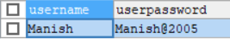

- Distributer Table:

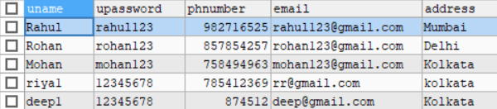

- Product Table:

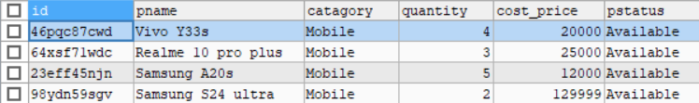

- Order Table:

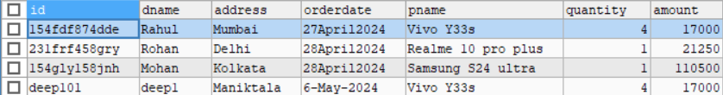

Snapshot and Source Code

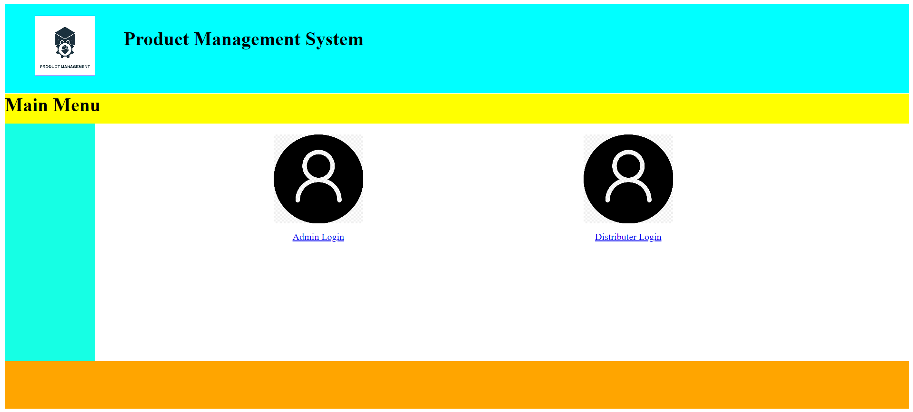
Product Management System Main Page
Source Code:
<html>
<head>
<style>
#container
{
width:100%;
height:auto;
}
#header
{
width:100%;
height:150px;
background-color:cyan;
}
#logo
{
width:100px;
height:100px;
border:1px solid blue;
margin-top:20px;
position:absolute;
margin-left:50px;
background-image:url("product.jpg");
background-size:cover;
}
#heading
{
width:100%;
height:150px;
margin-left:200px;
}
#home
{
width:100%;
height:50px;
background-color:yellow;
margin-top:-20px;
}
#contain
{
width:100%;
height:400px;
}
#side1
{
width:10%;
height:400px;
background-color:rgb(22,255,228);
float:left;
}
#side2
{
width:90%;
height:400px;
background-color:white;
margin-left:10%;
}
#footer
{
width:100%;
height:80px;
background-color:orange;
}
#admin
{
width:150px;
height:150px;
background-image:url("login.jpg");
background-size:cover;
margin-left:300px;
float:left;
}
#dist
{
width:150px;
height:150px;
margin-left:60%;
background-image:url("login.jpg");
background-size:cover;
}

</style>
</head>
<body>
<div id = "container">
<div id = "header">
<div id = "logo"></div>
<div id = "heading"><br><h1>Product Management System</h1></div>
</div>
<div id = "home"><h1>Main Menu</h1></div>
<div id = "contain">
<div id = "side1"></div>
<div id = "side2">
<br>
<div id="admin">
<br><br><br><br><br><br><br><br>
<p><center><a href="login1.jsp">Admin Login</a></center></p>
</div>
<div id="dist">
<br><br><br><br><br><br><br><br>
<p><center><a href="login3.jsp">Distributer Login</a></center></p>
</div>
</div>
</div>
<div id = "footer"></div>
</div>
</body>
</html>

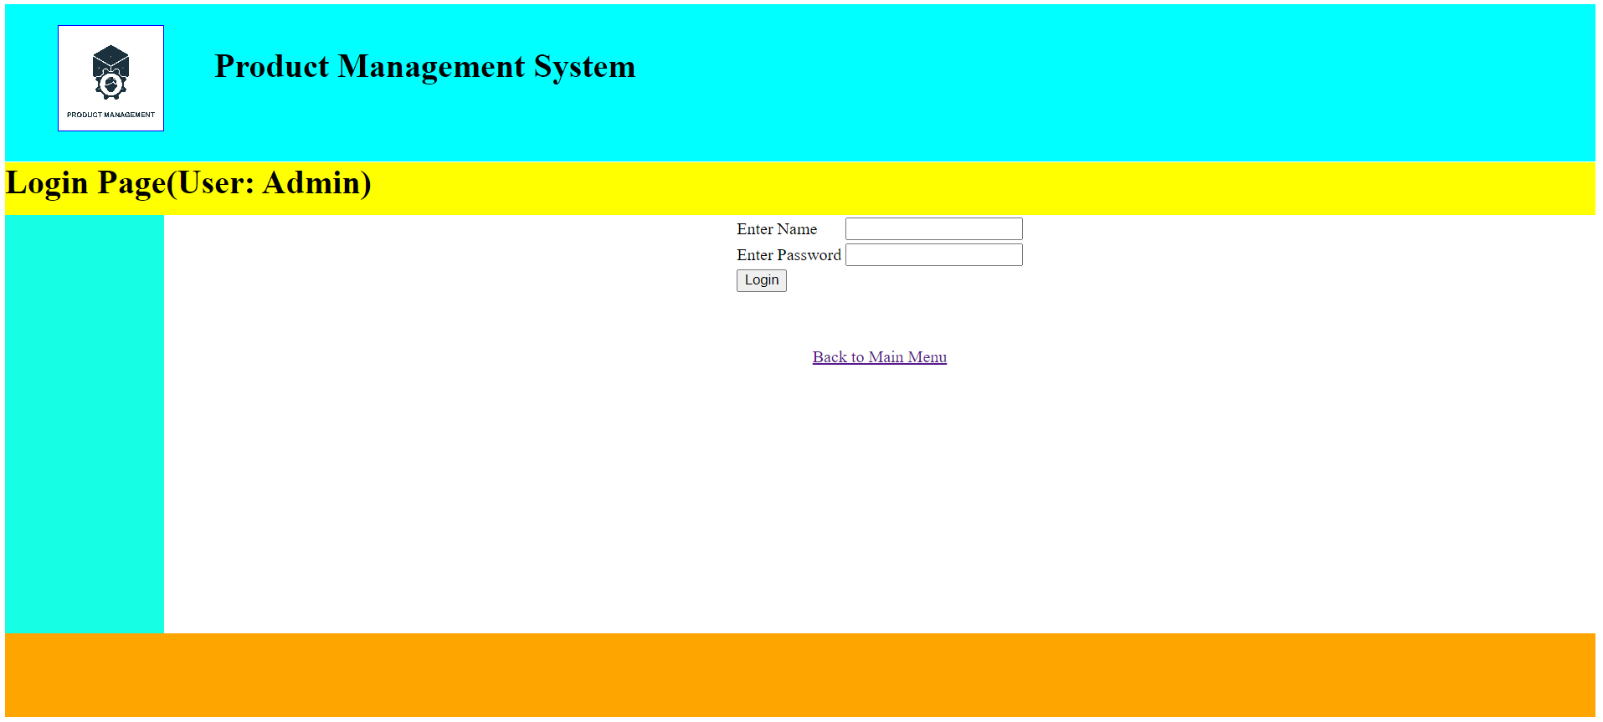
Admin’s Login Page
Source Code:

<html>
<head>
<style>
#container
{
width:100%;
height:auto;
}
#header
{
width:100%;
height:150px;
background-color:cyan;
}
#logo
{
width:100px;
height:100px;
border:1px solid blue;
margin-top:20px;
position:absolute;
margin-left:50px;
background-image:url("product.jpg");
background-size:cover;
}
#heading
{
width:100%;
height:150px;
margin-left:200px;
}
#home
{
width:100%;
height:50px;
background-color:yellow;
margin-top:-20px;
}
#contain
{
width:100%;
height:400px;
}
#side1
{
width:10%;
height:400px;
background-color:rgb(22,255,228);
float:left;
}
#side2
{
width:90%;
height:400px;
background-color:white;
margin-left:10%;
}
#footer
{
width:100%;
height:80px;
background-color:orange;
}
</style>
<script>
function abc()
{
var a = document.f1.txt1.value;
var b = document.f1.txt2.value;

if(a=="" || b=="")
{
alert("Please fill the box!");
return false;
}
else if(b.length<8)
{
alert("Password must be 8 characters!");
return false;
}
else
{
return true;
}
}
</script>
</head>
<body>
<div id = "container">
<div id = "header">
<div id = "logo"></div>
<div id = "heading"><br><h1>Product Management System</h1></div>
</div>
<div id = "home"><h1>Login Page(User: Admin)</h1></div>
<div id = "contain">
<div id = "side1"></div>
<div id = "side2">
<center>
<form name = "f1" action = "login2.jsp" method = "post">
<table>
<tr><td>Enter Name</td><td><input type = "text" name = "txt1"></td></tr>
<tr><td>Enter Password</td><td><input type = "password" name = "txt2"></td></tr>
<tr><td><input type = "submit" name = "sub" value = "Login" onclick = "return abc()"></td></tr>
</table>
</form>
</center>
<br>
<center>
<p><a href="Main.html">Back to Main Menu</a></p>
</center>
</div>
</div>
<div id = "footer"></div>
</div>
</body>
</html>

Source Code for Admin Login:

<%@ page language="java" contentType="text/html; charset=ISO-8859-1"
pageEncoding="ISO-8859-1"%>
<!DOCTYPE html PUBLIC "-//W3C//DTD HTML 4.01 Transitional//EN" "http://www.w3.org/TR/html4/loose.dtd">
<html>
<head>
<meta http-equiv="Content-Type" content="text/html; charset=ISO-8859-1">
<title>Insert title here</title>
</head>
<body>

<%@ page import = "java.sql.*" %>
<%
try
{

Class.forName("com.mysql.jdbc.Driver");
Connection con = DriverManager.getConnection("jdbc:mysql://localhost:3306/product_management_system","root","");
String a = request.getParameter("txt1");
String b = request.getParameter("txt2");
String sql = "select * from admin where username = '"+a+"' and userpassword = '"+b+"'";
Statement st = con.createStatement();
ResultSet rs = st.executeQuery(sql);

int flag = 0;
while(rs.next())
{
flag=1;
}
if(flag==1)
{
response.sendRedirect("home.html");
}

else
{
response.sendRedirect("login1.jsp");
}
}
catch(Exception ae)
{
out.println(ae);
}

%>

</body>
</html>

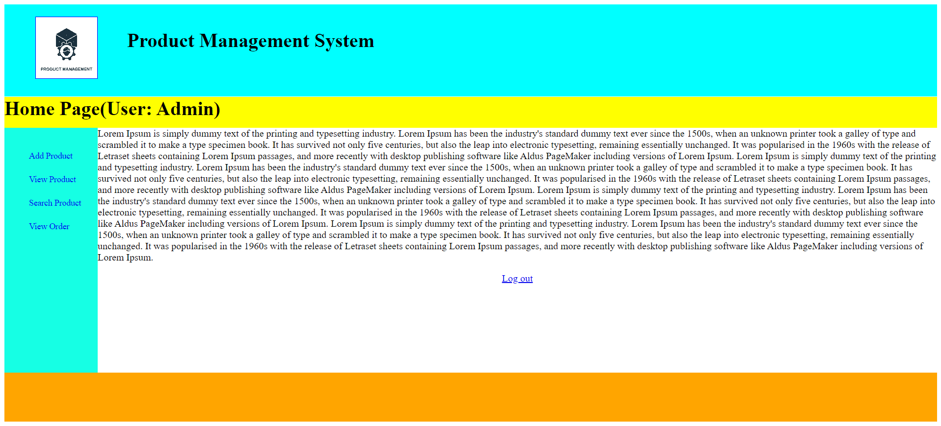

Admin’s Home Page
Source Code:

<html>
<head>
<style>
#container
{
width:100%;
height:auto;
}
#header
{
width:100%;
height:150px;
background-color:cyan;
}
#logo
{
width:100px;
height:100px;
border:1px solid blue;
margin-top:20px;
position:absolute;
margin-left:50px;
background-image:url("product.jpg");
background-size:cover;
}
#heading
{
width:100%;
height:150px;
margin-left:200px;
}
#home
{
width:100%;
height:50px;
background-color:yellow;
margin-top:-20px;
}
#contain
{
width:100%;
height:400px;
}
#side1
{
width:10%;
height:400px;
background-color:rgb(22,255,228);
float:left;
}
#side2
{
width:90%;
height:400px;
background-color:white;
margin-left:10%;
}
#footer
{
width:100%;
height:80px;
background-color:orange;
}
ul li
{
list-style-type:none;
padding-top:20px;
}
ul li a
{
text-decoration:none;
font-size:14px;
}
ul li a:hover
{
border-bottom:3px solid rgb(66,64,255);
cursor pointer;
}
</style>
</head>
<body>
<div id = "container">
<div id = "header">
<div id = "logo"></div>
<div id = "heading"><br><h1>Product Management System</h1></div>
</div>
<div id = "home"><h1>Home Page(User: Admin)</h1></div>
<div id = "contain">
<div id = "side1">
<ul>
<li><a href="addproduct.jsp">Add Product</a></li>
<li><a href="viewproduct.jsp">View Product</a></li>
<li><a href="searchproduct.jsp">Search Product</a></li>
<li><a href="view.jsp">View Order</a></li>
</ul>
</div>
<div id = "side2">
Lorem Ipsum is simply dummy text of the printing and typesetting industry. Lorem Ipsum has been the industry's standard dummy text ever since the 1500s, when an unknown printer took a galley of type and scrambled it to make a type specimen book. It has survived not only five centuries, but also the leap into electronic typesetting, remaining essentially unchanged. It was popularised in the 1960s with the release of Letraset sheets containing Lorem Ipsum passages, and more recently with desktop publishing software like Aldus PageMaker including versions of Lorem Ipsum.
Lorem Ipsum is simply dummy text of the printing and typesetting industry. Lorem Ipsum has been the industry's standard dummy text ever since the 1500s, when an unknown printer took a galley of type and scrambled it to make a type specimen book. It has survived not only five centuries, but also the leap into electronic typesetting, remaining essentially unchanged. It was popularised in the 1960s with the release of Letraset sheets containing Lorem Ipsum passages, and more recently with desktop publishing software like Aldus PageMaker including versions of Lorem Ipsum.
Lorem Ipsum is simply dummy text of the printing and typesetting industry. Lorem Ipsum has been the industry's standard dummy text ever since the 1500s, when an unknown printer took a galley of type and scrambled it to make a type specimen book. It has survived not only five centuries, but also the leap into electronic typesetting, remaining essentially unchanged. It was popularised in the 1960s with the release of Letraset sheets containing Lorem Ipsum passages, and more recently with desktop publishing software like Aldus PageMaker including versions of Lorem Ipsum.
Lorem Ipsum is simply dummy text of the printing and typesetting industry. Lorem Ipsum has been the industry's standard dummy text ever since the 1500s, when an unknown printer took a galley of type and scrambled it to make a type specimen book. It has survived not only five centuries, but also the leap into electronic typesetting, remaining essentially unchanged. It was popularised in the 1960s with the release of Letraset sheets containing Lorem Ipsum passages, and more recently with desktop publishing software like Aldus PageMaker including versions of Lorem Ipsum.

<br>
<p><center><a href="login1.jsp">Log out</a></center><p>
</div>
</div>
<div id = "footer"></div>
</div>
</body>
</html>

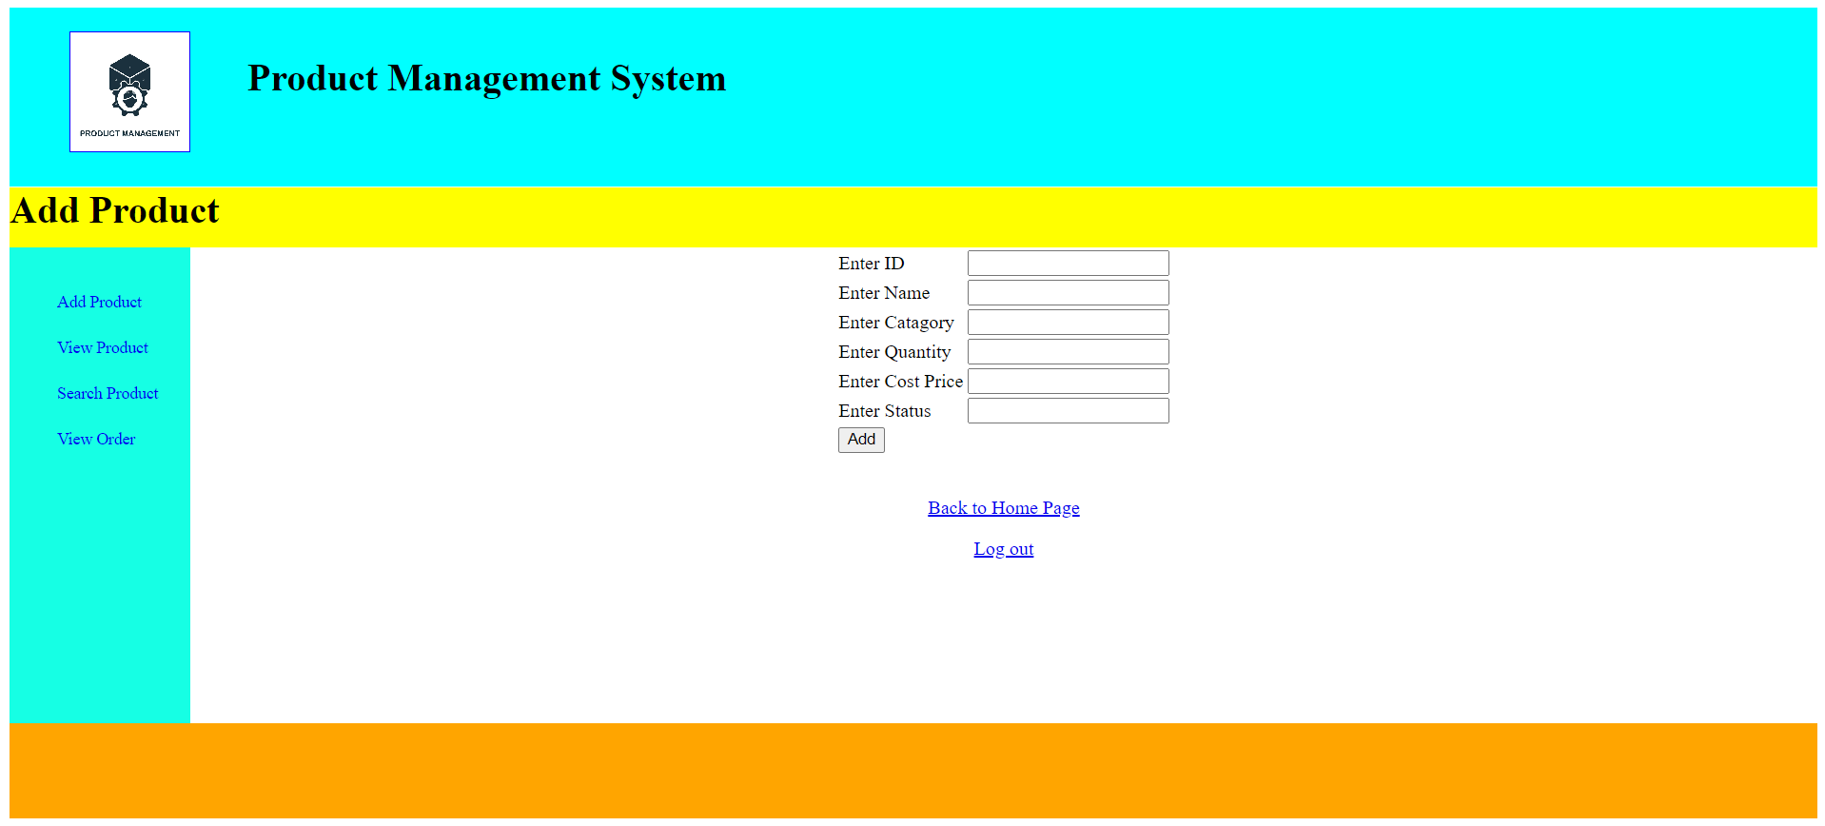

Add Product Page:
Source Code:

<%@ page language="java" contentType="text/html; charset=ISO-8859-1"
pageEncoding="ISO-8859-1"%>
<!DOCTYPE html PUBLIC "-//W3C//DTD HTML 4.01 Transitional//EN" "http://www.w3.org/TR/html4/loose.dtd">
<html>
<head>
<meta http-equiv="Content-Type" content="text/html; charset=ISO-8859-1">
<style>
#container
{
width:100%;
height:auto;
}
#header
{
width:100%;
height:150px;
background-color:cyan;
}
#logo
{
width:100px;
height:100px;
border:1px solid blue;
margin-top:20px;
position:absolute;
margin-left:50px;
background-image:url("product.jpg");
background-size:cover;
}
#heading
{
width:100%;
height:150px;
margin-left:200px;
}
#home
{
width:100%;
height:50px;
background-color:yellow;
margin-top:-20px;
}
#contain
{
width:100%;
height:400px;
}
#side1
{
width:10%;
height:400px;
background-color:rgb(22,255,228);
float:left;
}
#side2
{
width:90%;
height:400px;
background-color:white;
margin-left:10%;
}
#footer
{
width:100%;
height:80px;
background-color:orange;
}
ul li
{
list-style-type:none;
padding-top:20px;
}
ul li a
{
text-decoration:none;
font-size:14px;
}
ul li a:hover
{
border-bottom:3px solid rgb(66,64,255);
cursor pointer;
}
</style>

<script>
function abc()
{
var a = document.f1.txt1.value;
var b = document.f1.txt2.value;
var c = document.f1.txt3.value;
var d = document.f1.txt4.value;
var e = document.f1.txt5.value;
var f = document.f1.txt6.value;

if(a=="" || b=="" || c=="" || d=="" || e=="" || f=="")
{
alert("Please fill the box!");
return false;
}
else
{
return true;
}
}
</script>

</head>
<body>
<div id = "container">
<div id = "header">
<div id = "logo"></div>
<div id = "heading"><br><h1>Product Management System</h1></div>
</div>
<div id = "home"><h1>Add Product</h1></div>
<div id = "contain">
<div id = "side1">
<ul>
<li><a href="addproduct.jsp">Add Product</a></li>
<li><a href="viewproduct.jsp">View Product</a></li>
<li><a href="searchproduct.jsp">Search Product</a></li>
<li><a href="view.jsp">View Order</a></li>
</ul>
</div>
<div id = "side2">
<center>
<form name = "f1" action = "addproduct2.jsp" method = "post">
<table>
<tr><td>Enter ID</td><td><input type = "text" name = "txt1"></td></tr>
<tr><td>Enter Name</td><td><input type = "text" name = "txt2"></td></tr>
<tr><td>Enter Catagory</td><td><input type = "text" name = "txt3"></td></tr>
<tr><td>Enter Quantity</td><td><input type = "text" name = "txt4"></td></tr>
<tr><td>Enter Cost Price</td><td><input type = "text" name = "txt5"></td></tr>
<tr><td>Enter Status</td><td><input type = "text" name = "txt6"></td></tr>
<tr><td><input type = "submit" name = "sub" value = "Add" onclick = "return abc()"></td></tr>
</table>
</form>
</center>
<br>
<p><center><a href="home.html">Back to Home Page</a></center><p>
<p><center><a href="login1.jsp">Log out</a></center><p>
</div>
</div>
<div id = "footer"></div>
</div>
</body>
</html>

Source Code for Adding Product:

<%@ page language="java" contentType="text/html; charset=ISO-8859-1"
pageEncoding="ISO-8859-1"%>
<!DOCTYPE html PUBLIC "-//W3C//DTD HTML 4.01 Transitional//EN" "http://www.w3.org/TR/html4/loose.dtd">
<html>
<head>
<meta http-equiv="Content-Type" content="text/html; charset=ISO-8859-1">
<title>Insert title here</title>
</head>
<body>
<%@ page import = "java.sql.*" %>
<%
try
{

Class.forName("com.mysql.jdbc.Driver");
Connection con = DriverManager.getConnection("jdbc:mysql://localhost:3306/product_management_system","root","");
String a = request.getParameter("txt1");
String b = request.getParameter("txt2");
String c = request.getParameter("txt3");
String d = request.getParameter("txt4");
String e = request.getParameter("txt5");
String f = request.getParameter("txt6");
int x = Integer.parseInt(d);
int y = Integer.parseInt(e);
String sql = "insert into products values ('"+a+"','"+b+"','"+c+"',"+x+","+y+",'"+f+"')";
Statement st = con.createStatement();
st.executeUpdate(sql);
response.sendRedirect("home.html");
}
catch(Exception ae)
{
out.println(ae);
}

%>
</body>
</html>

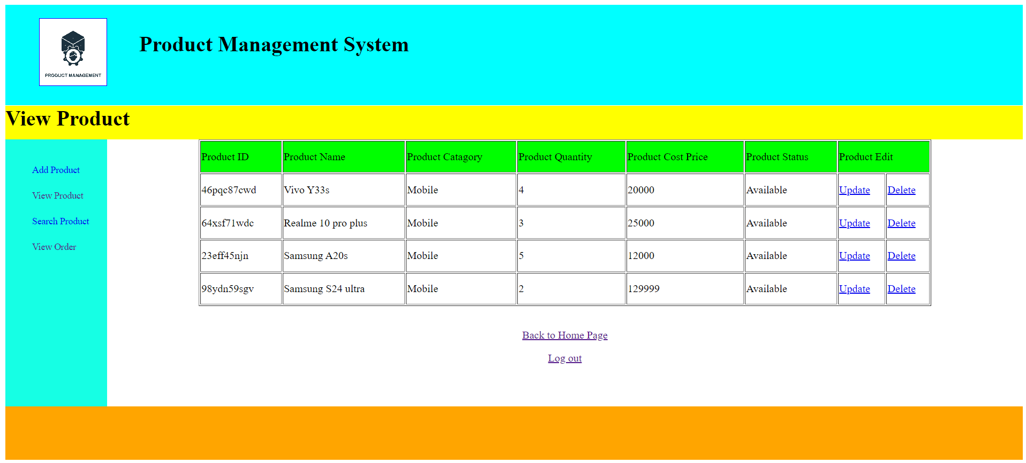
View Product Page:
Source Code:

<%@ page language="java" contentType="text/html; charset=ISO-8859-1"
pageEncoding="ISO-8859-1"%>
<!DOCTYPE html PUBLIC "-//W3C//DTD HTML 4.01 Transitional//EN" "http://www.w3.org/TR/html4/loose.dtd">
<html>
<head>
<meta http-equiv="Content-Type" content="text/html; charset=ISO-8859-1">
<style>
#container
{
width:100%;
height:auto;
}
#header
{
width:100%;
height:150px;
background-color:cyan;
}
#logo
{
width:100px;
height:100px;
border:1px solid blue;
margin-top:20px;
position:absolute;
margin-left:50px;
background-image:url("product.jpg");
background-size:cover;
}
#heading
{
width:100%;
height:150px;
margin-left:200px;
}
#home
{
width:100%;
height:50px;
background-color:yellow;
margin-top:-20px;
}
#contain
{
width:100%;
height:400px;

}
#side1
{
width:10%;
height:400px;
background-color:rgb(22,255,228);
float:left;
}
#side2
{
width:90%;
height:400px;
background-color:white;
margin-left:10%;
}
#footer
{
width:100%;
height:80px;
background-color:orange;
}
ul li
{
list-style-type:none;
padding-top:20px;
}
ul li a
{
text-decoration:none;
font-size:14px;
}
ul li a:hover
{
border-bottom:3px solid rgb(66,64,255);
cursor pointer;
}

table
{
height:250px;
width:80%;
margin-left:10%;
}
</style>
</head>
<body>
<div id = "container">
<div id = "header">
<div id = "logo"></div>
<div id = "heading"><br><h1>Product Management System</h1></div>
</div>
<div id = "home"><h1>View Product</h1></div>
<div id = "contain">
<div id = "side1">
<ul>
<li><a href="addproduct.jsp">Add Product</a></li>
<li><a href="viewproduct.jsp">View Product</a></li>
<li><a href="searchproduct.jsp">Search Product</a></li>
<li><a href="view.jsp">View Order</a></li>
</ul>
</div>
<div id = "side2">

<%@ page import = "java.sql.*" %>
<%
try
{

Class.forName("com.mysql.jdbc.Driver");
Connection con = DriverManager.getConnection("jdbc:mysql://localhost:3306/product_management_system","root","");
String sql = "select * from products";
Statement st = con.createStatement();
ResultSet rs = st.executeQuery(sql);
out.println("<table border = '1'>");
out.println("<tr bgcolor='lime'>");
out.println("<td>Product ID</td>");
out.println("<td>Product Name</td>");
out.println("<td>Product Catagory</td>");
out.println("<td>Product Quantity</td>");
out.println("<td>Product Cost Price</td>");
out.println("<td>Product Status</td>");
out.println("<td colspan = '2'>Product Edit</td>");
out.println("</tr>");
while(rs.next())
{
String a = rs.getString(1);
String b = rs.getString(2);
String c = rs.getString(3);
int d = rs.getInt(4);
int e = rs.getInt(5);
String f = rs.getString(6);

out.println("<tr>");
out.println("<td>"+a+"</td>");
out.println("<td>"+b+"</td>");
out.println("<td>"+c+"</td>");
out.println("<td>"+d+"</td>");
out.println("<td>"+e+"</td>");
out.println("<td>"+f+"</td>");
out.println("<td><a href='edit.jsp?txt1="+a+"'>Update</a></td>");
out.println("<td><a href='deleteproduct2.jsp?txt1="+a+"'>Delete</a></td>");
out.println("</tr>");
}

out.println("</table>");
}
catch(Exception ae)
{
out.println(ae);
}

%>

<br>
<p><center><a href="home.html">Back to Home Page</a></center><p>
<p><center><a href="login1.jsp">Log out</a></center><p>
</div>
</div>
<div id = "footer"></div>
</div>
</body>
</html>

Source Code for Deleting Product:

<%@ page language="java" contentType="text/html; charset=ISO-8859-1"
pageEncoding="ISO-8859-1"%>
<!DOCTYPE html PUBLIC "-//W3C//DTD HTML 4.01 Transitional//EN" "http://www.w3.org/TR/html4/loose.dtd">
<html>
<head>
<meta http-equiv="Content-Type" content="text/html; charset=ISO-8859-1">
<title>Insert title here</title>
</head>
<body>

<%@ page import = "java.sql.*" %>
<%
try
{

Class.forName("com.mysql.jdbc.Driver");
Connection con = DriverManager.getConnection("jdbc:mysql://localhost:3306/product_management_system","root","");
String a = request.getParameter("txt1");
String sql = "delete from products where id = '"+a+"'";
Statement st = con.createStatement();
st.executeUpdate(sql);
response.sendRedirect("viewproduct.jsp");
}
catch(Exception ae)
{
out.println(ae);
}

%>

</body>
</html>

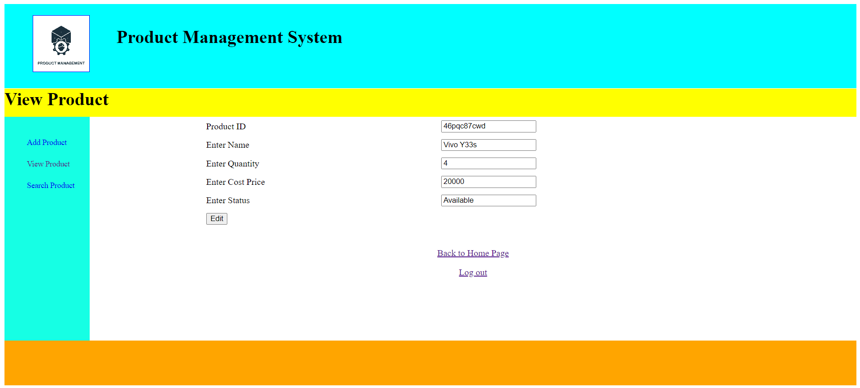

Source Code for Editing Product:
<%@ page language="java" contentType="text/html; charset=ISO-8859-1"
pageEncoding="ISO-8859-1"%>
<!DOCTYPE html PUBLIC "-//W3C//DTD HTML 4.01 Transitional//EN" "http://www.w3.org/TR/html4/loose.dtd">
<html>
<head>
<meta http-equiv="Content-Type" content="text/html; charset=ISO-8859-1">
<title>Insert title here</title>
<style>
#container
{
width:100%;
height:auto;
}
#header
{
width:100%;
height:150px;
background-color:cyan;
}
#logo
{
width:100px;
height:100px;
border:1px solid blue;
margin-top:20px;
position:absolute;
margin-left:50px;
background-image:url("product.jpg");
background-size:cover;
}
#heading
{
width:100%;
height:150px;
margin-left:200px;
}
#home
{
width:100%;
height:50px;
background-color:yellow;
margin-top:-20px;
}
#contain
{
width:100%;
height:400px;

}
#side1
{
width:10%;
height:400px;
background-color:rgb(22,255,228);
float:left;
}
#side2
{
width:90%;
height:400px;
background-color:white;
margin-left:10%;
}
#footer
{
width:100%;
height:80px;
background-color:orange;
}
ul li
{
list-style-type:none;
padding-top:20px;
}
ul li a
{
text-decoration:none;
font-size:14px;
}
ul li a:hover
{
border-bottom:3px solid rgb(66,64,255);
cursor pointer;
}

table
{
height:200px;
width:80%;
margin-left:10%;
}
</style>

</head>
<body>
<div id = "container">
<div id = "header">
<div id = "logo"></div>
<div id = "heading"><br><h1>Product Management System</h1></div>
</div>
<div id = "home"><h1>View Product</h1></div>
<div id = "contain">
<div id = "side1">
<ul>
<li><a href="addproduct.jsp">Add Product</a></li>
<li><a href="viewproduct.jsp">View Product</a></li>
<li><a href="searchproduct.jsp">Search Product</a></li>
</ul>
</div>
<div id = "side2">

<%@ page import = "java.sql.*" %>
<%

String a="",b="",c="",f="";
int d=0,e=0;
try
{

Class.forName("com.mysql.jdbc.Driver");
Connection con = DriverManager.getConnection("jdbc:mysql://localhost:3306/product_management_system","root","");

String s = request.getParameter("txt1");

String sql = "select * from products where id='"+s+"'";
Statement st = con.createStatement();
ResultSet rs = st.executeQuery(sql);

while(rs.next())
{
a = rs.getString(1);
b = rs.getString(2);
c = rs.getString(3);
d = rs.getInt(4);
e = rs.getInt(5);
f = rs.getString(6);
}
}
catch(Exception ae)
{
out.println(ae);
}

%>
<center>
<form name = "f1" action = "updateproduct2.jsp" method = "post">
<table>
<tr><td>Product ID</td><td><input type="text" name="txt1" value="<%=a%>" readonly></td></tr>
<tr><td>Enter Name</td><td><input type = "text" name = "txt2" value="<%=b%>"></td></tr>
<tr><td>Enter Quantity</td><td><input type = "text" name = "txt3" value="<%=d%>"></td></tr>
<tr><td>Enter Cost Price</td><td><input type = "text" name = "txt4" value="<%=e%>"></td></tr>
<tr><td>Enter Status</td><td><input type = "text" name = "txt5" value="<%=f%>"></td></tr>
<tr><td><input type = "submit" name = "sub" value = "Edit" onclick = "return abc()"></td></tr>
</table>
</form>
</center>
<br>
<p><center><a href="home.html">Back to Home Page</a></center><p>
<p><center><a href="login1.jsp">Log out</a></center><p>
</div>
</div>
<div id = "footer"></div>
</div>
</body>
</html>

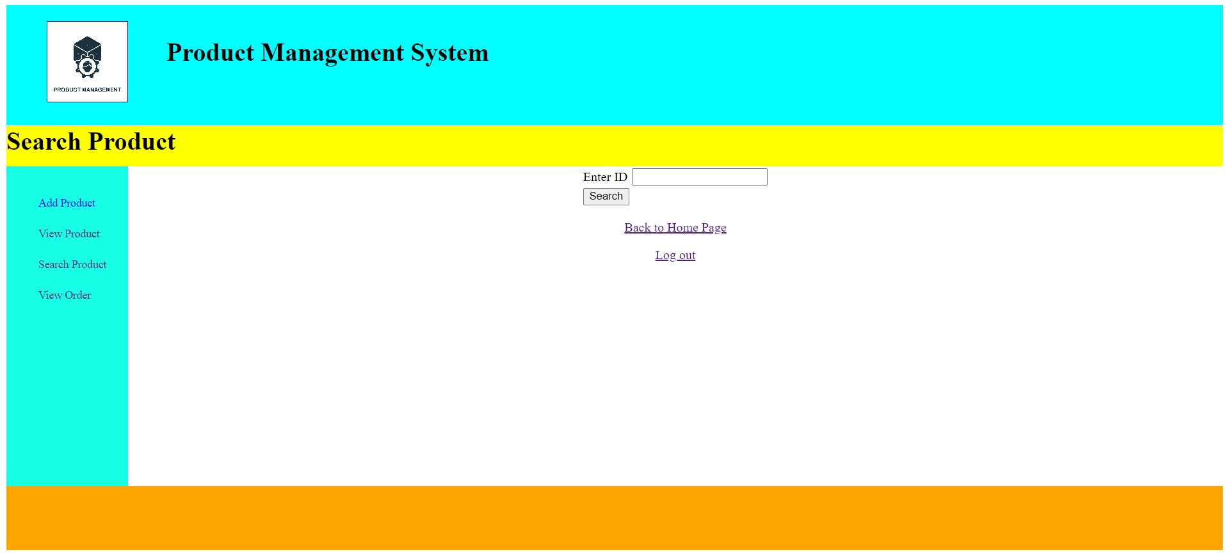

Search Product Page:
Source Code:

<%@ page language="java" contentType="text/html; charset=ISO-8859-1"
pageEncoding="ISO-8859-1"%>
<!DOCTYPE html PUBLIC "-//W3C//DTD HTML 4.01 Transitional//EN" "http://www.w3.org/TR/html4/loose.dtd">
<html>
<head>
<meta http-equiv="Content-Type" content="text/html; charset=ISO-8859-1">
<style>
#container
{
width:100%;
height:auto;
}
#header
{
width:100%;
height:150px;
background-color:cyan;
}
#logo
{
width:100px;
height:100px;
border:1px solid blue;
margin-top:20px;
position:absolute;
margin-left:50px;
background-image:url("product.jpg");
background-size:cover;
}
#heading
{
width:100%;
height:150px;
margin-left:200px;
}
#home
{
width:100%;
height:50px;
background-color:yellow;
margin-top:-20px;
}
#contain
{
width:100%;
height:400px;
}
#side1
{
width:10%;
height:400px;
background-color:rgb(22,255,228);
float:left;
}
#side2
{
width:90%;
height:400px;
background-color:white;
margin-left:10%;
}
#footer
{
width:100%;
height:80px;
background-color:orange;
}
ul li
{
list-style-type:none;
padding-top:20px;
}
ul li a
{
text-decoration:none;
font-size:14px;
}
ul li a:hover
{
border-bottom:3px solid rgb(66,64,255);
cursor pointer;
}
</style>

<script>
function abc()
{
var a = document.f1.txt1.value;

if(a=="")
{
alert("Please fill the box!");
return false;
}
else
{
return true;
}
}
</script>

</head>
<body>
<div id = "container">
<div id = "header">
<div id = "logo"></div>
<div id = "heading"><br><h1>Product Management System</h1></div>
</div>
<div id = "home"><h1>Search Product</h1></div>
<div id = "contain">
<div id = "side1">
<ul>
<li><a href="addproduct.jsp">Add Product</a></li>
<li><a href="viewproduct.jsp">View Product</a></li>
<li><a href="searchproduct.jsp">Search Product</a></li>
<li><a href="view.jsp">View Order</a></li>
</ul>
</div>
<div id = "side2">
<center>
<form name = "f1" action = "searchproduct2.jsp" method = "post">
<table>
<tr><td>Enter ID</td><td><input type = "text" name = "txt1"></td></tr>
<tr><td><input type = "submit" name = "sub" value = "Search" onclick = "return abc()"></td></tr>
</table>
</form>
</center>
<p><center><a href="home.html">Back to Home Page</a></center><p>
<p><center><a href="login1.jsp">Log out</a></center><p>
</div>
</div>
<div id = "footer"></div>
</div>
</body>
</html>

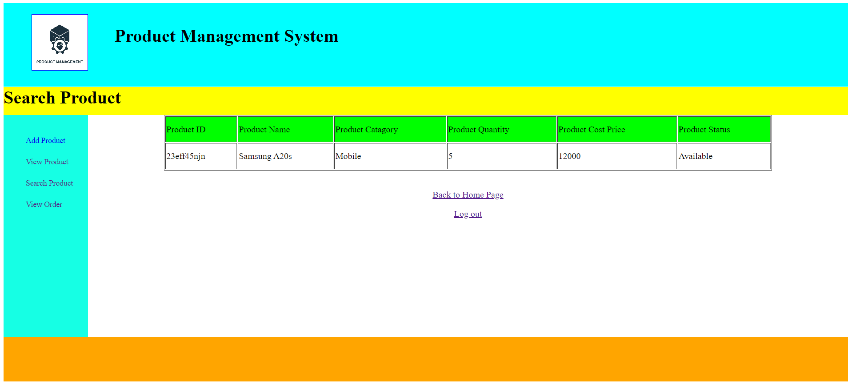

Source Code for Searching Product:

<%@ page language="java" contentType="text/html; charset=ISO-8859-1"
pageEncoding="ISO-8859-1"%>
<!DOCTYPE html PUBLIC "-//W3C//DTD HTML 4.01 Transitional//EN" "http://www.w3.org/TR/html4/loose.dtd">
<html>
<head>
<meta http-equiv="Content-Type" content="text/html; charset=ISO-8859-1">
<style>
#container
{
width:100%;
height:auto;
}
#header
{
width:100%;
height:150px;
background-color:cyan;
}
#logo
{
width:100px;
height:100px;
border:1px solid blue;
margin-top:20px;
position:absolute;
margin-left:50px;
background-image:url("product.jpg");
background-size:cover;
}
#heading
{
width:100%;
height:150px;
margin-left:200px;
}
#home
{
width:100%;
height:50px;
background-color:yellow;
margin-top:-20px;
}
#contain
{
width:100%;
height:400px;

}
#side1
{
width:10%;
height:400px;
background-color:rgb(22,255,228);
float:left;
}
#side2
{
width:90%;
height:400px;
background-color:white;
margin-left:10%;
}
#footer
{
width:100%;
height:80px;
background-color:orange;
}
ul li
{
list-style-type:none;
padding-top:20px;
}
ul li a
{
text-decoration:none;
font-size:14px;
}
ul li a:hover
{
border-bottom:3px solid rgb(66,64,255);
cursor pointer;
}
table
{
height:100px;
width:80%;
margin-left:10%;
}
</style>
</head>
<body>
<div id = "container">
<div id = "header">
<div id = "logo"></div>
<div id = "heading"><br><h1>Product Management System</h1></div>
</div>
<div id = "home"><h1>Search Product</h1></div>
<div id = "contain">
<div id = "side1">
<ul>
<li><a href="addproduct.jsp">Add Product</a></li>
<li><a href="viewproduct.jsp">View Product</a></li>
<li><a href="searchproduct.jsp">Search Product</a></li>
<li><a href="view.jsp">View Order</a></li>
</ul>
</div>
<div id = "side2">

<%@ page import = "java.sql.*" %>
<%
try
{

Class.forName("com.mysql.jdbc.Driver");
Connection con = DriverManager.getConnection("jdbc:mysql://localhost:3306/product_management_system","root","");
String a = request.getParameter("txt1");
String sql = "select * from products where id = '"+a+"'";
Statement st = con.createStatement();
ResultSet rs = st.executeQuery(sql);

Statement st1 = con.createStatement();
ResultSet rs1 = st1.executeQuery(sql);

int flag = 0;
while(rs.next())
{
flag=1;
}
if(flag==1)
{
out.println("<table border = '1'>");
out.println("<tr bgcolor='lime'>");
out.println("<td>Product ID</td>");
out.println("<td>Product Name</td>");
out.println("<td>Product Catagory</td>");
out.println("<td>Product Quantity</td>");
out.println("<td>Product Cost Price</td>");
out.println("<td>Product Status</td>");
out.println("</tr>");
while(rs1.next())
{
String a1 = rs1.getString(1);
String b = rs1.getString(2);
String c = rs1.getString(3);
int d = rs1.getInt(4);
int e = rs1.getInt(5);
String f = rs1.getString(6);

out.println("<tr>");
out.println("<td>"+a1+"</td>");
out.println("<td>"+b+"</td>");
out.println("<td>"+c+"</td>");
out.println("<td>"+d+"</td>");
out.println("<td>"+e+"</td>");
out.println("<td>"+f+"</td>");
out.println("</tr>");
}
out.println("</table>");
}

else
{
out.println("Data not found");
}
}
catch(Exception ae)
{
out.println(ae);
}

%>
<br>
<p><center><a href="home.html">Back to Home Page</a></center><p>
<p><center><a href="login1.jsp">Log out</a></center><p>
</div>
</div>
<div id = "footer"></div>
</div>

</body>
</html>

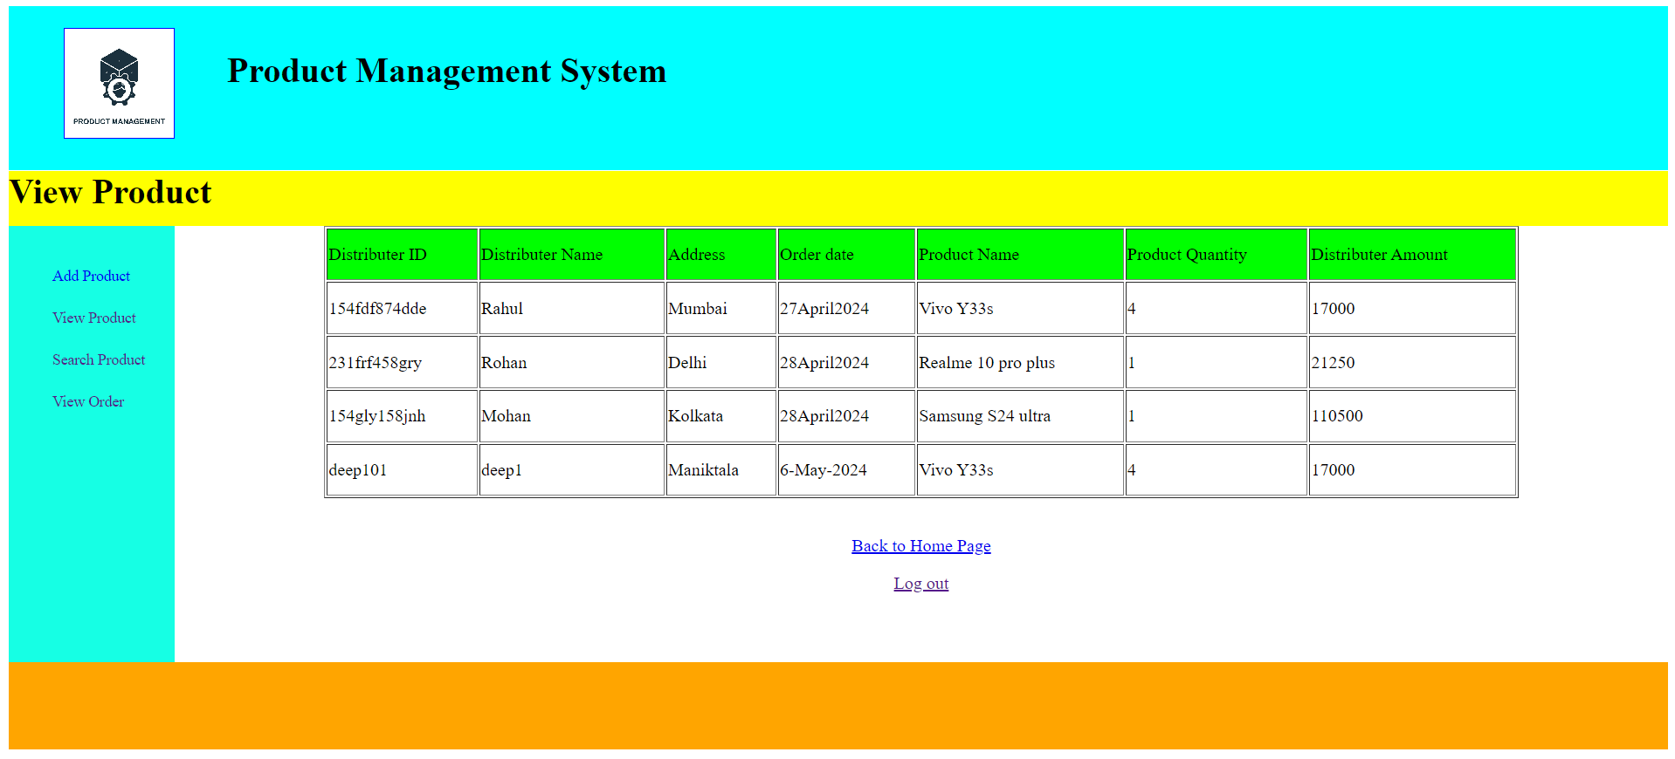

View Order Page:
Source Code:

<%@ page language="java" contentType="text/html; charset=ISO-8859-1"
pageEncoding="ISO-8859-1"%>
<!DOCTYPE html PUBLIC "-//W3C//DTD HTML 4.01 Transitional//EN" "http://www.w3.org/TR/html4/loose.dtd">
<html>
<head>
<meta http-equiv="Content-Type" content="text/html; charset=ISO-8859-1">
<style>
#container
{
width:100%;
height:auto;
}
#header
{
width:100%;
height:150px;
background-color:cyan;
}
#logo
{
width:100px;
height:100px;
border:1px solid blue;
margin-top:20px;
position:absolute;
margin-left:50px;
background-image:url("product.jpg");
background-size:cover;
}
#heading
{
width:100%;
height:150px;
margin-left:200px;
}
#home
{
width:100%;
height:50px;
background-color:yellow;
margin-top:-20px;
}
#contain
{
width:100%;
height:400px;

}
#side1
{
width:10%;
height:400px;
background-color:rgb(22,255,228);
float:left;
}
#side2
{
width:90%;
height:400px;
background-color:white;
margin-left:10%;
}
#footer
{
width:100%;
height:80px;
background-color:orange;
}
ul li
{
list-style-type:none;
padding-top:20px;
}
ul li a
{
text-decoration:none;
font-size:14px;
}
ul li a:hover
{
border-bottom:3px solid rgb(66,64,255);
cursor pointer;
}

table
{
height:250px;
width:80%;
margin-left:10%;
}
</style>
</head>
<body>
<div id = "container">
<div id = "header">
<div id = "logo"></div>
<div id = "heading"><br><h1>Product Management System</h1></div>
</div>
<div id = "home"><h1>View Product</h1></div>
<div id = "contain">
<div id = "side1">
<ul>
<li><a href="addproduct.jsp">Add Product</a></li>
<li><a href="viewproduct.jsp">View Product</a></li>
<li><a href="searchproduct.jsp">Search Product</a></li>
<li><a href="view.jsp">View Order</a></li>
</ul>
</div>
<div id = "side2">

<%@ page import = "java.sql.*" %>
<%
try
{

Class.forName("com.mysql.jdbc.Driver");
Connection con = DriverManager.getConnection("jdbc:mysql://localhost:3306/product_management_system","root","");
String sql = "select * from order1";
Statement st = con.createStatement();
ResultSet rs = st.executeQuery(sql);
out.println("<table border = '1'>");
out.println("<tr bgcolor='lime'>");
out.println("<td>Distributer ID</td>");
out.println("<td>Distributer Name</td>");
out.println("<td>Address</td>");
out.println("<td>Order date</td>");
out.println("<td>Product Name</td>");
out.println("<td>Product Quantity</td>");
out.println("<td>Distributer Amount</td>");
out.println("</tr>");
while(rs.next())
{
String a = rs.getString(1);
String b = rs.getString(2);
String c = rs.getString(3);
String d = rs.getString(4);
String e = rs.getString(5);
int f = rs.getInt(6);
int g = rs.getInt(7);

out.println("<tr>");
out.println("<td>"+a+"</td>");
out.println("<td>"+b+"</td>");
out.println("<td>"+c+"</td>");
out.println("<td>"+d+"</td>");
out.println("<td>"+e+"</td>");
out.println("<td>"+f+"</td>");
out.println("<td>"+g+"</td>");
out.println("</tr>");
}

out.println("</table>");
}
catch(Exception ae)
{
out.println(ae);
}

%>

<br>
<p><center><a href="home2.html">Back to Home Page</a></center><p>
<p><center><a href="Main.html">Log out</a></center><p>
</div>
</div>
<div id = "footer"></div>
</div>
</body>
</html>

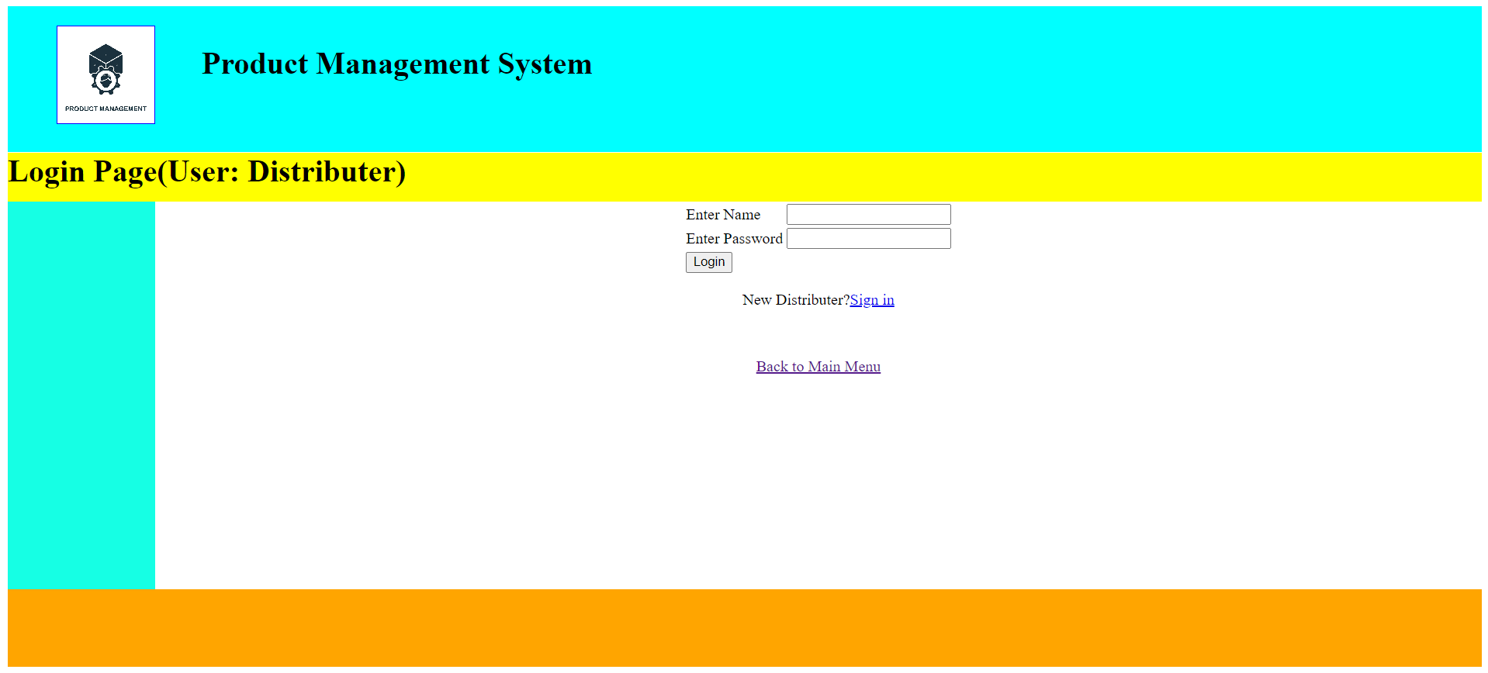
Distributer’s Login Page
Source Code:

<html>
<head>
<style>
#container
{
width:100%;
height:auto;
}
#header
{
width:100%;
height:150px;
background-color:cyan;
}
#logo
{
width:100px;
height:100px;
border:1px solid blue;
margin-top:20px;
position:absolute;
margin-left:50px;
background-image:url("product.jpg");
background-size:cover;
}
#heading
{
width:100%;
height:150px;
margin-left:200px;
}
#home
{
width:100%;
height:50px;
background-color:yellow;
margin-top:-20px;
}
#contain
{
width:100%;
height:400px;
}
#side1
{
width:10%;
height:400px;
background-color:rgb(22,255,228);
float:left;
}
#side2
{
width:90%;
height:400px;
background-color:white;
margin-left:10%;
}
#footer
{
width:100%;
height:80px;
background-color:orange;
}
</style>
<script>
function abc()
{
var a = document.f1.txt1.value;
var b = document.f1.txt2.value;

if(a=="" || b=="")
{
alert("Please fill the box!");
return false;
}
else if(b.length<8)
{
alert("Password must be 8 characters!");
return false;
}
else
{
return true;
}
}
</script>
</head>
<body>
<div id = "container">
<div id = "header">
<div id = "logo"></div>
<div id = "heading"><br><h1>Product Management System</h1></div>
</div>
<div id = "home"><h1>Login Page(User: Distributer)</h1></div>
<div id = "contain">
<div id = "side1"></div>
<div id = "side2">
<center>
<form name = "f1" action = "login4.jsp" method = "post">
<table>
<tr><td>Enter Name</td><td><input type = "text" name = "txt1"></td></tr>
<tr><td>Enter Password</td><td><input type = "password" name = "txt2"></td></tr>
<tr><td><input type = "submit" name = "sub" value = "Login" onclick = "return abc()"></td></tr>
</table>
</form>

<p>New Distributer?<a href="add_distrubuter.jsp">Sign in</a></p>
</center>
<br>
<center>
<p><a href="Main.html">Back to Main Menu</a></p>
</center>
</div>
</div>
<div id = "footer"></div>
</div>
</body>
</html>

Source Code for Distributer Login:

<%@ page language="java" contentType="text/html; charset=ISO-8859-1"
pageEncoding="ISO-8859-1"%>
<!DOCTYPE html PUBLIC "-//W3C//DTD HTML 4.01 Transitional//EN" "http://www.w3.org/TR/html4/loose.dtd">
<html>
<head>
<meta http-equiv="Content-Type" content="text/html; charset=ISO-8859-1">
<title>Insert title here</title>
</head>
<body>

<%@ page import = "java.sql.*" %>
<%
try
{

Class.forName("com.mysql.jdbc.Driver");
Connection con = DriverManager.getConnection("jdbc:mysql://localhost:3306/product_management_system","root","");
String a = request.getParameter("txt1");
String b = request.getParameter("txt2");
String sql = "select * from distributer2 where uname = '"+a+"' and upassword = '"+b+"'";

//set session
session.setAttribute("uid",a);

Statement st = con.createStatement();
ResultSet rs = st.executeQuery(sql);

int flag = 0;
while(rs.next())
{
flag=1;
}
if(flag==1)
{
response.sendRedirect("home2.html");
}

else
{
response.sendRedirect("login3.jsp");
}
}
catch(Exception ae)
{
out.println(ae);
}

%>

</body>
</html>
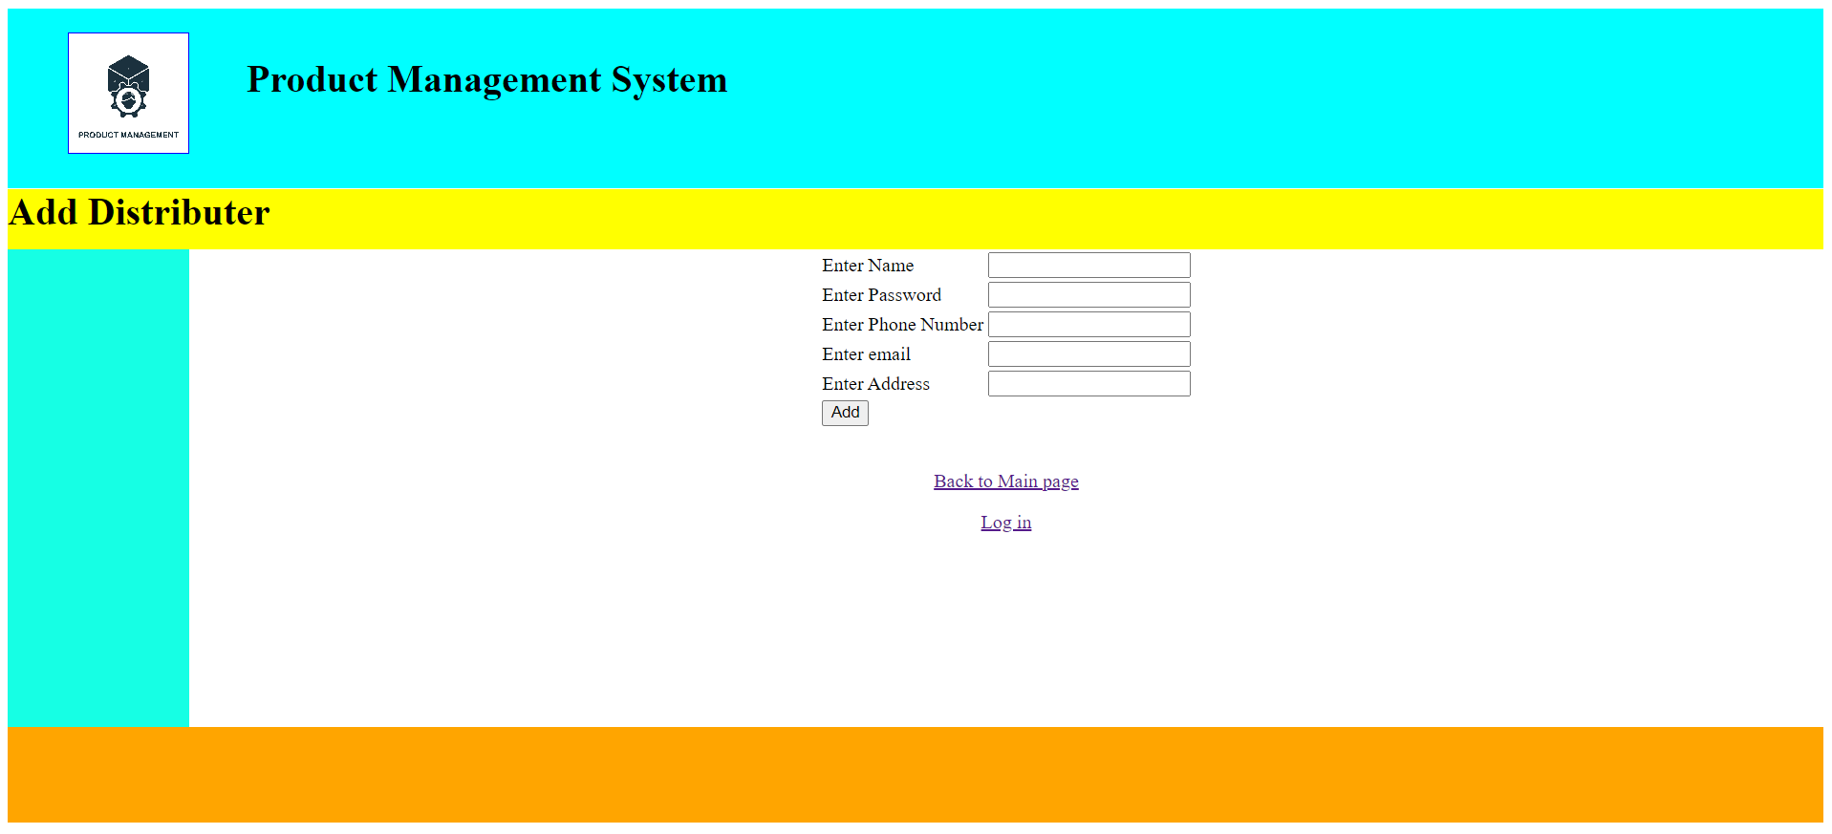
New Distributer’s Sign in Page
Source Code:

<%@ page language="java" contentType="text/html; charset=ISO-8859-1"
pageEncoding="ISO-8859-1"%>
<!DOCTYPE html PUBLIC "-//W3C//DTD HTML 4.01 Transitional//EN" "http://www.w3.org/TR/html4/loose.dtd">
<html>
<head>
<meta http-equiv="Content-Type" content="text/html; charset=ISO-8859-1">
<style>
#container
{
width:100%;
height:auto;
}
#header
{
width:100%;
height:150px;
background-color:cyan;
}
#logo
{
width:100px;
height:100px;
border:1px solid blue;
margin-top:20px;
position:absolute;
margin-left:50px;
background-image:url("product.jpg");
background-size:cover;
}
#heading
{
width:100%;
height:150px;
margin-left:200px;
}
#home
{
width:100%;
height:50px;
background-color:yellow;
margin-top:-20px;
}
#contain
{
width:100%;
height:400px;
}
#side1
{
width:10%;
height:400px;
background-color:rgb(22,255,228);
float:left;
}
#side2
{
width:90%;
height:400px;
background-color:white;
margin-left:10%;
}
#footer
{
width:100%;
height:80px;
background-color:orange;
}
ul li
{
list-style-type:none;
padding-top:20px;
}
ul li a
{
text-decoration:none;
font-size:14px;
}
ul li a:hover
{
border-bottom:3px solid rgb(66,64,255);
cursor pointer;
}
</style>

<script>
function abc()
{
var a = document.f1.txt1.value;
var b = document.f1.txt2.value;
var c = document.f1.txt3.value;
var d = document.f1.txt4.value;
var e = document.f1.txt5.value;

if(a=="" || b=="" || c=="" || d=="" || e=="")
{
alert("Please fill the box!");
return false;
}
else
{
return true;
}
}
</script>

</head>
<body>
<div id = "container">
<div id = "header">
<div id = "logo"></div>
<div id = "heading"><br><h1>Product Management System</h1></div>
</div>
<div id = "home"><h1>Add Distributer</h1></div>
<div id = "contain">
<div id = "side1">
<ul>

</ul>
</div>
<div id = "side2">
<center>
<form name = "f1" action = "add_distributer2.jsp" method = "post">
<table>
<tr><td>Enter Name</td><td><input type = "text" name = "txt1"></td></tr>
<tr><td>Enter Password</td><td><input type = "password" name = "txt2"></td></tr>
<tr><td>Enter Phone Number</td><td><input type = "text" name = "txt3"></td></tr>
<tr><td>Enter email</td><td><input type = "text" name = "txt4"></td></tr>
<tr><td>Enter Address</td><td><input type = "text" name = "txt5"></td></tr>
<tr><td><input type = "submit" name = "sub" value = "Add" onclick = "return abc()"></td></tr>
</table>
</form>
</center>
<br>
<p><center><a href="Main.html">Back to Main page</a></center><p>
<p><center><a href="login1.jsp">Log in</a></center><p>
</div>
</div>
<div id = "footer"></div>
</div>
</body>
</html>

Source Code for New Distributer Sign in:

<%@ page language="java" contentType="text/html; charset=ISO-8859-1"
pageEncoding="ISO-8859-1"%>
<!DOCTYPE html PUBLIC "-//W3C//DTD HTML 4.01 Transitional//EN" "http://www.w3.org/TR/html4/loose.dtd">
<html>
<head>
<meta http-equiv="Content-Type" content="text/html; charset=ISO-8859-1">
<title>Insert title here</title>
</head>
<body>
<%@ page import = "java.sql.*" %>
<%
try
{

Class.forName("com.mysql.jdbc.Driver");
Connection con = DriverManager.getConnection("jdbc:mysql://localhost:3306/product_management_system","root","");
String a = request.getParameter("txt1");
String b = request.getParameter("txt2");
String c = request.getParameter("txt3");
String d = request.getParameter("txt4");
String e = request.getParameter("txt5");
int x = Integer.parseInt(c);
String sql = "insert into distributer2 values ('"+a+"','"+b+"',"+x+",'"+d+"','"+e+"')";
Statement st = con.createStatement();
st.executeUpdate(sql);
response.sendRedirect("login3.jsp");
}
catch(Exception ae)
{
out.println(ae);
}

%>
</body>
</html>

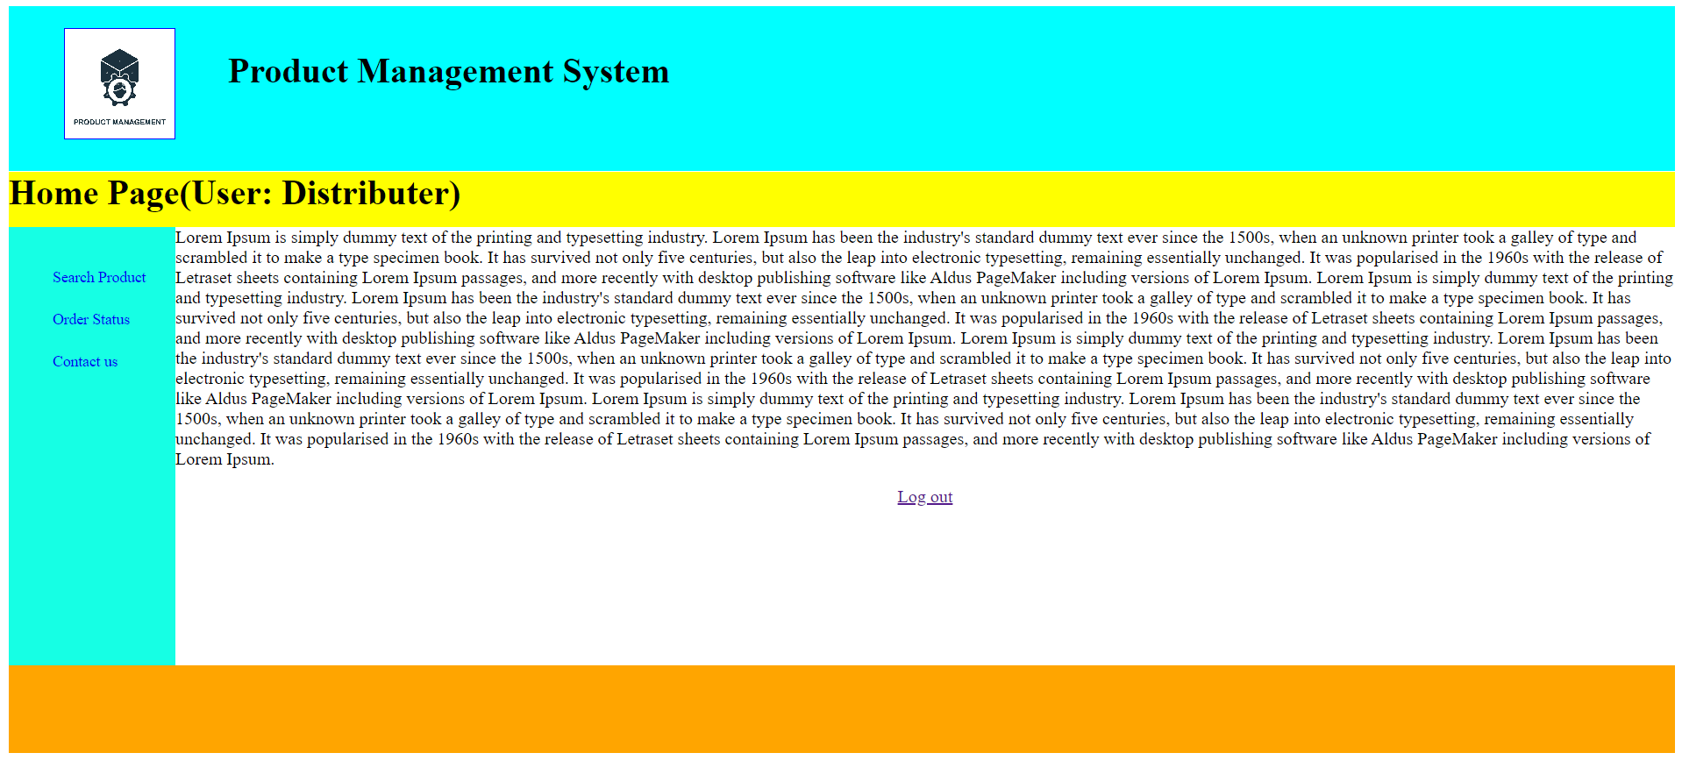

Admin’s Home Page
Source Code:

<html>
<head>
<style>
#container
{
width:100%;
height:auto;
}
#header
{
width:100%;
height:150px;
background-color:cyan;
}
#logo
{
width:100px;
height:100px;
border:1px solid blue;
margin-top:20px;
position:absolute;
margin-left:50px;
background-image:url("product.jpg");
background-size:cover;
}
#heading
{
width:100%;
height:150px;
margin-left:200px;
}
#home
{
width:100%;
height:50px;
background-color:yellow;
margin-top:-20px;
}
#contain
{
width:100%;
height:400px;
}
#side1
{
width:10%;
height:400px;
background-color:rgb(22,255,228);
float:left;
}
#side2
{
width:90%;
height:400px;
background-color:white;
margin-left:10%;
}
#footer
{
width:100%;
height:80px;
background-color:orange;
}
ul li
{
list-style-type:none;
padding-top:20px;
}
ul li a
{
text-decoration:none;
font-size:14px;
}
ul li a:hover
{
border-bottom:3px solid rgb(66,64,255);
cursor pointer;
}
</style>
</head>
<body>
<div id = "container">
<div id = "header">
<div id = "logo"></div>
<div id = "heading"><br><h1>Product Management System</h1></div>
</div>
<div id = "home"><h1>Home Page(User: Distributer)</h1></div>
<div id = "contain">
<div id = "side1">
<ul>
<li><a href="searchproduct3.jsp">Search Product</a></li>
<li><a href="Distributor_status.jsp">Order Status</a></li>
<li><a href="contact1.jsp">Contact us</a></li>
</ul>
</div>
<div id = "side2">
Lorem Ipsum is simply dummy text of the printing and typesetting industry. Lorem Ipsum has been the industry's standard dummy text ever since the 1500s, when an unknown printer took a galley of type and scrambled it to make a type specimen book. It has survived not only five centuries, but also the leap into electronic typesetting, remaining essentially unchanged. It was popularised in the 1960s with the release of Letraset sheets containing Lorem Ipsum passages, and more recently with desktop publishing software like Aldus PageMaker including versions of Lorem Ipsum.
Lorem Ipsum is simply dummy text of the printing and typesetting industry. Lorem Ipsum has been the industry's standard dummy text ever since the 1500s, when an unknown printer took a galley of type and scrambled it to make a type specimen book. It has survived not only five centuries, but also the leap into electronic typesetting, remaining essentially unchanged. It was popularised in the 1960s with the release of Letraset sheets containing Lorem Ipsum passages, and more recently with desktop publishing software like Aldus PageMaker including versions of Lorem Ipsum.
Lorem Ipsum is simply dummy text of the printing and typesetting industry. Lorem Ipsum has been the industry's standard dummy text ever since the 1500s, when an unknown printer took a galley of type and scrambled it to make a type specimen book. It has survived not only five centuries, but also the leap into electronic typesetting, remaining essentially unchanged. It was popularised in the 1960s with the release of Letraset sheets containing Lorem Ipsum passages, and more recently with desktop publishing software like Aldus PageMaker including versions of Lorem Ipsum.
Lorem Ipsum is simply dummy text of the printing and typesetting industry. Lorem Ipsum has been the industry's standard dummy text ever since the 1500s, when an unknown printer took a galley of type and scrambled it to make a type specimen book. It has survived not only five centuries, but also the leap into electronic typesetting, remaining essentially unchanged. It was popularised in the 1960s with the release of Letraset sheets containing Lorem Ipsum passages, and more recently with desktop publishing software like Aldus PageMaker including versions of Lorem Ipsum.

<br>
<p><center><a href="login1.jsp">Log out</a></center><p>
</div>
</div>
<div id = "footer"></div>
</div>
</body>
</html>

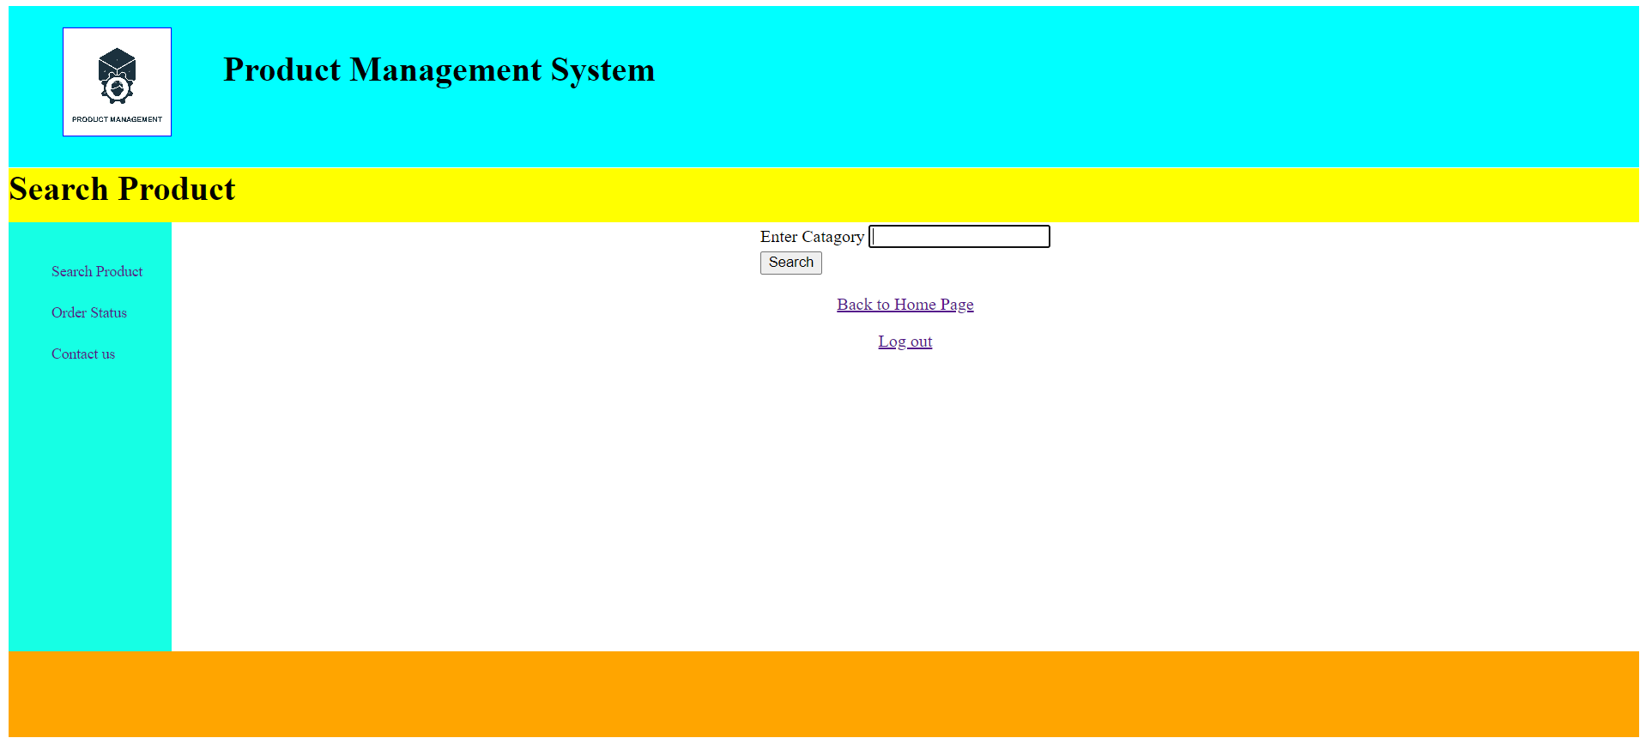
Search Product Page:
Source Code:

<%@ page language="java" contentType="text/html; charset=ISO-8859-1"
pageEncoding="ISO-8859-1"%>
<!DOCTYPE html PUBLIC "-//W3C//DTD HTML 4.01 Transitional//EN" "http://www.w3.org/TR/html4/loose.dtd">
<html>
<head>
<meta http-equiv="Content-Type" content="text/html; charset=ISO-8859-1">
<style>
#container
{
width:100%;
height:auto;
}
#header
{
width:100%;
height:150px;
background-color:cyan;
}
#logo
{
width:100px;
height:100px;
border:1px solid blue;
margin-top:20px;
position:absolute;
margin-left:50px;
background-image:url("product.jpg");
background-size:cover;
}
#heading
{
width:100%;
height:150px;
margin-left:200px;
}
#home
{
width:100%;
height:50px;
background-color:yellow;
margin-top:-20px;
}
#contain
{
width:100%;
height:400px;
}
#side1
{
width:10%;
height:400px;
background-color:rgb(22,255,228);
float:left;
}
#side2
{
width:90%;
height:400px;
background-color:white;
margin-left:10%;
}
#footer
{
width:100%;
height:80px;
background-color:orange;
}
ul li
{
list-style-type:none;
padding-top:20px;
}
ul li a
{
text-decoration:none;
font-size:14px;
}
ul li a:hover
{
border-bottom:3px solid rgb(66,64,255);
cursor pointer;
}
</style>

<script>
function abc()
{
var a = document.f1.txt1.value;

if(a=="")
{
alert("Please fill the box!");
return false;
}
else
{
return true;
}
}
</script>

</head>
<body>
<div id = "container">
<div id = "header">
<div id = "logo"></div>
<div id = "heading"><br><h1>Product Management System</h1></div>
</div>
<div id = "home"><h1>Search Product</h1></div>
<div id = "contain">
<div id = "side1">
<ul>
<li><a href="searchproduct3.jsp">Search Product</a></li>
<li><a href="Distributor_status.jsp">Order Status</a></li>
<li><a href="contact1.jsp">Contact us</a></li>
</ul>
</div>
<div id = "side2">
<center>
<form name = "f1" action = "searchproduct4.jsp" method = "post">
<table>
<tr><td>Enter Catagory</td><td><input type = "text" name = "txt1"></td></tr>
<tr><td><input type = "submit" name = "sub" value = "Search" onclick = "return abc()"></td></tr>
</table>
</form>
</center>

<p><center><a href="home2.html">Back to Home Page</a></center><p>
<p><center><a href="login3.jsp">Log out</a></center><p>
</div>
</div>
<div id = "footer"></div>
</div>
</body>
</html>

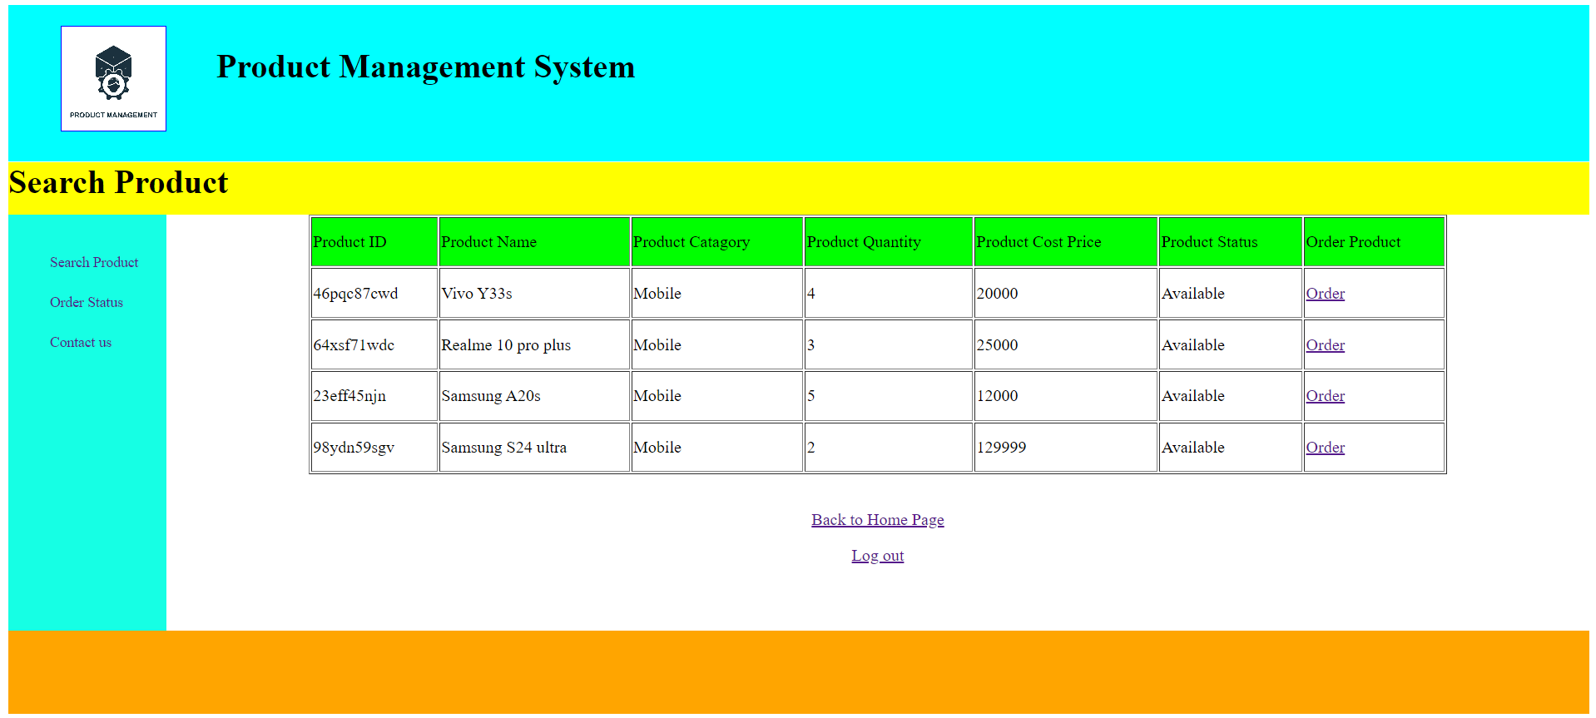

Source Code for Searching Product:

<%@ page language="java" contentType="text/html; charset=ISO-8859-1"
pageEncoding="ISO-8859-1"%>
<!DOCTYPE html PUBLIC "-//W3C//DTD HTML 4.01 Transitional//EN" "http://www.w3.org/TR/html4/loose.dtd">
<html>
<head>
<meta http-equiv="Content-Type" content="text/html; charset=ISO-8859-1">
<style>
#container
{
width:100%;
height:auto;
}
#header
{
width:100%;
height:150px;
background-color:cyan;
}
#logo
{
width:100px;
height:100px;
border:1px solid blue;
margin-top:20px;
position:absolute;
margin-left:50px;
background-image:url("product.jpg");
background-size:cover;
}
#heading
{
width:100%;
height:150px;
margin-left:200px;
}
#home
{
width:100%;
height:50px;
background-color:yellow;
margin-top:-20px;
}
#contain
{
width:100%;
height:400px;

}
#side1
{
width:10%;
height:400px;
background-color:rgb(22,255,228);
float:left;
}
#side2
{
width:90%;
height:400px;
background-color:white;
margin-left:10%;
}
#footer
{
width:100%;
height:80px;
background-color:orange;
}
ul li
{
list-style-type:none;
padding-top:20px;
}
ul li a
{
text-decoration:none;
font-size:14px;
}
ul li a:hover
{
border-bottom:3px solid rgb(66,64,255);
cursor pointer;
}
table
{
height:250px;
width:80%;
margin-left:10%;
}
</style>
</head>
<body>
<div id = "container">
<div id = "header">
<div id = "logo"></div>
<div id = "heading"><br><h1>Product Management System</h1></div>
</div>
<div id = "home"><h1>Search Product</h1></div>
<div id = "contain">
<div id = "side1">
<ul>
<li><a href="searchproduct3.jsp">Search Product</a></li>
<li><a href="Distributor_status.jsp">Order Status</a></li>
<li><a href="contact1.jsp">Contact us</a></li>
</ul>
</div>
<div id = "side2">

<%@ page import = "java.sql.*" %>
<%
try
{

Class.forName("com.mysql.jdbc.Driver");
Connection con = DriverManager.getConnection("jdbc:mysql://localhost:3306/product_management_system","root","");
String c = request.getParameter("txt1");
String sql = "select * from products where catagory = '"+c+"'";
Statement st = con.createStatement();
ResultSet rs = st.executeQuery(sql);

Statement st1 = con.createStatement();
ResultSet rs1 = st1.executeQuery(sql);

int flag = 0;
while(rs.next())
{
flag=1;
}
if(flag==1)
{
out.println("<table border = '1'>");
out.println("<tr bgcolor='lime'>");
out.println("<td>Product ID</td>");
out.println("<td>Product Name</td>");
out.println("<td>Product Catagory</td>");
out.println("<td>Product Quantity</td>");
out.println("<td>Product Cost Price</td>");
out.println("<td>Product Status</td>");
out.println("<td>Order Product</td>");
out.println("</tr>");
while(rs1.next())
{
String a = rs1.getString(1);
String b = rs1.getString(2);
String c1 = rs1.getString(3);
int d = rs1.getInt(4);
int e = rs1.getInt(5);
String f = rs1.getString(6);

out.println("<tr>");
out.println("<td>"+a+"</td>");
out.println("<td>"+b+"</td>");
out.println("<td>"+c1+"</td>");
out.println("<td>"+d+"</td>");
out.println("<td>"+e+"</td>");
out.println("<td>"+f+"</td>");
out.println("<td><a href='order1.jsp?txt1="+a+"'>Order</a></td>");
out.println("</tr>");
}
out.println("</table>");
}

else
{
out.println("Data not found");
}
}
catch(Exception ae)
{
out.println(ae);
}

%>
<br>
<p><center><a href="home2.html">Back to Home Page</a></center><p>
<p><center><a href="login3.jsp">Log out</a></center><p>
</div>
</div>
<div id = "footer"></div>
</div>

</body>
</html>

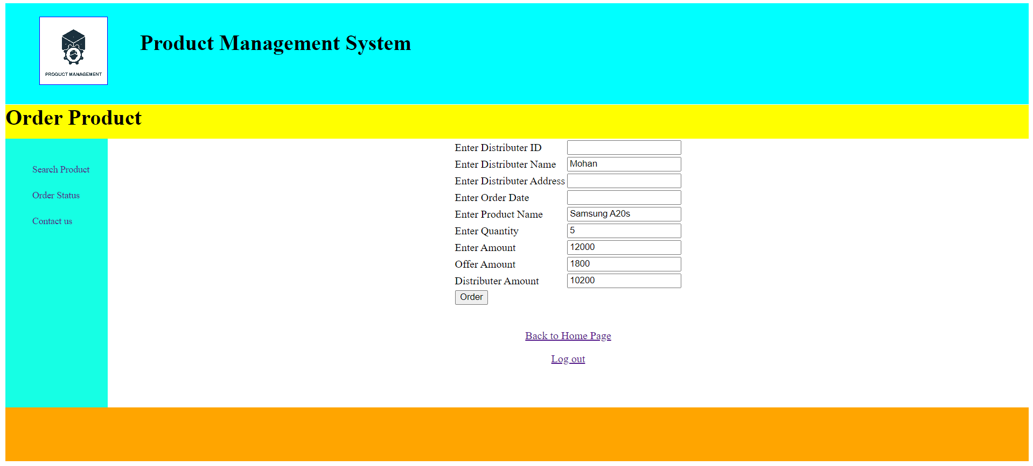
Order Product Page:
Source Code:
<%@ page language="java" contentType="text/html; charset=ISO-8859-1"
pageEncoding="ISO-8859-1"%>
<!DOCTYPE html PUBLIC "-//W3C//DTD HTML 4.01 Transitional//EN" "http://www.w3.org/TR/html4/loose.dtd">
<html>
<head>
<meta http-equiv="Content-Type" content="text/html; charset=ISO-8859-1">
<style>
#container
{
width:100%;
height:auto;
}
#header
{
width:100%;
height:150px;
background-color:cyan;
}
#logo
{
width:100px;
height:100px;
border:1px solid blue;
margin-top:20px;
position:absolute;
margin-left:50px;
background-image:url("product.jpg");
background-size:cover;
}
#heading
{
width:100%;
height:150px;
margin-left:200px;
}
#home
{
width:100%;
height:50px;
background-color:yellow;
margin-top:-20px;
}
#contain
{
width:100%;
height:400px;
}
#side1
{
width:10%;
height:400px;
background-color:rgb(22,255,228);
float:left;
}
#side2
{
width:90%;
height:400px;
background-color:white;
margin-left:10%;
}
#footer
{
width:100%;
height:80px;
background-color:orange;
}
ul li
{
list-style-type:none;
padding-top:20px;
}
ul li a
{
text-decoration:none;
font-size:14px;
}
ul li a:hover
{
border-bottom:3px solid rgb(66,64,255);
cursor pointer;
}
</style>

<script>
function abc()
{
var a = document.f1.txt1.value;
var b = document.f1.txt2.value;
var c = document.f1.txt3.value;
var d = document.f1.txt4.value;
var e = document.f1.txt5.value;
var f = document.f1.txt6.value;
var g = document.f1.txt7.value;
if(a=="" || b=="" || c=="" || d=="" || e=="" || f=="" || g=="")
{
alert("Please fill the box!");
return false;
}
else
{
return true;
}
}
</script>

</head>
<body>
<div id = "container">
<div id = "header">
<div id = "logo"></div>
<div id = "heading"><br><h1>Product Management System</h1></div>
</div>
<div id = "home"><h1>Order Product</h1></div>
<div id = "contain">
<div id = "side1">
<ul>
<li><a href="searchproduct3.jsp">Search Product</a></li>
<li><a href="Distributor_status.jsp">Order Status</a></li>
<li><a href="contact1.jsp">Contact us</a></li>
</ul>
</div>
<div id = "side2">

<%@ page import = "java.sql.*" %>
<%

String a="";
int b=0,c=0,offer=0,c1=0;
try
{
Class.forName("com.mysql.jdbc.Driver");
Connection con = DriverManager.getConnection("jdbc:mysql://localhost:3306/product_management_system","root","");

String s = request.getParameter("txt1");

String sql = "select * from products where id='"+s+"'";

Statement st = con.createStatement();
ResultSet rs = st.executeQuery(sql);

while(rs.next())
{
a = rs.getString(2);
b = rs.getInt(4);
c = rs.getInt(5);
}

offer = (c*15)/100;
c1 = c-offer;
}
catch(Exception ae)
{
out.println(ae);
}

%>

<%
String s = session.getAttribute("uid").toString();

%>
<center>
<form name = "f1" action = "order2.jsp" method = "post">
<table>
<tr><td>Enter Distributer ID</td><td><input type = "text" name = "txt1"></td></tr>
<tr><td>Enter Distributer Name</td><td><input type = "text" name = "txt2" value="<%=s%>"></td></tr>
<tr><td>Enter Distributer Address</td><td><input type = "text" name = "txt3"></td></tr>
<tr><td>Enter Order Date</td><td><input type = "text" name = "txt4"></td></tr>
<tr><td>Enter Product Name</td><td><input type = "text" name = "txt5" value="<%=a%>" readonly></td></tr>
<tr><td>Enter Quantity</td><td><input type = "text" name = "txt6" value="<%=b%>"></td></tr>
<tr><td>Enter Amount</td><td><input type = "text" name = "txt7" value="<%=c%>" readonly></td></tr>
<tr><td>Offer Amount</td><td><input type = "text" name = "txt8" value="<%=offer%>" readonly></td></tr>
<tr><td>Distributer Amount</td><td><input type = "text" name = "txt9" value="<%=c1%>"></td></tr>
<tr><td><input type = "submit" name = "sub" value = "Order" onclick = "return abc()"></td></tr>
</table>
</form>
</center>
<br>
<p><center><a href="home2.html">Back to Home Page</a></center><p>
<p><center><a href="login3.jsp">Log out</a></center><p>
</div>
</div>
<div id = "footer"></div>
</div>
</body>
</html>

Source Code for Searching Product:

<%@ page language="java" contentType="text/html; charset=ISO-8859-1"
pageEncoding="ISO-8859-1"%>
<!DOCTYPE html PUBLIC "-//W3C//DTD HTML 4.01 Transitional//EN" "http://www.w3.org/TR/html4/loose.dtd">
<html>
<head>
<meta http-equiv="Content-Type" content="text/html; charset=ISO-8859-1">
<title>Insert title here</title>
</head>
<body>

<%@ page import = "java.sql.*" %>
<%
try
{

Class.forName("com.mysql.jdbc.Driver");
Connection con = DriverManager.getConnection("jdbc:mysql://localhost:3306/product_management_system","root","");
String a = request.getParameter("txt1");
String b = request.getParameter("txt2");
String c = request.getParameter("txt3");
String d = request.getParameter("txt4");
String e = request.getParameter("txt5");
String f = request.getParameter("txt6");
String g = request.getParameter("txt9");
int x = Integer.parseInt(f);
int y = Integer.parseInt(g);

String sql = "insert into order1 values ('"+a+"','"+b+"','"+c+"','"+d+"','"+e+"',"+x+","+y+")";
Statement st = con.createStatement();
st.executeUpdate(sql);
response.sendRedirect("home2.html");
}
catch(Exception ae)
{
out.println(ae);
}

%>

</body>
</html>

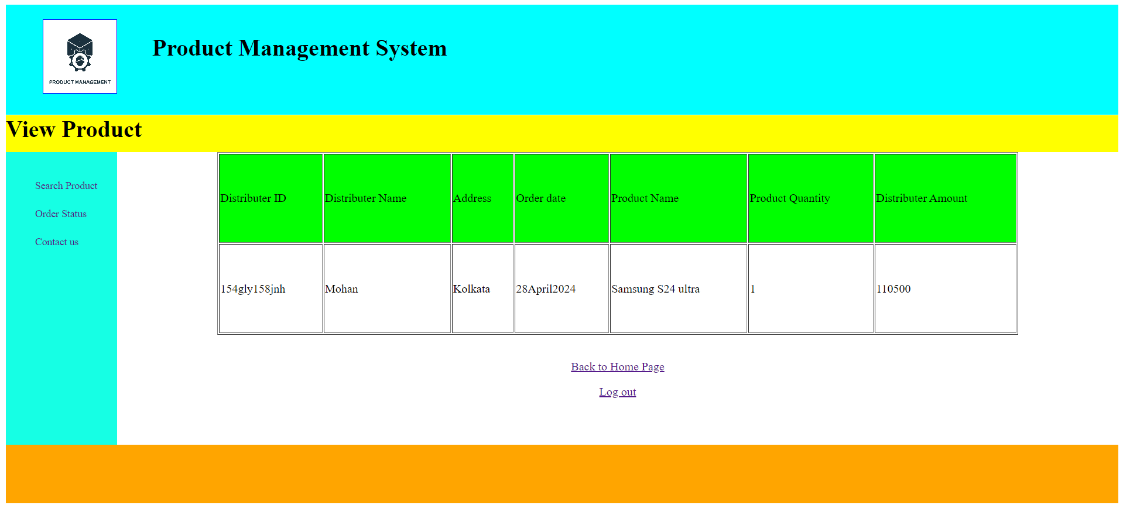

Order Status Page:
Source Code:

<%@ page language="java" contentType="text/html; charset=ISO-8859-1"
pageEncoding="ISO-8859-1"%>
<!DOCTYPE html PUBLIC "-//W3C//DTD HTML 4.01 Transitional//EN" "http://www.w3.org/TR/html4/loose.dtd">
<html>
<head>
<meta http-equiv="Content-Type" content="text/html; charset=ISO-8859-1">
<title>Insert title here</title>
<style>
#container
{
width:100%;
height:auto;
}
#header
{
width:100%;
height:150px;
background-color:cyan;
}
#logo
{
width:100px;
height:100px;
border:1px solid blue;
margin-top:20px;
position:absolute;
margin-left:50px;
background-image:url("product.jpg");
background-size:cover;
}
#heading
{
width:100%;
height:150px;
margin-left:200px;
}
#home
{
width:100%;
height:50px;
background-color:yellow;
margin-top:-20px;
}
#contain
{
width:100%;
height:400px;

}
#side1
{
width:10%;
height:400px;
background-color:rgb(22,255,228);
float:left;
}
#side2
{
width:90%;
height:400px;
background-color:white;
margin-left:10%;
}
#footer
{
width:100%;
height:80px;
background-color:orange;
}
ul li
{
list-style-type:none;
padding-top:20px;
}
ul li a
{
text-decoration:none;
font-size:14px;
}
ul li a:hover
{
border-bottom:3px solid rgb(66,64,255);
cursor pointer;
}

table
{
height:250px;
width:80%;
margin-left:10%;
}
</style>

</head>
<body>
<div id = "container">
<div id = "header">
<div id = "logo"></div>
<div id = "heading"><br><h1>Product Management System</h1></div>
</div>
<div id = "home"><h1>View Product</h1></div>
<div id = "contain">
<div id = "side1">
<ul>
<li><a href="searchproduct3.jsp">Search Product</a></li>
<li><a href="Distributor_status.jsp">Order Status</a></li>
<li><a href="contact1.jsp">Contact us</a></li>
</ul>
</div>
<div id = "side2">

<%@ page import = "java.sql.*" %>
<%
try
{

Class.forName("com.mysql.jdbc.Driver");
Connection con = DriverManager.getConnection("jdbc:mysql://localhost:3306/product_management_system","root","");

String s = session.getAttribute("uid").toString();

String sql = "select * from order1 where dname='"+s+"'";
Statement st = con.createStatement();
ResultSet rs = st.executeQuery(sql);
out.println("<table border = '1'>");
out.println("<tr bgcolor='lime'>");
out.println("<td>Distributer ID</td>");
out.println("<td>Distributer Name</td>");
out.println("<td>Address</td>");
out.println("<td>Order date</td>");
out.println("<td>Product Name</td>");
out.println("<td>Product Quantity</td>");
out.println("<td>Distributer Amount</td>");
out.println("</tr>");
while(rs.next())
{
String a = rs.getString(1);
String b = rs.getString(2);
String c = rs.getString(3);
String d = rs.getString(4);
String e = rs.getString(5);
int f = rs.getInt(6);
int g = rs.getInt(7);

out.println("<tr>");
out.println("<td>"+a+"</td>");
out.println("<td>"+b+"</td>");
out.println("<td>"+c+"</td>");
out.println("<td>"+d+"</td>");
out.println("<td>"+e+"</td>");
out.println("<td>"+f+"</td>");
out.println("<td>"+g+"</td>");
out.println("</tr>");
}

out.println("</table>");
}
catch(Exception ae)
{
out.println(ae);
}

%>

<br>
<p><center><a href="home2.html">Back to Home Page</a></center><p>
<p><center><a href="login3.jsp">Log out</a></center><p>
</div>
</div>
<div id = "footer"></div>
</div>
</body>
</html>

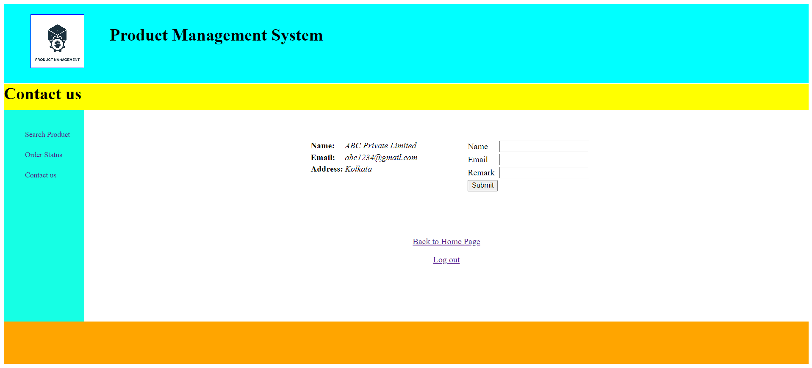

Contact Us Page:
Source Code:

<%@ page language="java" contentType="text/html; charset=ISO-8859-1"
pageEncoding="ISO-8859-1"%>
<!DOCTYPE html PUBLIC "-//W3C//DTD HTML 4.01 Transitional//EN" "http://www.w3.org/TR/html4/loose.dtd">
<html>
<head>
<meta http-equiv="Content-Type" content="text/html; charset=ISO-8859-1">
<style>
#container
{
width:100%;
height:auto;
}
#header
{
width:100%;
height:150px;
background-color:cyan;
}
#logo
{
width:100px;
height:100px;
border:1px solid blue;
margin-top:20px;
position:absolute;
margin-left:50px;
background-image:url("product.jpg");
background-size:cover;
}
#heading
{
width:100%;
height:150px;
margin-left:200px;
}
#home
{
width:100%;
height:50px;
background-color:yellow;
margin-top:-20px;
}
#contain
{
width:100%;
height:400px;
}
#side1
{
width:10%;
height:400px;
background-color:rgb(22,255,228);
float:left;
}
#side2
{
width:90%;
height:400px;
background-color:white;
margin-left:10%;
}

#submit
{
width:45%;
height: 100px;
background-color:white;
}
#footer
{
width:100%;
height:80px;
background-color:orange;
}
ul li
{
list-style-type:none;
padding-top:20px;
}
ul li a
{
text-decoration:none;
font-size:14px;
}
ul li a:hover
{
border-bottom:3px solid rgb(66,64,255);
cursor pointer;
}
#address
{
width:150px;
height:150px;
margin-left:425px;
float:left;
}
#submit
{
width:150px;
height:150px;
margin-left:225px;
}
</style>

<script>
function abc()
{
var a = document.f1.txt1.value;
var b = document.f1.txt2.value;
var c = document.f1.txt3.value;
var d = document.f1.txt4.value;
var e = document.f1.txt5.value;
var f = document.f1.txt6.value;

if(a=="" || b=="" || c=="" || d=="" || e=="" || f=="")
{
alert("Please fill the box!");
return false;
}
else
{
return true;
}
}
</script>

</head>
<body>
<div id = "container">
<div id = "header">
<div id = "logo"></div>
<div id = "heading"><br><h1>Product Management System</h1></div>
</div>
<div id = "home"><h1>Contact us</h1></div>
<div id = "contain">
<div id = "side1">
<ul>
<li><a href="searchproduct3.jsp">Search Product</a></li>
<li><a href="Distributor_status.jsp">Order Status</a></li>
<li><a href="contact1.jsp">Contact us</a></li>
</ul>
</div>
<div id = "side2">
<center>
<br>
<div id="address">
<br><br>
<center>
<table>
<tr><td><b>Name:</b></td><td><i>ABC Private Limited</i></td></tr>
<tr><td><b>Email:</b></td><td><i>abc1234@gmail.com</i></td></tr>
<tr><td><b>Address:</b></td><td><i> Kolkata</i></td></tr>
</table>
</center>
</div>
<div id = "submit">
<br><br>
<center>
<form name = "f1" action = "contact2.jsp" method = "post">
<table>
<tr><td>Name</td><td><input type = "text" name = "txt1"></td></tr>
<tr><td>Email</td><td><input type = "text" name = "txt2"></td></tr>
<tr><td>Remark</td><td><input type = "text" name = "txt3"></td></tr>
<tr><td><input type = "submit" name = "sub" value = "Submit" onclick = "return abc()"></td></tr>
</table>
</form>
</center>
</div>
</center>
<br><br><br>
<p><center><a href="home2.html">Back to Home Page</a></center><p>
<p><center><a href="login3.jsp">Log out</a></center><p>
</div>
</div>
<div id = "footer"></div>
</div>
</body>
</html>

Source Code for Contact Us:

<%@ page language="java" contentType="text/html; charset=ISO-8859-1"
pageEncoding="ISO-8859-1"%>
<!DOCTYPE html PUBLIC "-//W3C//DTD HTML 4.01 Transitional//EN" "http://www.w3.org/TR/html4/loose.dtd">
<html>
<head>
<meta http-equiv="Content-Type" content="text/html; charset=ISO-8859-1">
<title>Insert title here</title>
</head>
<body>
<%@ page import = "java.sql.*" %>
<%
try
{

Class.forName("com.mysql.jdbc.Driver");
Connection con = DriverManager.getConnection("jdbc:mysql://localhost:3306/product_management_system","root","");
String a = request.getParameter("txt1");
String b = request.getParameter("txt2");
String c = request.getParameter("txt3");
String sql = "insert into feedback values ('"+a+"','"+b+"','"+c+"')";
Statement st = con.createStatement();
st.executeUpdate(sql);
response.sendRedirect("home2.html");
}
catch(Exception ae)
{
out.println(ae);
}

%>
</body>
</html>

Conclusion

In conclusion, the integration of software solutions in the field of product management can address several challenges and offer numerous benefits:
Efficient management of product data: Software can digitize and streamline the documentation process, making it easier to store, access, and share product specifications, design documents, production schedules, and quality reports. This improves efficiency, reduces paperwork, and enhances collaboration among product development teams.
Empowering stakeholders through dashboards: Product-focused software applications provide stakeholders with convenient access to project information, enabling them to take an active role in the development process. Personalized dashboards promote better engagement, communication, and decision-making.
Comprehensive product development timeline for better analysis: Software can create a longitudinal view of a product’s development history, integrating data from multiple sources and enabling teams to analyze trends, identify patterns, and make more informed decisions about design, production, and market strategies.
Accurate analysis of product performance: By leveraging advanced analytics and machine learning algorithms, software can analyze vast amounts of product data, including design iterations, production metrics, and market feedback. This can lead to more accurate forecasting, personalized development plans, and improved product performance.
Convenient project management and task assignment: Software applications allow teams to manage projects and assign tasks efficiently, enhancing productivity and reducing bottlenecks. Real-time updates, priority filters, and reminders contribute to a better project management experience.
Streamlined interfaces for product managers: Software interfaces designed for product managers provide an organized view of project timelines, team activities, and product information. This simplifies project oversight, reduces administrative burden, and enables more focused and effective product management.
Implementing these software solutions requires careful consideration of data privacy and security measures to protect intellectual property, adherence to regulatory requirements, and ongoing user feedback for continuous improvement. With the right software tools, the field of product management can leverage technology to enhance product development, improve market outcomes, and streamline project processes.

MANISH MANDAL

Bibliography
BOOKS FOLLOWED:
- JAVA APPLICATION
. BY APC UNDERSTANDING COMPUTER SCIENCE.
- BLACK BOOK BY SANTOSH KUMAR K.



- JAVA CORE BY Dr . R. NAGESWARA


