E2 REPORT
MANISH
23B0354

We calculated the Pearson correlation Coefficient (r) for the dataset (used in E1)
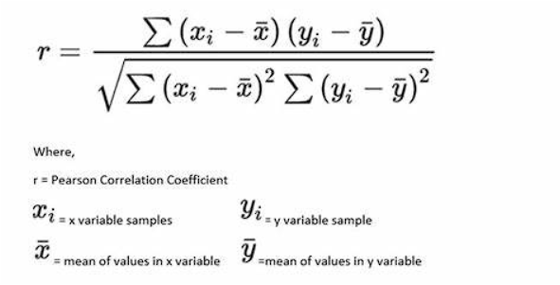
Which gives 0.946181204
The correlation coefficient tells us about the linear correlation. 0.946 showcases that x and y are highly correlated, which is true since we used x to calculate y previously with some added noise.
Next is the detailed regression output using built-in regression in Excel.
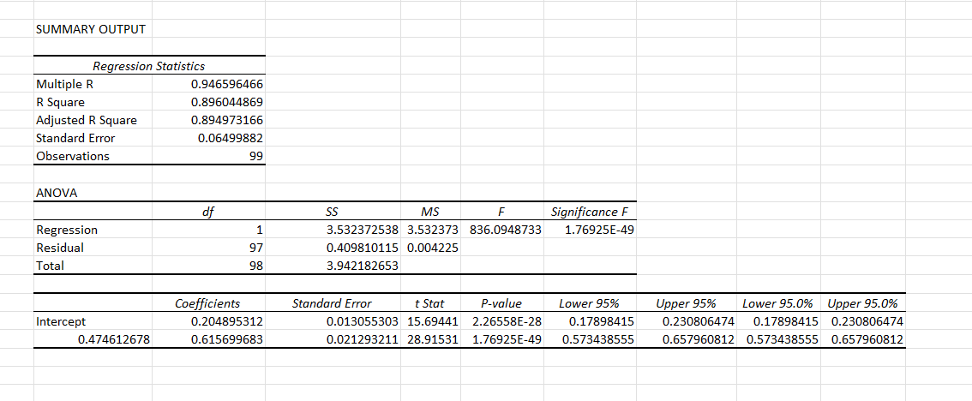
- The dataset's R2 (The Coefficient of Determination) is 0.896. The R2 shows how good the regression is the closer the R2 is to 1.
0.896 shows that regression here is good.
- R2 created by regression output = 0.896.
And R2 calculated using basic definition is 0.895. Both are almost the same.
- Both the R2 and r2 are the same because we use the same formula for R2 and r2 in linear regression.
- Standard Error is the average distance the observed values fall from the regression line.
The standard error in my dataset is 0.06499, which showcases that the precision of my dataset is quite high.
- The p-value here is 2.26E-28, which is very small; we know from the null hypothesis test that any value below 0.05 is good.
- A 95% confidence interval showcases that we are 95% sure that the actual parameter lies between the intervals. If zero is also included, it suggests that the actual coefficient could be zero, which means the coefficient is not statistically significant.
- F-value is the measure that evaluates the overall significance of a regression.

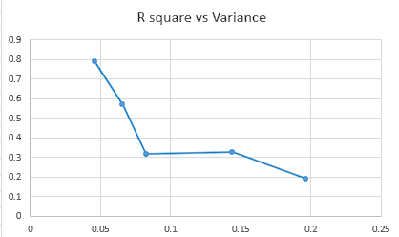
This shows that R square decreases with an increase in variance. This makes intuitive sense since Variance increases the spread of the dataset, and R2 shows how well the regression line fits.
However, online, I discovered that increasing the variance only by multiplying wouldn’t change the R2 since it’s a coefficient.

With this assignment, I learned more about
- Using Excel built-in analytical tool.
- Various statistical parameters
- About Null Hypotheses
- Improved how to communicate my learning

