INTERNSHIP REPORT
Of
AI-BASED INTELLIGENT CHATBOT FOR ACADEMIC
AND ADMINISTRATIVE SUPPORT ON COLLEGE WEBSITE

Submitted
To
School of Computer Science and Engineering
IILM University, Greater Noida, U.P.
In partial fulfilment of the requirement of degree of
B.Tech CSE

By
MANISH CHAUDHARY
Roll No.: 25SCS1003004767
ARYAN GUPTA
Roll No.: 25SCS1003003662
ARYAN SINGH
Roll No.: 25SCS1003004715
Under the Supervision of
Mr. Shantanu Bindhewari
Batch: 2025–2026

CANDIDATE’S DECLARATION
We, Manish Chaudhary, Aryan Gupta and Aryan Singh, hereby declare that the internship report titled “AI-Based Intelligent Chatbot for Academic and Administrative Support on College Website” has been completed by us to fulfil the requirement for the award of the degree of Bachelor of Technology in CSE. The work presented in this report is based on the project material supplied for this report. All references used in preparing the report have been acknowledged, and the report has not been submitted to any other institute for the fulfilment of any degree or diploma requirement. We shall be solely responsible for any copyright violation in this regard.

Student Name: Manish Chaudhary
Roll No: 25SCS1003004767

ACKNOWLEDGEMENT
We are using this opportunity to express our gratitude to everyone who supported us throughout the project work. We are thankful for the guidance, constructive criticism and advice that helped us understand the problem of scattered academic and administrative information and translate it into a practical AI-based chatbot concept. We are sincerely grateful to our supervisor, Mr. Shantanu Bindhewari, for his guidance and support during the work.
We also express our gratitude to our university, faculty members, classmates and parents for their encouragement and support throughout the project.
Signature(s): ______________________________
Student Name(s): Manish Chaudhary / Aryan Gupta / Aryan Singh
Roll No(s): 25SCS1003004767 / 25SCS1003003662 / 25SCS1003004715

INTERNSHIP COMPLETION CERTIFICATE
The supplied project presentation does not contain an internship completion certificate or details of the external internship organization. In accordance with the report-format instructions, the original certificate issued by the industry/organization should be attached on this page before submission.
[ ATTACH ORIGINAL INTERNSHIP COMPLETION CERTIFICATE HERE ]

TABLE OF CONTENTS
Chapter No. | Chapter Name | Page Nos.
 | Cover Page | ----
 |  | i
 |  | ii
 |  | iii
 |  | 1
 | 4.1 Introduction | 1
 | 4.2 Organization Profile | 2
 | 4.3 Problem Statement | 3
 | 4.4 Project Objectives | 4
 | 4.5 Scope of the Project | 5
 | 4.6 Technologies and Tools Used | 6
 | 4.7 System Architecture | 8
 | 4.8 Methodology | 10
 | 4.9 Expected Outcomes | 12
 | 4.10 Certificates of completion and communication proof | 13
 |  | 14

4. PROJECT DESCRIPTION
4.1 Introduction
College websites contain a large amount of academic and administrative information, but this information is often distributed across multiple pages and documents. This makes it difficult for students and other users to locate answers quickly. The project proposes an AI-based intelligent chatbot that provides a conversational interface for accessing verified institutional information.
The project is motivated by the growing use of conversational AI systems such as ChatGPT and Gemini. Instead of requiring users to manually navigate pages, the chatbot allows users to ask questions in natural language and receive an immediate response. The presentation identifies four key advantages of the proposed approach: 24/7 availability, instant query resolution, consistent answers and reduced repetitive administrative workload.
The proposed solution is designed as a lightweight retrieval-based system. A user's query is processed using NLP, classified into an appropriate intent, matched with a structured knowledge base, and then formatted into a response. This approach keeps the system institution-specific and aligned with verified information.
4.2 Organization Profile
The supplied project material is situated in a college/university website environment and identifies IILM University, Greater Noida, U.P. on the report-format cover. The presentation itself does not provide a separate external internship-organization profile. Therefore, the organization-specific internship details have not been invented in this report.
Project Context: The proposed chatbot is intended to support an educational institution by making academic and administrative information easier to access. Its intended users include students and other college website visitors who need quick answers to routine queries.
Note for submission: If this report is being submitted as an internship report for a specific company or organization, the official organization name, profile, internship role, duration and address should be inserted here from the internship records.
4.3 Problem Statement
Scattered content, complex navigation and the absence of interactive support make it difficult for users to quickly find information on a college website. As a result, routine questions are repeatedly directed to staff through email, telephone calls or in-person visits, increasing administrative workload and reducing the overall user experience.
• Fragmented Information: Content is spread across multiple pages and documents, requiring repeated manual searches.
• Administrative Burden: Routine queries consume staff time through email, phone and in-person channels.
• No Conversational Access: The website lacks an AI-driven conversational interface comparable to modern information-access tools.
4.4 Project Objectives
• Identify common information-accessibility issues on the college website.
• Design an AI chatbot that understands user queries using NLP techniques.
• Deliver instant, accurate and consistent answers to frequently asked questions.
• Reduce repetitive workload on administrative offices.
• Enable 24/7 conversational support to improve user engagement.
• Demonstrate practical AI/ML application aligned with the B.Tech curriculum.
• Build a scalable solution that can be prepared for institutional integration.
4.5 Scope of the Project
The scope of the proposed system is focused on academic and administrative information retrieval through a web-based conversational interface. The system is intended to cover verified frequently asked questions represented in a structured knowledge base.
• Web-based chat interface for users.
• NLP-based preprocessing of user questions.
• Intent classification to determine the category of a query.
• Retrieval of verified answers from a structured JSON knowledge base.
• Flask-based backend API for message handling and orchestration.
• Modular architecture that can be expanded with additional data and functionality.
The supplied presentation does not specify production deployment, a finalized dataset size, measured accuracy, or a live institutional integration. These should therefore be treated as future implementation or validation items rather than claimed completed results.
4.6 Technologies and Tools Used
The presentation specifies the following software and hardware requirements.
Category | Technology / Requirement
Programming Language | Python — core development language
Backend | Flask — backend REST API server
Deep Learning | TensorFlow / Keras — deep learning model
Machine Learning | Scikit-learn — ML classification models
NLP | NLTK — tokenization, lemmatization and preprocessing
Frontend | HTML, CSS and JavaScript — web chat interface
Knowledge Base | Structured JSON Q&A store
Hardware | Minimum 8 GB RAM; Intel i5 or equivalent; stable internet connectivity
Table 4.1: Software and hardware requirements
The lightweight retrieval-based design keeps computational requirements modest and is intended to be suitable for a standard development machine.
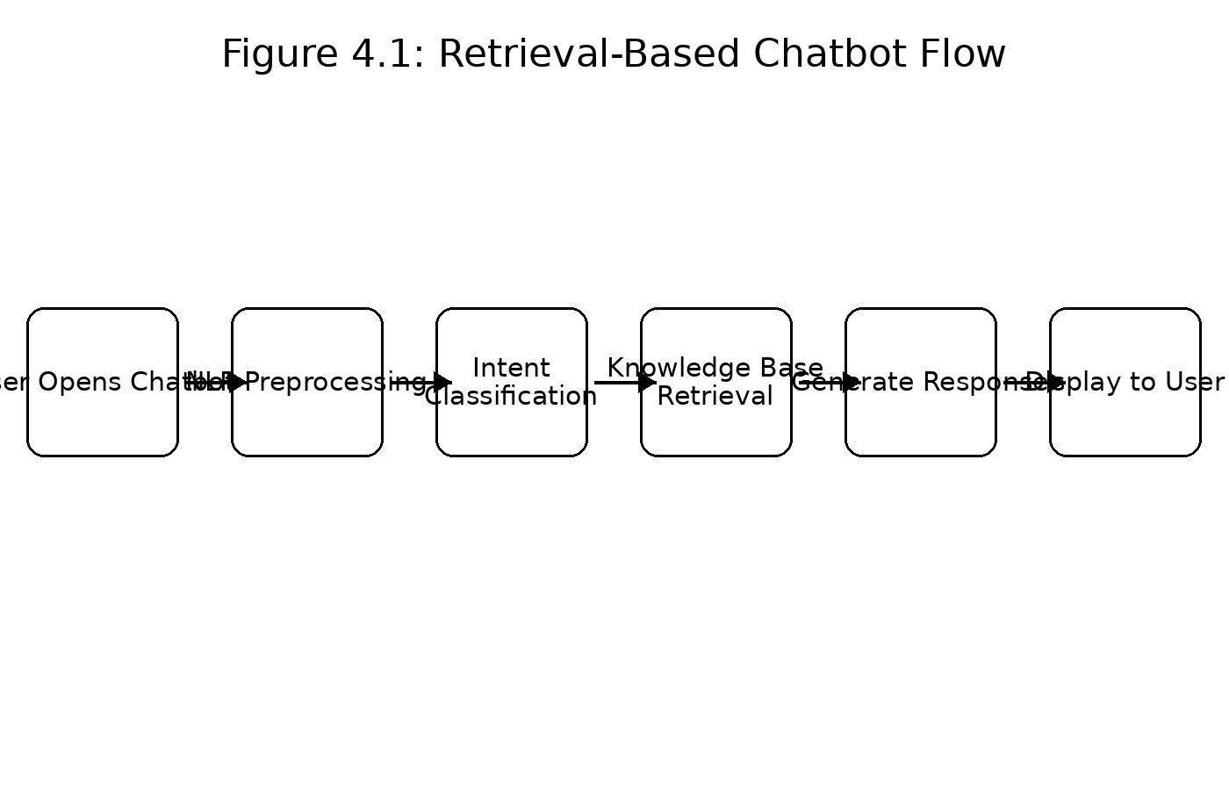
Figure 4.1: System flow of the proposed chatbot
4.7 System Architecture
The proposed system follows a modular three-tier design consisting of presentation, processing and data layers. These layers communicate through a lightweight REST API so that responses remain aligned with verified institutional information.
• Frontend — Web Chat Interface: HTML, CSS and JavaScript provide the user-facing conversational interface.
• Backend — Flask API: Handles incoming messages, orchestration and communication between the interface and processing components.
• NLP Engine: Performs tokenization and lemmatization as part of query preprocessing.
• Intent Classifier: Uses an ML/DL model to predict the category or intent of the user's query.
• Knowledge Base: Stores verified question-and-answer pairs in structured JSON format.
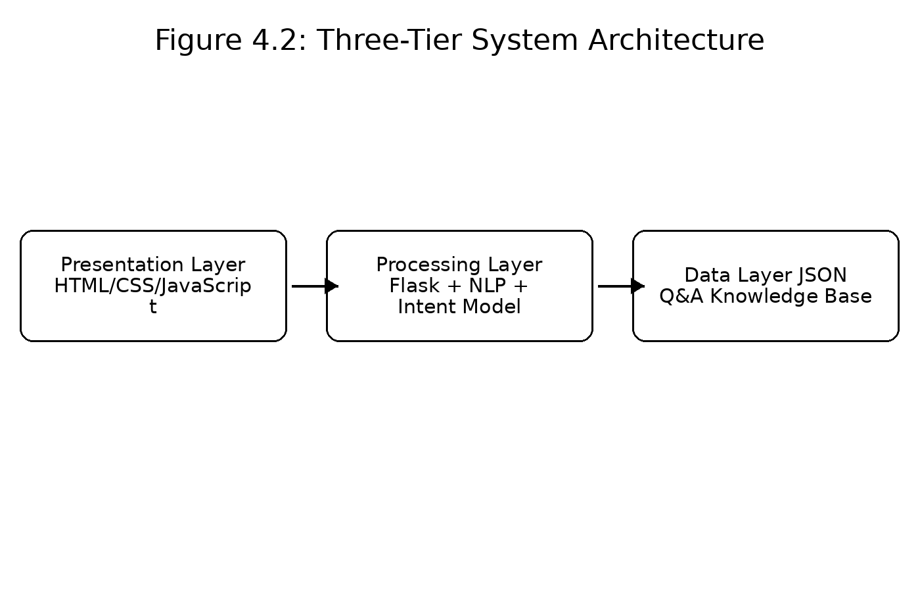
Figure 4.2: Modular three-tier architecture
4.8 Methodology
The methodology described in the presentation uses a retrieval-based pipeline. The user's input is cleaned through NLP preprocessing, classified into an intent, matched against a structured knowledge base, and then converted into a response displayed to the user.
4.8.1 NLP Preprocessing
The preprocessing stage includes tokenization, lemmatization and stop-word removal. These operations help convert raw natural-language input into a form that can be handled by the intent-classification stage.
4.8.2 Intent Classification
After preprocessing, an ML/DL model predicts the category of the query. The predicted intent is used to determine which part of the knowledge base should be consulted.
4.8.3 Knowledge Base and Response Retrieval
The knowledge base is represented as structured JSON containing verified question-and-answer pairs. Once an intent is identified, the system retrieves the relevant information and formats it into a response for the user.
4.8.4 Development Timeline
Week | Activity
1 | Problem Identification
2 | Literature Review
3 | Requirement Analysis
4 | System Design
5–6 | Data Collection & Structuring
7 | Data Preprocessing
8 | Model Development
9 | Backend Development
10 | Frontend Development
11 | Integration & Testing
12 | Optimization
13 | Documentation
Table 4.2: Project timeline — 13 weeks
4.8.5 Literature Review and Research Gap
The comparative review in the presentation considers college enquiry bots, AI student bots, retrieval-augmented generation (RAG) bots and rule-based bots. The identified strengths and limitations are summarized below.
System | Technique | Strengths / Limitations
College Enquiry Bot | NLP + Q&A | Simple and efficient; limited flexibility.
AI Student Bot | NLP + ML | Better intent recognition; requires frequent updates.
RAG Bot | Retrieval + Generation | Context-aware; higher complexity.
Rule-Based Bot | Rule logic | Predictable; poor adaptability.
Table 4.3: Comparative literature review
Research Gap: The presentation identifies a lack of moderately intelligent, institution-specific chatbot systems that balance feasibility, accuracy and ease of deployment while remaining suitable for undergraduate-level implementation.
4.8.6 Benefits and Challenges Identified
Benefits Identified | Challenges Identified
Instant support with no waiting time | Limited context understanding
Enhanced accessibility and anytime access | Heavy dependency on quality data
Improved student engagement | Ethical and accuracy concerns
Reduced administrative workload | Website integration complexity
Personalized, context-aware assistance | Frequent dataset/model updates
Table 4.4: Benefits and challenges identified from the literature
4.9 Expected Outcomes
Based on the supplied presentation, the expected outcome is an AI-powered college website chatbot that makes academic and administrative information easier to access through a conversational interface.
• Faster access to routine academic and administrative information.
• Consistent responses based on a verified institutional knowledge base.
• Reduced repetition of routine queries handled by administrative staff.
• 24/7 availability of conversational support.
• A modular architecture that can be expanded for institutional integration.
• A practical demonstration of AI, NLP, ML/DL and web-development concepts.
The presentation also identifies future improvements including expansion of the FAQ database, multilingual support, an administrator dashboard, query analytics and improved intent handling through periodic retraining on real user queries.
4.10 Certificates of Completion and Other Communication Mail Proof
The supplied presentation does not include an internship completion certificate, offer letter, communication email or other organizational proof. The report-format instructions require such evidence to be attached. The following placeholders are therefore provided for insertion before final submission.
[Attach Internship Completion Certificate]
[Attach Internship Offer / Joining Letter, if applicable]
[Attach Relevant Communication Email / Official Proof, if applicable]

5. BIBLIOGRAPHY / REFERENCES
Project presentation supplied for this report: “AI-Based Intelligent Chatbot for Academic and Administrative Support on College Website,” B.Tech CSE (IBM), 2025–2026.
Python Software Foundation. Python Documentation. https://docs.python.org/
Pallets Projects. Flask Documentation. https://flask.palletsprojects.com/
NLTK Project. Natural Language Toolkit Documentation. https://www.nltk.org/
Scikit-learn Developers. Scikit-learn User Guide. https://scikit-learn.org/
TensorFlow. TensorFlow Documentation. https://www.tensorflow.org/

