RESEARCH LANDSCAPE, SYSTEM DESIGN AND USER GUIDE
Extractive Writing AI Harness for Embodied AI Research
Professor census across QS-2027 top-100 universities (NeurIPS, ICML, ICLR, CVPR, ICCV, ECCV), a style dictionary of how these labs write, a rule-following paper writer and a 12-role scientific editor - for world models, vision-language-action models, Gaussian splatting robotics, humanoids, digital twins, AI safety and 3D/4D/6D vision.
Prepared for Manish Pandey | Research snapshot 5 November 2026 | Version 1.1 | Public edition
Website: manish-genai.github.io/paper-writing-site

Measure | Value
QS-2027 institutions | 102
accepted papers indexed | 94,806
List A professors (5 venues) | 738
List B professors (6 venues) | 581
topic-relevant List B | 444
evidence records | 10,641

Scope statement. This is an auditable, reproducible census built from public data, not a claim that every renowned professor in the world is listed. QS ranks institutions, not people; 'renowned' is represented only by transparent indicators (venue breadth, accepted-paper counts, presentation status, topic output). Every list entry links to evidence, and gaps are reported rather than hidden.

Public edition. This edition leaves out the per-professor tables of the full edition (top professors by topic score, topic leaders, strong output outside the QS top 100, lab style corpora and the list appendices). The professor lists are partly derived from CSRankings data, whose licence (CC BY-NC-ND 4.0) does not allow sharing modified versions. Counts and charts remain. The worked example in Section 11.3 is a made-up project.

How to use this report
Your task | Start here
Find professors / labs by topic | Sections 3-4 (method and counts); the per-professor lists are in the full edition and the local app
Understand the research frontier | Section 5 (per-topic synthesis + award papers)
Learn how top labs write | Section 6 (style dictionary) and web app 'Style Dictionary'
Follow venue rules | Section 7 and web app 'Rules & Venues'
Draft and edit your paper | Sections 8 and 11 (localhost app, Claude API or Azure)
Audit a claim or a number | Section 3 and Appendix B; audit.json exports from the app

Contents
1 Executive summary
2 Scope, definitions and evidence rules
3 How the professor census works
4 Results: List A and List B in numbers
5 Research landscape and open problems
6 The style dictionary: how these labs write
7 Venue requirements and writing rules
8 Application architecture and the multiple harnesses
9 GitHub repository map
10 Verification, evaluation and release gates
11 Running the application and writing your paper
12 Limitations and next steps
Appendix A QS World University Rankings 2027 top 100
Appendix B Data files, sources and licences
Headings are navigation landmarks (Word: View > Navigation Pane). Links are clickable in Word and PDF.

1 Executive summary
Decision. Treat research writing as a constrained evidence transformation, not free generation. Models may propose text and critiques; deterministic gates (hashes, exact quotes, number and citation provenance, venue rules, verbatim-overlap checks) and the author decide what enters the paper. The delivered application implements this end to end and runs locally with a Claude API key, with Claude on Microsoft Foundry (Azure billing), with Azure OpenAI, with any OpenAI-compatible server, or offline in a clearly labelled mock mode.
- Professor census. 738 professors at QS-2027 top-100 universities have accepted main-track papers at all of NeurIPS, ICML, ICLR, CVPR and ICCV (List A); 581 of them also at ECCV (List B). 511 (List A) and 444 (List B) are topic-relevant to the requested directions. Sources: CSRankings DBLP-derived counts (589 List A entries), OpenReview self-reported professor titles (141), and the verified 2026-10-26 dossiers (8).
- Evidence. 10,641 ledger records: current affiliation, QS rank, venue counts, one witness paper per venue with a primary-proceedings link (OpenReview / CVF / ECVA / PMLR / NeurIPS), match basis and author position. 683 of 738 List A entries reach evidence grade E2 (all required venues linked with strong identity evidence, or a recent self-reported professor title confirming the CSRankings affiliation).
- Data-quality discovery. About 12-16% of OpenReview-derived records in some years carry per-author profile fields (position, affiliation, DBLP id) in a different order from the author list. Left unchecked this produced errors such as a senior Berkeley professor appearing as an assistant professor elsewhere. The harness now detects permutations from homepage evidence, discards misaligned metadata, and learns DBLP ids only from verified records. Joined roles such as 'Associate Professor+Postdoc' are split per affiliation, e-mail domains veto affiliation-name matches that point elsewhere, and later records reveal moves (31 self-reports excluded; 28 flagged where CSRankings disagrees).
- Style dictionary. 264 profiles (global, venue, topic and lab corpora) from 4013 accepted papers (691 with arXiv full text): sentence shape, stance (hedges, boosters, promotional terms), voice, citation and number density, rhetorical moves and generic formulas. A hashed n-gram index guards against verbatim reuse; no paper text is redistributed.
- Rules. 12 venue profiles (NeurIPS/ICML/ICLR/CVPR/ICCV/ECCV 2025-2027, TPAMI, Nature, Nature Machine Intelligence) and 148 atomic writing rules distilled from venue checklists, reviewer guides and public advice by Freeman, Black, Peyton Jones, Widom, Lipton & Steinhardt, Huang, Karpathy and others - each with sources.
- Research map. 240 curated accepted papers (including 38 award winners) and 172 GitHub repositories with API-verified metadata and licence caveats.
- Software. A FastAPI + React application (localhost) and a GitHub Pages build (browser mode). Tests: 33 passed, 0 failed. On 30 synthetic domain fixtures the mechanical checks detect 22/22 meaning-changing edits with 0/8 false alarms on safe edits (development fixtures, not a benchmark).
What is not claimed. No live model was available in the build environment (no API key), so the quality of model-written drafts and model critiques has not been measured; only the deterministic layer, the workflow and the mock path were executed. A style profile describes a paper collection (co-authored, edited text), not an individual's mind. Inclusion in a list is evidence of publication breadth, not a ranking of scientific merit.

2 Scope, definitions and evidence rules
Rule | Operational meaning
Institution filter | QS World University Rankings 2027 overall rank <= 100, ties included (102 institutions). The rank attaches to the professor's current institution.
List A | At least one accepted main-track paper at each of NeurIPS, ICML, ICLR, CVPR and ICCV.
List B | List A plus at least one accepted main-track ECCV paper (List B is a subset of List A).
Tracks | Main proceedings; NeurIPS Datasets & Benchmarks and ICML/NeurIPS position papers are labelled. Workshops, journal-to-conference presentations, rejected, withdrawn and conditional decisions never count.
Venue presence | CSRankings DBLP-derived count > 0, or a strongly attributed accepted-paper witness, or a verified 2026-10-26 dossier witness outside paper-list coverage.
Identity | Seed title, affiliation/e-mail domain, DBLP id, >= 2 shared co-authors, or exact rare name. A conflicting DBLP id always rejects a match. Common names need affiliation, DBLP id or co-author evidence.
Topic relevance | Weighted count of accepted six-venue papers whose own title/keywords match the ontology (narrow topics weight 1; 3D vision and safety 0.5; abstract-only matches half); threshold 3.
Evidence levels | V1 all required venues linked with strong identity; V2 some rest on counts/dossiers. R1 CSRankings affiliation + OpenReview professor title in 2024+; R2 one role source. E2 = V1 or R1 (compatible with the 26 October rubric); E3 otherwise.
Professor | Assistant, associate or full professor (incl. research professor). Adjunct, visiting, emeritus, honorary and courtesy titles are excluded from the OpenReview channel.

Nature-family and TPAMI papers enrich the research map (Section 5) but never fill a missing conference cell. Topic tags describe published output, not expertise; a famous co-author is not evidence of who wrote a paper's prose.

3 How the professor census works
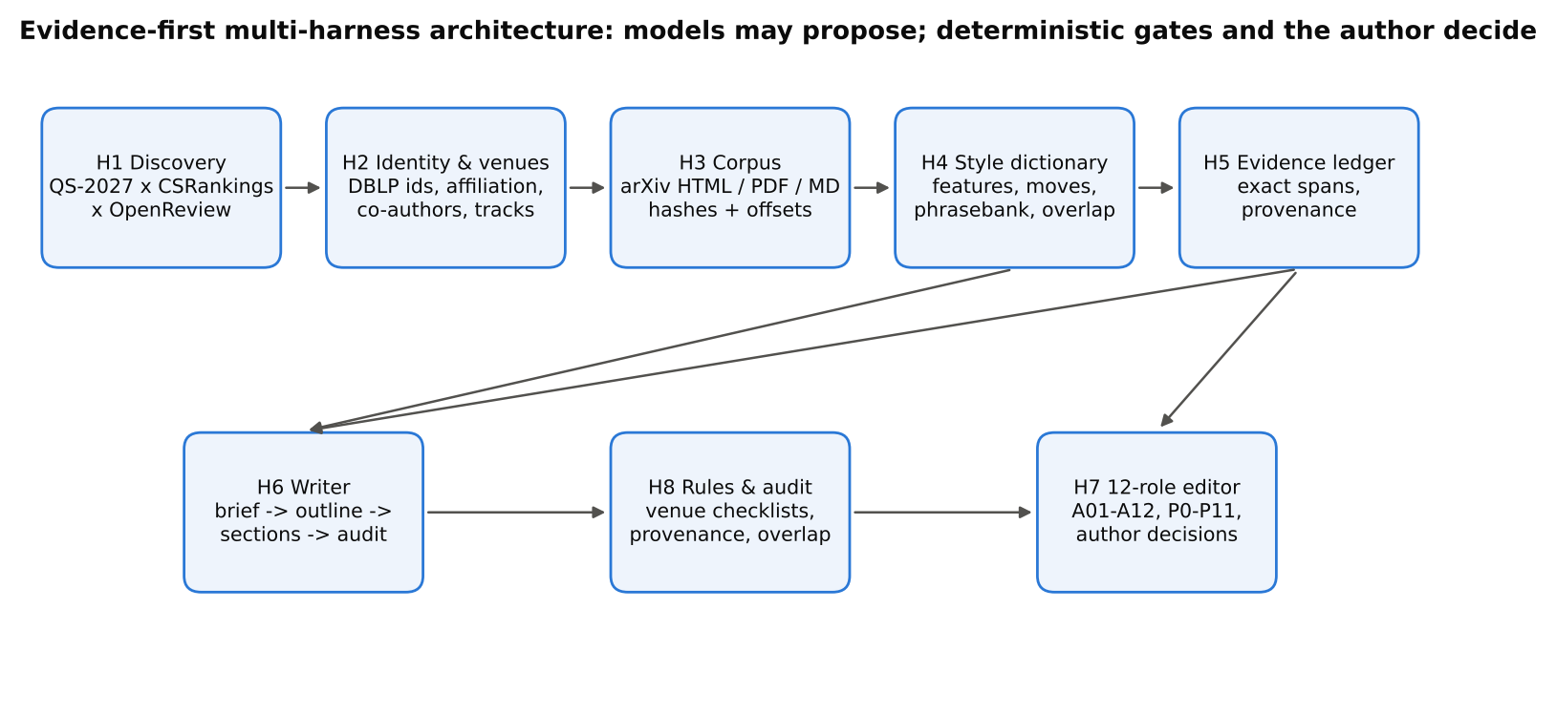
Figure 1. Harness architecture. H1-H2 produce the professor lists in this report.

3.1 Three discovery channels
Channel | What it contributes | Main limitation
CSRankings faculty file + generated-author-info.csv | Current affiliation, homepage and DBLP-derived main-track paper counts per conference and year for 3,571 QS-institution faculty with six-venue papers. | Covers faculty who can advise CS PhD students; misses some EE/ME/BCS faculty and people on leave or in industry roles; DBLP lags the newest proceedings.
OpenReview self-reported professors (Paper Copilot lists) | Authors of accepted ICLR/NeurIPS/ICML papers whose profile states a professor title at a QS top-100 institution (>= 2 verified records, latest in 2023 or later). | Self-reported; only people active at OpenReview venues; titles can be stale.
Seed dossiers (2026-10-26 report) | 162 verified witness titles for F01-F27 anchor identities, including movers (e.g. Hao Su to Fudan) and faculty outside CSRankings (e.g. Tenenbaum, Vedaldi, Zisserman). | Only as complete as the earlier audit.

3.2 Identity resolution and venue verification
- Venue counts come from CSRankings' DBLP identities (disambiguated names such as 'Xiaolong Wang 0004').
- 94,806 accepted papers from Paper Copilot (NeurIPS 2010-2025, ICML 2017-2026, ICLR 2013-2026, CVPR 2017-2025, ICCV 2017-2025, ECCV 2018-2024, CoRL, RSS) supply witness titles and primary links; rejected/withdrawn/workshop records are excluded by status and track.
- Matching passes: seed titles, affiliation strings and e-mail/affiliation domains (102 curated institution patterns with exclusions such as CUHK-Shenzhen vs CUHK, HKUST-Guangzhou vs HKUST, British Columbia vs Columbia), DBLP-id learning from verified records, co-author continuity, and exact rare names.
- Profile-field permutation detection: a homepage in a slot that names a different co-author marks the record misaligned; its per-author fields are discarded rather than guessed.
- Self-reported roles: '+'-joined titles are paired with their own affiliations (a postdoc at a QS university with a professorship elsewhere is not counted); an institutional e-mail domain that belongs to another institution vetoes an affiliation-name match (HKUST-Guangzhou, CUHK-Shenzhen, Polytechnique Montreal, NTHU vs Tsinghua, UCLouvain vs UCL); a later OpenReview record with another role marks a move. Where CSRankings names a different institution the entry is kept with an affiliation note to verify (data/faculty/self_report_conflicts.csv).
- Presence also accepts strongly attributed witnesses for proceedings DBLP has not indexed yet (e.g. ICML 2026).

3.3 Reconciliation with the 26 October lists
Earlier source | Status now | Count
discovery queue | confirmed List A | 7
discovery queue | confirmed List B | 50
discovery queue | not found at a QS top-100 institution in any channel | 33
discovery queue | not on List A | 72
report F01-F27 (six venues) | confirmed List B | 27
report specialists (not certified) | confirmed List A | 1
report specialists (not certified) | confirmed List B | 4
report specialists (not certified) | not found at a QS top-100 institution in any channel | 2
report specialists (not certified) | not on List A | 8
strict CSV (List A only) | confirmed List A | 3
strict CSV (List B) | confirmed List B | 30

Typical reasons an earlier name is not on List A now: no main-track paper at one venue in the evidence (e.g. a robotics specialist without ICCV papers), or a different person with the same name. These are not judgements of quality. The full row-level comparison is in data/faculty/prior_list_reconciliation.csv.

4 Results: List A and List B in numbers
Source | List A | of which List B | Topic-relevant List B
csrankings | 589 | 476 | 362
openreview_self_reported | 141 | 97 | 74
seed_dossier | 8 | 8 | 8
Total | 738 | 581 | 444

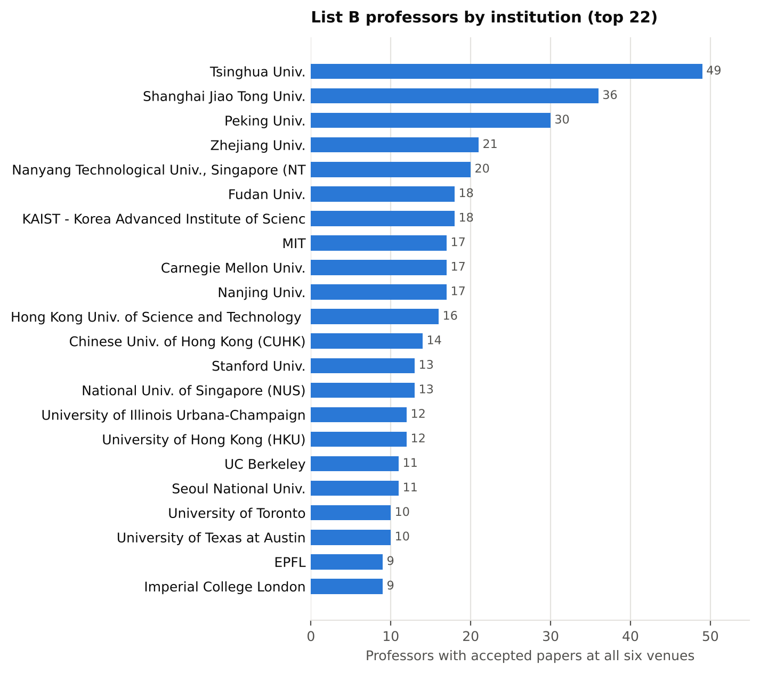
Figure 2. List B professors by institution (top 22).
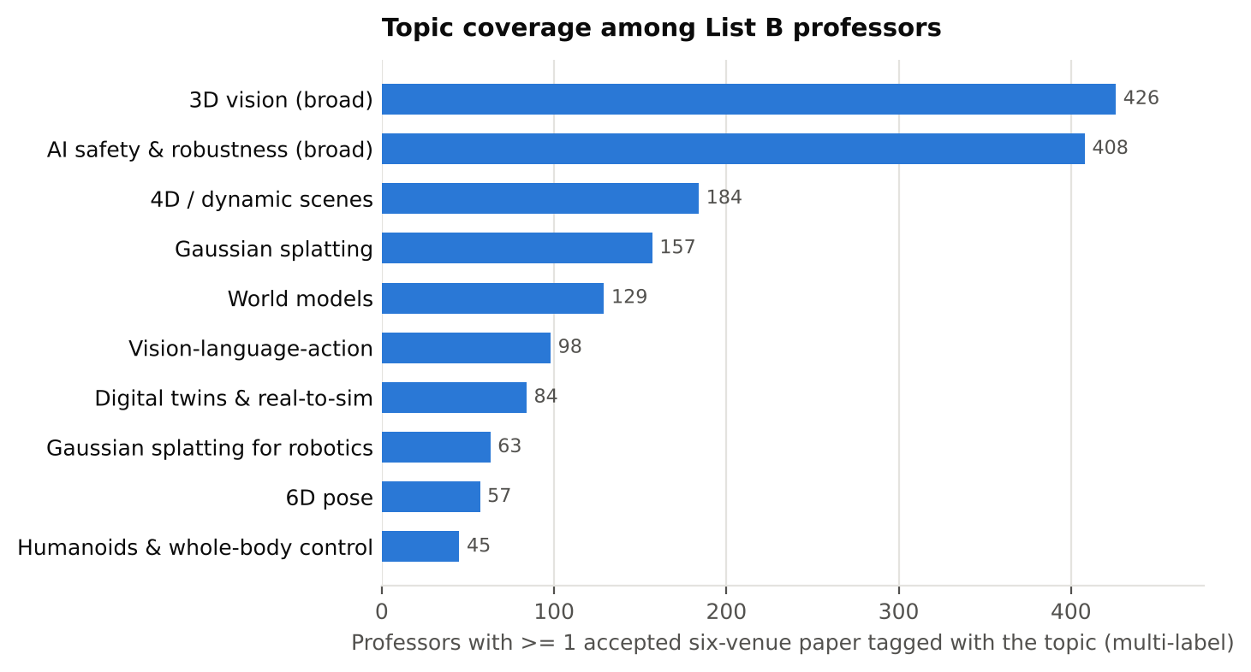
Figure 3. Topic coverage among List B professors (multi-label).
The per-professor tables of the full edition (top 40 List B professors by topic score, the leaders of each topic and strong topic output outside the QS top 100) are not part of this public edition.

5 Research landscape and open problems
The organising principle is the loop from observation to representation, predicted consequences, selected action and measured outcome. A scene representation, a video predictor, a control policy and a calibrated simulator occupy different parts of that loop; calling all of them 'world models' hides what is actually evaluated. For each direction below: what the field is converging on, the distinctions a paper must keep, and open questions worth a paper. The tables list curated accepted papers (venue, year, award where applicable) from the research map; confidence labels are in data/papers/top_papers.json.

5.1 World models
Two lines are converging: control-oriented latent world models used for planning and policy learning (the Dreamer and TD-MPC families) and generative interactive video models used as simulators and data engines (Genie, UniSim, navigation and long-memory video world models). Action conditioning, memory and 3D consistency over long horizons are now the frontier, together with learning from video without action labels.
Distinctions a paper must keep.
- Prediction quality (FVD/PSNR), action-conditioned accuracy and closed-loop control utility are three different claims; report them separately.
- A latent action inferred from video is not an actuator command; a plausible rollout is not a calibrated physical simulator.
- State the horizon, the training distribution and which embodiments were held out.
Open questions. Action-space alignment across embodiments; Calibrated uncertainty over long rollouts; Evaluation protocols that link prediction errors to decision quality; Which details a predictive model can discard while preserving decisions.
Paper | Venue | Year | Award / status
NitroGen: An Open Foundation Model for Generalist Gaming Agents | CVPR | 2026 | CVPR 2026 Best Paper Honorable Mention
Navigation World Models | CVPR | 2025 | CVPR 2025 Best Paper Honorable Mention
Genie: Generative Interactive Environments | ICML | 2024 | ICML 2024 Best Paper Award
Learning Interactive Real-World Simulators | ICLR | 2024 | ICLR 2024 Outstanding Paper Award
Robust agents learn causal world models | ICLR | 2024 | ICLR 2024 Outstanding Paper Honorable Mention
Generative Image Dynamics | CVPR | 2024 | CVPR 2024 Best Paper Award
Latent Particle World Models: Self-supervised Object-centric Stochastic Dynamics Modeling | ICLR | 2026 | Oral
WoW!: World Models in a Closed-Loop World | ICLR | 2026 | Oral
Ctrl-World: A Controllable Generative World Model for Robot Manipulation | ICLR | 2026 | Poster

5.2 Vision-language-action
Vision-language-action models map images and instructions to robot actions; the design space now centres on action representation (discrete tokens vs continuous diffusion/flow heads, chunking), cross-embodiment data mixtures, reasoning traces grounded in actions, efficient fine-tuning and distributed real-world evaluation.
Distinctions a paper must keep.
- Policy frequency is not controller frequency.
- Separate seen tasks, novel semantics and novel motor skills; report trials per task and the success definition.
- Simulation success is not real-robot success; generated explanations are outputs, not faithful accounts of computation.
Open questions. Data-efficient adaptation to new embodiments; Safety constraints and failure detection inside VLA policies; Latency-aware action decoding; Standardised real-world evaluation.
Paper | Venue | Year | Award / status
NitroGen: An Open Foundation Model for Generalist Gaming Agents | CVPR | 2026 | CVPR 2026 Best Paper Honorable Mention
Learning Interactive Real-World Simulators | ICLR | 2024 | ICLR 2024 Outstanding Paper Award
WoW!: World Models in a Closed-Loop World | ICLR | 2026 | Oral
Ctrl-World: A Controllable Generative World Model for Robot Manipulation | ICLR | 2026 | Poster
DreamDojo: A Generalist Robot World Model from Large-Scale Human Videos | ICML | 2026 | Spotlight
SimpleVLA-RL: Scaling VLA Training via Reinforcement Learning | ICLR | 2026 | Poster
Cosmos Policy: Fine-Tuning Video Models for Visuomotor Control and Planning | ICLR | 2026 | Poster
WholeBodyVLA: Towards Unified Latent VLA for Whole-body Loco-manipulation Control | ICLR | 2026 | Poster
RoboCasa365: A Large-Scale Simulation Framework for Training and Benchmarking Generalist Robots | ICLR | 2026 | Poster

5.3 Gaussian splatting
Explicit Gaussian scene representations moved from offline novel-view synthesis to SLAM (dense RGB-D, monocular and dynamic-scene variants), feed-forward reconstruction, anti-aliasing and robot-centric uses: feature fields for manipulation, physics-augmented Gaussians and real-to-sim scene construction.
Distinctions a paper must keep.
- Rendering speed is not end-to-end SLAM throughput; report tracking (ATE) and mapping quality separately.
- State sensor assumptions (monocular, RGB-D, stereo), metric scale and static/dynamic scene assumptions.
- Photometric quality is not geometric accuracy, and neither is manipulation success.
Open questions. Dynamic and articulated scenes with uncertainty; Physical property estimation for simulation; Memory-bounded large-scale maps; Closing the loop from map to control.
Paper | Venue | Year | Award / status
3D Student Splatting and Scooping | CVPR | 2025 | CVPR 2025 Best Paper Honorable Mention
pixelSplat: 3D Gaussian Splats from Image Pairs for Scalable Generalizable 3D Reconstruction | CVPR | 2024 | CVPR 2024 Best Paper Honorable Mention
Mip-Splatting: Alias-free 3D Gaussian Splatting | CVPR | 2024 | CVPR 2024 Best Student Paper
LSD-SLAM: Large-Scale Direct Monocular SLAM | ECCV | 2014 | ECCV 2024 Koenderink Prize (Test of Time)
SoMA: A Real-to-Sim Neural Simulator for Robotic Soft-Body Manipulation | ICML | 2026 | Poster
D-REX: Differentiable Real-to-Sim-to-Real Engine for Learning Dexterous Grasping | ICLR | 2026 | Poster
Dream to Manipulate: Compositional World Models Empowering Robot Imitation Learning with Imagin | ICLR | 2025 | Poster
Building Interactable Replicas of Complex Articulated Objects via Gaussian Splatting | ICLR | 2025 | Poster
WildGS-SLAM: Monocular Gaussian Splatting SLAM in Dynamic Environments | CVPR | 2025 | Accepted (paperlists label: Poster; oral/highlig

5.4 Humanoids & whole-body control
Learning-based whole-body control has advanced through large-scale simulation, motion imitation from human data and explicit sim-to-real alignment of physics; universal controllers expose several command modes (navigation, teleoperation, manipulation) through one policy.
Distinctions a paper must keep.
- Keep simulated and physical results separate; give trial counts, falls and recovery behaviour.
- Tracking error is not task completion.
- State contact assumptions, disturbances and hardware.
Open questions. Contact-rich loco-manipulation; Scaling with human video and teleoperation data; Safety, fall avoidance and recovery; Comparable evaluation across hardware platforms.
Paper | Venue | Year | Award / status
BFM-Zero: A Promptable Behavioral Foundation Model for Humanoid Control Using Unsupervised Rein | ICLR | 2026 | Poster
WholeBodyVLA: Towards Unified Latent VLA for Whole-body Loco-manipulation Control | ICLR | 2026 | Poster
PlayerOne: Egocentric World Simulator | NeurIPS | 2025 | Oral
Whole-Body Conditioned Egocentric Video Prediction | NeurIPS | 2025 | Poster
Hierarchical World Models as Visual Whole-Body Humanoid Controllers | ICLR | 2025 | Poster
Zero-Shot Whole-Body Humanoid Control via Behavioral Foundation Models | ICLR | 2025 | Poster
InterMimic: Towards Universal Whole-Body Control for Physics-Based Human-Object Interactions | CVPR | 2025 | Highlight
KungfuBot: Physics-Based Humanoid Whole-Body Control for Learning Highly-Dynamic Skills | NeurIPS | 2025 | Poster
From Experts to a Generalist: Toward General Whole-Body Control for Humanoid Robots | NeurIPS | 2025 | Spotlight

5.5 Digital twins & real-to-sim
Real-to-sim pipelines build simulated counterparts of real scenes (digital twins and 'digital cousins' that vary scenes while preserving affordances), procedural environment generation scales embodied training, and learned interactive simulators complement physics engines.
Distinctions a paper must keep.
- A static reconstruction is a replica; a twin needs synchronisation and validated conditions.
- Visual fidelity and physical validity are separate axes; report calibration and validation tasks.
- Keep sim-to-real success tied to the task conditions it was measured under.
Open questions. Automatic inference of physical parameters; Uncertainty-aware transfer; Does more realism improve held-out task performance?; Continual synchronisation.
Paper | Venue | Year | Award / status
SAM 3D: 3Dfy Anything in Images | CVPR | 2026 | CVPR 2026 Best Paper Honorable Mention
Generating Physically Stable and Buildable Brick Structures from Text | ICCV | 2025 | ICCV 2025 Best Paper Award (Marr Prize)
Learning Interactive Real-World Simulators | ICLR | 2024 | ICLR 2024 Outstanding Paper Award
ProcTHOR: Large-Scale Embodied AI Using Procedural Generation | NeurIPS | 2022 | NeurIPS 2022 Outstanding Paper Award
LSRM: High-Fidelity Object-Centric Reconstruction via Scaled Context Windows | ECCV | 2026 | ECCV 2026 Best Paper Honorable Mention
Do Differentiable Simulators Give Better Policy Gradients? | ICML | 2022 | ICML 2022 Outstanding Paper Award
SoMA: A Real-to-Sim Neural Simulator for Robotic Soft-Body Manipulation | ICML | 2026 | Poster
RoboCasa365: A Large-Scale Simulation Framework for Training and Benchmarking Generalist Robots | ICLR | 2026 | Poster
RobotArena ∞: Unlimited Robot Benchmarking via Real-to-Sim Translation | ICLR | 2026 | Poster

5.6 AI safety & robustness
Technical safety spans alignment training (RLHF to direct preference optimisation), robustness to jailbreaks and adaptive attacks, evaluation suites, interpretability and scalable oversight (e.g. debate), plus safe control for embodied systems. Award papers in 2024-2026 stress that shallow alignment is brittle and that evaluation must be adversarial and representative.
Distinctions a paper must keep.
- A finite test with zero failures is not a guarantee; report the exposure denominator.
- Preference, factuality and physical safety are different objectives.
- State the threat model and whether attacks were adaptive.
Open questions. Robustness under adaptive adversaries; Oversight that scales with capability; Safety of embodied agents under distribution shift; Interpretability that changes decisions.
Paper | Venue | Year | Award / status
Safety Alignment Should be Made More Than Just a Few Tokens Deep | ICLR | 2025 | ICLR 2025 Outstanding Paper Award
Robust agents learn causal world models | ICLR | 2024 | ICLR 2024 Outstanding Paper Honorable Mention
Debating with More Persuasive LLMs Leads to More Truthful Answers | ICML | 2024 | ICML 2024 Best Paper Award
Stealing part of a production language model | ICML | 2024 | ICML 2024 Best Paper Award
The PRISM Alignment Dataset: What Participatory, Representative and Individualised Human Feedba | NeurIPS | 2024 | NeurIPS 2024 Best Paper (Datasets & Benchmarks t
Concept Arithmetics for Circumventing Concept Inhibition in Diffusion Models | ECCV | 2024 | ECCV 2024 Best Paper Honorable Mention
Direct Preference Optimization: Your Language Model is Secretly a Reward Model | NeurIPS | 2023 | NeurIPS 2023 Outstanding Main Track Runner-Up
DecodingTrust: A Comprehensive Assessment of Trustworthiness in GPT Models | NeurIPS | 2023 | NeurIPS 2023 Outstanding Paper (Datasets & Bench
Intriguing properties of neural networks | ICLR | 2014 | ICLR 2024 Test of Time Award (runner-up)

5.7 3D vision
Feed-forward geometry models predict cameras, depth and point maps directly from images (the DUSt3R / VGGT line; VGGT received the CVPR 2025 Best Paper Award), alongside large reconstruction models and 3D generation with structured latents.
Distinctions a paper must keep.
- Scale ambiguity, camera assumptions and view coverage determine what a reconstruction proves.
- Evaluate on held-out scenes and report geometry, not only rendering.
Open questions. Metric-scale reconstruction in the wild; 3D foundation features for robotics; Uncertainty-aware geometry.
Paper | Venue | Year | Award / status
Native and Compact Structured Latents for 3D Generation | CVPR | 2026 | CVPR 2026 Best Student Paper Award
SAM 3D: 3Dfy Anything in Images | CVPR | 2026 | CVPR 2026 Best Paper Honorable Mention
Efficiently Reconstructing Dynamic Scenes One D4RT at a Time | CVPR | 2026 | CVPR 2026 Best Paper Award
VGGT: Visual Geometry Grounded Transformer | CVPR | 2025 | CVPR 2025 Best Paper Award
3D Student Splatting and Scooping | CVPR | 2025 | CVPR 2025 Best Paper Honorable Mention
Neural Inverse Rendering from Propagating Light | CVPR | 2025 | CVPR 2025 Best Student Paper
Generating Physically Stable and Buildable Brick Structures from Text | ICCV | 2025 | ICCV 2025 Best Paper Award (Marr Prize)
MegaSaM: Accurate, Fast and Robust Structure and Motion from Casual Dynamic Videos | CVPR | 2025 | CVPR 2025 Best Paper Honorable Mention
pixelSplat: 3D Gaussian Splats from Image Pairs for Scalable Generalizable 3D Reconstruction | CVPR | 2024 | CVPR 2024 Best Paper Honorable Mention

5.8 4D / dynamic scenes
Dynamic reconstruction and tracking (tracking any point, dynamic scene reconstruction from casual video, 4D Gaussians) matured quickly; CVPR 2026's Best Paper addressed efficient dynamic-scene reconstruction.
Distinctions a paper must keep.
- Time-varying geometry is not action-conditioned dynamics.
- Separate camera motion from scene motion.
- Report temporal consistency, not only per-frame accuracy.
Open questions. Long-horizon 4D memory; Physically consistent dynamics; Linking 4D perception to control.
Paper | Venue | Year | Award / status
Efficiently Reconstructing Dynamic Scenes One D4RT at a Time | CVPR | 2026 | CVPR 2026 Best Paper Award
VGGT: Visual Geometry Grounded Transformer | CVPR | 2025 | CVPR 2025 Best Paper Award
MegaSaM: Accurate, Fast and Robust Structure and Motion from Casual Dynamic Videos | CVPR | 2025 | CVPR 2025 Best Paper Honorable Mention
Generative Image Dynamics | CVPR | 2024 | CVPR 2024 Best Paper Award
DynIBaR: Neural Dynamic Image-Based Rendering | CVPR | 2023 | CVPR 2023 Best Paper Honorable Mention
Tracking Everything Everywhere All at Once | ICCV | 2023 | ICCV 2023 Best Student Paper
Depth Anything 3: Recovering the Visual Space from Any Views | ICLR | 2026 | Oral
Trellis4D: Complex 4D Mesh Generation | NeurIPS | 2026 | Oral
Aether: Geometric-Aware Unified World Modeling | ICCV | 2025 | Accepted (paperlists label: Poster; oral/highlig

5.9 6D pose
Model-based and model-free novel-object pose estimation and tracking (FoundationPose), category-level pose (normalised object coordinates), and probabilistic PnP layers define the area; BOP-style evaluation is standard.
Distinctions a paper must keep.
- State the transform direction and coordinate frames.
- Handle symmetry explicitly (ADD vs ADD-S) and report thresholds.
- CAD-based and reference-image settings are different problems.
Open questions. Pose under heavy occlusion and transparency; Pose for articulated and deformable objects; Uncertainty-aware pose for grasping.
Paper | Venue | Year | Award / status
EPro-PnP: Generalized End-to-End Probabilistic Perspective-N-Points for Monocular Object Pose E | CVPR | 2022 | CVPR 2022 Best Student Paper
6D Object Pose Tracking in Internet Videos for Robotic Manipulation | ICLR | 2025 | Poster
Any6D: Model-free 6D Pose Estimation of Novel Objects | CVPR | 2025 | Accepted (paperlists label: Poster; oral/highlig
CRISP: Object Pose and Shape Estimation with Test-Time Adaptation | CVPR | 2025 | Highlight
6DOPE-GS: Online 6D Object Pose Estimation using Gaussian Splatting | ICCV | 2025 | Accepted (paperlists label: Poster; oral/highlig
FoundationPose: Unified 6D Pose Estimation and Tracking of Novel Objects | CVPR | 2024 | Highlight
SAM-6D: Segment Anything Model Meets Zero-Shot 6D Object Pose Estimation | CVPR | 2024 | Accepted (paperlists label: Poster; oral/highlig
GigaPose: Fast and Robust Novel Object Pose Estimation via One Correspondence | CVPR | 2024 | Accepted (paperlists label: Poster; oral/highlig
HouseCat6D - A Large-Scale Multi-Modal Category Level 6D Object Perception Dataset with Househo | CVPR | 2024 | Highlight

6 The style dictionary: how these labs write
The style dictionary answers 'what does a successful paper in this area typically look like, section by section?' with measurements, so that writing guidance is evidence-based and never a matter of copying. It is built from the accepted papers attributed to the topic-relevant professors in Section 4.
Corpus measure | Value
Documents (accepted papers) | 4013
With arXiv full text (sections) | 691
Lab corpora (professors) | 246
Profiles (global + venue + topic + lab) | 264
Phrasebank formulas | 381
Overlap-guard hashes | 892,005

6.1 What is measured
Feature family | Measurements | How the writer uses it
Sentence shape | mean / SD / p90 sentence length, MATTR lexical diversity, long-word rate | match the compression level typical of the venue and section
Stance (metadiscourse) | hedges, boosters, promotional terms, self-mention ('we/our'), engagement per 1k words | set claim strength: hedge interpretations, state measurements plainly, avoid hype
Voice and nominalisation | passive constructions per sentence, nominalisation rate | keep actions in verbs and actors visible
Evidence density | citations, numbers and inline math per sentence | e.g. related work vs experiments
Rhetorical moves | abstract: background, gap, purpose, method, result, implication, resource; introduction: territory, niche, occupy (Swales' CARS) | plan move order; contributions list placement
Formulas | content-masked n-grams recurring across >= 4 labs (generic by construction) | optional connective phrasing; never content
Function words | relative frequencies of 150 function words (Burrows' Delta) | measure style distance of a draft

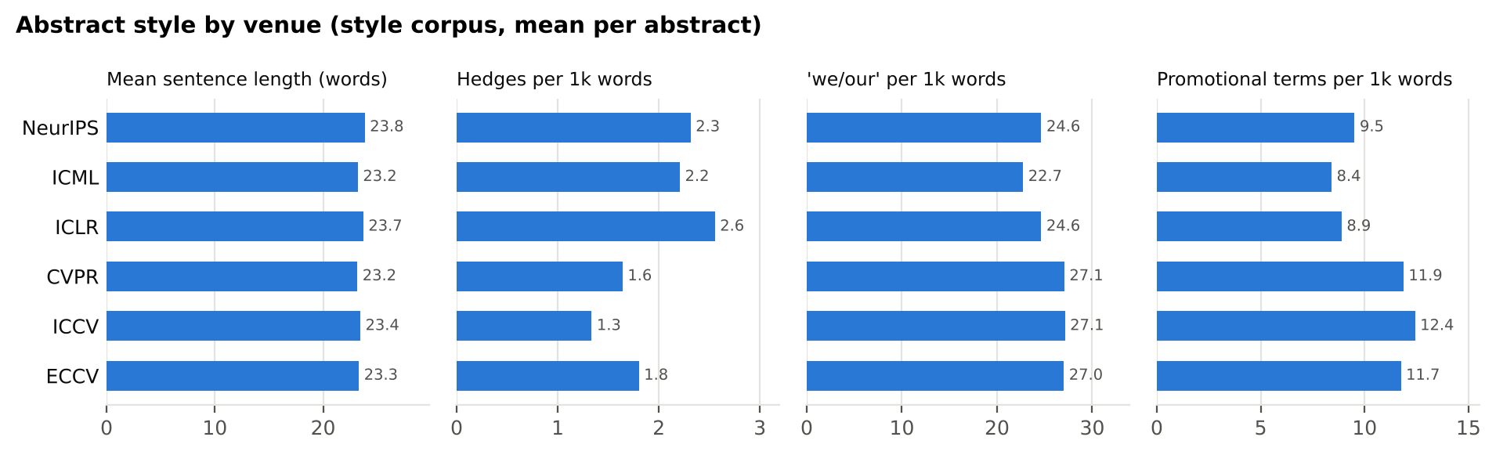
Figure 4. Abstract-level style by venue in the style corpus.
Reading the figure. Abstracts at the vision venues hedge less (1.6 vs 2.4 hedges per 1k words at NeurIPS/ICML/ICLR), use more promotional terms (12.0 vs 8.9) and more 'we/our' (27.1 vs 24.0), with similar sentence length (about 23 words). These are descriptive statistics of accepted papers whose topic mix differs by venue, not evidence that a style causes acceptance; the writer uses them as ranges, and the rule set still discourages unsupported promotional claims.

6.2 Guidance derived from the whole corpus
- Abstracts: about 180 words in 7.9 sentences (mean sentence 23.5 words, IQR 20.7-25.6).
- Common abstract move sequences: B-G-P-M-R (4%), P-M-R (3%), B-M-P-M-R (2%) (B=background, G=gap, P=purpose, M=method, R=result, I=implication, S=resource).
- Abstract stance: hedges 2.0/1k words, boosters 7.4/1k, promotional terms 10.5/1k, 'we/our' 25.6/1k.
- Preferred self-reporting verbs after 'we': propose, introduce, present, show, demonstrate, design.
- Introductions: about 737 words; mean sentence 24.8 words; citations per sentence 0.38.
- 68% of introductions state an explicit contribution list; the first 'occupy-the-niche' sentence appears on average at 37% of the introduction.
- Method sections: passive constructions 0.28/sentence, inline math 1.09/sentence, mean sentence 22.6 words.
- Experiment sections: numbers per sentence 0.74; hedges 3.2/1k words.

6.3 Generic formulas (phrasebank)
Content words are masked as [X]; a formula is kept only if it recurs in many papers from at least four labs, so these are shared conventions rather than anyone's distinctive prose.
Formula | Papers | Labs
we propose a | 1126 | 235
in this paper, we | 974 | 220
in this work, we | 650 | 200
we introduce a | 524 | 192
the effectiveness of | 461 | 174
due to the | 459 | 179
we show that | 438 | 163
to address this | 413 | 181
the [X] of the | 405 | 186
we propose a novel | 405 | 172
we propose a [X] | 379 | 170
show that our | 368 | 160
in this paper, we propose | 345 | 151
as well as | 342 | 167
that our method | 340 | 148
demonstrate that our | 336 | 161
code is available at | 315 | 133
we present a | 308 | 143
we propose [X], a | 306 | 157
based on the | 305 | 155
extensive experiments on | 300 | 126
large language models | 298 | 125
we introduce [X], a | 287 | 147
experiments show that | 280 | 142
to address these | 268 | 145

Lab profiles (one per professor) are part of the full edition and the local app; this public edition describes them only in aggregate.
Ethics and attribution. Profiles are statistics of co-authored, edited text and are attributed to a collection. The writer receives numbers and generic formulas, never corpus sentences, and every draft is screened against the hashed n-gram index for verbatim overlap. Imitating a person's identity or distinctive passages is out of scope.

7 Venue requirements and writing rules
Venue | Main-text limit | Abstract | Anonymity
NeurIPS 2026 | 9 content pages (text, figures and tables all count) | Exactly one paragraph (template). | Double-blind. Compile in the default anonymous mode ('Anonymous Author
ICML 2026 | 8 pages of main body | Unverified for 2026. | Double-blind. Submissions must contain nothing intended to, or with th
ICLR 2026 | 9 pages of main text at initial submission | One paragraph (template). | Double-blind on OpenReview; non-anonymous submissions are rejected wit
ICLR 2027 | 9 pages of main text at initial submission | One paragraph (template). | Double-blind; revealing author identity in the main text or supplement
CVPR 2026 | 8 pages including figures and tables | No fixed limit; follow the style and length of previous | Double-blind. Cite own work in the third person; no acknowledgments in
CVPR 2027 | 8 pages including figures and tables | No fixed limit (template). | Double-blind, same rules as CVPR 2026 (template). The 2027 template re
ICCV 2025 | 8 pages including figures and tables | No fixed limit (CVPR/ICCV author kit). | Double-blind, same conventions as the CVPR/ICCV author kit.
ICCV 2027
ECCV 2026 | 14 LNCS pages including figures and tables | 150 | Double-blind: reviewers/ACs must not be able to infer authors beyond r
IEEE TPAMI Regular paper (ro | 12 double-column pages including references and author biogr | 250 | Review model (single- vs double-anonymous) not verified in this sessio
Nature Article (current auth | None words and display items | 200 | Not verified in this session (Nature has offered optional double-anony
Nature Machine Intelligence | 3500 words of main text | 150 | Not verified in this session.

Unverified items are marked inside data/rules/writing_rulebook.json with the year that was confirmed. Always re-check the official call for papers before submission.
148 rules. 39 are checked by code today; 100 are reviewed by a model that must quote the manuscript verbatim (quotes are verified; this includes 43 rules designed for code checks that are not implemented yet); 9 are checklist items for the author. Categories: formatting (12), style (12), structure (11), experiments (10), introduction (9), claims (9), ethics (9), figures (8), anonymity (8), abstract (7), related_work (7), method (7), notation (7), reproducibility (7), rebuttal (7), tables (5), hedging (4), limitations (4), results (3), title (2).
Rule | What to do | Checked by | Source
R-ABS-001 | Make the abstract a self-contained miniature of the paper that names the gap or problem, what you did, the main finding and why it matters, spending at most one | model | Jennifer Widom; Brett Mensh and Konrad Kording
R-ABS-003 | Keep the abstract within the venue's length limit or recommendation. | engine | Nature Machine Intelligence; Nature (Springer Nature)
R-ABS-004 | Write the abstract as a single paragraph. | engine | NeurIPS 2026 organizers; ICLR
R-ABS-005 | Leave citations out of the abstract wherever the venue requires an unreferenced abstract. | engine | ECCV 2026 organizers; Nature Machine Intelligence
R-ABS-006 | For a Nature Article, open with a fully referenced summary paragraph of roughly 200 words that a scientist outside the field can follow. | model | Nature (Springer Nature); Nature (Springer Nature)
R-INTRO-001 | Make the introduction answer, in this order, what the problem is, why it matters, why it is hard (why obvious approaches fail), why earlier work falls short and | model | Jennifer Widom; Andrej Karpathy
R-INTRO-003 | Phrase every contribution as a specific claim that the paper's evidence could refute, not as an activity. | model | Simon Peyton Jones
R-RW-002 | For each topic, trace how the line of work developed and close by saying how your work relates to it, naming the key difference. | model | Jia-Bin Huang; NeurIPS 2026 organizers
R-RW-006 | Cite all closely related and competing work, including recent work that weakens your novelty argument. | model | Jia-Bin Huang; NeurIPS 2026 organizers
R-METH-001 | Justify every non-obvious design choice: why it is needed, what the alternatives are, and why this option won (ideally backed by an ablation). | model | Andrej Karpathy; Kayvon Fatahalian
R-METH-007 | For each theoretical result, state all assumptions in or beside the statement, number and cross-reference it, and give a complete proof (with a short sketch in | model | NeurIPS 2026 organizers
R-EXP-001 | Map every claim in the abstract and contribution list to at least one experiment, figure, table or theorem that tests it. | model | Jason Eisner; Andrej Karpathy
R-EXP-002 | Include ablations that isolate the effect of each proposed component so the source of the improvement is clear. | model | Zachary C. Lipton and Jacob St
R-EXP-004 | Report uncertainty (error bars, confidence intervals or significance tests) for the results behind the main claims, and say what variability it captures, how it | engine | NeurIPS 2026 organizers
R-EXP-005 | Specify in the main text the setup needed to interpret the results (datasets and splits, preprocessing, exact metric protocols, key hyperparameters, optimizer, | model | NeurIPS 2026 organizers
R-EXP-006 | Report compute: hardware type and memory, time or GPU-hours per run, total compute, and whether unreported preliminary or failed runs used substantially more. | engine | NeurIPS 2026 organizers
R-EXP-009 | Compare against the strongest relevant and recent baselines under the same protocol, and never omit a known baseline because it performs well. | model | Andrej Karpathy; NeurIPS 2026 organizers
R-CLAIM-001 | Make the claims in the abstract and introduction match what the results show, including their scope and key assumptions. | model | NeurIPS 2026 organizers; ICLR 2025 organizers
R-CLAIM-003 | Support every explanation of why something works with evidence, or mark it explicitly as a hypothesis. | model | Zachary C. Lipton and Jacob St
R-CLAIM-007 | Scope generalization claims to what was actually evaluated (datasets, embodiments, environments, simulation vs. real world, number of runs). | model | NeurIPS 2026 organizers
R-CLAIM-008 | Do not claim one method beats another when the gap lies within the reported uncertainty, and reserve 'significant(ly)' for differences backed by a statistical t | model | NeurIPS 2026 organizers
R-FIG-007 | Place figure captions below figures and table captions above tables. | model | CVPR organizers (cvpr-org); ECCV 2026 organizers
R-FIG-008 | Reference every figure and table in the text, near where it appears. | model | ECCV 2026 organizers
R-NOT-005 | Define every symbol and acronym at or before its first use. | engine | Andrej Karpathy; Steven Pinker

8 Application architecture and the multiple harnesses
Harness | Input -> output | Gate that cannot be bypassed
H1 Discovery & scope | QS table, CSRankings, paper lists -> candidate people and papers | institution filter; accepted status and track
H2 Identity & venues | candidates -> List A / List B with witnesses | conflicting DBLP id rejects; misaligned metadata discarded
H3 Corpus | arXiv HTML / PDF / Markdown -> sectioned text with hashes and offsets | raw text stays local; parser warnings recorded
H4 Style dictionary | corpus -> profiles, phrasebank, overlap index | formulas need >= 4 labs; no sentences stored
H5 Evidence ledger | sources -> exact spans with provenance | quotes verified verbatim
H6 Writer | research brief -> outline -> sections -> audit -> revision | numbers only from the brief; citations only from the bibliography; placeholders instead of invention
H7 Scientific editor | Markdown -> candidates -> 12-role review -> author decision -> export | approval bound to candidate and context hashes; stale decisions rejected
H8 Rules & audit | draft -> rule findings, provenance, style distance, overlap | deterministic findings are reproducible; model rule reviews must quote

8.1 The 12 roles and the phases P0-P11
Phase | What happens | Roles
P0 Ingest | validate UTF-8 .md, keep original bytes, parse blocks, protect code/math/citations/URLs/tables | -
P1 Context | source-linked context record (definitions, quantities, constraints, unknowns) + author context | A07
P2 Draft | one candidate per paragraph (never writes the document) | A01
P3 Mechanical | protected content, numbers and bindings, citations, negation, modality, quantifiers, causality, risky domain substitutions | app
P4 Language | independent critics on the same candidate | A05, A06, A08, A09, A10
P5 Science | independent critics against original, candidate and context | A02, A03, A04, A07
P6 Rebuttal | uphold / challenge / duplicate / insufficient evidence for every finding | A11
P7 Revision | targeted repair of upheld material findings (bounded cycles) | A01
P8 Verification | fresh checks and critics on changed wording | A02-A10
P9 Judge | decision per finding; approve / request revision / needs author | A12
P10 Author | accept, reject, edit (re-verified), accept with explicit override | author
P11 Export | verified source-span patches, document-level checks, change report, audit JSON | app

- Invariant: an approval applies only to the exact candidate (SHA-256) and context revision reviewed; any new wording or glossary change invalidates it.
- Majority never wins against evidence: mandatory scientific reviews must complete; unresolved material/critical findings block automatic approval; author overrides are recorded and never labelled machine-verified; a no-change export is byte-identical to the upload.
- Providers: Claude API (default claude-opus-5-5 with adaptive thinking, explicit effort, structured JSON outputs, prompt caching and server-side refusal fallback), Claude on Microsoft Foundry (Azure billing; client-side fallback middleware), Azure OpenAI, OpenAI-compatible servers (e.g. self-hosted XtraGPT) and an offline mock. Each role can be routed to a different provider; the actual model is recorded per call.
- Safety and privacy: manuscript text is treated as data (prompt-injection resistant prompts), keys stay server-side and are masked, the server binds to localhost, uploads are size/encoding checked, previews are sanitised, and documents can be deleted.

9 GitHub repository map
172 repositories with metadata copied from the GitHub API on 2026-11-05: prose linting stylometry (17), research writing agents (16), document parsing scholarly (15), factuality citation eval (15), orchestration (15), scientific discourse revision (12), topic humanoids (11), topic 3d 4d 6d vision (10), topic world models (9), topic vla (9), peer review rebuttal (8), topic gaussian splatting robotics (8), topic digital twins sim (8), topic ai safety (8), scholarly discovery (7), curated lists (4). Integration decisions: research_map_only (64), design_reference (57), optional_adapter (29), adopt_as_dependency (22).
Repository | Stars | Licence | What we borrow
stanford-oval/storm | 31,786 | MIT | Split pre-writing from writing: (1) perspective-guided question asking to enumerate what each section must cover, (2) an
Future-House/paper-qa | 9,546 | Apache-2.0 | Use its 'gather evidence -> summarize each chunk relative to the claim with a score -> answer only from top-scored evide
SakanaAI/AI-Scientist | 14,947 | NOASSERTION | Section-by-section LaTeX drafting with a fixed number of self-reflection rounds per section, a compile-and-repair loop f
SakanaAI/AI-Scientist-v2 | 7,443 | NOASSERTION | Its best-first tree search over alternatives (parameters in bfts_config.yaml) suggests keeping several candidate drafts
SamuelSchmidgall/AgentLaboratory | 5,919 | MIT | Explicit phases (literature review, experimentation, report writing) with co-pilot checkpoints where a human steers each
HKUDS/AI-Researcher | 5,867 | - | Their benchmark idea of grading generated work against reference papers suggests an evaluation for us: redraft a section
Technion-Kishony-lab/data-to-paper | 836 | MIT | Make data-chaining a hard rule: every number, comparison and percentage in a draft must link to an evidence record (resu
AkariAsai/OpenScholar | 1,683 | Apache-2.0 | The self-feedback loop (draft -> feedback -> extra retrieval -> revision -> final citation-verification pass that drops
assafelovic/gpt-researcher | 30,490 | Apache-2.0 | Planner -> parallel researchers -> report writer layout with source tracking per paragraph, and a 'local documents only'
TIGER-AI-Lab/ScholarCopilot | 253 | MIT | Treat 'citation needed here' as an explicit decision: the writer emits a placeholder that must be resolved against our c
Xtra-Computing/XtraGPT | 5 | - | Represent every edit request as (selected span, full-paper context, named criterion) and keep a per-section criteria lis
AutoSurveys/AutoSurvey | 478 | - | Parallel section drafting from one shared outline followed by a global integration pass; its citation-quality evaluation
IAAR-Shanghai/SurveyX | 996 | - | The requirement that every reference be pre-converted to Markdown and pre-processed before generation is the same corpus
allenai/ai2-scholarqa-lib | 288 | Apache-2.0 | Quote-first synthesis: the model must extract verbatim supporting quotes before writing, and each section is generated o
THUDM/LongWriter | 1,881 | Apache-2.0 | Plan with explicit per-paragraph word budgets so page limits (e.g. 9-page NeurIPS/ICLR main text) are enforced at planni
PaperDebugger/paperdebugger | 1,554 | AGPL-3.0 | Edits delivered as reviewable hunks anchored to positions in the LaTeX source (accept/reject one at a time) and critics
zhu-minjun/Researcher | 409 | NOASSERTION | Structure the judge like DeepReviewer: retrieval-backed novelty check -> per-dimension assessment -> reliability/self-ve
ResearAI/DeepReviewer-v2 | 596 | MIT | A reviewer that must ground each weakness in a retrieved source or a paper span, behind a clean parser -> agent -> repor
allenai/marg-reviewer | 66 | Apache-2.0 | Chunk-owning workers plus a coordinating leader lets critics reason over a whole paper beyond one context window, and th
Ahren09/AgentReview | 701 | Apache-2.0 | Reviewer persona knobs (expert, lazy, adversarial) to stress-test our rebuttal agent, and the staged rebuttal -> discuss
maxidl/openreviewer | 18 | - | A cheap, specialised 'hostile reviewer' to generate likely objections for the rebuttal agent to pre-empt, using the offi
allenai/PeerRead | 432 | - | Aspect-score schema (e.g. clarity, originality, soundness, substance, impact) as a starting rubric for the judge, plus d
nnkennard/DISAPERE | 1 | NOASSERTION | Make the rebuttal agent's output an explicit alignment: every reviewer point maps to a response sentence with an action
UKPLab/nlpeer | 36 | Apache-2.0 | Its data model linking paper versions, reviews and revisions is a good schema for our corpus, so reviewer comments can b
Leey21/awesome-ai-research-writing | 35,610 | - | Mine it for critic personas and checklists (e.g. a reviewer persona that tolerates no logic gaps) and for how writing sk
handsome-rich/Awesome-Auto-Research-Tools | 1,273 | CC0-1.0 | Use as a watchlist feed; the LLM-API column quickly shows which systems already support Azure OpenAI or Anthropic models
natnew/awesome-ai-scientists | 20 | MIT | Source of benchmarks for scientific critique and overclaim detection to evaluate our evidence and verb/modality critics.
ai4s-research/awesome-ai-for-science | 2,074 | MIT | Pointers to paper-search agents and MCP servers that could feed the corpus builder, and to figure/chart tools for the fi
grobidOrg/grobid | 5,218 | Apache-2.0 | Make it the canonical PDF -> structure step of the corpus builder: TEI gives paragraph and section IDs, in-text citation
grobidOrg/grobid-client-python | 416 | Apache-2.0 | Use for corpus ingestion with concurrency control and resumable batches; keep raw TEI next to derived JSON for provenanc

Licence caveats. Several widely used research assets are non-commercial or copyleft (e.g. the original 3D Gaussian Splatting code, DUSt3R/MASt3R, FoundationPose, CoTracker; AGPL PyMuPDF; GPL tools) and the CSRankings data is CC BY-NC-ND. Repository popularity is not evidence of correctness or reproducibility; check licences before reuse or redistribution. Details per repository are in data/repos/github_repos.json.

10 Verification, evaluation and release gates
What was verified | Result
Automated test suite (parser, patches, checks, rules, writer, editor workflow, API) | 33 passed, 0 failed
Domain fixtures: harmful edits detected by mechanical checks | 22/22
Domain fixtures: safe edits raising material/critical findings | 0/8
No-change export byte-identical (LF, CRLF, BOM) | verified in tests
Stale / overlapping patches and stale author decisions rejected | verified in tests (HTTP 409)
Harmful writer edit cannot be auto-approved; override recorded as unverified | verified in tests
Missing provider leaves reviews 'skipped_unavailable', never 'passed' | verified in tests
Live model quality (drafts, critiques, Judge) | NOT measured - no API key in the build environment

Fixture results by expected check: causality 1/1, certainty 1/1, claim_strength 1/1, negation 1/1, numbers 2/2, numeric_binding 2/2, protected_content 2/2, quantifier 1/1, risky_substitution 10/10, statistics 1/1, terminology 1/1. These fixtures were written alongside the checks; treat them as regression tests, not as evidence of general accuracy.

10.1 Evaluation plan for model-assisted editing
- Datasets: ParaReval (instruction following, acceptability, preference; keep its splits) and HPMET's arXiv meaning-preservation subset (pairwise a/b/tie; judgements are not unique sentences) - loaders are included; data is not bundled.
- Expert fixtures: extend the 30 synthetic fixtures with author-reviewed paragraphs from your own drafts, split by source paper.
- Ablations under matched budgets: Writer only; Writer + one scientific critic; deterministic checks + Writer; 9 roles without the POS-style critics; full 12 roles. Report harmful-edit acceptance, safe-edit rejection, issue localisation, abstention, author effort, latency, tokens and cost by error category, with intervals.
Release gate | Condition
Exact extraction | 100% of exported quotations match the canonical source span and version
Number and citation provenance | 0 unsupported numbers and 0 unknown citation keys in a draft marked final
Meaning preservation | no known critical fixture auto-approved; material findings require explicit author override
Professor lists | every list entry has role evidence and one witness per required venue; conflicts surfaced
Reproducibility | repeated runs keep inputs, prompt hashes, model ids and configuration in the audit

11 Running the application and writing your paper

11.1 Localhost (full application)
- Windows: double-click launch_app.cmd (or run launch_app.ps1). macOS/Linux: ./launch_app.sh. The script creates a virtual environment, installs the package and opens http://127.0.0.1:8765.
- Manual: python -m venv .venv; activate; pip install -e .; python -m extractive_harness serve --open.
- Keys: put them in .env (copy .env.example) or enter them on the Settings page; they are stored only in .harness/config.json on your machine and are never returned by the API.
Option | What to configure | Billing
Claude API | ANTHROPIC_API_KEY; model claude-opus-5-5 (default), claude-sonnet-5-5 or claude-haiku-5-5; effort | Anthropic account (your Claude credits)
Claude on Microsoft Foundry (Azure) | ANTHROPIC_FOUNDRY_API_KEY, Foundry resource name, deployment name | Microsoft Marketplace through Azure; check whether your Azure credits apply to Marketplace models
Azure OpenAI | AZURE_OPENAI_ENDPOINT, AZURE_OPENAI_API_KEY, deployment, API version | Azure subscription credits
OpenAI-compatible | base URL + model (e.g. a vLLM server hosting XtraGPT) | your own hardware
Offline mock | tick 'template mode' / 'use offline mock backend' | free; labelled, not model review

Price basis used for estimates (USD per million input/output tokens, first-party rates that also apply to Claude on Foundry): Opus 5.5 $4 / $20, Sonnet 5.5 $2 / $10, Haiku 5.5 $0.10 / $0.50. Each editor paragraph makes about 11-14 role calls; set a run budget on the Run panel.

11.2 Public website (browser mode)
The public website (https://manish-genai.github.io/paper-writing-site/) is a static build of the same interface without per-professor data: institution, topic, paper, repository, rule and style explorers work without a server, and a browser-only Writer and Editor Lite call the Claude API directly with your key (kept in the browser tab unless you choose to remember it). The professor lists, lab style profiles and the full 12-role workflow are in the local application (Section 11.1).

11.3 Worked example: a made-up demo brief
The Writer's example brief describes a fictional project, object-centric Gaussian world models for robot manipulation (object-grouped 3D Gaussians, action-conditioned group dynamics, render-and-compare planning). It is not a real paper or result; its citations are real papers, and all result values are empty on purpose.
1. Open Writer, load the example brief, choose the venue (e.g. NeurIPS) and style profiles (venue-neurips plus topic-world-models), and run. Every missing number appears as [[RESULT: ...]].
2. Read the audit: rule findings (e.g. missing limitations or compute report), unsupported numbers, unknown citations, style distance, verbatim-overlap hits. Fill the brief's results table after experiments; re-run.
3. 'Send to Editor': build context (add protected terms such as method names and symbols), run the 12 roles, review each paragraph's diff and findings, accept or override explicitly, then compose and export Markdown, the change report and the audit JSON. LaTeX and BibTeX come from the Writer.
4. Before submission: run 'Check my manuscript' for the venue, complete the venue checklist, and verify every related-work claim against the cited paper (the brief's summaries are paraphrases).
Timing note. The rulebook records a CVPR 2027 paper deadline of CFP published. Submission deadline 2026-11-16 AoE; supplementary material until 2026-11-23 AoE. Verify dates on the official site.

12 Limitations and next steps
- The census denominator is CSRankings plus OpenReview self-reports plus earlier dossiers; robotics faculty in engineering departments who rarely publish at OpenReview venues may be missing, and self-reported titles can be stale. Next: verify roles against official faculty pages on your machine before outreach.
- QS ranks were reconstructed from QS and university announcements (69 high-, 33 medium-confidence entries).
- Paper lists end at NeurIPS 2025, ICML 2026, ICLR 2026, CVPR 2025, ICCV 2025 and ECCV 2024; later proceedings rely on CSRankings counts.
- Style profiles use abstracts for all labs and full text for a subset; section detection depends on LaTeXML headings. More full text per lab will make lab profiles more stable.
- Model-assisted quality is unmeasured until keys are configured; run the evaluation plan in Section 10.1 before trusting automatic approvals.
- Next research step: a focused corpus on one question (e.g. action-conditioned world models for cross-embodiment manipulation), with author-annotated paragraphs as a held-out set.

Appendix A QS World University Rankings 2027 top 100
Rank | Institution | Country | Confidence | List A | List B
1 | Massachusetts Institute of Technology (MIT) | United States | high | 20 | 17
=2 | Imperial College London | United Kingdom | high | 9 | 9
=2 | Stanford University | United States | high | 18 | 13
4 | University of Oxford | United Kingdom | high | 8 | 7
5 | Harvard University | United States | high | 2 | 1
6 | University of Cambridge | United Kingdom | high | 3 | 3
7 | California Institute of Technology (Caltech) | United States | high | 3 | 2
=8 | ETH Zurich | Switzerland | high | 9 | 7
=8 | UCL | United Kingdom | high | 2 | 2
10 | National University of Singapore (NUS) | Singapore | high | 19 | 13
11 | The University of Hong Kong (HKU) | Hong Kong SAR | high | 13 | 12
12 | Nanyang Technological University, Singapore (NTU Singapore) | Singapore | high | 24 | 20
13 | Peking University | China (Mainland) | high | 37 | 30
14 | Tsinghua University | China (Mainland) | high | 60 | 49
15 | University of Pennsylvania | United States | high | 11 | 7
=16 | Cornell University | United States | high | 5 | 4
=16 | Yale University | United States | high | 2 | 2
18 | The Chinese University of Hong Kong (CUHK) | Hong Kong SAR | high | 17 | 14
19 | UNSW Sydney | Australia | high | 3 | 2
=20 | Johns Hopkins University | United States | high | 8 | 6
=20 | University of California, Berkeley (UCB) | United States | high | 16 | 11
=22 | EPFL | Switzerland | high | 10 | 9
=22 | The University of Melbourne | Australia | high | 3 | 2
24 | The University of Chicago | United States | high | 2 | 1
25 | Technical University of Munich | Germany | high | 8 | 7
26 | Fudan University | China (Mainland) | medium | 24 | 18
27 | Princeton University | United States | high | 3 | 3
28 | The University of Sydney | Australia | medium | 2 | 2
29 | Australian National University (ANU) | Australia | high | 6 | 6
30 | McGill University | Canada | high | 0 | 0
31 | Monash University | Australia | high | 8 | 8
32 | University of Toronto | Canada | high | 12 | 10
33 | The Hong Kong University of Science and Technology (HKUST) | Hong Kong SAR | medium | 19 | 16
34 | Université PSL | France | high | 2 | 1
35 | The University of Edinburgh | United Kingdom | high | 5 | 3
36 | Shanghai Jiao Tong University | China (Mainland) | high | 43 | 36
37 | King's College London | United Kingdom | high | 0 | 0
38 | Seoul National University | South Korea | medium | 14 | 11
39 | The University of Tokyo | Japan | medium | 5 | 4
=40 | The University of Manchester | United Kingdom | high | 0 | 0
=40 | The University of Queensland | Australia | high | 3 | 3
42 | Yonsei University | South Korea | medium | 7 | 7
=43 | Columbia University | United States | high | 6 | 6
=43 | Institut Polytechnique de Paris | France | high | 2 | 2
=45 | Northwestern University | United States | high | 1 | 0
=45 | The University of British Columbia | Canada | high | 4 | 3
47 | Zhejiang University | China (Mainland) | medium | 43 | 21
48 | Delft University of Technology | Netherlands | medium | 1 | 1
49 | University of California, Los Angeles (UCLA) | United States | medium | 8 | 6
50 | The Hong Kong Polytechnic University | Hong Kong SAR | medium | 8 | 6
51 | University of Michigan-Ann Arbor | United States | medium | 6 | 5
=52 | City University of Hong Kong (CityUHK) | Hong Kong SAR | high | 10 | 7
=52 | Korea University | South Korea | medium | 3 | 3
54 | National Taiwan University (NTU) | Taiwan | medium | 4 | 4
55 | Carnegie Mellon University | United States | high | 19 | 17
56 | Universiti Malaya (UM) | Malaysia | high | 0 | 0
57 | University of Bristol | United Kingdom | high | 1 | 1
58 | New York University (NYU) | United States | high | 11 | 5
59 | KU Leuven | Belgium | medium | 1 | 1
60 | University of Amsterdam | Netherlands | medium | 6 | 6
61 | Ludwig-Maximilians-Universität München | Germany | medium | 3 | 3
62 | The London School of Economics and Political Science (LSE) | United Kingdom | medium | 0 | 0
63 | King Fahd University of Petroleum & Minerals (KFUPM) | Saudi Arabia | high | 0 | 0
64 | Kyoto University | Japan | high | 0 | 0
65 | KAIST - Korea Advanced Institute of Science & Technology | South Korea | medium | 21 | 18
66 | Brown University | United States | medium | 5 | 4
67 | The University of Auckland | New Zealand | high | 0 | 0
=68 | University of Warwick | United Kingdom | high | 0 | 0
=68 | University of Birmingham | United Kingdom | high | 1 | 1
70 | Duke University | United States | medium | 4 | 2
71 | Lund University | Sweden | high | 0 | 0
72 | The University of Texas at Austin | United States | medium | 13 | 10
73 | Sorbonne University | France | medium | 1 | 1
74 | University of Illinois Urbana-Champaign | United States | medium | 17 | 12
75 | Trinity College Dublin, The University of Dublin | Ireland | high | 0 | 0
76 | Université Paris-Saclay | France | medium | 0 | 0
=77 | The University of Western Australia | Australia | medium | 2 | 1
=77 | University of Leeds | United Kingdom | high | 0 | 0
79 | Adelaide University | Australia | medium | 4 | 4
80 | University of Glasgow | United Kingdom | high | 0 | 0
81 | University of California, San Diego (UCSD) | United States | medium | 10 | 8
=82 | KTH Royal Institute of Technology | Sweden | high | 1 | 1
=82 | The University of Sheffield | United Kingdom | high | 1 | 1
84 | Universidad de Buenos Aires (UBA) | Argentina | high | 0 | 0
85 | Durham University | United Kingdom | high | 0 | 0
86 | Heidelberg University | Germany | medium | 3 | 3
=87 | Politecnico di Milano | Italy | high | 0 | 0
=87 | University of Technology Sydney | Australia | high | 2 | 0
=87 | Uppsala University | Sweden | high | 0 | 0
=90 | Nanjing University | China (Mainland) | medium | 20 | 17
=90 | University of Copenhagen | Denmark | high | 2 | 2
=92 | The Pennsylvania State University | United States | high | 1 | 1
=92 | University of Washington | United States | medium | 11 | 8
94 | Boston University | United States | high | 5 | 5
95 | The University of Osaka | Japan | medium | 1 | 1
96 | University of Alberta | Canada | high | 1 | 1
=97 | Institute of Science Tokyo | Japan | high | 2 | 1
=97 | University of Nottingham | United Kingdom | high | 0 | 0
=98 | Freie Universitaet Berlin | Germany | medium | 0 | 0
=98 | University of Zurich | Switzerland | high | 0 | 0
=100 | Purdue University | United States | high | 8 | 4
=100 | University College Dublin | Ireland | medium | 0 | 0

Appendix B Data files, sources and licences
Files under data/ are in the private source repository; the website ships only the public data (docs/data).
File | Content | Source / licence
data/faculty/list_a_five_venues.csv, list_b_six_venues.csv | lists with venue presence, counts, topics, links | derived; see below
data/faculty/evidence_ledger.jsonl | atomic evidence records | derived
data/faculty/professor_dossiers.json | witness papers per venue, topic papers, positions | derived
data/rankings/qs_wur_2027_top100.json | QS 2027 ranks with sources and confidence | QS / university releases
data/papers/top_papers.json | 240 curated accepted papers | proceedings, Paper Copilot, web
data/repos/github_repos.json | 172 repositories | GitHub API
data/rules/writing_rulebook.json | 12 venues, 148 rules with sources | venue sites and public writing advice
data/style/* | profiles, phrasebank, overlap index, manifest (no text) | derived from arXiv / Paper Copilot
Upstream: CSRankings | faculty affiliations and DBLP-derived counts | CC BY-NC-ND 4.0 (attribution: Emery Berger)
Upstream: DBLP | bibliographic records behind CSRankings | CC0
Upstream: Paper Copilot paperlists | accepted-paper metadata | no licence file; facts and links only

