**1.What are the two values of the Boolean data type? How do you write them?**

Ans1: The 2 values of the Boolean data type are True and False. We can write them as – **True** and **False**.

**2. What are the three different types of Boolean operators?**

Ans2: The three different types of Boolean operators are: and, or, not

**3. Make a list of each Boolean operator's truth tables (i.e. every possible combination of Boolean values for the operator and what it evaluates).**

Ans3:   
 Considering True = 1 and False = 0

Following will be the truth table for: **and, or, not**

1. True (1) **and** True (1) = True (1)
2. True (1) **and** False (0) = False (0)
3. False (0) **and** True (1) = False (0)
4. False (0) **and** False (0) = False (0)
5. True (1) **or** True (1) = True (1)
6. True (1) **or** False (0) = True (1)
7. False (0) **or** True (1) = True (1)
8. False (0) **or** False (0) = False (0)
9. **not** True (1) = False (0)
10. **not** False (0) = True (1)

**4. What are the values of the following expressions?**

**(5 > 4) and (3 == 5)**

**not (5 > 4)**

**(5 > 4) or (3 == 5)**

**not ((5 > 4) or (3 == 5))**

**(True and True) and (True == False)**

**(not False) or (not True)**

Ans4:

print((5 > 4) and (3 == 5)) -> **False**

print(not (5 > 4)) -> **False**

print((5 > 4) or (3 == 5)) -> **True**

print(not ((5 > 4) or (3 == 5))) -> **False**

print((True and True) and (True == False)) -> **False**

print((not False) or (not True)) -> **True**

**5. What are the six comparison operators?**

Ans5:

Six comparison operators are as follows:

1. == (equals equals)
2. < (less than)
3. > (greater than)
4. <= (less than equals to)
5. >= (greater than equals to)
6. != (not equals to)

**6. How do you tell the difference between the equal to and assignment operators? Describe a condition and when you would use one.**

Ans6:

Equal to (==) operator compares the values and returns True or False.

Eg:

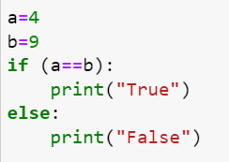

Output- False

Whereas assignment operator (=) uses to store data in a variable.

Eg:

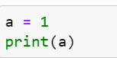

Output- 1

**7. Identify the three blocks in this code:**

**spam = 0**

**if spam == 10:**

**print('eggs')**

**if spam > 5:**

**print('bacon')**

**else:**

**print('ham')**

**print('spam')**

**print('spam')**

Ans7:

spam = 0

if spam == 10:

**BLOCK 1**

print('eggs')

if spam > 5:

**BLOCK 2**

print('bacon')

else:

print('ham')

**BLOCK 3**

print('spam')

print('spam')

**8. Write code that prints Hello if 1 is stored in spam, prints Howdy if 2 is stored in spam, and prints Greetings! if anything else is stored in spam.**

Ans8:

spam = int(input("Enter number 1 or 2: "))

print(spam)

if spam == 1:

print("Hello")

elif spam == 2:

print("Howdy")

else:

print("Greetings!")

**9.If your programme is stuck in an endless loop, what keys you’ll press?**

Ans9:

We can stop endless loop by pressing – CNTRL + C

**10. How can you tell the difference between break and continue?**

Ans10:

**Break** statement will terminate the loop as soon as condition met, whereas **continue** statement will not terminate the loop and proceed further with next iteration.

Eg:

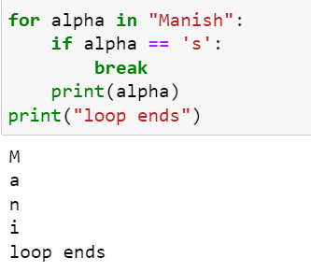

This will break the loop as soon as alpha equals to ‘s’ and comes out of the loop.

This will skip the iteration when alpha equals to ‘s’ and continues to next iteration or comes back to starting of the loop.

**11. In a for loop, what is the difference between range(10), range(0, 10), and range(0, 10, 1)?**

Ans11:  
  
range(10) – It shows that the loop will end at 10. [range(stop)] (*prints number 0 to 9)

range(0,10) – It shows that the loop will start from 0 and stops at 10. [range(start, stop)] (*prints number 0 to 9)

range(0,10,1) – It shows that the loop will start from 0 and stops at 10 with increment value of 1. [range(start,stop,step)] (*prints number 0 to 9)

**12. Write a short program that prints the numbers 1 to 10 using a for loop. Then write an equivalent program that prints the numbers 1 to 10 using a while loop.**

Ans12:

Program to print numbers 1 to 10 using ‘for’ loop:

for i in range(1, 11):

print(i)

Program to print numbers 1 to 10 using ‘while’ loop:

i=1

while (i <= 10):

print(i)

i = i+1

**13. If you had a function named bacon() inside a module named spam, how would you call it after importing spam?**

Ans13: If a function bacon() is inside a module named spam then after importing spam, we can call it by using following syntax:

spam.bacon()