**Output_ScreenShots_OnlineTestApplication**

1. **The review and result view has also been implemented similarly by iterating over the quiz questions and displaying the needed stuff. Below is the screenshot of Review and Result View:**

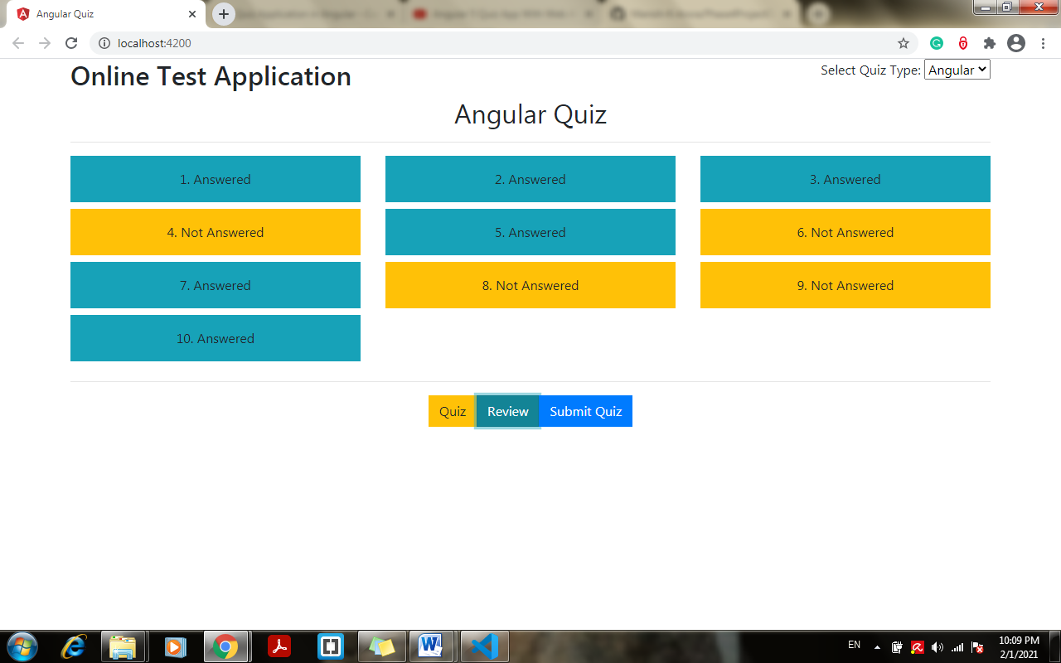

1. **Click on quiz to go back to the quiz:**

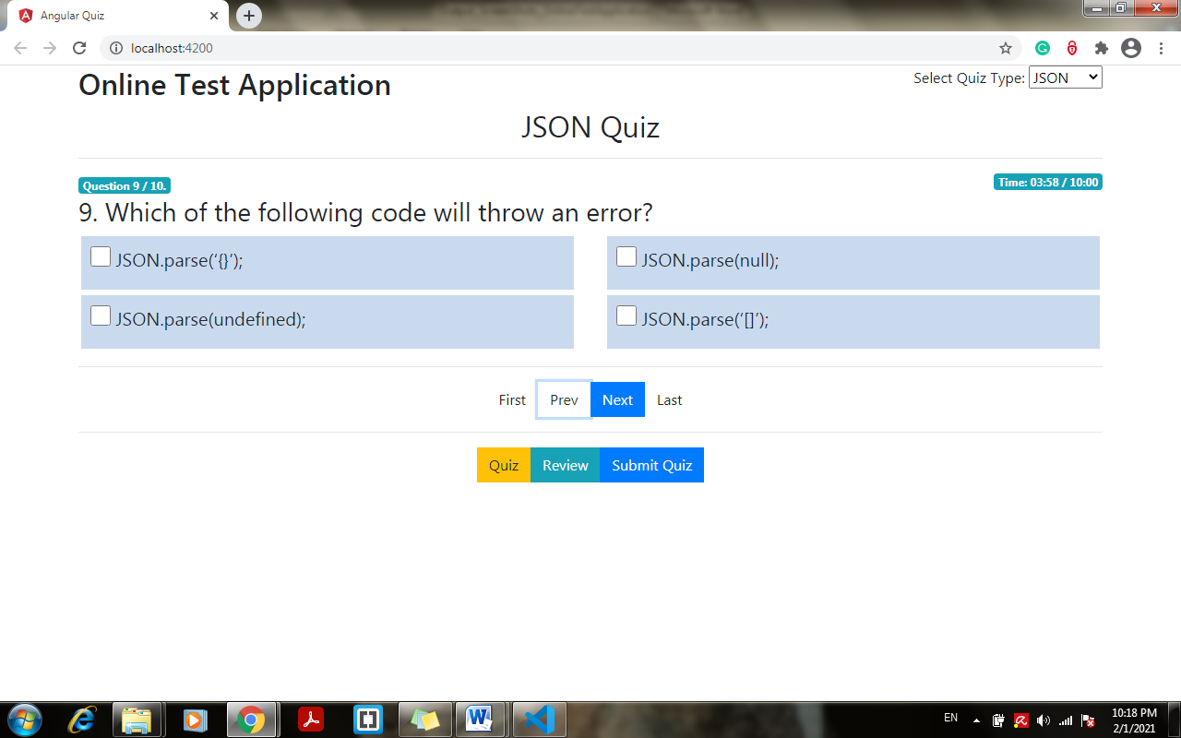

1. **The quiz result view looks like the below image:**

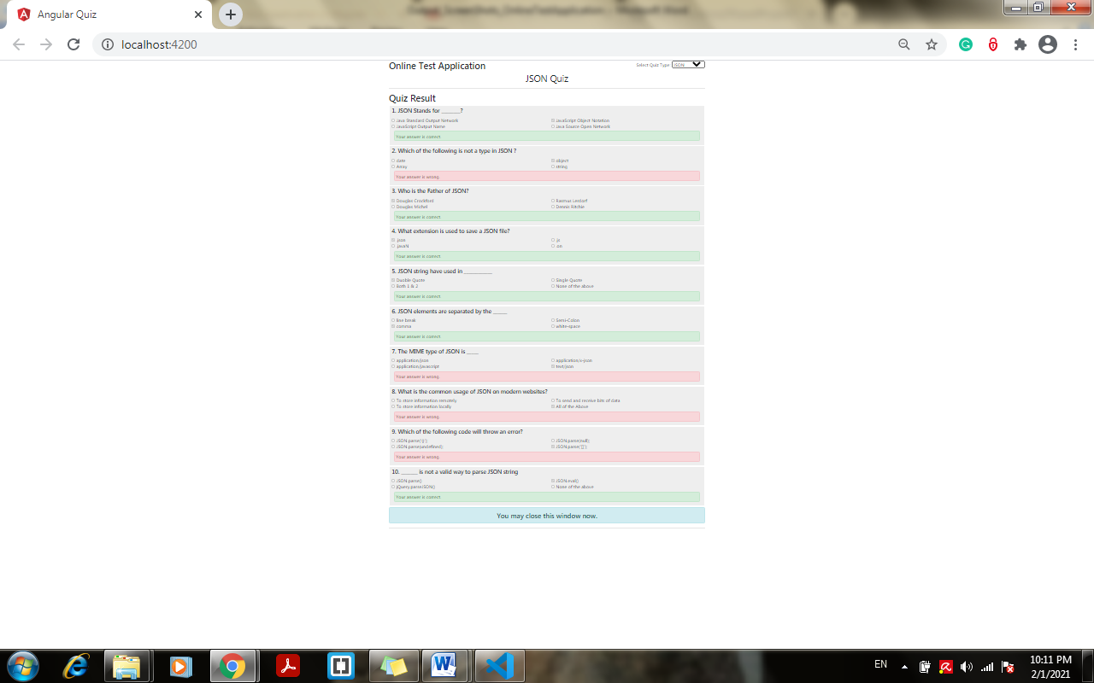

1. **Select Quiz Type from scroll down option:**

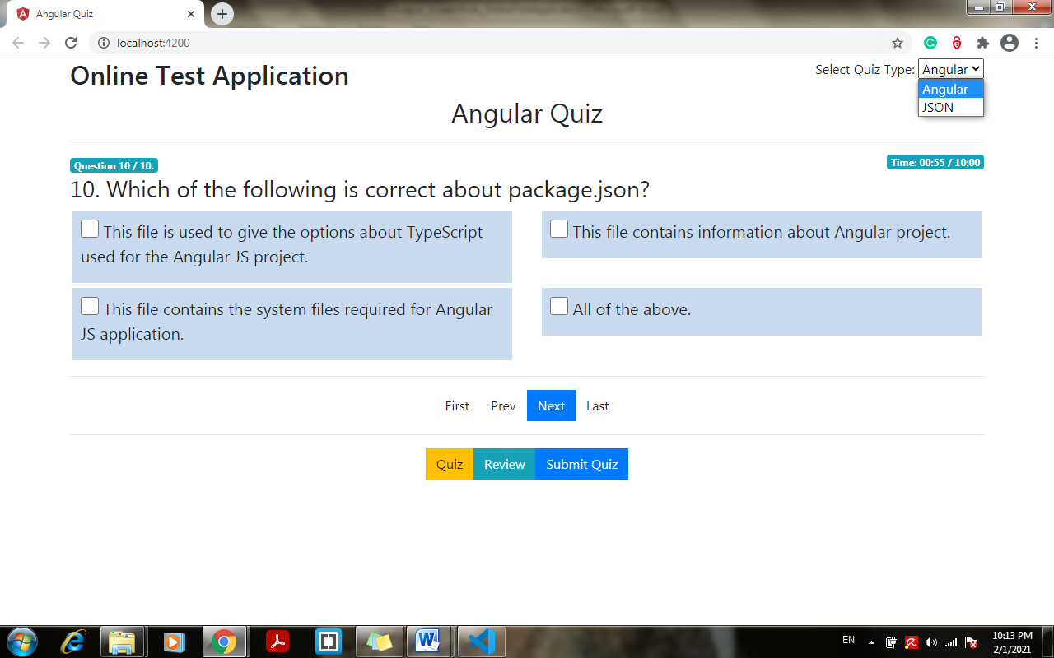

1. **Click on last to go to the last question:**

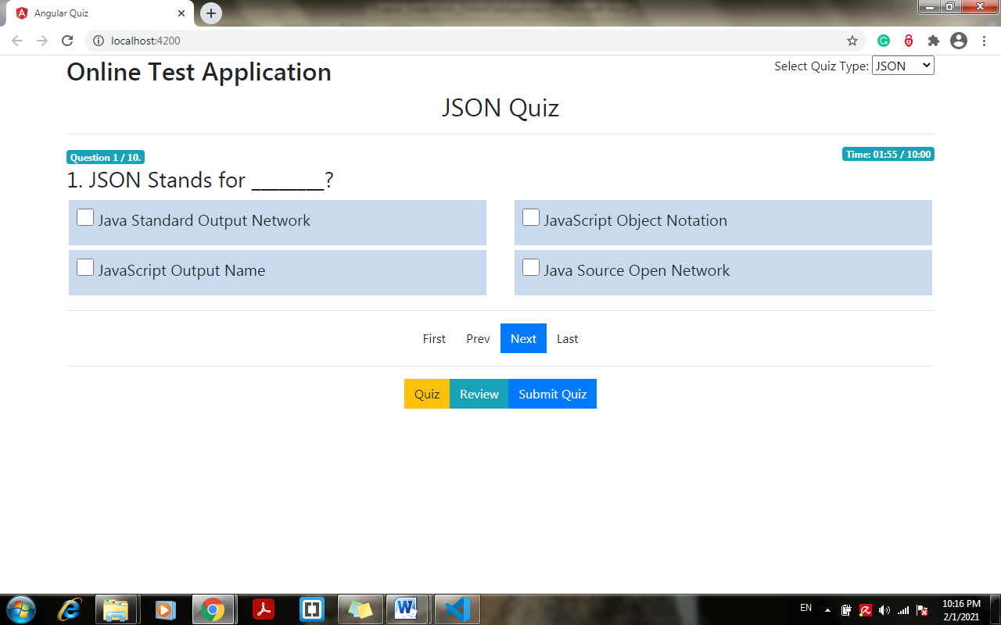

1. **Screenshot Last question:**



1. **Click on prev to go back to previous:**

