**LIBRARY MANAGEMENT SYSTEM –**

**A mini project on Library management system where functions like getting list of available books in library, updating book list with - addition of new books, borrowing available books, returning books are managed. A shell script file is written and run on linux based operating system (ubuntu) for performing stated functions.**

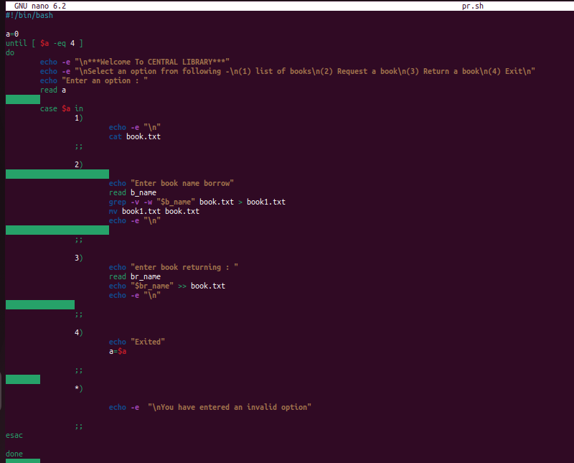

Here I used Until loop to iterate over a block of commands until the required condition becomes true and Case statement to get choice from user and perform block of commands written in matched choice.

At start value of variable a is equal to zero, so it does not satisfy the loop condition thus enters into the loop. Inside the loop case statement written which works as a switch statement in other programming languages i.e. if specified value match with the pattern then it will execute associated block of commands of that particular pattern until the double semicolon.

If choice 1 is input, list of available books is printed (Here ‘cat’ command is used which prints the contents written in book.txt file).

If choice 2 is input, it asks for name of book which wants to borrow and update the file book.txt (“grep -v -w $value book1.txt” command will search the $value word and written lines other than the line containing searched word in another file book1.txt) then (“mv book1.txt book.txt”) move command moves book1.txt to book.txt in this way book.txt file will be updated.

If choice 3 is input, it asks for book name that wants to return (redirection command “>>”) will append book name in book.txt file thus returning book name updated.

If option 4 is entered, then respective block of commands will execute and value of a becomes equal to 4 which satisfies the loop condition and control will come out of the loop.

If there is no match i.e. choice other than available options entered, then the block of commands written in default patten (*) will execute and prints message “You have entered an invalid option”.

Let see the working, When Script is executed,

1. **It displays Welcome message, the options available and ask to enter the choice.**

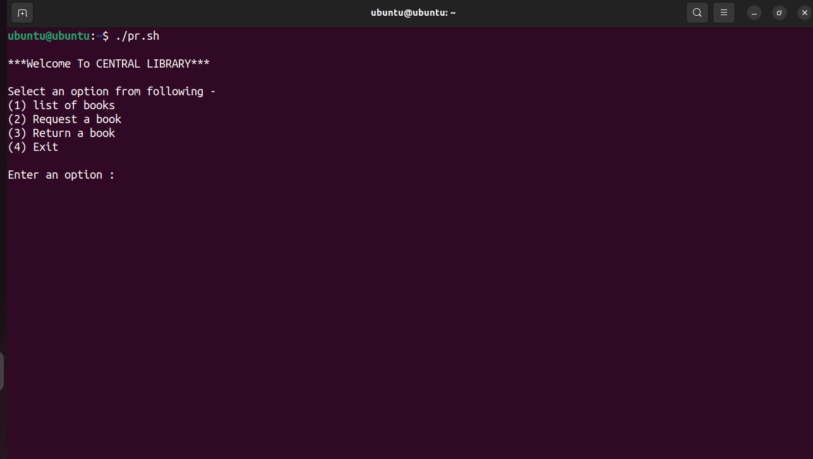

1. After entering 1 option, list of all books shown and again ask for choice to enter from available options.

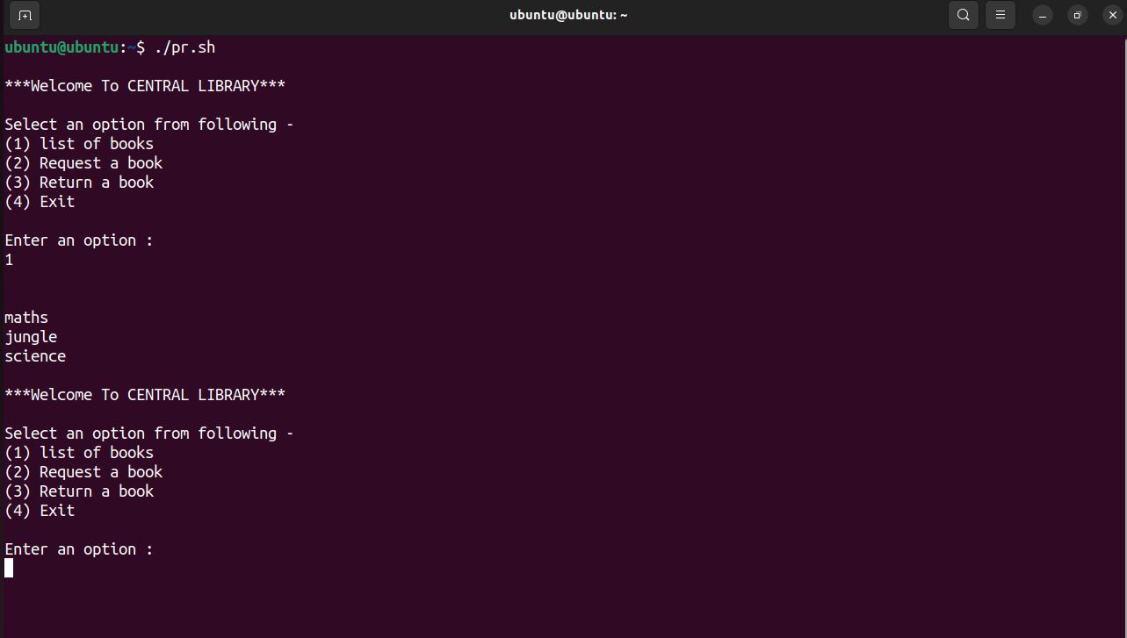

1. After entering choice 2, ask for book name to borrow from available list, after that book from

list removed as we can seen it from list of available books.

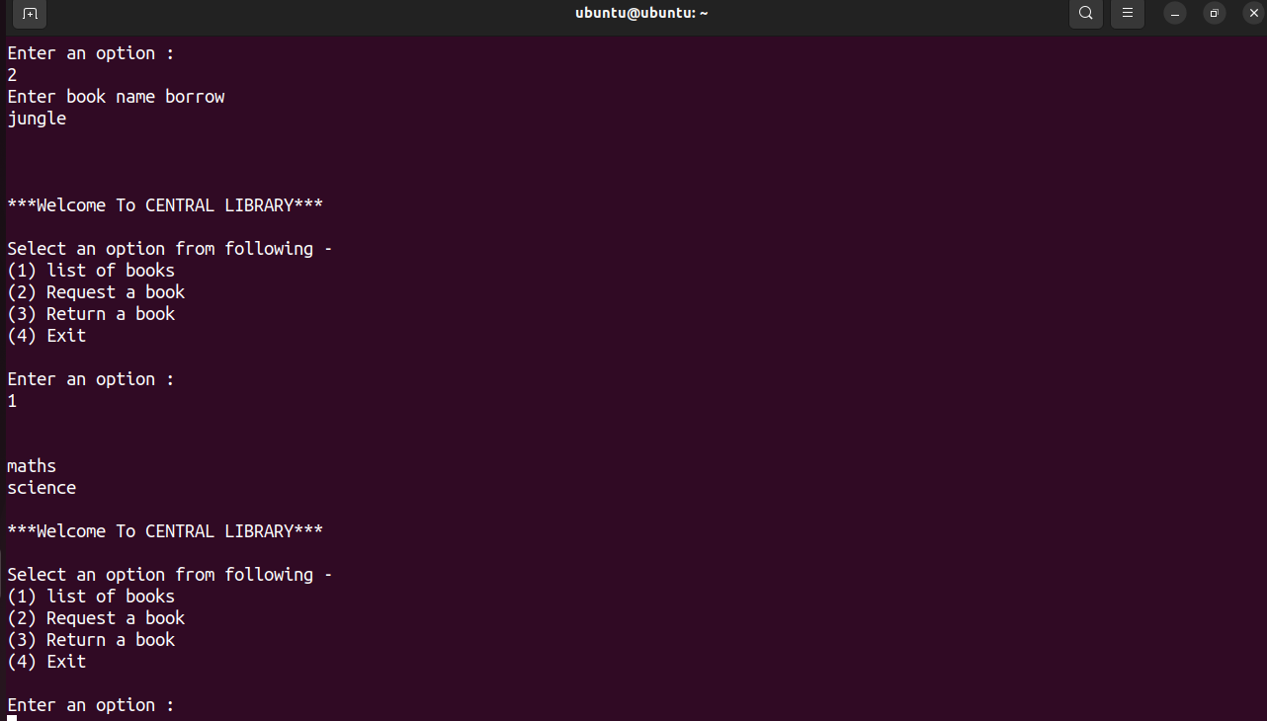

1. After entering choice 3, ask for book name to return , after that book returned will append into the book list file that we can seen

from list of available books.

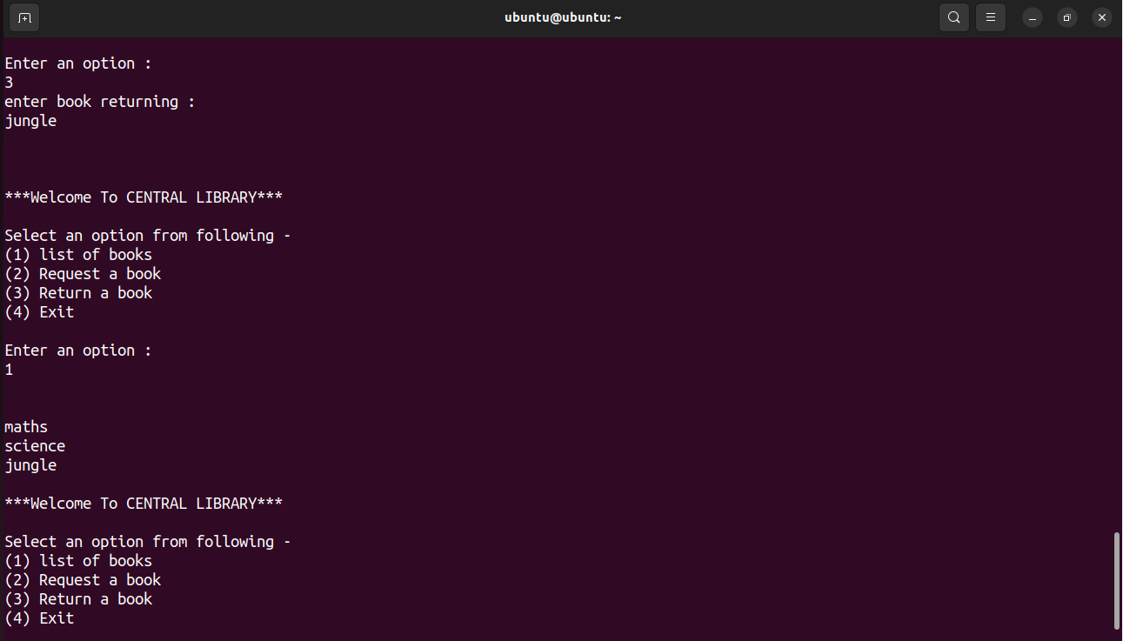

1. After entering choice 4, loop condition becomes true and exited.

