DATA LANDSCAPE ASSIGNMENT
WEB SCRAPING

- Description of the Website Scraped
Books to Scrape (https://books.toscrape.com/) is a demo site created specifically for practicing web scraping. It lists books with prices, ratings, availability, and detail pages. This makes it ideal for learning and demonstrations without violating site policies.

- Fields Extracted
From list and detail pages:
- title – Book title
- price – Original text price (e.g., £51.77)
- price_numeric – Numeric value parsed from price (e.g., 51.77)
- rating – Star rating mapped to 1–5
- availability – Availability text from listing
- product_page_url – Absolute URL to the book detail page
- upc – Unique product code from detail table
- category – Category from breadcrumb
- description – Book description (if available)

- Security Approach Used
- At-rest encryption with Fernet:
  - The scraped dataset is first saved as a temporary CSV.
  - The CSV is encrypted with Fernet (symmetric encryption ensuring confidentiality and integrity).
  - The plaintext CSV is deleted, leaving only the .enc file.
- Key management:
  - The script uses FERNET_KEY if set in the environment.
  - If not provided, it generates and stores a key at scraped_books/.fernet.key and restricts permissions where possible.
- Challenges Faced
Encoding issues: Pound symbol £ sometimes appears as Â£ due to encoding misdetection.
Fix: Force resp.encoding = 'utf-8' and use regex to extract numeric price (r'(\d+(?:\.\d+)?)') robustly.

- Screenshots and Code Snippets
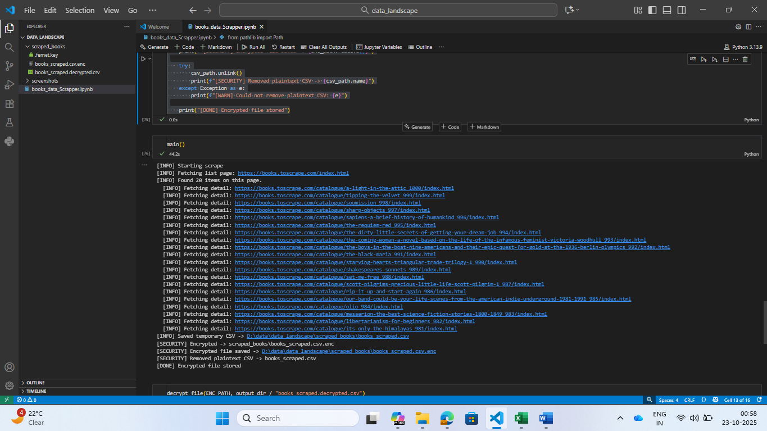
Figure1 Extracting Data
Figure 1 Web Scrapping in Progress

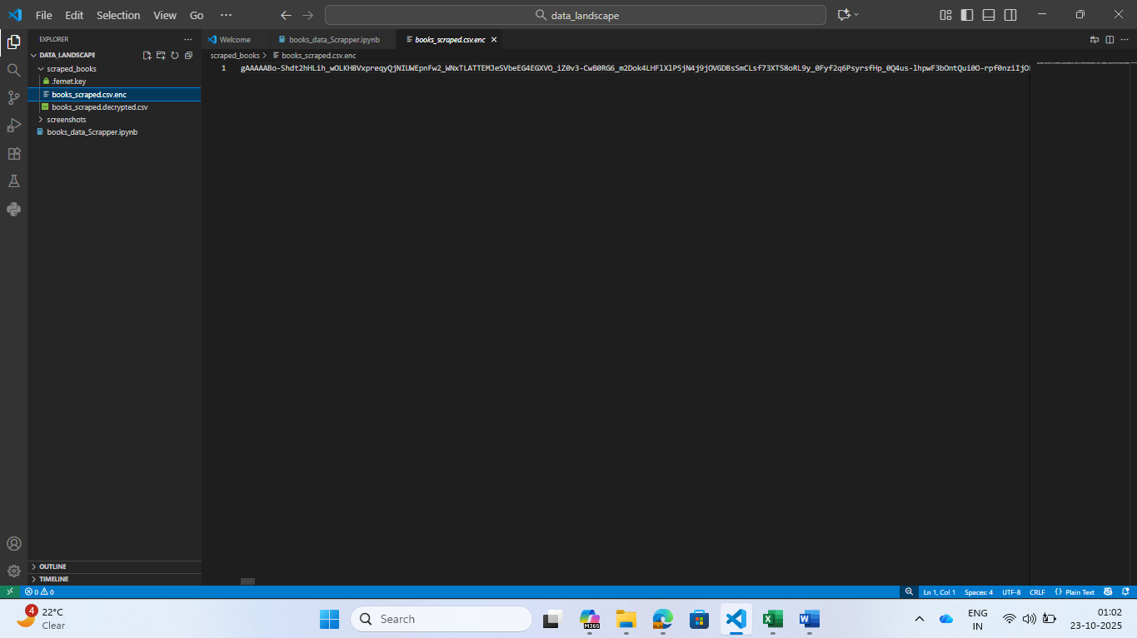
Figure 2 Extracted Data (Encrypted)

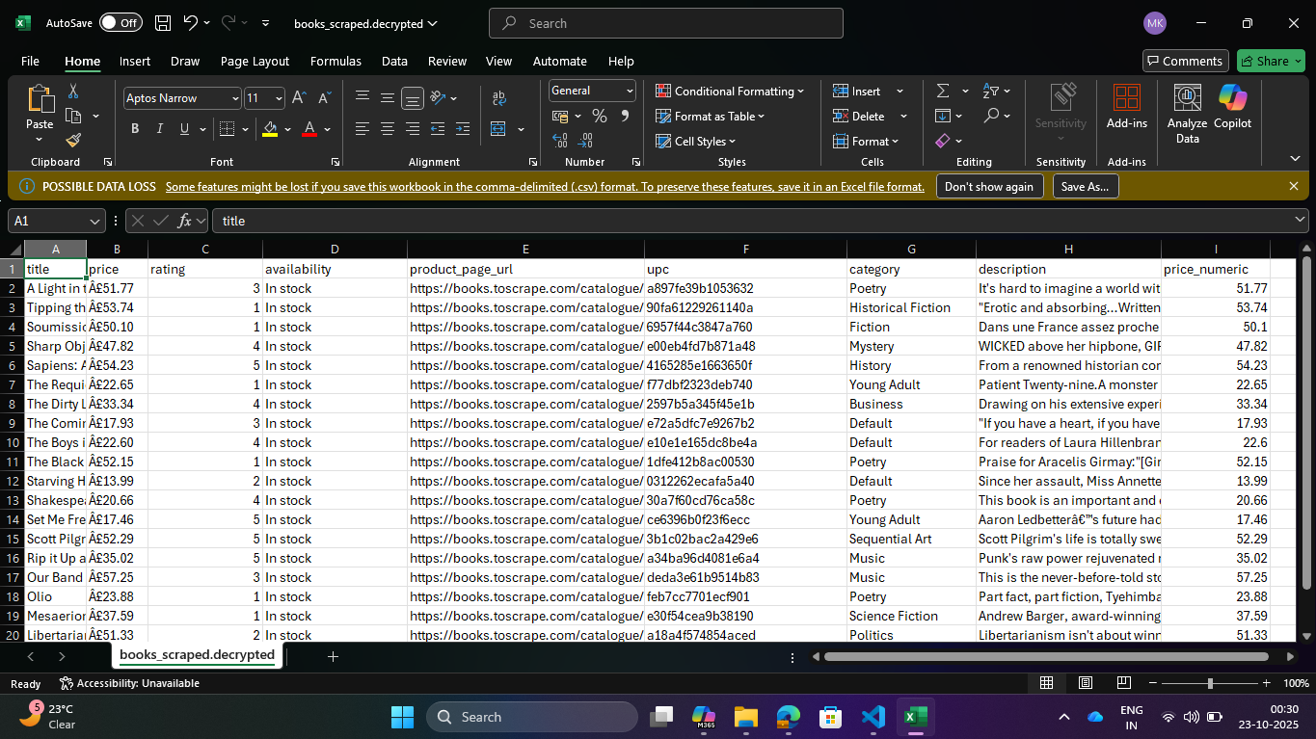
Figure 3 Decrypted Data
- Ethical Considerations
- Purpose-built site: The project uses a site designed for scraping practice.
- Respectful access pattern: Short delays (1–2s), retries with backoff, and request timeouts.
- Data handling: Demonstrates secure storage (encryption at rest) and avoids distribution of plaintext datasets.

