Exploring HDFS architecture

The HDFS architecture is based on master and slave patterns. NameNode is a master node and all DataNodes are SlaveNodes. Following are some important points to be noted about these two nodes.

NameNode

The NameNode is a master node of all DataNodes in the Hadoop cluster. It stores only the metadata of files and directories stored in the form of a tree. The important point is NameNode never stores any other data other than metadata. NameNode keeps track of all data written to DataNodes in the form of blocks. The default block size is 256 MB (which is configurable). Without the NameNode, the data on the DataNodes filesystem cannot be read. The metadata is stored locally on the NameNode using two files—filesystem namespace image file, FSImage, and edit logs. FSImage is the snapshot of the filesystem from the start of the NameNode, edit logs—all the changes of the filesystem since the NameNode started.
When a NameNode starts up, it reads HDFS state from an image file, fsimage, and then applies edits from the edits log file. It then overwrites fsimage with the new HDFS state and begins its normal operation with empty edits file.

Secondary NameNode

Since NameNode merges fsimage and edits files only during start up, the edits log file could get very large over time on a busy cluster and become unmanageable. Another side effect of a larger edits file is that next restart of NameNode takes longer.
The secondary NameNode merges the fsimage and the edits log files periodically and keeps edits log size within a limit. It is usually run on a different machine than the primary NameNode since its memory requirements are on the same order as the primary NameNode.
The start of the checkpoint process on the secondary NameNode is controlled by two configuration parameters.
- dfs.namenode.checkpoint.period, set to 1 hour by default, specifies the maximum delay between two consecutive checkpoints, and
- dfs.namenode.checkpoint.txns, set to 1 million by default, defines the number of uncheckpointed transactions on the NameNode which will force an urgent checkpoint, even if the checkpoint period has not been reached.
The secondary NameNode stores the latest checkpoint in a directory which is structured the same way as the primary NameNode’s directory. So that the check pointed image is always ready to be read by the primary NameNode if necessary.

Writing edits log file changes to FSImage are called commits. Regular commits help to reduce the NameNode start time. The secondary NameNode is also known as the Commit node.

NameNode safe mode

During start up the NameNode loads the file system state from the fsimage and the edits log file. It then waits for DataNodes to report their blocks so that it does not prematurely start replicating the blocks though enough replicas already exist in the cluster. During this time NameNode stays in Safemode. Safemode for the NameNode is essentially a read-only mode for the HDFS cluster, where it does not allow any modifications to file system or blocks. Normally the NameNode leaves Safemode automatically after applying edits to FSImage and DataNodes have reported that most file system blocks are available.

DataNode

DataNodes are the workhorses of the Hadoop cluster. Their main function is to store and retrieve data in the form of blocks. They always communicate their status to the NameNode in the form of heartbeats. That's how NameNode keeps track of any DataNodes, whether they are alive or dead. DataNodes keep three copies of the blocks known and the replication factor. DataNodes communicate with other DataNodes to copy data blocks to maintain data replication.

Data replication

HDFS architecture supports placing very large files across the machines in a cluster. Each file is stored as a series of blocks. In order to ensure fault tolerance, each block is replicated three times to three different machines. It is known as a replication factor, which can be changed at the cluster level or at the individual file level. It is a NameNode that makes all the decisions related to block replication. NameNode gets heartbeat and block reports from each DataNode. Heartbeat makes sure that the DataNode is alive. A block report contains a list of all blocks on a DataNode.

HDFS High Availability

The combination of replicating namenode metadata on multiple filesystems and using the secondary namenode to create checkpoints protects against data loss, but it does not provide high availability of the filesystem. The namenode is still a single point of failure (SPOF). If it did fail, all clients—including MapReduce jobs—would be unable to read, write, or list files, because the namenode is the sole repository of the metadata and the file-to-block mapping. In such an event, the whole Hadoop system would effectively be out of service until a new namenode could be brought online.
To recover from a failed namenode in this situation, an administrator starts a new primary namenode with one of the filesystem metadata replicas and configures datanodes and clients to use this new namenode. The new namenode is not able to serve requests until it has
- loaded its namespace image into memory,
- replayed its edit log, and
- received enough block reports from the datanodes to leave safe mode.

On large clusters with many files and blocks, the time it takes for a namenode to start from cold can be 30 minutes or more.
The long recovery time is a problem for routine maintenance, too. In fact, because unexpected failure of the namenode is so rare, the case for planned downtime is actually more important in practice. Hadoop 2 remedied this situation by adding support for HDFS high availability (HA).

In this implementation, there are a pair of namenodes in an active-standby configuration. In the event of the failure of the active namenode, the standby takes over its duties to continue servicing client requests without a significant interruption. A few architectural changes are needed to allow this to happen:
- The namenodes must use highly available shared storage to share the edit log. When a standby namenode comes up, it reads up to the end of the shared edit log to synchronize its state with the active namenode, and then continues to read new entries as they are written by the active namenode.
- Datanodes must send block reports to both namenodes because the block mappings are stored in a namenode’s memory, and not on disk.
- Clients must be configured to handle namenode failover, using a mechanism that is transparent to users.
- The secondary namenode’s role is subsumed by the standby, which takes periodic checkpoints of the active namenode’s namespace.

There are two choices for the highly available shared storage: an NFS filer, or a quorum journal manager (QJM).

HDFS HA cluster using NFS
The following diagram depicts the HDFS HA cluster using NFS for shared storage required by the NameNodes architecture:

Important architecture points
Following are some important points to remember about the HDFS HA using shared storage architecture:

- In the cluster, there are two separate machines: active state NameNode and standby state NameNode.
- At any given point in time, one-and-only, one of the NameNodes is in the active state, and the other is in the standby state.
- The active NameNode manages the requests from all client DataNodes in the cluster, while the standby remains a slave.
- All the DataNodes are configured in such a way that they send their block reports and heartbeats to both the active and standby NameNodes.
- The standby NameNode keeps its state synchronized with the active NameNode.
- Active and standby nodes both have access to a filesystem on a shared storage device (for example, an NFS mount from a NAS)
- When a client makes any filesystem change, the active NameNode makes the corresponding change (edits) to the edit log file residing on the network shared directory.
- The standby NameNode makes all the corresponding changes to its own namespace. That way, it remains in sync with the active NameNode.
- In the event of the active NameNode being unavailable, the standby NameNode makes sure that it absorbs all the changes (edits) from the shared network directory and promotes itself to an active NameNode.
- The Hadoop administrator should apply the fencing method to the shared storage to avoid a scenario that makes both the NameNodes active at a given time. In the event of failover, the fencing method cuts the access to the previous active NameNode to make any changes to the shared storage to ensure smooth failover to standby NameNode. After that, the standby NameNode becomes the active NameNode.

HDFS HA cluster using the quorum journal manager

The following diagram depicts the quorum journal manager (QJM) architecture to share edit logs between the active and standby NameNodes:

Important architecture points

Following are some important points to remember about the HDFS HA using the QJM architecture:

- In the cluster, there are two separate machines—the active state NameNode and standby state NameNode.
- At any point in time, exactly one of the NameNodes is in an active state, and the other is in a standby state.
- The active NameNode manages the requests from all client DataNodes in the cluster, while the standby remains a slave.
- All the DataNodes are configured in such a way that they send their block reports and heartbeats to both active and standby NameNodes.
- Both NameNodes, active and standby, remain synchronized with each other by communicating with a group of separate daemons called JournalNodes (JNs).
- When a client makes any filesystem change, the active NameNode durably logs a record of the modification to the majority of these JNs.
- The standby node immediately applies those changes to its own namespace by communicating with JNs.
- In the event of the active NameNode being unavailable, the standby NameNode makes sure that it absorbs all the changes (edits) from JNs and promotes itself as an active NameNode.
- To avoid a scenario that makes both the NameNodes active at a given time, the JNs will only ever allow a single NameNode to be a writer at a time. This allows the new active NameNode to safely proceed with failover.

Failover and fencing

The transition from the active namenode to the standby is managed by a new entity in the system called the failover controller. There are various failover controllers, but the default implementation uses ZooKeeper to ensure that only one namenode is active. Each namenode runs a lightweight failover controller process whose job it is to monitor its namenode for failures (using a simple heartbeating mechanism) and trigger a failover should a namenode fail.

Failover may also be initiated manually by an administrator, for example, in the case of routine maintenance. This is known as a graceful failover, since the failover controller arranges an orderly transition for both namenodes to switch roles. In the case of an ungraceful failover, however, it is impossible to be sure that the failed namenode has stopped running. For example, a slow network or a network partition can trigger a failover transition, even though the previously active namenode is still running and thinks it is still the active namenode. The HA implementation goes to great lengths to ensure that the previously active namenode is prevented from doing any damage and causing corruption—a method known as fencing.

The QJM only allows one namenode to write to the edit log at one time; however, it is still possible for the previously active namenode to serve stale read requests to clients, so setting up an SSH fencing command that will kill the namenode’s process is a good idea.
The range of fencing mechanisms includes revoking the namenode’s access to the shared storage directory (typically by using a vendor-specific NFS command), and disabling its network port via a remote management command. As a last resort, the previously active namenode can be fenced with a technique rather graphically known as STONITH, or “shoot the other node in the head,” which uses a specialized power distribution unit to forcibly power down the host machine.
Typical Hadoop cluster

The Hadoop cluster composition will look like the following:

Which file format is better?

The answer is: it depends on wer use cases. Generally, the criteria for selecting a file format is based on query-read and query-write performance. Also, it depends on which Hadoop distribution we are using. The ORC file format is the best for Hive and Tez using the Hortonworks distribution and a parquet file is recommended for Cloudera Impala implementations. For a use case involving schema evolution, Avro files are best suited. If we want to import data from RDBMS using Sqoop, text/CSV file format is the better choice. For storing map intermediate output, a sequence file is the ultimate choice.

Introducing YARN

The fundamental idea of YARN (Yet Another Resource Negotiator) is to split up the functionalities of resource management and job scheduling/monitoring into separate daemons. The idea is to have a global ResourceManager (RM) and per-application ApplicationMaster (AM). It helps to achieve 100% resource utilization of the cluster resources. YARN manages the CPU and memory of the cluster based on the Hadoop scheduler policy. YARN supports any type of application and is not restricted to just MapReduce. An application is either a single job or a DAG of jobs.

YARN architecture

YARN provides its core services via two types of long-running daemon: a ResourceManager (one per cluster), and NodeManagers running on all the nodes in the cluster. The ResourceManager and the NodeManager form the data-computation framework.

Resource manager

The ResourceManager is the ultimate authority that arbitrates resources among all the applications in the system. The resource manager has two main components: the Scheduler and the Application Manager.

Node manager

The NodeManager is the per-machine framework agent who is responsible for launching containers, monitoring their resource usage (cpu, memory, disk, network) and reporting the same to the ResourceManager/Scheduler.
Containers execute tasks as specified by the ApplicationMaster. It acts as a slave for the ResourceManager. Each NodeManager tracks the available data processing resources on its SlaveNode and sends regular reports to the ResourceManager. The processing resources in a Hadoop cluster are consumed in byte-size pieces called containers.

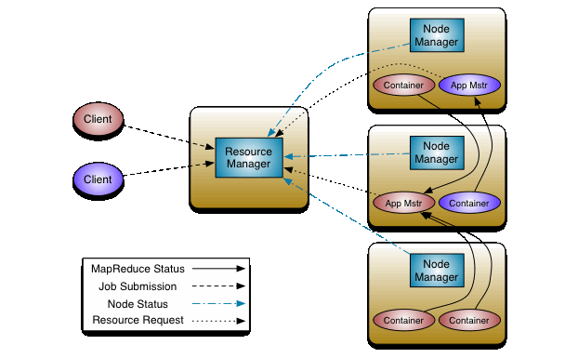
The ResourceManger has two important components –

- Scheduler
- Application Manager

Scheduler

The Scheduler is responsible for allocating resources to the various running applications subject to familiar constraints of capacities, queues etc. The Scheduler is pure scheduler in the sense that it performs no monitoring or tracking of status for the application. Also, it offers no guarantees about restarting failed tasks either due to application failure or hardware failures. The Scheduler performs its scheduling function based on the resource requirements of the applications; it does so based on the abstract notion of a resource Container which incorporates elements such as memory, cpu, disk, network etc.
The Scheduler has a pluggable policy which is responsible for partitioning the cluster resources among the various queues, applications etc. The current schedulers such as the CapacityScheduler and the FairScheduler would be some examples of plug-ins.

Application Manager

Following are the functions of ApplicationManager:

- Accepts job submissions.
- Negotiates the first container for executing the application specific ApplicationMaster. A container incorporates elements such as CPU, memory, disk, and network.
- Restarts the ApplicationMaster container on failure.

Functions of ApplicationMaster:-
- Initializes the job
- Negotiates appropriate resource container from Scheduler.
- After container allocation, communicating NodeManagers (NMs) to launch application containers on them.
- Tracks the resource container status.
- Monitors progress of the application.

So, when a job is submitted then ApplicationManager accepts the job and based on job, it negotiates for first container for executing ApplicationMaster. Scheduler allocates the container and ResourceManager launches the ApplicationMaster under Node Manager’s management. The ApplicationMaster initializes the job. The job of Node Manager is to monitor the resource usage by the container and report the same to Resource Manager. During the job, if additional resources are required then ApplicationMaster negotiates for resource container from ResourceManager. Once a task has been assigned resources for a container on a particular node by the ResourceManager’s Scheduler, the ApplicationMaster starts the container by contacting the NodeManager. It also monitors the progress of the application.

Scheduling in YARN

Scheduler Options
Three schedulers are available in YARN: the FIFO, Capacity, and Fair Schedulers.
FIFO Scheduler

The FIFO Scheduler places applications in a queue and runs them in the order of submission (first in, first out). Requests for the first application in the queue are allocated first; once its requests have been satisfied, the next application in the queue is served, and so on.

The FIFO Scheduler has the merit of being simple to understand and not needing any configuration, but it’s not suitable for shared clusters. Large applications will use all the resources in a cluster, so each application has to wait its turn. On a shared cluster it is better to use the Capacity Scheduler or the Fair Scheduler. Both of these allow long-running jobs to complete in a timely manner, while still allowing users who are running concurrent smaller ad hoc queries to get results back in a reasonable time.

The difference between schedulers is illustrated in Figure 4-3, which shows that under the FIFO Scheduler (i) the small job is blocked until the large job completes.

Capacity Scheduler

The Capacity Scheduler allows sharing of a Hadoop cluster along organizational lines, whereby each organization is allocated a certain capacity of the overall cluster. Each organization is set up with a dedicated queue that is configured to use a given fraction of the cluster capacity. Queues may be further divided in hierarchical fashion, allowing each organization to share its cluster allowance between different groups of users within the organization. Within a queue, applications are scheduled using FIFO scheduling.
As we saw in Figure 4-3, a single job does not use more resources than its queue’s capacity. However, if there is more than one job in the queue and there are idle resources available, then the Capacity Scheduler may allocate the spare resources to jobs in the queue, even if that causes the queue’s capacity to be exceeded. This behaviour is known as queue elasticity.

Fair Scheduler

With the Fair Scheduler (iii in Figure 4-3), there is no need to reserve a set amount of capacity, since it will dynamically balance resources between all running jobs. Just after the first (large) job starts, it is the only job running, so it gets all the resources in the cluster. When the second (small) job starts, it is allocated half of the cluster resources so that each job is using its fair share of resources.

Note that there is a lag between the time the second job starts and when it receives its fair share, since it has to wait for resources to free up as containers used by the first job complete. After the small job completes and no longer requires resources, the large job goes back to using the full cluster capacity again. The overall effect is both, high cluster utilization and timely small job completion.

Delay Scheduling

On a busy cluster, if an application requests a particular node, there is a good chance that other containers are running on it at the time of the request. The obvious course of action is to immediately loosen the locality requirement and allocate a container on the same rack. However, it has been observed in practice that waiting a short time (no more than a few seconds) can dramatically increase the chances of being allocated a container on the requested node, and therefore increase the efficiency of the cluster. This feature is called delay scheduling, and it is supported by both the Capacity Scheduler and the Fair Scheduler.

Every NodeManager in a YARN cluster periodically sends a heartbeat request to the resource manager—by default, one per second. Heartbeats carry information about the NodeManager’s running containers and the resources available for new containers, so each heartbeat is a potential scheduling opportunity for an application to run a container. When using delay scheduling, the scheduler doesn’t simply use the first scheduling opportunity it receives, but waits for up to a given maximum number of scheduling opportunities to occur before loosening the locality constraint and taking the next scheduling opportunity.

MapReduce

MapReduce works by breaking the processing into two phases: the map phase and the reduce phase. Each phase has key-value pairs as input and output, the types of which may be chosen by the programmer. The programmer also specifies two functions: the map function and the reduce function.

Anatomy of a MapReduce Job Run

We can run a MapReduce job with a single method call: submit() on a Job object. The whole process is illustrated in below figure. At the highest level, there are five independent entities:

- The client, which submits the MapReduce job.
- The YARN resource manager, which coordinates the allocation of compute resources on the cluster.
- The YARN node managers, which launch and monitor the compute containers on machines in the cluster.
- The MapReduce application master, which coordinates the tasks running the Map‐Reduce job. The application master and the MapReduce tasks run in containers that are scheduled by the resource manager and managed by the node managers.
- The distributed filesystem (normally HDFS), which is used for sharing job files between the other entities.

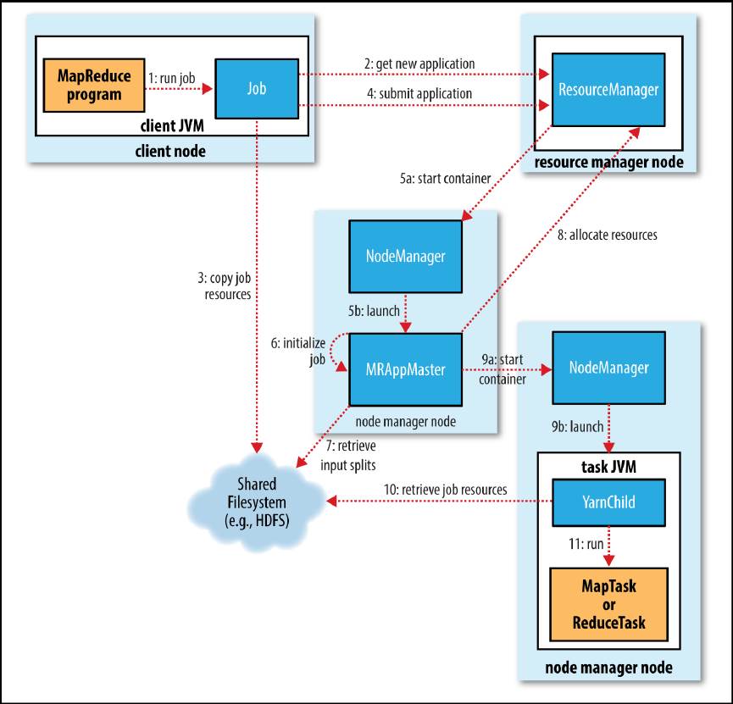
Job Submission

The submit() method on Job creates an internal JobSubmitter instance and calls submitJobInternal() on it (step 1 in Figure). Having submitted the job, waitForCompletion() polls the job’s progress once per second and reports the progress to the console, if it has changed since the last report. When the job completes successfully, the job counters are displayed. Otherwise, the error that caused the job to fail is logged to the console.

The job submission process implemented by JobSubmitter does the following:

- Asks the resource manager for a new application ID, used for the MapReduce job ID(step 2).
- Checks the output specification of the job. For example, if the output directory has not been specified or it already exists, the job is not submitted and an error is thrown to the MapReduce program.
- Computes the input splits for the job. If the splits cannot be computed (because the input paths don’t exist, for example), the job is not submitted and an error is thrown to the MapReduce program.
- Copies the resources needed to run the job, including the job JAR file, the configuration file, and the computed input splits, to the shared filesystem in a directory named after the job ID (step 3). The job JAR is copied with a high replication factor (controlled by the mapreduce.client.submit.file.replication property, which defaults to 10) so that there are lots of copies across the cluster for the node managers to access when they run tasks for the job.
- Submits the job by calling submitApplication() on the resource manager (step 4).

Job Initialization

When the ResourceManager receives a call to its submitApplication() method, it hands off the request to the YARN scheduler. The scheduler allocates a container, and the resource manager then launches the application master’s process there, under the node manager’s management (steps 5a and 5b). The ApplicationMaster for MapReduce jobs is a Java application whose main class is MRAppMaster. It initializes the job by creating a number of bookkeeping objects to keep track of the job’s progress, as it will receive progress and completion reports from the tasks (step 6). Next, it retrieves the input splits computed in the client from the shared filesystem (step 7). It then creates a map task object for each split, as well as a number of reduce task objects determined by the mapreduce.job.reduces property (set by the setNumReduceTasks() method on Job). Tasks are given IDs at this point.
The ApplicationMaster must decide how to run the tasks that make up the MapReduce job. If the job is small, the application master may choose to run the tasks in the same JVM as itself. This happens when it judges that the overhead of allocating and running tasks in new containers outweighs the gain to be had in running them in parallel, compared to running them sequentially on one node. Such a job is said to be uberized, or run as an uber task.
What qualifies as a small job? By default, a small job is one that has less than 10 mappers, only one reducer, and an input size that is less than the size of one HDFS block. (Note that these values may be changed for a job by setting mapreduce.job.ubertask.maxmaps, mapreduce.job.ubertask.maxreduces, and mapreduce.job.ubertask.maxbytes.) Uber tasks must be enabled explicitly (for an individual job, or across the cluster) by setting mapreduce.job.ubertask.enable to true. Finally, before any tasks can be run, the application master calls the setupJob() method on the OutputCommitter. For FileOutputCommitter, which is the default, it will create the final output directory for the job and the temporary working space for the task output.

Task Assignment

If the job does not qualify for running as an uber task, then the ApplicationMaster requests containers for all the map and reduce tasks in the job from the ResourceManager (step 8). Requests for map tasks are made first and with a higher priority than those for reduce tasks, since all the map tasks must complete before the sort phase of the reduce can start. Requests for reduce tasks are not made until 5% of map tasks have completed.
Reduce tasks can run anywhere in the cluster, but requests for map tasks have data locality constraints that the scheduler tries to honour. In the optimal case, the task is data local—that is, running on the same node that the split resides on. Alternatively, the task may be rack local: on the same rack, but not the same node, as the split. Some tasks are neither data local nor rack local and retrieve their data from a different rack than the one they are running on. For a particular job run, we can determine the number of tasks that ran at each locality level by looking at the job’s counters.
Requests also specify memory requirements and CPUs for tasks. By default, each map and reduce task is allocated 1,024 MB of memory and one virtual core. The values are configurable on a per-job basis via the following properties: mapreduce.map.memory.mb, mapreduce.reduce.memory.mb, mapreduce.map.cpu.vcores and mapreduce.reduce.cpu.vcores.

Task Execution

Once a task has been assigned resources for a container on a particular node by the resource manager’s scheduler, the ApplicationMaster starts the container by contacting the node manager (steps 9a and 9b). The task is executed by a Java application whose main class is YarnChild. Before it can run the task, it localizes the resources that the task needs, including the job configuration and JAR file, and any files from the distributed cache (step 10). Finally, it runs the map or reduce task (step 11).

The YarnChild runs in a dedicated JVM, so that any bugs in the user-defined map and reduce functions (or even in YarnChild) don’t affect the node manager—by causing it to crash or hang, for example. Each task can perform setup and commit actions, which are run in the same JVM as the task itself and are determined by the OutputCommitter for the job. For file-based jobs, the commit action moves the task output from a temporary location to its final location. The commit protocol ensures that when speculative execution is enabled only one of the duplicate tasks is committed and the other is aborted.

Progress and Status Updates

A job and each of its tasks have a status, which includes such things as the state of the job or task (e.g., running, successfully completed, failed), the progress of maps and reduces, the values of the job’s counters, and a status message or description (which may be set by user code).

When a task is running, it keeps track of its progress (i.e., the proportion of the task completed). For map tasks, this is the proportion of the input that has been processed. For reduce tasks, it’s a little more complex, but the system can still estimate the proportion of the reduce input processed. It does this by dividing the total progress into three parts, corresponding to the three phases of the shuffle. For example, if the task has run the reducer on half its input, the task’s progress is 5/6, since it has completed the copy and sort phases (1/3 each) and is halfway through the reduce phase (1/6).

Tasks also have a set of counters that count various events as the task runs, which are either built into the framework, such as the number of map output records written, or defined by users.
As the map or reduce task runs, the child process communicates with its parent ApplicationMaster through the umbilical interface. The task reports its progress and status (including counters) back to its ApplicationMaster, which has an aggregate view of the job, every three seconds over the umbilical interface. The ResourceManager web UI displays all the running applications with links to the web UIs of their respective application masters, each of which displays further details on the MapReduce job, including its progress.

During the course of the job, the client receives the latest status by polling the ApplicationMaster every second (the interval is set via mapreduce.client.progressmonitor.pollinterval). Clients can also use Job’s getStatus() method to obtain a JobStatus instance, which contains all of the status information for the job. The process is illustrated in Figure 7-3.

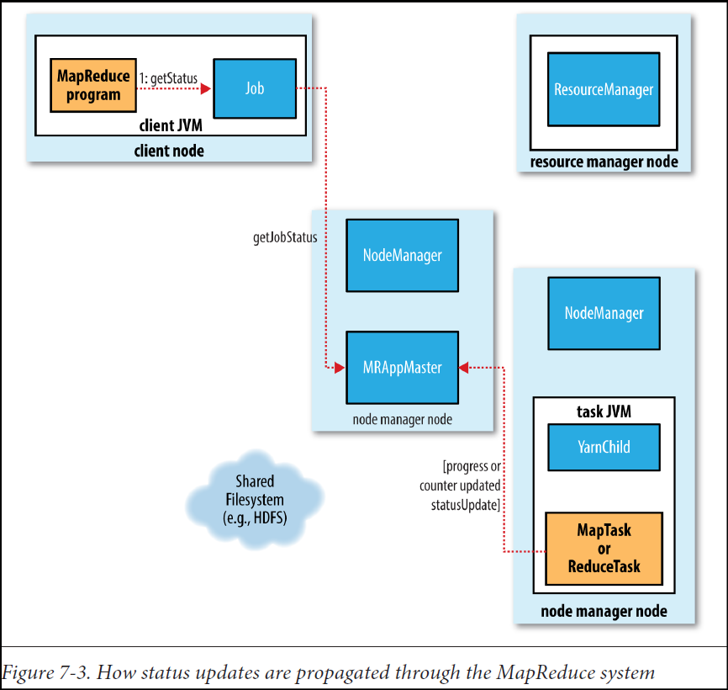

Job Completion

When the ApplicationMaster receives a notification that the last task for a job is completed, it changes the status for the job to “successful.” Then, when the Job polls for status, it learns that the job has completed successfully, so it prints a message to tell the user and then returns from the waitForCompletion() method. Job statistics and counters are printed to the console at this point.
The ApplicationMaster also sends an HTTP job notification if it is configured to do so. This can be configured by clients wishing to receive callbacks, via the mapreduce.job.end-notification.url property.
Finally, on job completion, the ApplicationMaster and the task containers clean up their working state (so intermediate output is deleted), and the OutputCommitter’s commit Job() method is called. Job information is archived by the job history server to enable later interrogation by users if desired.

Failures
We need to consider the failure of any of the following entities: the task, the application master, the node manager, and the resource manager.

Task Failure

Consider first the case of the task failing. The most common occurrence of this failure is when user code in the map or reduce task throws a runtime exception. If this happens, the task JVM reports the error back to its parent application master before it exits. The error ultimately makes it into the user logs. The application master marks the task attempt as failed, and frees up the container so its resources are available for another task.

Hanging tasks are dealt with differently. The application master notices that it hasn’t received a progress update for a while and proceeds to mark the task as failed. The task JVM process will be killed automatically after this period. The timeout period after which tasks are considered failed is normally 10 minutes and can be configured on a per-job basis (or a cluster basis) by setting the mapreduce.task.timeout property to a value in milliseconds.
Setting the timeout to a value of zero disables the timeout, so long-running tasks are never marked as failed. In this case, a hanging task will never free up its container, and over time there may be cluster slowdown as a result. This approach should therefore be avoided, and making sure that a task is reporting progress periodically should suffice.

When the application master is notified of a task attempt that has failed, it will reschedule execution of the task. The application master will try to avoid rescheduling the task on a node manager where it has previously failed. Furthermore, if a task fails four times, it will not be retried again. This value is configurable. The maximum number of attempts to run a task is controlled by the mapreduce.map.maxattempts property for map tasks
and mapreduce.reduce.maxattempts for reduce tasks. By default, if any task fails four times (or whatever the maximum number of attempts is configured to), the whole job fails.

Application Master Failure

The maximum number of attempts to run a MapReduce application master is controlled by the
mapreduce.am.max-attempts property. The default value is 2, so if a MapReduce application master fails twice it will not be tried again and the job will fail.
YARN imposes a limit for the maximum number of attempts for any YARN application master running on the cluster, and individual applications may not exceed this limit. The limit is set by yarn.resourcemanager.am.max-attempts and defaults to 2, so if we want to increase the number of MapReduce application master attempts, we will have to increase the YARN setting on the cluster, too.

The way recovery works is as follows. An application master sends periodic heartbeats to the resource manager, and in the event of application master failure, the resource manager will detect the failure and start a new instance of the master running in a new container (managed by a node manager). In the case of the MapReduce application master, it will use the job history to recover the state of the tasks that were already run by the (failed) application so they don’t have to be rerun. Recovery is enabled by default, but can

Node Manager Failure

If a node manager fails by crashing or running very slowly, it will stop sending heartbeats to the resource manager (or send them very infrequently). The resource manager will notice a node manager that has stopped sending heartbeats if it hasn’t received one for 10 minutes (this is configured, in milliseconds, via the
yarn.resourcemanager.nm.liveness-monitor.expiry-interval-ms property) and remove it from its pool of nodes to schedule containers on.
Any task or application master running on the failed node manager will be recovered. In addition, the application master arranges for map tasks that were run and completed successfully on the failed node manager to be rerun if they belong to incomplete jobs, since their intermediate output residing on the failed node manager’s local filesystem may not be accessible to the reduce task.
Node managers may be blacklisted if the number of failures for the application is high, even if the node manager itself has not failed. Blacklisting is done by the application master, and for MapReduce the application master will try to reschedule tasks on different nodes if more than three tasks fail on a node manager. The user may set the
threshold with the mapreduce.job.maxtaskfailures.per.tracker job property.

Resource Manager Failure

Failure of the resource manager is serious, because without it, neither jobs nor task containers can be launched. In the default configuration, the resource manager is a single point of failure, since in the (unlikely) event of machine failure, all running jobs fail—and can’t be recovered.
To achieve high availability (HA), it is necessary to run a pair of resource managers in an active-standby configuration. If the active resource manager fails, then the standbycan take over without a significant interruption to the client.
Information about all the running applications is stored in a highly available state store (backed by ZooKeeper or HDFS), so that the standby can recover the core state of the failed active resource manager. Node manager information is not stored in the state store since it can be reconstructed relatively quickly by the new resource manager as the node managers send their first heartbeats.

When the new resource manager starts, it reads the application information from the state store, then restarts the application masters for all the applications running on the cluster.
The transition of a resource manager from standby to active is handled by a failover controller. The default failover controller is an automatic one, which uses ZooKeeper leader election to ensure that there is only a single active resource manager at one time.

Shuffle and Sort

MapReduce makes the guarantee that the input to every reducer is sorted by key. The process by which the system performs the sort—and transfers the map outputs to the reducers as inputs—is known as the shuffle.

The Map Side

When the map function starts producing output, it is not simply written to disk. The process is more involved, and takes advantage of buffering writes in memory and doing some presorting for efficiency reasons. Figure 7-4 shows what happens.

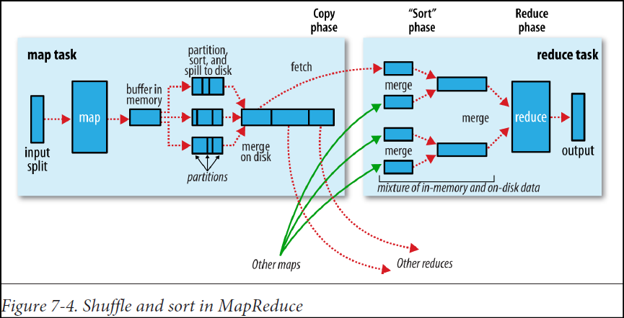

Each map task has a circular memory buffer that it writes the output to. The buffer is 100 MB by default (the size can be tuned by changing the mapreduce.task.io.sort.mb property). When the contents of the buffer reach a certain threshold size (mapre duce.map.sort.spill.percent, which has the default value 0.80, or 80%), a background
thread will start to spill the contents to disk. Map outputs will continue to be written to the buffer while the spill takes place, but if the buffer fills up during this time, the map will block until the spill is complete. Spills are written in round-robin fashion to the directories specified by the mapreduce.cluster.local.dir property, in a jobspecific subdirectory.
Before it writes to disk, the thread first divides the data into partitions corresponding to the reducers that they will ultimately be sent to. Within each partition, the background thread performs an in-memory sort by key, and if there is a combiner function, it is run on the output of the sort. Each time the memory buffer reaches the spill threshold, a new spill file is created, so after the map task has written its last output record, there could be several spill files.
Before the task is finished, the spill files are merged into a single partitioned and sorted output file. The configuration property mapreduce.task.io.sort.factor controls the maximum number of streams to merge at once; the default is 10.
It is often a good idea to compress the map output as it is written to disk, because doing so makes it faster to write to disk, saves disk space, and reduces the amount of data to transfer to the reducer. By default, the output is not compressed, but it is easy to enable this by setting mapreduce.map.output.compress to true.

The Reduce Side

The map output file is sitting on the local disk of the machine that ran the map task (note that although map outputs always get written to local disk, reduce outputs may not be), but now it is needed by the machine that is about to run the reduce task for the partition. Moreover, the reduce task needs the map output for its particular partition from several map tasks across the cluster. The map tasks may finish at different times, so the reduce task starts copying their outputs as soon as each completes. This is known as the copy phase of the reduce task. The reduce task has a small number of copier threads so that it can fetch map outputs in parallel. The default is five threads, but this number can be changed by setting the mapreduce.re duce.shuffle.parallelcopies property.

Map outputs are copied to the reduce task JVM’s memory if they are small enough; otherwise, they are copied to disk. When the in-memory buffer reaches a threshold size (controlled by mapreduce.reduce.shuffle.merge.percent) or reaches a threshold number of map outputs (mapreduce.reduce.merge.inmem.threshold), it is merged and spilled to disk. As the copies accumulate on disk, a background thread merges them into larger, sorted files. This saves some time merging later on. Note that any map outputs that were compressed (by the map task) have to be decompressed in memory in order to perform a merge on them. When all the map outputs have been copied, the reduce task moves into the sort phase (which should properly be called the merge phase, as the sorting was carried out on the map side), which merges the map outputs, maintaining their sort ordering. This is done in rounds. For example, if there were 50 map outputs and the merge factor was 10, there would be five rounds. Each round would merge 10 files into 1, so at the end there would be 5 intermediate files.

Rather than have a final round that merges these five files into a single sorted file, the merge saves a trip to disk by directly feeding the reduce function in what is the last phase: the reduce phase. This final merge can come from a mixture of in-memory and on-disk segments.
During the reduce phase, the reduce function is invoked for each key in the sorted output. The output of this phase is written directly to the output filesystem, typically HDFS. In the case of HDFS, because the node manager is also running a datanode, the first block replica will be written to the local disk.

Speculative Execution

Tasks may be slow for various reasons, including hardware degradation or software misconfiguration, but the causes may be hard to detect because the tasks still complete successfully, albeit after a longer time than expected. Hadoop doesn’t try to diagnose and fix slow-running tasks; instead, it tries to detect when a task is running slower than expected and launches another equivalent task as a backup. This is termed speculative
execution of tasks.
It’s important to understand that speculative execution does not work by launching two duplicate tasks at about the same time so they can race each other. This would be wasteful of cluster resources. Rather, the scheduler tracks the progress of all tasks of the same type (map and reduce) in a job, and only launches speculative duplicates for the small proportion that are running significantly slower than the average. When a task completes
successfully, any duplicate tasks that are running are killed since they are no longer needed. So, if the original task completes before the speculative task, the speculative task is killed; on the other hand, if the speculative task finishes first, the original is killed.

Speculative execution is an optimization, and not a feature to make jobs run more reliably. If there are bugs that sometimes cause a task to hang or slow down, relying on speculative execution to avoid these problems is unwise and won’t work reliably, since the same bugs are likely to affect the speculative task. We should fix the bug so that the task doesn’t hang or slow down.
Speculative execution is turned on by default. It can be enabled or disabled independently for map tasks and reduce tasks, on a cluster-wide basis, or on a per-job basis. The relevant properties are shown in Table 7-4.

Table 7-4. Speculative execution properties
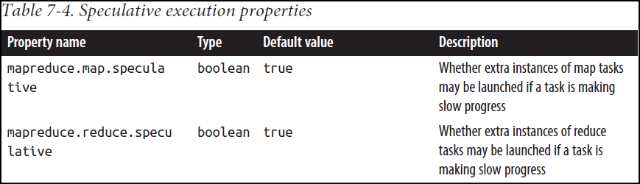

Distributed Cache

DistributedCache is a facility provided by the Map-Reduce framework to cache files (text, archives, jars etc.) needed by applications.
Applications specify the files, via urls (hdfs:// or http://) to be cached via the JobConf. The DistributedCache assumes that the files specified via urls are already present on the FileSystem at the path specified by the url and are accessible by every machine in the cluster.
The framework will copy the necessary files on to the worker node before any tasks for the job are executed on that node. Its efficiency stems from the fact that the files are only copied once per job and the ability to cache archives which are un-archived on the workers.
DistributedCache can be used to distribute simple, read-only data/text files and/or more complex types such as archives, jars etc. Archives (zip, tar and tgz/tar.gz files) are un-archived at the worker nodes.

