Understanding Spark Application Concepts

Application
A user program built on Spark using its APIs. It consists of a driver program and executors on the cluster.

SparkSession

An object that provides a point of entry to interact with underlying Spark functionality and allows programming Spark with its APIs. In an interactive Spark shell, the Spark driver instantiates a SparkSession for us, while in a Spark application, we create a SparkSession object ourself.

Run-time Architecture of Spark

Spark uses master/slave architecture i.e., one central coordinator and many distributed workers called executors. Here, the central coordinator is called the driver.
The driver runs in its own Java process. The driver communicates with a potentially large number of distributed workers called executors. A cluster manager will be there in-between to interact with these two cluster nodes. Each executor is a separate java process. A Spark Application is a combination of driver and its own executors. With the help of cluster manager, a Spark Application is launched on a set of machines.
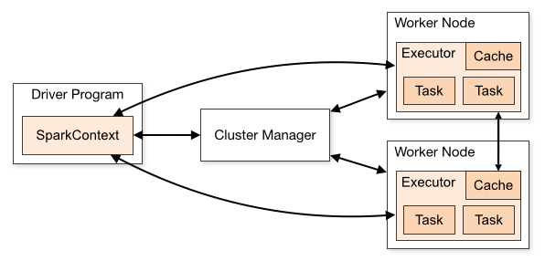

There are 4 important components of Runtime architecture of Apache Spark as described below.’

- Client process
- Driver
- Executor
- Cluster Manager

i. Client process
The client process starts the driver program. For example, the client process can be a spark-submit script for running applications, a spark-shell script, or a custom application using Spark API. The client process prepares the classpath and all configuration options for the Spark application. It also passes application arguments, if any, to the application running on the driver.

ii. Spark Driver
The driver program runs the main() function of the application and is the place where the SparkContext/SparkSession is created. It runs the user code that creates RDDs, and performs transformation and action. Spark Driver contains various components – DAGScheduler, TaskScheduler, BackendScheduler and BlockManager responsible for the translation of spark user code into actual spark jobs executed on the cluster. The driver and its subcomponents (the Spark context and scheduler) are responsible for:

- requesting memory and CPU resources from cluster managers
- breaking application logic into stages and tasks
- sending tasks to executors
- collecting the results

In Spark Program, the DAG (directed acyclic graph) of operations created implicitly. And when the driver runs, it converts that Spark DAG into a physical execution plan.

iii. Spark Executors
The individual task in the given Spark job runs in the Spark executors. Executors launch once in the beginning of Spark Application and then they run for the entire lifetime of an application. Even if the Spark executor fails, the Spark application can continue with ease. There are some main roles of the executors:

- Runs the task that makes up the application and returns the result to the driver.
- Read from and write the data to the external sources
- Provide in-memory storage for RDDs that are cached by the user.
Note: Before the execution of tasks, the executors are registered with the driver program through the cluster manager, so that the driver knows how many numbers of executors are running to perform the scheduled tasks. The executors then start executing the tasks scheduled by the worker nodes through the cluster manager. Whenever any of the worker nodes fail, the tasks that are required to perform will automatically allocates to any other worker nodes.

iv. Cluster Manager
The cluster manager is responsible for maintaining a cluster of machines that will run the Spark Application(s). When actual application is submitted, Cluster manager launches Spark driver process only. When Driver begins running application code, it interfaces with the cluster manager in order to actually get physical resources and launch executors.
The resources used by a Spark application can dynamically adjust based on the workload. Thus, the application can free unused resources and request them again when there is a demand.

spark.dynamicAllocation.enabled=true

Execution Modes
An execution mode gives us the power to determine where the aforementioned resources are
physically located when we go to run our application. We have three modes to choose from:
- Cluster mode
- Client mode
- Local mode

Note: rectangles with solid borders represent Spark driver process whereas those with dotted
borders represent the executor processes

Cluster mode
- Cluster mode is probably the most common way of running Spark Applications.
- In cluster mode, a user submits a pre-compiled JAR, Python script, or R script to a cluster manager.
- The cluster manager then launches the driver process on a worker node inside the cluster, in addition to the executor processes. This means that the cluster manager is responsible for maintaining all Spark Application–related processes. Figure below shows that the cluster manager placed our driver on a worker node and the executors on other worker nodes.

- Since in this mode, “driver” component will be running within “Spark infrastructure” so it reduces data movement between job submitting machine and “spark infrastructure”. Thus, this mode works totally fine for cases where job submitting machine is remote from “Spark infrastructure”.
- While we work with this spark mode, the chance of network disconnection between “driver” and “spark infrastructure” reduces. Since they reside in the same infrastructure. Also, reduces the chance of job failure.
- Driver program can be monitored from the Master node using the --supervise flag and be reset in case it dies.

Client mode

- Client mode is nearly the same as cluster mode except that the Spark driver remains on the client machine that submitted the application. This means that the client machine is responsible for maintaining the Spark driver process, and the cluster manager maintains the executor processes.
- In below Figure, we are running the Spark Application from a machine that is not co-located on the cluster. These machines are commonly referred to as gateway machines or edge nodes. In Figure, we can see that the driver is running on a machine outside of the cluster but that the workers are located on machines in the cluster.
- The driver opens up a dedicated Netty HTTP server and distributes the JAR files specified to all Worker nodes (big advantage)

- When the job submitting machine is within or near to “spark infrastructure”, then this mode works very fine since there is no high network latency of data movement for final result generation between “spark infrastructure” and “driver”.
- When a job submitting machine is very remote to “spark infrastructure”, and also has high network latency, in that case, this spark mode does not work in a good manner.
- If the driver process dies, we need an external monitoring system to reset its execution.

Local mode
- Local mode is a significant departure from the previous two modes: it runs the entire Spark Application on a single machine.
- It achieves parallelism through threads on that single machine.
- This is a common way to learn Spark, to test our applications, or experiment iteratively with local development. However, it is not recommend using local mode for running production apps.

The Life Cycle of a Spark Application (Outside Spark)

We assume that a cluster is already running with four nodes, a driver (not a Spark driver but cluster manager driver) and three worker nodes. The actual cluster manager does not matter at this point: this section uses the vocabulary from the previous section to walk through a step-by-step Spark Application life cycle from initialization to program exit.

NOTE: This section also makes use of illustrations and follows the same notation that we introduced previously. Additionally, we now introduce lines that represent network communication. Darker arrows represent communication by Spark or Spark-related processes, whereas dashed lines represent more general communication (like cluster management communication).

Client Request
The first step for us is to submit an actual application. This will be a pre-compiled JAR or library. At this point, we are executing code on our local machine and we’re going to make a request to the cluster manager driver node (Figure 15-4). Here, we are explicitly asking for resources for the Spark driver process only. We assume that the cluster manager accepts this request and places the driver onto a node in the cluster. The client process that submitted the original job exits and the application is off and running on the cluster.

Figure 15-4. Requesting resources for a driver

To do this, we’ll run something like the following command in our terminal:

./bin/spark-submit \
--class <main-class> \
--master <master-url> \
--deploy-mode cluster \
--conf <key>=<value> \
... # other options
<application-jar> \
[application-arguments]

Launch
Now that the driver process has been placed on the cluster, it begins running user code (Figure 15-5). This code must include a SparkSession that initializes a Spark cluster (e.g., driver + executors). The SparkSession will subsequently communicate with the cluster manager (the darker line, red), asking it to launch Spark executor processes across the cluster (the lighter lines). The number of executors and their relevant configurations are set by the user via the command-line arguments in the original spark-submit call.

Figure 15-5. Launching the Spark Application

The cluster manager responds by launching the executor processes (assuming all goes well) and sends the relevant information about their locations to the driver process(yellow lines). After everything is hooked up correctly, we have a “Spark Cluster” as we likely think of it today.

Execution
Now that we have a “Spark Cluster,” Spark goes about its merry way executing code, as shown in Figure 15-6. The driver and the workers communicate among themselves, executing code and moving data around (red line). The driver schedules tasks onto each worker, and each worker responds with the status of those tasks as success or failure.
Figure 15-6. Application execution

Completion
After a Spark Application completes, the driver process exits with either success or failure (Figure 15-7). The cluster manager then shuts down the executors in that Spark cluster for the driver. At this point, we can see the success or failure of the Spark Application by asking the cluster manager for this information.

Figure 15-7. Shutting down the application

The Life Cycle of a Spark Application (Inside Spark)

Let’s talk about what happens within Spark when we run an application. This is “user-code” (the actual code that we write that defines our Spark Application). Each application is made up of one or more Spark jobs. Spark jobs within an application are executed serially (unless we use threading to launch multiple actions in parallel).

The SparkSession
The first step of any Spark Application is creating a SparkSession. In many interactive modes,
this is done for we, but in an application, we must do it manually.
Some of the legacy code might use the new SparkContext pattern. This should be avoided in
favour of the builder method on the SparkSession, which more robustly instantiates the Spark
and SQL Contexts and ensures that there is no context conflict, given that there might be
multiple libraries trying to create a session in the same Spark Application:

// Creating a SparkSession in Scala
import org.apache.spark.sql.SparkSession
val spark = SparkSession.builder().appName("Databricks Spark Example")
.config("spark.sql.warehouse.dir", "/user/hive/warehouse")
.getOrCreate()

# Creating a SparkSession in Python
from pyspark.sql import SparkSession
spark = SparkSession.builder.master("local").appName("Word Count")\
.config("spark.some.config.option", "some-value")\
.getOrCreate()

After we have a SparkSession, we should be able to run our Spark code. From the SparkSession, we can access all of low-level and legacy contexts and configurations accordingly, as well.

THE SPARKSESSION, SQLCONTEXT, AND HIVECONTEXT
In previous versions of Spark, the SQLContext and HiveContext provided the ability to
work with DataFrames and Spark SQL and were commonly stored as the variable
sqlContext in examples, documentation, and legacy code. As a historical point, Spark 1.X
had effectively two contexts. The SparkContext and the SQLContext. These two each
performed different things. The former focused on more fine-grained control of Spark’s
central abstractions, whereas the latter focused on the higher-level tools like Spark SQL. In
Spark 2.X, the community combined the two APIs into the centralized SparkSession that
we have today. However, both of these APIs still exist and we can access them via the
SparkSession. It is important to note that we should never need to use the SQLContext and
rarely need to use the SparkContext.

Logical Instructions

Logical instructions to physical execution

We will walk through some more code, line by line, explain what’s happening behind the scenes so that we can walk away with a better understanding of our Spark Applications. We are going to do a three-step job: using a simple DataFrame, we’ll repartition it, perform a value-by-value manipulation, and then aggregate some values and collect the final result.

# in Python
df1 = spark.range(2, 10000000, 2)
df2 = spark.range(2, 10000000, 4)
step1 = df1.repartition(5)
step12 = df2.repartition(6)
step2 = step1.selectExpr("id * 5 as id")
step3 = step2.join(step12, ["id"])
step4 = step3.selectExpr("sum(id)")
step4.collect() # 2500000000000

When we run this code, we can see that our action triggers one complete Spark job. Let’s take
a look at the explain plan to ground our understanding of the physical execution plan. We can
access this information on the SQL tab (after we actually run a query) in the Spark UI, as well:

step4.explain()

== Physical Plan ==
*HashAggregate(keys=[], functions=[sum(id#15L)])
+- Exchange SinglePartition
+- *HashAggregate(keys=[], functions=[partial_sum(id#15L)])
+- *Project [id#15L]
+- *SortMergeJoin [id#15L], [id#10L], Inner
:- *Sort [id#15L ASC NULLS FIRST], false, 0
: +- Exchange hashpartitioning(id#15L, 200)
: +- *Project [(id#7L * 5) AS id#15L]
: +- Exchange RoundRobinPartitioning(5)
: +- *Range (2, 10000000, step=2, splits=8)
+- *Sort [id#10L ASC NULLS FIRST], false, 0
+- Exchange hashpartitioning(id#10L, 200)
+- Exchange RoundRobinPartitioning(6)
+- *Range (2, 10000000, step=4, splits=8)

What we have when we call collect (or any action) is the execution of a Spark job that individually consist of stages and tasks. If we are running this on our local machine then to see the Spark UI, go to localhost:4040. We will follow along on the “jobs” tab eventually jumping to stages and tasks as we proceed to further levels of detail.

A Spark Job
In general, there should be one Spark job for one action. Actions always return results. Each job
breaks down into a series of stages, the number of which depends on how many shuffle operations need to take place. This job breaks down into the following stages and tasks:

Stage 1 with 8 Tasks
Stage 2 with 8 Tasks
Stage 3 with 6 Tasks
Stage 4 with 5 Tasks
Stage 5 with 200 Tasks
Stage 6 with 1 Task

Stages
Stages in Spark represent groups of tasks that can be executed together to compute the same
operation on multiple machines. In general, Spark will try to pack as much work as possible (i.e.,
as many transformations as possible inside our job) into the same stage, but the engine starts
new stages after operations called shuffles. A shuffle represents a physical repartitioning of the
data—for example, sorting a DataFrame, or grouping data that was loaded from a file by key
(which requires sending records with the same key to the same node). This type of repartitioning
requires coordinating across executors to move data around. Spark starts a new stage after each
shuffle, and keeps track of what order the stages must run in to compute the final result.

In the job we looked at earlier, the first two stages correspond to the range that we perform in
order to create our DataFrames. By default when we create a DataFrame with range, it has
8 partitions. The next step is the repartitioning. This changes the number of partitions by
shuffling the data. These DataFrames are shuffled into six partitions and five partitions, corresponding to the number of tasks in stages 3 and 4.

Stages 3 and 4 perform on each of those DataFrames and the end of the stage represents the join
(a shuffle). Suddenly, we have 200 tasks. This is because of a Spark SQL configuration. The
spark.sql.shuffle.partitions default value is 200, which means that when there is a shuffle performed during execution, it outputs 200 shuffle partitions by default. We can change this value, and the number of output partitions will change.

Note: The number of partitions should be set according to the number of cores in our cluster to ensure efficient
execution. Here’s how to set it:

spark.conf.set("spark.sql.shuffle.partitions", 50)

A good rule of thumb is that the number of partitions should be larger than the number of
executors on our cluster, potentially by multiple factors depending on the workload. If we are
running code on our local machine, it would be our duty to set this value lower because our
local machine is unlikely to be able to execute that number of tasks in parallel. This is more of a
default for a cluster in which there might be many more executor cores to use. Regardless of the
number of partitions, that entire stage is computed in parallel. The final result aggregates those
partitions individually, brings them all to a single partition before finally sending the final result
to the driver.

Tasks
Stages in Spark consist of tasks. Each task corresponds to a combination of blocks of data and a
set of transformations that will run on a single executor. If there is one big partition in our
dataset, we will have one task. If there are 1,000 little partitions, we will have 1,000 tasks that
can be executed in parallel. A task is just a unit of computation applied to a unit of data (the
partition). Partitioning our data into a greater number of partitions means that more can be
executed in parallel. This is not a solution for all situations, but it is a simple place to begin with optimization.

Execution Details
Tasks and stages in Spark have some important properties that are worth reviewing. First, Spark automatically pipelines stages and tasks that can be done together, such as a map operation followed by another map operation. Second, for all shuffle operations, Spark writes the data to stable storage (e.g., disk), and can reuse it across multiple jobs.

Pipelining
An important part of what makes Spark an “in-memory computation tool” is that unlike the tools
that came before it (e.g., MapReduce), Spark performs as many steps as it can at one point in
time before writing data to memory or disk. One of the key optimizations that Spark performs is
pipelining, which occurs at and below the RDD level.

With pipelining, any sequence of operations that feed data directly into each other, without needing to move it across nodes, is collapsed into a single stage of tasks that do all the operations together. For example, if we write an RDD-based program that does a map, then a filter, then another map, these will result in a single stage of tasks that immediately read each input record, pass it through the first map, pass it through the filter, and pass it through the last map function if needed. This pipelined version of the computation is much faster than writing the intermediate results to memory or disk after each step. The same kind of pipelining happens for a DataFrame or SQL computation that does a select, filter, and select.

From a practical point of view, pipelining will be transparent to we as we write an application
—the Spark runtime will automatically do it—but we will see it if we ever inspect our
application through the Spark UI or through its log files, where we will see that multiple RDD
or DataFrame operations were pipelined into a single stage.

Shuffle Persistence
The second property we’ll sometimes see is shuffle persistence. When Spark needs to run an
operation that has to move data across nodes, such as a reduce-by-key operation (where input
data for each key needs to first be brought together from many nodes), the engine can’t perform
pipelining anymore, and instead it performs a cross-network shuffle.

Spark always executes shuffles by first having the “source” tasks (those sending data) write shuffle files to their local disks during their execution stage. Then, the stage that does the grouping and reduction launches and runs tasks that fetch their corresponding records from each shuffle file and performs that computation (e.g., fetches and processes the data for a specific range of keys). Saving the shuffle files to disk lets Spark run this stage later in time than the source stage (e.g., if there are not enough executors to run both at the same time), and also lets the engine re-launch reduce tasks on failure without rerunning all the input tasks.

One side effect we’ll see for shuffle persistence is that running a new job over data that’s
already been shuffled does not rerun the “source” side of the shuffle. Because the shuffle files
were already written to disk earlier, Spark knows that it can use them to run the later stages of
the job, and it need not redo the earlier ones. In the Spark UI and logs, we will see the pre-shuffle
stages marked as “skipped”. This automatic optimization can save time in a workload
that runs multiple jobs over the same data, but of course, for even better performance we can
perform our own caching with the DataFrame or RDD cache method, which lets we control
exactly which data is saved and where. We’ll quickly grow accustomed to this behaviour after
we run some Spark actions on aggregated data and inspect them in the UI.

The Anatomy of a Spark Job
In the Spark lazy evaluation paradigm, a Spark application doesn’t “do anything” until the driver program calls an action. With each action, the Spark scheduler builds an execution graph and launches a Spark job. Each job consists of stages, which are steps in the transformation of the data needed to materialize the final RDD. Each stage consists of a collection of tasks that represent each parallel computation and are performed on the executors.
Below figure shows a tree of the different components of a Spark application and how these correspond to the API calls. An application corresponds to start a SparkContext/SparkSession. Each application may contain many jobs that correspond to one RDD action. Each job may contain several stages that correspond to each wide transformation.
Each stage is composed of one or many tasks that correspond to a parallelizable unit of computation done in each stage. There is one task for each partition in the resulting RDD of that stage.

The DAG
Spark’s high-level scheduling layer uses RDD dependencies to build a Directed Acyclic Graph (a DAG) of stages for each Spark job. In the Spark API, this is called the DAG Scheduler. The DAG builds a graph of stages for each job, determines the locations to run each task, and passes that information on to the TaskScheduler, which is responsible for running tasks on the cluster. The TaskScheduler creates a graph with dependencies between partitions.
https://spark.apache.org/docs/latest/web-ui.html#jobs-tab

Jobs
A Spark job is the highest element of Spark’s execution hierarchy. Each Spark job corresponds to one action, and each action is called by the driver program of a Spark application. One way to conceptualize an action is as something that brings data out of the RDD world of Spark into some other storage system (usually by bringing data to the driver or writing to some stable storage system).
The edges of the Spark execution graph are based on dependencies between the partitions in RDD transformations (as illustrated by Figures 2-2 and 2-3). Thus, an operation that returns something other than an RDD cannot have any children. In graph theory, we would say the action forms a “leaf” in the DAG. Thus, an arbitrarily large set of transformations may be associated with one execution graph. However, as soon as an action is called, Spark can no longer add to that graph. The application launches a job including those transformations that were needed to evaluate the final RDD, that called the action.

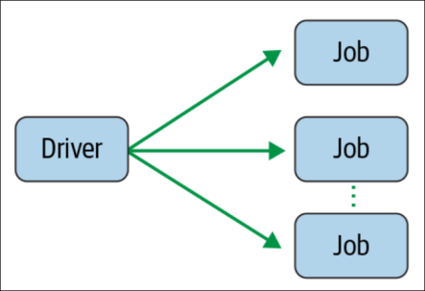

Stages
Recall that Spark lazily evaluates transformations; transformations are not executed until an action is called. As mentioned previously, a job is defined by calling an action. The action may include one or several transformations, and wide transformations define the breakdown of jobs into stages.

Each stage corresponds to a shuffle dependency created by a wide transformation in the Spark program. At a high level, one stage can be thought of as the set of computations (tasks) that can each be computed on one executor without communication with other executors or with the driver. In other words, a new stage begins whenever network communication between workers is required; for instance, in a shuffle.

These dependencies that create stage boundaries are called ShuffleDependencies. Shuffles are caused by those wide transformations, such as sort or groupByKey, which require the data to be redistributed across the partitions. Several transformations with narrow dependencies can be grouped into one stage.

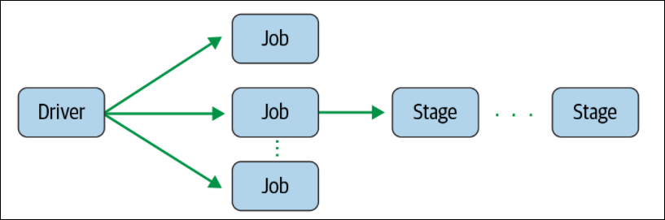

As we saw in word count example where we filtered stop words, Spark can combine the flatMap, map & filter steps into one stage since none of those transformations requires a shuffle. Thus, each executor can apply the flatMap, map & filter steps consecutively in one pass of the data.

NOTE: Spark keeps track of how an RDD is partitioned, so that it does not need to partition the same RDD by the same partitioner more than once. This has some interesting consequences for the DAG: the same operations on RDDs with known partitioners and RDDs without a known partitioner can result in different stage boundaries, because there is no need to shuffle an RDD with a known partition (and thus the subsequent transformations happen in the same stage).

Because the stage boundaries require communication with the driver, the stages associated with one job generally have to be executed in sequence rather than in parallel. It is possible to execute stages in parallel if they are used to compute different RDDs that are combined in a downstream transformation such as a join. However, the wide transformations needed to compute one RDD have to be computed in sequence. Thus, it is usually desirable to design our program to require fewer shuffles.

Tasks
A stage consists of tasks. The task is the smallest unit in the execution hierarchy, and each can represent one local computation. All of the tasks in one stage execute the same code on a different piece of the data. One task cannot be executed on more than one executor. However, each executor has a dynamically allocated number of slots for running tasks and may run many tasks concurrently throughout its lifetime. The number of tasks per stage corresponds to the number of partitions in the output RDD of that stage.

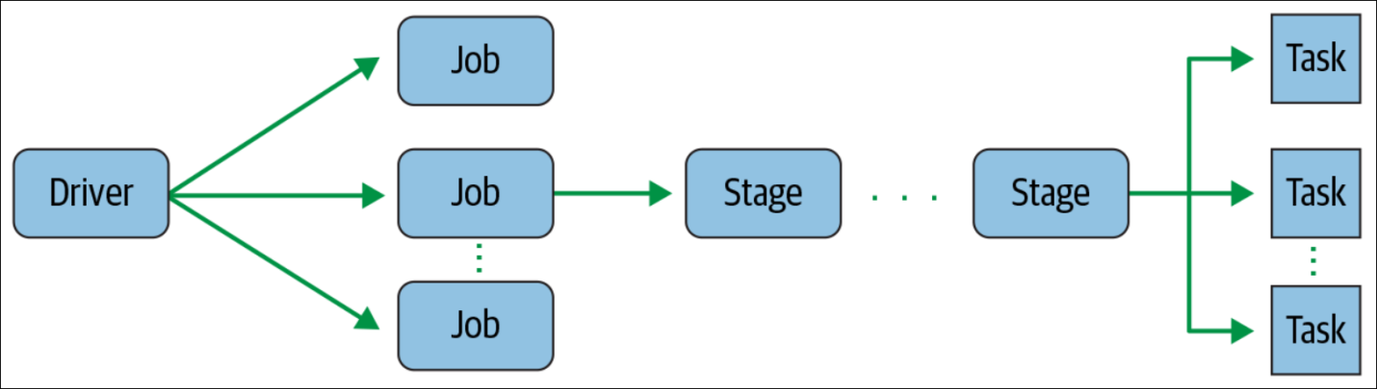

Figure 2-5. Spark stage creating one or more tasks to be distributed to executors

Figure 2-6 shows the evaluation of a Spark job that is the result of a driver program that calls the simpleSparkProgram shown in below example. Different types of transformations showing stage boundaries.

def simpleSparkProgram(rdd : RDD[Double]): Long ={
//stage1
rdd.filter(_< 1000.0)
.map(x => (x, x) )
//stage2
.groupByKey()
.map{ case(value, groups) => (groups.sum, value)}
//stage 3
.sortByKey()
.count()
}

The stages (blue boxes) are bounded by the shuffle operations groupByKey and sortByKey. Each stage consists of several tasks: one for each partition in the result of the RDD transformations (shown as red rectangles), which are executed in parallel.

Figure 2-6. A stage diagram for the simple Spark program shown in Example 2-3

A cluster cannot necessarily run every task in parallel for each stage. Each executor has a number of cores. The number of cores per executor is configured at the application level, but likely corresponding to the physical cores on a cluster. Spark can run no more tasks at once than the total number of executor cores allocated for the application.

We can calculate the number of tasks from the settings from the Spark Conf as (total number of executor cores = # of cores per executor × number of executors). If there are more partitions (and thus more tasks) than the number of slots for running tasks, then the extra tasks will be allocated to the executors as the first round of tasks finish and resources are available. In most cases, all the tasks for one stage must be completed before the next stage can start. The process of distributing these tasks is done by the TaskScheduler and varies depending on whether the fair scheduler or FIFO scheduler is used.

In some ways, the simplest way to think of the Spark execution model is that a Spark job is the set of RDD transformations needed to compute one final result. Each stage corresponds to a segment of work, which can be accomplished without involving the driver. In other words, one stage can be computed without moving data across the partitions. Within one stage, the tasks are the units of work done for each partition of the data.

Spark RDD – Introduction, Features & Operations

2. What is Apache Spark RDD?

RDD is the fundamental data structure of Apache Spark which is an immutable distributed collection of elements, partitioned across the nodes of the cluster that can be operated in parallel. RDD stands for “Resilient Distributed Dataset”.
Decomposing the name RDD:
- Resilient, i.e. fault-tolerant with the help of RDD lineage graph(DAG) and so able to recompute missing or damaged partitions due to node failures.
- Distributed, since Data resides on multiple nodes.
- Dataset represents records of the data we work with. The user can load the data set externally which can be either JSON file, CSV file, text file or database via JDBC with no specific data structure.

Hence, each and every dataset in RDD is logically partitioned across many servers so that they can be computed on different nodes of the cluster. RDDs are fault tolerant i.e. It possess self-recovery in the case of failure.
There are three ways to create RDDs in Spark such as – Data in stable storage, other RDDs, and parallelizing already existing collection in driver program.

Spark RDD can also be cached and manually partitioned. Caching is beneficial when we use RDD several times. And manual partitioning is important to correctly balance partitions. Generally, smaller partitions allow distributing RDD data more equally, among more executors. Hence, fewer partitions make the work easy.

Programmers can also call a persist method to indicate which RDDs they want to reuse in future operations. Spark keeps persistent RDDs in memory by default, but it can spill them to disk if there is not enough RAM. Users can also request other persistence strategies, such as storing the RDD only on disk or replicating it across machines, through flags to persist.

3. Why do we need RDD in Spark?

When it comes to iterative distributed computing, i.e. processing data over multiple jobs in computations such as Logistic Regression, K-means clustering, Page rank algorithms, it is fairly common to reuse or share the data among multiple jobs or we may want to do multiple ad-hoc queries over a shared data set.
There is an underlying problem with data reuse or data sharing in existing distributed computing systems (such as MapReduce) and that is, we need to store data in some intermediate stable distributed store such as HDFS or Amazon S3. This makes the overall computations of jobs slower since it involves multiple I/O operations, replications and serializations in the process.

RDDs, tries to solve these problems by enabling fault tolerant distributed In-memory computations.

5. Features of Spark RDD

Several features of Apache Spark RDD are:

- In-memory Computation
Spark RDDs have a provision of in-memory computation. It stores intermediate results in distributed memory(RAM) instead of stable storage(disk). Keeping the data in-memory improves the performance by an order of magnitudes.

- Lazy Evaluations

Evaluation of RDDs is completely lazy. Spark does not begin computing the partitions until an action is called. An action is a Spark operation that returns something other than a RDD, triggering evaluation of partitions and possibly returning some output to a non-Spark system (outside of the Spark executors); for example, bringing data back to the driver (with operations like count or collect) or writing data to an external storage system (such as copyToHadoop).

Actions trigger the scheduler, which builds a directed acyclic graph (called the DAG), based on the dependencies between RDD transformations. In other words, Spark evaluates an action by working backward to define the series of steps it has to take to produce each object in the final distributed dataset (each partition). Then, using this series of steps, called the execution plan, the scheduler computes the missing partitions for each stage until it computes the result.
Not all transformations are 100% lazy. sortByKey needs to evaluate the RDD to determine the range of data, so it involves both a transformation and an action.

There are some benefits of Lazy evaluation in Apache Spark-

a. Increases Manageability
Spark’s lazy evaluation strategy helps to express the same logic in far fewer lines of code: we can chain together operations with narrow dependencies and let the Spark evaluation engine do the work of consolidating them.

b. Saves Computation and increases Speed
Spark Lazy Evaluation plays a key role in saving calculation overhead. Since only necessary values get compute. It saves the trip between driver and cluster, thus speeds up the process.

c. Reduces Complexities
The two main complexities of any operation are time and space complexity. Using Apache Spark lazy evaluation, we can overcome both. Since we do not execute every operation, hence, the time gets saved. It let us work with an infinite data structure. The action is triggered only when the data is required, it reduces overhead.

d. Optimization
A huge advantage of the lazy evaluation scheme is that Spark can inspect our computational query and ascertain how it can optimize it. This optimization can be done by either joining or pipelining some operations and assigning them to a stage, or breaking them into stages by determining which operations require a shuffle or exchange of data across clusters.

- Fault tolerance

Spark is fault-tolerant, meaning Spark will not fail, lose data, or return inaccurate results in the event of a host machine or network failure. Spark’s unique method of fault tolerance is achieved because RDDs contains all the dependency information needed to replicate/recalculate each of its partitions. Thus, if a partition is lost, the RDD has enough information about its lineage to recompute it, and that computation can be parallelized to make recovery faster.

- Immutability
RDDs are immutable in nature meaning once we create an RDD we cannot manipulate it. And if we perform any transformation, it creates new RDD. We achieve consistency through immutability.

- Partitioning
Partitioning is the fundamental unit of parallelism in Spark RDD. RDD partition the records logically and distributes the data across various nodes in the cluster. Each partition is one logical division of data which is mutable. One can create a partition through some transformations on existing partitions.

- Persistence
We can store the frequently used RDD in in-memory and we can also retrieve them directly from memory without going to disk, this speedup the execution. We can perform Multiple operations on the same data, this happens by storing the data explicitly in memory by calling persist() or cache() function.

- Coarse-grained Operations
It applies to all elements in the datasets through maps or filter or group by operation.
- Location-Stickiness
RDDs are capable of defining placement preference to compute partitions. Placement preference refers to information about the location of RDD. The DAGScheduler places the partitions in such a way that task is close to data as much as possible. Thus, speed up the computation.

When to use RDDs?

Consider these scenarios or common use cases for using RDDs when:
- We want low-level transformation and actions and control on our dataset;
- Our data is unstructured, such as media streams or streams of text;
- We want to manipulate our data with functional programming constructs than domain specific expressions;
- We don’t care about imposing a schema, such as columnar format, while processing or accessing data attributes by name or column
- We can go without some optimization and performance benefits available with DataFrames and Datasets for structured and semi-structured data.

6. Spark RDD Operations

RDD in Apache Spark supports two types of operations:
- Transformation
- Actions

i. Transformations
Spark RDD Transformations are functions that take an RDD as the input and produce one or many RDDs as the output. They do not change the input RDD (since RDDs are immutable and hence one cannot change it), but always produce one or more new RDDs by applying the computations they represent e.g. Map(), filter(), flatMap() etc.
Transformations are lazy operations on an RDD in Apache Spark. It creates one or many new RDDs, which executes when an Action is called. Hence, Transformation creates a new dataset from an existing one.
There are two kinds of transformations: narrow transformation, wide transformation.

a. Narrow Transformations

Any transformation where a single output partition can be computed from a single input partition is a narrow transformation. For example, map(), filter() and contains(). An output RDD has partitions with records that originate from a single partition in the parent RDD. Only a limited subset of partitions used to calculate the result. Spark groups narrow transformations as a stage known as pipelining.

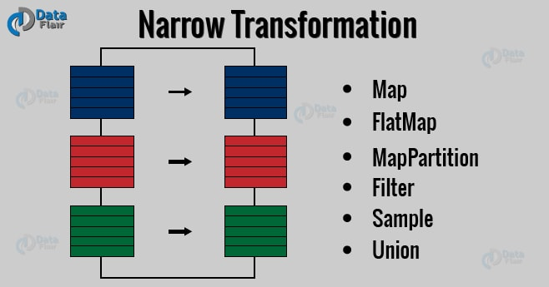
Spark RDD – Narrow Transformation

b. Wide Transformations

The data required to compute the records in a single partition may live in many partitions of the parent RDD. So the transformations, where the data is read in, combined, from many partitions to compute the records of a single partition, is known as wide transformation. It is the result of groupByKey() and reduceByKey() like functions. Wide transformations are also known as shuffle transformations because they may or may not depend on a shuffle.

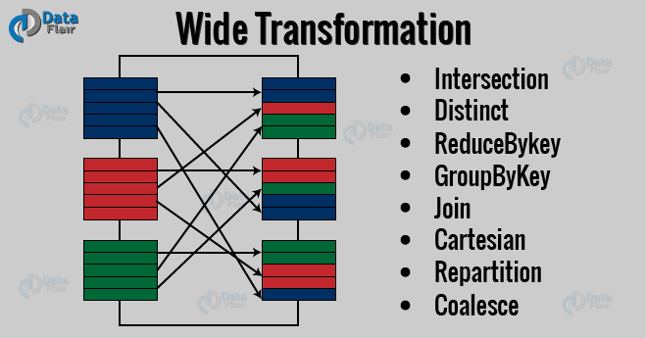
Wide Transformation

There are various functions in RDD transformation. Let us see RDD transformation with examples.

3.1. map(func)

The map function iterates over every line in RDD and split into new RDD. Using map() transformation we take in any function, and that function is applied to every element of RDD.
In the map, we have the flexibility that the input and the return type of RDD may differ from each other. For example, we can have input RDD type as String, after applying the map() function the return RDD can be Boolean.
For example, in RDD {1, 2, 3, 4, 5} if we apply “rdd.map(x=>x+2)” we will get the result as (3, 4, 5, 6, 7).

Map Transformation-2
- val tag = data.map {line => {
- val xml = XML.loadString(line)
- xml.attribute("Tags").get.toString()
- }
- }

3.2. flatMap()

A flatMap is a transformation operation. It applies to each element of RDD and it returns the result as new RDD. It is similar to Map, but flatMap allows returning of 0, 1 or more elements from map function. In the flatMap operation, a developer can define their own custom business logic. The same logic will be applied to all the elements of the RDD.
A flatMap function takes one element as input, process it according to custom code (specified by the developer) and returns 0 or more element at a time. flatMap() transforms an RDD of length N into another RDD of length M. flatMap() example:

- val data = spark.read.textFile("spark_test.txt").rdd
- val flatmapFile = data.flatMap(lines => lines.split(" "))
- flatmapFile.foreach(println)

Above flatMap transformation will convert a line into words. One word will be an individual element of the newly created RDD.

3.3. filter(func)

Spark RDD filter() function returns a new RDD, containing only the elements that meet a predicate. It is a narrow operation because it does not shuffle data from one partition to many partitions. Filter() example:

- val data = spark.read.textFile("spark_test.txt").rdd
- val mapFile = data.flatMap(lines => lines.split(" ")).filter(value => value=="spark")
- println(mapFile.count())

Note – In above code, flatMap function map line into words and then count the word “spark” using count() Action after filtering lines containing “spark” from mapFile.

3.4. mapPartitions(func)

The MapPartition converts each partition of the source RDD into many elements of the result. In mapPartition(), the map() function is applied on each partitions simultaneously. It is like a map, but the difference is it runs separately on each partition(block) of the RDD.

3.5. mapPartitionWithIndex()

It is like mapPartition; Besides mapPartition it provides func with an integer value representing the index of the partition, and the map() is applied on partition index-wise one after the other.

3.6. union(dataset)

With the union() function, we get the elements of both the RDDs in the new RDD. The key rule of this function is that the two RDDs should be of the same type.
For example, the elements of RDD1 are (Spark, Spark, Hadoop, Flink) and that of RDD2 are (Big data, Spark, Flink) so the resultant rdd1.union(rdd2) will have elements (Spark, Spark, Spark, Hadoop, Flink, Flink, Big data).

3.7. intersection(other-dataset)

With the intersection() function, we get only the common element of both the RDDs in the new RDD. The key rule of this function is that the two RDDs should be of the same type.
Consider an example, the elements of RDD1 are (Spark, Spark, Hadoop, Flink) and that of RDD2 are (Big data, Spark, Flink) so the resultant rdd1.intersection(rdd2) will have elements (Spark, Flink).

3.8. distinct()

It returns a new dataset that contains the distinct elements of the source dataset. It is helpful to remove duplicate data.
For example, if RDD has elements (Spark, Spark, Hadoop, Flink), then rdd.distinct() will give elements (Spark, Hadoop, Flink).

3.9. groupByKey()

When we use groupByKey() on a dataset of (K, V) pairs, the data is shuffled according to the key value K in another RDD. In this transformation, lots of unnecessary data get to transfer over the network. Spark provides the provision to save data to disk when there is more data shuffled onto a single executor machine than can fit in memory. groupByKey() example:

- val data = spark.sparkContext.parallelize(Array((1, 2), (3, 4), (3, 6)),3)
- val group = data.groupByKey().collect()
- group.foreach(println)

Result: {(1, [2]), (3, [4, 6])}

Note – The groupByKey() will group the integers on the basis of same key(alphabet). After that collect() action will return all the elements of the dataset as an Array.

3.10. reduceByKey(func, [numTasks])

When we use reduceByKey on a dataset (K, V), the pairs on the same machine with the same key are combined, before the data is shuffled. reduceByKey() example:

- val words = Array("one","two","two","four","five","six","six","eight","nine","ten")
- val data = spark.sparkContext.parallelize(words).map(w => (w,1)).reduceByKey(_+_)
- data.foreach(println)

Result: Array(("one",1),("two",2),("four",1),("five",1),("six",2),("eight",1),("nine",1),("ten",1))

Note – The above code will parallelize the Array of String. It will then map each word with count 1, then reduceByKey will merge the count of values having the similar key.

3.11. sortByKey()

When we apply the sortByKey() function on a dataset of (K, V) pairs, the data is sorted according to the key K in another RDD. sortByKey() example:

- val data = spark.sparkContext.parallelize(Seq(("maths",52), ("english",75), ("science",82), ("computer",65), ("maths",85)))
- val sorted = data.sortByKey()
- sorted.foreach(println)

Note – In above code, sortByKey() transformation sort the data RDD into Ascending order of the Key(String).

3.12. join()

The Join is database term. It combines the fields from two table using common values. join() operation in Spark is defined on pair-wise RDD. Pair-wise RDDs are RDD in which each element is in the form of tuples, where the first element is key and the second element is the value.
The benefit of using keyed data is that we can combine the data together. The join() operation combines two data sets on the basis of the key. Join() example:

- val data = spark.sparkContext.parallelize(Array((‘A’,1),(‘b’,2),(‘c’,3)))
- val data2 =spark.sparkContext.parallelize(Array((‘A’,4),(‘A’,6),(‘b’,7),(‘c’,3),(‘c’,8)))
- val result = data.join(data2)
- println(result.collect().mkString(","))

Note – The join() transformation will join two different RDDs on the basis of Key.

3.13. coalesce()

The coalesce method reduces the number of partitions in an RDD. Coalesce avoids full shuffle, instead of creating new partitions, it shuffles and adjusts the data into existing partitions using Hash Partitioner (Default), to minimize the amount of data that’s shuffled. This means it can only decrease the number of partitions. Coalesce results in partitions with different amounts of data that is, partition of unequal sizes. Coalesce() example:

- val rdd1 = spark.sparkContext.parallelize(Array("jan","feb","mar","april","may","jun"),3)
- val result = rdd1.coalesce(2)
- result.foreach(println)

Note – The coalesce will decrease the number of partitions of the source RDD to numPartitions define in coalesce argument.

3.14. repartition()

The repartition method can be used to either increase or decrease the number of partitions in an RDD. Repartition is a full Shuffle operation, whole data is taken out from existing partitions and equally distributed into newly formed partitions. Repartition creates new partitions of roughly equal sized partitions.

Let’s look at the below example for the answer.

Now, if we manually pass the number of partitions to 10, see how the data gets distributed:

Comparatively, coalesce took less time as compared with repartitioning. And the data gets partitioned as below:

Repartitioning | Coalesce
19M repartition/part-00000  19M repartition/part-00001  19M repartition/part-00002  19M repartition/part-00003  19M repartition/part-00004  19M repartition/part-00005  19M repartition/part-00006  19M repartition/part-00007  19M repartition/part-00008  19M repartition/part-00009 | 33M coalesce/part-00000  29M coalesce/part-00001  30M coalesce/part-00002  31M coalesce/part-00003  32M coalesce/part-00004  33M coalesce/part-00005

If we observe above table when repartitioned, data over all the partitions are equally populated, but when we used coalesce the data is not equally distributed.
Also, if we observed above coalesce didn’t partition our data to 10 partitions instead it created 6 partitions. That means even if we provide a large number of partitions, it partitions our data to the default one in the above case it is 6.

Now, where to use which function?

Coalesce use case: we pass in all 10 above partitions into our RDD and perform some action, the partition which processes the file part-00000 will finish first followed by others but the executor with part-00005 will be still running meanwhile 1st executor will be idle. Hence, the load is not balanced on executors equally.
Repartition use case: All the executors finish the job at the same time, and the resources are consumed equally because all input partitions have the same size.

So, here is the answer:

- If we have loaded a dataset, includes huge data, and a lot of transformations that need an equal distribution of load on executors, we need to use Repartition.
- Once all the transformations are applied and we want to save all the data into fewer files (no. of files = no. of partitions) instead of many files, use coalesce.

ii. Actions

An Action in Spark is the operation which brings laziness of RDD into motion and returns final result of RDD computations. It triggers execution using lineage graph to load the data into original RDD, carry out all intermediate transformations and return final results to Driver program or write it out to file system. Lineage graph is dependency graph of all parallel RDDs of RDD.

Actions are RDD operations that produce non-RDD values. They materialize a value in a Spark program. An Action is one of the ways to send result from executors to the driver. First(), take(), reduce(), collect(), the count() are some of the Actions in spark.

4.1. count()

Action count() returns the number of elements in RDD. For example, RDD has values {1, 2, 2, 3, 4, 5, 5, 6} in this RDD “rdd.count()” will give the result 8.

4.2. collect()

The action collect() is the common and simplest operation that returns our entire RDDs content to driver program. The application of collect() is unit testing where the entire RDD is expected to fit in memory. As a result, it makes easy to compare the result of RDD with the expected result. Action Collect() had a constraint that all the data should fit in the machine, and copies to the driver.

4.3. take(n)

The action take(n) returns n number of elements from RDD. It tries to cut the number of partitions it accesses, so it represents a biased collection. We cannot presume the order of the elements.
For example, consider RDD {1, 2, 2, 3, 4, 5, 5, 6} in this RDD “take (4)” will give result { 2, 2, 3, 4}.

4.4. top()

If ordering is present in our RDD, then we can extract top elements from our RDD using top(). Action top() use default ordering of data.

- val data = spark.read.textFile("spark_test.txt").rdd
- val mapFile = data.map(line => (line, line.length))
- val res = mapFile.top(3)
- res.foreach(println)

Note – map() operation will map each line with its length. And top(3) will return 3 records from mapFile with default ordering.

4.5. countByValue()

The countByValue() returns, the number of times each element occur in RDD. For example, RDD has values {1, 2, 2, 3, 4, 5, 5, 6} in this RDD “rdd.countByValue()” will give the result {(1,1), (2,2), (3,1), (4,1), (5,2), (6,1)}

4.6. reduce()

Reduce is a spark action that aggregates a data set (RDD) element using a function. That function takes two arguments and returns one. The function must be (Function | Operator | Map | Mapping | Transformation | Method | Rule | Task | Subroutine) enabled. reduce can return a single value such as an int.

- val rdd1 = spark.sparkContext.parallelize(List(20,32,45,62,8,5))
- val sum = rdd1.reduce(_+_)
- println(sum)

Note – The reduce() action in above code will add the elements of the source RDD.

4.7. fold()

The signature of the fold() is like reduce(). Besides, it takes “zero value” as input, which is used for the initial call on each partition. But, the condition with zero value is that it should be the identity element of that operation. The key difference between fold() and reduce() is that, reduce() throws an exception for empty collection, but fold() is defined for empty collection.
For example, zero is an identity for addition; one is identity element for multiplication. The return type of fold() is same as that of the element of RDD we are operating on.
For example, rdd.fold(0)((x, y) => x + y).

- val rdd1 = spark.sparkContext.parallelize(List(("maths", 80),("science", 90)))
- val additionalMarks = ("extra", 4)
- val sum = rdd1.fold(additionalMarks){ (acc, marks) => val add = acc._2 + marks._2
- ("total", add)
- }
- println(sum)

Note – In above code additionalMarks is an initial value. This value will be added to the int value of each record in the source RDD.

4.9. foreach()

In Spark, foreach() is an action operation that iterate/loop over each element in the dataset. It doesn’t return a value instead it executes input function on each element of an RDD. Foreach() example:

- val data = spark.sparkContext.parallelize(Array((‘k’,5),(‘s’,3),(‘s’,4),(‘p’,7),(‘p’,5),(‘t’,8),(‘k’,6)),3)
- val group = data.groupByKey().collect()
- group.foreach(println)

Note – The foreach() action run a function (println) on each element of the dataset group.

7. Limitation of Spark RDD
There is also some limitation of Apache Spark RDD. Let’s discuss them one by one-

- No input optimization engine

There is no provision in RDD for automatic optimization. It cannot make use of Spark advance optimizers like catalyst optimizer and Tungsten execution engine. We can optimize each RDD manually.
This limitation is overcome in Dataset and DataFrame, both make use of Catalyst to generate optimized logical and physical query plan.

- Runtime type safety

There is no Static typing and run-time type safety in RDD. It does not allow us to check error at the runtime.
Dataset provides compile-time type safety to build complex data workflows. Compile-time type safety means if we try to add any other type of element to this list, it will give the compile time error. It helps detect errors at compile time and makes our code safe.

- Degrade when not enough memory

The RDD degrades when there is not enough memory to store RDD in-memory or on disk. There comes storage issue when there is a lack of memory to store RDD. The partitions that overflow from RAM can be stored on disk and will provide the same level of performance. By increasing the size of RAM and disk it is possible to overcome this issue.

- Performance limitation & Overhead of serialization & garbage collection

Since the RDD are in-memory JVM object, it involves the overhead of Garbage Collection and Java serialization this is expensive when the data grows.
Since the cost of garbage collection is proportional to the number of Java objects. Using data structures with fewer objects will lower the cost. Or we can persist the object in serialized form.

- Handling structured data

RDD does not provide schema view of data. It has no provision for handling structured data.
Dataset and DataFrame provide the Schema view of data. It is a distributed collection of data organized into named columns.

How to Create RDDs in Apache Spark?

There are three ways to create an RDD in Spark.

i. Parallelized collection (parallelizing)

RDDs are generally created by parallelized collection i.e. by taking an existing collection in the program and passing it to SparkContext’s parallelize() method. This method is rarely used outside testing and prototyping because this method requires entire dataset on one machine.
Consider the following example of sortByKey(). In this, the data to be sorted is taken through parallelized collection:

- val data=spark.sparkContext.parallelize(Seq(("maths",52),("english",75),("science",82), ("computer",65),("maths",85)))
- val sorted = data.sortByKey()
- sorted.foreach(println)
The key point to note in parallelized collection is the number of partitions the dataset is cut into. Spark will run one task for each partition of cluster. Spark sets number of partition based on our cluster. But we can also manually set the number of partitions. This is achieved by passing number of partitions as second parameter to parallelize. e.g. sc.parallelize(data, 10), here we have manually given number of partition as 10.
Consider one more example, here we have used parallelized collection and manually given the number of partitions:

- val rdd1 = spark.sparkContext.parallelize(Array("jan","feb","mar","april","may","jun"),3)
- val result = rdd1.coalesce(2)
- result.foreach(println)

ii. External Datasets (Referencing a dataset)

In Spark, the distributed dataset can be formed from any data source supported by Hadoop, including the local file system, HDFS, Cassandra, HBase etc. In this, the data is loaded from the external dataset. It takes URL of the file and read it as a collection of line. URL can be a local path on the machine or a hdfs://, s3n://, etc.

DataFrameReader Interface is used to load a Dataset from external storage systems (e.g. file systems, key-value stores, etc). Use SparkSession.read to access an instance of DataFrameReader. DataFrameReader supports many file formats-

- csv (String path)
It loads a CSV file and returns the result as a Dataset<Row>. Example:

- import org.apache.spark.sql.SparkSession
- def main(args: Array[String]):Unit = {
- object DataFormat {
- val spark = SparkSession.builder.appName("AvgAnsTime").master("local").getOrCreate()
- val dataRDD = spark.read.csv("path/of/csv/file").rdd
Note – Here .rdd method is used to convert Dataset<Row> to RDD<Row>.

- json (String path)
It loads a JSON file (one object per line) and returns the result as a Dataset<Row>
val dataRDD = spark.read.json("path/of/json/file").rdd

- textFile (String path)
It loads text files and returns a Dataset of String.
val dataRDD = spark.read.textFile("path/of/text/file").rdd

iii. Creating RDD from existing RDD

Transformation mutates one RDD into another RDD, thus transformation is the way to create an RDD from already existing RDD. Transformation acts as a function that intakes an RDD and produces one. Some of the operations applied on RDD are: filter, count, distinct, Map, FlatMap etc.
Example:

- val words=spark.sparkContext.parallelize(Seq("the", "quick", "brown", "fox", "jumps", "over", "the", "lazy", "dog"))
- val wordPair = words.map(w => (w.charAt(0), w))
- wordPair.foreach(println)
Note – In above code RDD “wordPair” is created from existing RDD “word” using map() transformation which contains word and its starting character together.

Spark In-Memory Computing

In in-memory computation, the data is kept in random access memory (RAM) instead of some slow disk drives and is processed in parallel. This has become popular because it reduces the cost of memory. So, in-memory processing is economic for applications. The two main columns of in-memory computation are-
- RAM storage
- Parallel distributed processing.

Introduction to Spark In-memory Computing

Keeping the data in-memory improves the performance by an order of magnitudes. The main abstraction of Spark is its RDDs and the RDDs are cached using the cache() or persist() method.
When we use cache() method, all the RDD stores in-memory. When RDD stores the value in memory, the data that does not fit in memory is either recalculated or the excess data is sent to disk. Whenever we want RDD, it can be extracted without going to disk. This reduces the space-time complexity and overhead of disk storage.
The in-memory capability of Spark is good for machine learning and micro-batch processing. It provides faster execution for iterative jobs.

Advantages of In-memory Processing

  - When we need a data to analyze, it is already available on the go or we can retrieve it easily. The data becomes highly accessible.
  - It is good for real-time risk management and fraud detection.
  - The computation speed of the system increases.
  - Improves complex event processing.
  - Cached a large amount of data.

What is RDD Persistence and Caching in Spark?

Spark RDD persistence is an optimization technique in which the result of RDD evaluation is saved using cache() and persist() methods. Using this we save the intermediate result so that we can use it further if required. It reduces the computation overhead.
When we use the cache() method we can store all the RDD in-memory. We can persist the RDD in memory and use it efficiently across parallel operations.
The difference between cache() and persist() is that using cache() the default storage level is MEMORY_ONLY while using persist() we can use various storage levels.

Need of Persistence in Apache Spark

In Spark, we may need to use some RDD’s multiple times. If we repeat the same process of RDD evaluation each time it required or brought into action, the task can be time and memory consuming, especially for iterative algorithms that look at data multiple times. To solve the problem of repeated computation the technique of persistence came into the picture.

There are some advantages of RDD caching and persistence mechanism in spark. It makes the whole system:
- Time efficient
- Cost efficient
- Lessen the execution time.

Storage levels of Persisted RDDs
Using persist() we can use various storage levels to Store Persisted RDDs in Apache Spark. Let’s discuss each RDD storage level one by one-

a. MEMORY_ONLY
In this storage level, RDD is stored as deserialized Java object in the JVM. If the size of RDD is greater than memory, it will not cache some partition and recompute them next time whenever needed.
This form of in-memory storage is the fastest, since it reduces serialization time; however, it may not be the most memory efficient, since it requires the data to be stored as objects.

b. MEMORY_ONLY_SER
Using the standard Java serialization library, Spark objects are converted into streams of bytes as they are moved around the network (one-byte array per partition). This approach may be slower, since serialized data is more CPU-intensive to read than deserialized data; however, it is often more memory efficient as compared to deserialized objects, especially when it uses fast serializer.
While Java serialization is more efficient than full objects, Kryo serialization can be even more space efficient.

c. MEMORY_AND_DISK
By default, if partitions do not fit in memory, they will simply be evicted and will need to be recomputed when the persisted RDD is used. Therefore, persisting to disk can ensure that re-computation of those additional large partitions is avoided. However, reading from disk can be time-intensive, so persistence to disk is only important if the cost of re-computation is
particularly high.

In this level, RDD is stored as deserialized Java object in the JVM. When the size of RDD is greater than the size of memory, it stores the excess partition on the disk, and retrieve from disk whenever required.

NOTE: It may be beneficial to allow writing to disk if we expect that an RDD cannot fit in memory. However, if the cost of recomputing the partitions is not high (they are simple mappings and don’t reduce the size of the data) it may actually be faster to recompute some partitions rather than read from disk.

d. MEMORY_AND_DISK_SER
It is similar to MEMORY_ONLY_SER, but it drops the partition that does not fits into memory to disk, rather than recomputing each time it is needed. In this storage level, the space used for storage is low, the CPU computation time is high, it makes use of both in-memory and on disk storage.

e. DISK_ONLY
In this storage level, RDD is stored only on disk. There are some cases where disk-only persistence makes sense, e.g., when the computation is more expensive than reading in from local disk or the network filesystem is especially slow (such as with certain object stores).

f. MEMORY_ONLY_2 and MEMORY_AND_DISK_2
It is like MEMORY_ONLY and MEMORY_AND_DISK. The only difference is that each partition gets replicate on two nodes in the cluster.
Use this option to ensure faster fault tolerance. However, be aware that persistence with replication incurs double the space and speed costs of persistence, than without replication. Replication is usually only necessary in an instance of a noisy cluster or bad connection where failures are unusually likely. It might also be useful if we do not have time to recompute in case of failure, such as when serving a live web application.

Checkpointing

Checkpointing writes the RDD to an external storage system such as HDFS or S3, and—in contrast to persisting—forgets the RDD’s lineage. Since checkpointing requires writing the RDD outside of Spark, checkpointed information survives beyond the duration of a single Spark application and forces evaluation of an RDD. Checkpointing takes up more space in external storage and may be slower than persisting since it requires potentially costly write operations. However, it does not use any Spark memory and will not incur re-computation if a Spark worker fails.

Figure 5-2. Caching versus checkpointing

It is best to use checkpointing when the cost of failure and re-computation is of more concern than additional space in external storage. Broadly speaking, we advise persisting when jobs are slow and checkpointing when they are failing. If a Spark job is failing due to out-of-memory errors, checkpointing will reduce the cost and likelihood of failure without using up memory on the executors. If our jobs are failing due to network errors or preemption on a noisy cluster, checkpointing can reduce the likelihood of failure by breaking up a long-running job into smaller segments.

To call checkpoint, call setCheckpointDir(directory: String) from the SparkContext object and pass in a path to a location on HDFS to write the intermediate results. Then, in the Spark job, call .checkpoint() from the RDD.

How to Unpersist RDD in Spark?

Spark monitor the cache of each node automatically and drop out the old data partition in the LRU (least recently used) fashion. LRU is an algorithm which ensures the least frequently used data. It spills out that data from the cache. We can also remove the cache manually using RDD.unpersist() method.

Introduction on Spark Paired RDD

Spark Paired RDDs are nothing but RDDs containing a key-value pair. Basically, key-value pair (KVP) consists of a two linked data item in it. Here, the key is the identifier, whereas value is the data corresponding to the key value.
Moreover, Spark operations work on RDDs containing any type of objects. However, key-value pair RDDs attains few special operations in it. Such as, distributed “shuffle” operations, grouping or aggregating the elements by a key.

1. Importance of Paired RDD in Apache Spark

We can say pair RDDs plays the role of very useful building block, in many programs. Through this, we can regroup the data across the network. Like, in spark paired RDDs reduceByKey() method aggregates data separately for each key. Whereas join() method, merges two RDDs together by grouping elements with the same key. However, we can easily extract fields from an RDD. Such as customer ID, an event time, representing, for instance, or other identifiers. Afterward, it uses those fields as keys in spark pair RDD operations.

2. How to Create Spark Paired RDD

There are several ways to create Paired RDD in Spark, like by running a map() function that returns key-value pairs. However, language differs the procedure to build the key-value RDD. Such as

a. In Python language
It is a requirement to return an RDD composed of Tuples for the functions of keyed data to work. Moreover, in spark for creating a pair RDD, we use the first word as the key in python.
pairs = lines.map(lambda x: (x.split(” “)[0], x))

b. In Scala language
As similar to the previous example here also we need to return tuples. Furthermore, this will make available the functions of keyed data. Also, to offer the extra key or value functions, an implicit conversion on Spark RDD of tuples exists.
Afterward, again by using the first word as the keyword creating spark pair RDD.
val pairs = lines.map(x => (x.split(” “)(0), x))

3. Spark Paired RDD Operations

a. Transformation Operations

Paired RDD allows the same transformations which are available to standard RDDs. In Spark, there are tuples available in paired RDDs. Basically, we need to pass functions that operate on tuples, despite on individual elements. Let’s discuss some of the transformation methods below, like:

groupByKey

The groupbykey operation generally groups all the values with the same key.
rdd.groupByKey()

reduceByKey(fun)

Here, the reduceByKey operation generally combines values with the same key.
rdd.reduceByKey( (x, y) => x + y)

combineByKey(createCombiner, mergeValue, mergeCombiners, partitioner)

CombineByKey uses a different result type, then combine those values with the same key.

mapValues(func)

Even without changing the key, mapValues operation applies a function to each value of a paired RDD of spark.
rdd.mapValues(x => x+1)

keys()

Keys() operation generally returns a spark RDD of just the keys.
rdd.keys()

values()

values() operation generally returns an RDD of just the values.
rdd.values()

sortByKey()

Similarly, the sortByKey operation generally returns an RDD sorted by the key.
rdd.sortByKey()

b. Action Operations
As similar as RDD transformations, there are same RDD actions available on spark pair RDD. However, paired RDDs also attains some additional actions of spark. Basically, those leverages the advantage of data which is of keyvalue nature. Let’s discuss some of the action methods below:

countByKey()

Through countByKey operation, we can count the number of elements for each key.
rdd.countByKey()

collectAsMap()

Here, collectAsMap() operation helps to collect the result as a map to provide easy lookup.
rdd.collectAsMap()

lookup(key)

Moreover, it returns all values associated with the provided key.
rdd.lookup()

Introduction to RDD Lineage

Basically, evaluation of RDD is lazy in nature. It means a series of transformations are performed on an RDD, which is not even evaluated immediately.
While we create a new RDD from an existing Spark RDD, that new RDD also carries a pointer to the parent RDD in Spark. That is the same as all the dependencies between the RDDs, those are logged in a graph, rather than the actual data. It is what we call as lineage graph.
RDD lineage is nothing but the graph of all the parent RDDs of an RDD. We also call it an RDD operator graph or RDD dependency graph. To be very specific, it is an output of applying transformations to the spark. Then, it creates a logical execution plan. Also, physical execution plan or execution DAG is known as DAG of stages.

In other words, whenever on the basis of the existing RDDs we create new RDDs, using lineage graph, spark manage these dependencies. Basically, along with metadata about what type of relationship it has with the parent RDD, each RDD maintains a pointer to one or more parent RDD.
For example, if we say, on an
RDD val b=a.map().
Hence, RDD b keeps a reference to its parent RDD a. That is a sort of an RDD lineage.

1. Logical Execution Plan for RDD Lineage

Basically, logical execution plan gets initiated with earliest RDDs. Earliest RDDs are nothing but RDDs which are not dependent on other RDDs. Moreover, it ends with the RDD those produces the result of the action which has been called to execute.

2. ToDebugString Method to get RDD Lineage Graph in Spark

Although there are several methods to get RDD lineage graph in spark, one of the methods is toDebugString method. Such as, toDebugString: String
Basically, we can learn about an RDD lineage graph with the help of this method.

Fault tolerance in Apache Spark

Fault refers to failure, thus fault tolerance in Apache Spark is the capability to operate and to recover loss after a failure occurs. If we want our system to be fault tolerant, it should be redundant because we require a redundant component to obtain the lost data. The faulty data recovers by redundant data.

Spark RDD Fault Tolerance

Spark operates on data in fault-tolerant file systems like HDFS or S3. So, all the RDDs generated from fault tolerant data is fault tolerant. But this does not set true for streaming/live data (data over the network). So, the key need of fault tolerance in Spark is for this kind of data. The basic fault-tolerant semantic of Spark are:

- Since Spark RDD is an immutable dataset, each Spark RDD remembers the lineage of the deterministic operation that was used on fault-tolerant input dataset to create it.
- If due to a worker node failure any partition of an RDD is lost, then that partition can be re-computed from the original fault-tolerant dataset using the lineage of operations.
- Assuming that all of the RDD transformations are deterministic, the data in the final transformed RDD will always be the same irrespective of failures in the Spark cluster.
- To achieve fault tolerance for all the generated RDDs, the achieved data replicates among multiple Spark executors in worker nodes in the cluster. This results in two types of data that needs to recover in the event of failure:
  - Data received and replicated – In this, the data gets replicated on one of the other nodes thus the data can be retrieved when a failure occurs.
  - Data received but buffered for replication – The data is not replicated thus the only way to recover fault is by retrieving it again from the source.

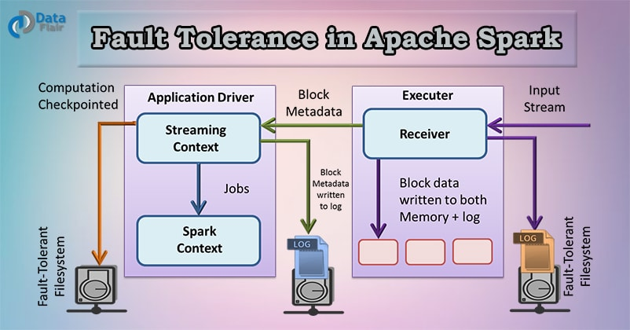
Fault tolerance in Apache Spark – Reliable Spark Streaming
Failure also occurs in worker as well as driver nodes:

- Failure of worker node – The node which runs the application code on the Spark cluster is Spark worker node. These are the slave nodes. Any of the worker nodes running executor can fail, thus resulting in loss of in-memory, if any receivers were running on failed nodes, then their buffer data will be lost.
- Failure of driver node – If there is a failure of the driver node that is running the Spark Streaming application, then SparkContent losses and all executors lose their in-memory data.

4. Fault Tolerance with Receiver-based sources

For input sources based on receivers, the fault tolerance depends on both- the failure scenario and the type of receiver. There are two types of receivers:
- Reliable receiver – Once we ensure that the received data replicates, the reliable sources are acknowledged. If the receiver fails, the source will not receive acknowledgment for the buffered data. So, the next time restarts the receiver, the source will resend the data. Hence, no data will lose due to failure.
- Unreliable Receiver – Due to the worker or driver failure, the data can loss since the receiver does not send an acknowledgment. In this case, data received but not replicated can be lost.

6. High Availability

We can say any system is highly available if its downtime is tolerable. This time depends on how critical the application is. Zero down time is an imaginary term for any system. Consider any machine has an uptime of 97.7%, so its probability to go down will be 0.023. If we have similar two machines, then the probability of both of them going down will be (0.023*0.023). In most high availability environment, we have three machines in use, in that case, the probability of going down would be (0.023*0.023*0.023) i.e., 0.000012167, which guarantees an uptime of system to be 99.9987833% which is highly acceptable uptime guarantee.

Directed Acyclic Graph DAG in Apache Spark

(Directed Acyclic Graph) DAG in Apache Spark is a set of Vertices and Edges, where vertices represent the RDDs and the edges represent the operation to be applied on RDD. In Spark DAG, every edge directs from earlier to later in the sequence. On calling of an Action, the created DAG submits to DAG Scheduler which further splits the graph into the stages of the task.

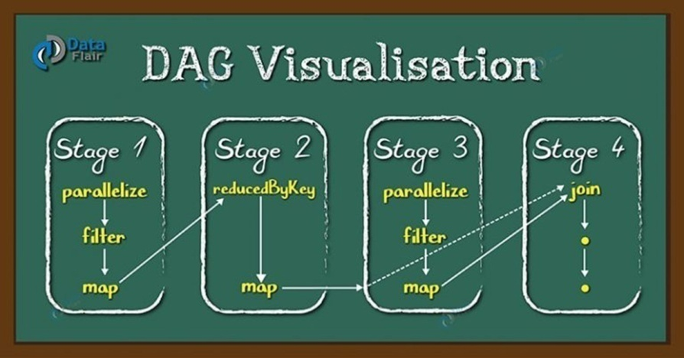
Directed Acyclic Graph DAG in Apache Spark

DAG a finite direct graph with no directed cycles. There are finitely many vertices and edges, where each edge directed from one vertex to another. It contains a sequence of vertices such that every edge is directed from earlier to later in the sequence. It is a strict generalization of MapReduce model. DAG operations can do better global optimization than other systems like MapReduce.

Apache Spark DAG allows the user to dive into the stage and expand on detail on any stage. In the stage view, the details of all RDDs belonging to that stage are expanded. The Scheduler splits the Spark RDD into stages based on various transformation applied. Each stage is comprised of tasks, based on the partitions of the RDD, which will perform same computation in parallel.

3. Need of Directed Acyclic Graph in Spark

The limitations of Hadoop MapReduce became a key point to introduce DAG in Spark. The computation through MapReduce in three steps:
- The data is read from HDFS.
- Then apply Map and Reduce operations.
- The computed result is written back to HDFS.

Each MapReduce operation is independent of each other and HADOOP has no idea of which Map reduce would come next. Sometimes for some iteration, it is irrelevant to read and write back the immediate result between two map-reduce jobs. In such case, the memory in stable storage (HDFS) or disk memory gets wasted. In multiple-step, till the completion of the previous job, all the jobs block from the beginning. As a result, complex computation can require a long time with small data volume.
While in Spark, a DAG (Directed Acyclic Graph) of consecutive computation stages is formed. In this way, we optimize the execution plan, e.g., to minimize shuffling data around. In contrast, it is done manually in MapReduce by tuning each MapReduce step.

4. How DAG works in Spark?

- The interpreter is the first layer, using a Scala interpreter, Spark interprets the code with some modifications.
- Spark creates an operator graph when we enter our code in Spark console.
- When we call an Action on Spark RDD at a high level, Spark submits the operator graph to the DAG Scheduler.
- Divide the operators into stages of the task in the DAG Scheduler. A stage contains task based on the partition of the input data. The DAG scheduler pipelines operators together. For example, map operators schedule in a single stage.
- The stages pass on to the Task Scheduler. It launches task through cluster manager. The dependencies of stages are unknown to the task scheduler.
- The Workers execute the task on the slave.

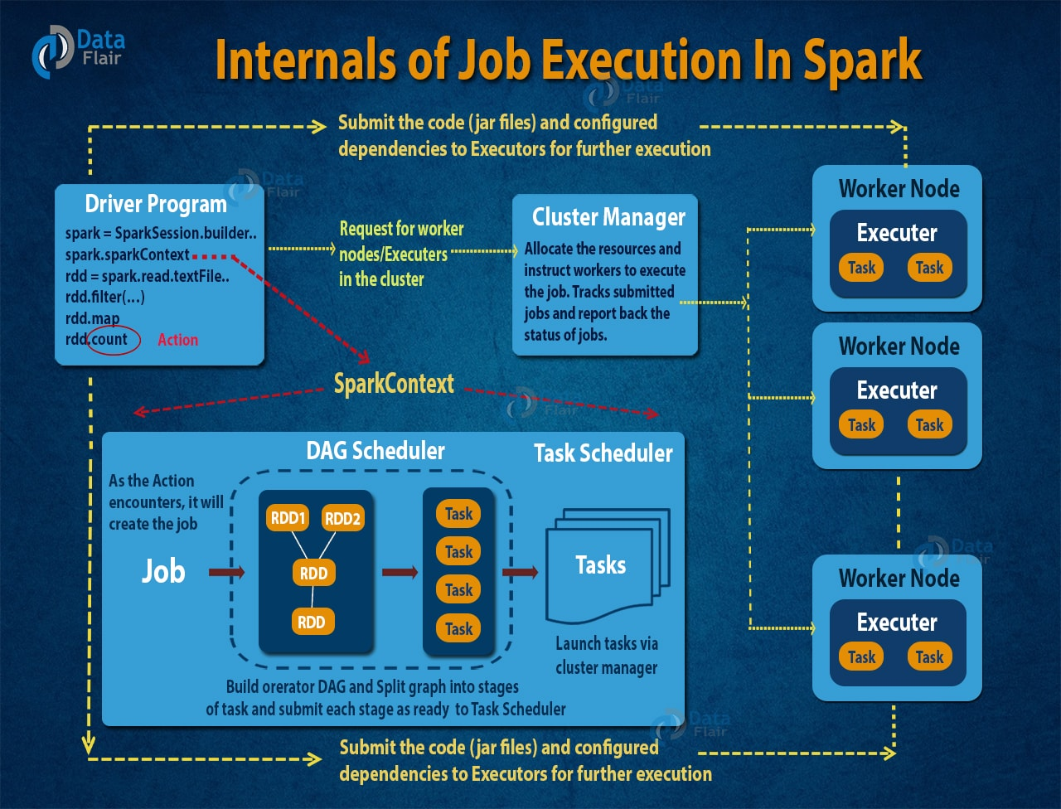
An Introduction to Job execution flow in Apache Spark
At higher level, we can apply two type of RDD transformations: narrow transformation (e.g. map(), filter() etc.) and wide transformation (e.g. reduceByKey()). Narrow transformation does not require the shuffling of data across a partition, it will group into single stage while in wide transformation the data shuffles. Hence, Wide transformation results in stage boundaries.
Each RDD maintains a pointer to one or more parent along with metadata about what type of relationship it has with the parent.

5. How to Achieve Fault Tolerance through DAG?

RDD splits into the partition and each node operates on a partition at any point in time. Here, the series of Scala function executes on a partition of the RDD. These operations compose together and Spark execution engine view these as DAG (Directed Acyclic Graph).
When any node crashes in the middle of any operation say O3 which depends on operation O2, which in turn O1. So, when the cluster manager comes to know that specific node is dead then it assigns another node to start processing. Because of the DAG, new worker node knows the tasks that it has to work on but it has to perform all the transformation from the start (O1->O2->O3). If the node fails all the stuffs that we had in memory also goes away. DAG helps spark to be fault-tolerant because it can recover from node failures.

6. Working of DAG Optimizer in Spark

DAG Optimizer optimizes the flow in Spark by rearranging and combining operators wherever possible. For example, if we submit a spark job which has a map() operation followed by a filter operation. The DAG Optimizer will rearrange the order of these operators since filtering will reduce the number of records to undergo map operation.

7. Advantages of DAG in Spark

There are multiple advantages of Spark DAG, let’s discuss them one by one:
- The lost RDD can recover using the DAG which helps to achieve fault tolerance.
- Map Reduce has just two queries the map, and reduce but in DAG we have multiple levels. So, to execute SQL query, DAG is more flexible.
- It can do a better global optimization than a system like Hadoop MapReduce.

Apache Spark Cluster Managers – YARN & Standalone

Introduction to Apache Spark Cluster Managers

Apache Spark is an engine for Big Data processing. One can run Spark on distributed mode on the cluster. In the cluster, there is a master and n number of workers. It schedules and divides resource in the host machine which forms the cluster.
The prime work of the cluster manager is to divide resources across the applications. It works as an external service for acquiring resources on the cluster.
The cluster manager dispatches work for the cluster. Spark supports pluggable cluster management. The cluster manager in Spark handles starting executor processes.

Apache Spark system supports three types of cluster managers namely-

a) Standalone Cluster Manager
b) Hadoop YARN
c) Apache Mesos

Apache Spark Standalone Cluster Manager

Spark’s standalone cluster manager is a lightweight platform built specifically for Apache Spark workloads. Using it, we can run multiple Spark Applications on the same cluster. It also provides simple interfaces for doing so but can scale to large Spark workloads. The main disadvantage of the standalone mode is that it’s more limited than the other cluster managers—in particular, our cluster can only run Spark.

How does Spark Standalone Cluster Works?

It has masters and number of workers with configured amount of memory and CPU cores. In Spark standalone cluster mode, Spark allocates resources based on the core. By default, an application will grab all the cores in the cluster.

To check the status of the application, each Spark application has a Web User Interface. The Web UI provides information of executors, storage usage, running task in the application. In this cluster manager, we have Web UI to view cluster and job statistics. It also has detailed log output for each job. If an application has logged event for its lifetime, Spark Web UI will reconstruct the application’s UI after the application exits.

Hadoop YARN

Hadoop YARN is a framework for job scheduling and cluster resource management. We can run our Spark jobs on Hadoop YARN by specifying the master as YARN in the spark-submit command-line arguments. Just like with standalone mode, there are a number of knobs that we are able to tune according to what we would like the cluster to do. The number of knobs is naturally larger than that of Spark’s standalone mode because Hadoop YARN is a generic scheduler for a large number of different execution frameworks.

YARN bifurcate the functionality of resource manager and job scheduling into different daemons. The plan is to get a Global Resource Manager (RM) and per-application Application Master (AM). An application is either a DAG of graph or an individual job.

How do Hadoop YARN works?

YARN data computation framework is a combination of the ResourceManager and NodeManager.
The Yarn ResourceManager manages resources among all the applications in the system. The Resource Manager has Scheduler and Application Manager. The Scheduler allocates resource to the various running application. It is pure Scheduler, performs no monitoring or tracking of status for the application. The Application Manager manages applications across all the nodes.

Yarn NodeManager contains Application Master and container. A container is a place where a unit of work happens. Each task runs in one container. The per-application Application Master is a framework specific library. It aims to negotiate resources from the Resource Manager. It continues with Node Manager(s) to execute and watch the tasks. The application or job requires one or more containers. Node Manager handles monitoring containers, resource usage (CPU, memory, disk, and network). It reports this to the Resource Manager.

There are two deploy modes that can be used to launch Spark applications on YARN. In cluster mode, the Spark driver runs inside an application master process which is managed by YARN on the cluster, and the client can go away after initiating the application. In client mode, the driver runs in the client process, and the application master is only used for requesting resources from YARN.

YARN provides security for authentication, service level authorization. It also provides authentication for Web consoles and data confidentiality. Hadoop authentication uses Kerberos to verify that each user and service has authentication.

Spark Standalone mode vs YARN

i. High Availability

The standalone cluster: with ZooKeeper Quorum, it supports an automatic recovery of the master. One can achieve manual recovery using the file system. The cluster tolerates the worker failure despite the recovery of the Master is enabled or not.

Apache Hadoop YARN: using a command line utility it supports manual recovery. And use Zookeeper-based ActiveStandbyElector embedded in the ResourceManager for automatic recovery. Thus, there is no need to run a separate ZooKeeper Failover Controller.

ii. Security

Spark supports authentication via a shared secret with all the cluster managers. The standalone manager requires the user to configure each of the nodes with the shared secret. Data can be encrypted using SSL for the communication protocols. SASL encryption is supported for block transfers of data. Other options are also available for encrypting data. Access to Spark applications in the Web UI can be controlled via access control lists.

Hadoop YARN: It contains security for authentication, service level authorization, authentication for Web consoles and data confidentiality. Using Service level authorization, it ensures that client using Hadoop services has authority. Using access control lists, Hadoop services can be controlled. Additionally, using SSL data and communication between clients and services is encrypted. The data transferred between the Web console and clients with HTTPS.

iii. Monitoring

Spark’s standalone cluster manager: To view cluster and job statistics it has a Web UI. It also has detailed log output for each job.

Hadoop YARN has a Web UI for the ResourceManager and the NodeManager. The ResourceManager UI provides metrics for the cluster. And the NodeManager provides information for each node, the applications and containers running on the node.

CHAPTER 3: Apache Spark’s Structured APIs

The DataFrame API

Spark DataFrames are like distributed in-memory tables with named columns and schemas, where each column has a specific data type: integer, string, array, map, real, date, timestamp, etc.

Schemas and Creating DataFrames
A schema in Spark defines the column names and associated data types for a DataFrame. Defining a schema up front as opposed to taking a schema-on-read approach offers three benefits:
- We relieve Spark from the onus of inferring data types.
- We prevent Spark from creating a separate job just to read a large portion of our file to ascertain the schema, which for a large data file can be expensive and time-consuming.
- We can detect errors early if data doesn’t match the schema.

Two ways to define a schema

One is to define it programmatically, and the other is to employ a Data Definition Language (DDL) string, which is much simpler and easier to read.
To define a schema programmatically for a DataFrame with three named columns, author, title, and pages, we can use the Spark DataFrame API. For example:

// In Scala
import org.apache.spark.sql.types._
val schema = StructType(Array(
StructField("author", StringType, false),
StructField("title", StringType, false),
StructField("pages", IntegerType, false)))

# In Python
from pyspark.sql.types import *
schema = StructType([
StructField("author", StringType(), False),
StructField("title", StringType(), False),
StructField("pages", IntegerType(), False)])

Defining the same schema using DDL is much simpler:

// In Scala
val schema = "author STRING, title STRING, pages INT"

Columns and Expressions

Named columns in DataFrames are conceptually similar to named columns in pandas or R DataFrames or in an RDBMS table: they describe a type of field. We can list all the columns by their names, and we can perform operations on their values using relational or computational expressions. In Spark’s supported languages, columns are objects with public methods (represented by the Column type).
We can also use logical or mathematical expressions on columns. For example, we could create a simple expression using expr("columnName * 5") or (expr("columnName - 5") > col(anothercolumnName)), where columnName is a Spark type (integer, string, etc.).
Column is the name of the object, while col() is a standard built-in function that returns a Column. Column objects in a DataFrame can’t exist in isolation; each column is part of a row in a record and all the rows together constitute a DataFrame.

Rows
A row in Spark is a generic Row object, containing one or more columns. It is an object in Spark and an ordered collection of fields, we can instantiate a Row in each of Spark’s supported languages and access its fields by an index starting at 0:

// In Scala
import org.apache.spark.sql.Row
// Create a Row
val blogRow = Row(6, "Reynold", "Xin", "https://tinyurl.6", 255568, "3/2/2015", Array("twitter", "LinkedIn"))

// Access using index for individual items
blogRow(1)
res62: Any = Reynold

Row objects can be used to create DataFrames if we need them for quick interactivity and exploration:

# In Scala
val rows = Seq(("Matei Zaharia", "CA"), ("Reynold Xin", "CA"))
val authorsDF = spark.createDataFrame(rows)
authorsDF.show()

The Dataset API

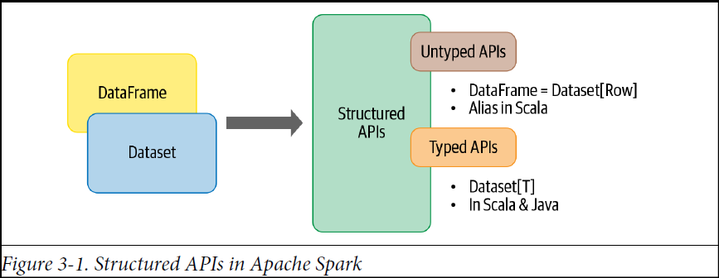

DataFrame in Scala can be thought as an alias for a collection of generic untyped JVM object that may hold different types of fields (Dataset[Row]).

Dataset is a strongly typed collection of domain-specific objects that can be transformed in parallel using functional or relational operations.

Typed Objects, Untyped Objects, and Generic Rows

In Scala, a DataFrame is just an alias for untyped Dataset[Row].

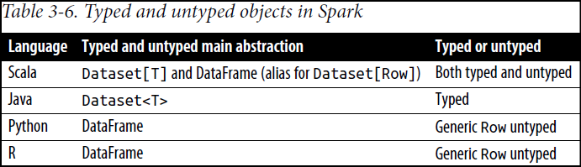

Row is a generic object type in Spark, holding a collection of mixed types that can be accessed using an index. Internally, Spark manipulates Row objects, converting them to the equivalent types. For example, an Int as one of our fields in a Row will be mapped or converted to IntegerType or IntegerType() respectively for Scala or Java and Python.

// In Scala
import org.apache.spark.sql.Row
val row = Row(350, true, "Learning Spark 2E", null)

By contrast, typed objects are actual Java or Scala class objects in the JVM. Each element in a Dataset maps to a JVM object.

Creating Datasets

When creating a Dataset we have to know the schema. The easiest way to specify the schema for the resulting Dataset is to use a case class.

Scala: Case classes

When we wish to instantiate our own domain-specific object as a Dataset, we can do so by defining a case class in Scala. As an example, let’s look at a collection of readings from Internet of Things (IoT) devices in a JSON file:

To express each JSON entry as DeviceIoTData, a domain-specific object, we can define a Scala case class:

case class DeviceIoTData (battery_level: Long, c02_level: Long,
cca2: String, cca3: String, cn: String, device_id: Long,
device_name: String, humidity: Long, ip: String, latitude: Double,
lcd: String, longitude: Double, scale:String, temp: Long,
timestamp: Long)

Once defined, we can use it to read our file and convert the returned Dataset[Row] into Dataset[DeviceIoTData]:

// In Scala
val ds = spark.read
.json("/databricks-datasets/learning-spark-v2/iot-devices/iot_devices.json")
.as[DeviceIoTData]

Dataset Operations
Just as we can perform transformations and actions on DataFrames, so we can with Datasets. Depending on the kind of operation, the results will vary:

// In Scala
val filterTempDS = ds.filter(d => {d.temp > 30 && d.humidity > 70})
filterTempDS.show(5, false)

Another thing to note is that with DataFrames, we express our filter() conditions as SQL-like DSL operations, which are language-agnostic. With Datasets, we use language-native expressions as Scala or Java code. Here’s another example that results in another, smaller Dataset:

// In Scala
case class DeviceTempByCountry(temp: Long, device_name: String, device_id: Long, cca3: String)

val dsTemp = ds
.filter(d => {d.temp > 25})
.map(d => (d.temp, d.device_name, d.device_id, d.cca3))
.toDF("temp", "device_name", "device_id", "cca3")
.as[DeviceTempByCountry]

dsTemp.show(5, false)

To recap, the operations we can perform on Datasets—filter(), map(), groupBy(), select(), take(), etc. are similar to the ones on DataFrames. In a way, Datasets are similar to RDDs in that they provide a similar interface to its aforementioned methods and compile-time safety but with a much easier to read and an object-oriented programming interface.
When we use Datasets, the underlying Spark SQL engine handles the creation, conversion, serialization, and deserialization of the JVM objects. It also takes care of off-Java heap memory management with the help of Dataset encoders.

DataFrames Versus Datasets

There are some situations where one is preferable to the other. Here are a few examples:

- If we want to tell Spark what to do, not how to do it, use DataFrames or Datasets.
- If we want rich semantics, high-level abstractions, and DSL operators, use DataFrames or Datasets.
- If we want strict compile-time type safety and don’t mind creating multiple case classes for a specific Dataset[T], use Datasets.
- If our processing demands high-level expressions, filters, maps, aggregations, computing averages or sums, SQL queries, columnar access, or use of relational operators on semi-structured data, use DataFrames or Datasets.
- If our processing dictates relational transformations similar to SQL-like queries, use DataFrames.
- If we want to take advantage of and benefit from Tungsten’s efficient serialization with Encoders, use Datasets.
- If we want unification, code optimization, and simplification of APIs across Spark components, use DataFrames.
- If we are an R user, use DataFrames.
- If we are a Python user, use DataFrames and drop down to RDDs if we need more control.
- If we want space and speed efficiency, use DataFrames.
- If we want errors caught during compilation rather than at runtime, choose the appropriate API as depicted in Figure:

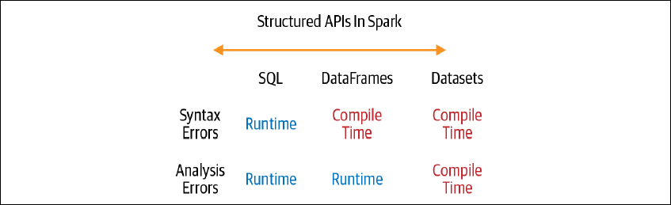

When to Use RDDs

There are some scenarios where we’ll want to consider using RDDs, such as when we:

- Are using a third-party package that’s written using RDDs
- Can forgo the code optimization, efficient space utilization, and performance benefits available with DataFrames and Datasets
- Want to precisely instruct Spark how to do a query

DataFrames and Datasets are built on top of RDDs, and they get decomposed to compact RDD code during wholestage code generation.

Structured APIs in Spark enable developers to tell Spark what to do, not how to do it, using high-level operations, and it ascertains the most efficient way to build a query and generates compact code for we. This process of building efficient queries and generating compact code is the job of the Spark SQL engine. It’s the substrate (underlying layer) upon which the Structured APIs we’ve been looking at are built.

Spark SQL and the Underlying Engine

Apart from allowing us to issue SQL-like queries on our data, the Spark SQL engine:
- Unifies Spark components and permits abstraction to DataFrames/Datasets in Java, Scala, Python, and R, which simplifies working with structured data sets.
- Connects to the Apache Hive metastore and tables.
- Reads and writes structured data with a specific schema from structured file formats (JSON, CSV, Text, Avro, Parquet, ORC, etc.) and converts data into temporary tables.
- Offers an interactive Spark SQL shell for quick data exploration.
- Provides a bridge to (and from) external tools via standard database JDBC/ODBC connectors.
- Generates optimized query plans and compact code for the JVM, for final execution.
- Below figure shows the components that Spark SQL interacts with to achieve all of this.

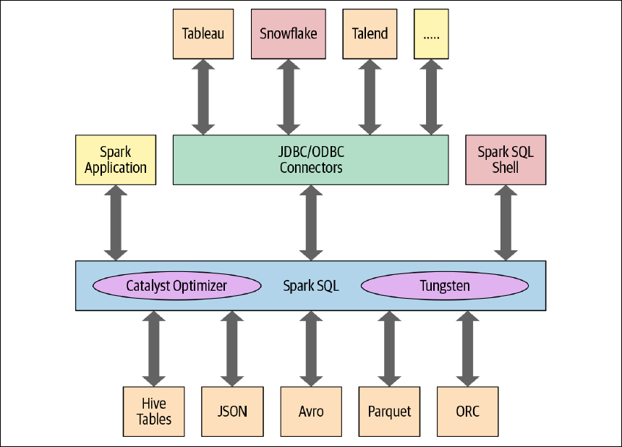

At the core of the Spark SQL engine are the Catalyst optimizer and Project Tungsten. Together, these support the high-level DataFrame and Dataset APIs and SQL queries.

The Catalyst Optimizer

The Catalyst optimizer takes a computational query and converts it into an execution plan. It goes through four transformational phases, as shown in Figure 3-4:

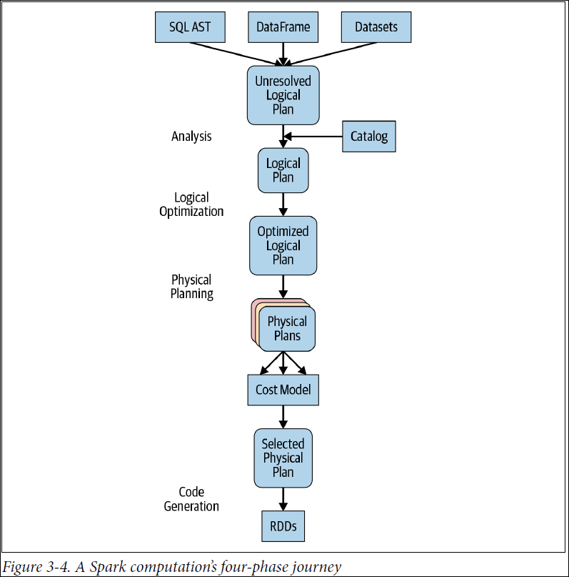

For example, consider one of the queries
# In Python
count_mnm_df = (mnm_df
.select("State", "Color", "Count")
.groupBy("State", "Color")
.agg(count("Count")
.alias("Total"))
.orderBy("Total", ascending=False))

-- In SQL
SELECT State, Color, Count, sum(Count) AS Total
FROM MNM_TABLE_NAME
GROUP BY State, Color, Count
ORDER BY Total DESC

To see the different stages the Python code goes through, we can use the count_mnm_df.explain(True) method on the DataFrame. Or, to get a look at the different logical and physical plans, in Scala we can call df.queryExecution.logical or df.queryExecution.optimizedPlan.

Let’s consider another DataFrame computation example.
// In Scala
// Users DataFrame read from a Parquet table
val usersDF = ...
// Events DataFrame read from a Parquet table
val eventsDF = ...
// Join two DataFrames
val joinedDF = users
.join(events, users("id") === events("uid"))
.filter(events("date") > "2015-01-01")

After going through an initial analysis phase, the query plan is transformed and rearranged by the Catalyst optimizer as shown in Figure:

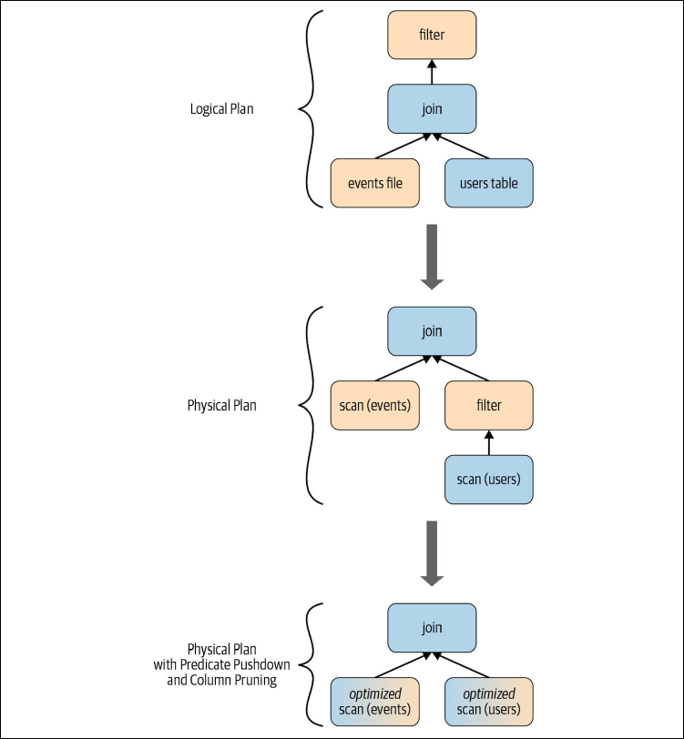

Let’s go through each of the four query optimization phases.

Phase 1: Analysis

The Spark SQL engine begins by generating an abstract syntax tree (AST) for the SQL or DataFrame query. In this initial phase, any columns or table names will be resolved by consulting an internal Catalog, a programmatic interface to Spark SQL that holds a list of names of columns, data types, functions, tables, databases, etc. Once they’ve all been successfully resolved, the query proceeds to the next phase.

Phase 2: Logical optimization

As Figure 3-4 shows, this phase comprises two internal stages. Applying a standard rule based optimization approach, the Catalyst optimizer will first construct a set of multiple plans and then, using its cost-based optimizer (CBO), assign costs to each plan. These plans are laid out as operator trees (like in Figure 3-5); they may include, for example, the process of constant folding, predicate pushdown, projection pruning, Boolean expression simplification, etc. This logical plan is the input into the physical plan.

Phase 3: Physical planning

In this phase, Spark SQL generates an optimal physical plan for the selected logical plan, using physical operators that match those available in the Spark execution engine.
Phase 4: Code generation

The final phase of query optimization involves generating efficient Java bytecode to run on each machine. Because Spark SQL can operate on data sets loaded in memory, Spark can use state-of-the-art compiler technology for code generation to speed up execution. In other words, it acts as a compiler. Project Tungsten, which facilitates whole-stage code generation, plays a role here.
Whole-stage code generation is a physical query optimization phase that collapses the whole query into a single function, getting rid of virtual function calls and employing CPU registers for intermediate data. The second-generation Tungsten engine, introduced in Spark 2.0, uses this approach to generate compact RDD code for final execution. This streamlined strategy significantly improves CPU efficiency and performance.

Cost-based optimization framework that collects and leverages a variety of per-column data statistics (e.g., cardinality, number of distinct values, NULL values, max/min, average/max length, etc.) to improve the quality of query execution plans. Leveraging these statistics helps Spark to make better decisions in picking the most optimal query plan. Examples of these optimizations include selecting the correct build side in a hash-join, choosing the right join type (broadcast hash-join vs. shuffled hash-join) or adjusting a multi-way join order, among others.

At its core, Spark’s Catalyst optimizer is a general library for representing query plans as trees and sequentially applying a number of optimization rules to manipulate them. A majority of these optimization rules are based on heuristics, i.e., they only account for a query’s structure and ignore the properties of the data being processed, which severely limits their applicability.

Consider a query shown below that filters a table t1 of size 500GB and joins the output with another table t2 of size 20GB. Spark implements this query using a hash join by choosing the smaller join relation as the build side (to build a hash table) and the larger relation as the probe side (The rationale here is that the smaller relation is more likely to fit in memory) .
Given that t2 is smaller than t1, Apache Spark 2.1 would choose the right side as the build side without factoring in the effect of the filter operator (which in this case filters out the majority of t1’s records). Choosing the incorrect side as the build side often forces the system to give up on a fast hash join and turn to sort-merge join due to memory constraints.

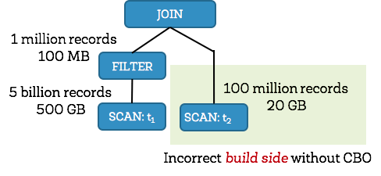

Apache Spark 2.2, on the other hand, collects statistics for each operator and figures out that the left side would be only 100MB (1 million records) after filtering, and the right side would be 20GB (100 million records). With the correct size/cardinality information for both sides, Spark 2.2 would choose the left side as the build side resulting in significant query speedups.

CHAPTER 4: Spark SQL and DataFrames: Introduction to Built-in Data Sources

In particular, Spark SQL:

- Provides the engine upon which the high-level Structured APIs are built.
- Can read and write data in a variety of structured formats (e.g., JSON, Hivetables, Parquet, Avro, ORC, CSV).
- Let’s us query data using JDBC/ODBC connectors from external (BI) data sources such as Tableau, Power BI, Talend, or from RDBMSs such as MySQL and PostgreSQL.
- Provides a programmatic interface to interact with structured data stored as tables or views in a database from a Spark application
- Offers an interactive shell to issue SQL queries on our structured data and HiveQL.

SQL Tables and Views

Instead of having a separate metastore for Spark tables, Spark by default uses the Apache Hive metastore, located at /user/hive/warehouse, to persist all the metadata about our tables. However, this default location can be changed by setting the Spark config variable spark.sql.warehouse.dir to another location, which can be set to a local or external distributed storage.

Creating SQL Databases and Tables
Spark creates tables under the default database. To create our own database name, we can issue a SQL command from our Spark application, for example for creating a database called learn_spark_db and tell Spark we want to use that database:

// In Scala/Python
spark.sql("CREATE DATABASE learn_spark_db")
spark.sql("USE learn_spark_db")

From this point, any commands we issue in our application to create tables will result in the tables being created in this database and residing under the database name learn_spark_db.

Creating a managed table

// In Scala/Python
spark.sql("CREATE TABLE managed_us_delay_flights_tbl (date STRING, delay INT,
distance INT, origin STRING, destination STRING)")

We can do the same thing using the DataFrame API like this:

# In Python
# Path to our US flight delays CSV file
csv_file = "/databricks-datasets/learning-spark-v2/flights/departuredelays.csv"

# Schema as defined in the preceding example
schema="date STRING, delay INT, distance INT, origin STRING, destination STRING"
flights_df = spark.read.csv(csv_file, schema=schema)
flights_df.write.saveAsTable("managed_us_delay_flights_tbl")

Both of these statements will create the managed table us_delay_flights_tbl in the learn_spark_db database.

Creating an unmanaged table

To create an unmanaged table from a data source such as a CSV file, in SQL use:

spark.sql("""CREATE TABLE us_delay_flights_tbl (date STRING, delay INT,
distance INT, origin STRING, destination STRING)
USING csv OPTIONS (PATH
‘/databricks-datasets/learning-spark-v2/flights/departuredelays.csv’)""")

And within the DataFrame API use:

(flights_df
.write
.option("path", "/tmp/data/us_flights_delay")
.saveAsTable("us_delay_flights_tbl"))

Create a partitioned table

These examples partition data that we write. Spark SQL discovers the partitions and registers them in the Hive metastore.

// Create managed table as select
dataframe.write.mode(SaveMode.Overwrite).partitionBy("id").saveAsTable("<example-table>")

// Create unmanaged/external table as select
dataframe.write.mode(SaveMode.Overwrite).option("path", "<file-path>").saveAsTable("<example-table>")

To find the difference between df1 & df2 DataFrames:

df1.unionAll(df2).except(df1.intersect(df2)).show()

Creating Views

Views can be global (visible across all SparkSessions on a given cluster) or session-scoped visible
only to a single SparkSession), and they are temporary: they disappear after our Spark application terminates.
For example, creating a temp and global temp view for the subset of the US flight delays data set with origin airports of New York (JFK) and San Francisco (SFO):

-- In SQL
CREATE OR REPLACE GLOBAL TEMP VIEW us_origin_airport_SFO_global_tmp_view AS
SELECT date, delay, origin, destination from us_delay_flights_tbl WHERE
origin = ‘SFO’;

CREATE OR REPLACE TEMP VIEW us_origin_airport_JFK_tmp_view AS
SELECT date, delay, origin, destination from us_delay_flights_tbl WHERE
origin = ‘JFK’;

Same thing with the DataFrame API as follows:

# In Python
df_sfo = spark.sql("SELECT date, delay, origin, destination FROM us_delay_flights_tbl WHERE origin = ‘SFO’")
df_jfk = spark.sql("SELECT date, delay, origin, destination FROM us_delay_flights_tbl WHERE origin = ‘JFK’")

# Create a temporary and global temporary view
df_sfo.createOrReplaceGlobalTempView("us_origin_airport_SFO_global_tmp_view")
df_jfk.createOrReplaceTempView("us_origin_airport_JFK_tmp_view")

Keep in mind that when accessing a global temporary view we must use the prefix global_temp.<view_name>, because Spark creates global temporary views in a global temporary database called global_temp. For example:

-- In SQL
SELECT * FROM global_temp.us_origin_airport_SFO_global_tmp_view

By contrast, we can access the normal temporary view without the global_temp prefix:

-- In SQL
SELECT * FROM us_origin_airport_JFK_tmp_view
// In Scala/Python
spark.read.table("us_origin_airport_JFK_tmp_view")
// Or
spark.sql("SELECT * FROM us_origin_airport_JFK_tmp_view")

We can also drop a view just like we would a table:

-- In SQL
DROP VIEW IF EXISTS us_origin_airport_SFO_global_tmp_view;
DROP VIEW IF EXISTS us_origin_airport_JFK_tmp_view

// In Scala/Python
spark.catalog.dropGlobalTempView("us_origin_airport_SFO_global_tmp_view")
spark.catalog.dropTempView("us_origin_airport_JFK_tmp_view")

Temporary views versus global temporary views

A temporary view is tied to a single SparkSession within a Spark application. In contrast, a global temporary view is visible across multiple SparkSessions within a Spark application. We can create multiple SparkSessions within a single Spark application—this can be handy, for example, in cases where we want to access (and combine) data from two different SparkSessions that don’t share the same Hive metastore configurations.

Viewing the Metadata
Spark manages the metadata associated with each managed or unmanaged table. This is captured in the Catalog, a high-level abstraction in Spark SQL for storing metadata. For example, within a Spark application, after creating the SparkSession variable (“spark”), we can access all the stored metadata through methods like these:

// In Scala/Python
spark.catalog.listDatabases()
spark.catalog.listTables()
spark.catalog.listColumns("us_delay_flights_tbl")

Caching SQL Tables

-- In SQL
CACHE [LAZY] TABLE <table-name>
UNCACHE TABLE <table-name>

LAZY, meaning that it should only be cached when it is first used instead of immediately.

Reading Tables into DataFrames
// In Scala
val usFlightsDF = spark.sql("SELECT * FROM us_delay_flights_tbl")
val usFlightsDF2 = spark.table("us_delay_flights_tbl")

Data Sources for DataFrames and SQL Tables

DataFrameReader
DataFrameReader is the core construct for reading data from a data source into a DataFrame. It has a defined format and a recommended pattern for usage:

DataFrameReader.format(args).option("key", "value").schema(args).load()

Note that we can only access a DataFrameReader through a SparkSession instance. To get an instance handle to it, use:

SparkSession.read
// or
SparkSession.readStream

Arguments to each of the public methods to DataFrameReader take different values. Below table enumerates these, with a subset of the supported arguments.

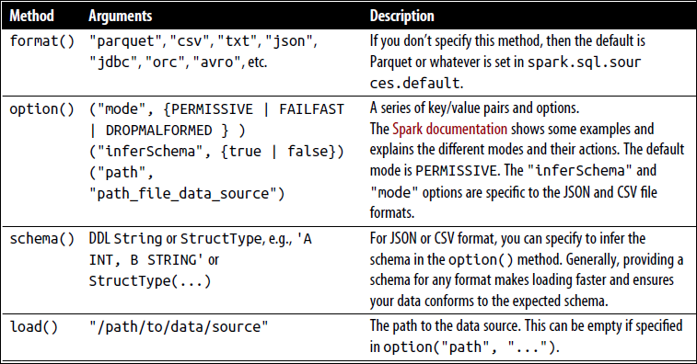

DataFrameWriter
DataFrameWriter does the reverse of its counterpart: it saves or writes data to a specified built-in data source. Unlike with DataFrameReader, we access its instance not from a SparkSession but from the DataFrame we wish to save. It has a few recommended usage patterns:

DataFrameWriter.format(args)
.option(args)
.bucketBy(args)
.partitionBy(args)
.save(path)

DataFrameWriter.format(args).option(args).sortBy(args).saveAsTable(table)

To get an instance handle, use:

DataFrame.write
// or
DataFrame.writeStream

Arguments to each of the methods to DataFrameWriter also take different values. We list these in below Table with a subset of the supported arguments.

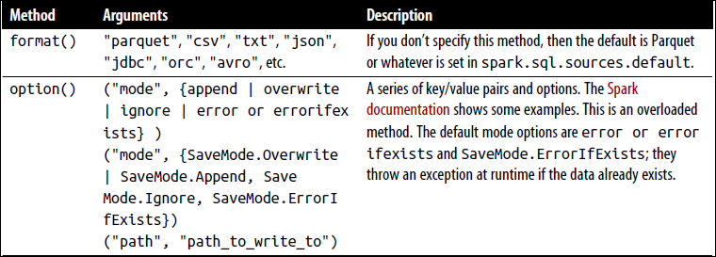
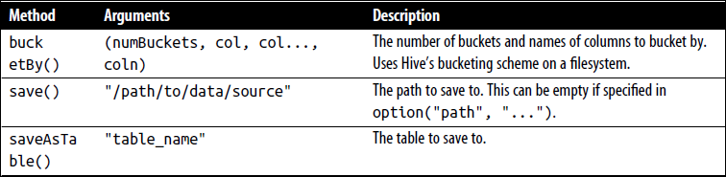

Example:

// In Scala
// Use JSON
val location = ...
df.write.format("json").mode("overwrite").save(location)

Parquet
Parquet is the default data source in Spark. It is an open source columnar file format that offers many I/O optimizations (such as compression, which saves storage space and allows for quick access to data columns).

Reading Parquet files into a DataFrame
Parquet files are stored in a directory structure that contains the data files, metadata, a number of compressed files, and some status files. Metadata in the footer contains the version of the file format, the schema, and column data such as the path, etc.
// In Scala
val file = """/databricks-datasets/learning-spark-v2/flights/summary-data/parquet/2010-summary.parquet/"""
val df = spark.read.format("parquet").load(file)

Unless we are reading from a streaming data source there’s no need to supply the schema, because Parquet saves it as part of its metadata.

Reading Parquet files into a Spark SQL table
-- In SQL
CREATE OR REPLACE TEMPORARY VIEW us_delay_flights_tbl
USING parquet
OPTIONS (
path "/databricks-datasets/learning-spark-v2/flights/summary-data/parquet/2010-summary.parquet/" )

Once we’ve created the table or view, we can read data into a DataFrame using SQL, as we saw in some earlier examples:
// In Scala
spark.sql("SELECT * FROM us_delay_flights_tbl").show()

Writing DataFrames to Parquet files
// In Scala
df.write.format("parquet")
.mode("overwrite")
.option("compression", "snappy")
.save("/tmp/data/parquet/df_parquet")

This will create a set of compact and compressed Parquet files at the specified path.

-rw-r--r-- 1 jules wheel 0 May 19 10:58 _SUCCESS
-rw-r--r-- 1 jules wheel 966 May 19 10:58 part-00000-<...>-c000.snappy.parquet

Writing DataFrames to Spark SQL tables
// In Scala
df.write
.mode("overwrite")
.saveAsTable("us_delay_flights_tbl")

JSON

JSON has two representational formats: single-line mode and multiline mode. Both modes are supported in Spark. In single-line mode each line denotes a single JSON object, whereas in multiline mode, the entire multiline object constitutes a single JSON object. To read in this mode, set multiLine to true in the option() method.

Reading a JSON file into a DataFrame
// In Scala
val file = "/databricks-datasets/learning-spark-v2/flights/summary-data/json/*"
val df = spark.read.format("json").load(file)

Reading a JSON file into a Spark SQL table
-- In SQL
CREATE OR REPLACE TEMPORARY VIEW us_delay_flights_tbl
USING json
OPTIONS (path "/databricks-datasets/learning-spark-v2/flights/summary-data/json/*")

Once the table is created, we can read data into a DataFrame using SQL:
// In Scala/Python
spark.sql("SELECT * FROM us_delay_flights_tbl").show()

Writing DataFrames to JSON files
// In Scala
df.write.format("json")
.mode("overwrite")
.option("compression", "snappy")
.save("/tmp/data/json/df_json")

This creates a directory at the specified path populated with a set of compact JSON files:

-rw-r--r-- 1 jules wheel 0 May 16 14:44 _SUCCESS
-rw-r--r-- 1 jules wheel 71 May 16 14:44 part-00000-<...>-c000.json

JSON data source options

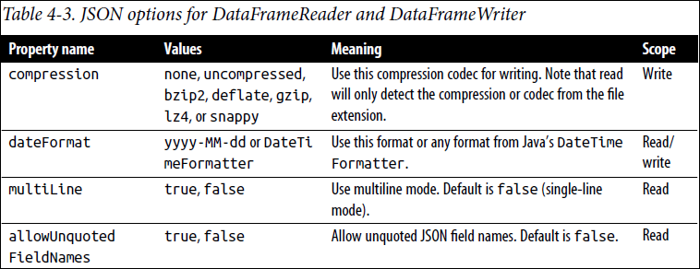

CSV
A comma is the default separator, other delimiters can be used to separate fields in cases where commas are part of our data.

Reading a CSV file into a DataFrame
// In Scala
val file = "/databricks-datasets/learning-spark-v2/flights/summary-data/csv/*"
val schema = "DEST_COUNTRY_NAME STRING, ORIGIN_COUNTRY_NAME STRING, count INT"
val df = spark.read.format("csv")
.schema(schema)
.option("header", "true")
.option("mode", "FAILFAST") // Exit if any errors & use “DROPMALFORMED” mode to discard corrupt/unwanted records.
.option("nullValue", "") // Replace any null data with quotes
.load(file)

Reading a CSV file into a Spark SQL table
-- In SQL
CREATE OR REPLACE TEMPORARY VIEW us_delay_flights_tbl
USING csv
OPTIONS (
path "/databricks-datasets/learning-spark-v2/flights/summary-data/csv/*",
header "true",
inferSchema "true",
mode "FAILFAST")

Once we’ve created the table, we can read data into a DataFrame using SQL as before:
// In Scala/Python
spark.sql("SELECT * FROM us_delay_flights_tbl").show(10)

Writing DataFrames to CSV files
// In Scala
df.write.format("csv").mode("overwrite").save("/tmp/data/csv/df_csv")

This generates a folder at the specified location, populated with a bunch of compressed and compact files:
-rw-r--r-- 1 jules wheel 0 May 16 12:17 _SUCCESS
-rw-r--r-- 1 jules wheel 36 May 16 12:17 part-00000-251690eb-<...>-c000.csv

CSV data source options
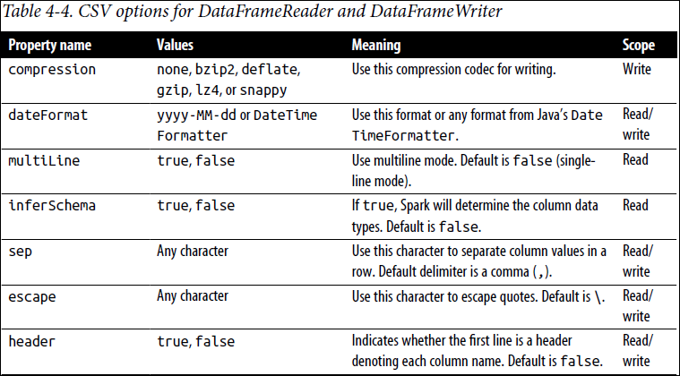

Avro
Avro format is used, for example, by Apache Kafka for message serializing and deserializing. It offers many benefits, including direct mapping to JSON, speed and efficiency, and bindings available for many programming languages.

Reading an Avro file into a DataFrame
// In Scala
val df = spark.read.format("avro")
.load("/databricks-datasets/learning-spark-v2/flights/summary-data/avro/*")

Reading an Avro file into a Spark SQL table
-- In SQL
CREATE OR REPLACE TEMPORARY VIEW episode_tbl
USING avro
OPTIONS (
path "/databricks-datasets/learning-spark-v2/flights/summary-data/avro/*")

Once we’ve created a table, we can read data into a DataFrame using SQL:
// In Scala
spark.sql("SELECT * FROM episode_tbl").show(false)

Writing DataFrames to Avro files
// In Scala
df.write
.format("avro")
.mode("overwrite")
.save("/tmp/data/avro/df_avro")

This generates a folder at the specified location, populated with a bunch of compressed and compact files:
-rw-r--r-- 1 jules wheel 0 May 17 11:54 _SUCCESS
-rw-r--r-- 1 jules wheel 526 May 17 11:54 part-00000-ffdf70f4-<...>-c000.

Avro data source options
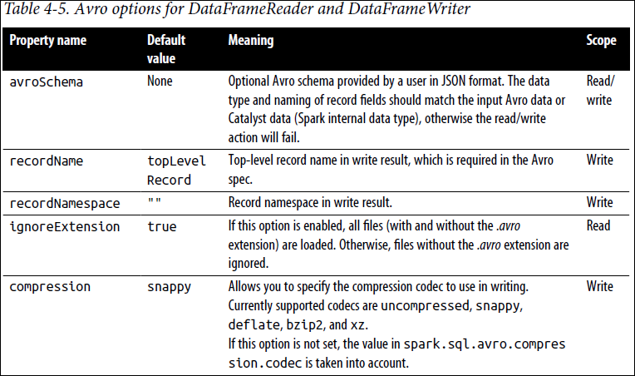

ORC
As an additional optimized columnar file format, Spark 2.x supports a vectorized ORC reader. Two Spark configurations dictate which ORC implementation to use. When spark.sql.orc.impl is set to native and spark.sql.orc.enableVectorizedReader is set to true, Spark uses the vectorized ORC reader. A vectorized reader reads blocks of rows (often 1,024 per block) instead of one row at a time, streamlining operations and reducing CPU usage for intensive operations like scans, filters, aggregations, and joins.
For Hive ORC SerDe (serialization and deserialization) tables created with the SQL command USING HIVE OPTIONS (fileFormat ‘ORC’), the vectorized reader is used when the Spark configuration parameter spark.sql.hive.convertMetastoreOrc is set to true.

Reading an ORC file into a DataFrame
// In Scala
val file = "/databricks-datasets/learning-spark-v2/flights/summary-data/orc/*"
val df = spark.read.format("orc").load(file)

Reading an ORC file into a Spark SQL table
-- In SQL
CREATE OR REPLACE TEMPORARY VIEW us_delay_flights_tbl
USING orc
OPTIONS (path "/databricks-datasets/learning-spark-v2/flights/summary-data/orc/*")

Once a table is created, we can read data into a DataFrame using SQL as usual:
// In Scala/Python
spark.sql("SELECT * FROM us_delay_flights_tbl").show()

Writing DataFrames to ORC files
// In Scala
df.write
.format("orc")
.mode("overwrite")
.option("compression", "snappy")
.save("/tmp/data/orc/df_orc")

The result will be a folder at the specified location containing some compressed ORC files:
-rw-r--r-- 1 jules wheel 0 May 16 17:23 _SUCCESS
-rw-r--r-- 1 jules wheel 547 May 16 17:23 part-00000-<...>-c000.snappy.orc

CHAPTER 5: Spark SQL and DataFrames: Interacting with External Data Sources

Spark SQL and Apache Hive

Spark SQL is a foundational component of Apache Spark that integrates relational processing with Spark’s functional programming API.
Spark SQL lets Spark programmers leverage the benefits of faster performance and relational programming (e.g., declarative queries and optimized storage), as well as call complex analytics libraries (e.g., ML).

User-Defined Functions
The flexibility of Spark allows data engineers and data scientists to define their own functions too. These are known as user-defined functions (UDFs).

Spark SQL UDFs
The benefit of creating our own PySpark or Scala UDFs is that we (and others) will be able to make use of them within Spark SQL itself.
Here’s a simplified example of creating a Spark SQL UDF. Note that UDFs operate per session and they will not be persisted in the underlying metastore:

// In Scala
// Create cubed function
val cubed = (s: Long) => {s * s * s}

// Register UDF
spark.udf.register("cubed", cubed)

// Create temporary view
spark.range(1, 9).createOrReplaceTempView("udf_test")

# In Python
from pyspark.sql.types import LongType

# Create cubed function
def cubed(s):
return s * s * s

# Register UDF
spark.udf.register("cubed", cubed, LongType())

# Generate temporary view
spark.range(1, 9).createOrReplaceTempView("udf_test")

We can now use Spark SQL to execute either of these cubed() functions:

// In Scala/Python

spark.sql("SELECT id, cubed(id) AS id_cubed FROM udf_test").show()
+---+--------+
| id|id_cubed|
+---+--------+
| 1| 1|
| 2| 8|
| 3| 27|
| 4| 64|
| 5| 125|
| 6| 216|
| 7| 343|
| 8| 512|
+---+--------+

Evaluation order and null checking in Spark SQL

Spark SQL (this includes SQL, the DataFrame API, and the Dataset API) does not guarantee the order of evaluation of subexpressions. For example, the following query does not guarantee that the “s is NOT NULL” clause is executed prior to the “strlen(s) > 1” clause:

spark.sql("SELECT s FROM test1 WHERE s IS NOT NULL AND strlen(s) > 1")

Therefore, to perform proper null checking, it is recommended that we do the following:
- Make the UDF itself null-aware and do null checking inside the UDF.
- Use IF or CASE WHEN expressions to do the null check and invoke the UDF in a conditional branch.

Querying with the Spark SQL Shell and Beeline

Using the Spark SQL Shell
Spark-SQL utility communicates with the Hive metastore service in local mode, it does not talk to the Thrift JDBC/ODBC server (a.k.a. Spark Thrift Server or STS). The STS allows JDBC/ODBC clients to execute SQL queries over JDBC and ODBC protocols on Apache Spark.
To start the Spark SQL CLI, execute the following command in the $SPARK_HOME folder:

./bin/spark-sql

Create a table

spark-sql> CREATE TABLE people (name STRING, age int);

Our output should be similar to this, noting the creation of the Spark SQL table people as well as its file location (/user/hive/warehouse/people):

20/01/11 22:42:16 WARN HiveMetaStore: Location: file:/user/hive/warehouse/people
specified for non-external table:people

Insert data into the table

spark-sql> INSERT INTO people VALUES ("Michael", NULL);
Time taken: 1.696 seconds
spark-sql> INSERT INTO people VALUES ("Samantha", 19);
Time taken: 0.637 seconds

Running a Spark SQL query
Now that we have data in our table, we can run Spark SQL queries against it. Let’s start by viewing what tables exist in our metastore:

spark-sql> SHOW TABLES;
default people false
Time taken: 0.016 seconds, Fetched 1 row(s)

spark-sql> SELECT * FROM people WHERE age < 20;
Samantha 19
Time taken: 0.593 seconds, Fetched 1 row(s)

Working with Beeline
Beeline, a common utility for running HiveQL queries against HiveServer2, is a JDBC client based on the SQLLine CLI. It can be used to execute Spark SQL queries against the Spark Thrift server.

Connect to the Thrift server via Beeline
To test the Thrift JDBC/ODBC server using Beeline, execute the following command:

./bin/beeline

Then configure Beeline to connect to the local Thrift server:
!connect jdbc:hive2://localhost:10000

Note: By default, Beeline is in non-secure mode. Thus, the username is our login (e.g., user@learningspark.org) and the password is blank.

Execute a Spark SQL query with Beeline

0: jdbc:hive2://localhost:10000> SHOW tables;

+-----------+------------+--------------+
| database | tableName | isTemporary |
+-----------+------------+--------------+
| default | people | false |
+-----------+------------+--------------+
1 row selected (0.417 seconds)

External Data Sources

The importance of partitioning

When transferring large amounts of data between Spark SQL and a JDBC external source, it is important to partition our data source. All of our data is going through one driver connection, which can saturate and significantly slow down the performance of our extraction, as well as potentially saturate the resources of our source system. While these JDBC properties are optional, for any large-scale operations it is highly recommended to use the properties shown in below table.

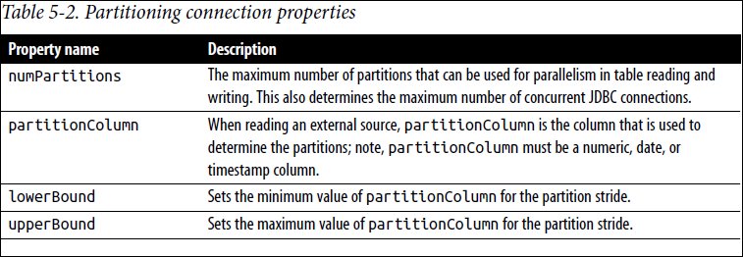

Let’s take a look at an example to help we understand how these properties work. Suppose we use the following settings:
• numPartitions: 10
• lowerBound: 1000
• upperBound: 10000

Then the stride is equal to 1,000, and 10 partitions will be created. This is the equivalent of executing these 10 queries (one for each partition):

• SELECT * FROM table WHERE partitionColumn BETWEEN 1000 and 2000
• SELECT * FROM table WHERE partitionColumn BETWEEN 2000 and 3000
• ...
• SELECT * FROM table WHERE partitionColumn BETWEEN 9000 and 10000

While not all-encompassing, the following are some hints to keep in mind when using these properties:
- A good starting point for numPartitions is to use a multiple of the number of Spark workers. For example, if we have four Spark worker nodes, then perhaps start with 4 or 8 partitions. But it is also important to note how well our source system can handle the read requests. For systems that have processing windows, we can maximize the number of concurrent requests to the source system; for systems lacking processing windows (e.g., an OLTP system continuously processing data), we should reduce the number of concurrent requests to prevent saturation of the source system.

- Initially, calculate the lowerBound and upperBound based on the minimum and maximum partitionColumn actual values. For example, if we choose {numPartitions:10, lowerBound: 1000, upperBound: 10000}, but all of the values are between 2000 and 4000, then only 2 of the 10 queries (one for each partition) will be doing all of the work. In this scenario, a better configuration would be {numPartitions:10, lowerBound: 2000, upperBound: 4000}.

- Choose a partitionColumn that can be uniformly distributed to avoid data skew. For example, if the majority of our partitionColumn has the value 2500, with {numPartitions:10, lowerBound: 1000, upperBound: 10000} most of the work will be performed by the task requesting the values between 2000 and 3000. Instead, choose a different partitionColumn, or if possible generate a new one (perhaps a hash of multiple columns) to more evenly distribute our partitions.

Higher-Order Functions in DataFrames and Spark SQL

Built-in Functions for Complex Data Types

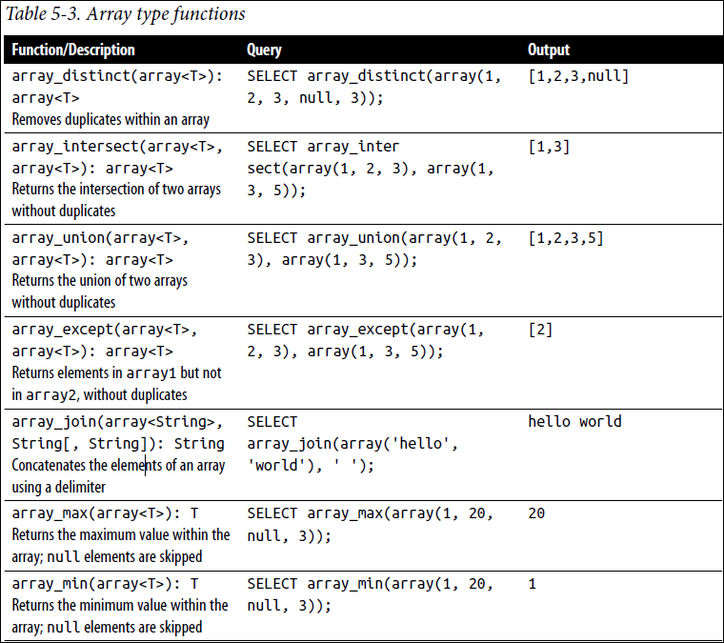

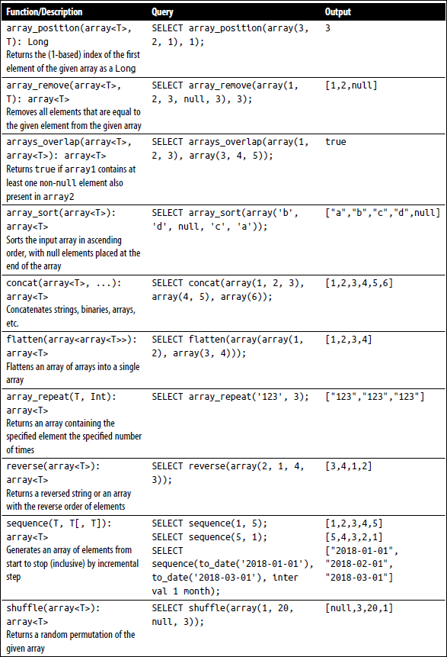

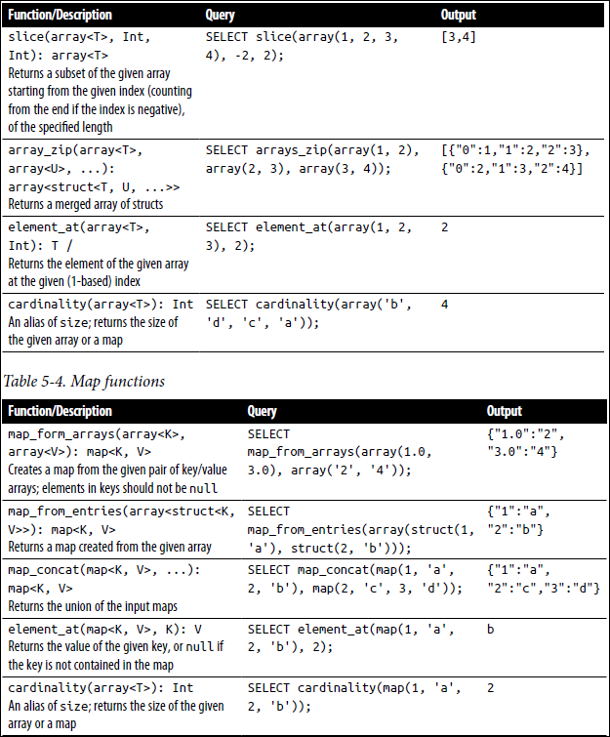

Higher-Order Functions

In addition to the previously noted built-in functions, there are higher-order functions that take anonymous lambda functions as arguments. An example of a higher-order function is the following:

-- In SQL
transform(values, value -> lambda expression)

The transform() function takes an array (values) and anonymous function (lambda expression) as input. The function transparently creates a new array by applying the anonymous function to each element, and then assigning the result to the output array (similar to the UDF approach, but more efficiently).

transform()

transform(array<T>, function<T, U>): array<U>

The transform() function produces an array by applying a function to each element of the input array (similar to a map() function):
// In Scala/Python
// Calculate Fahrenheit from Celsius for an array of temperatures
spark.sql("""
SELECT celsius, transform(celsius, t -> ((t * 9) div 5) + 32) as Fahrenheit FROM tC
""").show()
+--------------------+--------------------+
| celsius| fahrenheit|
+--------------------+--------------------+
|[35, 36, 32, 30, ...|[95, 96, 89, 86, ...|
|[31, 32, 34, 55, 56]|[87, 89, 93, 131,...|
+--------------------+--------------------+

filter()

filter(array<T>, function<T, Boolean>): array<T>

The filter() function produces an array consisting of only the elements of the input array for which the Boolean function is true:

// In Scala/Python
// Filter temperatures > 38C for array of temperatures
spark.sql("""
SELECT celsius, filter(celsius, t -> t > 38) as high
FROM tC
""").show()

+--------------------+--------+
| celsius| high|
+--------------------+--------+
|[35, 36, 32, 30, ...|[40, 42]|
|[31, 32, 34, 55, 56]|[55, 56]|
+--------------------+--------+

exists()

exists(array<T>, function<T, V, Boolean>): Boolean

The exists() function returns true if the Boolean function holds for any element in the input array:

// In Scala/Python
// Is there a temperature of 38C in the array of temperatures
spark.sql("""
SELECT celsius, exists(celsius, t -> t = 38) as threshold
FROM tC
""").show()

+--------------------+---------+
| celsius|threshold|
+--------------------+---------+
|[35, 36, 32, 30, ...| true|
|[31, 32, 34, 55, 56]| false|
+--------------------+---------+

reduce()

reduce(array<T>, B, function<B, T, B>, function<B, R>)
The reduce() function reduces the elements of the array to a single value by merging the elements into a buffer B using function<B, T, B> and applying a finishing function<B, R> on the final buffer:

// In Scala/Python
// Calculate average temperature and convert to F
spark.sql("""
SELECT celsius,
reduce(celsius,
0,
(t, acc) -> t + acc,
acc -> (acc div size(celsius) * 9 div 5) + 32
) as avgFahrenheit
FROM tC
""").show()

+--------------------+-------------+
| celsius|avgFahrenheit|
+--------------------+-------------+
|[35, 36, 32, 30, ...| 96|
|[31, 32, 34, 55, 56]| 105|
+--------------------+-------------+

Common DataFrames and Spark SQL Operations

To perform these DataFrame operations, we’ll first prepare some data. In the following code snippet, we:
- Import two files and create two DataFrames. Using expr(), convert the delay and distance columns from STRING to INT.
- Create a smaller table, foo, that we can focus on for our demo examples; it contains only information on three flights originating from Seattle (SEA) to the destination of San Francisco (SFO) for a small time range.
// In Scala
import org.apache.spark.sql.functions._
// Set file paths
val delaysPath ="/databricks-datasets/learning-spark-v2/flights/departuredelays.csv"
val airportsPath ="/databricks-datasets/learning-spark-v2/flights/airport-codes-na.txt"

// Obtain airports data set
val airports = spark.read
.option("header", "true")
.option("inferschema", "true")
.option("delimiter", "\t")
.csv(airportsPath)

airports.createOrReplaceTempView("airports_na")

// Obtain departure Delays data set
val delays = spark.read
.option("header","true")
.csv(delaysPath)
.withColumn("delay", expr("CAST(delay as INT) as delay"))
.withColumn("distance", expr("CAST(distance as INT) as distance"))

delays.createOrReplaceTempView("departureDelays")

// Create temporary small table
val foo = delays.filter(
expr("""origin == ‘SEA’ AND destination == ‘SFO’ AND date like ‘01010%’ AND delay > 0"""))

foo.createOrReplaceTempView("foo")

foo DataFrame contains just three rows with information on flights from SEA to SFO for a specific time range, as noted in the following output:

spark.sql("SELECT * FROM foo").show()
+--------+-----+--------+------+-----------+
| date|delay|distance|origin|destination|
+--------+-----+--------+------+-----------+
|01010710| 31| 590| SEA| SFO|
|01010955| 104| 590| SEA| SFO|
|01010730| 5| 590| SEA| SFO|
+--------+-----+--------+------+-----------+

Unions
A common pattern within Apache Spark is to union two different DataFrames with the same schema together. This can be achieved using the union() method:

// Scala
// Union two tables
val bar = delays.union(foo)
bar.createOrReplaceTempView("bar")
bar.filter(expr("""origin == ‘SEA’ AND destination == ‘SFO’ AND date LIKE ‘01010%’ AND delay > 0""")).show()

# In Python
# Union two tables
bar = departureDelays.union(foo)
bar.createOrReplaceTempView("bar")
# Show the union (filtering for SEA and SFO in a specific time range)
bar.filter(expr("""origin == ‘SEA’ AND destination == ‘SFO’ AND date LIKE ‘01010%’ AND delay > 0""")).show()

The bar DataFrame is the union of foo with delays. Using the same filtering criteria results in the bar DataFrame, we see a duplication of the foo data, as expected:

-- In SQL
spark.sql("""
SELECT * FROM bar
WHERE origin = ‘SEA’
AND destination = ‘SFO’
AND date LIKE ‘01010%’
AND delay > 0
""").show()

+--------+-----+--------+------+-----------+
| date|delay|distance|origin|destination|
+--------+-----+--------+------+-----------+
|01010710| 31| 590| SEA| SFO|
|01010955| 104| 590| SEA| SFO|
|01010730| 5| 590| SEA| SFO|
|01010710| 31| 590| SEA| SFO|
|01010955| 104| 590| SEA| SFO|
|01010730| 5| 590| SEA| SFO|
+--------+-----+--------+------+-----------+

Joins
A common DataFrame operation is to join two DataFrames (or tables) together. By default, a Spark SQL join is an inner join, with the options being inner, cross, outer, full, full_outer, left, left_outer, right, right_outer, left_semi, and left_anti. The following code sample performs the default of an inner join between the airportsna and foo DataFrames:

// In Scala
foo.join(airports.as(‘air’), $"air.IATA" === $"origin")
.select("City", "State", "date", "delay", "distance", "destination").show()

# In Python
# Join departure delays data (foo) with airport info
foo.join(airports, airports.IATA == foo.origin)
.select("City", "State", "date", "delay", "distance", "destination").show()

-- In SQL
spark.sql("""
SELECT a.City, a.State, f.date, f.delay, f.distance, f.destination
FROM foo f
JOIN airports_na a
ON a.IATA = f.origin
""").show()

+-------+-----+--------+-----+--------+-----------+
| City|State| date|delay|distance|destination|
+-------+-----+--------+-----+--------+-----------+
|Seattle| WA|01010710| 31| 590| SFO|
|Seattle| WA|01010955| 104| 590| SFO|
|Seattle| WA|01010730| 5| 590| SFO|
+-------+-----+--------+-----+--------+-----------+

Windowing
A window function uses values from the rows in a window (a range of input rows) to return a set of values, typically in the form of another row. With window functions, it is possible to operate on a group of rows while still returning a single value for every input row. In this section, we will show how to use the dense_rank() window function; there are many other functions, as noted in below table.

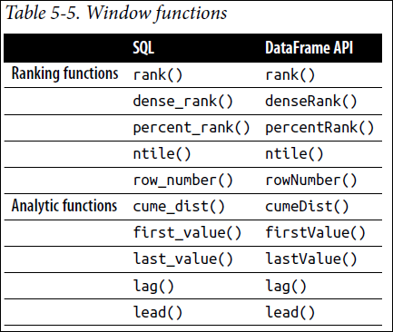

Let’s start with a review of the TotalDelays (calculated by sum(Delay)) experienced by flights originating from Seattle (SEA), San Francisco (SFO), and New York City (JFK) and going to a specific set of destination locations, as noted in the following query:
-- In SQL
DROP TABLE IF EXISTS departureDelaysWindow;

CREATE TABLE departureDelaysWindow AS
SELECT origin, destination, SUM(delay) AS TotalDelays
FROM departureDelays
WHERE origin IN (‘SEA’, ‘SFO’, ‘JFK’)
AND destination IN (‘SEA’, ‘SFO’, ‘JFK’, ‘DEN’, ‘ORD’, ‘LAX’, ‘ATL’)
GROUP BY origin, destination;

SELECT * FROM departureDelaysWindow

+------+-----------+-----------+
|origin|destination|TotalDelays|
+------+-----------+-----------+
| JFK| ORD| 5608|
| SEA| LAX| 9359|
| JFK| SFO| 35619|
| SFO| ORD| 27412|
| JFK| DEN| 4315|
| SFO| DEN| 18688|
| SFO| SEA| 17080|
| SEA| SFO| 22293|
| JFK| ATL| 12141|
| SFO| ATL| 5091|
| SEA| DEN| 13645|
| SEA| ATL| 4535|
| SEA| ORD| 10041|
| JFK| SEA| 7856|
| JFK| LAX| 35755|
| SFO| JFK| 24100|
| SFO| LAX| 40798|
| SEA| JFK| 4667|
+------+-----------+-----------+

What if for each of these origin airports we wanted to find the three destinations that experienced the most delays? We could achieve this by running three different queries for each origin and then unioning the results together, but a better approach would be to use a window function like dense_rank() to perform the following calculation:

-- In SQL
spark.sql("""
SELECT origin, destination, TotalDelays, rank
FROM (
SELECT origin, destination, TotalDelays,
dense_rank() OVER (PARTITION BY origin ORDER BY TotalDelays DESC) as rank
FROM departureDelaysWindow
) t
WHERE rank <= 3
""").show()

+------+-----------+-----------+----+
|origin|destination|TotalDelays|rank|
+------+-----------+-----------+----+
| SEA| SFO| 22293| 1|
| SEA| DEN| 13645| 2|
| SEA| ORD| 10041| 3|
| SFO| LAX| 40798| 1|
| SFO| ORD| 27412| 2|
| SFO| JFK| 24100| 3|
| JFK| LAX| 35755| 1|
| JFK| SFO| 35619| 2|
| JFK| ATL| 12141| 3|
+------+-----------+-----------+----+

By using the dense_rank() window function, we can quickly ascertain that the destinations with the worst delays for the three origin cities were:
- Seattle (SEA): San Francisco (SFO), Denver (DEN), and Chicago (ORD)
- San Francisco (SFO): Los Angeles (LAX), Chicago (ORD), and New York (JFK)
- New York (JFK): Los Angeles (LAX), San Francisco (SFO), and Atlanta (ATL)

It’s important to note that each window grouping needs to fit in a single executor and will get composed into a single partition during execution. Therefore, we need to ensure that our queries are not unbounded (i.e., limit the size of our window).

Modifications
Another common operation is to perform modifications to the DataFrame. While DataFrames themselves are immutable, we can modify them through operations that create new, different DataFrames, with different column.

Adding new columns
// In Scala
import org.apache.spark.sql.functions.expr
val foo2 = foo.withColumn("status", expr("CASE WHEN delay <= 10 THEN ‘On-time’ ELSE ‘Delayed’ END"))
foo2.show()
+--------+-----+--------+------+-----------+-------+
| date|delay|distance|origin|destination| status|
+--------+-----+--------+------+-----------+-------+
|01010710| 31| 590| SEA| SFO|Delayed|
|01010955| 104| 590| SEA| SFO|Delayed|
|01010730| 5| 590| SEA| SFO|On-time|
+--------+-----+--------+------+-----------+-------+

Dropping columns
// In Scala
val foo3 = foo2.drop("delay")
foo3.show()

+--------+--------+------+-----------+-------+
| date|distance|origin|destination| status|
+--------+--------+------+-----------+-------+
|01010710| 590| SEA| SFO|Delayed|
|01010955| 590| SEA| SFO|Delayed|
|01010730| 590| SEA| SFO|On-time|
+--------+--------+------+-----------+-------+

Renaming columns
We can rename a column using the rename() method:

// In Scala
val foo4 = foo3.withColumnRenamed("status", "flight_status")
foo4.show()

+--------+--------+------+-----------+-------------+
| date|distance|origin|destination|flight_status|
+--------+--------+------+-----------+-------------+
|01010710| 590| SEA| SFO| Delayed|
|01010955| 590| SEA| SFO| Delayed|
|01010730| 590| SEA| SFO| On-time|
+--------+--------+------+-----------+-------------+

Pivoting
When working with our data, sometimes we will need to swap the columns for the rows—i.e., pivot our data. Let’s grab some data to demonstrate this concept:

-- In SQL
SELECT destination, CAST(SUBSTRING(date, 0, 2) AS int) AS month, delay
FROM departureDelays
WHERE origin = ‘SEA’

+-----------+-----+-----+
|destination|month|delay|
+-----------+-----+-----+
| ORD| 1| 92|
| JFK| 1| -7|
| DFW| 1| -5|
| MIA| 1| -3|
| DFW| 1| -3|
| DFW| 1| 1|
| ORD| 1| -10|
| DFW| 1| -6|
| DFW| 1| -2|
| ORD| 1| -3|
+-----------+-----+-----+
only showing top 10 rows

Pivoting allows us to place names in the month column (instead of 1 and 2 we can show Jan and Feb, respectively) as well as perform aggregate calculations (in this case average and max) on the delays by destination and month:
-- In SQL
SELECT * FROM (
SELECT destination, CAST(SUBSTRING(date, 0, 2) AS int) AS month, delay
FROM departureDelays WHERE origin = ‘SEA’
)
PIVOT (
CAST(AVG(delay) AS DECIMAL(4, 2)) AS AvgDelay, MAX(delay) AS MaxDelay
FOR month IN (1 JAN, 2 FEB)
)
ORDER BY destination

+-----------+------------+------------+------------+------------+
|destination|JAN_AvgDelay|JAN_MaxDelay|FEB_AvgDelay|FEB_MaxDelay|
+-----------+------------+------------+------------+------------+
| ABQ| 19.86| 316| 11.42| 69|
| ANC| 4.44| 149| 7.90| 141|
| ATL| 11.98| 397| 7.73| 145|
| AUS| 3.48| 50| -0.21| 18|
| BOS| 7.84| 110| 14.58| 152|
| BUR| -2.03| 56| -1.89| 78|
| CLE| 16.00| 27| null| null|
| CLT| 2.53| 41| 12.96| 228|
| COS| 5.32| 82| 12.18| 203|
| CVG| -0.50| 4| null| null|
| DCA| -1.15| 50| 0.07| 34|
| DEN| 13.13| 425| 12.95| 625|
| DFW| 7.95| 247| 12.57| 356|
| DTW| 9.18| 107| 3.47| 77|
| EWR| 9.63| 236| 5.20| 212|
| FAI| 1.84| 160| 4.21| 60|
| FAT| 1.36| 119| 5.22| 232|
| FLL| 2.94| 54| 3.50| 40|
| GEG| 2.28| 63| 2.87| 60|
| HDN| -0.44| 27| -6.50| 0|
+-----------+------------+------------+------------+------------+
only showing top 20 rows

Aggregations

A handful of transformations and actions on DataFrames, such as groupBy(), orderBy(), and count(), offer the ability to aggregate by column names and then aggregate counts across them.

// In Scala
fireTsDF
.select("CallType")
.where(col("CallType").isNotNull)
.groupBy("CallType")
.count()
.orderBy(desc("count"))
.show(10, false)

CHAPTER 6: Spark SQL and Datasets

Scala Case Classes and JavaBeans for Datasets

Spark has internal data types, such as StringType, BinaryType, IntegerType, BooleanType, and MapType, that it uses to map seamlessly to the language-specific data types in Scala and Java during Spark operations. This mapping is done via encoders.

In order to create Dataset[T], where T is our typed object in Scala, we need a case class that defines the object. Say we have a JSON file with millions of entries about bloggers writing about Apache Spark in the following format:

{id: 1, first: "Jules", last: "Damji", url: "https://tinyurl.1", date: "1/4/2016", hits: 4535, campaigns: {"twitter", "LinkedIn"}},
...
{id: 87, first: "Brooke", last: "Wenig", url: "https://tinyurl.2", date: "5/5/2018", hits: 8908, campaigns: {"twitter", "LinkedIn"}}

To create a distributed Dataset[Bloggers], we must first define a Scala case class that defines each individual field that comprises a Scala object. This case class serves as a blueprint or schema for the typed object Bloggers:

// In Scala
case class Bloggers(id:Int, first:String, last:String, url:String, date:String,
hits: Int, campaigns:Array[String])

val bloggers = "../data/bloggers.json"
val bloggersDS = spark
.read
.format("json")
.option("path", bloggers)
.load()
.as[Bloggers]
Each row in the resulting distributed data collection is of type Bloggers.

As we can see, creating Datasets in Scala and Java requires a bit of forethought. Unlike with DataFrames, where we can optionally let Spark infer the schema, the Dataset API requires that we define our data types ahead of time and that our case class or JavaBean class matches our schema.

NOTE: The names of the fields in the Scala case class or Java class definition must match the order in the data source. The column names for each row in the data are automatically mapped to the corresponding names in the class and the types are automatically preserved.

Working with Datasets

Creating Sample Data

First, let’s generate some sample data:

// In Scala
import scala.util.Random._
// Our case class for the Dataset
case class Usage(uid:Int, uname:String, usage: Int)

val r = new scala.util.Random(42)

// Create 1000 instances of scala Usage class
val data = for (i <- 0 to 1000)
yield (Usage(i, "user-" + r.alphanumeric.take(5).mkString(""), r.nextInt(1000)))

// Create a Dataset of Usage typed data
val dsUsage = spark.createDataset(data)
dsUsage.show(10)

+---+----------+-----+
|uid| uname|usage|
+---+----------+-----+
| 0|user-Gpi2C| 525|
| 1|user-DgXDi| 502|
| 2|user-M66yO| 170|
| 3|user-xTOn6| 913|
| 4|user-3xGSz| 246|
| 5|user-2aWRN| 727|
| 6|user-EzZY1| 65|
| 7|user-ZlZMZ| 935|
| 8|user-VjxeG| 756|
| 9|user-iqf1P| 3|
+---+----------+-----+
only showing top 10 rows

In Java the idea is similar, but we have to use explicit Encoders (in Scala, Spark handles this implicitly).

Transforming Sample Data

Higher-order functions and functional programming

For a simple example, let’s use filter() to return all the users in our dsUsage Dataset whose usage exceeds 900 minutes. One way to do this is to use a functional expression as an argument to the filter() method:

// In Scala
import org.apache.spark.sql.functions._

dsUsage
.filter(d => d.usage > 900)
.orderBy(desc("usage"))
.show(5, false)

Another way is to define a function and supply that function as an argument to filter():

def filterWithUsage(u: Usage) = u.usage > 900
dsUsage.filter(filterWithUsage(_)).orderBy(desc("usage")).show(5)

+---+----------+-----+
|uid| uname|usage|
+---+----------+-----+
|561|user-5n2xY| 999|
|113|user-nnAXr| 999|
|605|user-NL6c4| 999|
|634|user-L0wci| 999|
|805|user-LX27o| 996|
+---+----------+-----+
only showing top 5 rows

In the first case, we used a lambda expression, {d.usage > 900}, as an argument to the filter() method, whereas in the second case we defined a Scala function, def filterWithUsage(u: Usage) = u.usage > 900. In both cases, the filter() method iterates over each row of the Usage object in the distributed Dataset and applies the expression or executes the function, returning a new Dataset of type Usage for rows where the value of the expression or function is true.

Not all lambdas or functional arguments must evaluate to Boolean values; they can return computed values too. Consider this example using the higher-order function map(), where our aim is to find out the usage cost for each user whose usage value is over a certain threshold so we can offer those users a special price per minute.

// In Scala
dsUsage.map(u => {if (u.usage > 750) u.usage*0.15 else u.usage*0.50 })
.show(5, false)

// Define a function to compute the usage
def computeCostUsage(usage: Int): Double = {
if (usage > 750) usage * 0.15 else usage * 0.50
}

// Use the function as an argument to map()
dsUsage.map(u => {computeCostUsage(u.usage)}).show(5, false)

+------+
|value |
+------+
|262.5 |
|251.0 |
|85.0 |
|136.95|
|123.0 |
+------+
only showing top 5 rows

Though we have computed values for the cost of usage, we don’t know which users the computed values are associated with. How do we get this information? The steps are simple:
- Create a Scala case class or JavaBean class, UsageCost, with an additional field or column named cost.
- Define a function to compute the cost and use it in the map() method.

Here’s what this looks like in Scala:

// Create a new case class with an additional field, cost
case class UsageCost(uid: Int, uname:String, usage: Int, cost: Double)

// Compute the usage cost with Usage as a parameter
// Return a new object, UsageCost
def computeUserCostUsage(u: Usage): UsageCost = {
val v = if (u.usage > 750) u.usage * 0.15 else u.usage * 0.50
UsageCost(u.uid, u.uname, u.usage, v)
}

// Use map() on our original Dataset
dsUsage.map(u => {computeUserCostUsage(u)}).show(5)

+---+----------+-----+------+
|uid| uname|usage| cost|
+---+----------+-----+------+
| 0|user-Gpi2C| 525| 262.5|
| 1|user-DgXDi| 502| 251.0|
| 2|user-M66yO| 170| 85.0|
| 3|user-xTOn6| 913|136.95|
| 4|user-3xGSz| 246| 123.0|
+---+----------+-----+------+
only showing top 5 rows

Converting DataFrames to Datasets

To convert an existing DataFrame df to a Dataset of type SomeCaseClass, simply use the df.as[SomeCaseClass] notation.

// In Scala
val bloggersDS = spark
.read
.format("json")
.option("path", "/data/bloggers/bloggers.json")
.load()
.as[Bloggers]

spark.read.format("json") returns a DataFrame<Row>, which in Scala is a type alias for Dataset[Row]. Using .as[Bloggers] instructs Spark to use encoders, to serialize/deserialize objects from Spark’s internal memory representation to JVM Bloggers objects.

Memory Management for Datasets and DataFrames
Spark is an intensive in-memory distributed big data engine, so its efficient use of memory is crucial to its execution speed. Throughout its release history, Spark’s usage of memory has significantly evolved:

- Spark 1.0 used RDD-based Java objects for memory storage, serialization, and deserialization, which was expensive in terms of resources and slow. Also, storage was allocated on the Java heap, so we were at the mercy of the JVM’s garbage collection (GC) for large data sets.

- Spark 1.x introduced Project Tungsten. One of its prominent features was a new internal row-based format to lay out Datasets and DataFrames in off-heap memory, using offsets and pointers. Spark uses an efficient mechanism called encoders to serialize and deserialize between the JVM and its internal Tungsten format. Allocating memory off-heap means that Spark is less encumbered by GC.

- Spark 2.x introduced the second-generation Tungsten engine, featuring wholestage code generation and vectorized column-based memory layout. Built on ideas and techniques from modern compilers, this new version also capitalized on modern CPU and cache architectures for fast parallel data access with the “single instruction, multiple data” (SIMD) approach.

Dataset Encoders

Encoders convert data in off-heap memory from Spark’s internal Tungsten format to JVM Java objects. In other words, they serialize and deserialize Dataset objects from Spark’s internal format to JVM objects, including primitive data types. For example, an Encoder[T] will convert from Spark’s internal Tungsten format to Dataset[T].

Tungsten --> Data to Off-Heap Memory(Spark’s internal Tungsten format) --> Encoders convert data in off-heap memory (Spark’s internal Tungsten format to JVM Java objects)

Spark has built-in support for automatically generating encoders for primitive types (e.g., string, integer, long), Scala case classes, and JavaBeans. Compared to Java and Kryo serialization and deserialization, Spark encoders are significantly faster.

Spark’s Internal Format Versus Java Object Format

Java objects have large overheads—header info, hashcode, Unicode info, etc. Instead of creating JVM-based objects for Datasets or DataFrames, Spark allocates off-heap Java memory to lay out their data and employs encoders to convert the data from in-memory representation to JVM object. For example, Figure 6-1 shows how the JVM object MyClass(Int, String, String) would be stored internally.

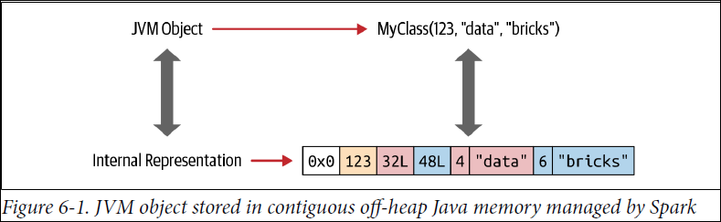

When data is stored in this contiguous manner and accessible through pointer arithmetic and offsets, encoders can quickly serialize or deserialize that data.

Serialization and Deserialization (SerDe)

When data frequently travels over the network among computer nodes in a cluster, serialization and deserialization is the process by which a typed object is encoded (serialized) into a binary presentation or format by the sender and decoded (deserialized) from binary format into its respective data-typed object by the receiver.

For example, if the JVM object MyClass in Figure 6-1 had to be shared among nodes in a Spark cluster, the sender would serialize it into an array of bytes, and the receiver would deserialize it back into a JVM object of type MyClass.

The JVM has its own built-in Java serializer and deserializer, but it’s inefficient because the Java objects created by the JVM in the heap memory are bloated (excessive in size). Hence, the process is slow.
This is where the Dataset encoders come to the rescue, for a few reasons:
- Spark’s internal Tungsten binary format (see Figures 6-1 and 6-2) stores objects off the Java heap memory, and it’s compact so those objects occupy less space.
- Encoders can quickly serialize by traversing across the memory using simple pointer arithmetic with memory addresses and offsets (Figure 6-2).
- On the receiving end, encoders can quickly deserialize the binary representation into Spark’s internal representation. Encoders are not hindered by the JVM’s garbage collection pauses.

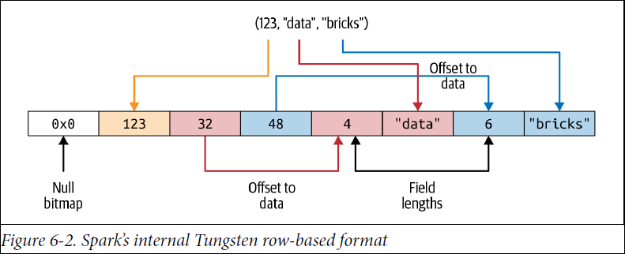

Costs of Using Datasets

When Datasets are passed to higher-order functions such as filter(), map(), or flatMap() that take lambdas and functional arguments, there is a cost associated with deserializing from Spark’s internal Tungsten format into the JVM object.
Compared to other serializers, used before encoders were introduced in Spark, this cost is minor and tolerable. However, over larger data sets and many queries, this cost accrues and can affect performance.

Strategies to Mitigate Costs

One strategy to mitigate excessive serialization and deserialization is to use DSL expressions in our queries and avoid excessive use of lambdas as anonymous functions as arguments to higher-order functions. Because lambdas are anonymous and opaque to the Catalyst optimizer until runtime, when we use them it cannot efficiently recognize what we’re doing (we’re not telling Spark what to do) and thus cannot optimize the queries.

The second strategy is to chain our queries together in such a way that serialization and deserialization is minimized. Chaining queries together is a common practice in Spark. Let’s illustrate with a simple example. Suppose we have a Dataset of type Person, where Person is defined as a Scala case class:

// In Scala
Person(id: Integer, firstName: String, middleName: String, lastName: String,
gender: String, birthDate: String, ssn: String, salary: String)

Let’s examine a case where we compose a query inefficiently, in such a way that we unwittingly incur the cost of repeated serialization and deserialization:

import java.util.Calendar

val earliestYear = Calendar.getInstance.get(Calendar.YEAR) - 40

personDS

// Everyone above 40: lambda-1
.filter(x => x.birthDate.split("-")(0).toInt > earliestYear)

// Everyone earning more than 80K
.filter($"salary" > 80000)

// Last name starts with J: lambda-2
.filter(x => x.lastName.startsWith("J"))

// First name starts with D
.filter($"firstName".startsWith("D"))
.count()

As we can observe in Figure 6-3, each time we move from lambda to DSL (filter($"salary" > 8000)) we incur the cost of serializing and deserializing the Person JVM object.

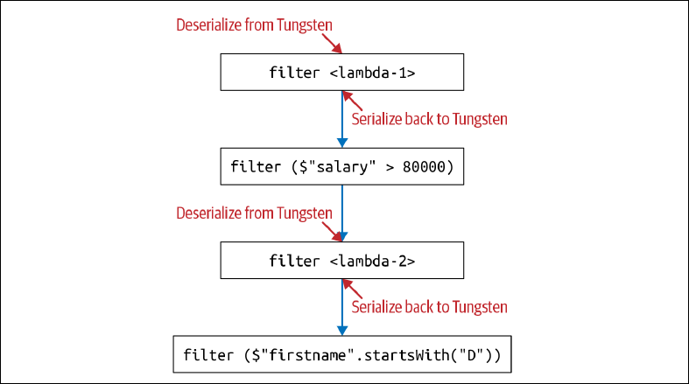

By contrast, the following query uses only DSL and no lambdas. As a result, it’s much more efficient—no serialization/deserialization is required for the entire composed and chained query:

personDS
.filter(year($"birthDate") > earliestYear) // Everyone above 40
.filter($"salary" > 80000) // Everyone earning more than 80K
.filter($"lastName".startsWith("J")) // Last name starts with J
.filter($"firstName".startsWith("D")) // First name starts with D
.count()

