# Knowledge base articles where we need manual efforts or need to exclude some html portions:

## KnowledgeBaseArticles\Accounts\Accounts (UDN)

1. 205053589-How-do-I-change-my-username-
2. 205057499-Why-is-my-account-disabled-
3. 205142919-Why-have-I-not-received-my-confirmation-email-
4. 205752275-How-do-I-change-the-e-mail-address-attached-to-my-Unity-account-
5. 205754635-I-have-misspelled-my-email-address-when-creating-my-user-account-How-do-I-change-this-
6. 205756265-Could-you-re-enable-my-Unity-Account-
7. 210716003-How-do-I-change-my-billing-details-

### Findings

1. // Replace '<p><strong><u>' with '<p><strong>' tag
2. // Replace '</u></strong></p>' with '</strong></p>' tag
3. // Replace '<strong><strong>' with '<strong>'
4. // Replace '</strong></strong>' with '</strong>'
5. // Replace '<strong><br></strong>' with '</br>'
6. // Replace '<br></strong>' with '</strong>'
7. // Replace '<br></em>' with '</em>'
8. // Replace '<em><strong>' with '<strong>'
9. // Replace '</strong></em>' with </strong>
10. // Replace '<strong><em>' with '<strong>'
11. // Replace '</em></strong>' with '</strong>'

## KnowledgeBaseArticles\Accounts\Organizations

1. 206494363-How-do-I-add-members-to-my-organization-
2. 208592876-How-do-I-create-a-new-Organization-
3. 208592986-Where-are-my-Unity-projects-and-who-has-access-to-them-
4. 210141563-What-is-an-Organization-
5. 115000075126-How-do-I-archive-a-Project-
6. 115003176383-How-do-I-change-the-Owner-of-my-Organization-

## KnowledgeBaseArticles\Asset-Store\Asset Store (Customers)

1. 205646083-How-do-I-update-my-purchased-assets-
2. 207520186-How-do-I-redeem-an-Asset-Store-voucher-
3. 208601846-How-do-I-purchase-multiple-seats-for-the-same-Asset-

### Findings

1. Get child class ‘article-body’ content as html
2. ‘Symptoms’ title in original article is not coming correct

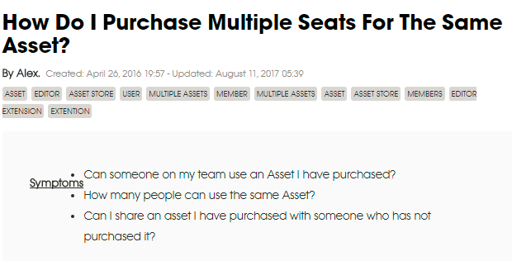

## KnowledgeBaseArticles\Asset-Store\Asset Store (Publishers)

1. 205755245-Why-has-my-asset-store-payout-not-been-sent-
2. 206598305-What-different-payment-methods-are-available-to-publishers-
3. 206601765-When-and-how-will-I-receive-my-Asset-Store-payout-
4. 208468576-How-do-I-create-upgrades-for-my-assets-
5. 208578066-How-can-I-increase-my-chances-of-being-part-of-a-Sale-
6. 210122403-What-makes-a-great-key-image-

### Findings

1. Replace ‘<strong><strong><br></strong></strong>’ with ‘<br>’
2. Handle ‘$’ symbol in markdown, between two ‘$’ symbol content is getting italic
3. There is no space between ending ‘</em>’ tag and next word. So instead of emphasize content html is showing ‘*’ symbols.
4. Get child class ‘article-body’ content as html

## KnowledgeBaseArticles\Community\Community

1. 206081526-Why-has-my-post-in-the-Forums-been-rejected-
2. 206081576-Why-has-my-Forums-account-been-banned-
3. 206082296-Why-has-my-post-on-Answers-been-rejected-
4. 206095076-I-cannot-log-into-the-Forums-The-community-says-my-username-is-already-in-use-
5. 209622673-Why-is-my-Answers-post-being-moderated-
6. 210072463-Who-are-the-Administrators-Moderators-

### Findings

1. Multiple ‘<em>’ tags in same line, while one ‘<em>’ tag is enough.

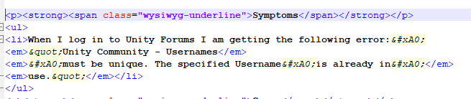

1. There should be proper ‘<p>’ tag for titles, in our case Cause title doesn’t have proper ‘<p>’ tag.

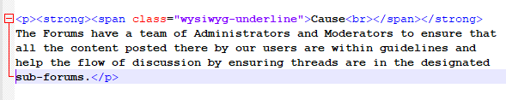

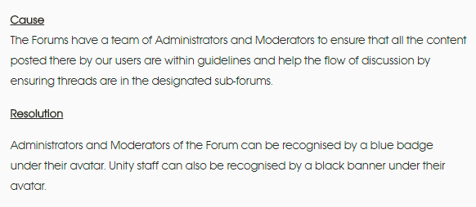

## KnowledgeBaseArticles\Community\Connect

1. 209019766-How-do-I-get-paid-or-pay-a-Contractor-in-Unity-Connect-
2. 209028526-Where-do-I-find-Applicants-to-my-job-post-
3. 209054526-How-do-I-terminate-a-contract-in-Unity-Connect-
4. 210621763-How-do-I-post-a-job-on-Unity-Connect-
5. 115002006106-How-can-I-make-a-Schools-page-

### Findings

1. Replace ‘<strong></strong>’ with blank space
2. There should be space between ending ‘</em>’ tag and next coming word.
3. Unnecessary div tags are coming

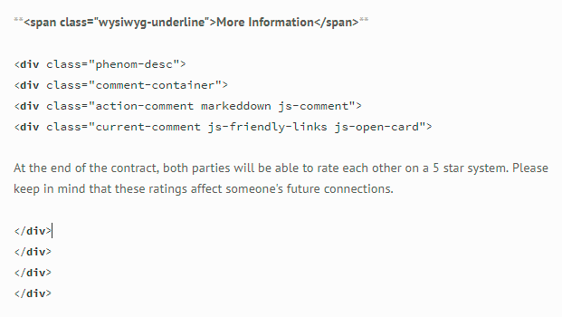

1. Span tags for title should come in single line

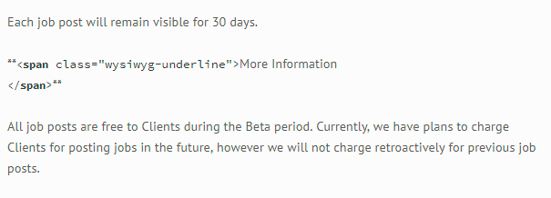

1. ‘<em>’ tags are used mistakenly for single character, while it is already used in whole sentence

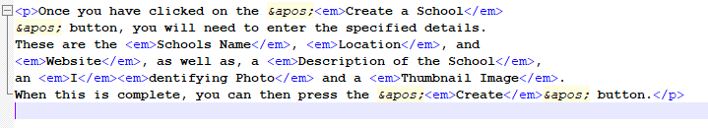

## KnowledgeBaseArticles\Community\Made With Unity

1. 205989773-Is-it-possible-to-showcase-a-game-we-have-been-working-on-in-Unity-
2. 115003744123-Will-links-posted-to-the-old-Made-With-Unity-site-still-work-
3. 115003744183-Will-my-draft-on-the-Made-With-Unity-website-be-public-after-the-migration-to-Unity-Connect-

### Findings

1. There should be space between ending ‘</em>’ tag and next coming word.
2. Replace ‘<strong>&#xA0;</strong>’ with blank space

## KnowledgeBaseArticles\Licenses\Activations and Management

1. 205056069-How-do-I-return-the-activations-on-my-Pro-Plus-license-
2. 205265449-I-am-unable-to-add-my-license-to-my-account
3. 205676999-I-have-not-received-an-e-mail-with-my-serial-number
4. 205958825-My-serial-number-does-not-work-during-activation-of-Unity
5. 206506105-Why-can-t-I-use-version-control-
6. 206586053-Unity-Editor-crashes-whenever-I-try-to-run-it-It-says-Unity-editor-has-stopped-working-
7. 206590155-I-get-a-message-saying-Checking-License-Unity-is-checking-your-license-authorization-stay-tuned-when-I-launch-the-Editor
8. 208609916-Where-am-I-able-to-see-my-Unity-Licenses-
9. 210001066-Can-I-activate-more-than-one-version-of-Unity-on-the-same-machine-
10. 115004452043-License-error-Unity-License-return-request-has-timed-out-Please-verify-that-you-are-connected-to-the-Internet-and-or-try-again-later-

### Findings

1. Remove all <p> tags which are coming in between of <li> tags
2. There should be space between ending ‘</strong>’ tag and next coming word.
3. Multiple ‘<em>’ tags in same line, while one ‘<em>’ tag is enough.
4. Replace ‘</strong><strong>’ with blank space
5. Replace ‘</em><em>’ with blank space

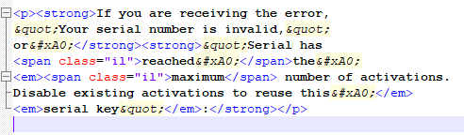

1. There should not be any blank space between starting ‘<em>’ tag and next coming word, otherwise single ‘*’ treated as ‘<li>’ by markdown
2. There are unnecessary div tags

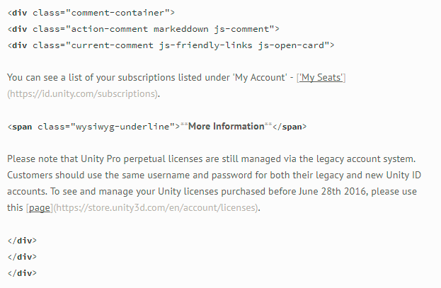

1. Replace ‘<strong>&#xA0;</strong>’ with blank space

## KnowledgeBaseArticles\Licenses\Licensing and Payments

1. 205253119-Can-I-make-a-commercial-game-with-Unity-Free-Personal-Edition-
2. 205767635-How-do-I-change-my-subscription-billing-details-
3. 205767715-How-do-I-cancel-my-subscription-
4. 206336795-What-platforms-are-supported-by-Unity-
5. 208610336-What-subscription-tiers-are-available-
6. 208659006-Can-I-purchase-different-subscription-tiers-on-my-Organization-
7. 209018426-Do-I-have-to-switch-to-the-new-subscription-plan-
8. 209961006-How-can-I-download-a-copy-of-my-invoice-
9. 210135803-What-do-I-get-with-a-Unity-Pro-Subscription-license-
10. 210223843-How-do-I-downgrade-my-subscription-tier-
11. 210246713-My-flexible-subscription-plan-has-been-deactivated-
12. 210290483-How-do-I-reduce-the-number-of-seats-in-my-subscription-plan-
13. 210326043-Will-my-Unity-subscription-renew-automatically-when-I-have-finished-my-12-month-contract-
14. 211948583-Can-I-combine-content-from-my-school-with-my-home-Personal-Edition-
15. 115001547326-How-are-my-Unity-Services-impacted-as-a-Unity-5-x-Pro-perpetual-license-holder-

### Findings

1. Replace ‘<strong><span class="wysiwyg-underline"><br></span></strong>’ with blank space

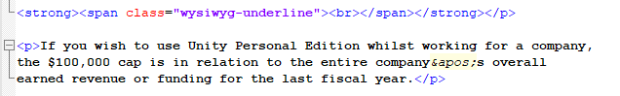

1. Replace ‘<strong><br></strong>’ with ‘<br>’ tag
2. Unnecessary div tags

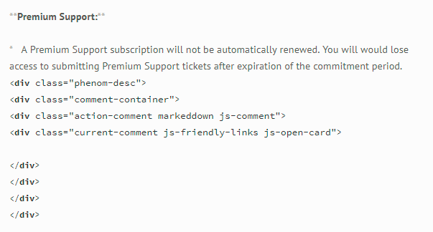

## KnowledgeBaseArticles\Services\Ads – Publishers

1. 205263819-How-much-can-I-earn-from-Unity-Ads-
2. 206587593-I-am-logging-in-with-my-UDN-account-but-cannot-see-my-projects-and-earnings-listed-
3. 206658353-Are-there-any-age-restrictions-on-monetization-with-Unity-Ads-
4. 207853376-Why-have-I-seen-a-sudden-drop-in-my-eCPM-
5. 207935333-I-am-seeing-a-gambling-Ad-campaign-in-my-under-13s-game-
6. 208056303-How-do-I-move-my-projects-from-the-old-Unity-Ads-dashboard-to-the-new-one-
7. 208056343-How-can-I-edit-the-name-of-my-project-in-Ads-
8. 208155943-Why-haven-t-my-users-received-their-in-app-rewards-
9. 208247846-How-do-I-change-the-types-of-adverts-shown-in-my-game-
10. 210548826-Can-I-invoice-an-amount-less-than-100-for-Unity-Ads-
11. 210903326-Can-Unity-Ads-be-implemented-through-mediation-
12. 210903386-What-do-the-fields-in-the-monetization-stat-reports-mean-
13. 212333083-How-do-I-create-a-Unity-Ads-account-
14. 212453263-How-much-money-can-I-expect-to-make-with-my-game-
15. 213079383-How-can-we-set-ad-filtering-for-our-game-
16. 213524303-How-do-I-transfer-my-Project-to-a-different-Unity-Organization-
17. 218324523-How-do-I-register-a-test-device-
18. 115000123906-How-can-I-generate-stats-reports-for-my-games-
19. 115000564306-What-is-eCPM-

### Findings

1. Handle ‘$’ symbol in markdown, between two ‘$’ symbol content is getting italic
2. Remove ‘<u>’ tags, because in articles they used class already
3. There should be no space between ‘</em>’ and ‘</strong>’ tag
4. There should be space between ending ‘</strong>’ and next coming word

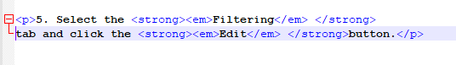

1. There are div tags which are affecting the behavior of markdown

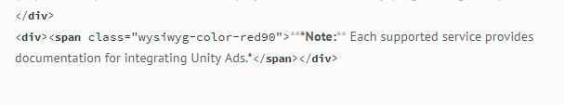

1. Replace ‘<p><span class="wysiwyg-underline">&#xA0;</span></p>’ with blank space
2. Replace ‘<p><strong><span class="wysiwyg-underline">&#xA0;</span></strong></p>‘ with blank space
3. Missing ‘<p>’ tag



1. Used strong and span tags with class ‘wysiwyg-underline’ for outer of image tag which is not required

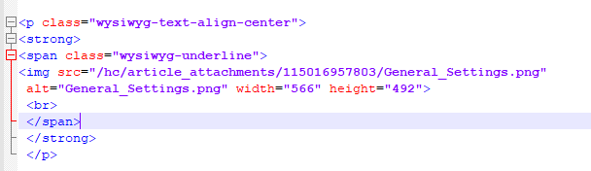

1. Number 5 is italic, because in html <em> tag is used for number

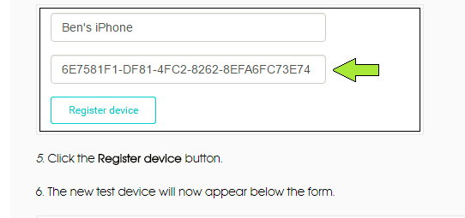

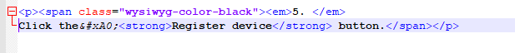

1. End </p> tag is missing

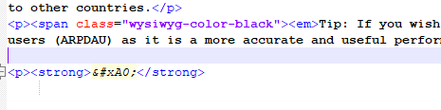

## KnowledgeBaseArticles\Services\Analytics

1. 115002917683-Using-Charles-Proxy-with-Unity
2. 115004052703-Advanced-Queries-with-Unity-Analytics-and-Raw-Data-Export

### Findings

1. So many <strong> tags are used in html which is not required at all

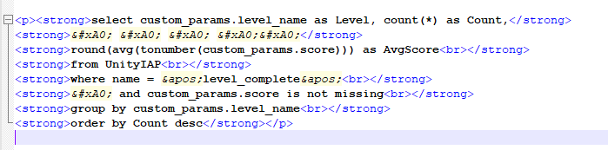

## KnowledgeBaseArticles\Services\Certification

1. 208117616-How-much-does-Certification-with-Unity-cost-
2. 208117646-Where-can-I-purchase-Certification-Courseware-
3. 208117686-Where-can-I-take-my-Unity-Certification-exam-
4. 208152016-What-does-the-Unity-Certification-Exam-involve-
5. 208152046-How-can-I-find-out-my-Exam-score-
6. 208152066-What-languages-is-Unity-Certification-available-in-
7. 209643753-What-is-Unity-Certification-
8. 209681343-Are-there-any-discounts-for-Certification-Courseware-materials-and-Exam-
9. 209681513-What-happens-if-I-do-not-finish-or-fail-the-Unity-Certification-Exam-

### Findings

1. Multiple ‘<div class="article-body markdown">’ class is used in single document
2. Multiple <ul> tags which are not needed

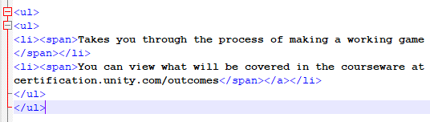

## KnowledgeBaseArticles\Services\Cloud Build

1. 205828349-How-do-I-activate-Cloud-Build-
2. 207790896-Do-different-Tiers-of-Unity-Cloud-Build-have-different-hardware-speeds-
3. 208593736-How-can-I-symbolicate-iOS-crash-logs-from-projects-generated-with-Cloud-Build-
4. 115000368166-Which-versions-of-Xcode-does-Unity-Cloud-Build-support-

### Findings

1. Wrong use of <strong> tags

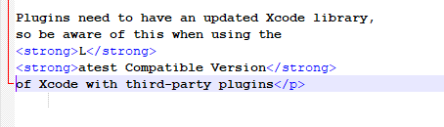

## KnowledgeBaseArticles\Services\Collaborate

1. 208676086-How-do-I-set-up-Unity-Collaborate-for-my-project-
2. 115000513426-How-do-I-see-differences-between-commits-

### Findings

1. Wrong use of <strong> tag

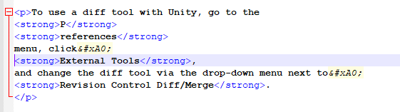

## KnowledgeBaseArticles\Services\Multiplayer

1. 208072136-What-does-Unity-Multiplayer-consist-of-
2. 209642813-I-want-to-go-live-from-my-Unity-Personal-account-How-do-I-do-this-

### Findings

1. Wrong use of <ol> tags

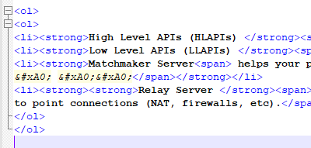

1. Wrong use of <strong> tag

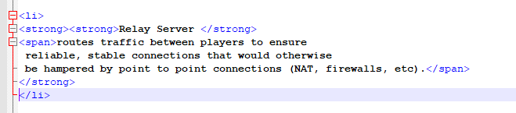

1. Replace ‘<p>&#xA0;</p>’ with blank space

## KnowledgeBaseArticles\Services\Performance Reporting

1. 207643796-I-cannot-access-Performance-Reporting
2. 212064726-How-do-I-access-the-Performance-Reporting-tool-

## KnowledgeBaseArticles\Unity-Editor\Android

1. 208246446-libhoudini-so-crashes-on-Android-x86-devices
2. 214721883-Why-are-my-streaming-Assets-making-my-APK-so-big-
3. 115000292166-Symbolicate-Android-crash

### Findings

1. Lot of <div> tags are used which are not needed, might be because of html editor they came

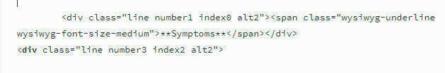

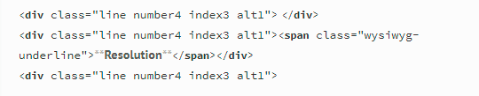

## KnowledgeBaseArticles\Unity-Editor\Animation

1. 205845885-Animator-state-is-reset-when-AnimationClips-are-replaced-using-an-AnimatorControllerOverride
2. 115001622823-transform-eulerAngles-returns-a-different-value-in-Unity-5-4-compared-to-5-3

### Findings

1. Lot of <div> tags are used which are not needed

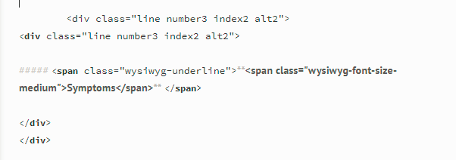

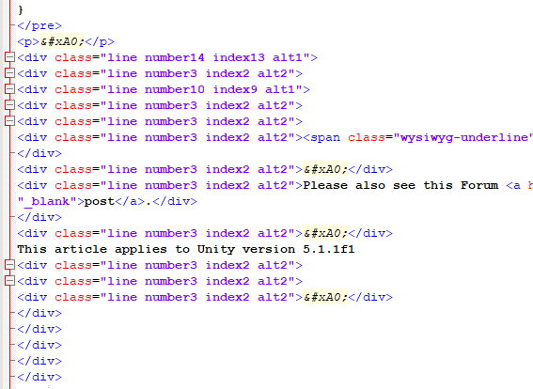

1. Replace ‘<strong><br></strong>’ with ‘<br>’ tag
2. Wrong use of <em> tags

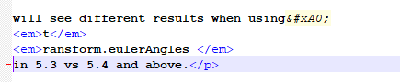

## KnowledgeBaseArticles\Unity-Editor\Asset Importer

1. 206486626-How-can-I-get-pixels-from-unreadable-textures-
2. 207349003-How-can-I-load-Assets-asynchronously-from-AssetBundles-stored-in-disk-

### Findings

1. Different font-size class style is used for title

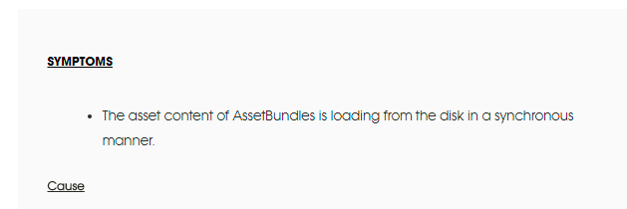

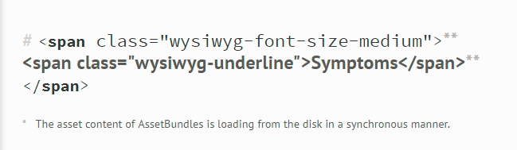

## KnowledgeBaseArticles\Unity-Editor\AssetBundles

1. 207710103-How-do-I-delete-AssetBundles-from-the-cache-
2. 208380753-Shaders-are-pink-when-loaded-from-an-AssetBundle
3. 214947183-My-game-crashes-when-loading-an-AssetBundle-that-contains-a-scene
4. 217123266-How-do-I-determine-what-is-in-my-Scene-bundle-

### Findings

1. Wrong use of <em> tags



1. Wrong use of <strong> tags

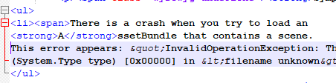

## KnowledgeBaseArticles\Unity-Editor\Audio

1. 206116056-How-do-I-use-an-Audio-Source-in-a-script-
2. 206116386-How-do-I-play-multiple-Audio-Sources-from-one-GameObject-
3. 206484923-I-want-my-game-to-trigger-an-AudioClip-but-I-cannot-hear-anything-What-is-going-wrong-
4. 208211393-Sometimes-when-a-sound-is-played-the-application-freezes-for-a-moment-

Findings

1. Replace ‘<strong><strong><br></strong></strong>’ with ‘<br>’
2. Wrong use of <em> tags

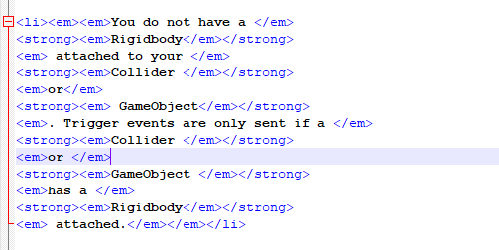

1. Wrong use of <strong> tags



## KnowledgeBaseArticles\Unity-Editor\C# Compiler Errors

1. 205057609-What-is-error-CS8025-
2. 205851926-What-is-CS1502-
3. 206059953-I-keep-getting-a-message-saying-the-Assembly-CSharp-dll-mdb-is-denied
4. 206193836-What-is-CS1061-
5. 206206516-What-is-CS0227-
6. 206455506-What-is-CS0131-
7. 206462813-What-is-CS0022-
8. 206470966-What-is-CS0165-
9. 206471436-What-is-CS0219
10. 206471466-What-is-CS0414-
11. 206496883-What-is-CS0120-
12. 206507033-What-is-CS1010-
13. 206518473-What-is-CS0432-
14. 206804326-Problems-with-Project-Space-Shooter
15. 206829863-What-is-CS0236-
16. 207020693-Problems-with-Project-Roll-a-Ball-
17. 207515893-What-is-CS0664-

### Findings

1. Wrong use of <strong> tags
2. Instead of <ol> for list, paragraph tags are being used

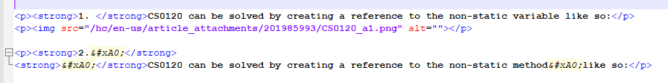

1. Replace ‘<strong><em>&#xA0;</em></strong>’ with blank space

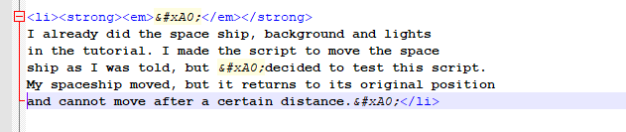

1. Wrong use of tags

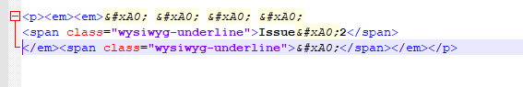

## KnowledgeBaseArticles\Unity-Editor\General

1. 205930479-How-do-I-create-a-minimal-repro-
2. 206560153-I-cannot-open-the-Unity-Editor-in-Windows-due-to-a-failure-initializing-unity-graphics-
3. 206619726-The-characters-are-displayed-with-a-different-font-Where-can-I-see-the-Fallback-font-list-per-platform-
4. 207020786-How-can-I-debug-Unity-s-Cache-Server-
5. 207907706-The-Cache-server-has-a-bad-performance-or-freezes
6. 208060696-Enabling-the-Fog-in-a-built-game-is-not-working-
7. 208240283-Export-Package-exports-everything
8. 208298636-How-to-modify-the-Editor-Application-Layout-from-a-script
9. 208504286-How-can-I-remove-the-fade-out-on-the-shadows-
10. 208707516-Why-should-I-use-Threads-instead-of-Coroutines-
11. 209641433-How-to-modify-Perforce-settings-via-script
12. 210223733-How-to-customize-Unity-script-templates
13. 210223933-How-can-I-profile-a-specific-part-of-my-code-
14. 210224803-Can-I-restore-my-unsaved-scene-after-Unity-crash-
15. 210290023-Is-there-a-simple-way-to-make-a-sprite-render-in-front-of-everything-in-the-scene-
16. 210606003-How-does-the-Anisotropic-Textures-Quality-Setting-affect-each-texture-s-Aniso-Level-
17. 210719486-Enter-Play-Mode-with-F5-key
18. 211013503-How-can-I-have-a-fully-automated-build-process-that-can-fetch-and-install-any-version-of-Unity-into-our-build-environment-
19. 211195263-Why-doesn-t-a-failed-BuildPipeline-BuildPlayer-return-an-error-code-in-the-command-line-
20. 211590863-How-can-I-load-scenes-additively-including-a-NavMesh-set-at-the-same-position-
21. 214582043-How-can-I-make-a-UI-button-light-up-instead-of-the-default-darken-
22. 115000229323-Graphics-Blit-does-not-copy-RenderTexture-depth
23. 115002294603-How-do-I-make-a-scene-dirty-when-modifying-a-property-via-script-
24. 115004982743-How-can-I-change-my-Editor-skin-

### Findings

1. Difference between normal title text and use heading for that

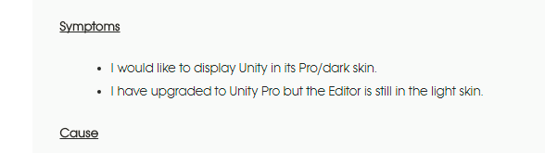

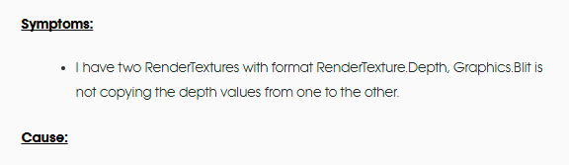

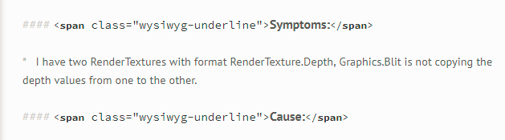

1. Wrong use of <strong> tags

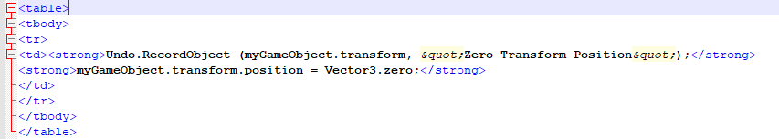

## KnowledgeBaseArticles\Unity-Editor\iOS and tvOS

1. 205824295-Mobile-game-flips-between-running-at-30FPS-and-60FPS
2. 208411836-Optimizing-iOS-tvOS-apps-with-app-thinning-and-IL2CPP
3. 208412046-Optimizing-iOS-tvOS-app-size-with-resource-slicing
4. 208412186-IL2CPP-build-size-optimizations
5. 208532136-Orientation-problem-on-iOS-with-GameCenter
6. 208593516-How-to-symbolicate-iOS-tvOS-crashlogs
7. 209933103-Bitcode-Support-in-iOS-tvOS
8. 209933113-Mastering-on-demand-resources-for-iOS-tvOS
9. 210141723-How-can-I-get-symbols-in-Instruments-during-profiling-

Problem:

* Sequence of <strong> and <code> tags are not correct
* Correct sequence should be ‘<strong><code>Content</code></strong>’

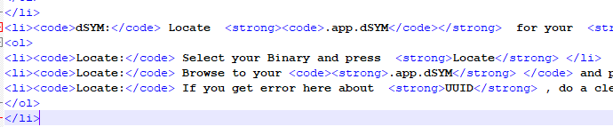

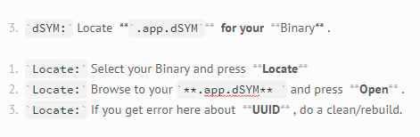

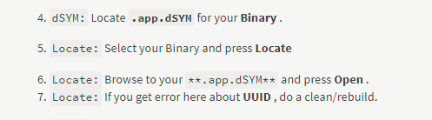

Findings

1. Use of unnecessary <div> tags

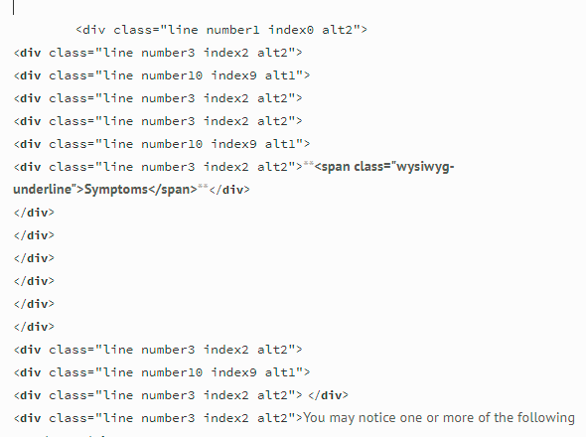

1. Multiple ‘<**div** class="article-body markdown">’ tags present

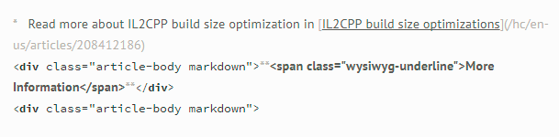

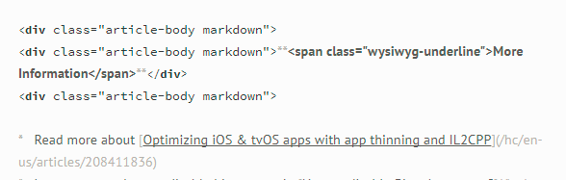

## KnowledgeBaseArticles\Unity-Editor\Lighting

1. 204837026-Lightmapping-GI-calculation-takes-a-very-long-time-
2. 207518996-Mixed-mode-lighting-Baked-vs-RealTime-shadows
3. 207820473-Mixed-mode-lighting-my-baked-objects-are-not-casting-shadows-on-RealTime-objects
4. 207927086-Shadows-My-Shadows-do-not-show-in-the-Editor-view-or-Game-View-
5. 208400853-Using-lightmaps-with-prefab-render-meshes
6. 208668136-How-can-I-get-the-baking-type-of-a-light-component-through-scripting-
7. 214718843-My-Emissive-material-shader-does-not-appear-in-the-Lightmap-

Problem:

* There are numerous spaces between starting <em> tag and next coming word.

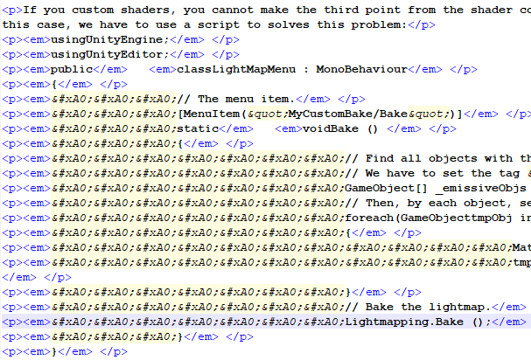

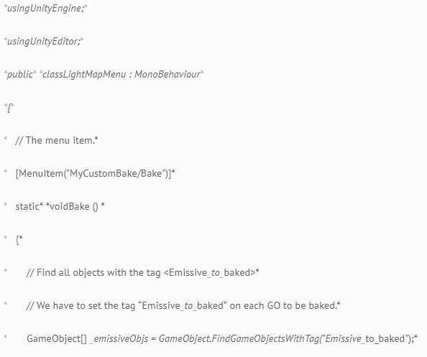

### Findings

1. Wrong use of <strong> tags

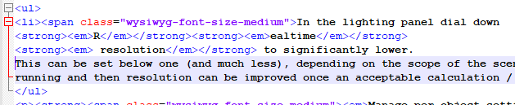

1. Use of unnecessary html tags

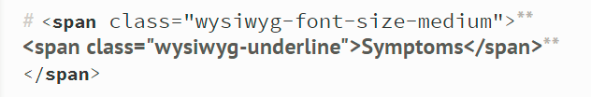

1. Difference between right and wrong usage of html tags,First one is right and second one is wrong

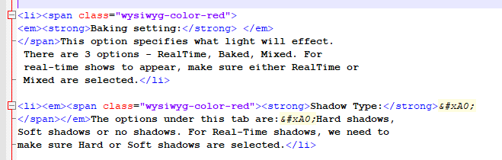

1. Unnecessary usage of <span> tags

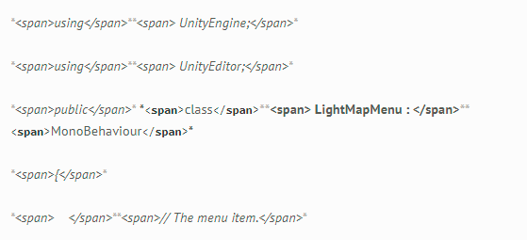

## KnowledgeBaseArticles\Unity-Editor\PC Standalone

1. 211505603-How-well-Unity-does-scale-with-SLI-

Problem:

* Proper spacing and paragraph tags are missing for titles like ‘Symptoms, Cause’

1. 212792423-Why-I-am-getting-a-StartAsync-error-running-my-app-that-uses-Windows-Speech-

Problem:

* There should not be any paragraph tags after just starting <li> tags
* <em> tag is starting with space.

## KnowledgeBaseArticles\Unity-Editor\Performance

1. 115000227183-Camera-main-is-slow

## KnowledgeBaseArticles\Unity-Editor\Shaders

1. 207482023-Shaders-in-AssetBundles-for-Desktop-platforms-Win-Mac-

Problem:

* Paragraph tags are missing in titles like ‘Symptoms and Cause and other titles too’

1. 207843283-Material-RenderQueue-does-not-match-Shader-RenderQueue

Problem:

* ‘More Information’ title and its content is wrapped in one single paragraph tag, it should be two separate paragraph tags. One paragraph tag for title and one for content.
* There is <br> tag is used after <strong> tag in title ‘More Information’.

1. 208457766-Is-it-possible-to-add-custom-shaders-Render-states-preview-mode-to-the-Unity-Scene-View-

Problem:

* Paragraph tags are missing in titles like ‘Symptoms and Cause and other titles too’

1. 115001681783-Passing-shader-parameters-by-scripting-on-masked-GameObjects

## KnowledgeBaseArticles\Unity-Editor\Shuriken- Particles

1. 207840303-Particle-Systems-are-no-longer-batched-in-Unity-5-3

Problem:

* Paragraph tags are missing in titles like ‘Symptoms and Cause and other titles too’

1. 208982486-I-need-two-particle-systems-to-behave-identically-to-each-other

## KnowledgeBaseArticles\Unity-Editor\Terrain

1. 208820266-How-can-I-add-a-seasonal-flare-to-my-trees-

Problem:

* Paragraph tags are missing in titles like ‘Symptoms and Cause and other titles too’

## KnowledgeBaseArticles\Unity-Editor\UnityScript Compiler Errors

1. 208455146-Using-WWW-with-a-Proxy

Problem:

* Paragraph tags are missing in titles like ‘Symptoms and Cause’

1. 208456906-Excluding-Scripts-and-Assets-from-builds

Problem:

* Paragraph tags are missing in titles like ‘Symptoms and Cause’

## KnowledgeBaseArticles\Unity-Editor\WebGL

1. 214948483-WebGL-looks-wrong-on-High-resolutions-Retina-

Problem:

* Canvas and other html tags are being used in article to display sample code block, which is not able to convert in markdown format correctly.

## Related articles

1. <https://discourse.gohugo.io/t/markdown-not-being-rendered-within-html-block/2532/5>

## Related Notes

1. We can replace ‘*’ in html with ‘&ast;’ , so when html will converted to markdown it will retain this and again when we will convert markdown to html it will work fine.