Airtel Network Dashboard — Feature Summary
A compact overview of the current dashboard features, component architecture, and interaction flow.

1. Key Features
- Network Map: Interactive India map with OLT, complaint, and ideal topologies.
- Alerts Sidebar: Live-ranked complaints and trouble spots by city and ratio.
- BNG Utilization: Hierarchical drilldown from circles to AE interfaces with utilization filtering.
- Mobile Networks: District-level 4G/5G volume visualization with trends and map drilldown.
- Mobile Hubs: Hub-to-district connections, volume analytics, and circle filters.
- Top Controls: Date slider, 4G/5G mode, line toggle, fixed coordinate highlights.

2. Architecture Overview
The dashboard uses Google Sheets as a data backend, a Next.js API layer for transformation and caching, and a React client with Leaflet and Recharts for visualization.
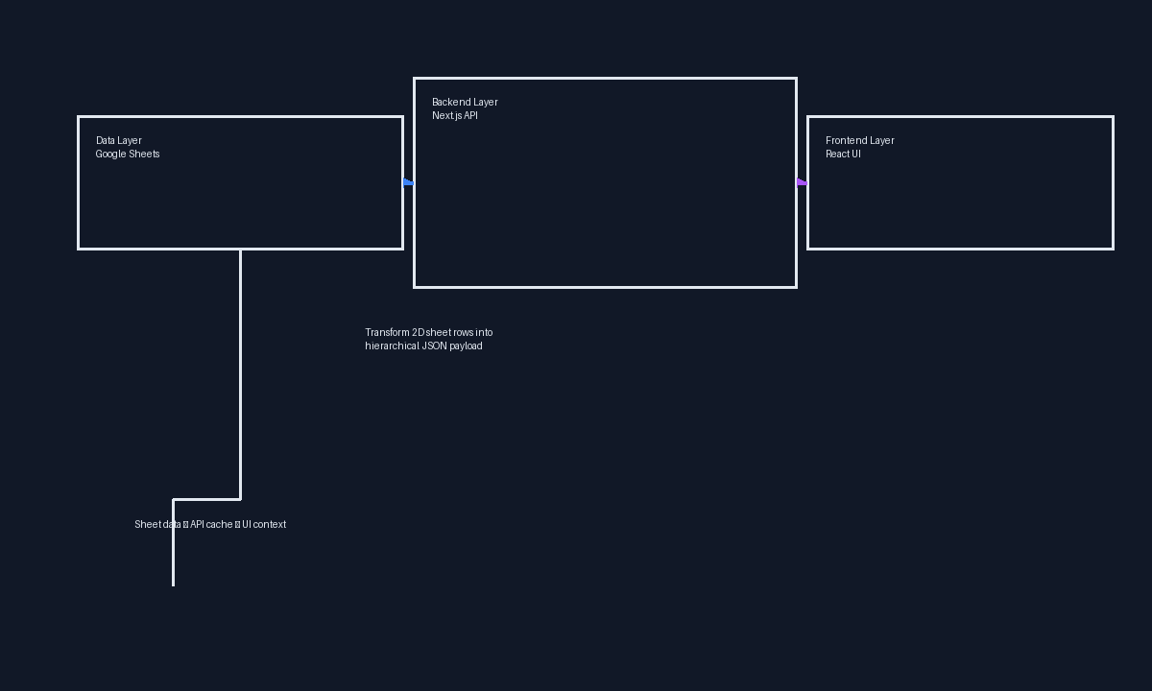

3. Data Flow
Changes from network operations flow through the Google Sheet into the API, then to the dashboard UI, where alerts are re-ranked and visuals are updated.
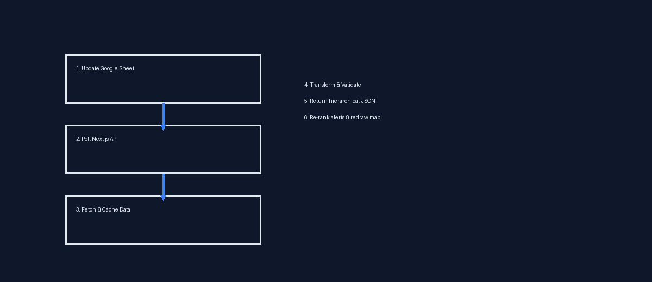

4. User Interaction Summary
- Select circle filters to show or hide hub groups on the map.
- Click hubs or districts to open detailed side panels with volume charts.
- Use the date slider to examine historical traffic across 4G/5G waves.
- Open the alerts panel to review complaint ratios and prioritize action.

5. Notes
This document is generated from the current dashboard codebase and includes visuals to explain the platform flow and features. It is suitable for stakeholder review or handoff documentation.

