Social Media Application
  - System Design and High Level Architecture
Version 1.0 | 16 October 2026 | Product owner: Manish
Build the first release as a React frontend and a Node.js / Express modular monolith backed by MongoDB. This document turns the agreed V1 scope into an implementation design for Codex, including boundaries, data ownership, request flows and release checks.
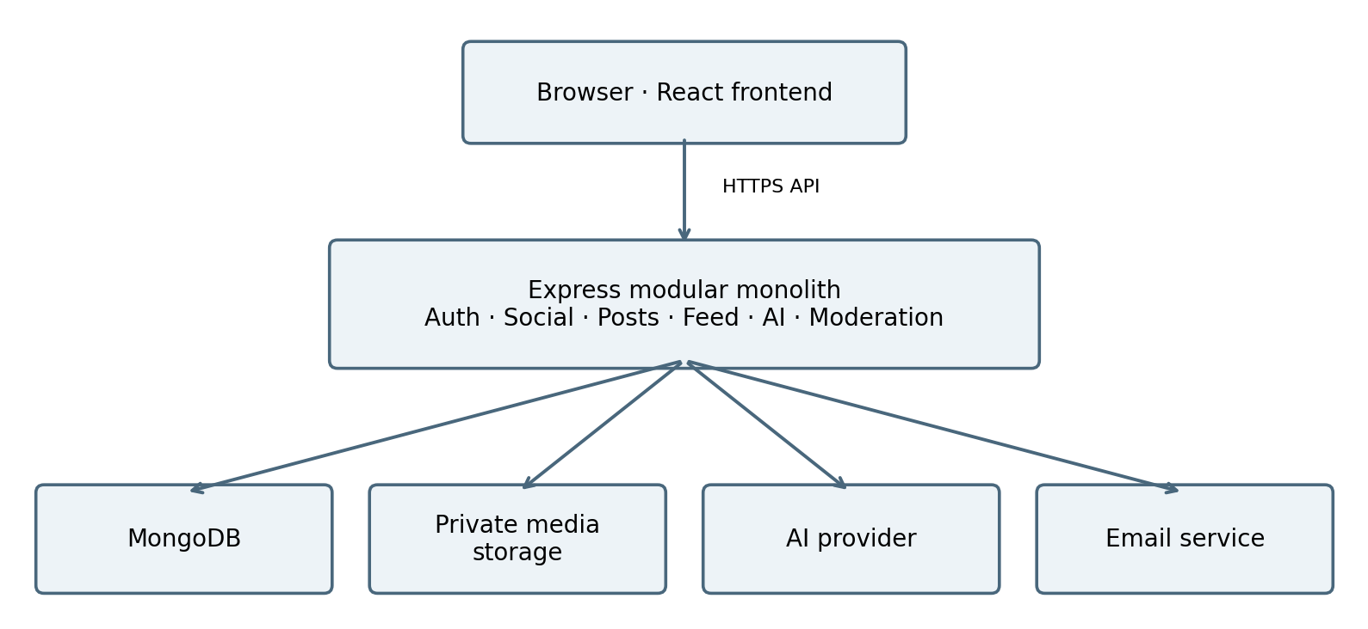
Figure 1. Logical architecture. Arrows show dependencies. A proposed direct browser upload path is described in Section 4; private media reads remain authorized by the backend.

Agreed decisions
MERN stack; one backend application and deployment; email/password authentication; MongoDB-backed sessions; photo-first social features; chronological following feed; public Explore; polling notifications; text-based AI captions; free-tier-first beta.

Scope and planning assumptions
V1 includes profiles, public/private accounts, follows, posts, likes, comments, saved collections, sharing, basic search, notifications, block/report and moderation. Chat, calls, stories, reels and advanced AI are later phases. Redis and microservices are not required for V1.
Plan for roughly 100–1,000 registered beta users. This is a sizing assumption, not tested capacity. Provider choices, exact quotas, schema fields and operational targets below remain proposals until implementation validation. No free-tier availability or uptime guarantee is assumed.

1 Application boundaries

Frontend and backend structure
React handles routes, forms, previews, loading states and paginated lists. Express owns identity, permissions, validation and business rules. Client checks improve usability but never authorize access. The frontend and backend may be hosted separately while the backend remains one monolith.
Module | Owned behaviour
Auth and users | Registration, verification, login, sessions, recovery, profiles and privacy settings.
Social graph | Follow requests, accepted follows, follower removal, block and mute.
Posts and media | Upload intent, media validation, publish, edit, delete and access checks.
Engagement | Likes, comments, replies, saved collections and share links.
Feed and search | Chronological feed, public Explore, usernames and hashtags.
Notifications | Persistent in-app events, unread state and polling.
AI | Caption generation, provider adapter, quotas and timeouts.
Moderation | Reports, removals, suspensions and audit records.

Internal dependency rules
Use route → controller → service → repository layers. Controllers parse requests and map responses; services enforce business rules; repositories access MongoDB. Shared middleware handles sessions, validation, errors and rate limits. Modules call service interfaces rather than issuing HTTP requests to each other.
Centralize canViewPost, canInteract and canManageResource rules so feed, direct post reads, comments, saved items and media delivery apply the same authorization. A block in either direction overrides normal access. Mute affects the muting member’s feed and notifications, not the other member’s permissions.

Proposed repository layout
Keep client, server and docs directories in one repository. Inside server, use modules/auth, users, social, posts, engagement, feed, notifications, ai and moderation. Shared configuration and middleware live outside feature modules. Provider adapters isolate email, media and AI integrations.

2 Data model and consistency
Use references for growing relationships. Do not embed all followers, likes or comments inside a user or post document. Bounded fields such as a photo carousel and profile details can remain embedded or referenced by a bounded list.
Collection | Key data and proposed index
User | Normalized email and username, password hash, profile, privacy, status. Unique email and username.
Session and AuthToken | User, token hash, expiresAt; purpose and usedAt for reset/verification tokens. Unique hash; TTL expiry cleanup.
Follow and Block | Follower/followee or blocker/blocked IDs; follow status pending/accepted. Unique ordered pair; reverse lookup index.
Mute | Muter and muted IDs. Unique ordered pair.
Post and MediaAsset | Author, caption, hashtags, media IDs, publication state/time. Media owner, storage key, validation state. Post index on author, state, createdAt, _id.
Like and Comment | Post, author, createdAt; comment body and optional parent. Unique Like(postId,userId); Comment(postId,createdAt,_id).
Collection and SavedItem | Collection owner/name; collection and post references. Unique SavedItem(collectionId,postId).
Notification | Recipient, actor, event type, resource, readAt. Recipient/time index; unique event deduplication key.
Report and AuditEvent | Reporter, target, reason, status; moderator action and timestamp. Status/time and target lookup indexes.
AIUsage and RateLimit | User/time bucket, reserved/used requests; limit key/count/expiry. Unique bucket key; TTL cleanup.
OutboxJob | Event type, resource, deduplication key, attempts, lease and nextAttemptAt. Due-job index and unique event key.

Consistency rules
Unique indexes prevent duplicate follows and likes; idempotency keys prevent duplicate publishes on retries. Keep like/comment documents authoritative; cached counts are optional and must be reconcilable. Use MongoDB transactions for coupled database changes when required, subject to deployment support.
Store a durable outbox event with the domain mutation when notification delivery must survive restarts. A bounded dispatcher inside the same backend deployment claims jobs with a lease and retries with backoff. External actions remain idempotent where supported; dead jobs are visible to an operator.

3 Authentication and API boundary

Session lifecycle
Register → validate input → hash password → save pending account → send a verification link. Store only a hash of each random, single-use verification/reset token. Verification enables publishing; a resend endpoint handles email failures without duplicating accounts.
Login → verify password and account status → generate an opaque random session token → store its hash and expiry in MongoDB → send the raw token in a Secure, HttpOnly cookie. Each protected request resolves the session and checks expiresAt and account state. TTL deletion is cleanup, not the authorization check.
Logout deletes or revokes the session and clears the cookie. Password reset consumes the token atomically and revokes existing sessions. Proposed defaults: seven-day absolute sessions and fifteen-minute reset tokens, to be confirmed before implementation.

Browser security and deployment origins
Prefer a same-origin API path through a reverse proxy, even if frontend and backend are separately hosted. This simplifies cookie delivery and CSRF protection. Verify that the chosen free hosting supports it before selecting the deployment layout.
For any separate origin, use an exact CORS allowlist and credentialed requests. Cookie SameSite settings must match the actual site relationship. Truly cross-site cookies may be blocked by browsers, so test them before committing to that arrangement. Use CSRF tokens and Origin validation for state-changing requests; CORS alone is not a CSRF defence.

Representative API groups
Group | Example routes under /api/v1
Authentication | POST /auth/register, /login, /logout, /verify, /forgot-password, /reset-password
Profiles and follows | GET /users/:id; PATCH /me; POST /users/:id/follow; PATCH /follow-requests/:id
Media and posts | POST /uploads; POST /uploads/:id/complete; POST /posts; GET/PATCH/DELETE /posts/:id
Feed and engagement | GET /feed, /explore; PUT/DELETE /posts/:id/like; GET/POST /posts/:id/comments
Supporting features | GET /search, /notifications; POST /reports, /ai/captions; collection and block routes
These routes establish boundaries, not a complete API contract. Before coding, specify request schemas, ownership checks, pagination, idempotency and error responses. Return stable error codes with a request ID; never return raw stack traces or password/token fields.

4 Media feed and engagement flows

Photo upload and publication
1. React requests an upload intent. Express checks the session, verification status, quota, declared file count and size, then creates a pending MediaAsset owned by that member.
2. The backend issues a short-lived, constrained upload authorization for private staging storage. The browser uploads directly where the provider supports this safely; otherwise use a bounded backend upload route.
3. Completion triggers server-side inspection of actual file size, decoded type and dimensions. Re-encode supported images to remove metadata, enforce resource limits and reject malformed files. Never trust client MIME headers or completion claims.
4. Publishing checks ownership and ready state for every media ID, writes the Post, and prevents reuse that violates ownership. Draft, failed and abandoned uploads stay inaccessible; scheduled cleanup removes orphans. Initial proposal: up to 10 photos per post, 10 MB per input image.

Private media access
Keep source objects private for all accounts so switching an account to private does not leave permanent public photo URLs. For V1, an authenticated backend media endpoint checks current post access and streams eligible content. Avoid shared public caching for protected responses. This trades backend bandwidth for simpler revocation.
Short-lived signed reads may be introduced later only with an explicitly accepted revocation window. Already downloaded bytes cannot be recalled. Storage must support private objects and authenticated backend reads; a provider without these capabilities is unsuitable for this design.

Feed and search
On each feed request, resolve accepted follows and exclusions, then query published posts from eligible authors and the member. Sort by createdAt descending, then _id descending. An opaque cursor contains both values; use a fixed page-size cap and seek pagination rather than growing offsets.
Apply visibility, blocking and mute filters before returning results; fetch further eligible candidates when filtering leaves a short page. Check direct post access independently. Explore includes eligible public content only. Start with indexed normalized username and hashtag queries; semantic ranking is deferred.

Engagement and notifications
Like and unlike use idempotent operations backed by a unique relationship. Comments verify parent post access and parent-comment membership. Saved entries retain references, not permanent access. Share links point to the app and never expose private object keys.
Notifications reference domain events and are deduplicated. Proposed polling: every 30 seconds while the app is visible, with backoff on failure. Opening a notification rechecks access; removed content shows an unavailable state.

5 AI reliability and operations

Caption generation flow
The member enters a text idea and optional tone. React sends it to Express; the AI module validates length, reserves a quota slot atomically, constructs a constrained prompt and calls the provider with a timeout. Validate returned structure and length before presenting editable suggestions.
AI never publishes, sends messages or changes account settings. Provider keys stay server-side. The V1 model receives only user-submitted text and necessary instructions, not private feeds or chats. Photo understanding and standalone assistant conversations are deferred.
Proposed limits: 10 requests per member per day, up to 3 caption suggestions and a 20-second provider timeout. Count requests at admission to prevent retries bypassing quotas; define refunds for known provider failures. Avoid automatic retries after an ambiguous timeout that may already have incurred usage.

Failure behaviour
Failure | User behaviour and recovery
AI unavailable or exhausted | Preserve the draft; allow normal posting; show a clear retry/quota message.
Email delivery failure | Account remains pending; permit throttled resend. Persist retry state without plaintext tokens in logs.
Upload fails | Keep an editable draft; retry the failed asset; remove orphaned staging files later.
MongoDB unavailable | Return a controlled service error; do not claim a write succeeded. Never bypass authorization.
Backend sleeps or restarts | Show loading/retry state; recover sessions from MongoDB and jobs from the outbox.
Notification delivery delayed | Keep the core write successful once committed; retry durable jobs and expose failed jobs to operators.

Rate limits and minimal background work
Use atomic MongoDB-backed fixed-window counters for account/IP-sensitive actions such as login, reset, upload and AI. Enforce time buckets in application logic; TTL cleanup may lag. Keep cheap request/body limits ahead of expensive work. Account for this database overhead during load tests.
Run only bounded outbox and cleanup work within the monolith; free hosting can pause execution, so do not promise exact scheduling. Resume overdue work on wake-up. Add Redis or a separate worker from the same codebase only when reliable scheduling, throughput or shared coordination justifies it.

Observability
Record request IDs, route latency, error categories, upload outcomes, AI latency/quota usage and queue age. Redact passwords, session tokens, reset links and sensitive inputs. Provide liveness and readiness endpoints, operator-visible failures, and quota alerts where supported.

6 Deployment validation and evolution

Deployment topology
Serve the built React app from static hosting. Run one Express backend instance, connect to a managed MongoDB deployment, and use separate media, transactional email and AI services. Use environment-specific secrets and separate development/test data from beta data.
Choose a same-origin API proxy if available, validate TLS and cookie behaviour, and restrict database network access to the deployment’s supported controls. Keep uploaded files out of ephemeral application storage. No vendor or current free allowance is committed by this document.

Provider selection gates
- Backend hosting must support the Node runtime, required memory, TLS, environment secrets, API routing and an acceptable sleep/restart model.
- MongoDB must provide sufficient storage, connections and index support; confirm transaction support if used. Define a backup/export and restore approach rather than assuming free managed backups.
- Media storage must support private objects, authorized uploads/reads, cleanup and usable storage/transfer quotas. Email must support verification/reset delivery within its limits.
- The AI provider must offer a usable access arrangement within the zero-spend constraint. If none is available, ship the core beta with AI disabled or a clearly labelled development mock; do not present mock output as live AI.

Release gates
CI runs lint/build checks and meaningful integration tests. Staging must demonstrate sign-up through post publication, logout revocation, password reset, private account access, block enforcement, rejected uploads, direct private-media denial, pagination and AI failure fallback.
Exercise duplicate publish/like retries, concurrent quota reservations, database restarts, outbox retries and deletion cleanup. Run a proposed initial load test at 20 concurrent active sessions on 10,000 seeded posts; measure p95 API latency, errors, database load and media bandwidth. Report measured results rather than inferring capacity from registered user count.
Before beta, restore a backup into an isolated environment, document the manual recovery process and verify rollback to the previous application build. Use compatible schema changes and versioned index/migration scripts. Public launch also requires resolved age eligibility, retention and moderation ownership.

Implementation sequence
1. Repository, environments and API conventions. 2. Auth and profiles. 3. Follow/privacy/block rules. 4. Media and posts. 5. Feed and engagement. 6. Notifications and moderation. 7. AI captions. 8. Staging tests, recovery rehearsal and beta deployment.

When to change the architecture
Add Redis when measured query load, caching or coordinated limits justify it. Extract background work when media processing or job delays affect request reliability. Add real-time infrastructure with chat, and video transport with calls. Keep module boundaries now; consider service extraction only after a measured operational need.
Next design deliverables: concrete MongoDB schemas and indexes, complete API contracts, permission test matrix, provider decision record and feature-sized Codex tasks.

