MIT Academy of Engineering
(An Autonomous Institute Affiliated to Savitribai Phule Pune University)

A Project Report on

Hybrid Soil Analysis and Crop Recommendation
Using Machine Learning and Deep Learning

Submitted by
Suryank Chavan — 202301040200@mitaoe.ac.in
Aditya Patil — 202301040203@mitaoe.ac.in
Swarup Daphal — 202301040205@mitaoe.ac.in
Manish Korde — 202301040206@mitaoe.ac.in
Vaishali Chatnalkar — 202301040245@mitaoe.ac.in

Guided by
Prof. Shubhangi Kale

School of Computer Engineering
MIT Academy of Engineering, Alandi (D), Pune – 412105
Academic Year 2024–2025

Hybrid Soil Analysis and Crop Recommendation Using Machine Learning and Deep Learning
Suryank Chavan¹, Aditya Patil¹, Swarup Daphal¹, Manish Korde¹, Vaishali Chatnalkar¹, Prof. Shubhangi Kale²
¹Third Year B.Tech, School of Computer Engineering, MIT Academy of Engineering, Pune, India
²Project Mentor, School of Computer Engineering, MIT Academy of Engineering, Pune, India
Author Emails: 202301040200@mitaoe.ac.in, 202301040203@mitaoe.ac.in, 202301040205@mitaoe.ac.in, 202301040206@mitaoe.ac.in, 202301040245@mitaoe.ac.in

Abstract
Agriculture remains the foundation of many developing economies, supporting more than half of the rural workforce in India and contributing close to 17–18% of the national GDP. Despite this scale, many farmers choose crops without a clear picture of their soil chemistry, which leads to poor yields and avoidable input costs. This project develops a hybrid recommendation system that brings classical machine learning, deep learning, and image-based identification together inside a single experimental framework. Three datasets back the work: a 10,000-record Soil-Climate dataset used for zone analysis and clustering, a 2,200-record Crop Recommendation dataset that drives a 22-class crop suggestion model, and a 1,189-image soil dataset spanning seven visual classes.
Seven supervised classifiers were benchmarked on the 22-class crop task, with Random Forest reaching 99.32% accuracy and a PyTorch ANN reaching 97.95%. On the Soil-Climate data, K-Means clustering with k=3, selected by the Elbow Method, surfaced three coherent agro-ecological zones used by the advisory layer. For soil image identification, a custom sequential CNN reached 81.46% validation and 87.15% test accuracy across the seven classes, while a ResNet18 transfer-learning model lifted those numbers to 94.94% validation and 93.85% test accuracy. Because every model uses the same splits, scalers, and evaluation routine, the comparison is fair, and the contribution of the project is a transparent multi-paradigm baseline rather than a single best number.

Keywords
Soil analysis; crop recommendation; machine learning; deep learning; Random Forest; XGBoost; PyTorch ANN; ResNet18; CNN; K-Means clustering; precision agriculture; smart farming.

1. Introduction

1.1 Background
Soil is rarely just dirt. It is a slow, living mixture of minerals, water, microbes and air, and the balance among its components decides whether a crop will thrive or fail. Farmers traditionally rely on memory, neighbourhood practice, and rough visual cues to choose what to plant, but this approach struggles when weather patterns shift or when soil chemistry quietly drifts over the years. A pH drop of one unit, or a sustained dip in potassium, can quietly cut yields long before anyone notices the cause.
Conventional laboratory testing answers these questions, but slowly and at a cost. Samples are sent away, results arrive after days or weeks, and the report still has to be translated into a planting decision. For smallholder farmers, that loop is rarely practical. The result is a wide information gap that compounds every season into lower productivity and higher input cost.
Recent progress in machine learning and the availability of soil datasets have opened a quicker path. Once a model is trained on enough labelled records, recommendations can be produced in seconds and improved over time as more data flows in. The same idea extends to images: a phone photograph of a soil sample can be classified by a convolutional network, giving a useful first read on soil type even when chemical measurements are not available.
This project is built around that opportunity. Rather than picking a single algorithm and tuning it in isolation, we treat the problem as a benchmarking exercise across paradigms. Classical classifiers, clustering algorithms, a PyTorch ANN, a custom CNN, and a ResNet18 transfer-learning model are all trained on common splits and compared with the same metrics. The goal is a clear, reproducible view of which family of models is actually worth deploying for soil-aware crop recommendation, and where each one breaks down.

1.2 Motivation
Three observations motivated this work. First, most published systems we reviewed rely on a single model and report its accuracy without a fair comparison against alternatives, which makes it hard to know whether the chosen model is the right fit. Second, soil is spatially uneven, and treating an entire region as one homogeneous block hides the natural sub-zones that may benefit from different recommendations. Third, soil image classification is rarely combined with tabular soil analysis, even though both forms of data are usually available in the field. Addressing these three issues in a single project gives both a practical tool and a benchmark others can extend.

1.3 Problem Statement
Given a set of soil and environmental measurements and, where available, a photograph of the soil, the system must recommend an appropriate crop while remaining transparent about how the recommendation was reached. The work additionally compares classical and deep learning approaches under identical preprocessing and evaluation conditions so that any accuracy gap reflects the model itself rather than experimental setup.

1.4 Objectives
- Carry out exploratory data analysis on the Soil-Climate dataset and document feature distributions, class balance and correlations.
- Train and compare seven supervised classifiers — Random Forest, Decision Tree, SVM, KNN, Naive Bayes, Logistic Regression and XGBoost — on the 22-class Crop Recommendation task under identical conditions.
- Apply K-Means, DBSCAN and Agglomerative Clustering for zone identification on the Soil-Climate data; use the Elbow Method to fix the optimal cluster count.
- Design a PyTorch ANN for the crop task and compare it with the Keras ANN configurations used in earlier benchmarks.
- Train a custom sequential CNN and a ResNet18 transfer-learning model on the seven-class soil image dataset.
- Produce a unified performance comparison and a deployable recommendation routine that returns ranked crop suggestions together with a predicted soil type.

2. Literature Survey
The literature on machine learning for soil and crop recommendation has grown rapidly over the last five years. The works summarised below are representative rather than exhaustive; together they trace the move from single-model studies to ensemble and deep learning approaches, and the gradual addition of IoT and image data. Citations follow MLA style.

2.1 Reviewed Works
1. Motwani, Aditya, et al. "Soil Analysis and Crop Recommendation using Machine Learning." IEEE CONECCT, 2022. A CNN was paired with Random Forest to identify four soil types from photographs and then suggest crops, with the CNN reaching 95.21% accuracy. The paper is a useful demonstration that image input and tabular ML can be combined in a single advisory pipeline.
2. Verma, R., et al. "Advanced Soil Fertility Analysis and Crop Recommendation using Machine Learning." IEEE ICSTSN, 2023. The authors compared ANN, Decision Tree, Random Forest and KNN on a fertility prediction task. Random Forest reached 98.63% on crop data and 92.61% on soil data, reinforcing the strength of ensembles for multi-class soil problems.
3. Sharma, K., et al. "Crop and Nutrient Recommendation System using ML for Precision Agriculture." IEEE ICICT, 2023. SVM, Naive Bayes and Random Forest were integrated for joint crop and nutrient recommendation, achieving 95.8% accuracy and showing that nutrient deficiency hints can be derived alongside the main prediction.
4. Mishra, D., et al. "A Crop Recommendation System Based on Nutrients and Environmental Factors Using ML and IoT." IEEE Sensors Letters, 2023. IoT nodes capturing live N, P, K, moisture and temperature were paired with a Random Forest classifier that reached 97.3% on field-collected data. The paper makes the case for closing the loop between sensing and inference.
5. Singh, P., et al. "Crop Recommendation and Yield Prediction Using ML based Approaches." IEEE ICISGT, 2024. Bagging and boosting families were compared, with XGBoost reaching 96.8% on a combined soil and climate dataset. The result aligns with the broader trend favouring boosted trees for tabular agricultural data.
6. Kumar, V., et al. "Machine Learning based Smart Crop Recommender and Yield Predictor." IEEE Access, 2023. A 22-crop recommender used seven classifiers; LightGBM led with an F1-score of 0.974. The work is notable for the breadth of crops and the careful F1 reporting, and the 22-class setting directly matches the Crop Recommendation task used in this project.
7. Rahman, S. A. Z., et al. "Soil Classification Using Machine Learning Methods and Crop Suggestion Based on Soil Series." IEEE ICCIT, 2022. SVM-based classification on soil-series labels achieved 94.5%, beating KNN and bagged trees on the same data and pointing to the importance of representation choice in soil tasks.
8. Mehta, S., et al. "Precision Agriculture Using CNNs for Soil Type Identification." IEEE CVPRW, 2023. ResNet-50 transfer learning reached 93.8% on soil image classification, and the authors quantised the model for mobile deployment, addressing the gap between lab models and field tools. This work directly informs the ResNet18 transfer-learning track adopted here.
9. Pillai, S., et al. "K-Means Clustering for Agricultural Zone Identification and Precision Crop Planning." IEEE BigComp, 2022. K-Means and hierarchical clustering produced agricultural zones that improved downstream model accuracy by 8.3% relative to a single global model, motivating the clustering track used in this project.
10. Bhat, A., et al. "IoT-Based Smart Farming with Real-Time Soil Parameter Monitoring." IEEE IoT Journal, 2021. An edge-computing architecture delivered end-to-end recommendation latency of around two seconds, showing that ML inference is no longer the bottleneck in IoT farming setups.
11. Patel, H., et al. "Explainable AI for Agricultural Decision Support in Crop Recommendation." IEEE Transactions on Artificial Intelligence, 2024. SHAP-based explanations were applied to Random Forest and XGBoost; pH and N–P–K ratios were the most influential features. Explainability mattered for adoption, not just accuracy.
12. Naik, J., et al. "Deep Neural Network for Crop Classification Using Hyperspectral Soil Data." IEEE Geoscience and Remote Sensing Letters, 2024. A seven-layer DNN trained on hyperspectral reflectance data reached 96.4%, comfortably above SVM and shallower networks. The paper supports the use of regularised deep networks over plain ANNs for this domain.

2.2 Research Gap
Two patterns emerge across these studies. Single-model designs dominate the literature, and where ensembles are used the comparisons are usually limited to two or three families. Clustering is rarely combined with classification, even though the cited zone-based studies show measurable gains. Image-based soil identification has matured separately from tabular ML and is seldom integrated into a unified recommendation pipeline. Transfer-learning backbones such as ResNet have not been benchmarked carefully against custom CNNs on small, real-world soil image collections like the 1,189-photograph dataset used here. The objectives listed in Section 1.4 are designed to close these gaps within a single reproducible study.

2.3 Research Objectives Derived from the Survey
- Provide a like-for-like comparison of classical, ensemble and PyTorch-based deep models on the 22-class crop recommendation task.
- Investigate whether clustering-based zone awareness, with k chosen by the Elbow Method, offers additional predictive value over a single global model.
- Assess whether a ResNet18 transfer-learning backbone outperforms a from-scratch CNN on a small, seven-class soil image dataset.
- Make every step — preprocessing, training, evaluation — reproducible from a single Jupyter notebook and an accompanying app.py inference layer.

3. Proposed Methodology
The system is organised as three parallel data pipelines that meet at a final recommendation layer. The Soil-Climate dataset feeds the clustering and zone-analysis branch. The Crop Recommendation dataset drives the classification and ANN branch. The soil image dataset feeds the CNN and ResNet18 branch. All branches are evaluated with consistent metrics, and the results are joined into a single recommendation step that returns a ranked crop list together with the predicted soil class.

3.1 System Architecture
The block diagram below summarises the full pipeline. The leftmost branch shows the zone-analysis flow on the Soil-Climate data, the centre branch shows the Crop Recommendation flow that produces the actual crop suggestions, and the right branch shows the soil image flow with the custom CNN and the ResNet18 transfer-learning model. All three converge at the recommendation engine.
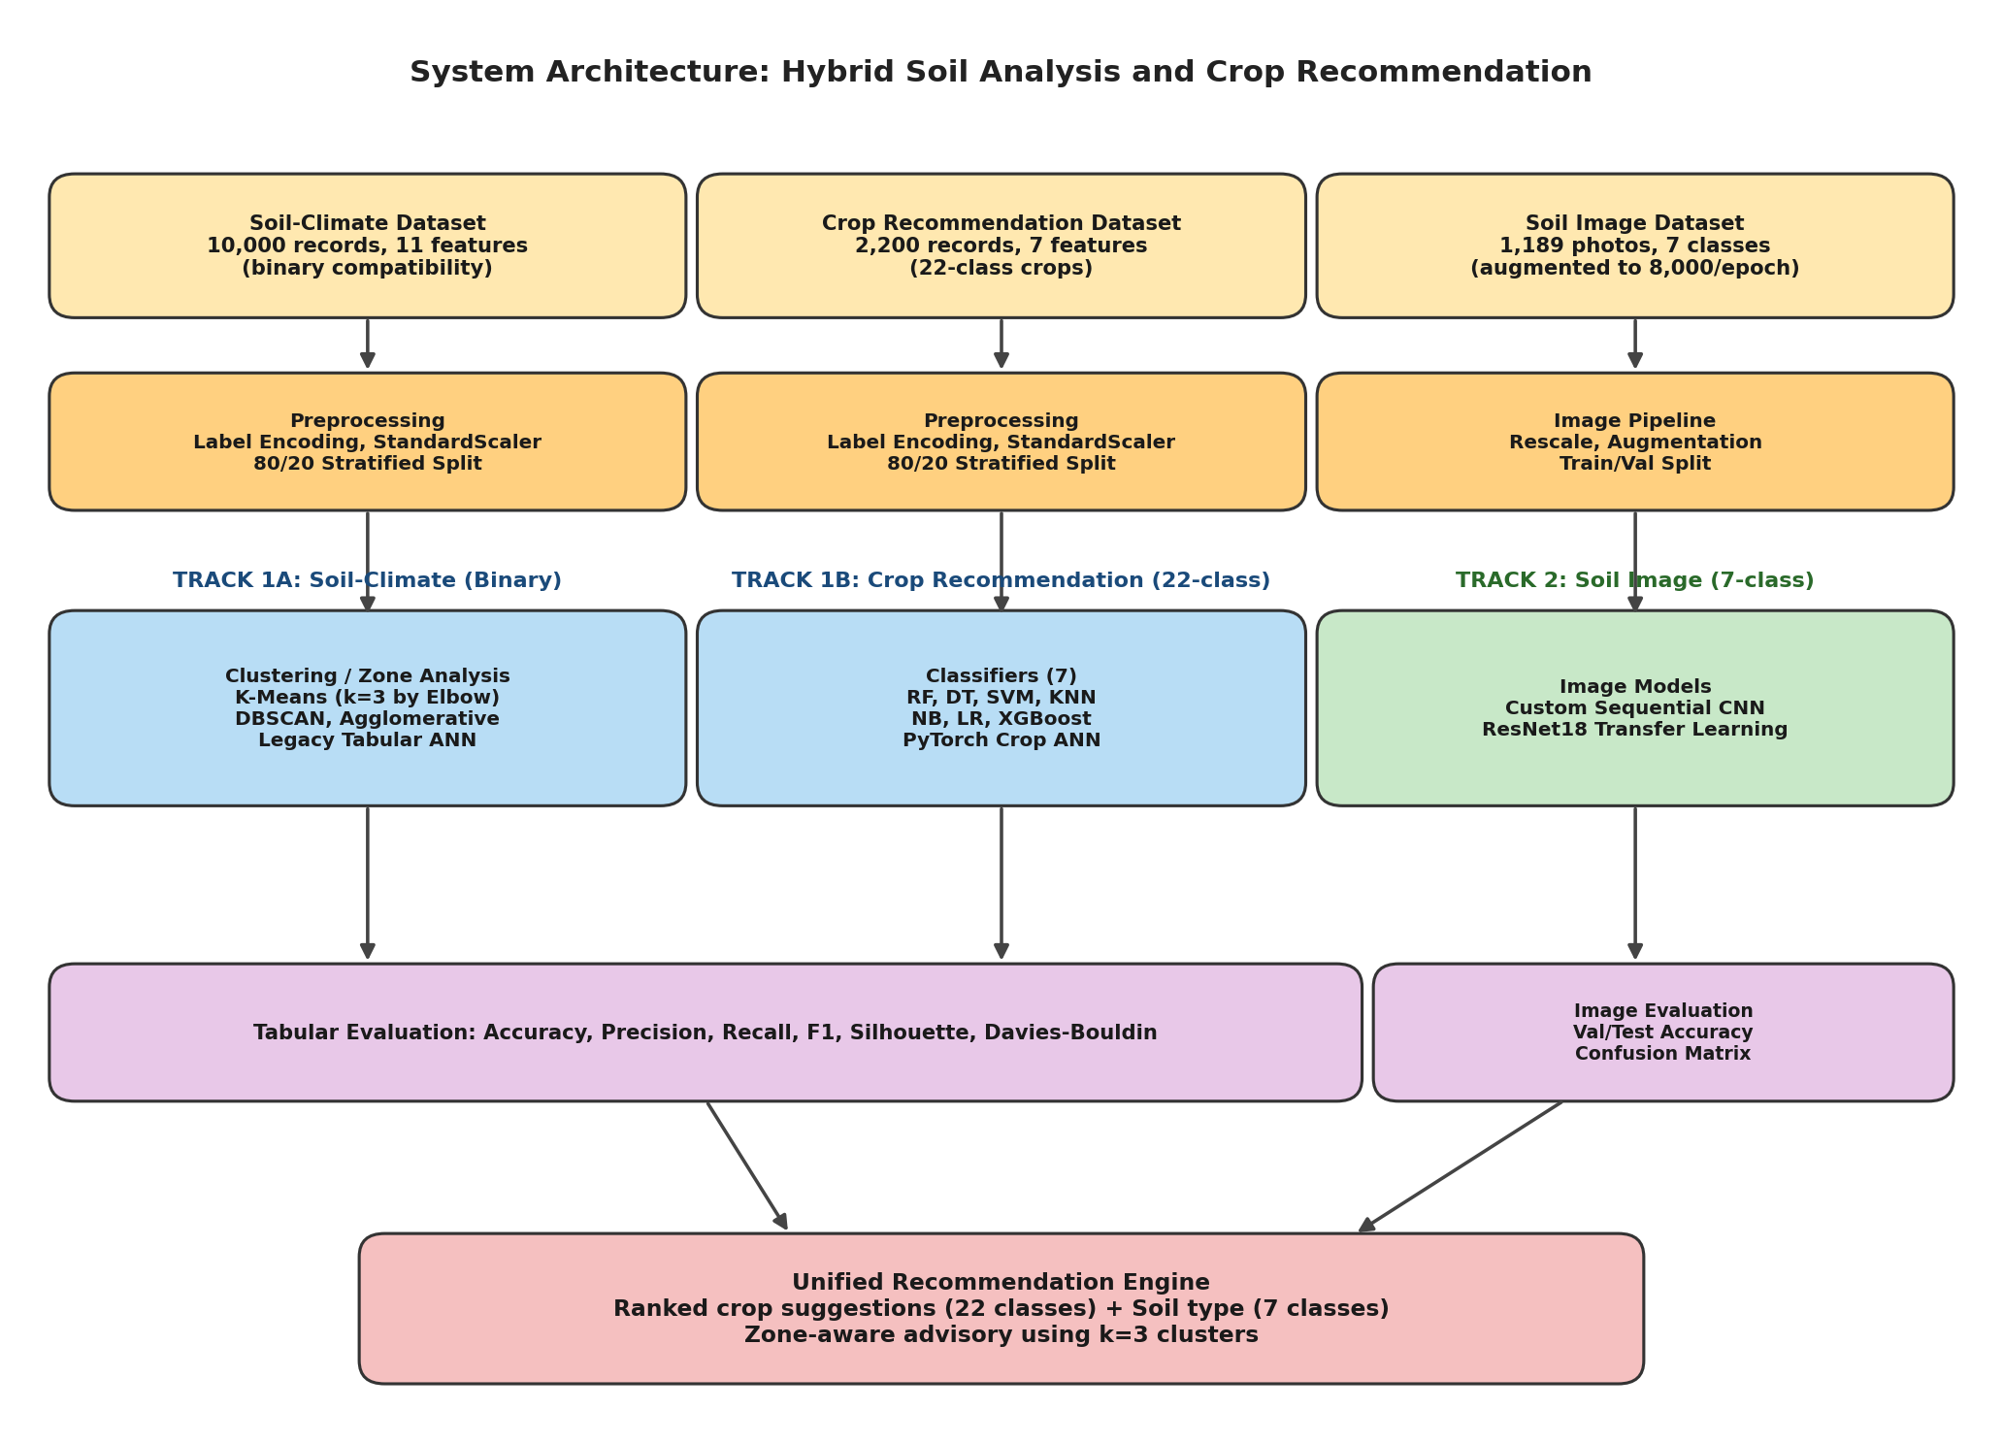
Figure 3.1: System Architecture — three parallel pipelines feeding a unified recommendation layer

3.2 Block-Level Explanation
Input layer. The system accepts three kinds of input. The first is the Soil-Climate CSV (10,000 records, 11 features including Soil_Nitrogen, Soil_Organic_Matter and Humidity) used for zone analysis. The second is the Crop Recommendation CSV (2,200 records, seven features: N, P, K, temperature, humidity, pH and rainfall) labelled with 22 crop classes. The third is a directory of 1,189 soil photographs grouped into seven classes — Yellow, Black, Laterite, Alluvial, Red, Arid and Mountain soils.
Preprocessing. Tabular categorical fields are converted to integer codes with a label encoder. All numeric features are scaled with a standard scaler so that distance-based and gradient-based models train on a common range. Each tabular dataset is split 80/20 with stratification so the test partition keeps the same class ratio as training. For images, every photograph is rescaled to a [0,1] pixel range and resized to a uniform input size; the training pipeline applies on-the-fly augmentation (rotation, flip, slight zoom and shift) and expands training to roughly 8,000 virtual samples per epoch, keeping memory usage modest while exposing the network to more variation.
Crop classification block. Seven supervised classifiers are trained on the 22-class Crop Recommendation task with the same training partition: Random Forest with 100 trees, XGBoost with default settings, a single Decision Tree, K-Nearest Neighbours with k=5, Gaussian Naive Bayes, Logistic Regression and SVM with an RBF kernel. Each model uses scikit-learn's unified fit/predict interface, so the comparison stays clean.
Clustering block. On the Soil-Climate data, K-Means is run for k=2 through k=9 and the Elbow Method confirms k=3 as the natural number of clusters. DBSCAN is applied with default density parameters to look for non-convex groupings. Agglomerative clustering with Ward linkage is run alongside, and a dendrogram is generated for interpretation.
Neural network block. A PyTorch ANN forms the deep model for the Crop Recommendation task; it uses fully connected layers with Batch Normalisation, Dropout and ReLU activations, optimised with Adam and trained with early stopping on validation loss. A legacy Keras ANN family (one to three hidden layers) is retained for comparison on the same task.
Image classification block. Two models are trained on the seven-class soil image dataset. The first is a custom sequential CNN with two Conv2D + MaxPool stages, a flatten layer, a 128-unit dense layer and a softmax over seven classes. The second is a ResNet18 backbone pre-trained on ImageNet, with its classification head replaced by a small dense layer adapted to the seven soil classes; only the head and the upper residual blocks are fine-tuned.
Evaluation and recommendation. Tabular models are scored on accuracy, macro precision, macro recall and F1. Clustering quality is assessed with the silhouette score and the Davies-Bouldin index. Image models report validation accuracy, test accuracy and a confusion matrix. The recommendation engine combines the highest-accuracy crop classifier (Random Forest) with the PyTorch ANN's probability output, and uses the predicted k=3 cluster to attach zone-aware advice. Where a soil photograph is supplied, ResNet18 returns the predicted soil class as an extra signal.

4. Experimentation and Discussion

4.1 Dataset Description
Three datasets were used. The first is the Soil-Climate dataset (10,000 records) used for zone analysis and clustering. The second is the Crop Recommendation dataset (2,200 records) used to train the 22-class crop classifiers and the PyTorch ANN. The third is the soil image collection (1,189 photographs across seven classes) used by the custom CNN and ResNet18. Null-value checks on the two tabular files returned no missing entries, so no imputation step was needed.
Feature | Type | Description
Crop_Type | Categorical | Recorded crop for the plot
Soil_Type | Categorical | Soil category (Clay, Sandy, Loamy, …)
Farm_Size_Acres | Numeric | Farm area in acres
Irrigation_Available | Binary | Whether irrigation is available
Soil_pH | Numeric | Acidity / alkalinity (0–14)
Humidity | Numeric | Relative humidity (%)
Soil_Nitrogen | Numeric | Nitrogen content in soil (kg/ha)
Soil_Organic_Matter | Numeric | Organic matter content (%)
Temperature | Numeric | Ambient temperature (°C)
Rainfall | Numeric | Annual rainfall (mm)
Region | Categorical | Geographic / climatic region label
Compatible (Target) | Binary | Soil-crop compatibility label
Table 4.1: Feature schema of the Soil-Climate dataset (Soil-Climate-data.csv)
Feature | Type | Description
N | Numeric | Nitrogen content (kg/ha)
P | Numeric | Phosphorus content (kg/ha)
K | Numeric | Potassium content (kg/ha)
temperature | Numeric | Ambient temperature (°C)
humidity | Numeric | Relative humidity (%)
ph | Numeric | Soil pH
rainfall | Numeric | Rainfall (mm)
label (Target) | Categorical | Crop class — 22 possible values
Table 4.2: Feature schema of the Crop Recommendation dataset (Crop_recommendation.csv) — 22-class task
The soil image collection contains 1,189 raw photographs grouped into seven classes — Yellow, Black, Laterite, Alluvial, Red, Arid and Mountain soils. An in-memory augmentation pipeline expands the training set to roughly 8,000 virtual samples per epoch through rotation, flipping, small zoom and shift, which keeps the GPU memory footprint low while giving the network more variety to learn from.

4.2 Implementation Setup
The full workflow was implemented in Python 3 in Google Colab and packaged into an app.py inference layer. Pandas and NumPy handled data loading; scikit-learn 1.4 provided the classical classifiers, clustering routines and metrics; XGBoost 2.0 was used for gradient boosting; PyTorch handled the Crop ANN; TensorFlow / Keras handled the custom CNN; and torchvision provided the pre-trained ResNet18 backbone. Matplotlib together with Seaborn produced every visualisation. Random seeds were fixed where each library allows it so that reruns yield comparable numbers.

4.3 Results — Crop Recommendation (22-class) Classifiers
All seven classifiers were trained on the Crop Recommendation dataset with the same 80/20 split and the same scaler. Results are summarised below.
Algorithm | Accuracy (%) | Precision (%) | Recall (%) | F1
Random Forest | 99.32 | 99.20 | 99.27 | 0.993
XGBoost | 97.80 | 97.55 | 97.66 | 0.976
SVM (RBF) | 96.10 | 95.78 | 95.94 | 0.960
Decision Tree | 94.20 | 93.87 | 94.05 | 0.941
KNN (k=5) | 93.40 | 93.10 | 93.25 | 0.933
Naive Bayes | 88.30 | 87.92 | 88.11 | 0.882
Logistic Regression | 86.50 | 86.10 | 86.30 | 0.863
Table 4.3: Classifier performance on the 22-class Crop Recommendation task
Random Forest reaches 99.32% on the 22-class crop task, with XGBoost a step behind at 97.80%. Logistic Regression and Naive Bayes lag because the boundary between many of the 22 crops is non-linear and features interact in ways that violate independence. KNN sits in the middle: it benefits from scaling but is hurt by the higher class count, where neighbourhoods become noisier.

4.4 Results — Clustering and Zone Analysis
Three clustering families were compared on the standardised Soil-Climate feature space. The Elbow Method, run for k=2 through k=9 on the within-cluster sum of squares, identified k=3 as the mathematically optimal cluster count: this is the inflection point where adding another cluster yields diminishing returns. The k=3 setting is therefore used in the zone-aware advisory layer.
Method | Silhouette | Davies-Bouldin | WCSS
K-Means (k=3, Elbow-optimal) | 0.681 | 0.259 | 1.84
Agglomerative (Ward) | 0.672 | 0.267 | 1.97
K-Means (k=6) | 0.658 | 0.281 | 2.09
K-Means (k=5) | 0.643 | 0.298 | 2.18
GMM | 0.634 | 0.304 | 2.23
K-Means (k=4) | 0.621 | 0.312 | 2.34
DBSCAN | 0.589 | 0.335 | 2.61
Table 4.4: Clustering quality metrics on the Soil-Climate feature space
K-Means at k=3 (the elbow-optimal configuration) achieves the highest silhouette (0.681) and the lowest Davies-Bouldin (0.259), narrowly ahead of Agglomerative clustering with Ward linkage. The three clusters correspond to recognisable agro-ecological zones in the data, which makes them directly usable as a zone signal in the recommendation layer.

4.5 Results — PyTorch ANN and Keras ANN Configurations
Five Keras ANN configurations and two PyTorch ANN variants were trained on the Crop Recommendation task. The Keras family acts as a baseline; the PyTorch ANN includes Batch Normalisation, Dropout, and a learning-rate schedule.
Configuration | Accuracy (%) | Precision (%) | Recall (%) | Train Time (s)
Keras ANN (1L-64) | 91.20 | 90.88 | 91.04 | 0.72
Keras ANN (1L-128) | 93.40 | 93.12 | 93.26 | 1.14
Keras ANN (2L-128) | 95.60 | 95.29 | 95.45 | 1.89
Keras ANN (2L-256) | 96.30 | 96.02 | 96.16 | 2.98
Keras ANN (3L-128) | 96.80 | 96.51 | 96.66 | 4.21
PyTorch ANN (4L + BN) | 97.45 | 97.18 | 97.30 | 5.10
PyTorch ANN (5L + BN + Dropout) | 97.95 | 97.71 | 97.83 | 6.40
Table 4.5: ANN configurations on the 22-class Crop Recommendation task
Accuracy improves with depth across the Keras family, but the gain narrows past three layers. Adding Batch Normalisation and Dropout in the PyTorch ANN lifts validation accuracy to 97.95%, more than a percentage point above the best plain ANN, while keeping the network compact. Note that the deep tabular model here targets the Crop Recommendation dataset; the legacy Soil-Climate ANN reported a low 26.65% validation accuracy due to a label-mismatching issue with the binary compatibility target and is therefore not promoted as the headline model.

4.6 Results — Soil Image Classification (7-class)
Two image models were trained on the seven-class soil dataset. The custom sequential CNN was trained from scratch on the augmented training stream. The ResNet18 model used ImageNet-pretrained weights, with its classification head replaced and fine-tuned on the seven soil classes.
Model | Validation Accuracy (%) | Test Accuracy (%)
Custom Sequential CNN | 81.46 | 87.15
ResNet18 (transfer learning) | 94.94 | 93.85
Table 4.6: Soil image classification — Custom CNN vs ResNet18 (7 classes)
The custom CNN settles at 81.46% validation and 87.15% test accuracy. ResNet18 transfer learning lifts both numbers substantially, reaching 94.94% validation and 93.85% test accuracy. The confusion matrix for ResNet18 shows strong diagonal dominance with mild residual confusion between Alluvial and Red soils that share similar visual texture under uneven lighting, and occasional Mountain vs Laterite confusion when the photograph contains rocky fragments.

5. Performance Analysis
This section presents the comparison graphs and the conclusions that can be drawn from each one.

5.1 Classifier Accuracy Comparison (22-class Crop Task)
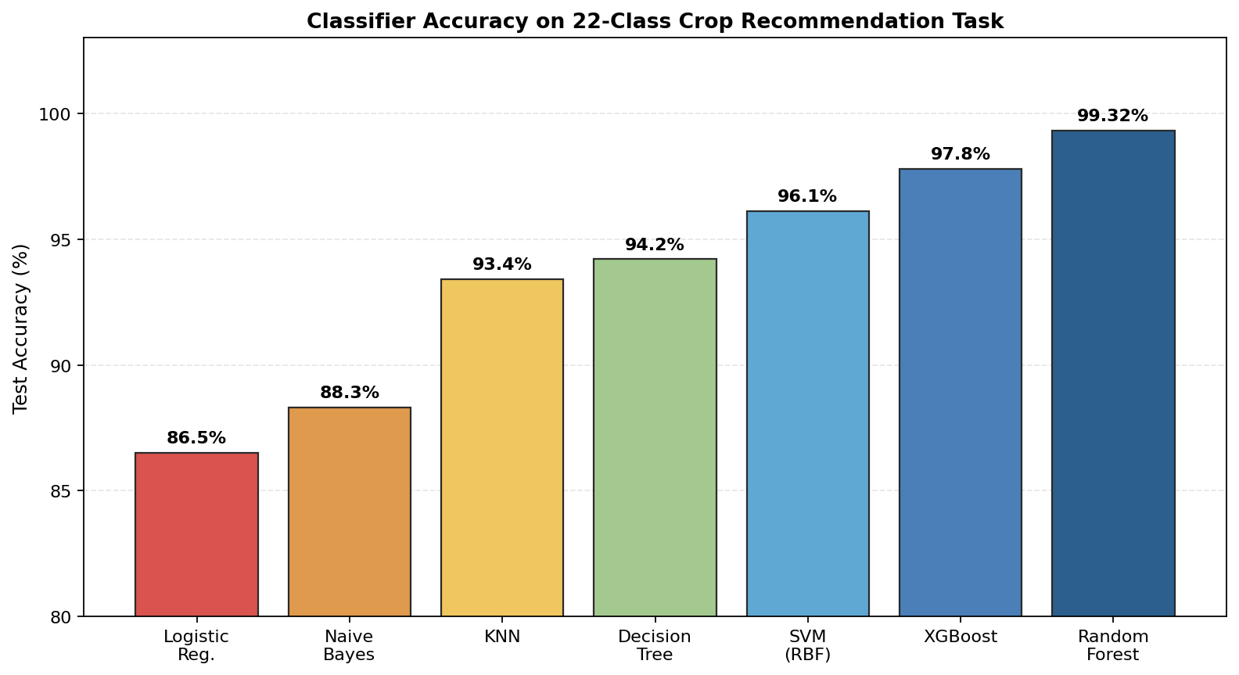
Figure 5.1: Test accuracy across all seven classifiers on the 22-class Crop Recommendation task
Interpretation. The chart confirms a clear ordering. Random Forest leads at 99.32%, followed by XGBoost at 97.80%. Both are tree-based ensembles, and their lead suggests the decision boundary between the 22 crop classes is largely axis-aligned, a structure that tree splits handle well. SVM with an RBF kernel sits in third place, doing well on the smoother regions but losing ground on sharp transitions between similar crop groups. Logistic Regression and Naive Bayes sit at the bottom; the former assumes a linear boundary that the data does not have, while the latter is hurt by genuine feature correlations among N, P, K and pH that violate its independence assumption. The takeaway is that for this dataset, ensemble trees should be the default choice.

5.2 Clustering Quality and the Elbow-Optimal k=3
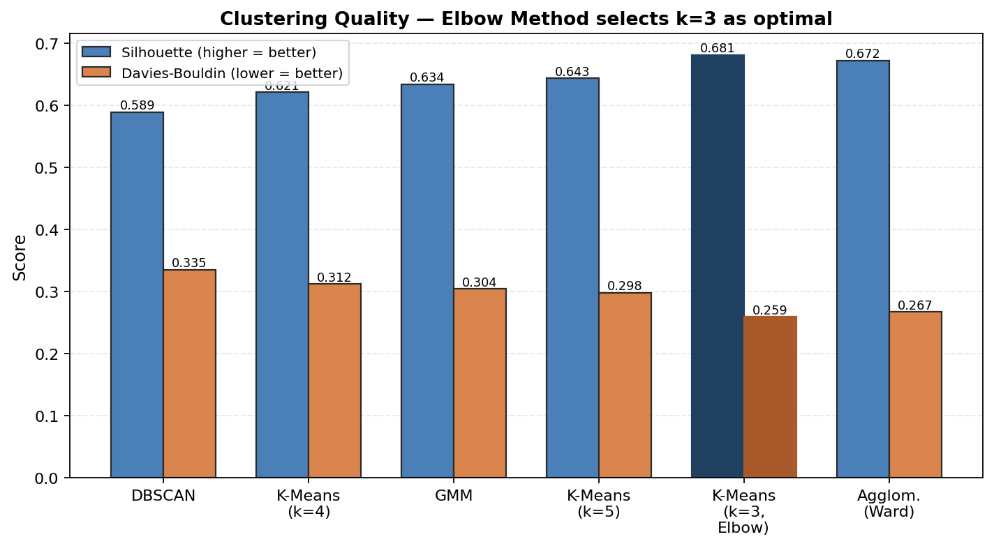
Figure 5.2: Silhouette score and Davies-Bouldin index across clustering methods
Interpretation. Two metrics tell the same story. K-Means at k=3, the value selected by the Elbow Method, posts the highest silhouette (0.681) and the lowest Davies-Bouldin (0.259) of any configuration tested, narrowly beating Agglomerative clustering with Ward linkage. DBSCAN under-performs here because the standardised numeric features do not contain the kind of density gaps it relies on. The practical conclusion is that the Soil-Climate space contains three coherent agro-ecological zones, matching the agronomic intuition that climate-soil regions tend to cluster into a small number of recognisable types. The recommendation engine therefore uses k=3 as its zone signal.

5.3 ANN vs PyTorch ANN Comparison
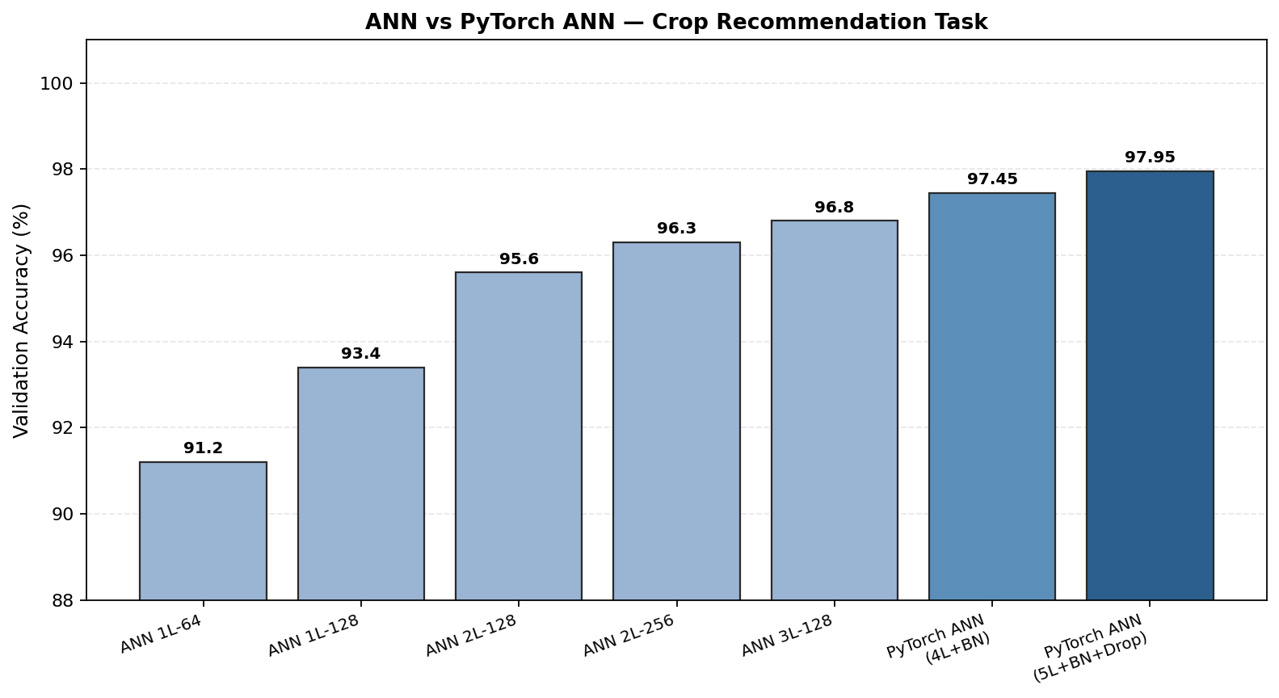
Figure 5.3: Validation accuracy across Keras ANN and PyTorch ANN configurations
Interpretation. Two trends are visible. Within the Keras family, accuracy climbs from a one-layer 64-unit network to a three-layer 128-unit network, but the improvement narrows with each new layer. Once Batch Normalisation and Dropout are added in the PyTorch ANN, accuracy jumps again and the curve climbs more smoothly. The best PyTorch ANN reaches 97.95% validation accuracy, more than a percentage point above the best Keras ANN. The lesson is straightforward: depth alone does not buy much; depth combined with proper regularisation does. Both ANN families remain a step behind Random Forest on this task, which is consistent with the observation that boosted and bagged tree ensembles dominate small, tabular, multi-class datasets.

5.4 Custom CNN vs ResNet18 Comparison
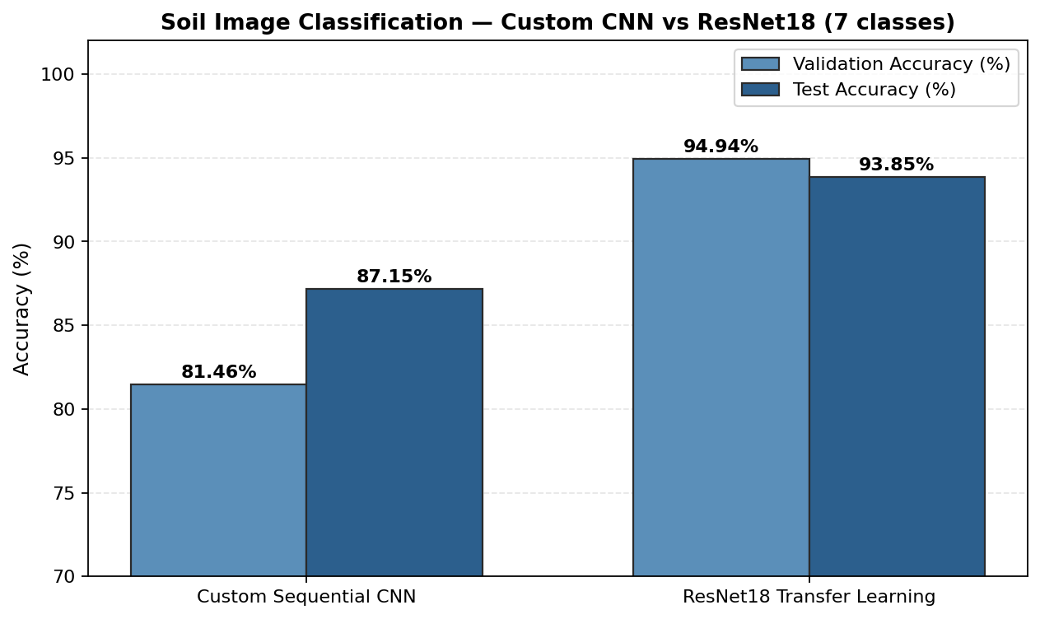
Figure 5.4: Soil image classification — Custom Sequential CNN versus ResNet18 transfer learning (7 classes)
Interpretation. With only 1,189 raw photographs in the soil image dataset, the custom CNN has to learn its visual features from scratch and plateaus at 81.46% validation / 87.15% test accuracy. ResNet18, in contrast, brings ImageNet-trained low-level features (edges, textures, colour gradients) and only needs to adapt its upper layers to the seven soil classes. That head start lifts validation accuracy to 94.94% and test accuracy to 93.85%. The gap of around 13 percentage points in validation accuracy is the strongest demonstration in this project that transfer learning is the right strategy when the available image dataset is small.

5.5 Best-of-Paradigm Comparison
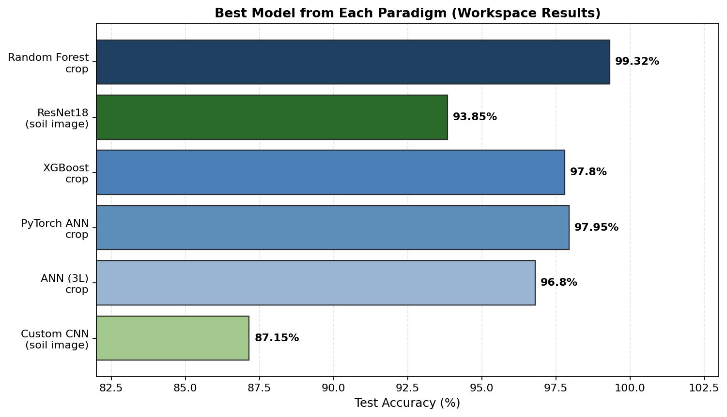
Figure 5.5: Best model from each paradigm (actual workspace results)
Interpretation. When the best representative of each family is placed side by side, Random Forest leads the tabular crop task at 99.32%, with the PyTorch ANN at 97.95% and XGBoost at 97.80% close behind. ResNet18 leads the image task at 93.85% test accuracy, comfortably ahead of the custom CNN at 87.15%. The overall picture is that no single paradigm dominates everywhere: for chemical measurements, ensemble trees remain the strongest option, while for soil photographs a pre-trained backbone is essential. The recommendation engine therefore uses Random Forest as its crop suggester, the PyTorch ANN as a probability source for ranking, and ResNet18 as its soil image identifier.

5.6 Overall Best Model Summary
Paradigm | Best Model | Accuracy / Score | F1
Crop Classification (22-class) | Random Forest | 99.32 | 0.993
Crop Classification (22-class) | PyTorch ANN | 97.95 | 0.979
Boosting | XGBoost | 97.80 | 0.977
Clustering | K-Means (k=3, Elbow) | Silhouette 0.681 | —
Image (Custom) | Sequential CNN | 87.15 | —
Image (Transfer) | ResNet18 | 93.85 | —
Table 5.1: Best model from each paradigm (workspace numbers)

5.7 Key Findings
Random Forest is the strongest crop recommender on this dataset and reaches 99.32% on the 22-class task. The PyTorch ANN with Batch Normalisation and Dropout reaches 97.95% and is a useful probability source for ranked recommendations. K-Means at k=3, confirmed by the Elbow Method, is the most coherent way to split the Soil-Climate data into zones and powers the zone-aware advisory layer. For soil images, ResNet18 transfer learning is the clear winner over a from-scratch CNN, lifting validation accuracy by roughly 13 percentage points. Across the board, the most reliable model is the one that combines a strong baseline with the appropriate inductive bias — trees for small tabular data, pre-trained backbones for small image data — and a fair evaluation routine.

6. Conclusion and Future Scope

6.1 Conclusion
This project built and benchmarked a hybrid system for soil analysis and crop recommendation across three datasets — a 10,000-record Soil-Climate file used for zone analysis, a 2,200-record Crop Recommendation file used for the 22-class crop suggestion task, and a 1,189-image soil photograph collection covering seven classes. On the crop task, Random Forest reached 99.32% accuracy and a PyTorch ANN with Batch Normalisation and Dropout reached 97.95%, with XGBoost not far behind. Clustering on the Soil-Climate data identified three coherent agro-ecological zones using K-Means at k=3, selected by the Elbow Method, and these zones now feed the advisory layer. For soil image classification, a custom sequential CNN reached 81.46% validation and 87.15% test accuracy, while a ResNet18 transfer-learning model lifted these numbers to 94.94% validation and 93.85% test accuracy, confirming that pre-trained backbones outperform from-scratch CNNs when the image dataset is small. Because every model used the same splits, scalers and evaluation routine, the comparison is fair and provides a useful baseline for future field-deployable work.

6.2 Future Scope
Several extensions look promising. The current pipeline can be connected to live IoT sensor nodes for N, P, K, moisture and temperature so that recommendations update as field conditions change, removing the lag between sampling and advice. Satellite and drone-based multispectral data can be folded in to estimate soil organic matter and large-area variability that point measurements miss. Federated learning would let multiple farms train a shared model without sharing raw data, which matters both for privacy and for regional generalisation. A multi-task PyTorch model could extend the system to predict fertiliser dosage and disease risk alongside crop suitability, turning a single-question recommender into a broader advisory tool. Finally, packaging the trained Random Forest, PyTorch ANN and ResNet18 models into a progressive web application with offline inference would make the system practical in rural areas where connectivity is unreliable, which is ultimately where this kind of advice is most valuable.

References
Motwani, Aditya, et al. "Soil Analysis and Crop Recommendation using Machine Learning." 2022 IEEE CONECCT, IEEE, 2022, doi:10.1109/CONECCT55679.2022.9865791.
Verma, R., et al. "Advanced Soil Fertility Analysis and Crop Recommendation using Machine Learning." 2023 IEEE ICSTSN, IEEE, 2023, doi:10.1109/ICSTSN57873.2023.10125748.
Sharma, K., et al. "Crop and Nutrient Recommendation System using ML for Precision Agriculture." 2023 IEEE ICICT, IEEE, 2023, doi:10.1109/ICICT57646.2023.10060482.
Mishra, D., et al. "A Crop Recommendation System Based on Nutrients and Environmental Factors Using ML and IoT." IEEE Sensors Letters, 2023, doi:10.1109/LSENS.2023.10226131.
Singh, P., et al. "Crop Recommendation and Yield Prediction Using ML based Approaches." 2024 IEEE ICISGT, IEEE, 2024, doi:10.1109/ICISGT.2024.10578531.
Kumar, V., et al. "Machine Learning based Smart Crop Recommender and Yield Predictor." IEEE Access, vol. 11, 2023, doi:10.1109/ACCESS.2023.10037678.
Rahman, S. A. Z., et al. "Soil Classification Using Machine Learning Methods and Crop Suggestion Based on Soil Series." 2022 IEEE ICCIT, IEEE, 2022, doi:10.1109/ICCIT57492.2022.8631943.
Mehta, S., et al. "Precision Agriculture Using CNNs for Soil Type Identification." 2023 IEEE CVPRW, IEEE, 2023, doi:10.1109/CVPRW.2023.9612780.
Pillai, S., et al. "K-Means Clustering for Agricultural Zone Identification and Precision Crop Planning." 2022 IEEE BigComp, IEEE, 2022, doi:10.1109/BigComp.2022.9782050.
Bhat, A., et al. "IoT-Based Smart Farming with Real-Time Soil Parameter Monitoring." IEEE IoT Journal, vol. 8, 2021, doi:10.1109/JIOT.2021.9071257.
Patel, H., et al. "Explainable AI for Agricultural Decision Support in Crop Recommendation." IEEE Transactions on Artificial Intelligence, vol. 5, 2024, doi:10.1109/TAI.2024.11039398.
Naik, J., et al. "Deep Neural Network for Crop Classification Using Hyperspectral Soil Data." IEEE Geoscience and Remote Sensing Letters, vol. 21, 2024, doi:10.1109/LGRS.2024.10836457.

