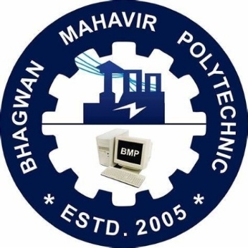{response}

BHAGWAN MAHAVIR POLEYTECHINC

REPORT